Labor Market Outlook:
January 2018

15 January 2018

A SHARP DECREASE IN UNEMPLOYMENT
Seyfettin Gürsel*, Mine Durmaz Aslan ∗∗ and Yazgı Genç***

Executive Summary

Seasonally adjusted labor market data show that non-agricultural unemployment rate decreased by 0.5 percentage points in the period of October from September reaching 12.2 percent. On the other hand, according to seasonally adjusted labor data, non-agricultural unemployment rate of both females and males decreased. Betam’s forecasting model predicts that the non-agricultural unemployment will remain at 12.2 percent in the period of November 2017.

Strong increase in employment, weak increase in labor force

According to seasonally adjusted labor market data, in the period of October 2017 compared to September 2017, the non-agricultural labor force increased by 19 thousand and reached 26 million 318 thousand while the number people employed in non-agricultural sectors increased by 148 thousand and reached 23 million 107 thousand (Figure 1, Table 1). As result, the number of unemployed in non-agricultural sectors decreased by 129 thousand and recorded as 3 million 211 thousand and the non-agricultural unemployment rate decreased from 12.7 percent to 12.2 percent. Nevertheless, the declining unemployment rate since January 2017 is still above the lowest level of 11.7 per cent in March 2016.

Figure 1 Seasonally adjusted non-agricultural labor force, employment, and unemployment

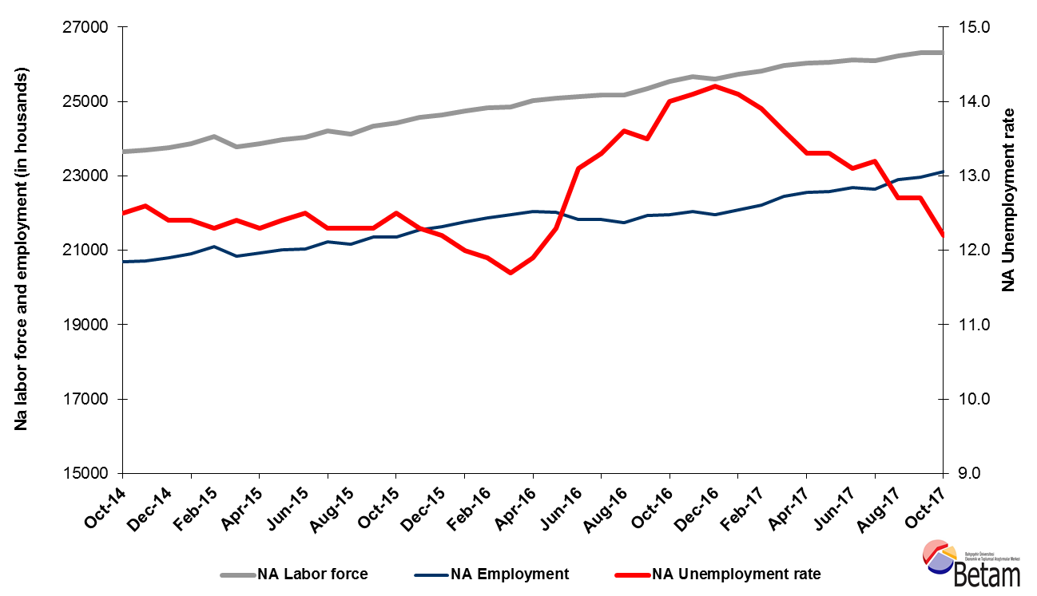

Source: Turkstat, Betam

No change in unemployment rate is expected in the period of October 2017

Betam's forecasting model had predicted that the seasonally adjusted non-agricultural unemployment rate would decrease by 0.2 percentage points reaching 12.5 percent in the period of October 2017. However, seasonally adjusted non-agricultural unemployment rate in October 2017 decreased by 0,5 percentage points and reached 12.2 compared to the previous period. Betam’s forecasting model predicts the seasonally adjusted November 2017 non-agricultural unemployment will remain at 12,2. Forecasting model details are available on Betam's website. Kariyer.net application per vacancy series used in the Betam forecasting model is depicted in Figure 3. Kariyer.net series is only one of the inputs of Betam forecast model. Indeed, several variables such as employment agency (İŞKUR) data, reel sector confidence index, capacity utilization rate are used in forecasting. Taken into account all these factors, Betam's forecasting model predicts that seasonally adjusted non-agricultural unemployment rate will decline in the period of November 2017.

Figure 2 Seasonally adjusted non-agricultural unemployment rate and application per vacancy
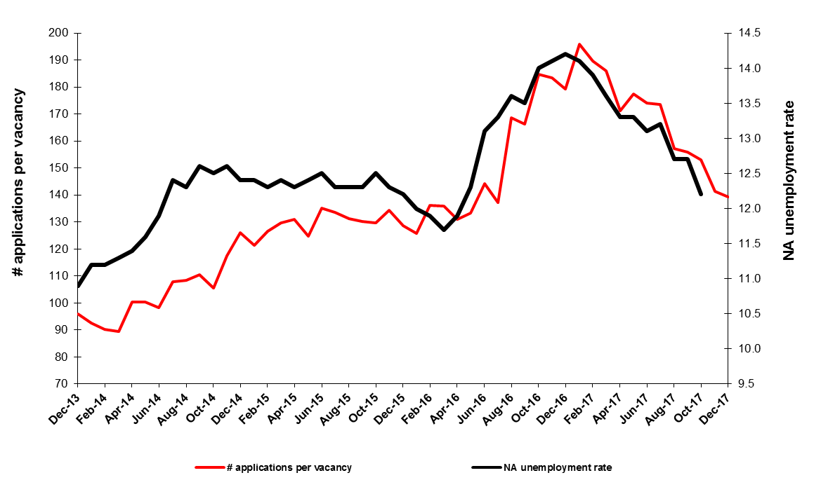
Source: Kariyer.net, Turkstat, Betam

A strong employment increase in services continues
According to seasonally adjusted sectoral labor market data, in October 2017 employment decreased in agriculture and construction sectors while the number of people employed in manufacture and services sectors increased compared to September 2017. An employment decrease of 16 thousand has been observed in manufacture sectors in the period of September 2017, while employment increased by 49 thousand in this sector in the period of October 2017. In the construction sector 23 thousand employment decline observed in September 2017 continued by 8 thousand in October 2017. High employment growth over 100 thousand observed in services since the period of August 2017 continued in the period of October 2017, employment increase attaining 107 thousand (Error! Reference source not found.,Error! Reference source not found.).

Figure 3: Employment by sectors (in thousands)
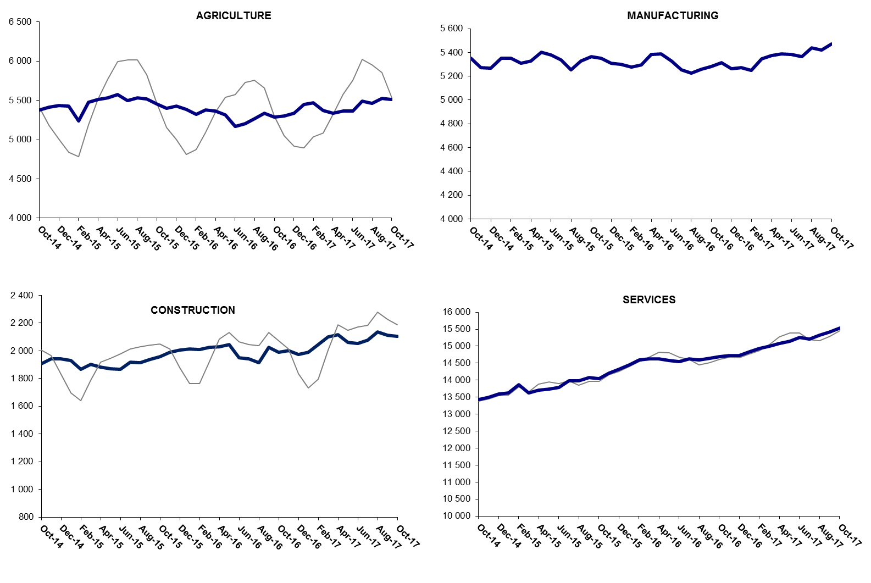

Source: TURKSTAT, Betam

The number of non-agricultural unemployed has decreased by 364 thousand in the last year

From October 2016 to October 2017 non-agricultural labor force increased by 784 thousand (3.1 percent) and non-agricultural employment by 1 million 148 thousand (5.2 percent) (Figure 4). Thus, the decrease in non-agricultural unemployed decreased by 364 thousand and attained 3 million 241 thousand (Figure 4).

Figure 4 Year-on-year changes in non-agricultural labor force, employment, and unemployment
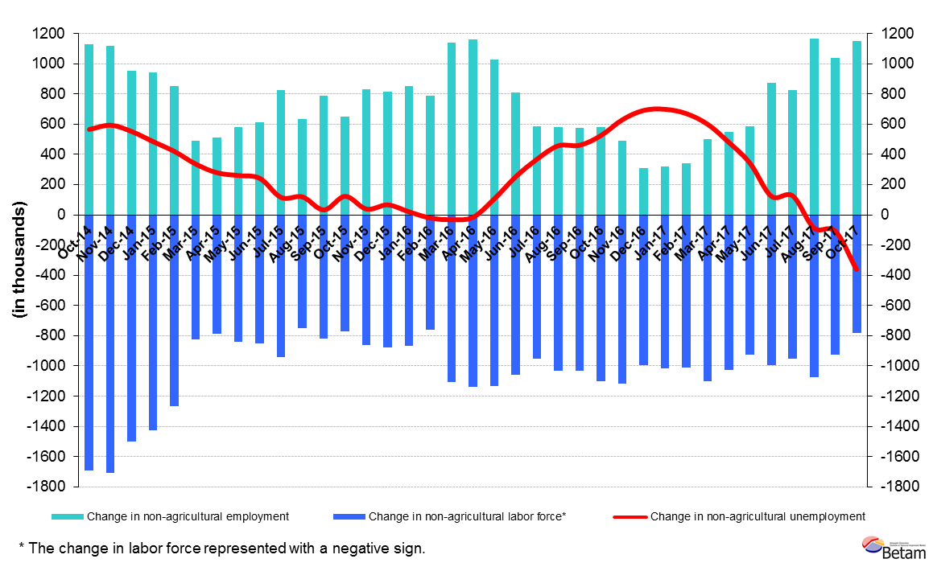
Source: Turkstat, Betam

Female and male unemployment

Figure 5 shows seasonally adjusted non-agricultural unemployment rate for males (green) and for females (purple). From the period of September 2017 to the period of October 2017, the non-agricultural female and male unemployment rate decreased by 1,0 and 0.3 percentage points respectively. Thus, non-agricultural unemployment decreased to 17.3 percent for females and to 9.9 percent for males.

Figure 5: Seasonally adjusted nonagricultural unemployment rate by gender
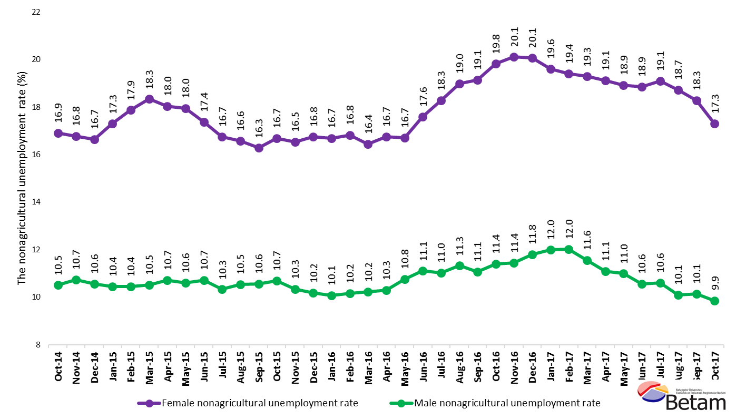
Source: Turkstat, Betam

Table 1 Seasonally adjusted non-agricultural labor market indicators (in thousands) *
 | Labor force | Employment | Unemployment | Unemployment rate | Monthly changes
September-14 | 23514 | 20551 | 2963 | 12.6% | Labor force | Employment | Unemployment
October-14 | 23649 | 20693 | 2956 | 12.5% | 135 | 142 | -7
November-14 | 23689 | 20704 | 2985 | 12.6% | 40 | 11 | 29
December-14 | 23748 | 20803 | 2945 | 12.4% | 59 | 99 | -40
January-15 | 23858 | 20900 | 2958 | 12.4% | 111 | 97 | 14
February-15 | 24049 | 21091 | 2958 | 12.3% | 191 | 191 | 0
March-15 | 23781 | 20832 | 2949 | 12.4% | -268 | -259 | -9
April-15 | 23855 | 20921 | 2934 | 12.3% | 74 | 89 | -15
May-15 | 23981 | 21007 | 2974 | 12.4% | 125 | 86 | 39
June-15 | 24033 | 21029 | 3004 | 12.5% | 53 | 22 | 31
July-15 | 24217 | 21238 | 2979 | 12.3% | 184 | 209 | -25
August-15 | 24121 | 21154 | 2967 | 12.3% | -96 | -84 | -12
September-15 | 24342 | 21348 | 2994 | 12.3% | 221 | 194 | 27
October-15 | 24415 | 21363 | 3052 | 12.5% | 73 | 15 | 58
November-15 | 24564 | 21543 | 3021 | 12.3% | 150 | 180 | -30
December-15 | 24644 | 21637 | 3007 | 12.2% | 79 | 94 | -15
January-16 | 24733 | 21765 | 2968 | 12.0% | 89 | 128 | -39
February-16 | 24837 | 21881 | 2956 | 11.9% | 104 | 116 | -12
March-16 | 24855 | 21947 | 2908 | 11.7% | 18 | 66 | -48
April-16 | 25012 | 22036 | 2976 | 11.9% | 157 | 89 | 68
May-16 | 25097 | 22010 | 3087 | 12.3% | 84 | -26 | 110
June-16 | 25120 | 21829 | 3291 | 13.1% | 23 | -181 | 204
July-16 | 25174 | 21826 | 3348 | 13.3% | 54 | -3 | 57
August-16 | 25162 | 21740 | 3422 | 13.6% | -12 | -86 | 74
September-16 | 25348 | 21926 | 3422 | 13.5% | 186 | 186 | 0
October-16 | 25534 | 21959 | 3575 | 14.0% | 186 | 33 | 153
November-16 | 25666 | 22047 | 3619 | 14.1% | 132 | 88 | 44
December-16 | 25601 | 21966 | 3635 | 14.2% | -64 | -81 | 17
January-17 | 25722 | 22095 | 3627 | 14.1% | 120 | 129 | -9
February-17 | 25812 | 22224 | 3588 | 13.9% | 90 | 129 | -39
March-17 | 25972 | 22440 | 3532 | 13.6% | 160 | 216 | -56
April-17 | 26023 | 22562 | 3461 | 13.3% | 51 | 122 | -71
May-17 | 26048 | 22584 | 3464 | 13.3% | 25 | 22 | 3
June-17 | 26109 | 22689 | 3420 | 13.1% | 61 | 105 | -44
July-17 | 26096 | 22651 | 3445 | 13.2% | -14 | -38 | 24
August-17 | 26219 | 22889 | 3330 | 12.7% | 123 | 238 | -115
September-17 | 26299 | 22959 | 3340 | 12.7% | 80 | 70 | 10
October-17 | 26318 | 23107 | 3211 | 12.2% | 19 | 148 | -129
Source: Turkstat, Betam

Table 2 Seasonally adjusted employment by sectors (in thousands) *
 | Agriculture | Manufacturing | Construction | Service | Monthly changes
September-14 | 5332 | 5306 | 1875 | 13370 | Agriculture | Manufacturing | Construction | Service
October-14 | 5381 | 5353 | 1906 | 13433 | 49 | 47 | 31 | 63
November-14 | 5414 | 5273 | 1940 | 13491 | 33 | -80 | 34 | 58
December-14 | 5435 | 5266 | 1941 | 13596 | 21 | -7 | 1 | 105
January-15 | 5427 | 5349 | 1929 | 13623 | -8 | 83 | -12 | 27
February-15 | 5239 | 5351 | 1868 | 13871 | -188 | 2 | -61 | 248
March-15 | 5476 | 5308 | 1901 | 13623 | 237 | -43 | 33 | -248
April-15 | 5510 | 5326 | 1883 | 13713 | 34 | 18 | -18 | 90
May-15 | 5535 | 5404 | 1871 | 13733 | 25 | 78 | -12 | 20
June-15 | 5573 | 5380 | 1866 | 13784 | 38 | -24 | -5 | 51
July-15 | 5500 | 5336 | 1918 | 13985 | -73 | -44 | 52 | 201
August-15 | 5532 | 5252 | 1915 | 13987 | 32 | -84 | -3 | 2
September-15 | 5516 | 5327 | 1938 | 14082 | -16 | 75 | 23 | 95
October-15 | 5454 | 5363 | 1959 | 14042 | -62 | 36 | 21 | -40
November-15 | 5398 | 5353 | 1990 | 14200 | -56 | -10 | 31 | 158
December-15 | 5428 | 5311 | 2004 | 14322 | 30 | -42 | 14 | 122
January-16 | 5384 | 5300 | 2014 | 14452 | -44 | -11 | 10 | 130
February-16 | 5325 | 5276 | 2010 | 14596 | -59 | -24 | -4 | 144
March-16 | 5378 | 5295 | 2026 | 14626 | 53 | 19 | 16 | 30
April-16 | 5362 | 5381 | 2030 | 14625 | -16 | 86 | 4 | -1
May-16 | 5315 | 5386 | 2046 | 14578 | -47 | 5 | 16 | -47
June-16 | 5172 | 5330 | 1948 | 14551 | -143 | -56 | -98 | -27
July-16 | 5205 | 5254 | 1943 | 14628 | 33 | -76 | -5 | 77
August-16 | 5269 | 5224 | 1915 | 14602 | 64 | -30 | -28 | -26
September-16 | 5338 | 5260 | 2023 | 14643 | 69 | 36 | 108 | 41
October-16 | 5289 | 5282 | 1990 | 14687 | -49 | 22 | -33 | 44
November-16 | 5302 | 5316 | 2000 | 14732 | 13 | 34 | 10 | 45
December-16 | 5339 | 5265 | 1974 | 14727 | 37 | -51 | -26 | -5
January-17 | 5451 | 5274 | 1988 | 14833 | 112 | 9 | 14 | 106
February-17 | 5472 | 5251 | 2045 | 14929 | 21 | -23 | 57 | 96
March-17 | 5372 | 5346 | 2100 | 14994 | -100 | 95 | 55 | 65
April-17 | 5339 | 5372 | 2116 | 15073 | -33 | 26 | 16 | 79
May-17 | 5363 | 5386 | 2060 | 15138 | 24 | 14 | -56 | 65
June-17 | 5364 | 5383 | 2053 | 15254 | 1 | -3 | -7 | 116
July-17 | 5494 | 5363 | 2077 | 15211 | 130 | -20 | 24 | -43
August-17 | 5461 | 5437 | 2134 | 15318 | -33 | 74 | 57 | 107
September-17 | 5528 | 5421 | 2111 | 15427 | 67 | -16 | -23 | 109
October-17 | 5515 | 5470 | 2103 | 15534 | -13 | 49 | -8 | 107

Source: Turkstat, Betam

Table 1: Seasonally adjusted non-agricultural labor force by gender (thousands)
 | Female Labor Force | Female Employment | Female Unemployed | Male Labor Force | Male Employment | Male Unemployed
October-14 | 6388 | 5308 | 1080 | 17248 | 15436 | 1812
November-14 | 6399 | 5325 | 1074 | 17241 | 15390 | 1852
December-14 | 6419 | 5350 | 1069 | 17333 | 15503 | 1831
January-15 | 6505 | 5380 | 1125 | 17322 | 15514 | 1808
February-15 | 6565 | 5392 | 1173 | 17425 | 15605 | 1819
March-15 | 6520 | 5325 | 1196 | 17243 | 15429 | 1814
April-15 | 6540 | 5360 | 1180 | 17299 | 15445 | 1854
May-15 | 6623 | 5434 | 1189 | 17351 | 15512 | 1838
June-15 | 6654 | 5498 | 1156 | 17429 | 15561 | 1868
July-15 | 6747 | 5617 | 1130 | 17493 | 15686 | 1807
August-15 | 6712 | 5600 | 1112 | 17487 | 15646 | 1841
September-15 | 6758 | 5658 | 1100 | 17587 | 15729 | 1858
October-15 | 6780 | 5649 | 1132 | 17630 | 15744 | 1886
November-15 | 6873 | 5737 | 1136 | 17630 | 15806 | 1824
December-15 | 6973 | 5805 | 1168 | 17660 | 15862 | 1798
January-16 | 7017 | 5846 | 1171 | 17678 | 15898 | 1780
February-16 | 7053 | 5867 | 1187 | 17717 | 15917 | 1800
March-16 | 7057 | 5897 | 1160 | 17823 | 15999 | 1824
April-16 | 7141 | 5945 | 1196 | 17856 | 16017 | 1839
May-16 | 7173 | 5975 | 1198 | 17930 | 16000 | 1930
June-16 | 7258 | 5981 | 1277 | 17872 | 15888 | 1984
July-16 | 7268 | 5939 | 1328 | 17926 | 15950 | 1976
August-16 | 7325 | 5935 | 1390 | 17919 | 15890 | 2029
September-16 | 7375 | 5964 | 1411 | 17987 | 15998 | 1990
October-16 | 7441 | 5967 | 1475 | 18064 | 16006 | 2058
November-16 | 7457 | 5957 | 1500 | 18156 | 16077 | 2079
December-16 | 7462 | 5965 | 1497 | 18151 | 16011 | 2141
January-17 | 7457 | 5994 | 1463 | 18259 | 16067 | 2192
February-17 | 7519 | 6060 | 1459 | 18257 | 16065 | 2193
March-17 | 7612 | 6144 | 1468 | 18379 | 16255 | 2125
April-17 | 7598 | 6145 | 1453 | 18410 | 16369 | 2041
May-17 | 7649 | 6202 | 1448 | 18375 | 16356 | 2019
June-17 | 7666 | 6221 | 1445 | 18468 | 16520 | 1949
July-17 | 7678 | 6211 | 1467 | 18465 | 16506 | 1959
August-17 | 7731 | 6284 | 1447 | 18578 | 16702 | 1876
September-17 | 7765 | 6345 | 1420 | 18531 | 16654 | 1877
October-17 | 7791 | 6443 | 1348 | 18499 | 16677 | 1823
Source: Turkstat, Betam

*Prof. Dr. Seyfettin Gürsel, Betam, Director, seyfettin.gursel@eas.bau.edu.tr
∗∗ Mine Durmaz Aslan, Betam, Research Assistant, mine.durmaz@eas.bau.edu.tr *** Yazgı Genç, Betam, Research Assistant, yazgi.genc@eas.bau.edu.tr
For detailed information on Betam's forecasting model, please see Betam Research Brief 168 titled as "Kariyer.net Verisiyle Kısa Vadeli Tarım Dışı İşsizlik Tahmini" . For the innovations in the model please see Betam Research Brief 14 titled as "Mevsim Etkilerinden Arındırılmış İşsizlik Tahmini" Soybilgen, B., "Kariyer.net Verisiyle Kısa Vadeli Tarım Dışı İşsizlik Tahmini", Betam Research Brief 168. http://betam.bahcesehir.edu.tr/tr/2014/06/kariyer-net-verisiyle-kisa-vadeli-tarim-disi-issizlik-tahmini/ Soybilgen, B., "Mevsim Etkilerinden Arındırılmış İşsizlik Tahmini", Betam Research Brief 14 http://betam.bahcesehir.edu.tr/2015/08/mevsim-etkilerinden-arindirilmis-tarim-disi-issizlik-tahmini/
Betam has been calculating application per vacancy using series released by Kariyer.net for a while. Seasonal and calendar adjustment procedure is applied to application per vacancy series. A decrease in applications per vacancy may be caused by an increase in vacancies or by a decrease in the number of applications. An increase in vacancies signals economic growth while decreasing number of applications indicates a decrease in number of people looking for a job. Monthly labor market series released by TurkStat is the average of three months. Therefore, application per vacancy statistics calculated using Kariyer.net series is the average of three months as well.
Employment in each sector is seasonally adjusted separately. Hence the sum of these series may differ from the seasonally adjusted series of total employment. The difference stems from the non-linearity of the seasonal adjustment process.
Turkstat revised the labor market statistics drastically in February 2014. Within this framework, they back casted various labor market indicators and they also continued to announce seasonally adjusted series. However, Turkstat is not providing back-casted series by gender. Therefore, female and male labor market statistics are not sufficiently long for the seasonal adjustment procedures (There should be minimum 36 observations). With the announcement of the period of February 2017 data, the number of observations required for the seasonal decontamination process was provided. From this period Betam get seasonal adjustment series in terms of gender. Nevertheless, it should not be forgotten that seasonal adjustment may cause extra volatility in the series for at least a while.

