14 December 2017

Growth Evaluation:

2017 3RD Quarter

3RD QUARTER GROWTH HIGHER THAN EXPECTED
Seyfettin Gürsel, Ozan Bakış and Uğurcan Acar

Executive Summary

In the third quarter of 2017, according to seasonally and calendar day adjusted data, Gross Domestic Product (GDP) increased by 1.2 percent compared to the previous quarter and by 11.1 percent compared to the third quarter of last year. The highest contribution to annually economic growth has been provided by private consumption, growing by 11.7% (6.9 percentage points contribution). The contribution of investments that grew by more than 12 percent was 3.5 percentage points. Since contributions of exports and imports are in opposite directions and almost of equal size, it may be said that net foreign trade did not make any contribution to growth. On the contrary, the contribution of public consumption and stock change remained very small but positive.
Third quarter growth figures have largely guaranteed that the 5.5 percent GDP growth for 2017 projected in the 2018-2020 Medium Term Programme (OVP) will be exceeded. It is understood that the Credit Guarantee Fund and other incentives were effective in this success. Assuming that these incentives that support domestic demand will not continue in the same way over the next few years, policies that will ensure sustainable (and good quality) growth in order to meet the 5.5 percent growth target foreseen in the OVP for the coming years should be considered.
Figure 1: Change in GDP components from the third quarter of last year 2016-Q3 (right) and Contributions of GDP components to 2017-Q3 GDP growth (left)

Source: TurkStat, Betam.

Strong support from private consumption
According to the same quarter of last year, consumption which grew by 3.1 percent in the second quarter, jumped by 11.7 percent in the third quarter. The contribution to growth has increased very strongly, from 1.8 percentage points to 6.9 points. (Table 1). However, we see that there is a different trend when we look at the seasonally and calendar day adjusted figures. As we move from the second quarter to the third quarter, it appears that both the growth rate and the contribution to growth are decreasing (Table 2). We can say that the special consumption tax (ÖTV) reductions on consumption has been particularly effective in the second quarter.
Table 1: Growth rates and contributions to growth of GDP components in 2017 Q2-Q3 compared to same quarters of last year

 | 2017Q2 |  | 2017Q3
 | Change (%) | Contribution (%) | Change (%) | Contribution (%)
Consumption | 3.1 | 1.8 | 11.7 | 6.9
Government Spending | -2.1 | -0.3 | 2.8 | 0.4
Investment | 8.0 | 2.4 | 12.4 | 3.5
Change in Stock |  | -0.5 |  | 0.1
Import | 10.7 | 2.4 | 17.2 | 3.7
Export | 1.8 | -0.4 | 14.5 | -3.5
GDP | 5.4 |  | 11.1
Source: TurkStat, Betam
Table 2: Growth rates and contributions to growth of GDP components in 2017 Q2-Q3 compared to previous quarters

 | 2017Q2 |  | 2017Q3
 | Change (%) | Contribution (%) | Change (%) | Contribution (%) (%)
Consumption | 2.2 | 1.3 | 1.7 | 1.0
Government Spending | 0.8 | 0.1 | -2.1 | -0.3
Investment | 4.8 | 1.4 | 4.0 | 1.2
Change in Stock |  | 0.4 |  | 0.4
Import | 0.6 | 0.1 | -0.6 | -0.1
Export | 4.6 | -1.1 | 3.9 | -1.0
GDP | 2.2 |  | 1.2
Source: TurkStat, Betam
Investments continue to support the growth
We see that the investments that made an important contribution to growth in the second quarter of 2017 have furthered the growth in the third quarter. While the contribution of investments to annual growth was 2.4 percentage points in the second quarter, this contribution increased to 3.5 percentage points in the third quarter. We emphasized in our recent research note, "Economic Growth and Forecasts", that commercial loans are systematically exploding and increasing the investments. We understand that these findings are confirmed. As noted in the previous growth evaluation note, the impact of the Credit Guarantee Fund (KGF) lies behind the high investment growth.
The contribution of stock changes is positive
While the contribution to yearly growth of stock changes was negative and almost 0.5 percent in the second quarter of 2017, it is almost zero in the third quarter (Table 1). The contribution of seasonally and calendar day adjusted stock changes to quarterly growth is positive and relatively high with 0.4 percentage points (Table 2).
Let’s remind at this point that TurkStat uses the chained volume index method when calculating new national income series. The contribution to growth of the stock change cannot be easily calculated because there is an additivity problem in the chain method and a chain index cannot be derived for the "changes in stock". We discussed in detail in the research note that we recently published how to account for the contribution of stock change to growth in the chain-volume index approach (see Betam Research Note 17/217).
High contribution of exports
Compared to the same quarter of the previous year, net foreign trade contribution is almost zero in the third quarter. There is (minus) 3.5 percentage points contribution of import which eliminates 3.7 percentage points contribution of export. The negative contribution of imports in the second quarter was more limited (Table 1). It is necessary to mention that the import contribution is negative and relatively high, while the export contribution is almost zero in the seasonally and calendar day adjusted quarterly changes (Table 2). Even though Turkish Lira did not appreciate, the reason why imports increased so strongly might be attributed to the explosion in domestic demand
Weak contribution of public spending
The contributions of the government consumption expenditure to annually as well to quarterly growth are negligible we may notice that there is a change in sign regarding the contribution in quarterly growth. While the contribution to annual changes is positive (Table 1), we see that the quarterly seasonally and calendar day adjusted contribution is negative (Table 2).
Our forecast performance is changing with TurkStat’s revisions
Betam's annual growth forecast for 2017 was 5.0 percent for the first quarter and 6.2 percent for the second quarter. TurkStat firstly announced the first quarter growth as 5.0 percent on January 12. Then, on September 11, while the first quarter growth rate was revised to 5.2 percent, the second quarter growth rate was announced as 5.1 percent. Finally, on December 11, the first and second quarter growth rates were updated to 5.3 percent and 5.4 percent respectively. We need to mention that these revisions are much larger. It is difficult to talk about prediction success or failure when the growth figures change so often with revisions. We will take a closer look at this issue in a coming research brief.
The Future of Growth
The annual growth rate was expected to be high due to the base effect created by the contraction of Turkish economy in the third quarter of 2016, but it finally announced much higher than expectations. However, as seen in Figure 2, seasonally and calendar day adjusted quarterly growth figures show a downward trend. We will share our first forecast of the annual growth rate for the last quarter next week. Although the annual growth rate in the last quarter is revealed relatively low, it is not difficult to predict that the 2017 total annual growth will be well above 5.5 percent in the OVP. Since this high growth mostly depends on incentives which stimulate the domestic demand and they cannot be sustained at the same extent due to financial discipline concerns, we can say that the 5.5 percent growth targeted in the OVP for 2018-2020 cannot be taken for granted. Achieving this targeted growth rate and sustain it in the coming years requires policies that are able to enhance “higher quality investment” improving productivity and competition instead of “more investment”.
Figure 2: GDP growth rates compared to the previous quarter and same quarter of last year

Source: TurkStat, Betam.

Additional Figure 1: 2010-2017 Changing of Treasury-backed Securities
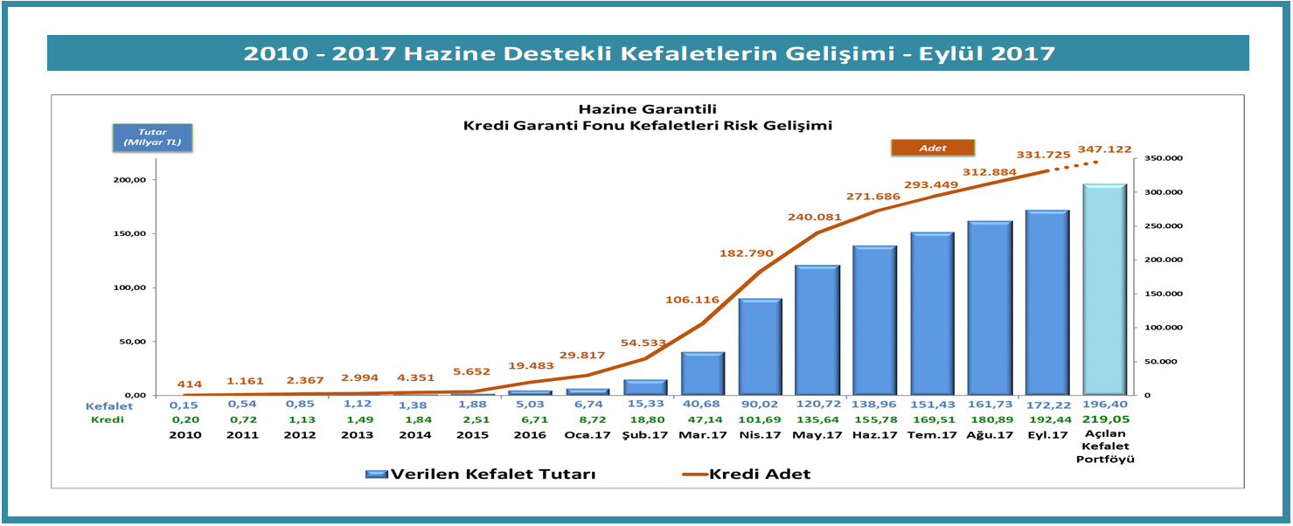
Source: KGF, http://www.kgf.com.tr/index.php/tr/bilgi-merkezi/rakamlarla-kgf

Betam, Director, seyfettin.gursel@eas.bahcesehir.edu.tr
Betam, ozan.bakis@eas.bau.edu.tr
Betam, ugurcan.acar@eas.bau.edu.tr
The amount of support the KGF received from the Treasury increased to 2 billion TL in 2015 and then 25 billion TL in 2015. In 2017, the total amount of bail given by KGF was limited to 250 billion TL. See Additional Figure 1 and http://www.kgf.com.tr/index.php/tr/bilgi-merkezi/rakamlarla-kgf and http://www.kgf.com.tr/index.php/tr/desteklerimiz/kaynaklarimiz/hazine-mustesarligi-fonu

