05 Ekim 2017

Growth Evaluation:

2017 2ND Quarter

HIGH GROWTH WITH INVESTMENT AND EXPORT IN 2ND QUARTER
Seyfettin Gürsel ve Ozan Bakış

Executive Summary

In the third quarter of 2017, according to seasonally and calendar day adjusted data, Gross Domestic Product (GDP) increased by 2.1 percent compared to the previous quarter and by 5.1 percent compared to the third quarter of last year. Betam have estimated quarter growth rate of 2.0 percent and annual growth rate of 6.2 percent. The highest contribution to annual growth was investments that grew close to 10 percent. The contribution of exports, which grew by more than 10 percent, was also very sizable. The contribution of consumption, which had a low growth rate compared to investment and exports, was also positive but relatively weak. In contrast, the contributions of public consumption, imports and stock changes were negative.
We foresee that the GDP growth of 5.5 per cent for the 2017-2020 Medium Term Programme (OVP), which was announced recently, will be exceeded thanks to the high growth provided by the base effect in the third quarter. When exceptional incentives are not expected to be in force in 2018, it is not clear what channels would contribute 5.5 per cent growth targets foreseen by OVP for the next years.

Figure 1: Change in GDP components from the second quarter of last year 2016-Q2 (left) and contributions of GDP components to 2017-Q2 GDP growth (right)

Source: TurkStat, Betam.

Increase in consumption
Annual changes in the consumption growth rate of 3.6 percent in the first quarter fell to 3.2 percent in the second quarter. Contribution to growth fell to 1.9 percent points from 2.1 percent points. (Table 1). However, we see that there is a different trend when we look at the seasonally and calendar-day adjusted figures. While contribution of consumption to growth in the first quarter is negative, this contribution is positive and relatively high in the second quarter (Table 2). It can be said that the support of discounted ÖTV (special consumption tax) on consumption has become effective from the second quarter.
Table 1: Growth rates and contributions to growth of GDP components in 2017 Q1-Q2 compared to same quarters of last year

 | 2017Q1 |  | 2017Q2
 | Change (%) | Contribution (%) | Change (%) | Contribution (%)
Consumption | 3.6 | 2.1 | 3.2 | 1.9
Government Spending | 9.7 | 1.4 | -4.3 | -0.7
Investment | 3.0 | 0.9 | 9.5 | 2.8
Change in Stock |  | -1.6 |  | -0.8
Import | 10.9 | 2.5 | 10.5 | 2.3
Export | 0.7 | -0.1 | 2.3 | -0.5
GDP | 5.2 |  | 5.1
Source: TurkStat, Betam

Table 2: Growth rates and contributions to growth of GDP components in 2017 Q2-Q3 compared to previous quarters

 | 2017Q1 |  | 2017Q2
 | Change (%) | Contribution (%) | Change (%) | Contribution (%)
Consumption | -0.9 | -0.5 | 2.1 | 1.2
Government Spending | 0.7 | 0.1 | -3.9 | -0.6
Investment | -1.0 | -0.3 | 6.3 | 1.8
Change in Stock |  | 0.4 |  | 1.0
Import | 6.4 | 1.4 | -0.7 | -0.2
Export | -0.9 | 0.2 | 5.3 | -1.3
GDP | 1.3 |  | 2.1
Source: TurkStat, Betam

Surprise increase in investments
The contribution of investments to second quarter growth of 2017 was surprising. In the Betam research note, "Economic Growth and Forecasts: August 2017", which we published earlier, we emphasized that commercial lending was booming and supported the investments. The realizations confirm our assertion. The contribution of investments to growth in the second quarter was 2.8 percentage points. This is slightly more than half of the 5.1 percent growth rate alone. We would like to remind you that investment contribution was only 0.9 percentage points in the first quarter. It is understood that the Credit Guarantee Fund (KGF) backed effectively this high investment increase.

The contribution of stock changes is negative
In both quarters of 2017, the contributions of stock changes to growth are negative: -1.6 and -0.8 percentage points respectively (Table 1). The contribution of stock changes which seasonally and calendar-day adjusted is relatively high and positive (Table 2).
Let’s remind at this point that TURKSTAT uses the chained volume index methodology when calculating new national income series. The contribution to growth of the stock change cannot be easily calculated because there are both an additivity problem in the chain methodology and a chain index cannot be derived for the "changes in stock". We discussed in detail in the research note that we recently published how the contribution of stock change to growth in the chain-volume index approach may be calculated (see Betam Research Note 17/217).

High contribution of export to growth
Net foreign trade contribution, which accelerated with the depreciation of TL in the last period, continued in the second quarter. While export contribution reached 2.3 percentage points, import contribution (minus) 0.5 percentage points. We would like to underline that the increase in imports in the second quarter is similar to that in the first quarter but the increase in import in the second quarter became stronger (Table 1). We see that the seasonally and calendar-day adjusted net export contribution to quarterly growth changed from positive to negative. Exports declined 0.7 percent from the first quarter to second quarter while import increased to 5.3 percent. We note that this development is consistent with the increase in domestic demand (Table 2).

Growth contribution of public expenditures is negative
The contribution of the government spending to annually growth is negative in the second quarter (-0.7 percentage points). However, the contribution in the first quarter was 1.4 percent points (Table 1). When we look at the quarterly growth contributions, we see that public consumption expenditures have made a negative contribution in both quarters. Regarding public expenditures that realized a strong increase in 2016 (year of referendum) it appears a push on the brakes in order to reestablish the fiscal discipline (Table 2).
The Future of Growth
The annual growth rate for 2017 was in line with our forecast in the first quarter, but it was one point lower than our forecast in the second quarter. On the other hand, the growth of the first quarter to the second quarter is realized along with Betam’s forecast. As it is known, in the third quarter of 2016, the economy has been contracted. Then, during the following three quarters, GDP growth was high. Considering that GDP growth is continuing in the third quarter of this year almost everyone agrees that yearly growth rate would attain quite high level. Even rating companies, which are known for their recent low estimates, forecasts third quarter GDP growth over 7 percent.
Betam will share its first predictions for the third quarter growth in the coming days. As we can see in Figure 2, it is no surprise that economic growth in the third quarter, even in the fourth quarter, except for an external shock situation, will be high. For this reason, we predict that the target of 5.5 percent stated in the Medium Term Program for 2017 will be exceeded. Since this growth is considered to be achieved through considerable internal supportive broad incentives and that these incentives are not sustainable due to fiscal discipline concerns, we can say that the main test of economic growth will take place in 2018 and 2019 which still targeted at 5.5 percent.

Figure 2: GDP growth rates compared to previous quarter and same quarter of previous year
Source: TurkStat, Betam.

Additional Figure 1. 2010-2017 Changing of Treasury-backed Securities
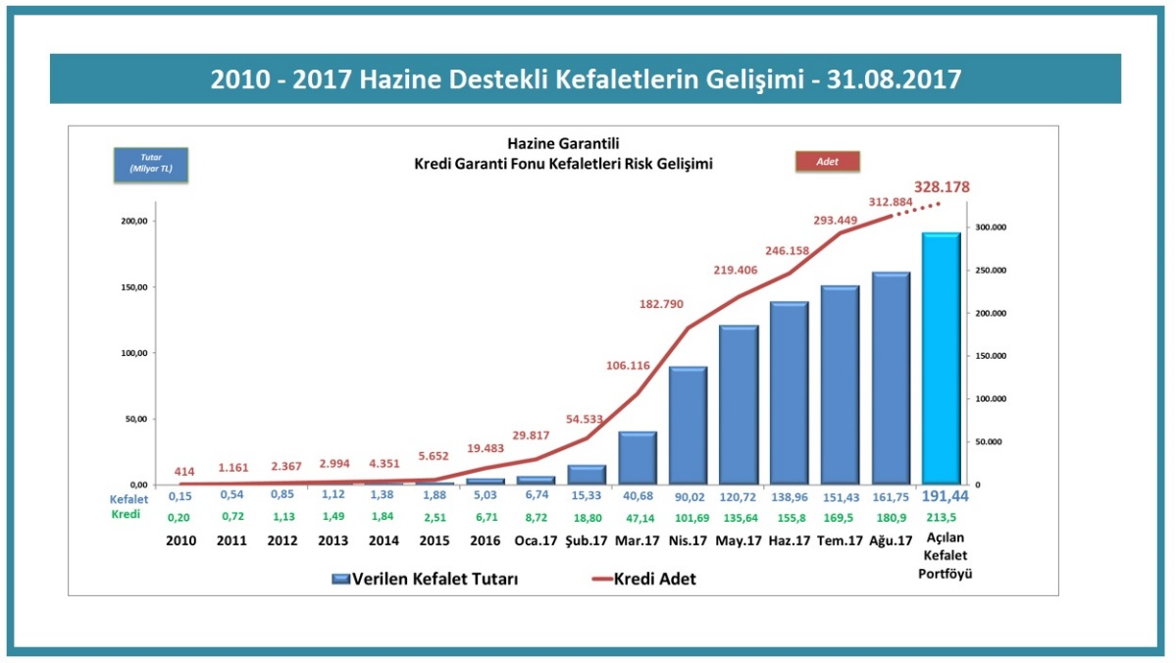
Source: KGF, http://www.kgf.com.tr/index.php/tr/bilgi-merkezi/rakamlarla-kgf

Betam, Director, seyfettin.gursel@eas.bahcesehir.edu.tr
Doç. Dr. Ozan Bakış, Betam, ozan.bakis@eas.bau.edu.tr
The amount of support the KGF received from the Treasury increased to 2 billion TL in 2015 and then 25 billion TL in 2015. In 2017, the total amount of bail given by KGF was limited to 250 billion TL. See Additional Figure 1 and http://www.kgf.com.tr/index.php/tr/bilgi-merkezi/rakamlarla-kgf and http://www.kgf.com.tr/index.php/tr/desteklerimiz/kaynaklarimiz/hazine-mustesarligi-fonu

