Labor Market Outlook:
December 2017

15 December 2017

UNEMPLOYMENT CONTUNIOUS ITS DECREASE
Seyfettin Gürsel*, Mine Durmaz Aslan ∗∗ and Yazgı Genç***

Executive Summary

Seasonally adjusted labor market data show that non-agricultural unemployment rate decreased by 0.1 points in the period of September from August reaching 12.7 percent. On the other hand, according to seasonally adjusted labor data, non-agricultural unemployment rate of females decreased while non-agricultural unemployment rate of males increased. Betam’s forecasting model predicts that the non-agricultural unemployment will decrease at 12.5 percent in the period of October 2017.

Decline in unemployment continues

According to seasonally adjusted labor market data, in the period of September 2017 compared to August 2017, the non-agricultural labor force increased by 49 thousand and reached 26 million 296 thousand and the number people employed in non-agricultural sectors increased by 69 thousand and reached 22 million 956 thousand (Figure 1, Table 1). In this framework, the number of unemployed in non-agricultural sectors decreased by 20 thousand and recorded as 3 million 340 thousand, the non-agricultural unemployment rate decreased from 12.8 percent to 12.7 percent. In the period of August, the rate of non-agricultural unemployment had decreased from 13.3 percent to 12.8 percent.

Figure 1 Seasonally adjusted non-agricultural labor force, employment, and unemployment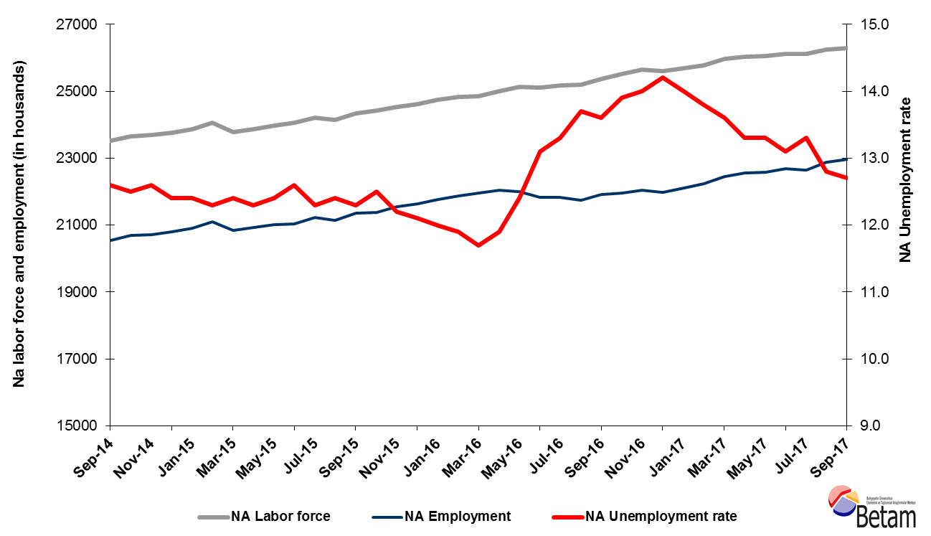Source: Turkstat, Betam

Decline in unemployment is expected in the period of October 2017

Betam's forecasting model had predicted that the seasonally adjusted non-agricultural unemployment rate would remain constant at 12.8 percent in the period of September 2017. Seasonally adjusted non-agricultural unemployment rate in September 2017 decreased by 0,1 percentage points and reached 12.7 compared to the previous period. Betam’s forecasting model predicts the seasonally adjusted October 2017 non-agricultural unemployment will decline by 0.2 percentage point and realize as 12,5. Forecasting model details are available on Betam's website. Kariyer.net application per vacancy series used in the Betam forecasting model is depicted in Figure 3. Kariyer.net series is only one of the inputs of Betam forecast model. Indeed, several variables such as employment agency (İŞKUR) data, reel sector confidence index, capacity utilization rate are used in forecasting. Taken into account all these factors, Betam's forecasting model predicts that seasonally adjusted non-agricultural unemployment rate will decline in the period of October 2017.

Figure 2 Seasonally adjusted non-agricultural unemployment rate and application per vacancy
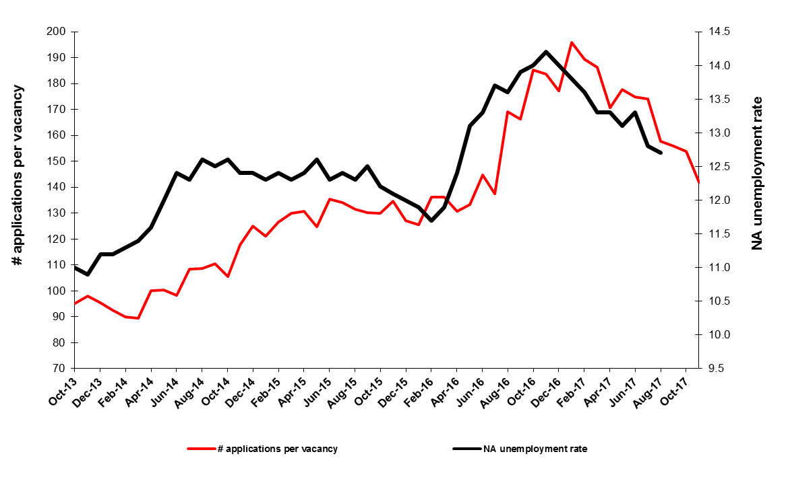
Source: Kariyer.net, Turkstat, Betam

A strong employment increase in services continues

According to seasonally adjusted sectoral labor market data, in September 2017 employment decreased in manufacturing and construction sectors while the number of people employed in agriculture and services sectors increased compared to August 2017. While employment increases were observed in construction and manufacture sectors in the period of August 2017, employment decreased in these sectors by 16 thousand and 22 thousand respectively in the period of September 2017. On the other hand, while employment in agriculture sector decreased by 33 thousand compared to previous period, in the period of September 2017 agricultural employment increased by 68 thousand. High employment growth observed in services during the period of August 2017 continued in the period of September 2017; an increase of 107 thousand in both periods has been observed (Figure 3,Table 2).
Figure 3: Employment by sectors (in thousands)
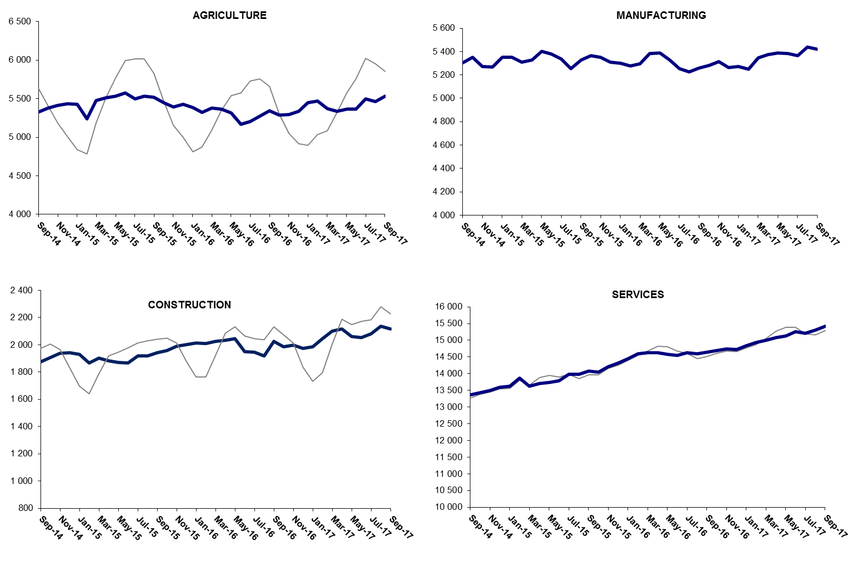

Source: TURKSTAT, Betam

The number of non-agricultural unemployed has decreased by 110 thousand in the last year

From September 2016 to September 2017 non-agricultural labor force increased by 926 thousand (3.6 percent) and non-agricultural employment by 1 million 36 thousand (4.7 percent) (Figure 4). Thus, the increase in non-agricultural unemployed decreased by 110 thousand and attained 3 million 368 thousand. Nevertheless, the number of non-agricultural unemployed declining since January is still higher than its lowest level reached at 2 million 754 thousand, in April 2016 (Figure 4).

Figure 4 Year-on-year changes in non-agricultural labor force, employment, and unemployment
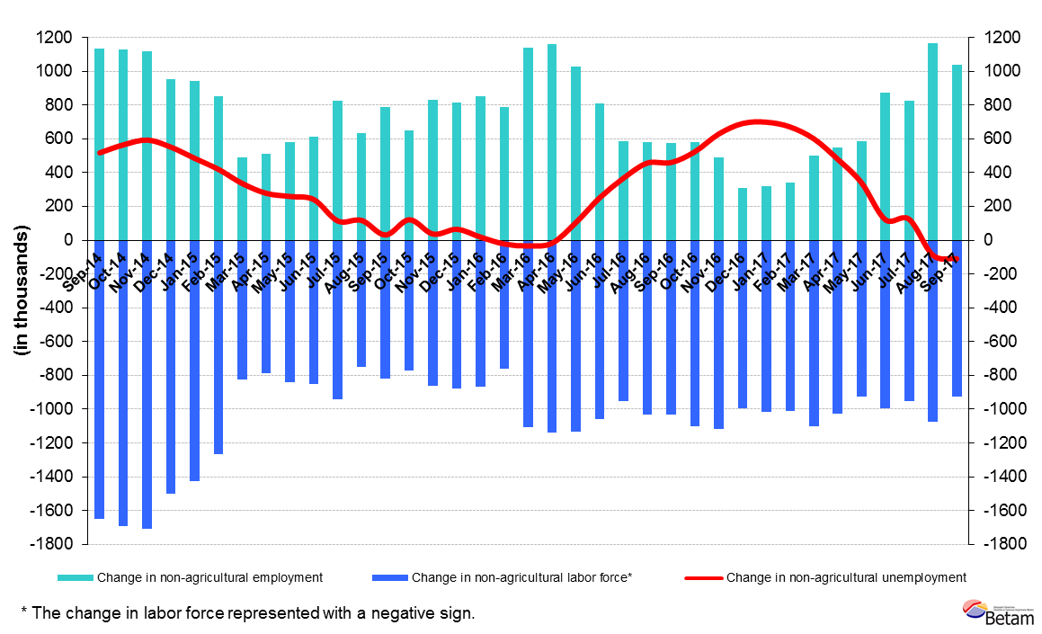
Source: Turkstat, Betam

Female and male unemployment

Figure 5 shows seasonally adjusted non-agricultural unemployment rate for males (green) and for females (purple). From the period of August 2017 to the period of September 2017, the non-agricultural female unemployment rate decreased by 0,1 percentage points while male unemployment rate has increased by 0,2 percentage points. Thus, non-agricultural unemployment decreased to 18.4 percent for females and increased to 10.2 percent for males.

Figure 5: Seasonally adjusted nonagricultural unemployment rate by gender
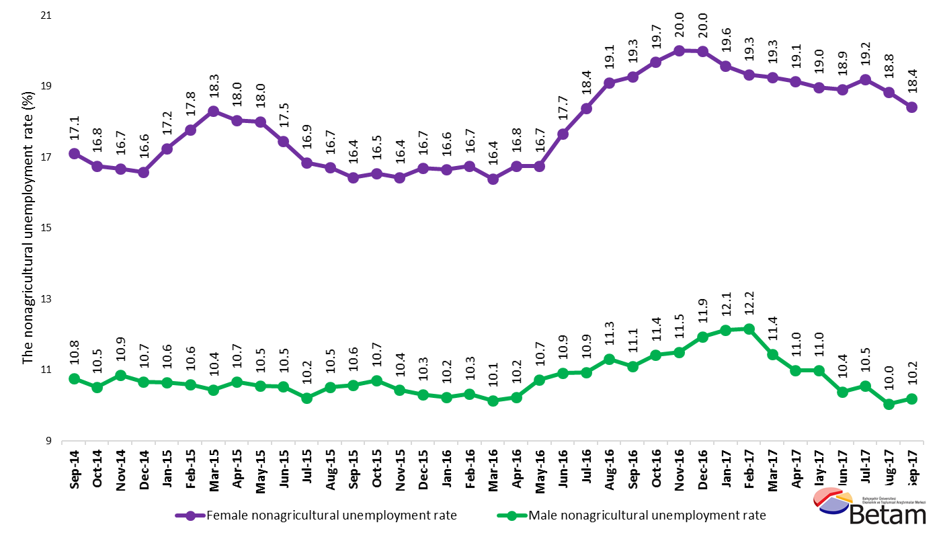
Source: Turkstat, Betam

Table 1 Seasonally adjusted non-agricultural labor market indicators (in thousands) *
 | Labor force | Employment | Unemployment | Unemployment rate | Monthly changes
August-14 | 23384 | 20508 | 2876 | 12.3% | Labor force | Employment | Unemployment
September-14 | 23511 | 20549 | 2962 | 12.6% | 127 | 41 | 86
October-14 | 23651 | 20695 | 2956 | 12.5% | 140 | 146 | -6
November-14 | 23691 | 20706 | 2985 | 12.6% | 40 | 11 | 29
December-14 | 23749 | 20804 | 2945 | 12.4% | 58 | 98 | -40
January-15 | 23860 | 20901 | 2959 | 12.4% | 111 | 97 | 14
February-15 | 24049 | 21091 | 2958 | 12.3% | 189 | 190 | -1
March-15 | 23781 | 20832 | 2949 | 12.4% | -268 | -259 | -9
April-15 | 23855 | 20921 | 2934 | 12.3% | 74 | 89 | -15
May-15 | 23981 | 21007 | 2974 | 12.4% | 125 | 86 | 39
June-15 | 24059 | 21028 | 3031 | 12.6% | 79 | 21 | 58
July-15 | 24216 | 21237 | 2979 | 12.3% | 156 | 209 | -53
August-15 | 24146 | 21152 | 2994 | 12.4% | -69 | -85 | 16
September-15 | 24340 | 21346 | 2994 | 12.3% | 194 | 194 | 0
October-15 | 24419 | 21367 | 3052 | 12.5% | 80 | 21 | 59
November-15 | 24539 | 21545 | 2994 | 12.2% | 119 | 178 | -59
December-15 | 24618 | 21639 | 2979 | 12.1% | 79 | 94 | -15
January-16 | 24734 | 21766 | 2968 | 12.0% | 116 | 127 | -11
February-16 | 24837 | 21881 | 2956 | 11.9% | 102 | 115 | -13
March-16 | 24854 | 21946 | 2908 | 11.7% | 17 | 65 | -48
April-16 | 25011 | 22035 | 2976 | 11.9% | 157 | 89 | 68
May-16 | 25124 | 22009 | 3115 | 12.4% | 113 | -26 | 139
June-16 | 25119 | 21828 | 3291 | 13.1% | -6 | -181 | 175
July-16 | 25172 | 21824 | 3348 | 13.3% | 53 | -4 | 57
August-16 | 25189 | 21738 | 3451 | 13.7% | 17 | -86 | 103
September-16 | 25375 | 21924 | 3451 | 13.6% | 186 | 186 | 0
October-16 | 25509 | 21963 | 3546 | 13.9% | 134 | 39 | 95
November-16 | 25640 | 22050 | 3590 | 14.0% | 131 | 87 | 44
December-16 | 25604 | 21968 | 3636 | 14.2% | -36 | -82 | 46
January-17 | 25693 | 22096 | 3597 | 14.0% | 89 | 128 | -39
February-17 | 25783 | 22225 | 3558 | 13.8% | 90 | 129 | -39
March-17 | 25972 | 22440 | 3532 | 13.6% | 189 | 215 | -26
April-17 | 26021 | 22560 | 3461 | 13.3% | 49 | 120 | -71
May-17 | 26047 | 22583 | 3464 | 13.3% | 27 | 23 | 4
June-17 | 26108 | 22688 | 3420 | 13.1% | 61 | 105 | -44
July-17 | 26122 | 22648 | 3474 | 13.3% | 14 | -40 | 54
August-17 | 26247 | 22887 | 3360 | 12.8% | 124 | 239 | -115
September-17 | 26296 | 22956 | 3340 | 12.7% | 49 | 69 | -20
Source: Turkstat, Betam

Table 2 Seasonally adjusted employment by sectors (in thousands) *
 | Agriculture | Manufacturing | Construction | Service | Monthly changes
August-14 | 5345 | 5257 | 1857 | 13393 | Agriculture | Manufacturing | Construction | Service
September-14 | 5333 | 5306 | 1876 | 13367 | -12 | 49 | 19 | -26
October-14 | 5379 | 5353 | 1905 | 13436 | 46 | 47 | 29 | 69
November-14 | 5412 | 5273 | 1939 | 13493 | 33 | -80 | 34 | 57
December-14 | 5434 | 5266 | 1941 | 13597 | 22 | -7 | 2 | 104
January-15 | 5426 | 5349 | 1928 | 13623 | -8 | 83 | -13 | 26
February-15 | 5240 | 5351 | 1868 | 13871 | -186 | 2 | -60 | 248
March-15 | 5477 | 5308 | 1902 | 13623 | 237 | -43 | 34 | -248
April-15 | 5511 | 5326 | 1883 | 13712 | 34 | 18 | -19 | 89
May-15 | 5536 | 5404 | 1871 | 13732 | 25 | 78 | -12 | 20
June-15 | 5574 | 5380 | 1866 | 13782 | 38 | -24 | -5 | 50
July-15 | 5500 | 5336 | 1918 | 13982 | -74 | -44 | 52 | 200
August-15 | 5534 | 5252 | 1916 | 13984 | 34 | -84 | -2 | 2
September-15 | 5518 | 5327 | 1940 | 14079 | -16 | 75 | 24 | 95
October-15 | 5451 | 5363 | 1957 | 14046 | -67 | 36 | 17 | -33
November-15 | 5396 | 5353 | 1988 | 14204 | -55 | -10 | 31 | 158
December-15 | 5426 | 5311 | 2003 | 14325 | 30 | -42 | 15 | 121
January-16 | 5384 | 5300 | 2013 | 14453 | -42 | -11 | 10 | 128
February-16 | 5325 | 5276 | 2009 | 14596 | -59 | -24 | -4 | 143
March-16 | 5379 | 5295 | 2026 | 14625 | 54 | 19 | 17 | 29
April-16 | 5362 | 5381 | 2031 | 14624 | -17 | 86 | 5 | -1
May-16 | 5316 | 5386 | 2046 | 14577 | -46 | 5 | 15 | -47
June-16 | 5172 | 5330 | 1949 | 14548 | -144 | -56 | -97 | -29
July-16 | 5206 | 5254 | 1945 | 14625 | 34 | -76 | -4 | 77
August-16 | 5271 | 5224 | 1916 | 14598 | 65 | -30 | -29 | -27
September-16 | 5341 | 5260 | 2026 | 14639 | 70 | 36 | 110 | 41
October-16 | 5285 | 5282 | 1987 | 14694 | -56 | 22 | -39 | 55
November-16 | 5298 | 5316 | 1997 | 14736 | 13 | 34 | 10 | 42
December-16 | 5337 | 5265 | 1972 | 14731 | 39 | -51 | -25 | -5
January-17 | 5451 | 5274 | 1986 | 14836 | 114 | 9 | 14 | 105
February-17 | 5472 | 5251 | 2044 | 14929 | 21 | -23 | 58 | 93
March-17 | 5372 | 5346 | 2100 | 14994 | -100 | 95 | 56 | 65
April-17 | 5340 | 5372 | 2117 | 15072 | -32 | 26 | 17 | 78
May-17 | 5363 | 5386 | 2061 | 15136 | 23 | 14 | -56 | 64
June-17 | 5364 | 5383 | 2054 | 15250 | 1 | -3 | -7 | 114
July-17 | 5497 | 5363 | 2079 | 15206 | 133 | -20 | 25 | -44
August-17 | 5464 | 5437 | 2137 | 15313 | -33 | 74 | 58 | 107
September-17 | 5532 | 5421 | 2115 | 15420 | 68 | -16 | -22 | 107

Source: Turkstat, Betam

Table 3: Seasonally adjusted non-agricultural labor force by gender (thousands)
 | Female Labor Force | Female Employment | Female Unemployed | Male Labor Force | Male Employment | Male Unemployed
September-14 | 6335 | 5252 | 1083 | 17191 | 15341 | 1850
October-14 | 6385 | 5315 | 1070 | 17238 | 15428 | 1810
November-14 | 6399 | 5333 | 1067 | 17260 | 15386 | 1874
December-14 | 6420 | 5356 | 1064 | 17352 | 15500 | 1851
January-15 | 6506 | 5384 | 1122 | 17359 | 15512 | 1847
February-15 | 6560 | 5394 | 1167 | 17451 | 15605 | 1847
March-15 | 6519 | 5326 | 1193 | 17227 | 15429 | 1798
April-15 | 6540 | 5360 | 1180 | 17288 | 15446 | 1842
May-15 | 6624 | 5432 | 1192 | 17341 | 15514 | 1828
June-15 | 6656 | 5495 | 1162 | 17396 | 15564 | 1833
July-15 | 6749 | 5612 | 1137 | 17473 | 15689 | 1783
August-15 | 6713 | 5592 | 1121 | 17487 | 15650 | 1837
September-15 | 6757 | 5647 | 1110 | 17591 | 15734 | 1858
October-15 | 6777 | 5656 | 1121 | 17621 | 15736 | 1885
November-15 | 6873 | 5745 | 1129 | 17643 | 15803 | 1839
December-15 | 6974 | 5811 | 1164 | 17681 | 15860 | 1821
January-16 | 7019 | 5850 | 1168 | 17708 | 15896 | 1812
February-16 | 7049 | 5869 | 1180 | 17746 | 15916 | 1830
March-16 | 7055 | 5898 | 1157 | 17802 | 15999 | 1804
April-16 | 7141 | 5945 | 1196 | 17842 | 16018 | 1824
May-16 | 7174 | 5973 | 1201 | 17924 | 16002 | 1922
June-16 | 7260 | 5978 | 1282 | 17837 | 15890 | 1947
July-16 | 7269 | 5934 | 1336 | 17910 | 15953 | 1957
August-16 | 7326 | 5927 | 1399 | 17920 | 15894 | 2025
September-16 | 7374 | 5953 | 1421 | 18000 | 16002 | 1998
October-16 | 7438 | 5974 | 1464 | 18060 | 15997 | 2063
November-16 | 7457 | 5965 | 1493 | 18163 | 16074 | 2089
December-16 | 7463 | 5971 | 1492 | 18176 | 16008 | 2168
January-17 | 7458 | 5998 | 1460 | 18280 | 16066 | 2215
February-17 | 7514 | 6062 | 1452 | 18286 | 16064 | 2223
March-17 | 7610 | 6145 | 1465 | 18353 | 16255 | 2098
April-17 | 7599 | 6145 | 1454 | 18391 | 16370 | 2021
May-17 | 7651 | 6200 | 1451 | 18375 | 16358 | 2018
June-17 | 7668 | 6218 | 1451 | 18436 | 16522 | 1914
July-17 | 7680 | 6206 | 1474 | 18455 | 16509 | 1946
August-17 | 7732 | 6276 | 1456 | 18570 | 16706 | 1864
September-17 | 7764 | 6334 | 1430 | 18548 | 16658 | 1890
Source: Turkstat, Betam

*Prof. Dr. Seyfettin Gürsel, Betam, Director, seyfettin.gursel@eas.bau.edu.tr
∗∗ Mine Durmaz Aslan, Betam, Research Assistant, mine.durmaz@eas.bau.edu.tr *** Yazgı Genç, Betam, Research Assistant, yazgi.genc@eas.bau.edu.tr
For detailed information on Betam's forecasting model, please see Betam Research Brief 168 titled as "Kariyer.net Verisiyle Kısa Vadeli Tarım Dışı İşsizlik Tahmini" . For the innovations in the model please see Betam Research Brief 14 titled as "Mevsim Etkilerinden Arındırılmış İşsizlik Tahmini" Soybilgen, B., "Kariyer.net Verisiyle Kısa Vadeli Tarım Dışı İşsizlik Tahmini", Betam Research Brief 168. http://betam.bahcesehir.edu.tr/tr/2014/06/kariyer-net-verisiyle-kisa-vadeli-tarim-disi-issizlik-tahmini/ Soybilgen, B., "Mevsim Etkilerinden Arındırılmış İşsizlik Tahmini", Betam Research Brief 14 http://betam.bahcesehir.edu.tr/2015/08/mevsim-etkilerinden-arindirilmis-tarim-disi-issizlik-tahmini/
Betam has been calculating application per vacancy using series released by Kariyer.net for a while. Seasonal and calendar adjustment procedure is applied to application per vacancy series. A decrease in applications per vacancy may be caused by an increase in vacancies or by a decrease in the number of applications. An increase in vacancies signals economic growth while decreasing number of applications indicates a decrease in number of people looking for a job. Monthly labor market series released by TurkStat is the average of three months. Therefore, application per vacancy statistics calculated using Kariyer.net series is the average of three months as well.
Employment in each sector is seasonally adjusted separately. Hence the sum of these series may differ from the seasonally adjusted series of total employment. The difference stems from the non-linearity of the seasonal adjustment process.
Turkstat revised the labor market statistics drastically in February 2014. Within this framework, they back casted various labor market indicators and they also continued to announce seasonally adjusted series. However, Turkstat is not providing back-casted series by gender. Therefore, female and male labor market statistics are not sufficiently long for the seasonal adjustment procedures (There should be minimum 36 observations). With the announcement of the period of February 2017 data, the number of observations required for the seasonal decontamination process was provided. From this period Betam get seasonal adjustment series in terms of gender. Nevertheless, it should not be forgotten that seasonal adjustment may cause extra volatility in the series for at least a while.

