Labor Market Outlook:
October 2017

16 October 2017

UNEXPECTED INCREASE IN UNEMPLOYMENT
Seyfettin Gürsel*, Mine Durmaz Aslan ∗∗ and Yazgı Genç***

Executive Summary

Seasonally adjusted labor market data show that declining non-agricultural unemployment rate since December 2016 increased by 0.2 points in the period of July from June reaching 13.4 percent. The most important reason behind this increase is a significant decrease in the non-agricultural employment in July compared to June. In that period, significant loss of employment was experienced in service sector. On the other hand, according to seasonally adjusted labor data, non-agricultural unemployment rate of males was increased by 0.5 points while non-agricultural unemployment rate of females was not changed. Betam’s forecasting model predicts that the non-agricultural unemployment will remain at 13.4 percent in the period of August 2017.

Decrease in non-agricultural employment

According to seasonally adjusted labor market data, in the period of July 2017, the nonagricultural labor force increased by 12 thousand and reached 26 million 132 thousand and the number people employed in non-agricultural sectors decreased by 42 thousand and reached 22 million 630 thousand (Figure 1, Table 1). While the number of unemployed in nonagricultural sectors increased by 54 thousand and recorded as 3 million 502 thousand, the nonagricultural unemployment rate increased from 13.2 percent to 13.4 percent.

Figure 1 Seasonally adjusted non-agricultural labor force, employment, and unemployment
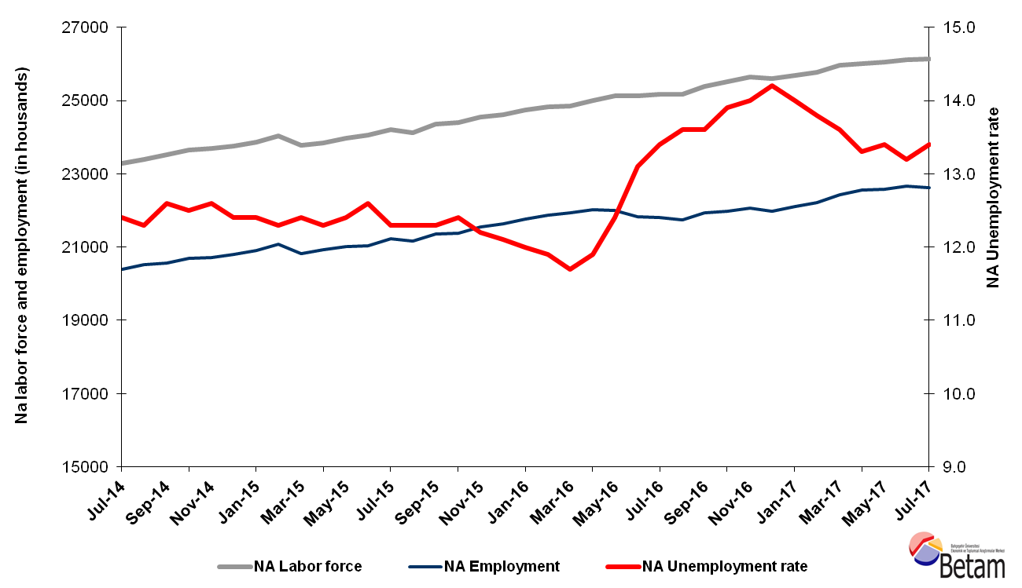
Source: Turkstat, Betam

No change in unemployment is expected in the period of August 2017

Betam's forecasting model had predicted that the seasonally adjusted nonagricultural unemployment rate would decrease from 13,2 percent to 13,1 percent in the period of July 2017. Seasonally adjusted nonagricultural unemployment rate in July 2017 increased by 0,2 percentage points compared to the previous period. Betam’s forecasting model predicts the seasonally adjusted August 2017 nonagricultural unemployment will remain constant at 13.4 percent. Forecasting model details are available on Betam's website. Kariyer.net application per vacancy series used in the Betam forecasting model is depicted in Figure 3. Kariyer.net series is only one of the inputs of Betam forecast model. Indeed, several variables such as employment agency (İŞKUR) data, reel sector confidence index, capacity utilization rate are used in forecasting. Taken into account all these factors, Betam's forecasting model predicts that seasonally adjusted nonagricultural unemployment rate will remain unchanged in the period of August 2017.

Figure 2 Seasonally adjusted nonagricultural unemployment rate and application per vacancy
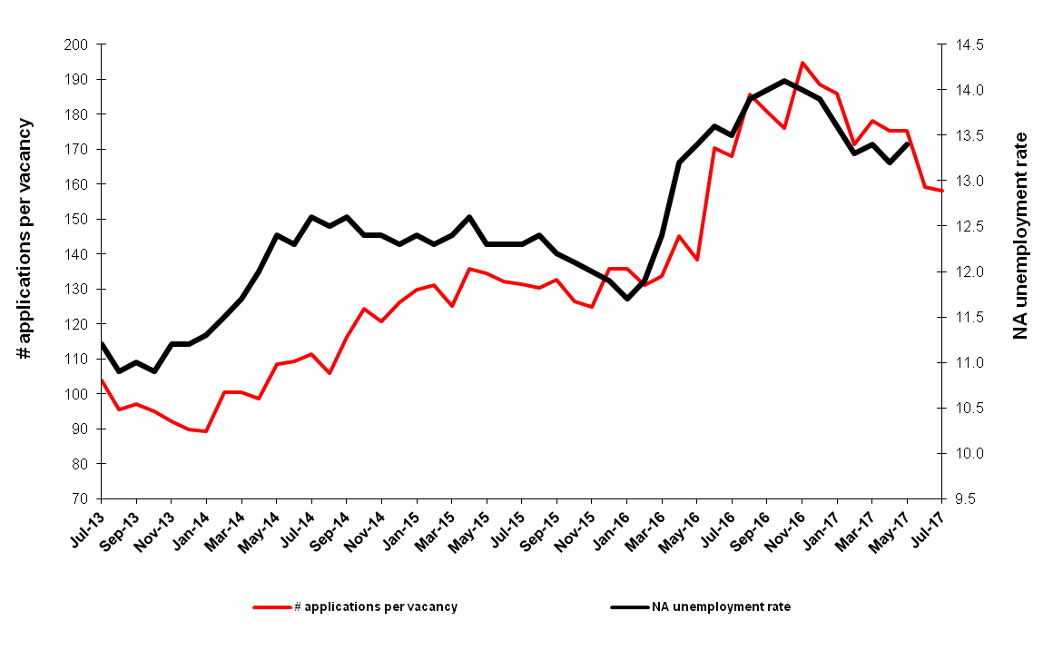
Source: Kariyer.net, Turkstat, Betam

Employment loss in services

According to seasonally adjusted sectoral labor market data, in July 2017 employment losses are observed in services and manufacture sector while the number of people employed in agriculture and construction sectors increased compared to June 2017. Employment in agriculture sector increased by 129 thousand in July while manufacture employment decreased by 20 thousand; the decrease in the manufacture has been limited to 3 thousand in the period of June 2017. On the other hand, Services lost 46 thousand employments for the first time since December 2016. Employment increased by 24 thousand in construction sector(Figure 3,Table 2).

Figure 3 Employment by sectors (in thousands)
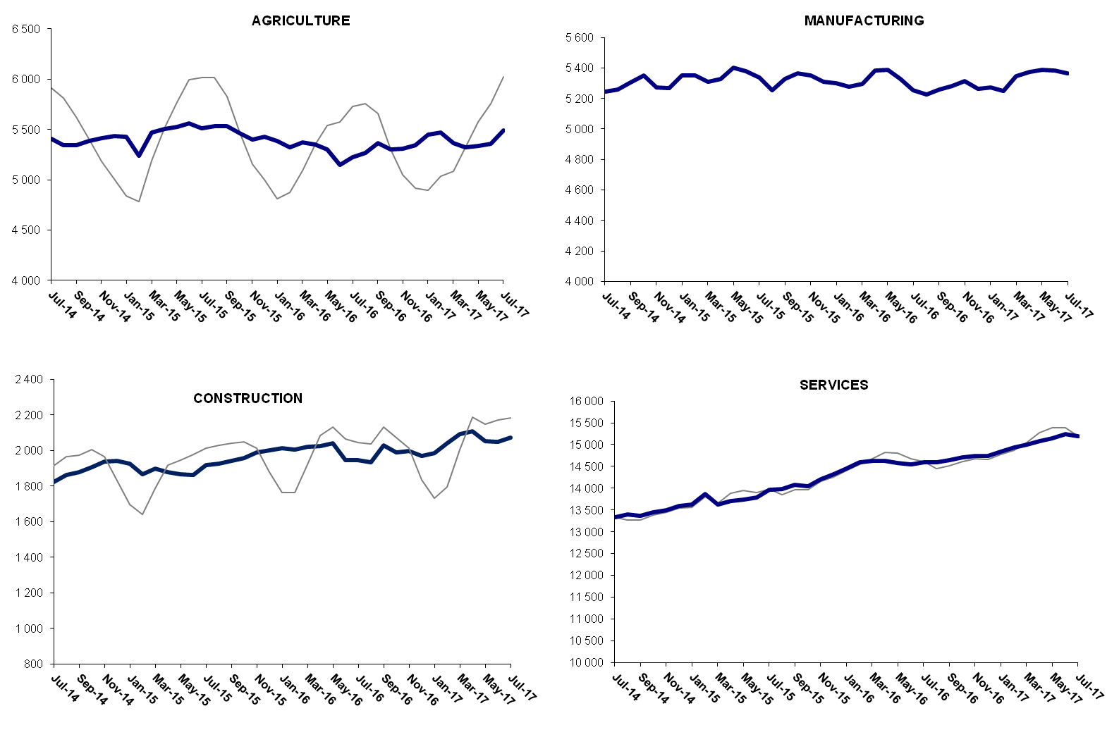
Source: Turkstat, Betam

Year-on-year Increase in non-agricultural unemployment

From July 2016 to July 2017 the non-agricultural labor force increased by 951 thousand (3.8 percent) and non-agricultural employment by 827 thousand (3.8 percent) (Figure 4). Thus the increase in non-agricultural unemployed reached 124 thousand within a year while unemployment did not change staying at 13 percent..

Figure 4 Year-on-year changes in non-agricultural labor force, employment, and unemployment
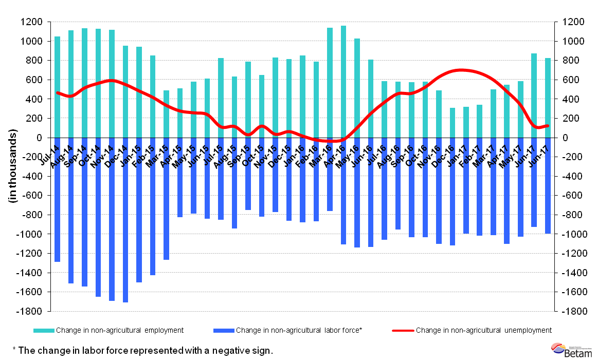
Source: Turkstat, Betam

Jump in male unemployment

Figure 5 shows seasonal adjusted non-agricultural unemployment rate for males (green) and for females (purple). From the period of June 2017 to the period of July 2017, the non-agricultural male unemployment rate grew by 0.5 percentage points and the non-agricultural female unemployment rate did not change. Thus non-agricultural unemployment increased to 11.3 for males and remained constant at 19.0 percent for females.

Figure 5: Seasonally adjusted nonagricultural unemployment rate by gender
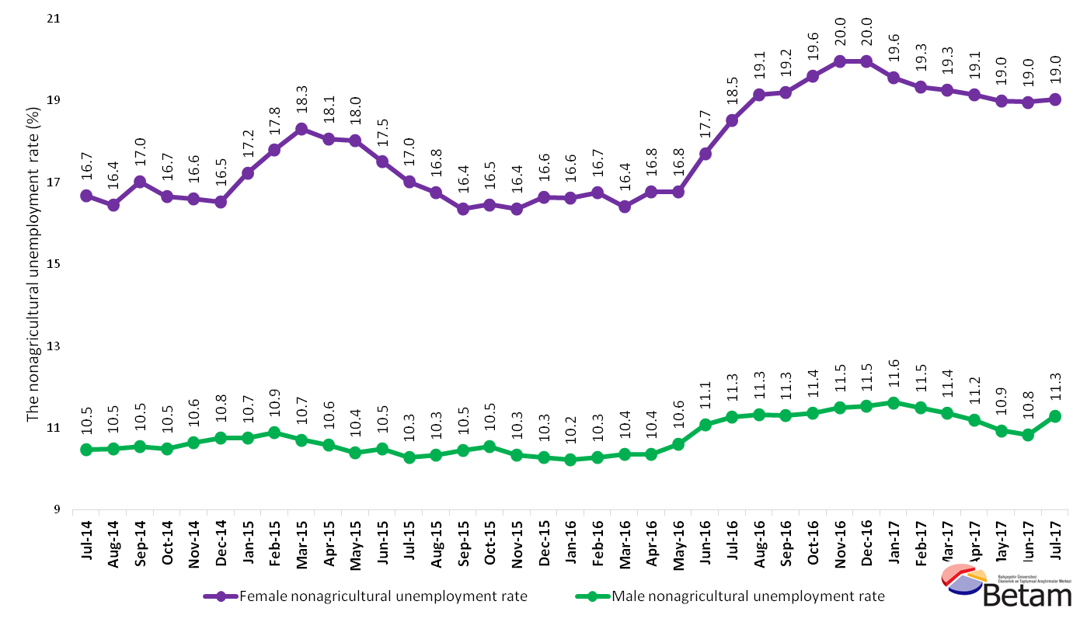
Source: Turkstat, Betam

Table 1 Seasonally adjusted non-agricultural labor market indicators (in thousands)*
 | Labor force | Employment | Unemployment | Unemployment rate | Monthly changes
May-14 | 23107 | 20427 | 2680 | 11.6% | Labor force | Employment | Unemployment
June-14 | 23185 | 20403 | 2782 | 12.0% | 78 | -24 | 102
July-14 | 23289 | 20401 | 2888 | 12.4% | 104 | -2 | 106
August-14 | 23390 | 20513 | 2877 | 12.3% | 101 | 112 | -11
September-14 | 23518 | 20555 | 2963 | 12.6% | 128 | 42 | 86
October-14 | 23656 | 20699 | 2957 | 12.5% | 138 | 144 | -6
November-14 | 23691 | 20706 | 2985 | 12.6% | 35 | 7 | 28
December-14 | 23748 | 20803 | 2945 | 12.4% | 57 | 97 | -40
January-15 | 23858 | 20900 | 2958 | 12.4% | 111 | 97 | 14
February-15 | 24046 | 21088 | 2958 | 12.3% | 187 | 188 | -1
March-15 | 23779 | 20830 | 2949 | 12.4% | -267 | -258 | -9
April-15 | 23851 | 20917 | 2934 | 12.3% | 72 | 87 | -15
May-15 | 23981 | 21007 | 2974 | 12.4% | 130 | 90 | 40
June-15 | 24063 | 21031 | 3032 | 12.6% | 82 | 24 | 58
July-15 | 24197 | 21221 | 2976 | 12.3% | 134 | 190 | -56
August-15 | 24128 | 21160 | 2968 | 12.3% | -70 | -61 | -9
September-15 | 24348 | 21353 | 2995 | 12.3% | 220 | 193 | 27
October-15 | 24400 | 21374 | 3026 | 12.4% | 52 | 21 | 31
November-15 | 24541 | 21547 | 2994 | 12.2% | 141 | 173 | -32
December-15 | 24619 | 21640 | 2979 | 12.1% | 78 | 93 | -15
January-16 | 24733 | 21765 | 2968 | 12.0% | 114 | 125 | -11
February-16 | 24830 | 21875 | 2955 | 11.9% | 97 | 110 | -13
March-16 | 24848 | 21941 | 2907 | 11.7% | 19 | 66 | -47
April-16 | 25006 | 22030 | 2976 | 11.9% | 157 | 89 | 68
May-16 | 25122 | 22007 | 3115 | 12.4% | 116 | -23 | 139
June-16 | 25120 | 21829 | 3291 | 13.1% | -2 | -178 | 176
July-16 | 25174 | 21801 | 3373 | 13.4% | 55 | -28 | 83
August-16 | 25176 | 21752 | 3424 | 13.6% | 2 | -49 | 51
September-16 | 25387 | 21934 | 3453 | 13.6% | 211 | 182 | 29
October-16 | 25520 | 21973 | 3547 | 13.9% | 134 | 39 | 95
November-16 | 25644 | 22054 | 3590 | 14.0% | 124 | 81 | 43
December-16 | 25608 | 21972 | 3636 | 14.2% | -36 | -82 | 46
January-17 | 25693 | 22096 | 3597 | 14.0% | 85 | 124 | -39
February-17 | 25776 | 22219 | 3557 | 13.8% | 83 | 123 | -40
March-17 | 25965 | 22434 | 3531 | 13.6% | 189 | 215 | -26
April-17 | 26013 | 22553 | 3460 | 13.3% | 47 | 119 | -72
May-17 | 26061 | 22569 | 3492 | 13.4% | 49 | 16 | 33
June-17 | 26120 | 22672 | 3448 | 13.2% | 59 | 103 | -44
July-17 | 26132 | 22630 | 3502 | 13.4% | 12 | -42 | 54
Source: Turkstat, Betam

Table 2 Seasonally adjusted employment by sectors (in thousands)*
 | Agriculture | Manufacturing | Construction | Service | Monthly changes
May-14 | 5571 | 5364 | 1872 | 13191 | Agriculture | Manufacturing | Construction | Service
June-14 | 5494 | 5332 | 1834 | 13237 | -77 | -32 | -38 | 46
July-14 | 5409 | 5243 | 1824 | 13333 | -85 | -89 | -10 | 96
August-14 | 5344 | 5257 | 1864 | 13392 | -65 | 14 | 40 | 59
September-14 | 5342 | 5306 | 1877 | 13372 | -2 | 49 | 13 | -20
October-14 | 5386 | 5353 | 1906 | 13441 | 44 | 47 | 29 | 69
November-14 | 5417 | 5273 | 1939 | 13494 | 31 | -80 | 33 | 53
December-14 | 5437 | 5266 | 1940 | 13597 | 20 | -7 | 1 | 103
January-15 | 5426 | 5349 | 1927 | 13623 | -11 | 83 | -13 | 26
February-15 | 5238 | 5351 | 1867 | 13870 | -188 | 2 | -60 | 247
March-15 | 5472 | 5308 | 1899 | 13622 | 234 | -43 | 32 | -248
April-15 | 5504 | 5326 | 1880 | 13712 | 32 | 18 | -19 | 90
May-15 | 5526 | 5404 | 1868 | 13736 | 22 | 78 | -12 | 24
June-15 | 5558 | 5380 | 1864 | 13787 | 32 | -24 | -4 | 51
July-15 | 5511 | 5336 | 1919 | 13966 | -47 | -44 | 55 | 179
August-15 | 5533 | 5252 | 1927 | 13981 | 22 | -84 | 8 | 15
September-15 | 5532 | 5327 | 1942 | 14085 | -1 | 75 | 15 | 104
October-15 | 5462 | 5363 | 1958 | 14053 | -70 | 36 | 16 | -32
November-15 | 5403 | 5353 | 1989 | 14206 | -59 | -10 | 31 | 153
December-15 | 5430 | 5311 | 2002 | 14327 | 27 | -42 | 13 | 121
January-16 | 5384 | 5300 | 2012 | 14453 | -46 | -11 | 10 | 126
February-16 | 5322 | 5276 | 2007 | 14593 | -62 | -24 | -5 | 140
March-16 | 5372 | 5295 | 2022 | 14624 | 50 | 19 | 15 | 31
April-16 | 5351 | 5381 | 2026 | 14623 | -21 | 86 | 4 | -1
May-16 | 5301 | 5386 | 2041 | 14581 | -50 | 5 | 15 | -42
June-16 | 5149 | 5330 | 1945 | 14554 | -152 | -56 | -96 | -27
July-16 | 5222 | 5254 | 1946 | 14602 | 73 | -76 | 1 | 48
August-16 | 5270 | 5224 | 1935 | 14593 | 48 | -30 | -11 | -9
September-16 | 5362 | 5260 | 2029 | 14645 | 92 | 36 | 94 | 52
October-16 | 5301 | 5282 | 1989 | 14702 | -61 | 22 | -40 | 57
November-16 | 5309 | 5316 | 1998 | 14741 | 8 | 34 | 9 | 39
December-16 | 5343 | 5265 | 1971 | 14736 | 34 | -51 | -27 | -5
January-17 | 5451 | 5274 | 1984 | 14838 | 108 | 9 | 13 | 102
February-17 | 5467 | 5251 | 2040 | 14928 | 16 | -23 | 56 | 90
March-17 | 5362 | 5346 | 2094 | 14994 | -105 | 95 | 54 | 66
April-17 | 5323 | 5372 | 2109 | 15072 | -39 | 26 | 15 | 78
May-17 | 5340 | 5386 | 2051 | 15142 | 17 | 14 | -58 | 70
June-17 | 5360 | 5383 | 2050 | 15239 | 20 | -3 | -1 | 97
July-17 | 5489 | 5363 | 2074 | 15193 | 129 | -20 | 24 | -46
Source: Turkstat, Betam

Table 3: Seasonally adjusted non-agricultural labor force by gender (thousands)
 | Female Labor Force | Female Employment | Female Unemployed | Male Labor Force | Male Employment | Male Unemployed
July-14 | 6200 | 5166 | 1034 | 17083 | 15295 | 1787
August-14 | 6300 | 5264 | 1036 | 17157 | 15356 | 1801
September-14 | 6337 | 5259 | 1079 | 17183 | 15372 | 1812
October-14 | 6386 | 5322 | 1064 | 17238 | 15429 | 1809
November-14 | 6400 | 5338 | 1062 | 17277 | 15437 | 1840
December-14 | 6421 | 5360 | 1061 | 17353 | 15487 | 1867
January-15 | 6507 | 5386 | 1121 | 17382 | 15514 | 1868
February-15 | 6561 | 5394 | 1167 | 17459 | 15559 | 1900
March-15 | 6519 | 5326 | 1193 | 17225 | 15380 | 1845
April-15 | 6540 | 5359 | 1181 | 17286 | 15456 | 1830
May-15 | 6624 | 5430 | 1194 | 17331 | 15528 | 1803
June-15 | 6656 | 5491 | 1165 | 17392 | 15569 | 1823
July-15 | 6742 | 5595 | 1147 | 17460 | 15665 | 1795
August-15 | 6713 | 5589 | 1125 | 17497 | 15687 | 1810
September-15 | 6759 | 5654 | 1106 | 17580 | 15741 | 1839
October-15 | 6779 | 5663 | 1115 | 17616 | 15759 | 1857
November-15 | 6875 | 5750 | 1124 | 17641 | 15817 | 1825
December-15 | 6975 | 5815 | 1160 | 17683 | 15865 | 1818
January-16 | 7019 | 5852 | 1167 | 17714 | 15901 | 1812
February-16 | 7049 | 5869 | 1180 | 17754 | 15928 | 1827
March-16 | 7055 | 5898 | 1157 | 17799 | 15957 | 1843
April-16 | 7141 | 5944 | 1197 | 17839 | 15990 | 1849
May-16 | 7174 | 5971 | 1203 | 17920 | 16020 | 1901
June-16 | 7260 | 5974 | 1285 | 17834 | 15857 | 1976
July-16 | 7262 | 5917 | 1345 | 17900 | 15884 | 2017
August-16 | 7326 | 5924 | 1403 | 17957 | 15923 | 2034
September-16 | 7376 | 5960 | 1417 | 18007 | 15972 | 2035
October-16 | 7440 | 5981 | 1458 | 18069 | 16014 | 2054
November-16 | 7458 | 5970 | 1488 | 18152 | 16064 | 2088
December-16 | 7464 | 5975 | 1489 | 18179 | 16084 | 2095
January-17 | 7459 | 6000 | 1458 | 18261 | 16139 | 2122
February-17 | 7514 | 6062 | 1453 | 18284 | 16180 | 2103
March-17 | 7610 | 6145 | 1466 | 18335 | 16252 | 2083
April-17 | 7599 | 6144 | 1454 | 18376 | 16321 | 2055
May-17 | 7651 | 6198 | 1452 | 18379 | 16369 | 2010
June-17 | 7668 | 6214 | 1454 | 18434 | 16437 | 1996
July-17 | 7700 | 6234 | 1466 | 18473 | 16388 | 2086
Kaynak: TÜİK, Betam

*Prof. Dr. Seyfettin Gürsel, Betam, Director, seyfettin.gursel@eas.bau.edu.tr
∗∗ Mine Durmaz Aslan, Betam, Research Assistant, mine.durmaz@eas.bau.edu.tr *** Yazgı Genç, Betam, Research Assistant , yazgi.genc@eas.bau.edu.tr
For detailed information on Betam's forecasting model, please see Betam Research Brief 168 titled as "Kariyer.net Verisiyle Kısa Vadeli Tarım Dışı İşsizlik Tahmini" . For the innovations in the model please see Betam Research Brief 14 titled as "Mevsim Etkilerinden Arındırılmış İşsizlik Tahmini" Soybilgen, B., "Kariyer.net Verisiyle Kısa Vadeli Tarım Dışı İşsizlik Tahmini", Betam Research Brief 168. http://betam.bahcesehir.edu.tr/tr/2014/06/kariyer-net-verisiyle-kisa-vadeli-tarim-disi-issizlik-tahmini/ Soybilgen, B., "Mevsim Etkilerinden Arındırılmış İşsizlik Tahmini", Betam Research Brief 14 http://betam.bahcesehir.edu.tr/2015/08/mevsim-etkilerinden-arindirilmis-tarim-disi-issizlik-tahmini/
Betam has been calculating application per vacancy using series released by Kariyer.net for a while. Seasonal and calendar adjustment procedure is applied to application per vacancy series. A decrease in applications per vacancy may be caused by an increase in vacancies or by a decrease in the number of applications. An increase in vacancies signals economic growth while decreasing number of applications indicates a decrease in number of people looking for a job. Monthly labor market series released by TurkStat is the average of three months. Therefore, application per vacancy statistics calculated using Kariyer.net series is the average of three months as well.
Employment in each sector is seasonally adjusted separately. Hence the sum of these series may differ from the seasonally adjusted series of total employment. The difference stems from the non-linearity of the seasonal adjustment process.
Turkstat revised the labor market statistics drastically in February 2014. Within this framework, they back casted various labor market indicators and they also continued to announce seasonally adjusted series. However, Turkstat is not providing back-casted series by gender. Therefore, female and male labor market statistics are not sufficiently long for the seasonal adjustment procedures (There should be minimum 36 observations). With the announcement of the period of February 2017 data, the number of observations required for the seasonal decontamination process was provided. From this period Betam get seasonal adjustment series in terms of gender. Nevertheless, it should not be forgotten that seasonal adjustment may cause extra volatility in the series for at least a while.

