Labor Market Outlook:
September 2017

15 September 2017

EMPLOYMENT IN SERVICES DECREASED UNEMPLOYMENT
Seyfettin Gürsel* Gökçe Uysal∗∗ and Mine Durmaz ∗∗∗

Executive Summary

Seasonally adjusted labor market data show that the nonagricultural unemployment rate decreased by 0.2 percentage points and is recorded as 13.2 percent in the period of June 2017. This is resulted from the acceleration of the increase in the non-agricultural employment in the period of June 2017 compared to the period of May 2017. In this period, there has been a significant increase in employment in services sector. According to seasonally adjusted labor market data, in looking at gender breakdown, the female unemployment rate remained constant while the male unemployment rate decreased. Betam forecast model predicts that the non-agricultural unemployment rate will decline by 0.1 percentage points and will be 13.1 percent in the period of July 2017.

Significant rise in the non-agricultural employment increase

According to seasonally adjusted data, the nonagricultural labor force increased by 61 thousand and reached 26 million 135 thousand and the number of people employed in non-agricultural sectors increased by 105 thousand and reached 22 million 585 thousand in the period of June 2017 compared to the period of May 2017 (Figure 1, Table 1). While the number of people unemployed in nonagricultural sectors decreased by 44 thousand and is recoded as 3 million 450 thousand, the nonagricultural unemployment rate declined from 13.4 percent to 13.2 percent.

Figure 1 Seasonally adjusted non-agricultural labor force, employment, and unemployment
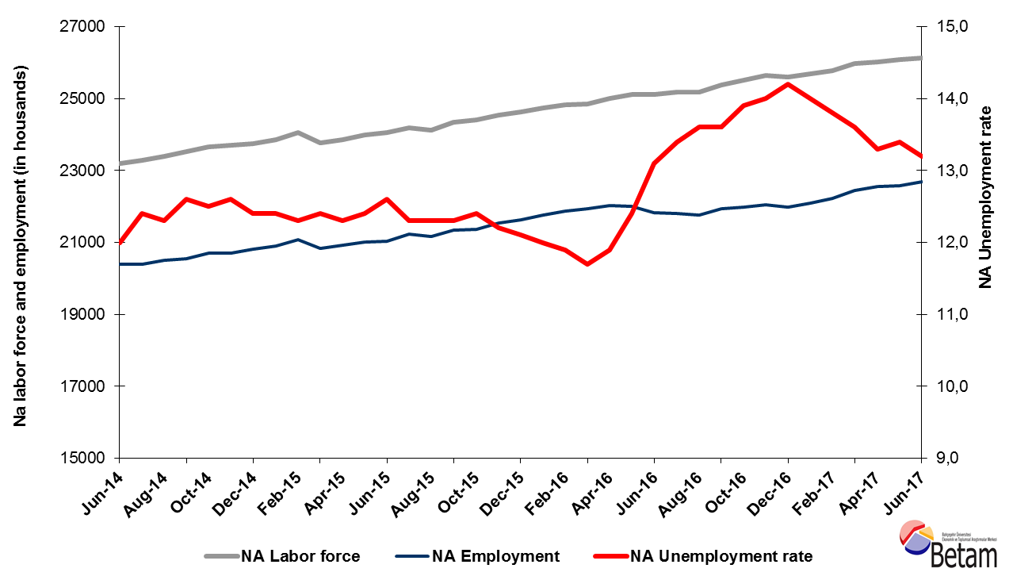
Source: Turkstat, Betam

The unemployment rate is expected to decline in the period of July 2017
Betam's forecasting model had predicted that the seasonally adjusted nonagricultural unemployment rate would decrease from 13.4 percent to 13.3 percent in the period of June 2017. The non-agricultural unemployment rate in June period decreased by 0.2 percentage points compared to the previous period and it recorded as 13.2 percent. Betam’s forecasting model predicts the seasonally adjusted July 2017 nonagricultural unemployment will decrease by 0.1 points and realize as 13.1 percent. Forecasting model details are available on Betam's website. Kariyer.net application per vacancy series used in the Betam forecasting model is depicted in Figure 1. Kariyer.net series is only one of the inputs of Betam forecast model. Indeed, several variables such as employment agency (İŞKUR) data, reel sector confidence index, capacity utilization rate are used in forecasting. Taken into account all these factors, Betam's forecasting model predicts that seasonally adjusted nonagricultural unemployment rate will continue to decrease in the period of July 2017.

Figure 2 Seasonally adjusted nonagricultural unemployment rate and application per vacancy
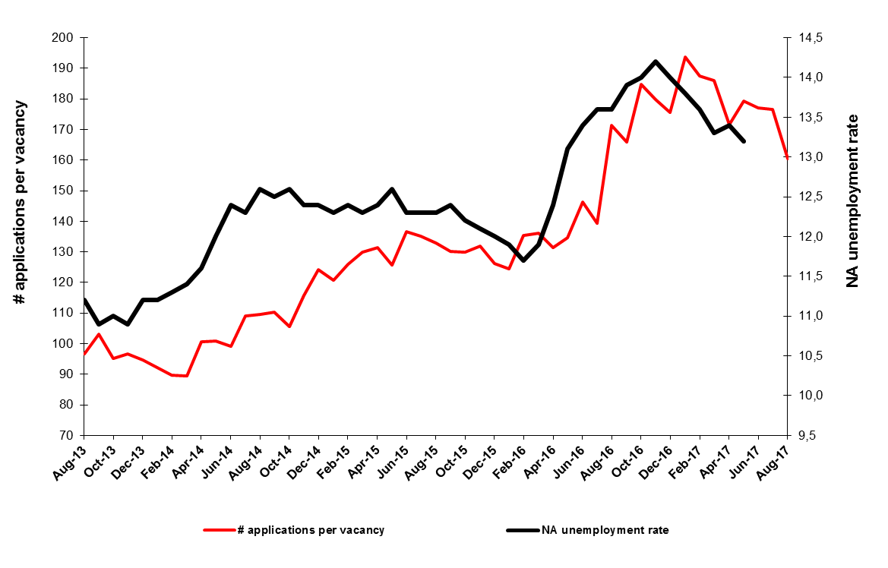
Source: Turkstat, Betam

Large increase in the employment of services

According to seasonally adjusted sectoral labor market data, the employment in all sectors, except services sector, decreased in the period of June 2017 compared to the period of May 2017. Employment decreased by 8 thousand in agriculture, by 3 thousand in industry and by 6 thousand in construction. In services sector employment increased by 114 thousand in June 2017 compared to the previous period. We observe that the decrease in the non-agricultural unemployment in June 2017 resulted from the increase in services sector employment.

Figure 3 Employment by sectors (in thousands)
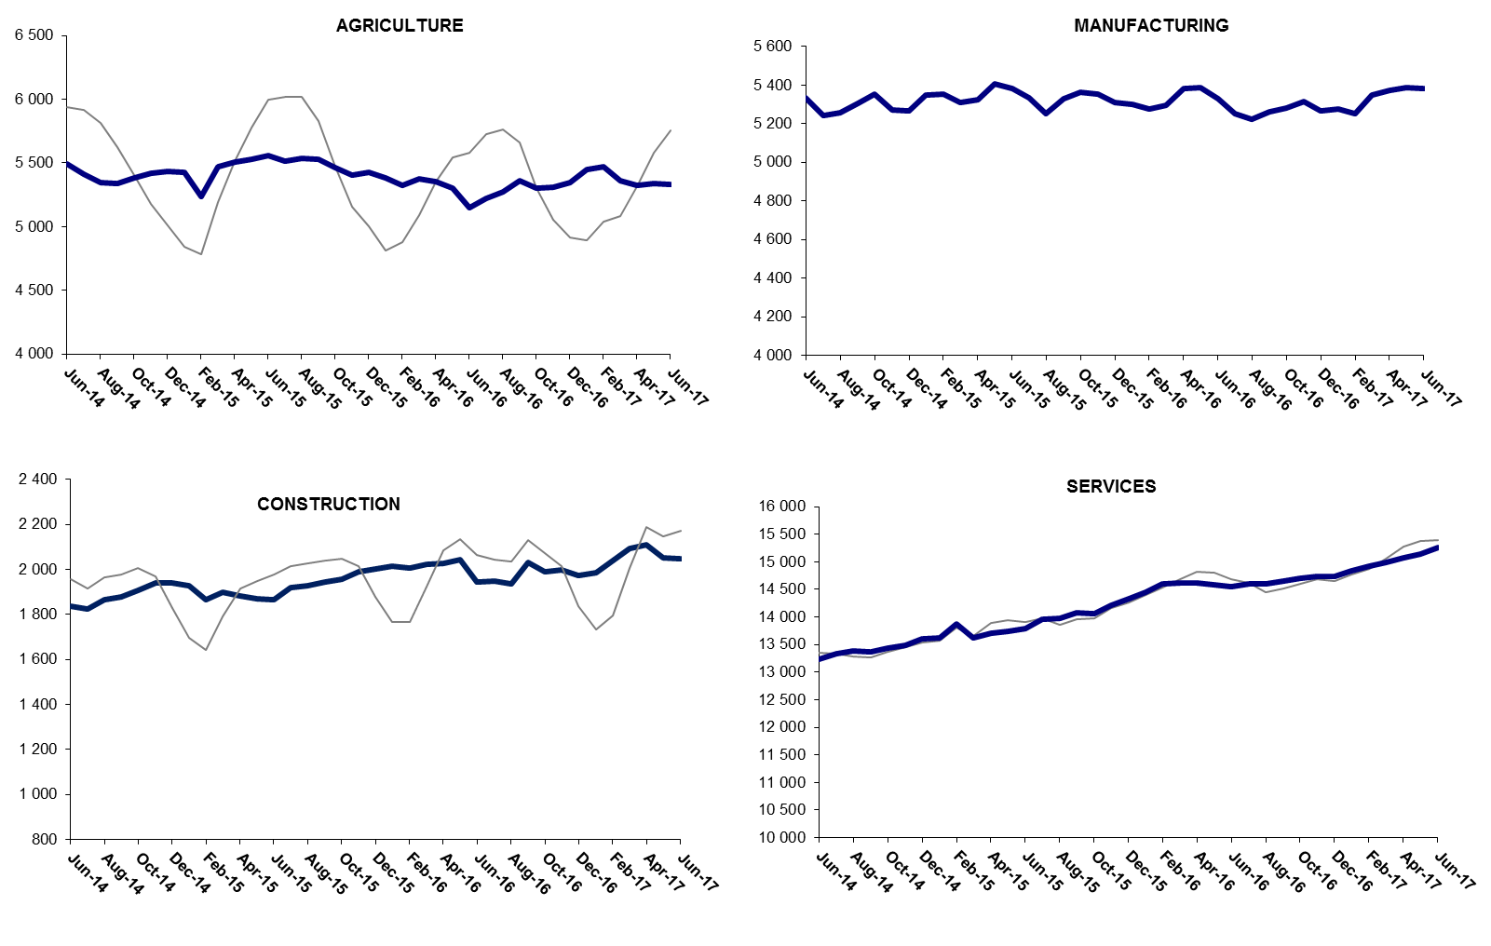
Source: Turkstat, Betam

Decrease in year-on-year nonagricultural unemployment

From May 2016 to June 2017 the nonagricultural labor force increased by 993 thousand (4.0 percent) and nonagricultural employment increased by 872 thousand (4.0 percent) (Figure 4). Thus, the number of non-agricultural unemployed increased by 121 thousand (4.0 percent) in the period of June 2017. The nonagricultural unemployment rate decreased to 11.7 percent. Then it started to soar in April 2016 and it increased to 14,2 percent in the January 2017. Although since January 2017 the unemployment tends to decrease at a slow pace, it is still high compared to the period of March 2016 (Table 1).

Figure 4 Year-on-year changes in non-agricultural labor force, employment, and unemployment
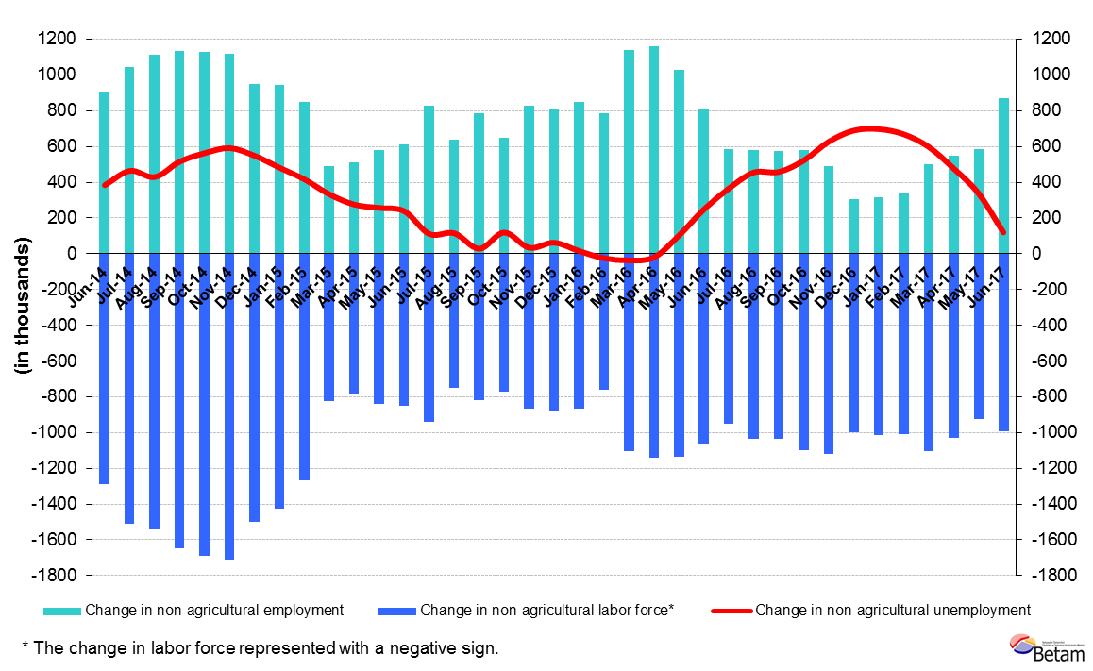
Source: Turkstat, Betam

Male unemployment decreased, female unemployment remained constant

Figure 5 shows the seasonally adjusted nonagricultural female and male unemployment rates. From May 2017 to June 2017, the male non-agricultural unemployment rate decreased by 0.1 percentage points while the female nonagricultural unemployment rate didn’t change. Therefore, the male non-agricultural unemployment rate decreased to 10.8 percent and the female unemployment rate remained constant at the level of 19.0 percent. Finally, we observe that gender gap in non-agricultural unemployment has slightly increased.

Figure 5 Seasonally adjusted female and male nonagricultural unemployment rates (%)
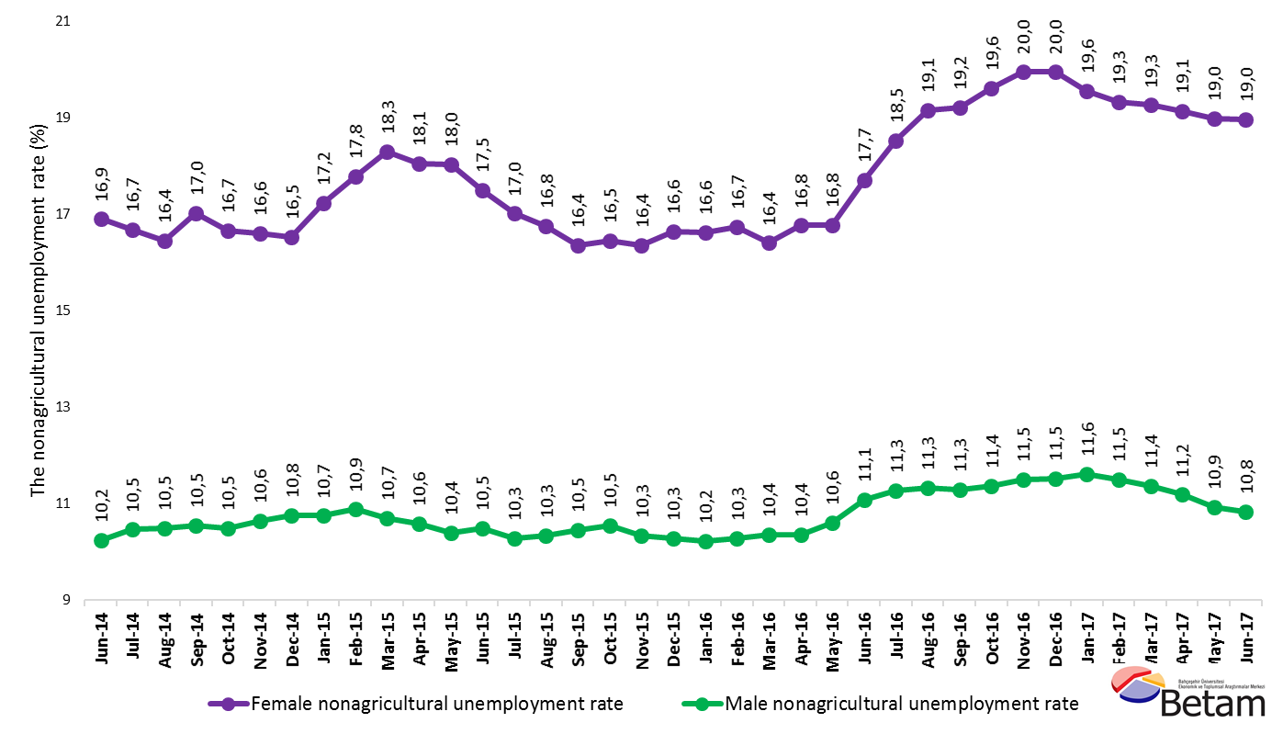
Source: Turkstat, Betam

Table 1 Seasonally adjusted non-agricultural labor market indicators (in thousands)
 | Labor force | Employment | Unemployment | Unemployment rate | Monthly changes
May-14 | 23107 | 20427 | 2680 | 11,6% | Labor force | Employment | Unemployment
June-14 | 23185 | 20403 | 2782 | 12,0% | 78 | -24 | 102
July-14 | 23289 | 20401 | 2888 | 12,4% | 104 | -2 | 106
August-14 | 23390 | 20513 | 2877 | 12,3% | 101 | 112 | -11
September-14 | 23518 | 20555 | 2963 | 12,6% | 128 | 42 | 86
October-14 | 23656 | 20699 | 2957 | 12,5% | 138 | 144 | -6
November-14 | 23691 | 20706 | 2985 | 12,6% | 35 | 7 | 28
December-14 | 23748 | 20803 | 2945 | 12,4% | 57 | 97 | -40
January-15 | 23858 | 20900 | 2958 | 12,4% | 111 | 97 | 14
February-15 | 24046 | 21088 | 2958 | 12,3% | 187 | 188 | -1
March-15 | 23779 | 20830 | 2949 | 12,4% | -267 | -258 | -9
April-15 | 23851 | 20917 | 2934 | 12,3% | 72 | 87 | -15
May-15 | 23981 | 21007 | 2974 | 12,4% | 130 | 90 | 40
June-15 | 24063 | 21031 | 3032 | 12,6% | 82 | 24 | 58
July-15 | 24197 | 21221 | 2976 | 12,3% | 134 | 190 | -56
August-15 | 24128 | 21160 | 2968 | 12,3% | -70 | -61 | -9
September-15 | 24348 | 21353 | 2995 | 12,3% | 220 | 193 | 27
October-15 | 24400 | 21374 | 3026 | 12,4% | 52 | 21 | 31
November-15 | 24541 | 21547 | 2994 | 12,2% | 141 | 173 | -32
December-15 | 24619 | 21640 | 2979 | 12,1% | 78 | 93 | -15
January-16 | 24733 | 21765 | 2968 | 12,0% | 114 | 125 | -11
February-16 | 24830 | 21875 | 2955 | 11,9% | 97 | 110 | -13
March-16 | 24848 | 21941 | 2907 | 11,7% | 19 | 66 | -47
April-16 | 25006 | 22030 | 2976 | 11,9% | 157 | 89 | 68
May-16 | 25122 | 22007 | 3115 | 12,4% | 116 | -23 | 139
June-16 | 25120 | 21829 | 3291 | 13,1% | -2 | -178 | 176
July-16 | 25174 | 21801 | 3373 | 13,4% | 55 | -28 | 83
August-16 | 25176 | 21752 | 3424 | 13,6% | 2 | -49 | 51
September-16 | 25387 | 21934 | 3453 | 13,6% | 211 | 182 | 29
October-16 | 25520 | 21973 | 3547 | 13,9% | 134 | 39 | 95
November-16 | 25644 | 22054 | 3590 | 14,0% | 124 | 81 | 43
December-16 | 25608 | 21972 | 3636 | 14,2% | -36 | -82 | 46
January-17 | 25693 | 22096 | 3597 | 14,0% | 85 | 124 | -39
February-17 | 25776 | 22219 | 3557 | 13,8% | 83 | 123 | -40
March-17 | 25965 | 22434 | 3531 | 13,6% | 189 | 215 | -26
April-17 | 26013 | 22553 | 3460 | 13,3% | 47 | 119 | -72
May-17 | 26074 | 22580 | 3494 | 13,4% | 61 | 27 | 34
June-17 | 26135 | 22685 | 3450 | 13,2% | 61 | 105 | -44
Source: Turkstat, Betam

Table 2 Seasonally adjusted employment by sectors (in thousands)
 | Agriculture | Manufacturing | Construction | Service | Monthly changes
May-14 | 5571 | 5364 | 1872 | 13191 | Agriculture | Manufacturing | Construction | Service
June-14 | 5494 | 5332 | 1834 | 13237 | -77 | -32 | -38 | 46
July-14 | 5409 | 5243 | 1824 | 13333 | -85 | -89 | -10 | 96
August-14 | 5344 | 5257 | 1864 | 13392 | -65 | 14 | 40 | 59
September-14 | 5342 | 5306 | 1877 | 13372 | -2 | 49 | 13 | -20
October-14 | 5386 | 5353 | 1906 | 13441 | 44 | 47 | 29 | 69
November-14 | 5417 | 5273 | 1939 | 13494 | 31 | -80 | 33 | 53
December-14 | 5437 | 5266 | 1940 | 13597 | 20 | -7 | 1 | 103
January-15 | 5426 | 5349 | 1927 | 13623 | -11 | 83 | -13 | 26
February-15 | 5238 | 5351 | 1867 | 13870 | -188 | 2 | -60 | 247
March-15 | 5472 | 5308 | 1899 | 13622 | 234 | -43 | 32 | -248
April-15 | 5504 | 5326 | 1880 | 13712 | 32 | 18 | -19 | 90
May-15 | 5526 | 5404 | 1868 | 13736 | 22 | 78 | -12 | 24
June-15 | 5558 | 5380 | 1864 | 13787 | 32 | -24 | -4 | 51
July-15 | 5511 | 5336 | 1919 | 13966 | -47 | -44 | 55 | 179
August-15 | 5533 | 5252 | 1927 | 13981 | 22 | -84 | 8 | 15
September-15 | 5532 | 5327 | 1942 | 14085 | -1 | 75 | 15 | 104
October-15 | 5462 | 5363 | 1958 | 14053 | -70 | 36 | 16 | -32
November-15 | 5403 | 5353 | 1989 | 14206 | -59 | -10 | 31 | 153
December-15 | 5430 | 5311 | 2002 | 14327 | 27 | -42 | 13 | 121
January-16 | 5384 | 5300 | 2012 | 14453 | -46 | -11 | 10 | 126
February-16 | 5322 | 5276 | 2007 | 14593 | -62 | -24 | -5 | 140
March-16 | 5372 | 5295 | 2022 | 14624 | 50 | 19 | 15 | 31
April-16 | 5351 | 5381 | 2026 | 14623 | -21 | 86 | 4 | -1
May-16 | 5301 | 5386 | 2041 | 14581 | -50 | 5 | 15 | -42
June-16 | 5149 | 5330 | 1945 | 14554 | -152 | -56 | -96 | -27
July-16 | 5222 | 5254 | 1946 | 14602 | 73 | -76 | 1 | 48
August-16 | 5270 | 5224 | 1935 | 14593 | 48 | -30 | -11 | -9
September-16 | 5362 | 5260 | 2029 | 14645 | 92 | 36 | 94 | 52
October-16 | 5301 | 5282 | 1989 | 14702 | -61 | 22 | -40 | 57
November-16 | 5309 | 5316 | 1998 | 14741 | 8 | 34 | 9 | 39
December-16 | 5343 | 5265 | 1971 | 14736 | 34 | -51 | -27 | -5
January-17 | 5451 | 5274 | 1984 | 14838 | 108 | 9 | 13 | 102
February-17 | 5467 | 5251 | 2040 | 14928 | 16 | -23 | 56 | 90
March-17 | 5362 | 5346 | 2094 | 14994 | -105 | 95 | 54 | 66
April-17 | 5323 | 5372 | 2109 | 15072 | -39 | 26 | 15 | 78
May-17 | 5340 | 5386 | 2051 | 15142 | 17 | 14 | -58 | 70
June-17 | 5332 | 5383 | 2045 | 15256 | -8 | -3 | -6 | 114
Source: Turkstat, Betam

Table 3: Seasonally adjusted female and male non-agricultural labor market indicators (in thousands)
 | Female Labor Force | Female Employment | Female Unemployed | Male Labor Force | Male Employment | Male Unemployed
June-14 | 6153 | 5113 | 1040 | 17038 | 15293 | 1745
July-14 | 6200 | 5166 | 1034 | 17083 | 15295 | 1787
August-14 | 6300 | 5264 | 1036 | 17157 | 15356 | 1801
September-14 | 6337 | 5259 | 1079 | 17183 | 15372 | 1812
October-14 | 6386 | 5322 | 1064 | 17238 | 15429 | 1809
November-14 | 6400 | 5338 | 1062 | 17277 | 15437 | 1840
December-14 | 6421 | 5360 | 1061 | 17353 | 15487 | 1867
January-15 | 6507 | 5386 | 1121 | 17382 | 15514 | 1868
February-15 | 6561 | 5394 | 1167 | 17459 | 15559 | 1900
March-15 | 6519 | 5326 | 1193 | 17225 | 15380 | 1845
April-15 | 6540 | 5359 | 1181 | 17286 | 15456 | 1830
May-15 | 6624 | 5430 | 1194 | 17331 | 15528 | 1803
June-15 | 6656 | 5491 | 1165 | 17392 | 15569 | 1823
July-15 | 6742 | 5595 | 1147 | 17460 | 15665 | 1795
August-15 | 6713 | 5589 | 1125 | 17497 | 15687 | 1810
September-15 | 6759 | 5654 | 1106 | 17580 | 15741 | 1839
October-15 | 6779 | 5663 | 1115 | 17616 | 15759 | 1857
November-15 | 6875 | 5750 | 1124 | 17641 | 15817 | 1825
December-15 | 6975 | 5815 | 1160 | 17683 | 15865 | 1818
January-16 | 7019 | 5852 | 1167 | 17714 | 15901 | 1812
February-16 | 7049 | 5869 | 1180 | 17754 | 15928 | 1827
March-16 | 7055 | 5898 | 1157 | 17799 | 15957 | 1843
April-16 | 7141 | 5944 | 1197 | 17839 | 15990 | 1849
May-16 | 7174 | 5971 | 1203 | 17920 | 16020 | 1901
June-16 | 7260 | 5974 | 1285 | 17834 | 15857 | 1976
July-16 | 7262 | 5917 | 1345 | 17900 | 15884 | 2017
August-16 | 7326 | 5924 | 1403 | 17957 | 15923 | 2034
September-16 | 7376 | 5960 | 1417 | 18007 | 15972 | 2035
October-16 | 7440 | 5981 | 1458 | 18069 | 16014 | 2054
November-16 | 7458 | 5970 | 1488 | 18152 | 16064 | 2088
December-16 | 7464 | 5975 | 1489 | 18179 | 16084 | 2095
January-17 | 7459 | 6000 | 1458 | 18261 | 16139 | 2122
February-17 | 7514 | 6062 | 1453 | 18284 | 16180 | 2103
March-17 | 7610 | 6145 | 1466 | 18335 | 16252 | 2083
April-17 | 7599 | 6144 | 1454 | 18376 | 16321 | 2055
May-17 | 7651 | 6198 | 1452 | 18379 | 16369 | 2010
June-17 | 7668 | 6214 | 1454 | 18434 | 16437 | 1996
Source: Turkstat, Betam

*Prof. Dr. Seyfettin Gürsel, Betam, Director, seyfettin.gursel@eas.bau.edu.tr
∗∗Asst. Prof. Gökçe Uysal, Betam, Deputy Director, gokce.uysal@eas.bau.edu.tr
∗∗∗ Mine Durmaz, Betam, Research Assistant, mine.durmaz@eas.bau.edu.tr
For detailed information on Betam's forecasting model, please see Betam Research Brief 168 titled as "Kariyer.net Verisiyle Kısa Vadeli Tarım Dışı İşsizlik Tahmini" http://betam.bahcesehir.edu.tr/tr/2014/06/kariyer-net-verisiyle-kisa-vadeli-tarim-disi-issizlik-tahmini/
Betam has been calculating application per vacancy using series released by Kariyer.net for a while. Seasonal and calendar adjustment procedure is applied to application per vacancy series. A decrease in applications per vacancy may be caused by an increase in vacancies or by a decrease in the number of applications. An increase in vacancies signals economic growth while decreasing number of applications indicates a decrease in number of people looking for a job. Monthly labor market series released by TurkStat is the average of three months. Therefore, application per vacancy statistics calculated using Kariyer.net series is the average of three months as well.
Employment in each sector is seasonally adjusted separately. Hence the sum of these series may differ from the seasonally adjusted series of total employment. The difference stems from the non-linearity of the seasonal adjustment process.
Turkstat revised the labor market statistics drastically in February 2014. Within this framework, they back casted various labor market indicators and they also continued to announce seasonally adjusted series. However, Turkstat is not providing back-casted series by gender. Therefore, female and male labor market statistics were not sufficiently long for a reliable seasonal-adjustment process and we need at least 36 observations to apply it. As of February 2017, we obtain the sufficient 36 observations to run the seasonal-adjustment process and since then Betam estimates the seasonally adjusted series at gender breakdown. Note that the seasonal-adjustment process might generate volatility in the series for some more time.

