LABOR MARKET OUTLOOK:
August 2017

15 August 2017

STAGNATION IN UNEMPLOYMENT
Seyfettin Gürsel* and Melike Kökkızıl ∗∗

Executive Summary

Seasonal adjusted labor market data show that non-agricultural unemployment rate did not change in the period of May from April staying at 13.4 percent. The most important reason behind this result is a significant slowdown in the increase of non-agricultural employment in May compared to April. In that period, significant loss of employment was experienced in construction sector while employment in service sector increased significantly. On the other hand, according to seasonally adjusted labor data, decline both for females and males in non-agricultural unemployment rates continued. Betam’s forecasting model predicts that the non-agricultural unemployment rate will decrease 0.1 points in the period of June 2017 reaching 13.3 percent.

Significant slowdown in non-agricultural employment

According to seasonally adjusted labor market data, in the period of May 2017 compared to April 2017, non-agricultural labor force increased by 31 thousand and reached 26 million 66 thousand and the number of people employed in non-agricultural sectors increased by 27 thousand and reached 22 million 573 thousand (Figure 1, Table1). While the number of unemployed in non-agricultural sectors increased by 4 thousand and recorded as 3 million 493 thousand, the nonagricultural unemployment rate remained at 13.4 percent. The most important reason behind this stagnation is a significant slowdown in employment growth. The non-agricultural employment increased by 575 thousand from January to April, monthly average being 144 thousand the lowest increase 119 thousand, far higher than the increase of from April to May, which has been limited to 27 thousand..

Figure 1 Seasonally adjusted non-agricultural labor force, employment, and unemployment
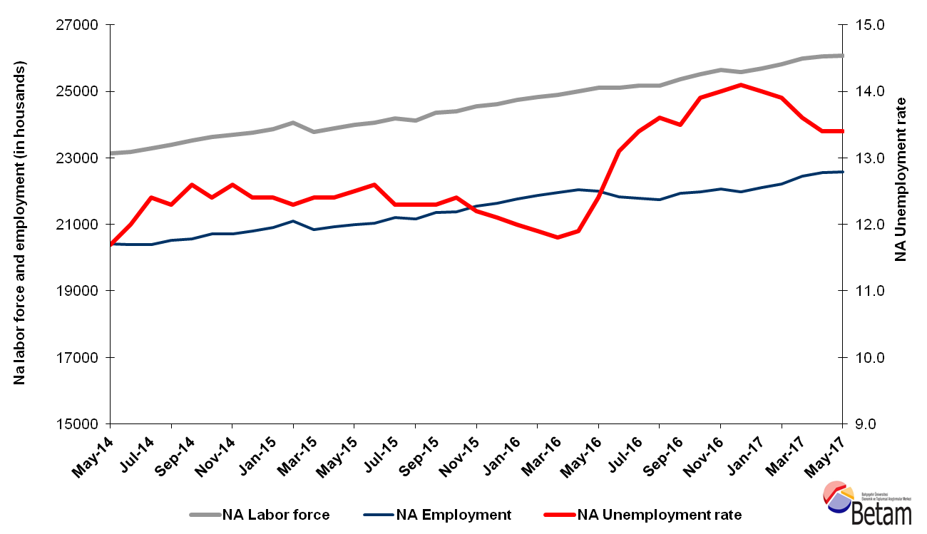
Source: Turkstat, Betam

Decrease in unemployment is expected in the period of May 2017

Betam's forecasting model had predicted that the seasonally adjusted nonagricultural unemployment rate would decrease from 13.4 to 13.3 percent in the period of May 2017. Seasonal adjusted mom-agricultural unemployment rate did not change in the period of May from April staying at 13.4 percent. Betam’s forecasting model predicts the seasonally adjusted June 2017 non-agricultural unemployment will decrease by 0.1 percentage points reach 13.3 percent. Forecasting model details are available on Betam's website. Kariyer.net application per vacancy series used in the Betam forecasting model is depicted in Figure 3. Kariyer.net series is only one of the inputs of Betam forecast model. Indeed, several variables such as employment agency (İŞKUR) data, reel sector confidence index, capacity utilization rate are used in forecasting. Taken into account all these factors, Betam's forecasting model predicts that seasonally adjusted nonagricultural unemployment rate will decrease in the period of June 2017.

Figure 2 Seasonally adjusted nonagricultural unemployment rate and application per vacancy
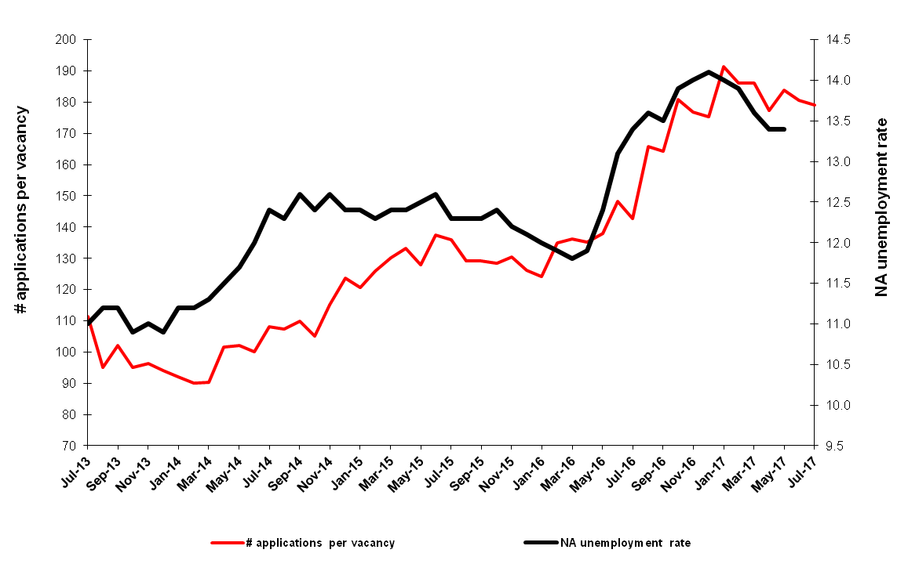
Source: Kariyer.net, Turkstat, Betam

Sectoral Employment: Significant loss in construction, high increase in services

According to seasonally adjusted sectoral labor market data, in April 2017 significant increases in non-agricultural sectors slowed down. In the period of May 2017, employment in services sector significantly increased while employment in construction sector significantly decreased (Figure 3, Table 2). In that period, employment increased by 17 thousand in agriculture, by 14 thousand in manufacture sector and by 70 thousand in services sector. At the same time, employment decreased by 58 thousand in construction.

.
Figure 3 Employment by sectors (in thousands)
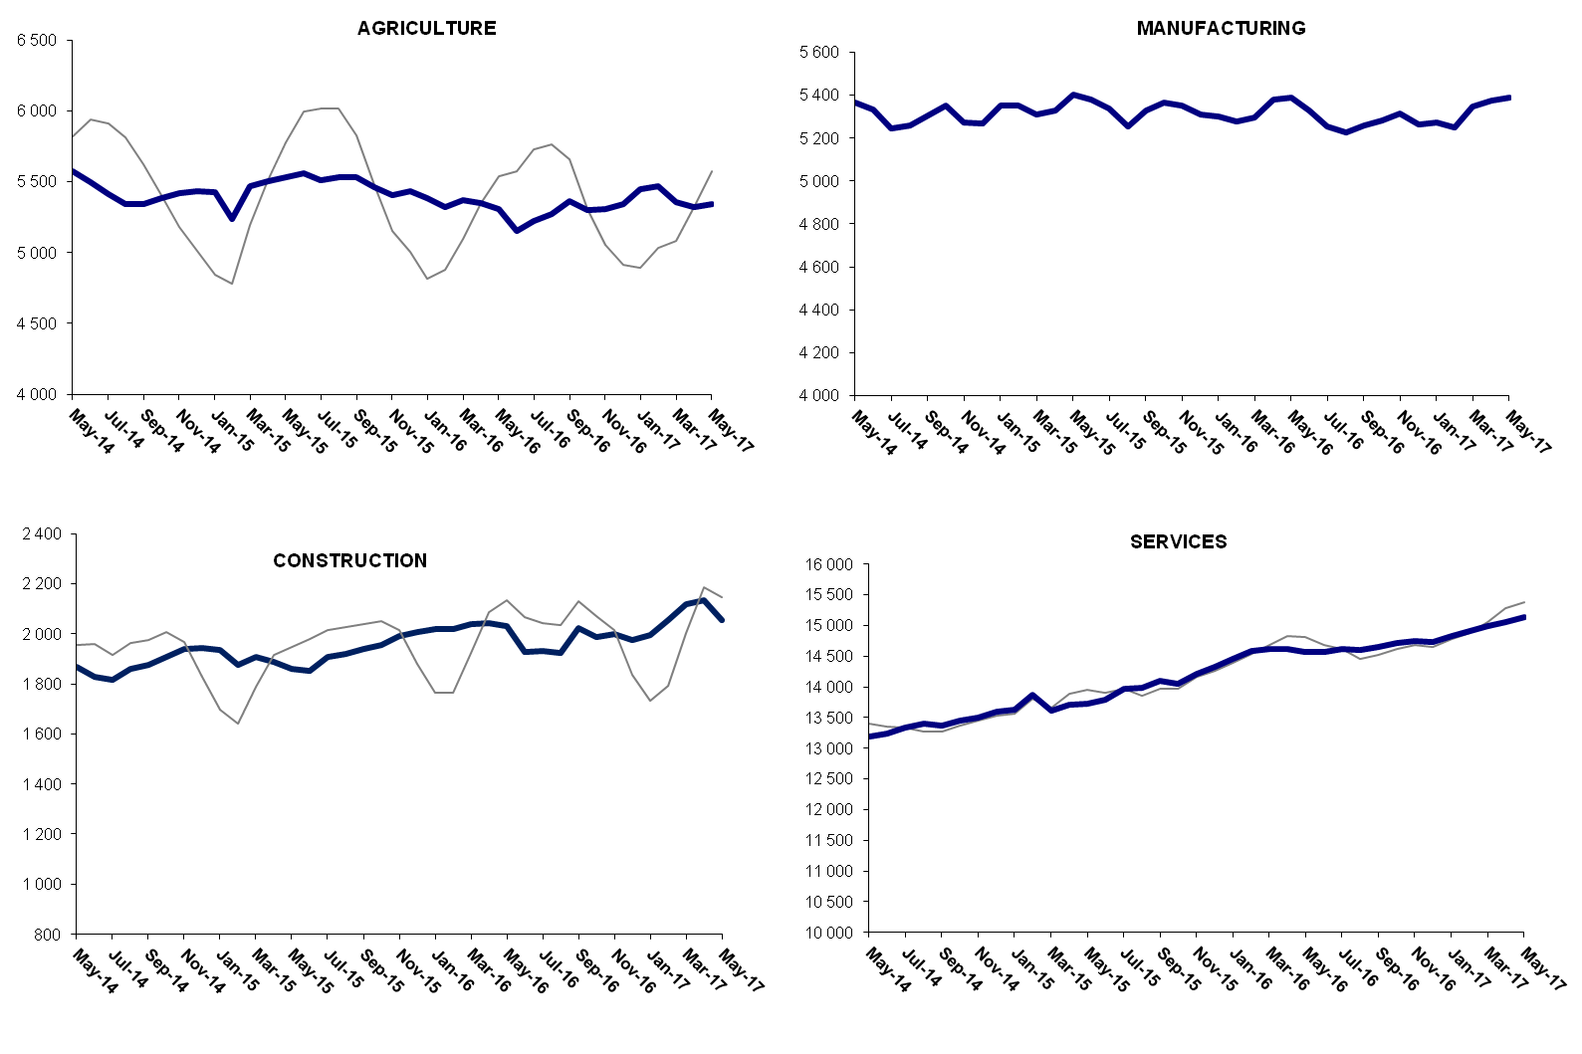
Source: Turkstat, Betam

Year-on-year decrease in non-agricultural unemployment

The decline in unemployment since January could not compensate the high increase in unemployment rate experienced during the period of May-December 2016. While seasonally adjusted non-agricultural unemployment rate was 11.9 percent in the period of April 2016, seasonally adjusted non-agricultural unemployment rate decreased only to13.4 in the period of May 2017. Non-agricultural labor force increased by 923 thousand (3.7 percent), non-agricultural employment increased by 584 thousand (2.6 percent) from May 2017 to May 2016. As result, the annual increase in the number of unemployed was 339 thousand.

Figure 4 Year-on-year changes in non-agricultural labor force, employment, and unemployment
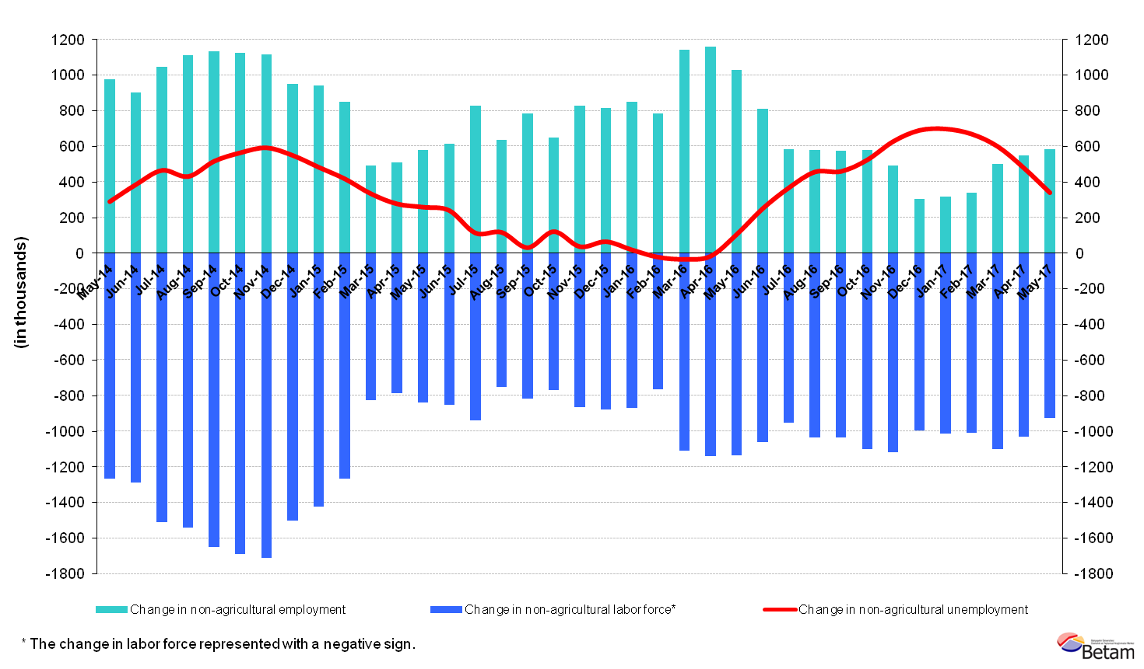
Source: Turkstat, Betam

Decreasing gender gap in unemployment

Figure 5 shows seasonal adjusted non-agricultural unemployment rate for males and females. The non-agricultural female unemployment rate decreased since the period of January 2017. The non-agricultural female unemployment rate which peaked at 19.9 percent, decreased steadily to 19 percent in the period of May 2017. On the other hand, the non-agricultural male unemployment rate decreased only the during the last two periods. The non-agricultural male unemployment rate which peaked at 11.8 percent in the March, decreased to 11.6 percent in May. Thus the gender gap in non-agricultural unemployment rates has decreased slightly.

Figure 5: Seasonally adjusted nonagricultural unemployment rate by gender

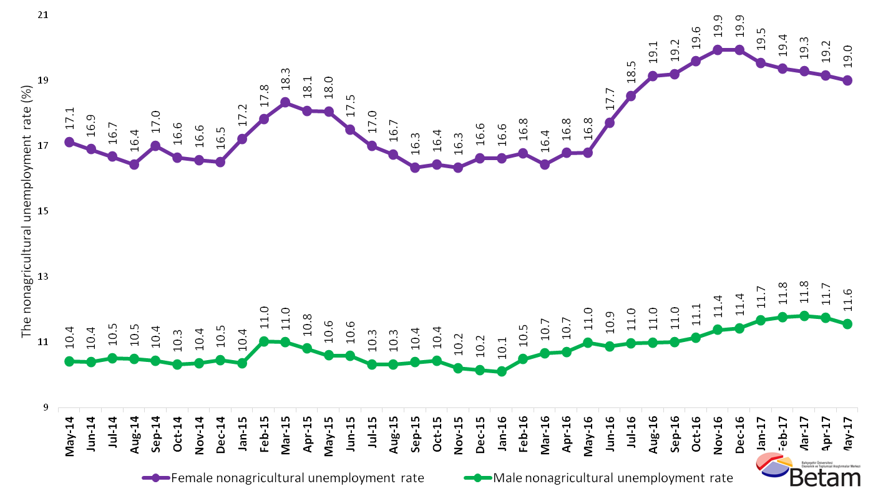

Source: Turkstat, Betam

Table 1 Seasonally adjusted non-agricultural labor market indicators (in thousands)*
 | Labor force | Employment | Unemployment | Unemployment rate | Monthly changes
March-14 | 22963 | 20368 | 2595 | 11.3% | Labor force | Employment | Unemployment
April-14 | 23090 | 20435 | 2655 | 11.5% | 128 | 67 | 61
May-14 | 23131 | 20425 | 2706 | 11.7% | 41 | -10 | 51
June-14 | 23188 | 20405 | 2783 | 12.0% | 56 | -20 | 76
July-14 | 23289 | 20401 | 2888 | 12.4% | 101 | -4 | 105
August-14 | 23392 | 20515 | 2877 | 12.3% | 103 | 114 | -11
September-14 | 23522 | 20558 | 2964 | 12.6% | 129 | 43 | 86
October-14 | 23632 | 20702 | 2930 | 12.4% | 111 | 144 | -33
November-14 | 23691 | 20706 | 2985 | 12.6% | 59 | 4 | 55
December-14 | 23748 | 20803 | 2945 | 12.4% | 57 | 97 | -40
January-15 | 23857 | 20899 | 2958 | 12.4% | 110 | 96 | 14
February-15 | 24042 | 21085 | 2957 | 12.3% | 185 | 186 | -1
March-15 | 23775 | 20827 | 2948 | 12.4% | -267 | -258 | -9
April-15 | 23874 | 20914 | 2960 | 12.4% | 99 | 87 | 12
May-15 | 24006 | 21005 | 3001 | 12.5% | 131 | 91 | 40
June-15 | 24066 | 21034 | 3032 | 12.6% | 61 | 29 | 32
July-15 | 24200 | 21223 | 2977 | 12.3% | 133 | 189 | -56
August-15 | 24132 | 21164 | 2968 | 12.3% | -67 | -59 | -8
September-15 | 24352 | 21357 | 2995 | 12.3% | 220 | 193 | 27
October-15 | 24403 | 21377 | 3026 | 12.4% | 51 | 20 | 31
November-15 | 24542 | 21548 | 2994 | 12.2% | 139 | 171 | -32
December-15 | 24619 | 21640 | 2979 | 12.1% | 77 | 92 | -15
January-16 | 24731 | 21763 | 2968 | 12.0% | 112 | 123 | -11
February-16 | 24825 | 21871 | 2954 | 11.9% | 95 | 108 | -13
March-16 | 24871 | 21936 | 2935 | 11.8% | 46 | 65 | -19
April-16 | 24999 | 22024 | 2975 | 11.9% | 128 | 88 | 40
May-16 | 25116 | 22002 | 3114 | 12.4% | 118 | -22 | 140
June-16 | 25124 | 21833 | 3291 | 13.1% | 8 | -169 | 177
July-16 | 25178 | 21804 | 3374 | 13.4% | 54 | -29 | 83
August-16 | 25181 | 21756 | 3425 | 13.6% | 3 | -48 | 51
September-16 | 25364 | 21940 | 3424 | 13.5% | 184 | 184 | 0
October-16 | 25525 | 21977 | 3548 | 13.9% | 161 | 37 | 124
November-16 | 25647 | 22056 | 3591 | 14.0% | 122 | 79 | 43
December-16 | 25579 | 21972 | 3607 | 14.1% | -68 | -84 | 16
January-17 | 25690 | 22093 | 3597 | 14.0% | 111 | 121 | -10
February-17 | 25800 | 22214 | 3586 | 13.9% | 111 | 121 | -10
March-17 | 25990 | 22429 | 3561 | 13.7% | 189 | 215 | -26
April-17 | 26035 | 22546 | 3489 | 13.4% | 45 | 117 | -72
May-17 | 26066 | 22573 | 3493 | 13.4% | 31 | 27 | 4
Source: Turkstat, Betam

Table 2 Seasonally adjusted employment by sectors (in thousands)*
 | Agriculture | Manufacturing | Construction | Service | Monthly changes
March-14 | 5598 | 5365 | 1944 | 13059 | Agriculture | Manufacturing | Construction | Service
April-14 | 5569 | 5373 | 1885 | 13177 | -29 | 8 | -59 | 118
May-14 | 5571 | 5364 | 1873 | 13188 | 2 | -9 | -12 | 11
June-14 | 5494 | 5332 | 1833 | 13241 | -77 | -32 | -40 | 53
July-14 | 5409 | 5243 | 1822 | 13336 | -85 | -89 | -11 | 95
August-14 | 5344 | 5257 | 1862 | 13395 | -65 | 14 | 40 | 59
September-14 | 5342 | 5306 | 1877 | 13375 | -2 | 49 | 15 | -20
October-14 | 5386 | 5353 | 1906 | 13443 | 44 | 47 | 29 | 68
November-14 | 5417 | 5273 | 1939 | 13494 | 31 | -80 | 33 | 51
December-14 | 5437 | 5266 | 1941 | 13596 | 20 | -7 | 2 | 102
January-15 | 5426 | 5349 | 1928 | 13621 | -11 | 83 | -13 | 25
February-15 | 5238 | 5351 | 1868 | 13866 | -188 | 2 | -60 | 245
March-15 | 5473 | 5308 | 1901 | 13619 | 235 | -43 | 33 | -247
April-15 | 5504 | 5326 | 1881 | 13707 | 31 | 18 | -20 | 88
May-15 | 5526 | 5404 | 1869 | 13731 | 22 | 78 | -12 | 24
June-15 | 5557 | 5380 | 1861 | 13793 | 31 | -24 | -8 | 62
July-15 | 5510 | 5336 | 1917 | 13970 | -47 | -44 | 56 | 177
August-15 | 5532 | 5252 | 1925 | 13986 | 22 | -84 | 8 | 16
September-15 | 5532 | 5327 | 1941 | 14089 | 0 | 75 | 16 | 103
October-15 | 5462 | 5363 | 1958 | 14056 | -70 | 36 | 17 | -33
November-15 | 5403 | 5353 | 1989 | 14207 | -59 | -10 | 31 | 151
December-15 | 5430 | 5311 | 2003 | 14326 | 27 | -42 | 14 | 119
January-16 | 5384 | 5300 | 2013 | 14450 | -46 | -11 | 10 | 124
February-16 | 5322 | 5276 | 2008 | 14587 | -62 | -24 | -5 | 137
March-16 | 5373 | 5295 | 2025 | 14617 | 51 | 19 | 17 | 30
April-16 | 5352 | 5381 | 2028 | 14615 | -21 | 86 | 3 | -2
May-16 | 5302 | 5386 | 2043 | 14574 | -50 | 5 | 15 | -41
June-16 | 5148 | 5330 | 1941 | 14563 | -154 | -56 | -102 | -11
July-16 | 5221 | 5254 | 1942 | 14608 | 73 | -76 | 1 | 45
August-16 | 5269 | 5224 | 1932 | 14600 | 48 | -30 | -10 | -8
September-16 | 5361 | 5260 | 2028 | 14651 | 92 | 36 | 96 | 51
October-16 | 5301 | 5282 | 1989 | 14706 | -60 | 22 | -39 | 55
November-16 | 5309 | 5316 | 1998 | 14742 | 8 | 34 | 9 | 36
December-16 | 5343 | 5265 | 1972 | 14735 | 34 | -51 | -26 | -7
January-17 | 5452 | 5274 | 1986 | 14834 | 109 | 9 | 14 | 99
February-17 | 5468 | 5251 | 2042 | 14921 | 16 | -23 | 56 | 87
March-17 | 5362 | 5346 | 2097 | 14985 | -106 | 95 | 55 | 64
April-17 | 5324 | 5372 | 2113 | 15062 | -38 | 26 | 16 | 77
May-17 | 5341 | 5386 | 2055 | 15132 | 17 | 14 | -58 | 70
Source: Turkstat, Betam

Table 3: Seasonally adjusted non-agricultural labor force by gender (thousands)
 | Female Labor Force | Female Employment | Female Unemployed | Male Labor Force | Male Employment | Male Unemployed
May-14 | 6122 | 5074 | 1048 | 17030 | 15255 | 1775
June-14 | 6152 | 5112 | 1039 | 17072 | 15295 | 1776
July-14 | 6199 | 5166 | 1033 | 17097 | 15300 | 1798
August-14 | 6299 | 5263 | 1035 | 17161 | 15361 | 1801
September-14 | 6336 | 5259 | 1077 | 17169 | 15376 | 1792
October-14 | 6385 | 5322 | 1062 | 17208 | 15433 | 1775
November-14 | 6399 | 5338 | 1060 | 17225 | 15441 | 1784
December-14 | 6420 | 5360 | 1059 | 17298 | 15490 | 1808
January-15 | 6507 | 5387 | 1120 | 17306 | 15514 | 1792
February-15 | 6563 | 5394 | 1169 | 17490 | 15561 | 1929
March-15 | 6521 | 5326 | 1195 | 17266 | 15367 | 1899
April-15 | 6542 | 5360 | 1183 | 17317 | 15446 | 1871
May-15 | 6627 | 5431 | 1196 | 17354 | 15515 | 1839
June-15 | 6655 | 5490 | 1165 | 17442 | 15596 | 1846
July-15 | 6741 | 5595 | 1147 | 17488 | 15683 | 1805
August-15 | 6712 | 5588 | 1124 | 17508 | 15701 | 1806
September-15 | 6758 | 5654 | 1104 | 17578 | 15752 | 1826
October-15 | 6777 | 5663 | 1114 | 17601 | 15765 | 1836
November-15 | 6873 | 5750 | 1123 | 17613 | 15815 | 1799
December-15 | 6974 | 5815 | 1159 | 17644 | 15853 | 1792
January-16 | 7019 | 5853 | 1166 | 17663 | 15879 | 1785
February-16 | 7052 | 5869 | 1183 | 17757 | 15895 | 1861
March-16 | 7057 | 5898 | 1159 | 17808 | 15907 | 1900
April-16 | 7144 | 5945 | 1199 | 17840 | 15930 | 1911
May-16 | 7177 | 5972 | 1205 | 17918 | 15949 | 1969
June-16 | 7259 | 5973 | 1285 | 17896 | 15949 | 1947
July-16 | 7261 | 5917 | 1345 | 17936 | 15968 | 1968
August-16 | 7325 | 5923 | 1402 | 17966 | 15991 | 1975
September-16 | 7375 | 5960 | 1415 | 18002 | 16021 | 1981
October-16 | 7438 | 5981 | 1457 | 18053 | 16043 | 2010
November-16 | 7457 | 5970 | 1486 | 18138 | 16074 | 2064
December-16 | 7463 | 5975 | 1488 | 18149 | 16074 | 2074
January-17 | 7458 | 6001 | 1457 | 18236 | 16108 | 2127
February-17 | 7517 | 6062 | 1455 | 18278 | 16126 | 2152
March-17 | 7613 | 6145 | 1468 | 18336 | 16172 | 2164
April-17 | 7601 | 6145 | 1456 | 18372 | 16215 | 2158
May-17 | 7653 | 6199 | 1454 | 18363 | 16239 | 2124
Source: Turkstat, Betam

*Prof. Dr. Seyfettin Gürsel, Betam, Director, seyfettin.gursel@eas.bau.edu.tr
∗∗ Melike Kökkızıl, Betam, Research Assistant, melike.kokkizil@eas.bau.edu.tr
For detailed information on Betam's forecasting model, please see Betam Research Brief 168 titled as "Kariyer.net Verisiyle Kısa Vadeli Tarım Dışı İşsizlik Tahmini" . For the innovations in the model please see Betam Research Brief 14 titled as "Mevsim Etkilerinden Arındırılmış İşsizlik Tahmini" Soybilgen, B., "Kariyer.net Verisiyle Kısa Vadeli Tarım Dışı İşsizlik Tahmini", Betam Research Brief 168. http://betam.bahcesehir.edu.tr/tr/2014/06/kariyer-net-verisiyle-kisa-vadeli-tarim-disi-issizlik-tahmini/ Soybilgen, B., "Mevsim Etkilerinden Arındırılmış İşsizlik Tahmini", Betam Research Brief 14 http://betam.bahcesehir.edu.tr/2015/08/mevsim-etkilerinden-arindirilmis-tarim-disi-issizlik-tahmini/
Betam has been calculating application per vacancy using series released by Kariyer.net for a while. Seasonal and calendar adjustment procedure is applied to application per vacancy series. A decrease in applications per vacancy may be caused by an increase in vacancies or by a decrease in the number of applications. An increase in vacancies signals economic growth while decreasing number of applications indicates a decrease in number of people looking for a job. Monthly labor market series released by TurkStat is the average of three months. Therefore, application per vacancy statistics calculated using Kariyer.net series is the average of three months as well.
Employment in each sector is seasonally adjusted separately. Hence the sum of these series may differ from the seasonally adjusted series of total employment. The difference stems from the non-linearity of the seasonal adjustment process.
Turkstat revised the labor market statistics drastically in February 2014. Within this framework, they back casted various labor market indicators and they also continued to announce seasonally adjusted series. However, Turkstat is not providing back-casted series by gender. Therefore, female and male labor market statistics are not sufficiently long for the seasonal adjustment procedures (There should be minimum 36 observations). With the announcement of the period of February 2017 data, the number of observations required for the seasonal decontamination process was provided. From this period Betam get seasonal adjustment series in terms of gender. Nevertheless, it should not be forgotten that seasonal adjustment may cause extra volatility in the series for at least a while.

