

**Labor Market Outlook:**

**July 2017**

**17 July 2017**

**UNEMPLOYMENT CONTINUES TO DECREASE**

**Seyfettin Gürsel[1]* Gökçe Uysal[2]** and Mine Durmaz [3]\*\*\***

**Executive Summary**

Seasonally adjusted labor market data show that the nonagricultural unemployment rate decreased by 0.2 percentage points and is recorded as 13.4 percent in the period of April 2017. In the period of April 2017 compared to the period of March 2017, increases in the nonagricultural employment continued. Parallel to these developments, the nonagricultural unemployment decreased. In this period, we observed employment increases in all nonagricultural sectors. According to seasonally adjusted labor market data, in looking at gender breakdown, the male unemployment rate remained constant while the female unemployment rate decreased. Betam forecast model predicts that the non-agricultural unemployment rate will decline by 0.1 percentage points down to 13.3 percent in the period of May 2017.

**Increase in nonagricultural employment has driven unemployment down**

According to seasonally adjusted data, the nonagricultural labor force increased by 79 thousand and reached 26 million 57 thousand and the number of people employed in non-agricultural sectors increased by 120 thousand and reached 22 million 565 thousand in the period of April 2017 compared to the period of March 2017 (Figure 1, Table 1). While the number of people unemployed in nonagricultural sectors decreased by 41 thousand and is recoded as 3 million 492 thousand, the nonagricultural unemployment rate declined to 13.4 percent. Since the period of September 2016, except December 2016, the non-agricultural labor force has been increasing over 100 thousand. However, it has slowed down during the period of April 2017 and declined to the level of 79 thousand. Therefore, relatively high increase in the nonagricultural employment pulled the nonagricultural unemployment rate down.

Figure 1 Seasonally adjusted non-agricultural labor force, employment, and unemployment



Source: Turkstat, Betam

**The unemployment rate is expected to decline in the period of May 2017**

Betam's forecasting model had predicted that the seasonally adjusted nonagricultural unemployment rate would decrease by 0.1 percentage points and would be 13.6 percent in the period of April 2017. Turkstat revised seasonally adjusted nonagricultural unemployment rate of the March 2017 period from 13.7 percent to 13.6 percent. As a result, the non-agricultural unemployment rate in April period decreased by 0.2 percentage points and it recorded as 13.4 percent. Betam’s forecasting model predicts the seasonally adjusted May 2017 nonagricultural unemployment will decrease by 0.1 points to 13.3 percent. Forecasting model details are available on Betam's website.[4] Kariyer.net[5] application per vacancy series used in the Betam forecasting model is depicted in Figure 1. Kariyer.net series is only one of the inputs of Betam forecast model. Indeed, several variables such as employment agency (İŞKUR) data, reel sector confidence index, capacity utilization rate are used in forecasting. Taken into account all these factors, Betam's forecasting model predicts that seasonally adjusted nonagricultural unemployment rate will continue to decrease in the period of May 2017.

**Figure 2 Seasonally adjusted nonagricultural unemployment rate and application per vacancy**

Source: Turkstat, Betam

**Slowdown in sectoral employment increases**

According to seasonally adjusted sectoral labor market data, strong increases in the employment of the nonagricultural sectors were recorded in the period of March 2017. Even though we observe employment increase in all non-agricultural sectors during the period of April 2017, their pace is relatively slower compared to previous periods (Figure 3, Table 2). [6] In this period, the employment increased by 26 thousand in industry, by 17 thousand in construction and by 76 thousand in services sector.

Figure 3 Employment by sectors (in thousands)

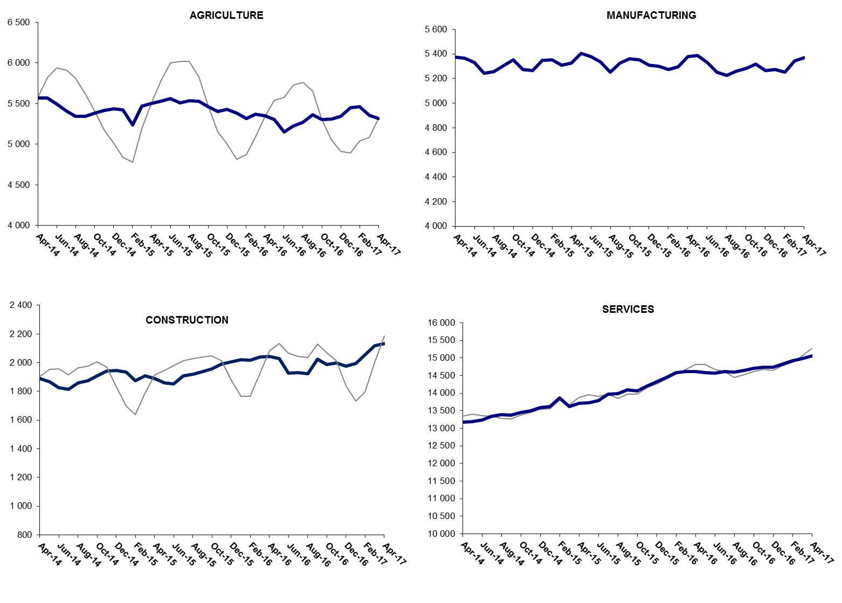

Source: Turkstat, Betam

**Decrease in year-on-year nonagricultural unemployment**

From March 2016 to April 2017 the nonagricultural labor force increased by 1 million 128 thousand (4.1 percent) and nonagricultural employment increased by 550 thousand (2.5 percent) (Figure 4). Thus, the number of non-agricultural unemployed increased by 478 thousand (17.4 percent).

Figure 4 Year-on-year changes in non-agricultural labor force, employment, and unemployment

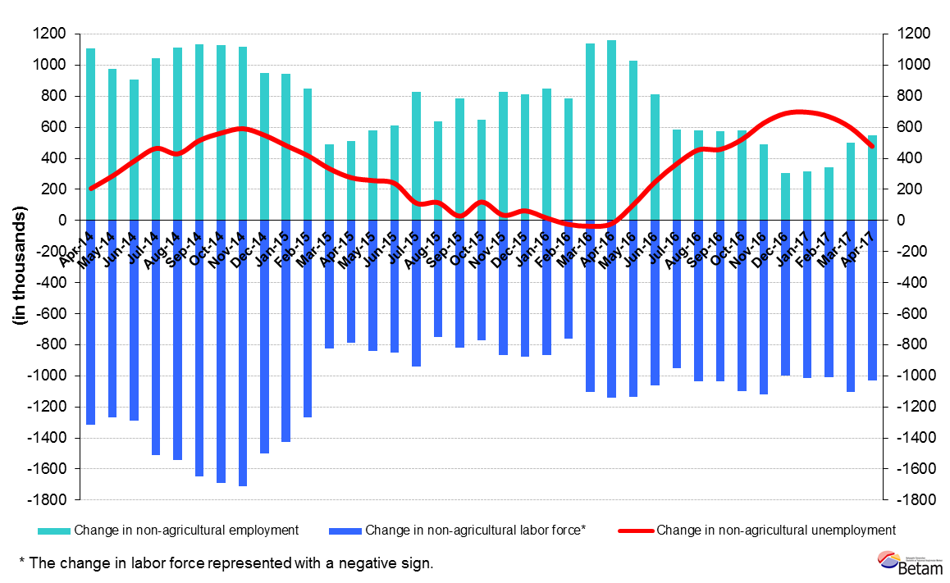

Source: Turkstat, Betam

Female unemployment decreased, male unemployment remained constant

Turkstat revised the labor market statistics drastically in February 2014. Within this framework, they back casted various labor market indicators and they also continued to announce seasonally adjusted series. However, Turkstat is not providing back-casted series by gender. Therefore, female and male labor market statistics were not sufficiently long for a reliable seasonal-adjustment process and we need at least 36 observations to apply it. As of February 2017, we obtain the sufficient 36 observations to run the seasonal-adjustment process. Note that the seasonal-adjustment process might generate volatility in the series for some more time.

Figure 5 shows the seasonally adjusted nonagricultural female and male unemployment rates. From March 2017 to April 2017, the male nonagricultural unemployment rate remained constant at the level of 12.2 percent while the female nonagricultural unemployment rate decreased by 0.1 percentage points. As a result, female unemployment rate declined to 19.2 percent. Finally, we observe that gender gap in non-agricultural unemployment has slightly narrowed.

Figure 5 Seasonally adjusted female and male nonagricultural unemployment rates (%)

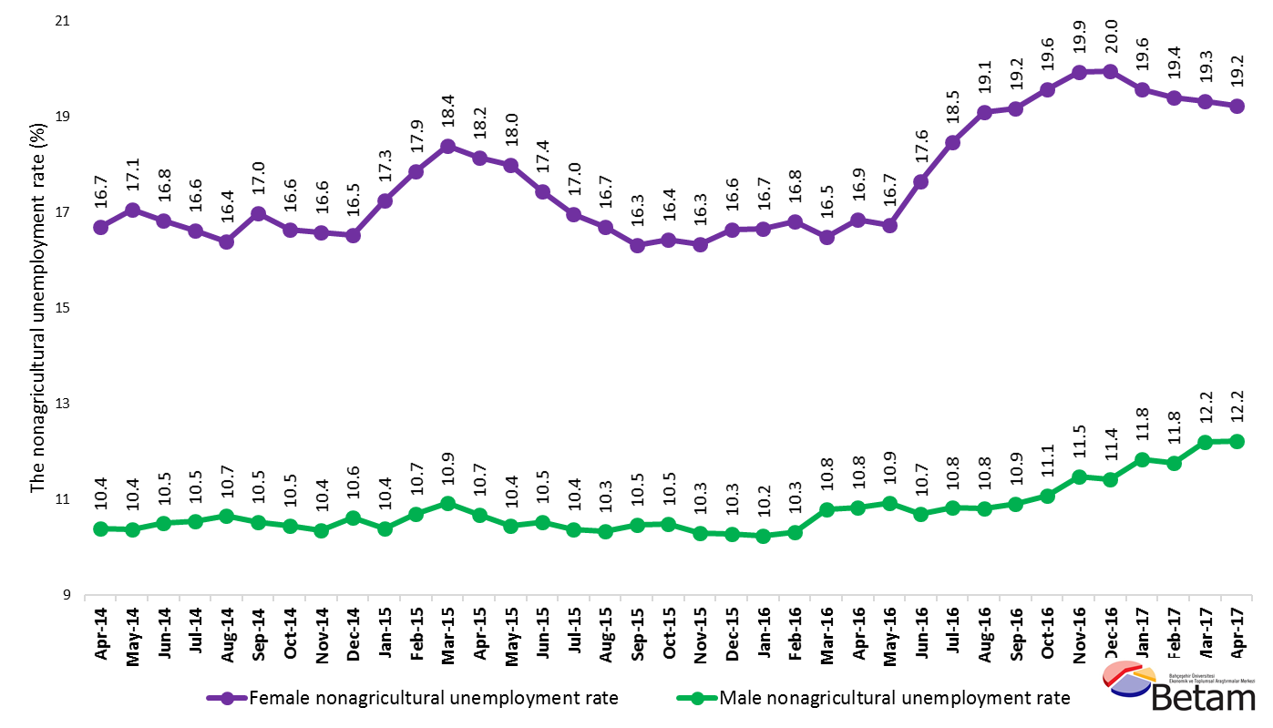

Source: Turkstat, Betam

Table 1 Seasonally adjusted non-agricultural labor market indicators (in thousands)

|  |  |  |  |  |  |  |  |
| --- | --- | --- | --- | --- | --- | --- | --- |
|  | **Labor force** | **Employment** | **Unemployment** | **Unemployment rate** | **Monthly changes** | | |
| **March-14** | 22968 | 20373 | 2595 | 11.3% | **Labor force** | **Employment** | **Unemployment** |
| **April-14** | 23094 | 20438 | 2656 | 11.5% | 125 | 65 | 60 |
| **May-14** | 23126 | 20420 | 2706 | 11.7% | 32 | -18 | 50 |
| **June-14** | 23181 | 20399 | 2782 | 12.0% | 55 | -21 | 76 |
| **July-14** | 23282 | 20395 | 2887 | 12.4% | 101 | -4 | 105 |
| **August-14** | 23388 | 20511 | 2877 | 12.3% | 106 | 116 | -10 |
| **September-14** | 23521 | 20557 | 2964 | 12.6% | 133 | 46 | 87 |
| **October-14** | 23634 | 20703 | 2931 | 12.4% | 113 | 146 | -33 |
| **November-14** | 23693 | 20708 | 2985 | 12.6% | 60 | 5 | 55 |
| **December-14** | 23752 | 20807 | 2945 | 12.4% | 59 | 99 | -40 |
| **January-15** | 23863 | 20904 | 2959 | 12.4% | 111 | 97 | 14 |
| **February-15** | 24048 | 21090 | 2958 | 12.3% | 185 | 186 | -1 |
| **March-15** | 23783 | 20834 | 2949 | 12.4% | -265 | -256 | -9 |
| **April-15** | 23881 | 20920 | 2961 | 12.4% | 98 | 86 | 12 |
| **May-15** | 23997 | 20997 | 3000 | 12.5% | 115 | 77 | 38 |
| **June-15** | 24057 | 21026 | 3031 | 12.6% | 61 | 29 | 32 |
| **July-15** | 24190 | 21215 | 2975 | 12.3% | 133 | 189 | -56 |
| **August-15** | 24128 | 21160 | 2968 | 12.3% | -63 | -55 | -8 |
| **September-15** | 24351 | 21356 | 2995 | 12.3% | 223 | 196 | 27 |
| **October-15** | 24404 | 21378 | 3026 | 12.4% | 53 | 22 | 31 |
| **November-15** | 24544 | 21550 | 2994 | 12.2% | 140 | 172 | -32 |
| **December-15** | 24622 | 21643 | 2979 | 12.1% | 78 | 93 | -15 |
| **January-16** | 24736 | 21768 | 2968 | 12.0% | 114 | 125 | -11 |
| **February-16** | 24833 | 21878 | 2955 | 11.9% | 97 | 110 | -13 |
| **March-16** | 24884 | 21948 | 2936 | 11.8% | 51 | 70 | -19 |
| **April-16** | 25011 | 22035 | 2976 | 11.9% | 127 | 87 | 40 |
| **May-16** | 25105 | 21992 | 3113 | 12.4% | 94 | -43 | 137 |
| **June-16** | 25113 | 21823 | 3290 | 13.1% | 8 | -169 | 177 |
| **July-16** | 25167 | 21795 | 3372 | 13.4% | 55 | -28 | 83 |
| **August-16** | 25174 | 21750 | 3424 | 13.6% | 6 | -45 | 51 |
| **September-16** | 25361 | 21937 | 3424 | 13.5% | 187 | 187 | 0 |
| **October-16** | 25524 | 21976 | 3548 | 13.9% | 163 | 39 | 124 |
| **November-16** | 25648 | 22057 | 3591 | 14.0% | 124 | 81 | 43 |
| **December-16** | 25582 | 21975 | 3607 | 14.1% | -66 | -82 | 16 |
| **January-17** | 25697 | 22099 | 3598 | 14.0% | 114 | 124 | -10 |
| **February-17** | 25812 | 22224 | 3588 | 13.9% | 115 | 125 | -10 |
| **March-17** | 25978 | 22445 | 3533 | 13.6% | 166 | 221 | -55 |
| **April-17** | 26057 | 22565 | 3492 | 13.4% | 79 | 120 | -41 |

Source: Turkstat, Betam

Table 2 Seasonally adjusted employment by sectors (in thousands)

|  |  |  |  |  |  |  |  |  |
| --- | --- | --- | --- | --- | --- | --- | --- | --- |
|  | **Agriculture** | **Manufacturing** | **Construction** | **Service** | **Monthly changes** | | | |
| **March-14** | 5596 | 5365 | 1950 | 13058 | **Agriculture** | **Manufacturing** | **Construction** | **Service** |
| **April-14** | 5568 | 5373 | 1889 | 13176 | -28 | 8 | -61 | 118 |
| **May-14** | 5572 | 5364 | 1867 | 13189 | 4 | -9 | -22 | 13 |
| **June-14** | 5495 | 5332 | 1826 | 13241 | -77 | -32 | -41 | 52 |
| **July-14** | 5410 | 5243 | 1815 | 13337 | -85 | -89 | -11 | 96 |
| **August-14** | 5345 | 5257 | 1858 | 13396 | -65 | 14 | 43 | 59 |
| **September-14** | 5342 | 5306 | 1875 | 13376 | -3 | 49 | 17 | -20 |
| **October-14** | 5386 | 5353 | 1907 | 13443 | 44 | 47 | 32 | 67 |
| **November-14** | 5417 | 5273 | 1941 | 13493 | 31 | -80 | 34 | 50 |
| **December-14** | 5436 | 5266 | 1945 | 13595 | 19 | -7 | 4 | 102 |
| **January-15** | 5425 | 5349 | 1935 | 13620 | -11 | 83 | -10 | 25 |
| **February-15** | 5237 | 5351 | 1875 | 13864 | -188 | 2 | -60 | 244 |
| **March-15** | 5471 | 5308 | 1909 | 13617 | 234 | -43 | 34 | -247 |
| **April-15** | 5502 | 5326 | 1889 | 13705 | 31 | 18 | -20 | 88 |
| **May-15** | 5528 | 5404 | 1860 | 13733 | 26 | 78 | -29 | 28 |
| **June-15** | 5559 | 5380 | 1851 | 13794 | 31 | -24 | -9 | 61 |
| **July-15** | 5512 | 5336 | 1908 | 13971 | -47 | -44 | 57 | 177 |
| **August-15** | 5533 | 5252 | 1920 | 13988 | 21 | -84 | 12 | 17 |
| **September-15** | 5532 | 5327 | 1938 | 14090 | -1 | 75 | 18 | 102 |
| **October-15** | 5462 | 5363 | 1957 | 14057 | -70 | 36 | 19 | -33 |
| **November-15** | 5403 | 5353 | 1991 | 14207 | -59 | -10 | 34 | 150 |
| **December-15** | 5430 | 5311 | 2007 | 14325 | 27 | -42 | 16 | 118 |
| **January-16** | 5383 | 5300 | 2020 | 14448 | -47 | -11 | 13 | 123 |
| **February-16** | 5320 | 5276 | 2018 | 14584 | -63 | -24 | -2 | 136 |
| **March-16** | 5370 | 5295 | 2038 | 14614 | 50 | 19 | 20 | 30 |
| **April-16** | 5349 | 5381 | 2042 | 14612 | -21 | 86 | 4 | -2 |
| **May-16** | 5305 | 5386 | 2030 | 14576 | -44 | 5 | -12 | -36 |
| **June-16** | 5151 | 5330 | 1928 | 14565 | -154 | -56 | -102 | -11 |
| **July-16** | 5223 | 5254 | 1932 | 14609 | 72 | -76 | 4 | 44 |
| **August-16** | 5271 | 5224 | 1925 | 14602 | 48 | -30 | -7 | -7 |
| **September-16** | 5362 | 5260 | 2024 | 14652 | 91 | 36 | 99 | 50 |
| **October-16** | 5301 | 5282 | 1987 | 14707 | -61 | 22 | -37 | 55 |
| **November-16** | 5309 | 5316 | 1999 | 14742 | 8 | 34 | 12 | 35 |
| **December-16** | 5342 | 5265 | 1975 | 14735 | 33 | -51 | -24 | -7 |
| **January-17** | 5449 | 5274 | 1993 | 14832 | 107 | 9 | 18 | 97 |
| **February-17** | 5465 | 5251 | 2056 | 14917 | 16 | -23 | 63 | 85 |
| **March-17** | 5359 | 5346 | 2118 | 14982 | -106 | 95 | 62 | 65 |
| **April-17** | 5320 | 5372 | 2135 | 15058 | -39 | 26 | 17 | 76 |

Source: Turkstat, Betam

Table 3: Seasonally adjusted female and male non-agricultural labor market indicators (in thousands)

|  |  |  |  |  |  |  |
| --- | --- | --- | --- | --- | --- | --- |
|  | **Female Labor Force** | **Female Employment** | **Female Unemployed** | **Male Labor Force** | **Male Employment** | **Male Unemployed** |
| **April-14** | 6116 | 5095 | 1021 | 16967 | 15203 | 1763 |
| **May-14** | 6123 | 5079 | 1044 | 17014 | 15248 | 1766 |
| **June-14** | 6153 | 5117 | 1035 | 17077 | 15284 | 1793 |
| **July-14** | 6200 | 5170 | 1030 | 17106 | 15303 | 1803 |
| **August-14** | 6299 | 5267 | 1033 | 17185 | 15355 | 1831 |
| **September-14** | 6337 | 5261 | 1076 | 17189 | 15381 | 1809 |
| **October-14** | 6385 | 5323 | 1062 | 17231 | 15429 | 1802 |
| **November-14** | 6399 | 5338 | 1061 | 17237 | 15451 | 1786 |
| **December-14** | 6420 | 5359 | 1061 | 17331 | 15490 | 1840 |
| **January-15** | 6507 | 5384 | 1123 | 17322 | 15520 | 1801 |
| **February-15** | 6561 | 5389 | 1172 | 17427 | 15561 | 1866 |
| **March-15** | 6519 | 5321 | 1199 | 17246 | 15363 | 1883 |
| **April-15** | 6540 | 5353 | 1187 | 17304 | 15454 | 1849 |
| **May-15** | 6628 | 5436 | 1193 | 17336 | 15525 | 1811 |
| **June-15** | 6656 | 5495 | 1160 | 17436 | 15601 | 1835 |
| **July-15** | 6742 | 5599 | 1143 | 17489 | 15675 | 1814 |
| **August-15** | 6713 | 5592 | 1121 | 17512 | 15701 | 1812 |
| **September-15** | 6758 | 5656 | 1103 | 17589 | 15748 | 1841 |
| **October-15** | 6778 | 5664 | 1113 | 17613 | 15766 | 1847 |
| **November-15** | 6874 | 5750 | 1123 | 17626 | 15809 | 1817 |
| **December-15** | 6974 | 5814 | 1161 | 17657 | 15842 | 1814 |
| **January-16** | 7019 | 5850 | 1169 | 17678 | 15868 | 1809 |
| **February-16** | 7050 | 5864 | 1185 | 17719 | 15889 | 1830 |
| **March-16** | 7055 | 5893 | 1163 | 17826 | 15902 | 1923 |
| **April-16** | 7142 | 5938 | 1204 | 17860 | 15926 | 1934 |
| **May-16** | 7178 | 5977 | 1202 | 17916 | 15959 | 1957 |
| **June-16** | 7259 | 5978 | 1281 | 17879 | 15967 | 1911 |
| **July-16** | 7262 | 5921 | 1342 | 17922 | 15982 | 1940 |
| **August-16** | 7326 | 5927 | 1399 | 17945 | 16005 | 1940 |
| **September-16** | 7376 | 5962 | 1414 | 17989 | 16025 | 1963 |
| **October-16** | 7439 | 5982 | 1456 | 18046 | 16046 | 2000 |
| **November-16** | 7457 | 5971 | 1487 | 18151 | 16066 | 2085 |
| **December-16** | 7463 | 5974 | 1489 | 18149 | 16074 | 2074 |
| **January-17** | 7458 | 5998 | 1460 | 18259 | 16097 | 2162 |
| **February-17** | 7515 | 6057 | 1458 | 18259 | 16112 | 2147 |
| **March-17** | 7611 | 6140 | 1471 | 18382 | 16140 | 2243 |
| **April-17** | 7599 | 6138 | 1461 | 18415 | 16165 | 2250 |

Source: Turkstat, Betam

1. **\***Prof. Dr. Seyfettin Gürsel, Betam, Director, seyfettin.gursel@eas.bau.edu.tr
2. **Asst. Prof. Gökçe Uysal, Betam, Deputy Director, gokce.uysal@eas.bau.edu.tr
3. *** Mine Durmaz, Betam, Research Assistant, [mine.durmaz@eas.bau.edu.tr](mailto:mine.durmaz@eas.bau.edu.tr)
4. For detailed information on Betam's forecasting model, please see Betam Research Brief 168 titled as "Kariyer.net Verisiyle Kısa Vadeli Tarım Dışı İşsizlik Tahmini"

   <http://betam.bahcesehir.edu.tr/tr/2014/06/kariyer-net-verisiyle-kisa-vadeli-tarim-disi-issizlik-tahmini/>
5. Betam has been calculating application per vacancy using series released by Kariyer.net for a while. Seasonal and calendar adjustment procedure is applied to application per vacancy series. A decrease in applications per vacancy may be caused by an increase in vacancies or by a decrease in the number of applications. An increase in vacancies signals economic growth while decreasing number of applications indicates a decrease in number of people looking for a job. Monthly labor market series released by TurkStat is the average of three months. Therefore, application per vacancy statistics calculated using Kariyer.net series is the average of three months as well.
6. Employment in each sector is seasonally adjusted separately. Hence the sum of these series may differ from the seasonally adjusted series of total employment. The difference stems from the non-linearity of the seasonal adjustment process.