Labor Market Outlook:
May 2017

15 May 2017

LIMITED DECREASE IN THE UNEMPLOYMENT
Seyfettin Gürsel* Gökçe Uysal∗∗ and Mine Durmaz ∗∗∗

Executive Summary

Seasonally adjusted labor market data show that nonagricultural unemployment rate decreased by 0.1 points and is recorded as 14.0 percent in the period of February 2017. The main reason behind this decrease in the nonagricultural unemployment rate is the increase in employment in both construction and services sectors in the periods of January and February 2017. Betam’s forecasting model predicts that the non-agricultural unemployment will remain constant at 14.0 percent in the period of February 2017. As of February 2017, Betam starts to provide the seasonally adjusted male and female nonagricultural unemployment rates. In this period, the seasonally adjusted nonagricultural male unemployment rate is 12 percent and that for females is 19.4 percent. In the second half of the year of 2016 female unemployment rates soared and thus, the gap between female and male unemployment rates increased. However, starting from January 2017, the difference between the seasonally adjusted nonagricultural unemployment rates has slightly decreased.

Increases in non-agricultural labor force and employment

In the period of February 2017, the nonagricultural labor force increased by 111 thousand and reached 25 million 820 thousand and the number of people employed in non-agricultural sectors increased by 121 thousand and reached 22 million 205 thousand (Figure 1, Table 1). While the number of people unemployed in nonagricultural sectors decreased by 10 thousand and is recoded as 3 million 615 thousand, the nonagricultural unemployment rate declined to 14.0 percent.

Figure 1 Seasonally adjusted non-agricultural labor force, employment, and unemployment
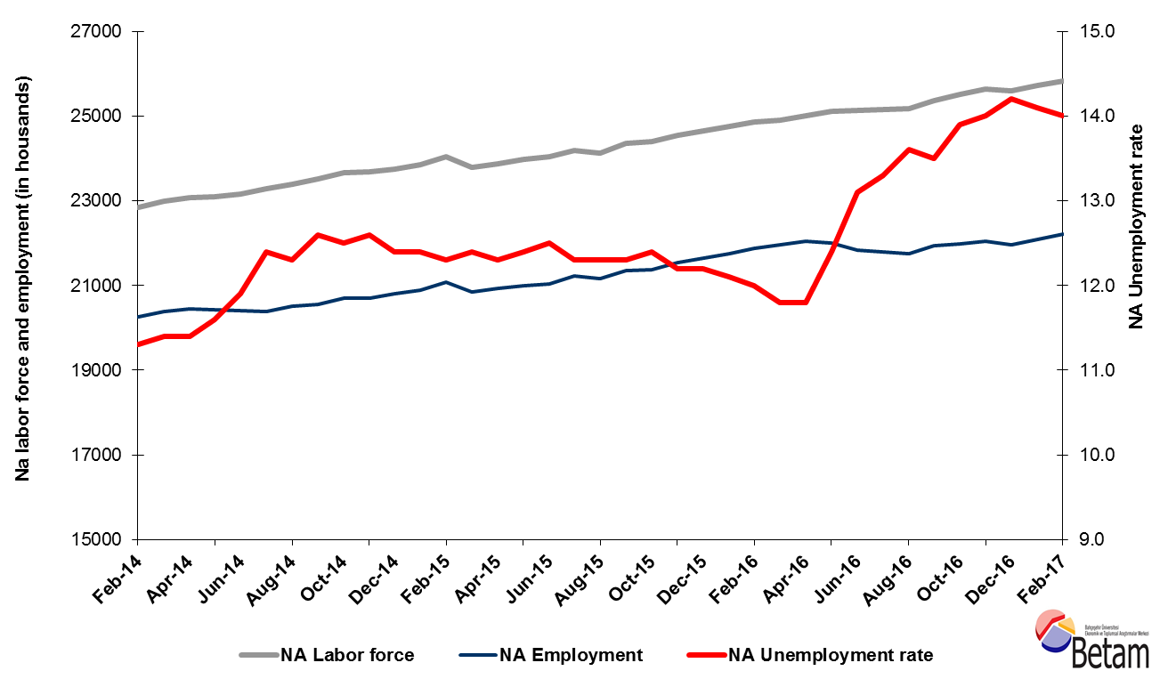

Source: Turkstat, Betam
The unemployment is expected to be constant in the period of March 2017

Betam's forecasting model had predicted that the seasonally adjusted nonagricultural unemployment rate would decrease by 0.1 percentage points and become 14.0 percent in the period of February 2017. We observe that this forecast has been confirmed. Betam’s forecasting model predicts the seasonally adjusted March 2017 nonagricultural unemployment remain constant at the level of 10.4 percent. Forecasting model details are available on Betam's website. Kariyer.net application per vacancy series used in the Betam forecasting model is depicted in Figure 1. Kariyer.net series is only one of the inputs of Betam forecast model. Indeed, several variables such as employment agency (İŞKUR) data, reel sector confidence index, capacity utilization rate are used in forecasting. Taken into account all these factors, Betam's forecasting model predicts that seasonally adjusted nonagricultural unemployment rate will remain constant in the period of March 2017.

Figure 2 Seasonally adjusted nonagricultural unemployment rate and application per vacancy
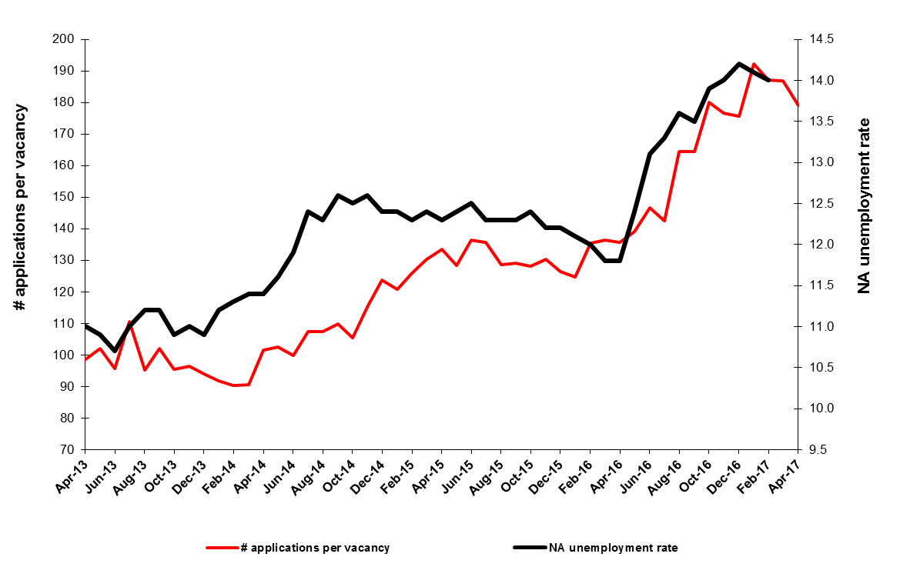
Source: Turkstat, Betam

Employment increases in services and construction

According to seasonally adjusted sectoral labor market data, recent developments in industry sector during the last three periods do not seem favorable (Figure 3, Table 2). The employment in the industry sector had decreased by 51 thousand in December 2016, had increased by just 9 thousand in January 2017 and declined by 23 thousand in the period of February 2017. On the other hand, the unemployment decreased in the last two periods has been provided by the employment increase in the services sector by 96 thousand and 61 thousand respectively.

Figure 3 Employment by sectors (in thousands)
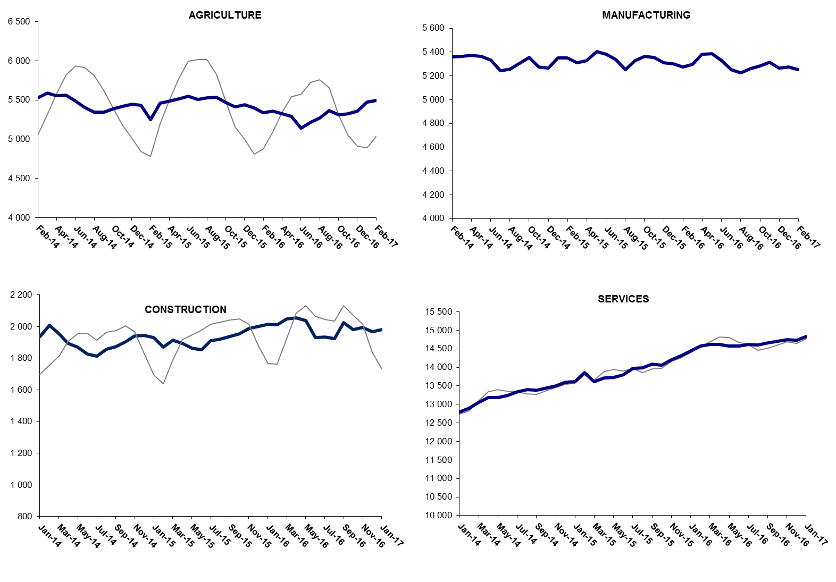
Source: Turkstat, Betam

Yearly increase of non-agricultural employment continues to be slow

From March 2016 to March 2017 the nonagricultural labor force increased by 1 million 8 thousand (4.1 percent) and the nonagricultural employment increased by 340 thousand (1.6 percent) (Figure 4). Thus, the number of non-agricultural unemployed increased by 668 thousand (21.3 percent) in the period of February 2017. The increase in non-agricultural employment declined to 340 thousand whereas the increase non-agricultural labor force remains around 1 million level. Parallel to this situation, the increase in non-agricultural unemployment reached 668 thousand within a year.

Figure 4 Year-on-year changes in non-agricultural labor force, employment, and unemployment

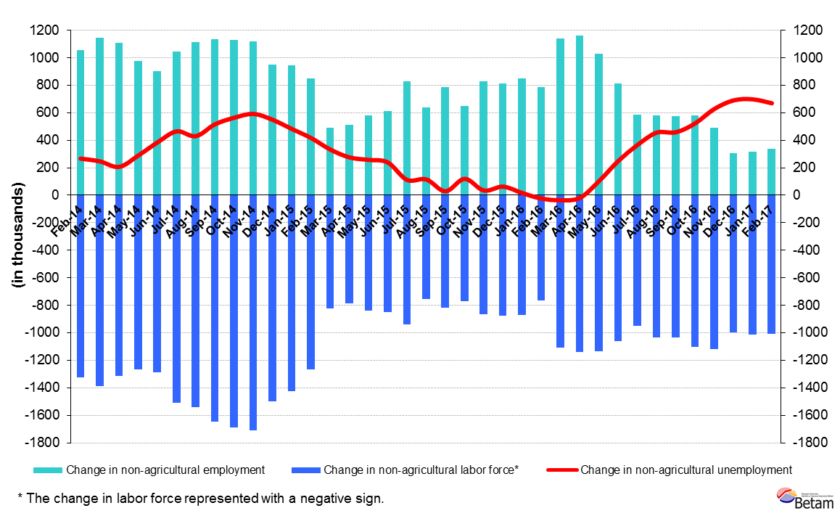
Source: Turkstat, Betam

Strong increase in female unemployment

Turkstat revised the labor market statistics drastically in February 2014. Within this framework, they back casted various labor market indicators and they also continued to announce seasonally adjusted series. However, Turkstat is not providing back-casted series by gender. Therefore, female and male labor market statistics were not sufficiently long for the seasonal adjustment procedures. Indeed, at least 36 observations are required to implement a reliable seasonal-adjustment procedure. When February 2017 data released, we have sufficient 36 observations to run the seasonal-adjustment procedure. Note that the seasonal-adjustment procedure might generate volatility in the series for some more time.

Figure 5 shows the seasonally adjusted nonagricultural female and male unemployment rates. In the period of February 2017, the male unemployment rate is 12 percent whereas that for women is 19.4 percent. The gender gap in the unemployment rates has soared since May 2016. From the period of May to the period of December the male unemployment rate increased from 10.9 percent to 12.0 percent while the female unemployment rate increased from 16.7 percent to 19.6 percent. In other words, during this period the increase in the male unemployment rate was 1.1 percentage points whereas the female unemployment rate increased by 2.9 percentage points. The difference between male and female unemployment rates had reached 8,4 percentage points (=20-11,6) in the period of December 2016. Starting from February-January 2017, the female unemployment rates have been decreased slightly while the male unemployment rates have followed a flat trend. Therefore, the difference between female and male unemployment rates declined to 7.4 percentage points (=19,4-12) in March period.

Figure 5 Seasonally adjusted female and male nonagricultural unemployment rates (%)
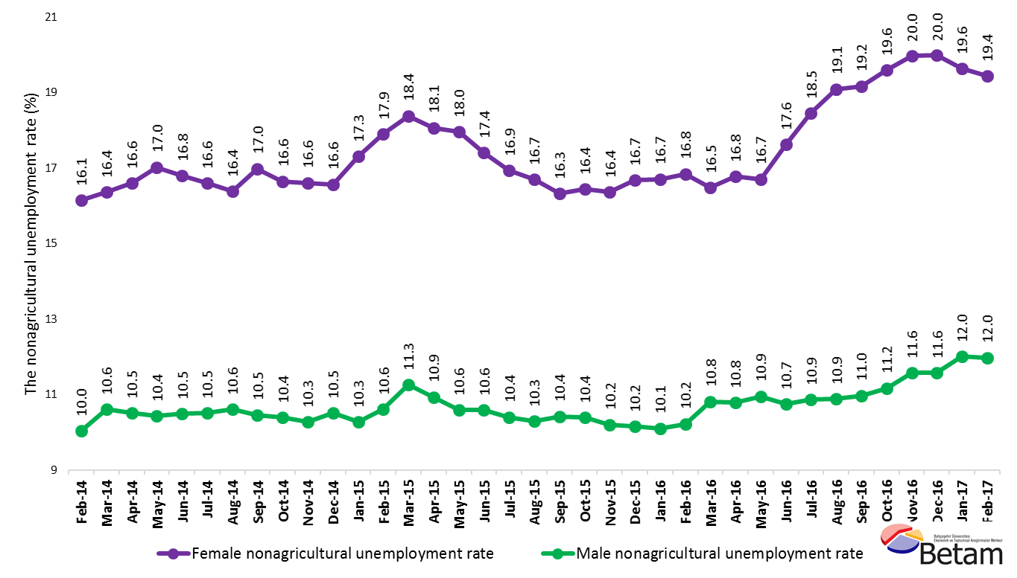

Source: Turkstat, Betam

Table 1 Seasonally adjusted non-agricultural labor market indicators (in thousands)
 | Labor force | Employment | Unemployment | Unemployment rate | Monthly changes
January-14 | 22484 | 19966 | 2518 | 11.2% | Labor force | Employment | Unemployment
February-14 | 22851 | 20269 | 2582 | 11.3% | 367 | 303 | 64
March-14 | 22998 | 20376 | 2622 | 11.4% | 147 | 107 | 40
April-14 | 23073 | 20443 | 2630 | 11.4% | 76 | 67 | 9
May-14 | 23103 | 20423 | 2680 | 11.6% | 30 | -20 | 50
June-14 | 23156 | 20400 | 2756 | 11.9% | 53 | -23 | 76
July-14 | 23282 | 20395 | 2887 | 12.4% | 126 | -5 | 131
August-14 | 23388 | 20511 | 2877 | 12.3% | 106 | 116 | -10
September-14 | 23521 | 20557 | 2964 | 12.6% | 133 | 46 | 87
October-14 | 23659 | 20702 | 2957 | 12.5% | 139 | 145 | -6
November-14 | 23689 | 20704 | 2985 | 12.6% | 29 | 2 | 27
December-14 | 23748 | 20803 | 2945 | 12.4% | 59 | 99 | -40
January-15 | 23857 | 20899 | 2958 | 12.4% | 110 | 96 | 14
February-15 | 24040 | 21083 | 2957 | 12.3% | 183 | 184 | -1
March-15 | 23789 | 20839 | 2950 | 12.4% | -251 | -244 | -7
April-15 | 23863 | 20928 | 2935 | 12.3% | 74 | 89 | -15
May-15 | 23976 | 21003 | 2973 | 12.4% | 113 | 75 | 38
June-15 | 24034 | 21030 | 3004 | 12.5% | 58 | 27 | 31
July-15 | 24193 | 21217 | 2976 | 12.3% | 158 | 187 | -29
August-15 | 24129 | 21161 | 2968 | 12.3% | -64 | -56 | -8
September-15 | 24349 | 21354 | 2995 | 12.3% | 220 | 193 | 27
October-15 | 24402 | 21376 | 3026 | 12.4% | 53 | 22 | 31
November-15 | 24540 | 21546 | 2994 | 12.2% | 138 | 170 | -32
December-15 | 24642 | 21636 | 3006 | 12.2% | 103 | 90 | 13
January-16 | 24753 | 21758 | 2995 | 12.1% | 111 | 122 | -11
February-16 | 24848 | 21866 | 2982 | 12.0% | 95 | 108 | -13
March-16 | 24892 | 21955 | 2937 | 11.8% | 45 | 89 | -44
April-16 | 24999 | 22049 | 2950 | 11.8% | 107 | 94 | 13
May-16 | 25116 | 22002 | 3114 | 12.4% | 118 | -47 | 165
June-16 | 25121 | 21830 | 3291 | 13.1% | 4 | -172 | 176
July-16 | 25143 | 21799 | 3344 | 13.3% | 22 | -31 | 53
August-16 | 25176 | 21752 | 3424 | 13.6% | 33 | -47 | 80
September-16 | 25360 | 21936 | 3424 | 13.5% | 184 | 184 | 0
October-16 | 25519 | 21972 | 3547 | 13.9% | 160 | 36 | 124
November-16 | 25638 | 22049 | 3589 | 14.0% | 119 | 77 | 42
December-16 | 25599 | 21964 | 3635 | 14.2% | -39 | -85 | 46
January-17 | 25709 | 22084 | 3625 | 14.1% | 110 | 120 | -10
February-17 | 25820 | 22205 | 3615 | 14.0% | 111 | 121 | -10
Source: Turkstat, Betam

Table 2 Seasonally adjusted employment by sectors (in thousands)
 | Agriculture | Manufacturing | Construction | Service | Monthly changes
January-14 | 5053 | 5131 | 1895 | 12805 | Agriculture | Manufacturing | Construction | Service
February-14 | 5382 | 5232 | 1937 | 12797 | 329 | 101 | 42 | -8
March-14 | 5525 | 5359 | 2009 | 12902 | 143 | 127 | 72 | 105
April-14 | 5590 | 5365 | 1954 | 13057 | 65 | 6 | -55 | 155
May-14 | 5558 | 5373 | 1893 | 13177 | -32 | 8 | -61 | 120
June-14 | 5565 | 5364 | 1869 | 13190 | 7 | -9 | -24 | 13
July-14 | 5490 | 5332 | 1826 | 13243 | -75 | -32 | -43 | 53
August-14 | 5407 | 5243 | 1814 | 13338 | -83 | -89 | -12 | 95
September-14 | 5344 | 5257 | 1857 | 13397 | -63 | 14 | 43 | 59
October-14 | 5343 | 5306 | 1874 | 13377 | -1 | 49 | 17 | -20
November-14 | 5389 | 5353 | 1905 | 13443 | 46 | 47 | 31 | 66
December-14 | 5423 | 5273 | 1939 | 13493 | 34 | -80 | 34 | 50
January-15 | 5444 | 5266 | 1943 | 13594 | 21 | -7 | 4 | 101
February-15 | 5435 | 5349 | 1932 | 13618 | -9 | 83 | -11 | 24
March-15 | 5252 | 5351 | 1871 | 13862 | -183 | 2 | -61 | 244
April-15 | 5462 | 5308 | 1915 | 13616 | 210 | -43 | 44 | -246
May-15 | 5488 | 5326 | 1895 | 13707 | 26 | 18 | -20 | 91
June-15 | 5517 | 5404 | 1864 | 13735 | 29 | 78 | -31 | 28
July-15 | 5551 | 5380 | 1853 | 13796 | 34 | -24 | -11 | 61
August-15 | 5507 | 5336 | 1909 | 13972 | -44 | -44 | 56 | 176
September-15 | 5531 | 5252 | 1919 | 13989 | 24 | -84 | 10 | 17
October-15 | 5534 | 5327 | 1937 | 14091 | 3 | 75 | 18 | 102
November-15 | 5467 | 5363 | 1955 | 14057 | -67 | 36 | 18 | -34
December-15 | 5411 | 5353 | 1987 | 14206 | -56 | -10 | 32 | 149
January-16 | 5441 | 5311 | 2002 | 14323 | 30 | -42 | 15 | 117
February-16 | 5398 | 5300 | 2013 | 14445 | -43 | -11 | 11 | 122
March-16 | 5341 | 5276 | 2010 | 14580 | -57 | -24 | -3 | 135
April-16 | 5357 | 5295 | 2048 | 14612 | 16 | 19 | 38 | 32
May-16 | 5328 | 5381 | 2053 | 14615 | -29 | 86 | 5 | 3
June-16 | 5289 | 5386 | 2037 | 14579 | -39 | 5 | -16 | -36
July-16 | 5139 | 5330 | 1932 | 14568 | -150 | -56 | -105 | -11
August-16 | 5216 | 5254 | 1934 | 14611 | 77 | -76 | 2 | 43
September-16 | 5268 | 5224 | 1925 | 14604 | 52 | -30 | -9 | -7
October-16 | 5364 | 5260 | 2023 | 14653 | 96 | 36 | 98 | 49
November-16 | 5309 | 5282 | 1982 | 14707 | -55 | 22 | -41 | 54
December-16 | 5322 | 5316 | 1993 | 14740 | 13 | 34 | 11 | 33
January-17 | 5359 | 5265 | 1967 | 14732 | 37 | -51 | -26 | -8
February-17 | 5472 | 5274 | 1982 | 14828 | 113 | 9 | 15 | 96
Source: Turkstat, Betam

 | Kadın İşgücü | Kadın İstihdam | Kadın İşsiz | Erkek İşgücü | Erkek İstihdam | Erkek İşsiz
Şubat 14 | 5913 | 4959 | 942 | 16800 | 15114 | 1686
Mart 14 | 6051 | 5062 | 963 | 16942 | 15145 | 1731
Mayıs 14 | 6115 | 5100 | 988 | 16978 | 15193 | 1753
Şubat 14 | 6124 | 5082 | 1009 | 17021 | 15246 | 1739
Mart 14 | 6153 | 5120 | 1021 | 17082 | 15290 | 1734
Mayıs 14 | 6200 | 5171 | 1032 | 17109 | 15312 | 1802
Şubat 14 | 6299 | 5267 | 1047 | 17186 | 15363 | 1795
Mart 14 | 6336 | 5260 | 1080 | 17188 | 15390 | 1823
Mayıs 14 | 6384 | 5321 | 1081 | 17227 | 15438 | 1795
Şubat 14 | 6398 | 5335 | 1090 | 17230 | 15459 | 1844
Mart 14 | 6418 | 5354 | 1093 | 17322 | 15502 | 1844
Mayıs 14 | 6504 | 5378 | 1128 | 17310 | 15532 | 1844
Şubat 14 | 6555 | 5382 | 1151 | 17416 | 15570 | 1861
Mart 14 | 6533 | 5333 | 1176 | 17262 | 15319 | 1835
Mayıs 14 | 6539 | 5358 | 1160 | 17315 | 15423 | 1849
Şubat 14 | 6630 | 5439 | 1172 | 17343 | 15508 | 1831
Mart 14 | 6656 | 5498 | 1148 | 17441 | 15593 | 1844
Mayıs 14 | 6742 | 5600 | 1138 | 17492 | 15673 | 1798
Şubat 14 | 6713 | 5592 | 1124 | 17513 | 15709 | 1815
Mart 14 | 6758 | 5655 | 1112 | 17587 | 15755 | 1842
Mayıs 14 | 6777 | 5662 | 1124 | 17609 | 15779 | 1865
Şubat 14 | 6872 | 5747 | 1133 | 17619 | 15821 | 1824
Mart 14 | 6972 | 5809 | 1167 | 17648 | 15857 | 1813
Mayıs 14 | 7016 | 5844 | 1176 | 17666 | 15882 | 1811
Şubat 14 | 7043 | 5857 | 1190 | 17708 | 15898 | 1839
Mart 14 | 7070 | 5905 | 1187 | 17841 | 15912 | 1850
Mayıs 14 | 7141 | 5943 | 1220 | 17872 | 15944 | 1849
Şubat 14 | 7180 | 5980 | 1230 | 17923 | 15960 | 1918
Mart 14 | 7260 | 5981 | 1285 | 17884 | 15963 | 1949
Mayıs 14 | 7262 | 5922 | 1327 | 17925 | 15977 | 1968
Şubat 14 | 7326 | 5927 | 1371 | 17945 | 15993 | 2001
Mart 14 | 7375 | 5961 | 1394 | 17987 | 16014 | 1992
Mayıs 14 | 7437 | 5980 | 1426 | 18043 | 16028 | 2044
Şubat 14 | 7456 | 5967 | 1453 | 18145 | 16044 | 2086
Mart 14 | 7461 | 5969 | 1463 | 18140 | 16041 | 2149
Mayıs 14 | 7455 | 5992 | 1464 | 18248 | 16056 | 2205
Şubat 14 | 7508 | 6050 | 1474 | 18249 | 16063 | 2222

*Prof. Dr. Seyfettin Gürsel, Betam, Director, seyfettin.gursel@eas.bau.edu.tr
∗∗Asst. Prof. Gökçe Uysal, Betam, Deputy Director, gokce.uysal@eas.bau.edu.tr
∗∗∗ Mine Durmaz, Betam, Research Assistant, mine.durmaz@eas.bau.edu.tr
For detailed information on Betam's forecasting model, please see Betam Research Brief 168 titled as "Kariyer.net Verisiyle Kısa Vadeli Tarım Dışı İşsizlik Tahmini" http://betam.bahcesehir.edu.tr/tr/2014/06/kariyer-net-verisiyle-kisa-vadeli-tarim-disi-issizlik-tahmini/
Betam has been calculating application per vacancy using series released by Kariyer.net for a while. Seasonal and calendar adjustment procedure is applied to application per vacancy series. A decrease in applications per vacancy may be caused by an increase in vacancies or by a decrease in the number of applications. An increase in vacancies signals economic growth while decreasing number of applications indicates a decrease in number of people looking for a job. Monthly labor market series released by TurkStat is the average of three months. Therefore, application per vacancy statistics calculated using Kariyer.net series is the average of three months as well.
Employment in each sector is seasonally adjusted separately. Hence the sum of these series may differ from the seasonally adjusted series of total employment. The difference stems from the non-linearity of the seasonal adjustment process.

