Research Brief 17/211

30 May 2017

THE WORSTS AND THE BESTS IN REGIONAL UNEMPLOYMENT
Seyfettin Gürsel* ve Selin Köksal**
Executive Summary
There has been substantial increases unemployment rates in Turkey from 2015 to 2016. Overall unemployment and non-agricultural unemployment rates increased from 10.3 percent to 10.9 and from 12.4 percent to 13 respectively. However, different regions were affected by the rising unemployment asymmetrically. Out of 26 regions, 17 registered increases in unemployment, while 9 had some decreases. Finally, the big differences already existing among regions have become even more pronounced. It is worth noting the significance of the gap between the region with the lowest (7.2 percent) and the highest (30.1 percent) non-agricultural unemployment rates.
For non-agricultural unemployment, Mardin-Batman-Şırnak-Siirt region in Southeast Anatolia has the highest rate. Furthermore, it holds the third rank on the magnitude in the increase of unemployment. The second worst region, Şanlıurfa-Diyarbakır follows Mardin-Batman-Şırnak-Siirt, with a high unemployment rate (23.2 percent) and also a very low employment ratio (27.9 percent). We observe a moderate increase in unemployment rate in this region.
The best region is Tekirdag-Edirne-Kırklareli (Thrace), with a low unemployment rate (8.8 percent), also the highest employment rate in Turkey (48.9 percent). The only negative development in this region is a marginal increase in the unemployment rate (0.1 percentage points). Nevertheless, this is the result of a faster increase in labor force than in employment
Methodogical difficulties in the regional comparison of unemployment
The data from the Labor Force Surveys (LFS) published by Turkstat (TÜİK) in March confirmed once again the big differences among regional labor markets, reflecting the existing regional inequalities in Turkey. The data also points that the increase in overall unemployment in 2016 had different effects in 26 regions (NUTS2). In this research, we investigate these differences, taking into consideration the level and the changes in unemployment along with some basic characteristics of regional labor markets
For an interregional comparison focused on unemployment, a set of methodological challenges are inevitable. The first question: which unemployment rate to take into account? Turkstat releases two measures: overall and non-agricultural unemployment rates. Which one should be used for an analysis of regional comparisons of unemployment? We definitely consider the non-agricultural unemployment more relevant. The main argument behind this choice is the fact that the share of agricultural employment in total employment shows very large differences from one region to another. The immediate consequence of this fact is the large gap between general and non-agricultural unemployment rates, depending on the relative size of agricultural employment to non-agricultural employment. (See the Box: Impact of agricultural employment on regional unemployment).
However, it is not enough to understand the severity of regional unemployment only through a ranking of regions on the basis of non-agricultural unemployment rates (thereafter “unemployment rate”) . The share of non-agricultural employment in the non-agricultural working age population (thereafter “employment ratio”) is as important as the level of unemployment. The high level of this share indicates implicitly a higher level of per capita income since the average labor productivity in non-agricultural sector is much higher than the labor productivity in agriculture. Also, as this share includes, again implicitly, the level of activity, in particular the female activity, a positive correlation exists with per capita income. In short, one could not conclude that in a region where unemployment rate is relatively low, things are going well in its labor market.
Another methodological difficulty in interregional comparisons is the evaluation of the changes in unemployment. We observe that, as expected, unemployment increased in the majority of regions (precisely 17) but decreased in the non-negligible number of regions (precisely 9). Furthermore, the increases and decreases in unemployment rate varies in size and by source across regions.
In this respect, a simple comparison according to the increase and decrease in unemployment will not be sufficient. Changes in unemployment rates reflect various regional labor market dynamics, i.e. differences in changes in the labor force and employment. Unemployment may increase due to a decline in employment or a faster increase in labor force compared to employment. In the first case, the severity of the increase in unemployment evident. In the second case, increasing employment mitigates the severity of the increase in unemployment. On the other hand, unemployment may decrease along with a stronger decline in labor force. It is doubtful that the decrease in unemployment in this case can be considered as a positive development. Let us note that there are examples which reflect this exceptional case. To summarize, the main labor market dynamics has to be taken into consideration when comparing changes in unemployment rates.
Worst regions in terms of unemployment
Figure 1 shows 26 regions in descending order for the 2016 unemployment data. While the unemployment rate is 13 percent at the country level, there are large differences across regions; the highest rate being at 30.1 percent and the lowest at 7.2 percent.
Considering only unemployment rates, the worst case is Mardin-Batman-Şırnak-Siirt (TRC3) region with 30.1 percent. In order to underline the exceptional magnitude of this rate, let us remind that during the Great Depression (1930-34) as well during the Great Recession the highest unemployment rates have been observed around 25 percent. The second place belongs to Şanlıurfa-Diyarbakır (TRC2) region with 28.3 percent.

Figure 1: Regional non-agricultural unemployment rates (%, 2016)
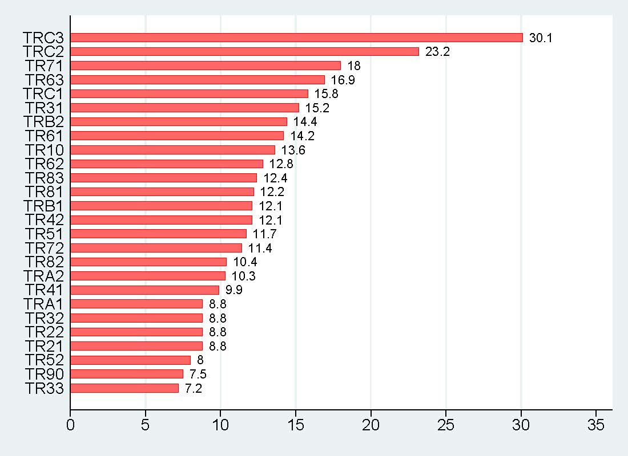
Source: Turkstat, Betam. TRC3:Mardin, Batman, Şırnak, Siirt, TRC2:Şanlıurfa, Diyarbakır, TR71: Kırıkkale, Aksaray, Niğde, Nevşehir, Kırşehir, TR63:Hatay, Kahramanmaraş, Osmaniye, TRC1:Gaziantep, Adıyaman, Kilis, TR31: İzmir, TRB2:Van, Muş, Bitlis, Hakkari, TR61: Antalya, Isparta, Burdur, TR10: İstanbul, TR62: Adana, Mersin, TR83:Samsun, Tokat, Çorum, Amasya, TR81:Zonguldak, Karabük, Bartın, TR42: Kocaeli, Sakarya, Düzce, Bolu, Yalova, TRB1:Malatya, Elazığ, Bingöl, Tunceli, TR51:Ankara, TR72: Kayseri, Sivas, Yozgat, TR82:Kastamonu, Çankırı, Sinop, TRA2:Ağrı, Kars, Iğdır, Ardahan, TR41: Bursa, Eskişehir, Bilecik, TR21: Tekirdağ, Edirne, Kırklareli, TR22: Balıkesir, Çanakkale, TR32: Aydın, Denizli, Muğla, TRA1:Erzurum, Erzincan, Bayburt, TR52: Konya, Karaman, TR90:Trabzon, Ordu, Giresun, Rize, Artvin, Gümüşhane, TR33: Manisa, Afyonkarahisar, Kütahya, Uşak
These two regions are followed by Kırıkkale-Aksaray-Niğde-Nevşehir-Kırşehir (TR 71) with an unemployment rate of 18 percent, Hatay-Kahramanmaraş-Osmaniye (TR 63) with 16.9 percent, Gaziantep-Adıyaman-Kilis (TRC 1) with 15.8 percent and by İzmir (TR 31) with 15.2 percent. It is worth mentioning that the ranking according to overall unemployment rates is not similar to the ranking with non-agricultural unemployment rates. For example, TR71 (Cappadocia) is ranked 6th place with a overall unemployment rate of 13.4 percent while it ranked in 3th place with 18 percent of non-agricultural unemployment.
The two regions which have the lowest unemployment are Manisa-Afyonkarahisar-Kütahya-Uşak (TR 33) (7.2 percent) and Trabzon-Ordu-Giresun-Rize-Artvin-Gümüşhane (TR 90) (7.5 percent) regions. These two regions are followed by Konya-Karaman (TR 52) with 8 percent and Tekirdağ-Kırklareli-Edirne (TR 21), Balıkesir-Çanakkale (TR 22), Aydın-Denizli-Muğla (TR 32), Erzurum-Erzincan-Bayburt (TRA 1) regions with an unemployment rate of 8.8 percent.
As we underlined in the methodology part, even a comparison limited to non-agricultural unemployment might not be sufficient for evaluating the labor market performances of the regions. We obtain a different picture when unemployment rates are considered together with employment ratios (non-agricultural employment/working age population - agricultural employment; See annex table). Taking them both into consideration, we can rank 26 regions as shown in the Figure 2. Interregional comparison becomes easier and more comprehensible when the figure is divided into four sub-spaces by the average unemployment rate of 13 percent and the average employment ratio of 38 percent. The worst regions are placed on the upper left part. The unemployment rates of these regions are above of the national level while their employment ratios are below the corresponding national level. On the other hand, the best regions are placed on the lower right part of the figure.
Figure 2: Regional distribution of non-agricultural unemployment and non-agricultural employment rates (%, 2016)
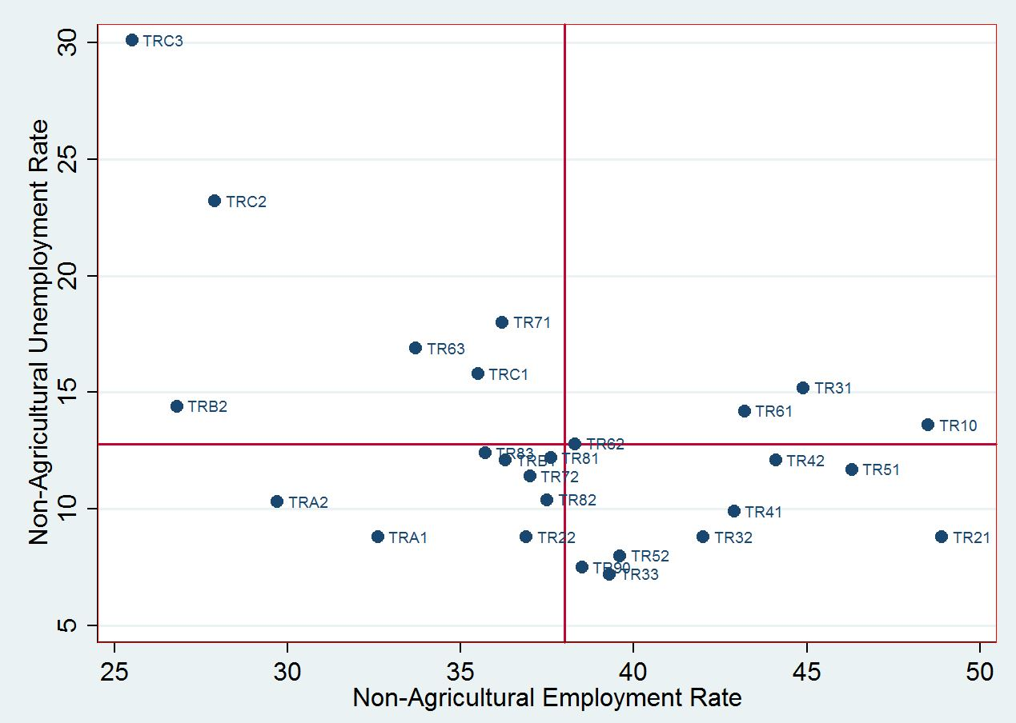
Source: Turkstat, Betam. TRC3:Mardin, Batman, Şırnak, Siirt, TRC2:Şanlıurfa, Diyarbakır, TR71: Kırıkkale, Aksaray, Niğde, Nevşehir, Kırşehir, TR63:Hatay, Kahramanmaraş, Osmaniye, TRC1:Gaziantep, Adıyaman, Kilis, TR31: İzmir, TRB2:Van, Muş, Bitlis, Hakkari, TR61: Antalya, Isparta, Burdur, TR10: İstanbul, TR62: Adana, Mersin, TR83:Samsun, Tokat, Çorum, Amasya, TR81:Zonguldak, Karabük, Bartın, TR42: Kocaeli, Sakarya, Düzce, Bolu, Yalova, TRB1:Malatya, Elazığ, Bingöl, Tunceli, TR51:Ankara, TR72: Kayseri, Sivas, Yozgat, TR82:Kastamonu, Çankırı, Sinop, TRA2:Ağrı, Kars, Iğdır, Ardahan, TR41: Bursa, Eskişehir, Bilecik, TR21: Tekirdağ, Edirne, Kırklareli, TR22: Balıkesir, Çanakkale, TR32: Aydın, Denizli, Muğla, TRA1:Erzurum, Erzincan, Bayburt, TR52: Konya, Karaman, TR90:Trabzon, Ordu, Giresun, Rize, Artvin, Gümüşhane, TR33: Manisa, Afyonkarahisar, Kütahya, Uşak
Note: This figure is suggested by Assoc. Prof. Insan Tunalı. We would like to thank him for his contribution
It is obvious that Mardin region (TRC3) represents the worst case by far. In so much that, the unemployment rate in the region (30.1 percent) is higher than employment ratio (25.5 percent). Indeed, this region is placed on the upper left corner among the worst cases. Şanlıurfa-Diyarbakır region (TRC2) is not very different from Mardin region as expected. Van region is the next (TRB2). Although the unemployment rate (14.4 percent) is not as high as the two previous regions, Van region hold the second lowest employment ratio (26.8). So, when we also considered the employment rates in our comparison, it appears that the three most desperate regions are from the Southeast of Turkey. This outcome is not surprising.
There are also three other regions (Cappadocia (TR71), Hatay (TR63) and Gaziantep (TRC1)) which are situated among the worst cases but they are rather closer to the lower right corner. In these regions, unemployment rates are quite high (from 18 to 15.8 percent) whereas employment ratios are closer to the country average.
Best cases in regional unemployment
When we look at the best cases (the lower right corner), Thrace (TR21) emerges clearly as the best region. Having a quite low unemployment rate (8.8 percent), Thrace has the highest employment ratio (48.9 percent) of Turkey. High employment ratio indicates not only a high level of industrialization but in the same time a high level of female participation rate.
Among seven other best regions, four of them deserve attention. Ankara (TR51) and Kocaeli (TR42), two of the best four regions, have relatively high unemployment rates though they are below the country average. These regions also have very high employment ratios. The other two best cases are Bursa (TR41) and Aydın (TR32) holding slightly lower unemployment rates than Ankara and Kocaeli. However, these two regions also have lower employment ratios. Nevertheless, if we pay more attention to unemployment level, Bursa and Aydın regions can be ranked as second and third best cases. Let us note that these regions are in Western Turkey.
Regions where unemployment increased
In the first part, we compared the regions according to the unemployment rates and employment ratios for 2016. Now we would like to compare them according to changes in unemployment and labor markets dynamics behind those changes. At the national level, unemployment rate increased from 12.4 percent to 13 annually from 2015 to 2016. However, this increase has not affected 26 region in the same way. Indeed, unemployment rate increased in 17 regions whereas it decreased in 9 of them. Furthermore, there are great differences in terms of the size and the causes of unemployment change across regions.
The regions where unemployment increased are presented in descending order in the Figure 3. The two regions that suffered from very high unemployment increases are Gaziantep (TRC1) and Cappadocia (TR71). Unemployment rates increased by 4.4 and 4.3 percentage points and reached 18 and 15.8 percent, respectively. The cause of this jump in Gaziantep region is the insufficient increase in employment against a strong labor force increase (Table 1). The employment increase in Gaziantep region is limited to 0.7 percent whereas labor force increased by 1.2 percent. As for Cappadocia, the employment decreased in absolute terms. Since the jump in unemployment stemmed from this absolute decrease in employment, one may consider Cappadocia as the worst case in terms of labor market dynamics. The impact of the crisis in tourism sector is obvious; as a matter of fact, employment by industry increased by 5 thousand, while employment in services decreased by 10 thousand.

Figure 3: Regions where non-agricultural unemployment increased (in pp, 2015-2016)
Source: Turkstat, Betam TRC1:Gaziantep, Adıyaman, Kilis, TR71: Kırıkkale, Aksaray, Niğde, Nevşehir, Kırşehir, TR83:Samsun, Tokat, Çorum, Amasya, Rize, Artvin, Gümüşhane, TRC3:Mardin, Batman, Şırnak, Siirt , TR61: Antalya, Isparta, Burdur, TR81:Zonguldak, Karabük, Bartın, TR22: Balıkesir, Çanakkale, TR41: Bursa, Eskişehir, Bilecik, TRB1:Malatya, Elazığ, Bingöl, Tunceli, TRA2:Ağrı, Kars, Iğdır, Ardahan, TR62: Adana, Mersin, TR33: Manisa, Afyonkarahisar, Kütahya, Uşak, TR10: İstanbul, TRC2:Şanlıurfa, Diyarbakır, TR51:Ankara, TR21: Tekirdağ, Edirne, Kırklareli, TR42: Kocaeli, Sakarya, Düzce, Bolu, Yalova
Note:$u_{na}$: Non-agricultural unemployment rate
We should note that in Mardin (TRC3) region, which has the highest unemployment rate with 30.1 percent, the increase in unemployment rate (2.1 pp) has been quite sizable. The reason behind this is the strong increase in labor force (50 thousand) which could not be balanced by the increase in employment (26 thousand). We had already noted that Mardin region was the worst case in terms of both unemployment and employment levels. Adding the sizable increase in unemployment, this region can be qualified as the worst case by all labor market indicators. On the other hand, it is worth mentioning that Şanlıurfa-Diyarbakır region classified as the second worst case in terms of both unemployment and employment levels; yet this region suffered only a relatively modest increase in unemployment (0.4 percentage points) as a result of a quite strong employment increase (46 thousand) and a stronger increase of labor force (63 thousand) (Fig.2, Table 1).
We would like to draw attention to the originality of Adana-Mersin (TR62) region in the South of Turkey. Unemployment increased in this region by 0.9 percentage points, which can be considered as relatively modest compared to other cases. However, the sources of this this increase pose serious problems. Indeed, this region holds the highest decline in employment (23 thousand). Exceptionally, labor force decreased by 14 thousand and limited the increase of unemployment rate. Hence, from a wider perspective we may qualify this region as one of the worst cases in terms of labor market dynamics.

Table 1: Change in non-agricultural labor force and employment in regions the where non-agricultural unemployment is increased (thousands, 2015-2016)
Regions | Δ LFna | Δ Ena | Δ una
TRC1 (Gaziantep, Adıyaman, Kilis) | 79 | 38 | 4,4
TR71 (Kırıkkale, Aksaray, Niğde, Nevşehir, Kırşehir ) | 15 | -5 | 4,3
TR83 (Samsun, Tokat, Çorum, Amasya) | 13 | -3 | 2,2
TRC3 (Mardin, Batman, Şırnak, Siirt) | 50 | 26 | 2,1
TR61 (Antalya, Isparta, Burdur) | 51 | 24 | 2,1
TR81 (Zonguldak, Karabük, Bartın) | 11 | 5 | 1,7
TR22 (Balıkesir, Çanakkale) | 16 | 7 | 1,6
TR41 (Bursa, Eskişehir, Bilecik) | 66 | 41 | 1,4
TRB1 (Malatya, Elazığ, Bingöl, Tunceli) | 12 | 5 | 1,2
TRA2 (Ağrı, Kars, Iğdır, Ardahan) | 13 | 10 | 1,1
TR62 (Adana, Mersin) | -14 | -23 | 0,9
TR33 (Manisa, Afyonkarahisar, Kütahya, Uşak) | 48 | 38 | 0,8
TR10 (İstanbul) | 318 | 238 | 0,6
TRC2 (Şanlıurfa, Diyarbakır) | 63 | 46 | 0,4
TR51 (Ankara) | 87 | 73 | 0,2
TR21 (Tekirdağ, Edirne, Kırklareli) | 31 | 28 | 0,1
TR42 (Kocaeli, Sakarya, Düzce, Bolu, Yalova) | 23 | 19 | 0,1
Source: TUIK, Betam.
Note: Δ Lfna: Change in non-agricultural labor force, Δ Ena: Change in non-agricultural employment, Δ una: Change in non-agricultural unemployment
Regions where unemployment decreased
Figure 3 shows the regions where unemployment rate has decreased. The strongest decline (2.6 pp) happened in Erzurum (TRA1) region in the east of Anatolia. This is the result of a higher increase in employment compared to the labor force (Table 2). In this sense, it is a positive development, all the more since unemployment rate was already below country average in 2015 (11.4 against 12.4 percent). Nevertheless, the only negative characteristic of this region is the low employment ratio (32.6 percent) (see Annex Table).
Kayseri (TR72) region in Central Anatolia follows Erzurum with 2-percentage point decrease in unemployment rate. Similar to Erzurum region, a higher increase in employment than the labor force is the main reason behind this decline (Table 2). Thanks to this development, Kayseri’s unemployment rate shifted below the national rate from 13.4 percent (2015) down to 11.4 percent (2016). Let us note that the employment ratio (37 percent) in Kayseri region is very close to country average (38 percent).
Regarding the positive labor market dynamics, there are other four regions where declines in unemployment rates stemmed from a stronger increase in employment than labor force. These regions are Kastamonu (TR82) (-1.2 pp), Hatay (TR63) (-1.1 pp), İzmir (-0.9 pp) and Trabzon (TR90) (-0.6 pp). Despite this, we should underline that Hatay and İzmir regions still have high unemployment rates (16.9 and 15.2). On the other hand, the performance of Trabzon region is remarkable since the unemployment rate declined to 7.5 percent, the second lowest unemployment rate, and the employment ratio (38.5 percent) is slightly above the national average. Therefore, Trabzon region belongs to the best case group (see Figure 2). In Kastamonu region, unemployment remains relatively high (10.4 percent) while the employment ratio (37.5 percent) is just below national average.
Figure 4: Regions where non-agricultural unemployment decreased (in pp, 2015-2016)
Source: TUIK, Betam TRA1:Erzurum, Erzincan, Bayburt TR72: Kayseri, Sivas, Yozgat, TRB2:Van, Muş, Bitlis, Hakkari, TR82:Kastamonu, Çankırı, Sinop, TR63:Hatay, Kahramanmaraş, Osmaniye, TR31: İzmir, TR90:Trabzon, Ordu, Giresun, TR52: Konya, Karaman, TR32: Aydın, Denizli, Muğla.
Note:$u_{na}$: Non-agricultural unemployment rate
Table 2: Change in non-agricultural labor force and employment in the regions where non-agricultural unemployment is decreased (thousand, 2015-2016)
Regions | Δ LFna | Δ Ena | Δ una
TRA1 (Erzurum, Erzincan, Bayburt) | 15 | 19 | -2,6
TR72 (Kayseri, Sivas, Yozgat) | 12 | 23 | -2,0
TRB2 (Van, Muş, Bitlis, Hakkari) | -5 | 1 | -1,8
TR82 (Kastamonu, Çankırı, Sinop) | 7 | 8 | -1,2
TR63 (Hatay, Kahramanmaraş, Osmaniye) | 72 | 68 | -1,1
TR31 (İzmir) | 60 | 65 | -0,9
TR90 (Trabzon, Ordu, Giresun, Rize, Artvin, Gümüşhane) | 27 | 29 | -0,6
TR52 (Konya, Karaman) | -16 | -11 | -0,5
TR32 (Aydın, Denizli, Muğla) | -13 | -10 | -0,2
Source: TUIK, Betam
Note: Δ Lfna: Change in non-agricultural labor force, Δ Ena: Change in non-agricultural employment, Δ una: Change in non-agricultural unemployment
The remaining three regions do not represent positive dynamics like the previous six regions. Although unemployment rate significantly decreased (-1.8 percentage points) in Van (TRB2) region, it is mainly due to the sizable decrease in the labor force (Table 2). As for Konya (TR52) and Aydın (TR32) regions, unemployment decreased because of the decline in labor force being stronger than the decline in employment (Table 2). It is worth noting that in Aydın region (southwest) nearly all employment losses (9 thousand) took place in the service sector. Similar to the case of Cappadocia, this shock is caused by the crisis in tourism sector.
Concluding remarks
While unemployment rate in Turkey increased from 12.4 to 13 percent in a year, regional labor markets behaved quite differently. The unemployment rate increased in 17 regions while it decreased in 9 regions. As result, the existing regional inequalities in unemployment have become even deeper. The regional standard deviation, 3.3 in 2015, increased to 3.6 in 2016. There is actually a profound gap between the lowest (7.2 percent) and the highest unemployment rates (30.1 percent) as if we are looking at different countries where labor markets present different characteristics. This striking divergence could not be explained only by insufficient labor mobility among regions. Factors like highly unequal development levels, large differences in female labor force participation and asymmetric effects of economic shocks produce particular labor market structures and dynamics for different regions.
Since there are no synthetic indicators combining unemployment rate, employment ratios, changes in unemployment and the sources of these changes, it is not possible to rank the regions systematically. Nevertheless, as we tried in this research brief, it seems that by using the main labor market indicators we can at least determine the regions in the worst and the best positions.
No doubt, Mardin-Batman-Şırnak-Siirt region is in the worst position. This region has not only the highest non-agricultural unemployment rate with 30.1 percent but also the lowest non-agricultural employment ratio with 25.5 percent. Moreover, the unemployment rate increased by 2.1 percentage points from 2015 to 2016. Mardin region is followed by Şanlıurfa-Diyarbakır region since it has a very high unemployment rate with 23.2 percent and very low employment ratio with 27.9 percent. Also, the unemployment rate is this region increased by 0.9 pp.
On the other hand, Thrace region appears as the best case since this region has a low unemployment rate with 8.8 percent and the highest employment ratio with 48.9 percent. Its unique negative side is the increase in unemployment by 0.1 pp. However, we would like to remind that this marginal increase occurred in a context characterized by strong labor force and employment increases.

Annex Table: Regional non-agricultural unemployment rates and non-agricultural employment ratios (%, 2016)
Regions | Non-agricultural unemployment rate | $${E_{na}}/{(WAP- E_{a})}$$
TR21 (Tekirdağ, Edirne, Kırklareli) | 8.8 | 48.9
TR10 (İstanbul) | 13.6 | 48.5
TR51 (Ankara) | 11.7 | 46.3
TR32 (Aydın, Denizli, Muğla) | 8.8 | 42.0
TR41 (Bursa, Eskişehir, Bilecik) | 9.9 | 42.9
TR33 (Manisa, Afyonkarahisar, Kütahya, Uşak) | 7.2 | 39.3
TR42 (Kocaeli, Sakarya, Düzce, Bolu, Yalova) | 12.1 | 44.1
TR52 (Konya, Karaman) | 8.0 | 39.6
TR90 (Trabzon, Ordu, Giresun, Rize, Artvin, Gümüşhane) | 7.5 | 38.5
TR31 (İzmir) | 15.2 | 44.9
TR61 (Antalya, Isparta, Burdur) | 14.2 | 43.2
TR22 (Balıkesir, Çanakkale) | 8.8 | 36.9
TR82 (Kastamonu, Çankırı, Sinop) | 10.4 | 37.5
TR72 (Kayseri, Sivas, Yozgat) | 11.4 | 37.0
TR62 (Adana, Mersin) | 12.8 | 38.3
TR81 (Zonguldak, Karabük, Bartın) | 12.2 | 37.6
TRB1 (Malatya, Elazığ, Bingöl, Tunceli) | 12.1 | 36.3
TRA1 (Erzurum, Erzincan, Bayburt) | 8.8 | 32.6
TR83 (Samsun, Tokat, Çorum, Amasya) | 12.4 | 35.7
TRC1 (Gaziantep, Adıyaman, Kilis) | 15.8 | 35.5
TRA2 (Ağrı, Kars, Iğdır, Ardahan) | 10.3 | 29.7
TR71 (Kırıkkale, Aksaray, Niğde, Nevşehir, Kırşehir ) | 18.0 | 36.2
TR63 (Hatay, Kahramanmaraş, Osmaniye) | 16.9 | 33.7
TRB2 (Van, Muş, Bitlis, Hakkari) | 14.4 | 26.8
TRC2 (Şanlıurfa, Diyarbakır) | 23.2 | 27.9
TRC3 (Mardin, Batman, Şırnak, Siirt) | 30.1 | 25.5
Source: Turkstat, Betam
Note: $E_{a }:$ Agricultural employment, $E_{na}:$ Non-agricultural employment, WAP: Working age population

Annex Figure : Relationship between $\frac{u_{na}}{u}$ and $1+\frac{E_{a}}{{LF}_{na}}$ (2016)
BOX: The impact of agricultural employment on regional unemployment rates
Turkish Statistical Institute releases overall and non-agricultural unemployment rates separately for the 26 regions (NUTS 2). To conduct a regional comparison, which of these rates should we preferred? This is a legitimate question since not only there exist large gaps between two rates for numerous regions but also the regional ranking according to these rates are different. For example, Ağrı-Kars-Iğdır-Ardahan (TRA2) region holding general unemployment rate of 4.9 percent is ranked second from bottom but it is ranked 7th with a non-agricultural unemployment rate of 10.3 percent.
The principal source of the gap between overall and non-agricultural rates is the large differences in the share of agricultural employment in total employment across regions. The Turkish agriculture sector is mainly dominated by family producers. The unemployment rate in agriculture is very low because individual members of farming families participate more or less in economic activities. Indeed, we measure the number of unemployed in non-agricultural sector as 3 million 274 thousand for 2016 by using the non-agricultural unemployment rate (13 percent) and the non-agricultural employment (21 million 900 thousand). Since the number of total unemployed is 3 million 300 thousand in 2016, the number of unemployed in agriculture can be estimated at 56 thousand level.
Assuming that unemployment in agriculture does not exist, the link between overall unemployment rate and non-agricultural rate can be formulated as below:
$${U \sim U}_{na} → \frac{u_{na}}{u}= \frac{U_{na}}{{LF}_{na}} × \frac{LF}{U} \sim \frac{{LF}_{na }+ {LF}_{t}}{{LF}_{na}} =1+ \frac{{LF}_{a}}{{LF}_{na}}$$
$U$: Total number of unemployed; $U_{an}:$ Number of non-agricultural unemployed, $u$: Unemployment rate
$u_{na}$: Non-agricultural unemployment rate $LF$: Total labor force; ${LF}_{na }$: Non-agricultural labor force; ${LF}_{a}$: Agricultural labor force
${U \sim U}_{na} → {LF}_{a} \sim E_{a }; E_{a} =$ agricultural employment
$$\frac{u_{na}}{u} =1+ \frac{E_{a}}{{LF}_{na}}$$
$\frac{u_{na}}{u}$ ratio represents the relative difference between the overall and the non-agricultural unemployment rates, $\frac{E_{a}}{{LF}_{na}}$ ratio represents the relative weight of agricultural employment.
The figure below shows the link between the relative differences among the overall and the non-agricultural unemployment rates ( $\frac{u_{na}}{u})$ and the relative weight of agricultural employment ( $\frac{E_{a}}{{LF}_{na}}$ ) for 26 regions using Turkstat data.

$\frac{u_{na}}{u}$

$$1+\frac{E_{a}}{{LF}_{na}}$$

Source: Turkstat, Betam

*Prof.Dr. Seyfettin Gürsel, Betam, Director, seyfettin.gursel@eas.bau.edu.tr
**Selin Köksal, Betam, Research Assistant, selin.koksal@eas.bau.edu.tr

