Labor Market Outlook:
April 2017

15 April 2017

A BREAK IN THE INCREASE IN UNEMPLOYMENT
Seyfettin Gürsel* Gökçe Uysal∗∗ and Mine Durmaz ∗∗∗

Executive Summary

Seasonally adjusted labor market data show that nonagricultural unemployment rate decreased by 0.1 points and is recorded as 14.1 percent in the period of January 2017. While the nonagricultural labor force, which had decreased in the previous period, increased by 109 thousand in the period of January 2017, the increase in the nonagricultural employment reached 119 thousand and thus, the number of unemployed people decreased by 10 thousand. The most important reason behind this decrease is a significant increase of 90 thousand in the services sector employment in the period of January 2017 although the services sector employment had decreased in the previous period. Employment increases in industry and construction were limited. Betam’s forecasting model predicts that the non-agricultural unemployment will decline to 14.0 percent in the period of February 2017.

Increase in non-agricultural labor force and employment

In the period of January 2017, the nonagricultural labor force increased by 109 thousand and reached 25 million 689 thousand and the number of people employed in non-agricultural sectors increased by 119 thousand and reached 22 million 67 thousand (Figure 1, Table 1). While the number of people unemployed in nonagricultural sectors decreased by 10 thousand and is recoded as 3 million 622 thousand, the nonagricultural unemployment rate declined to 14.1 percent. In the previous period (December 2016), there were decreases in both the nonagricultural labor force and the nonagricultural employment.

Figure 1 Seasonally adjusted non-agricultural labor force, employment, and unemployment
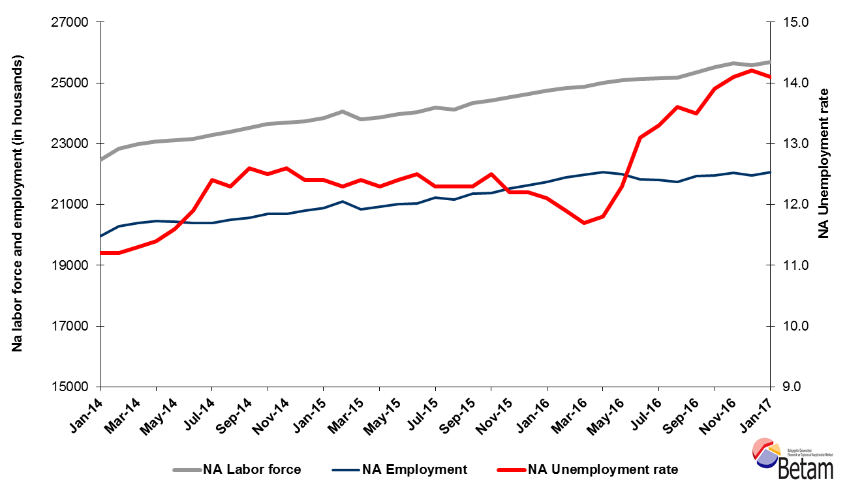
Source: Turkstat, Betam
A slight decrease in the unemployment is expected in the period of February 2017

Betam's forecasting model had predicted that the seasonally adjusted nonagricultural unemployment rate would increase by 0.1 percentage points and become 14.1 percent in the period of January 2017. Turkstat revised the December 2016 seasonally adjusted nonagricultural unemployment rate from 14.3 percent to 14.2 percent. So, the non-agricultural unemployment rate in January period decreased by 0.1 percentage points down to 14.1 percent. Betam’s forecasting model predicts the seasonally adjusted February 2017 nonagricultural unemployment will decrease by 0.1 points and realize as 14.0 percent. Forecasting model details are available on Betam's website. Kariyer.net application per vacancy series used in the Betam forecasting model is depicted in Error! Reference source not found.. Kariyer.net series is only one of the inputs of Betam forecast model. Indeed, several variables such as employment agency (İŞKUR) data, reel sector confidence index, capacity utilization rate are used in forecasting. Taken into account all these factors, Betam's forecasting model predicts that seasonally adjusted nonagricultural unemployment rate will slightly decrease in the period of February 2017.

Figure 2 Seasonally adjusted nonagricultural unemployment rate and application per vacancy
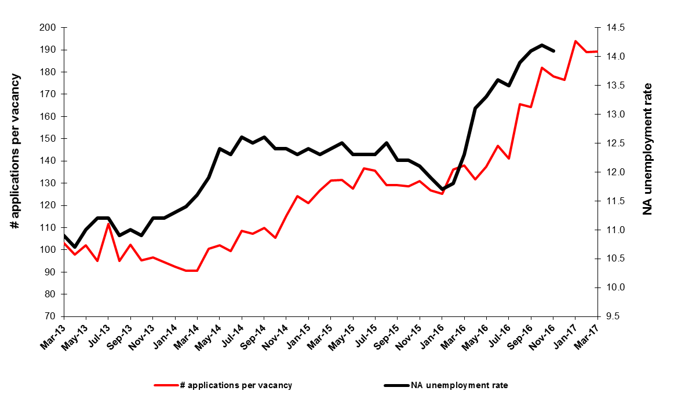
Source: Turkstat, Betam

Strong employment increase in services

According to seasonally adjusted sectoral labor market data, the number of people employed in services sector, which had declined by 9 thousand in the period of December 2016, significantly increased by 90 thousand in the period of January 2017. On the other hand, the increase in the industry sector employment was limited to 9 thousand and thus, it could not compensate the 51 thousand loss in the period of December 2016 (Figure 3,Error! Reference source not found. Table 2).

Figure 3 Employment by sectors (in thousands)
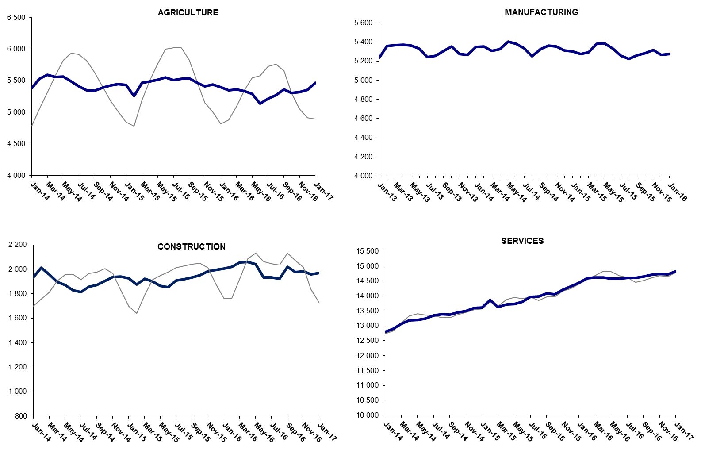
Source: Turkstat, Betam

Increase in year-on-year non-agricultural employment continues to be low

From January 2016 to January 2017 the nonagricultural labor force increased by 1 million 14 thousand (4.1 percent) and nonagricultural employment increased by 317 thousand (1.5 percent) (Figure 4). Thus, the number of non-agricultural unemployed increased by 697 thousand (22.7 percent) in the period of January 2017. The increase in non-agricultural employment declined to 317 thousand whereas the increase non-agricultural labor force remains around 1 million level. Parallel to this situation, the increase in non-agricultural unemployment reached 700 thousand within a year. While the adverse effect of decelerating economic growth (2.9 percent) in the year of 2016 on the employment is obviously observed, the labor force follows its high-increase trend (Figure 4).

Figure 4 Year-on-year changes in non-agricultural labor force, employment, and unemployment

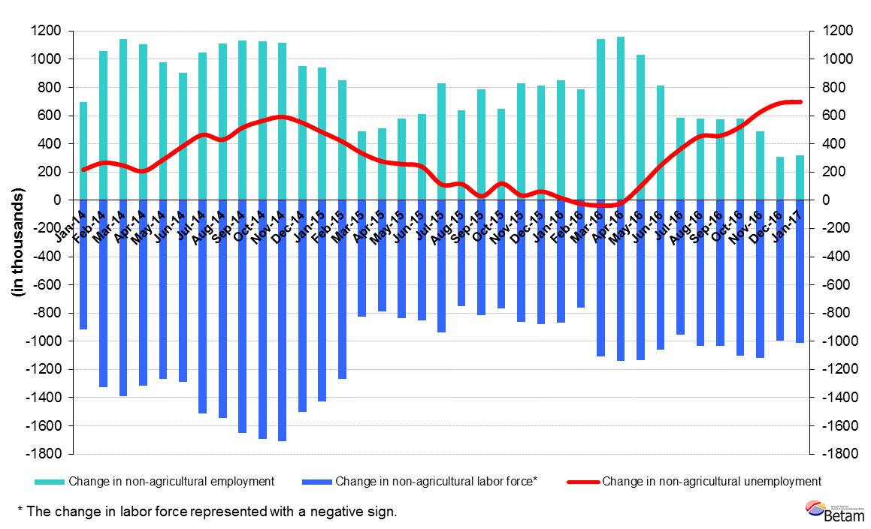
Source: Turkstat, Betam

Strong increase in female unemployment

Turkstat revised the labor market statistics drastically in February 2014. Within this framework, they back casted various labor market indicators and they also continued to announce seasonally adjusted series. However, Turkstat is not providing back-casted series by gender. Therefore, female and male labor market statistics are not sufficiently long for the seasonal adjustment procedures. Under these circumstances, we use the year-on-year changes in male and female labor market statistics to study the latest developments in the labor market. Figure 5 shows yearly non-agricultural employment (dark colors), non-agricultural labor force (light colors) for males (green) and for females (purple).

Figure 5 Year-on-year changes in nonagricultural labor force and employment by gender

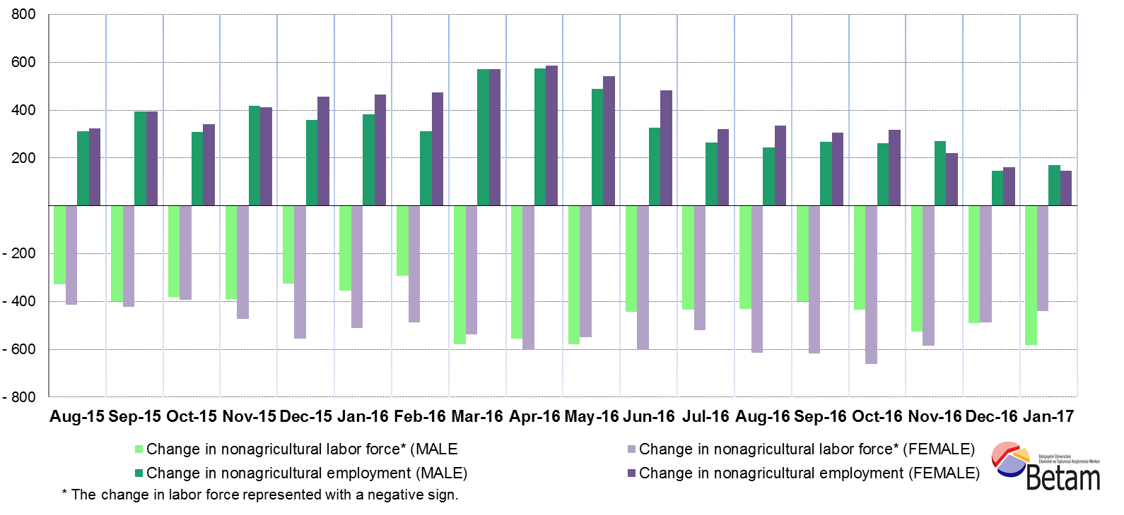
Source: Turkstat, Betam

In January 2017, nonagricultural female labor force and nonagricultural male labor force increased by 439 thousand and 581 thousand respectively compared to January 2016. On the other hand, nonagricultural male employment increased by 169 thousand whereas the increase in nonagricultural female employment was limited to 148 thousand. With respect to this, the number of non-agricultural unemployed women and men increased by 291 thousand and 412 thousand, respectively. From the period of January 2016 to the period of January 2017, the non-agricultural male unemployment rate grew from 11.5 percent to 13.4 percent and the non-agricultural female unemployment rate rose from 16.7 percent to 19.6 percent.

Table 1 Seasonally adjusted non-agricultural labor market indicators (in thousands)
 | Labor force | Employment | Unemployment | Unemployment rate | Monthly changes
December-13 | 22257 | 19831 | 2426 | 10.9% | Labor force | Employment | Unemployment
January-14 | 22480 | 19962 | 2518 | 11.2% | 223 | 131 | 92
February-14 | 22834 | 20277 | 2557 | 11.2% | 355 | 315 | 40
March-14 | 22979 | 20382 | 2597 | 11.3% | 144 | 105 | 39
April-14 | 23079 | 20448 | 2631 | 11.4% | 100 | 66 | 34
May-14 | 23106 | 20426 | 2680 | 11.6% | 27 | -22 | 49
June-14 | 23158 | 20402 | 2756 | 11.9% | 51 | -24 | 75
July-14 | 23282 | 20395 | 2887 | 12.4% | 124 | -7 | 131
August-14 | 23385 | 20509 | 2876 | 12.3% | 103 | 114 | -11
September-14 | 23516 | 20553 | 2963 | 12.6% | 131 | 44 | 87
October-14 | 23655 | 20698 | 2957 | 12.5% | 139 | 145 | -6
November-14 | 23683 | 20699 | 2984 | 12.6% | 28 | 1 | 27
December-14 | 23742 | 20798 | 2944 | 12.4% | 59 | 99 | -40
January-15 | 23849 | 20892 | 2957 | 12.4% | 107 | 94 | 13
February-15 | 24052 | 21094 | 2958 | 12.3% | 203 | 202 | 1
March-15 | 23799 | 20848 | 2951 | 12.4% | -253 | -246 | -7
April-15 | 23870 | 20934 | 2936 | 12.3% | 71 | 86 | -15
May-15 | 23981 | 21007 | 2974 | 12.4% | 111 | 73 | 38
June-15 | 24035 | 21031 | 3004 | 12.5% | 55 | 24 | 31
July-15 | 24193 | 21217 | 2976 | 12.3% | 157 | 186 | -29
August-15 | 24125 | 21158 | 2967 | 12.3% | -67 | -59 | -8
September-15 | 24344 | 21350 | 2994 | 12.3% | 219 | 192 | 27
October-15 | 24422 | 21369 | 3053 | 12.5% | 77 | 19 | 58
November-15 | 24531 | 21538 | 2993 | 12.2% | 109 | 169 | -60
December-15 | 24631 | 21626 | 3005 | 12.2% | 100 | 88 | 12
January-16 | 24741 | 21747 | 2994 | 12.1% | 110 | 121 | -11
February-16 | 24838 | 21882 | 2956 | 11.9% | 97 | 135 | -38
March-16 | 24880 | 21969 | 2911 | 11.7% | 42 | 87 | -45
April-16 | 25011 | 22060 | 2951 | 11.8% | 131 | 91 | 40
May-16 | 25096 | 22009 | 3087 | 12.3% | 84 | -51 | 135
June-16 | 25124 | 21833 | 3291 | 13.1% | 28 | -176 | 204
July-16 | 25144 | 21800 | 3344 | 13.3% | 20 | -33 | 53
August-16 | 25172 | 21749 | 3423 | 13.6% | 28 | -51 | 79
September-16 | 25351 | 21929 | 3422 | 13.5% | 179 | 180 | -1
October-16 | 25508 | 21962 | 3546 | 13.9% | 156 | 33 | 123
November-16 | 25654 | 22037 | 3617 | 14.1% | 147 | 75 | 72
December-16 | 25580 | 21948 | 3632 | 14.2% | -74 | -89 | 15
January-17 | 25689 | 22067 | 3622 | 14.1% | 109 | 119 | -10
Source: Turkstat, Betam

Table 2 Seasonally adjusted employment by sectors (in thousands)
 | Tarım | Sanayi | İnşaat | Hizmetler | Aylık değişimler
Aralık 13 | 5053 | 5131 | 1895 | 12805 | Tarım | Sanayi | İnşaat | Hizmetler
Ocak 14 | 5381 | 5232 | 1934 | 12796 | 328 | 101 | 39 | -9
Şubat 14 | 5527 | 5359 | 2013 | 12905 | 146 | 127 | 79 | 109
Mart 14 | 5591 | 5365 | 1958 | 13059 | 64 | 6 | -55 | 154
Nisan 14 | 5559 | 5373 | 1896 | 13179 | -32 | 8 | -62 | 120
Mayıs 14 | 5565 | 5364 | 1870 | 13191 | 6 | -9 | -26 | 12
Haziran 14 | 5490 | 5332 | 1827 | 13243 | -75 | -32 | -43 | 52
Temmuz 14 | 5407 | 5243 | 1814 | 13338 | -83 | -89 | -13 | 95
Ağustos 14 | 5344 | 5257 | 1856 | 13396 | -63 | 14 | 42 | 58
Eylül 14 | 5343 | 5306 | 1872 | 13375 | -1 | 49 | 16 | -21
Ekim 14 | 5388 | 5353 | 1903 | 13442 | 45 | 47 | 31 | 67
Kasım 14 | 5422 | 5273 | 1936 | 13491 | 34 | -80 | 33 | 49
Aralık 14 | 5442 | 5266 | 1939 | 13592 | 20 | -7 | 3 | 101
Ocak 15 | 5433 | 5349 | 1927 | 13616 | -9 | 83 | -12 | 24
Şubat 15 | 5255 | 5351 | 1877 | 13866 | -178 | 2 | -50 | 250
Mart 15 | 5463 | 5308 | 1921 | 13619 | 208 | -43 | 44 | -247
Nisan 15 | 5489 | 5326 | 1899 | 13709 | 26 | 18 | -22 | 90
Mayıs 15 | 5518 | 5404 | 1866 | 13736 | 29 | 78 | -33 | 27
Haziran 15 | 5552 | 5380 | 1854 | 13797 | 34 | -24 | -12 | 61
Temmuz 15 | 5507 | 5336 | 1909 | 13972 | -45 | -44 | 55 | 175
Ağustos 15 | 5531 | 5252 | 1918 | 13988 | 24 | -84 | 9 | 16
Eylül 15 | 5533 | 5327 | 1935 | 14089 | 2 | 75 | 17 | 101
Ekim 15 | 5466 | 5363 | 1951 | 14055 | -67 | 36 | 16 | -34
Kasım 15 | 5409 | 5353 | 1982 | 14203 | -57 | -10 | 31 | 148
Aralık 15 | 5439 | 5311 | 1995 | 14320 | 30 | -42 | 13 | 117
Ocak 16 | 5395 | 5300 | 2005 | 14442 | -44 | -11 | 10 | 122
Şubat 16 | 5346 | 5276 | 2020 | 14587 | -49 | -24 | 15 | 145
Mart 16 | 5360 | 5295 | 2057 | 14617 | 14 | 19 | 37 | 30
Nisan 16 | 5330 | 5381 | 2059 | 14619 | -30 | 86 | 2 | 2
Mayıs 16 | 5290 | 5386 | 2041 | 14581 | -40 | 5 | -18 | -38
Haziran 16 | 5140 | 5330 | 1934 | 14568 | -150 | -56 | -107 | -13
Temmuz 16 | 5216 | 5254 | 1934 | 14611 | 76 | -76 | 0 | 43
Ağustos 16 | 5267 | 5224 | 1924 | 14602 | 51 | -30 | -10 | -9
Eylül 16 | 5363 | 5260 | 2019 | 14651 | 96 | 36 | 95 | 49
Ekim 16 | 5307 | 5282 | 1977 | 14704 | -56 | 22 | -42 | 53
Kasım 16 | 5319 | 5316 | 1985 | 14736 | 12 | 34 | 8 | 32
Aralık 16 | 5356 | 5265 | 1957 | 14727 | 37 | -51 | -28 | -9
Ocak 17 | 5467 | 5274 | 1970 | 14823 | 111 | 9 | 13 | 96
Source: Turkstat, Betam

*Prof. Dr. Seyfettin Gürsel, Betam, Director, seyfettin.gursel@eas.bau.edu.tr
∗∗Asst. Prof. Gökçe Uysal, Betam, Deputy Director, gokce.uysal@eas.bau.edu.tr
∗∗∗ Selin Köksal, Betam, Research Assistant, selin.koksal@eas.bau.edu.tr
For detailed information on Betam's forecasting model, please see Betam Research Brief 168 titled as "Kariyer.net Verisiyle Kısa Vadeli Tarım Dışı İşsizlik Tahmini" http://betam.bahcesehir.edu.tr/tr/2014/06/kariyer-net-verisiyle-kisa-vadeli-tarim-disi-issizlik-tahmini/
Betam has been calculating application per vacancy using series released by Kariyer.net for a while. Seasonal and calendar adjustment procedure is applied to application per vacancy series. A decrease in applications per vacancy may be caused by an increase in vacancies or by a decrease in the number of applications. An increase in vacancies signals economic growth while decreasing number of applications indicates a decrease in number of people looking for a job. Monthly labor market series released by TurkStat is the average of three months. Therefore, application per vacancy statistics calculated using Kariyer.net series is the average of three months as well.
Employment in each sector is seasonally adjusted separately. Hence the sum of these series may differ from the seasonally adjusted series of total employment. The difference stems from the non-linearity of the seasonal adjustment process.

