Labor Market Outlook:

July 2015

15 July 2015

DECLINE IN UNEMPLOYMENT contınues
Seyfettin Gürsel* Mine Durmaz∗∗ and Melike Kökkızıl∗∗∗

Executive Summary

Seasonally adjusted labor market data shows that, compared to the previous period, nonagricultural unemployment rate decreased from 12.1 percent to 11.9 percent (0.2 percentage points) in the period of April 2015. The reason behind the decline in unemployment is the employment increases in manufacturing and services sectors which exceed the increases in the labor force. In addition, non-agricultural unemployment continues to stay at high levels.

Increase in annual non-agricultural employment

Strong employment increases observed since the period of November of 2014 have resulted in declines in unemployment. However, year-on-year non-agricultural unemployment rate is still high. According to data released by TurkStat in the period of April 2015, nonagricultural labor force increased by 787 thousand (3.4 percent), nonagricultural employment increased by 511 thousand (2.5 percent) and nonagricultural unemployment increased by 276 thousand compared the same period in the previous year (Figure 1). Hence, the non-agricultural unemployment rate which was at 10.8 percent for the period of April 2014 increased to 11.6 percent for the period of April 2015.

Figure 1 Year-on-year changes in non-agricultural labor force, employment, and unemployment
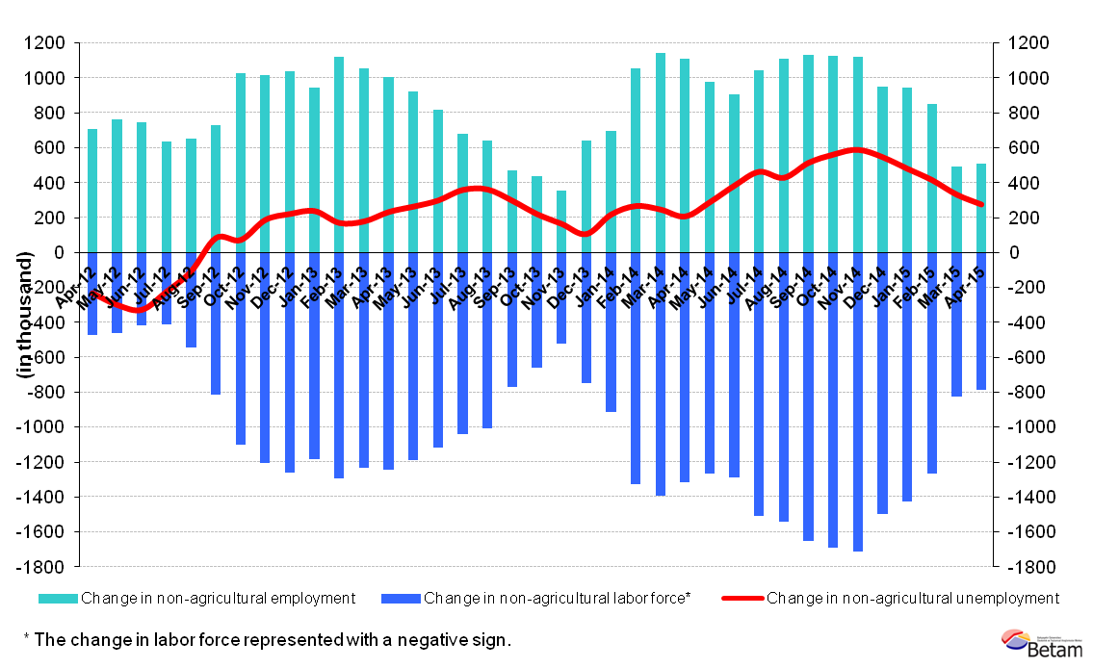
Source: Turkstat, Betam

Cyclical decline in non-agricultural employment

According to seasonally adjusted data in the period of April 2015, non-agricultural labor force increased by 46 thousand compared to the period of March 2015, and reached 23 million 871 thousand (Figure 2, Table 1). Non-agricultural employment increases by 88 thousand, and reached 21 million 30 thousand. Given that the increase in employment was greater than the rise in labor force, non-agricultural unemployed decreased by 42 thousand, and non-agricultural unemployment rate decreased by 0,2 percent points in the period of April 2015 compared to the previous period. Seasonally adjusted non-agricultural unemployment rate is 11,9 percent. Non-agricultural unemployment, which had increased to 12.7 percent until the period of November 2014, has been substantially decreasing due to the high employment increases. At the same time, total unemployment has decreased by 174 thousand in total (See Table 1).

Figure 2 Seasonally adjusted non-agricultural labor force, employment, and unemployment
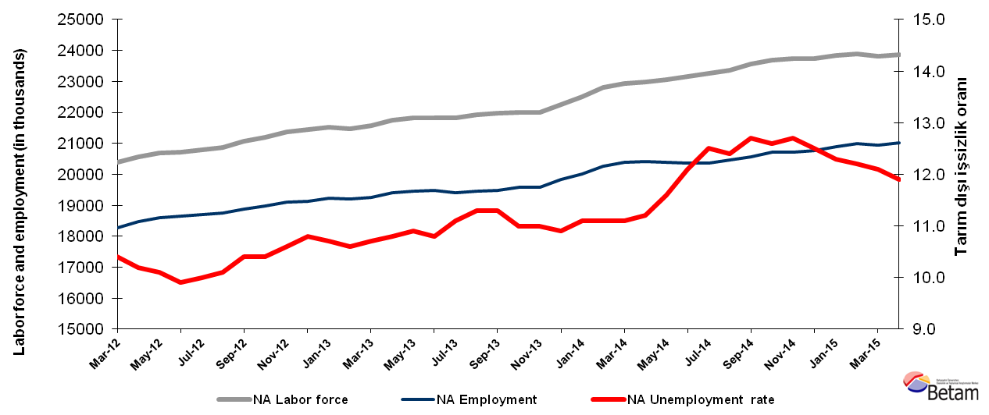Source: Turkstat, Betam

Non-agricultural unemployment forecast for the period of May 2015

Kariyer.net per vacancy series used in the Betam forecasting model is depicted in Figure 3. There is a decline in this rate in the period of May and increase in the period of June. Betam's forecasting model had predicted that nonagricultural unemployment would not change in the period of April. We predict that non-agricultural unemployment rate will decrease by 0.1 percent point to 11.8 percent in the period of May 2015.

Figure 3 Seasonally adjusted nonagricultural unemployment rate and application per vacancy

Source: Turkstat, Betam

Employment increases in manufacturing and services

According to seasonally adjusted labor market series, employment increased in all sectors except construction, , compared to the period of March 2015 (Figure 4, Table 2). Employment in construction decreased by 23 thousand. On the other hand, employment in agriculture and manufacturing sectors increased by 13 thousand and 18 thousand, respectively. Employment in services increased by 93 thousand for the period of April 2015. Hence, increases in non-agricultural employment amount to 88 thousand.

Figure 4 Employment by sectors (in thousands)

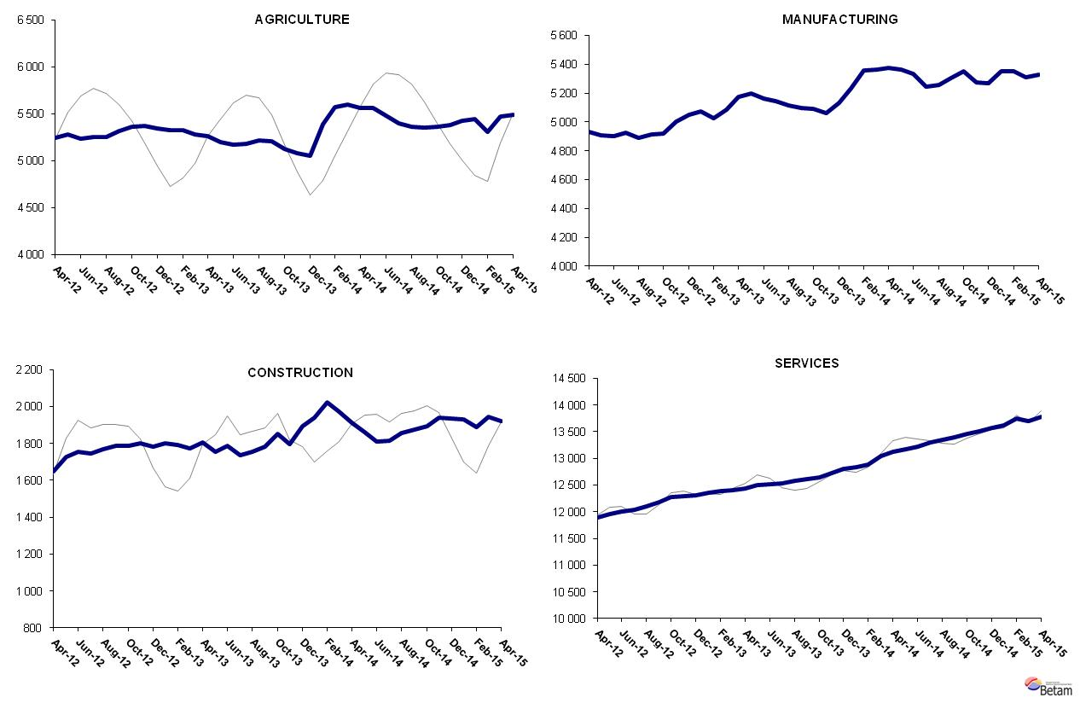

Source: Turkstat, Betam

Table 1 Seasonally adjusted non-agricultural labor force indicators (in thousands)*
 | Labor force | Employment | Unemployment | Unemployment rate | Monthly changes
March-12 | 20387 | 18267 | 2120 | 10.4% | Labor force | Employment | Unemployment
April-12 | 20568 | 18470 | 2098 | 10.2% | 181 | 203 | -22
May-12 | 20679 | 18590 | 2089 | 10.1% | 111 | 120 | -9
June-12 | 20707 | 18657 | 2050 | 9.9% | 28 | 67 | -39
July-12 | 20792 | 18713 | 2079 | 10.0% | 85 | 56 | 29
August-12 | 20865 | 18758 | 2107 | 10.1% | 73 | 45 | 28
September-12 | 21068 | 18877 | 2191 | 10.4% | 203 | 119 | 84
October-12 | 21185 | 18982 | 2203 | 10.4% | 117 | 105 | 12
November-12 | 21359 | 19095 | 2264 | 10.6% | 174 | 113 | 61
December-12 | 21459 | 19141 | 2318 | 10.8% | 99 | 46 | 53
January-13 | 21525 | 19222 | 2303 | 10.7% | 67 | 81 | -14
February-13 | 21482 | 19205 | 2277 | 10.6% | -43 | -17 | -26
March-13 | 21572 | 19264 | 2308 | 10.7% | 90 | 59 | 31
April-13 | 21760 | 19410 | 2350 | 10.8% | 188 | 146 | 42
May-13 | 21835 | 19455 | 2380 | 10.9% | 75 | 45 | 30
June-13 | 21833 | 19475 | 2358 | 10.8% | -2 | 20 | -22
July-13 | 21834 | 19410 | 2424 | 11.1% | 1 | -65 | 66
August-13 | 21923 | 19446 | 2477 | 11.3% | 90 | 36 | 54
September-13 | 21965 | 19483 | 2482 | 11.3% | 42 | 37 | 5
October-13 | 22009 | 19588 | 2421 | 11.0% | 44 | 105 | -61
November-13 | 22007 | 19586 | 2421 | 11.0% | -2 | -2 | 0
December-13 | 22256 | 19830 | 2426 | 10.9% | 249 | 244 | 5
January-14 | 22510 | 20011 | 2499 | 11.1% | 254 | 181 | 73
February-14 | 22795 | 20265 | 2530 | 11.1% | 286 | 254 | 32
March-14 | 22922 | 20378 | 2544 | 11.1% | 127 | 113 | 14
April-14 | 22981 | 20407 | 2574 | 11.2% | 58 | 29 | 29
May-14 | 23069 | 20393 | 2676 | 11.6% | 88 | -14 | 102
June-14 | 23167 | 20364 | 2803 | 12.1% | 98 | -29 | 127
July-14 | 23269 | 20360 | 2909 | 12.5% | 101 | -4 | 105
August-14 | 23356 | 20460 | 2896 | 12.4% | 88 | 100 | -12
September-14 | 23566 | 20573 | 2993 | 12.7% | 210 | 113 | 97
October-14 | 23697 | 20711 | 2986 | 12.6% | 131 | 138 | -7
November-14 | 23737 | 20722 | 3015 | 12.7% | 40 | 11 | 29
December-14 | 23744 | 20776 | 2968 | 12.5% | 7 | 54 | -47
January-15 | 23835 | 20903 | 2932 | 12.3% | 91 | 127 | -36
February-15 | 23899 | 20983 | 2916 | 12.2% | 64 | 80 | -16
March-15 | 23825 | 20942 | 2883 | 12.1% | -74 | -41 | -33
April- 15 | 23871 | 21030 | 2841 | 11.9% | 46 | 88 | -42
Source: Turkstat, Betam

Table 2 Seasonally adjusted employment by sectors (in thousands)*
 | Agriculture | Manufacturing | Construction | Services | Monthly changes
March-12 | 5220 | 4850 | 1563 | 11854 | Agriculture | Manufacturing | Construction | Services
April-12 | 5242 | 4930 | 1649 | 11891 | 22 | 80 | 86 | 37
May-12 | 5282 | 4908 | 1729 | 11953 | 40 | -22 | 80 | 62
June-12 | 5240 | 4900 | 1753 | 12004 | -42 | -8 | 24 | 51
July-12 | 5252 | 4926 | 1746 | 12041 | 12 | 26 | -7 | 37
August-12 | 5254 | 4892 | 1770 | 12097 | 2 | -34 | 24 | 56
September-12 | 5321 | 4911 | 1786 | 12179 | 67 | 19 | 16 | 82
October-12 | 5366 | 4917 | 1789 | 12276 | 45 | 6 | 3 | 97
November-12 | 5371 | 5003 | 1801 | 12291 | 5 | 86 | 12 | 15
December-12 | 5344 | 5051 | 1780 | 12310 | -27 | 48 | -21 | 19
January-13 | 5323 | 5073 | 1799 | 12351 | -21 | 22 | 19 | 41
February-13 | 5330 | 5023 | 1793 | 12389 | 7 | -50 | -6 | 38
March-13 | 5281 | 5083 | 1773 | 12407 | -49 | 60 | -20 | 18
April-13 | 5265 | 5176 | 1807 | 12428 | -16 | 93 | 34 | 21
May-13 | 5200 | 5200 | 1753 | 12502 | -65 | 24 | -54 | 74
June-13 | 5170 | 5163 | 1789 | 12523 | -30 | -37 | 36 | 21
July-13 | 5185 | 5146 | 1735 | 12529 | 15 | -17 | -54 | 6
August-13 | 5214 | 5117 | 1755 | 12574 | 29 | -29 | 20 | 45
September-13 | 5212 | 5096 | 1780 | 12607 | -2 | -21 | 25 | 33
October-13 | 5126 | 5090 | 1853 | 12645 | -86 | -6 | 73 | 38
November-13 | 5079 | 5064 | 1794 | 12728 | -47 | -26 | -59 | 83
December-13 | 5052 | 5131 | 1894 | 12805 | -27 | 67 | 100 | 77
January-14 | 5386 | 5232 | 1938 | 12841 | 334 | 101 | 44 | 36
February-14 | 5572 | 5359 | 2021 | 12885 | 186 | 127 | 83 | 44
March-14 | 5601 | 5365 | 1973 | 13039 | 29 | 6 | -48 | 154
April-14 | 5560 | 5373 | 1910 | 13124 | -41 | 8 | -63 | 85
May-14 | 5559 | 5364 | 1862 | 13167 | -1 | -9 | -48 | 43
June-14 | 5479 | 5332 | 1811 | 13221 | -80 | -32 | -51 | 54
July-14 | 5403 | 5243 | 1813 | 13304 | -76 | -89 | 2 | 83
August-14 | 5365 | 5257 | 1854 | 13348 | -38 | 14 | 41 | 44
September-14 | 5356 | 5306 | 1873 | 13394 | -9 | 49 | 19 | 46
October-14 | 5361 | 5353 | 1895 | 13463 | 5 | 47 | 22 | 69
November-14 | 5379 | 5273 | 1939 | 13511 | 18 | -80 | 44 | 48
December-14 | 5424 | 5266 | 1936 | 13574 | 45 | -7 | -3 | 63
January-15 | 5442 | 5349 | 1931 | 13622 | 18 | 83 | -5 | 48
February-15 | 5310 | 5351 | 1887 | 13745 | -132 | 2 | -44 | 123
March-15 | 5475 | 5308 | 1943 | 13691 | 165 | -43 | 56 | -54
April- 15 | 5488 | 5326 | 1920 | 13784 | 13 | 18 | -23 | 93
Source: Turkstat, Betam

*Prof. Dr. Seyfettin Gürsel, Betam, Director, seyfettin.gursel@eas.bahcesehir.edu.tr
∗∗Mine Durmaz, Betam, Research Assistant, mine.durmaz@eas.bahcesehir.edu.tr
∗∗∗Melike Kökkızıl, Betam, Research Assistant, melike.kokkizil@eas.bahcesehir.edu.tr
A general outlook to the progress of employment and economic growth during the last 3 years indicate that increase in employment is higher than the economic growth. For detail information on this paradox, please see the research brief titled as "Low Rate of Economic Growth, Extreme Increases in Employment ": http://betam.bahcesehir.edu.tr/2015/07/dusuk-buyume-olaganustu-istihdam-artisi/
Betam has been calculating application per vacancy using series released by Kariyer.net for a while. Seasonal and calendar adjustment procedure is applied to application per vacancy series. A decrease in applications per vacancy may be caused by an increase in vacancies or by a decrease in the number of applications. An increase in vacancies signals economic growth while decreasing number of applications indicates a decrease in number of people looking for a job. Monthly labor market series released by TurkStat is the average of three months. Therefore, application per vacancy statistics calculated using Kariyer.net series is the average of three months as well.
For detailed information on Betam's forecasting model, please see Betam Research Brief 168 titled as "Kariyer.net Verisiyle Kısa Vadeli Tarım Dışı İşsizlik Tahmini" http://betam.bahcesehir.edu.tr/tr/2014/06/kariyer-net-verisiyle-kisa-vadeli-tarim-disi-issizlik-tahmini/
Employment in each sector is seasonally adjusted separately. Hence the sum of these series may differ from the seasonally adjusted series of total employment. The difference stems from the non-linearity of the seasonal adjustment process

