Labor Market Outlook:

June 2015

15 June 2015

labor force and employment ARE DECLINING
Seyfettin Gürsel* Gökçe Uysal∗∗ and Melike Kökkızıl∗∗∗

Executive Summary

Seasonally adjusted labor market data shows that nonagricultural unemployment rate decreased from 12.2 percent to 12.1 percent (0.1 percentage point) in the period of March 2015 compared to the previous period. The decline in unemployment rate is caused by a faster decline in the non-agricultural labor force relative to previous period.
Compared to February 2015, non-agricultural labor force and employment decreased by 73 thousand and 40 thousand, respectively. The reason of decline in employment is job losses in manufacturing and services sectors. This is the first job loss in the service sector since 2012.

Deceleration in year-on-year increases

According to data released by TurkStat, nonagricultural labor force increased by 824 thousand (3.6 percent), nonagricultural employment increased by 491 thousand (2.4 percent) and nonagricultural unemployment increased by 333 thousand in the period of March 2015 compared the same period in the previous year (Figure 1). Given that we are looking at March 2015 data, we can say that the year-on-year data does not include the break in the labor market series introduced by TurkStat's revision in February 2014. Year-on-year employment increases have now become consistent with the low economic growth performance.

Figure 1 Year-on-year changes in non-agricultural labor force, employment, and unemployment

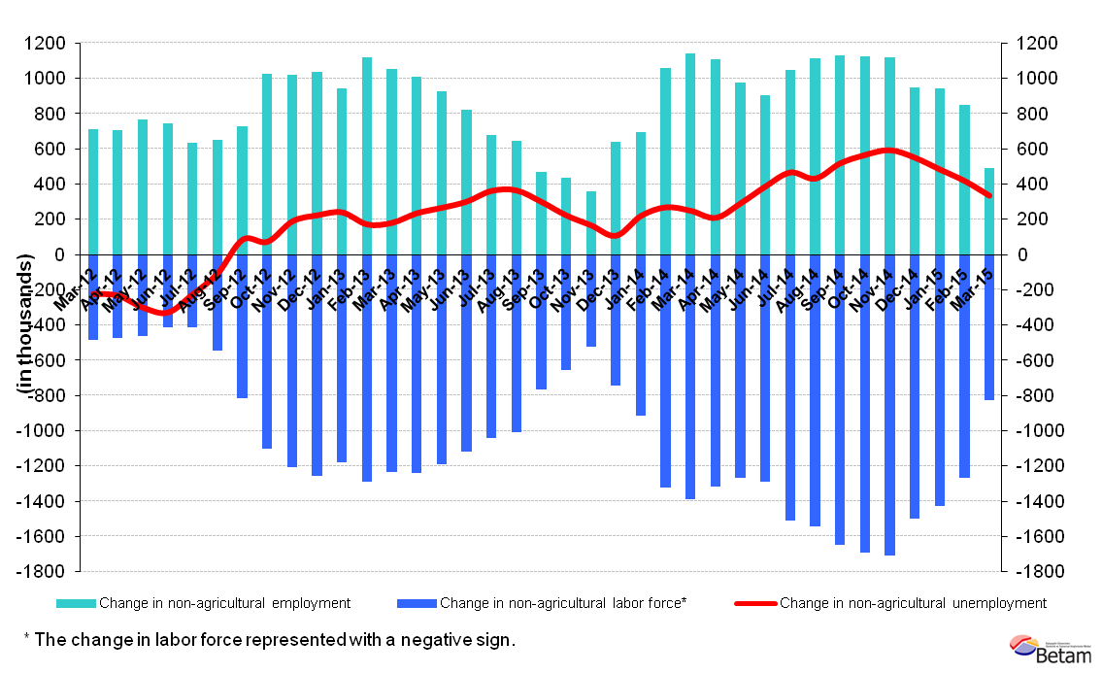
Source: Turkstat, Betam

Limited decline in nonagricultural unemployment

According to seasonally adjusted data, non-agricultural labor force increased by 73 thousand in the period of March 2015 compared to the period of February 2015, and reached 23 million 813 thousand (Figure 2, Table 1).
Hence, the number of persons unemployed in nonagricultural sectors decreased by 40 thousand to reach 20 million 932 thousand. Given that the decline in the labor force was faster than the decline in employment, the number of unemployed decreased by 33 thousand, causing the unemployment rate to decrease by 0.1 percentage points to reach 12.1 percentage in the period of March 2015 compared to the period of February 2015.

Figure 2 Seasonally adjusted non-agricultural labor force, employment, and unemployment
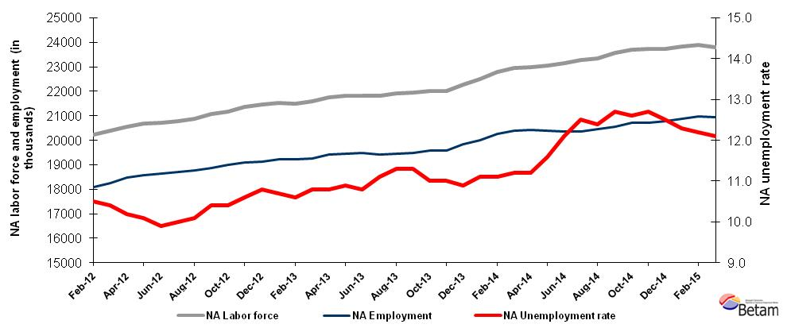Source: TurkStat, Betam

We are expecting no change in nonagricultural unemployment in next period

Kariyer.net's application per vacancy series used in the Betam forecasting model is depicted in Figure 3. For the period of March, we had predicted 0.1-point increase in nonagricultural unemployment rate. The error is due to the increase in the number of Kariyer.net’s application per vacancy series. Betam's forecasting model predicts that nonagricultural unemployment will not change in the next period (April 2015) .
Figure 3 Seasonally adjusted nonagricultural unemployment rate and application per vacancy
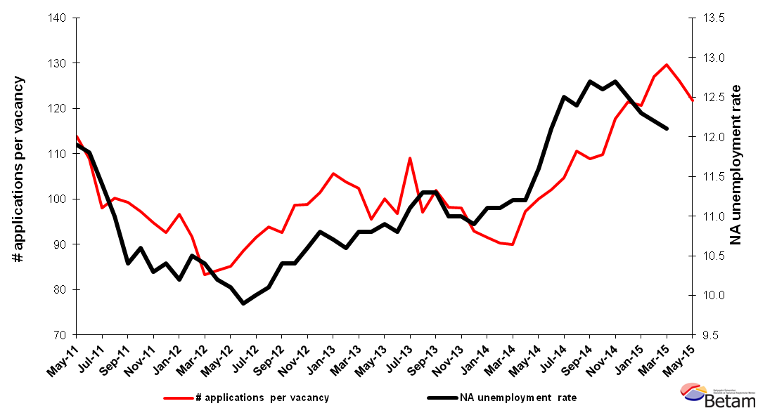
Source: Kariyer.net, TurkStat, Betam

Employment decreased in manufacturing and services

According to seasonally adjusted labor market series, employment in agriculture increased by 164 thousand in the period of March 2015 compared to the period of February 2015 (Figure 4, Table 2). In the same period, employment in construction increased by 57 thousand. On the other hand, employment in services and manufacturing sectors decreased by 54 thousand and 43 thousand, respectively.

Figure 4 Employment by sectors (in thousands)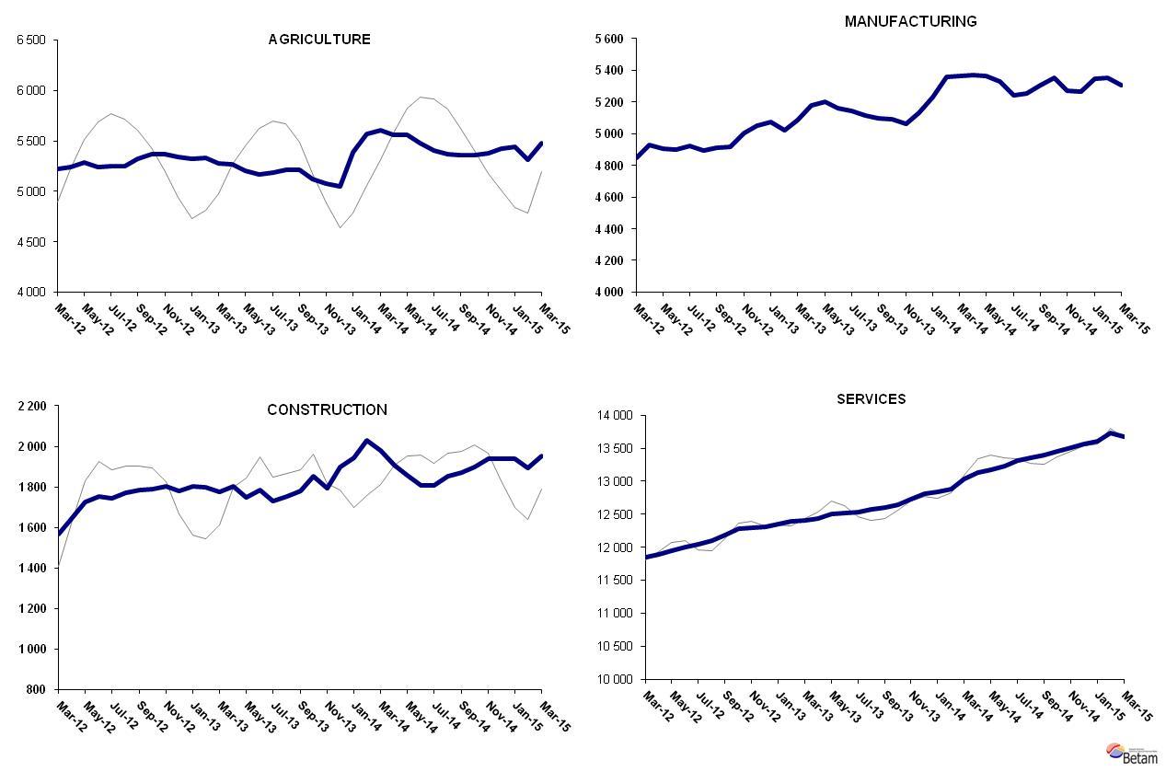
Source: TurkStat, Betam

Table 1 Seasonally adjusted non-agricultural labor force indicators (in thousands)*
 | Labor Force | Employment | Unemployment | Unemployment Rate | Monthly changes
February-12 | 20225 | 18101 | 2124 | 10.5% | Labor force | Employment | Unemployment
March-12 | 20388 | 18268 | 2120 | 10.4% | 164 | 167 | -3
April-12 | 20566 | 18468 | 2098 | 10.2% | 177 | 200 | -23
May-12 | 20676 | 18588 | 2088 | 10.1% | 111 | 120 | -9
June-12 | 20705 | 18655 | 2050 | 9.9% | 28 | 67 | -39
July-12 | 20790 | 18711 | 2079 | 10.0% | 85 | 56 | 29
August-12 | 20864 | 18757 | 2107 | 10.1% | 74 | 46 | 28
September-12 | 21067 | 18876 | 2191 | 10.4% | 203 | 119 | 84
October-12 | 21186 | 18983 | 2203 | 10.4% | 119 | 107 | 12
November-12 | 21359 | 19095 | 2264 | 10.6% | 173 | 112 | 61
December-12 | 21460 | 19142 | 2318 | 10.8% | 101 | 47 | 54
January-13 | 21529 | 19225 | 2304 | 10.7% | 69 | 83 | -14
February-13 | 21488 | 19210 | 2278 | 10.6% | -41 | -15 | -26
March-13 | 21601 | 19268 | 2333 | 10.8% | 113 | 58 | 55
April-13 | 21758 | 19408 | 2350 | 10.8% | 157 | 140 | 17
May-13 | 21832 | 19452 | 2380 | 10.9% | 74 | 44 | 30
June-13 | 21830 | 19472 | 2358 | 10.8% | -2 | 20 | -22
July-13 | 21829 | 19406 | 2423 | 11.1% | -1 | -66 | 65
August-13 | 21920 | 19443 | 2477 | 11.3% | 91 | 37 | 54
September-13 | 21964 | 19482 | 2482 | 11.3% | 44 | 39 | 5
October-13 | 22010 | 19589 | 2421 | 11.0% | 46 | 107 | -61
November-13 | 22008 | 19587 | 2421 | 11.0% | -2 | -2 | 0
December-13 | 22260 | 19834 | 2426 | 10.9% | 253 | 247 | 6
January-14 | 22515 | 20016 | 2499 | 11.1% | 255 | 182 | 73
February-14 | 22804 | 20273 | 2531 | 11.1% | 289 | 257 | 32
March-14 | 22954 | 20383 | 2571 | 11.2% | 150 | 110 | 40
April-14 | 22984 | 20410 | 2574 | 11.2% | 30 | 27 | 3
May-14 | 23070 | 20394 | 2676 | 11.6% | 86 | -16 | 102
June-14 | 23165 | 20362 | 2803 | 12.1% | 95 | -32 | 127
July-14 | 23265 | 20357 | 2908 | 12.5% | 100 | -5 | 105
August-14 | 23353 | 20457 | 2896 | 12.4% | 88 | 100 | -12
September-14 | 23562 | 20570 | 2992 | 12.7% | 210 | 113 | 97
October-14 | 23693 | 20708 | 2985 | 12.6% | 131 | 138 | -7
November-14 | 23732 | 20718 | 3014 | 12.7% | 39 | 10 | 29
December-14 | 23737 | 20770 | 2967 | 12.5% | 5 | 52 | -47
January-15 | 23824 | 20894 | 2930 | 12.3% | 87 | 124 | -37
February-15 | 23886 | 20972 | 2914 | 12.2% | 62 | 78 | -16
March-15 | 23813 | 20932 | 2881 | 12.1% | -73 | -40 | -33
Source: TurkStat, Betam

Table 2 Seasonally adjusted employment by sectors (in thousands)*
 | Agriculture | Manufacturing | Construction | Services | Monthly changes
February-12 | 5300 | 4808 | 1548 | 11745 | Agriculture | Manufacturing | Construction | Services
March-12 | 5220 | 4850 | 1565 | 11854 | -80 | 42 | 17 | 109
April-12 | 5242 | 4930 | 1647 | 11891 | 22 | 80 | 82 | 37
May-12 | 5283 | 4908 | 1727 | 11953 | 41 | -22 | 80 | 62
June-12 | 5241 | 4900 | 1752 | 12004 | -42 | -8 | 25 | 51
July-12 | 5252 | 4926 | 1744 | 12041 | 11 | 26 | -8 | 37
August-12 | 5254 | 4892 | 1769 | 12096 | 2 | -34 | 25 | 55
September-12 | 5321 | 4911 | 1786 | 12179 | 67 | 19 | 17 | 83
October-12 | 5366 | 4917 | 1790 | 12276 | 45 | 6 | 4 | 97
November-12 | 5371 | 5003 | 1801 | 12291 | 5 | 86 | 11 | 15
December-12 | 5344 | 5051 | 1781 | 12310 | -27 | 48 | -20 | 19
January-13 | 5323 | 5073 | 1802 | 12351 | -21 | 22 | 21 | 41
February-13 | 5329 | 5023 | 1797 | 12389 | 6 | -50 | -5 | 38
March-13 | 5281 | 5083 | 1777 | 12408 | -48 | 60 | -20 | 19
April-13 | 5265 | 5176 | 1804 | 12428 | -16 | 93 | 27 | 20
May-13 | 5200 | 5200 | 1750 | 12502 | -65 | 24 | -54 | 74
June-13 | 5170 | 5163 | 1786 | 12524 | -30 | -37 | 36 | 22
July-13 | 5185 | 5146 | 1731 | 12529 | 15 | -17 | -55 | 5
August-13 | 5214 | 5117 | 1753 | 12574 | 29 | -29 | 22 | 45
September-13 | 5212 | 5096 | 1779 | 12606 | -2 | -21 | 26 | 32
October-13 | 5126 | 5090 | 1854 | 12645 | -86 | -6 | 75 | 39
November-13 | 5079 | 5064 | 1795 | 12728 | -47 | -26 | -59 | 83
December-13 | 5052 | 5131 | 1898 | 12805 | -27 | 67 | 103 | 77
January-14 | 5386 | 5232 | 1943 | 12841 | 334 | 101 | 45 | 36
February-14 | 5572 | 5359 | 2029 | 12885 | 186 | 127 | 86 | 44
March-14 | 5601 | 5365 | 1980 | 13037 | 29 | 6 | -49 | 152
April-14 | 5560 | 5373 | 1906 | 13132 | -41 | 8 | -74 | 95
May-14 | 5558 | 5364 | 1857 | 13172 | -2 | -9 | -49 | 40
June-14 | 5479 | 5332 | 1805 | 13225 | -79 | -32 | -52 | 53
July-14 | 5403 | 5243 | 1807 | 13307 | -76 | -89 | 2 | 82
August-14 | 5365 | 5257 | 1851 | 13349 | -38 | 14 | 44 | 42
September-14 | 5356 | 5306 | 1871 | 13392 | -9 | 49 | 20 | 43
October-14 | 5361 | 5353 | 1896 | 13459 | 5 | 47 | 25 | 67
November-14 | 5379 | 5273 | 1941 | 13504 | 18 | -80 | 45 | 45
December-14 | 5425 | 5266 | 1941 | 13563 | 46 | -7 | 0 | 59
January-15 | 5443 | 5349 | 1938 | 13608 | 18 | 83 | -3 | 45
February-15 | 5311 | 5351 | 1895 | 13726 | -132 | 2 | -43 | 118
March-15 | 5475 | 5308 | 1952 | 13672 | 164 | -43 | 57 | -54
Source: TurkStat, Betam

*Prof. Dr. Seyfettin Gürsel, Betam, Director, seyfettin.gursel@eas.bahcesehir.edu.tr
∗∗ Yrd. Doç. Dr. Gokce Uysal, Betam, Assistant Director, gokce.uysal@eas.bahcesehir.edu.tr
∗∗∗Melike Kökkızıl, Betam, Research Assistant, melike.kokkizil@eas.bahcesehir.edu.tr
Betam has been calculating application per vacancy using series released by Kariyer.net for a while. Seasonal and calendar adjustment procedure is applied to application per vacancy series. A decrease in applications per vacancy may be caused by an increase in vacancies or by a decrease in the number of applications. An increase in vacancies signals economic growth while decreasing number of applications indicates a decrease in number of people looking for a job. Monthly labor market series released by TurkStat is the average of three months. Therefore, application per vacancy statistics calculated using Kariyer.net series is the average of three months as well.
For detailed information on Soybilgen's forecasting model, please see Betam Research Brief 168 titled as "Kariyer.net Verisiyle Kısa Vadeli Tarım Dışı İşsizlik Tahmini" http://betam.bahcesehir.edu.tr/tr/2014/06/kariyer-net-verisiyle-kisa-vadeli-tarim-disi-issizlik-tahmini/
Employment in each sector is seasonally adjusted separately. Hence the sum of these series may differ from the seasonally adjusted series of total employment. The difference stems from the non-linearity of the seasonal adjustment process. .

