Labor Market Outlook:

May 2015

15 May 2015

Slow DECREASE IN NONAGRICULTURAL UNEMPLOYMENT Contınues

Seyfettin Gürsel* Gökçe Uysal∗∗ and Melike Kökkızıl∗∗∗

Executive Summary

Seasonally adjusted labor market data shows that nonagricultural unemployment rate decreased from 12.3 percent to 12.2 percent (0.1 percentage points) in the period of February 2015 compared to the previous period. Nonagricultural labor force and employment increased by 58 thousand and 75 thousand, respectively. The increase in nonagricultural employment stems from a 118 thousand monthly increase in services employment. In this period, increase in manufacturing employment has been limited to 2 thousand and employment in the construction sector declined by 45 thousand.

Year-on-year increases continue rapidly

According to data released by Turkstat in the period of February 2015, nonagricultural labor force increased by 1 million 266 thousand (5.6 percent), nonagricultural employment increased by 849 thousand (4.3 percent) and nonagricultural unemployment increased by 417 thousand compared the same period in the previous year (Figure1). It has been exactly one year since TurkStat's revision in the labor force statistics in the period of February 2015. Therefore, year-on-year changes in this period are not affected by the revision. Still, nonagricultural labor force and nonagricultural employment have been rising sharply.

Figure 1 Year-on-year changes in non-agricultural labor force, employment, and unemployment
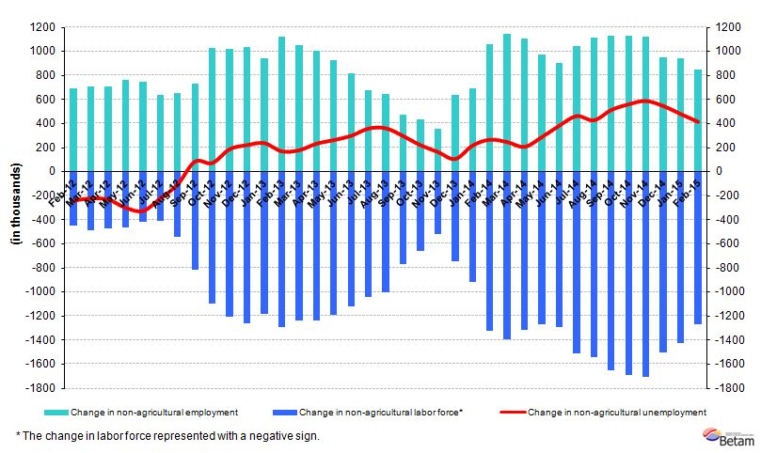
Source: TurkStat; Betam

Slight decline in nonagricultural unemployment

According to seasonally adjusted data in the period of February 2015, nonagricultural labor force increased by 58 thousand compared to the period of January 2015, and reached 23 million 975 thousand (Figure 2, Table 1). Nonagricultural employment increased by 75 thousand and reached 21 million 50 thousand. Compared to the period of January 2015, the number of persons unemployed in nonagricultural sectors decreased by 17 thousand and nonagricultural unemployment rate decreased by 0.1 percentage points to 12.2 percent in the period of February 2015

Figure 2 Seasonally adjusted non-agricultural labor force, employment, and unemployment
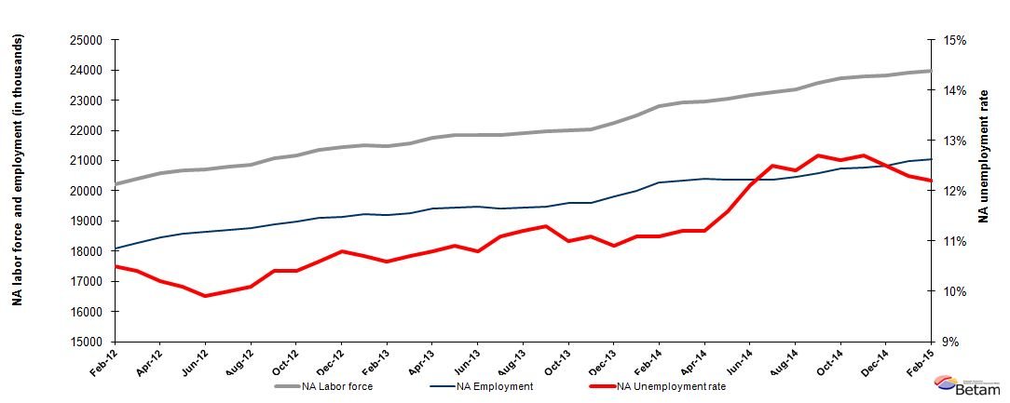
Source: TurkStat, Betam

We are expecting 0.1-point increase in nonagricultural unemployment in the next period

Kariyer.net's application per vacancy series used in the Betam forecasting model is depicted in Figure 3. Betam's forecasting model predicts that nonagricultural unemployment will increase by 0.1 percentage points in the next period (March 2015).

Figure 3 Seasonally adjusted nonagricultural unemployment rate and application per vacancy
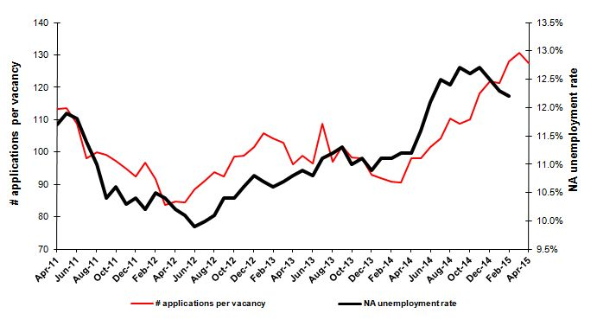
Source: Kariyer.net, TurkStat, Betam

Employment increased in manufacturing and services

According to seasonally adjusted labor market series, compared employment in agriculture decreased by 133 thousand in the period of February 2015 to the period of January 2015 (Figure 4, Table2). In the same period, employment in construction declined by 45 thousand. On the other hand, employment in services increased by 118 thousand. Manufacturing employment increased by only 2 thousand. Note that the industrial production index was high in March 2015. We expect a delayed response in the labor market.

Figure 4 Employment by sectors (in thousands)
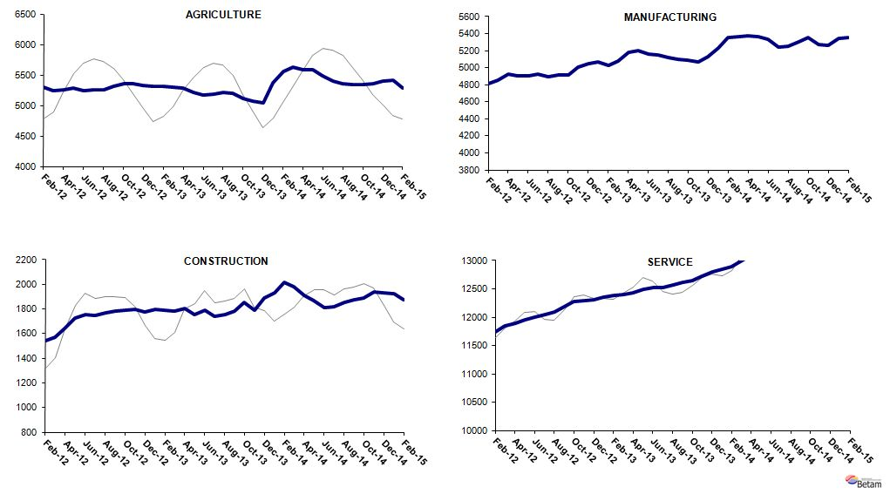
Source: Turkstat; Betam
Table 1:Seasonally adjusted non-agricultural labor force indicators (in thousands)*
 | Labor force |  | Employment |  | Unemployment | Unemployment rate | Monthly changes
January-12 | 20375 | 18297 |  | 2078 |  | 10.2% | Labor force | Employment | Unemployment
February-12 | 20221 | 18098 |  | 2123 |  | 10.5% | -154 | -199 | 45
March-12 | 20392 | 18271 |  | 2121 |  | 10.4% | 171 | 173 | -2
April-12 | 20568 | 18470 |  | 2098 |  | 10.2% | 176 | 199 | -23
May-12 | 20676 | 18588 |  | 2088 |  | 10.1% | 108 | 118 | -10
June-12 | 20705 | 18655 |  | 2050 |  | 9.9% | 28 | 67 | -39
July-12 | 20793 | 18714 |  | 2079 |  | 10.0% | 89 | 59 | 30
August-12 | 20867 | 18759 |  | 2108 |  | 10.1% | 73 | 45 | 28
September-12 | 21067 | 18876 |  | 2191 |  | 10.4% | 200 | 117 | 83
October-12 | 21183 | 18980 |  | 2203 |  | 10.4% | 116 | 104 | 12
November-12 | 21357 | 19093 |  | 2264 |  | 10.6% | 174 | 113 | 61
December-12 | 21455 | 19138 |  | 2317 |  | 10.8% | 98 | 45 | 53
January-13 | 21521 | 19218 |  | 2303 |  | 10.7% | 66 | 80 | -14
February-13 | 21478 | 19201 |  | 2277 |  | 10.6% | -43 | -17 | -26
March-13 | 21578 | 19269 |  | 2309 |  | 10.7% | 100 | 68 | 32
April-13 | 21759 | 19409 |  | 2350 |  | 10.8% | 181 | 140 | 41
May-13 | 21833 | 19453 |  | 2380 |  | 10.9% | 74 | 44 | 30
June-13 | 21833 | 19475 |  | 2358 |  | 10.8% | 0 | 22 | -22
July-13 | 21837 | 19413 |  | 2424 |  | 11.1% | 4 | -62 | 66
August-13 | 21902 | 19449 |  | 2453 |  | 11.2% | 65 | 36 | 29
September-13 | 21966 | 19484 |  | 2482 |  | 11.3% | 64 | 35 | 29
October-13 | 22007 | 19586 |  | 2421 |  | 11.0% | 41 | 102 | -61
November-13 | 22029 | 19584 |  | 2445 |  | 11.1% | 23 | -2 | 25
December-13 | 22251 | 19826 |  | 2425 |  | 10.9% | 222 | 242 | -20
January-14 | 22503 | 20005 |  | 2498 |  | 11.1% | 251 | 179 | 72
February-14 | 22799 | 20268 |  | 2531 |  | 11.1% | 296 | 263 | 33
March-14 | 22917 | 20350 |  | 2567 |  | 11.2% | 118 | 82 | 36
April-14 | 22961 | 20389 |  | 2572 |  | 11.2% | 44 | 39 | 5
May-14 | 23053 | 20379 |  | 2674 |  | 11.6% | 93 | -10 | 103
June-14 | 23158 | 20356 |  | 2802 |  | 12.1% | 105 | -23 | 128
July-14 | 23271 | 20362 |  | 2909 |  | 12.5% | 113 | 6 | 107
August-14 | 23368 | 20470 |  | 2898 |  | 12.4% | 97 | 108 | -11
September-14 | 23588 | 20592 |  | 2996 |  | 12.7% | 220 | 122 | 98
October-14 | 23729 | 20739 |  | 2990 |  | 12.6% | 141 | 147 | -6
November-14 | 23785 | 20764 |  | 3021 |  | 12.7% | 56 | 25 | 31
December-14 | 23806 | 20830 |  | 2976 |  | 12.5% | 21 | 66 | -45
January-15 | 23917 | 20975 |  | 2942 |  | 12.3% | 111 | 145 | -34
February-15 | 23975 | 21050 |  | 2925 |  | 12.2% | 58 | 75 | -17
Source: Turkstat; Betam

Table 2: Seasonally adjusted employment by sectors (in thousands)*
 | Agriculture | Manufacturing | Construction | Service | Monthly changes
January-12 | 5322 | 4864 | 1688 | 11745 | Agriculture | Manufacturing | Construction | Service
February-12 | 5294 | 4808 | 1544 | 11746 | -28 | -56 | -144 | 1
March-12 | 5236 | 4850 | 1568 | 11853 | -58 | 42 | 24 | 107
April-12 | 5254 | 4930 | 1649 | 11890 | 18 | 80 | 81 | 37
May-12 | 5288 | 4908 | 1729 | 11951 | 34 | -22 | 80 | 61
June-12 | 5243 | 4900 | 1754 | 12002 | -45 | -8 | 25 | 51
July-12 | 5251 | 4926 | 1747 | 12042 | 8 | 26 | -7 | 40
August-12 | 5251 | 4892 | 1770 | 12098 | 0 | -34 | 23 | 56
September-12 | 5316 | 4911 | 1786 | 12179 | 65 | 19 | 16 | 81
October-12 | 5362 | 4917 | 1788 | 12275 | 46 | 6 | 2 | 96
November-12 | 5364 | 5003 | 1800 | 12290 | 2 | 86 | 12 | 15
December-12 | 5335 | 5051 | 1778 | 12309 | -29 | 48 | -22 | 19
January-13 | 5310 | 5073 | 1795 | 12350 | -25 | 22 | 17 | 41
February-13 | 5319 | 5023 | 1788 | 12390 | 9 | -50 | -7 | 40
March-13 | 5305 | 5083 | 1780 | 12406 | -14 | 60 | -8 | 16
April-13 | 5285 | 5176 | 1807 | 12426 | -20 | 93 | 27 | 20
May-13 | 5212 | 5200 | 1755 | 12499 | -73 | 24 | -52 | 73
June-13 | 5175 | 5163 | 1791 | 12521 | -37 | -37 | 36 | 22
July-13 | 5184 | 5146 | 1738 | 12529 | 9 | -17 | -53 | 8
August-13 | 5210 | 5117 | 1756 | 12575 | 26 | -29 | 18 | 46
September-13 | 5206 | 5096 | 1780 | 12608 | -4 | -21 | 24 | 33
October-13 | 5118 | 5090 | 1852 | 12645 | -88 | -6 | 72 | 37
November-13 | 5067 | 5064 | 1792 | 12728 | -51 | -26 | -60 | 83
December-13 | 5037 | 5131 | 1891 | 12805 | -30 | 67 | 99 | 77
January-14 | 5367 | 5232 | 1932 | 12841 | 330 | 101 | 41 | 36
February-14 | 5555 | 5359 | 2014 | 12896 | 188 | 127 | 82 | 55
March-14 | 5635 | 5365 | 1984 | 13001 | 80 | 6 | -30 | 105
April-14 | 5589 | 5373 | 1911 | 13105 | -46 | 8 | -73 | 104
May-14 | 5579 | 5364 | 1865 | 13150 | -10 | -9 | -46 | 45
June-14 | 5489 | 5332 | 1814 | 13210 | -90 | -32 | -51 | 60
July-14 | 5403 | 5243 | 1817 | 13302 | -86 | -89 | 3 | 92
August-14 | 5360 | 5257 | 1856 | 13356 | -43 | 14 | 39 | 54
September-14 | 5348 | 5306 | 1873 | 13414 | -12 | 49 | 17 | 58
October-14 | 5349 | 5353 | 1892 | 13494 | 1 | 47 | 19 | 80
November-14 | 5362 | 5273 | 1935 | 13556 | 13 | -80 | 43 | 62
December-14 | 5405 | 5266 | 1930 | 13634 | 43 | -7 | -5 | 78
January-15 | 5417 | 5349 | 1923 | 13703 | 12 | 83 | -7 | 69
February-15 | 5284 | 5351 | 1878 | 13821 | -133 | 2 | -45 | 118
Source: Turkstat; Betam

*Prof. Dr. Seyfettin Gürsel, Betam, Director, seyfettin.gursel@eas.bahcesehir.edu.tr
∗∗ Yrd. Doç. Dr. Gokce Uysal, Betam, Assistant Director, gokce.uysal@eas.bahcesehir.edu.tr
∗∗∗Melike Kökkızıl, Betam, Research Assistant, melike.kokkizil@eas.bahcesehir.edu.tr
Betam has been calculating application per vacancy using series released by Kariyer.net for a while. Seasonal and calendar adjustment procedure is applied to application per vacancy series. A decrease in applications per vacancy may be caused by an increase in vacancies or by a decrease in the number of applications. An increase in vacancies signals economic growth while decreasing number of applications indicates a decrease in number of people looking for a job. Monthly labor market series released by TurkStat is the average of three months. Therefore, application per vacancy statistics calculated using Kariyer.net series is the average of three months as well.
For detailed information on Soybilgen's forecasting model, please see Betam Research Brief 168 titled as "Kariyer.net Verisiyle Kısa Vadeli Tarım Dışı İşsizlik Tahmini" http://betam.bahcesehir.edu.tr/tr/2014/06/kariyer-net-verisiyle-kisa-vadeli-tarim-disi-issizlik-tahmini/
Employment in each sector is seasonally adjusted separately. Hence the sum of these series may differ from the seasonally adjusted series of total employment. The difference stems from the non-linearity of the seasonal adjustment process. .

