Labor Market Outlook:

April 2015

15 April 015

SEASONALLY ADJUSTED UNEMPLOYMENT DECREASED
Seyfettin Gürsel* Gökçe Uysal∗∗ and Mine Durmaz∗∗∗

Executive Summary

Seasonally adjusted labor market data shows that nonagricultural unemployment rate decreased from 12.5 percent to 12.4 percent (0.1 percentage points) in the period of January 2015 compared to previous period. In January 2015, the total unemployment rate also decreased from 10.4 percent to 10.3 percent. We can conclude that unemployment decreased due to increases in manufacturing employment in parallel to the industrial production index. Along with the increases in the industrial production index in December 2014 and February 2015, employment in manufacturing sector increased by 83 thousand in January 2015. Moreover, services employment increased by 66 thousand.

Year-on-year changes

According to data released by TurkStat in the period of January 2015, nonagricultural labor force increased by 1 million 425 thousand (6.4 percent), nonagricultural employment increased by 943 thousand (4.8 percent) and nonagricultural unemployment increased by 482 thousand compared the same period in the previous year (Figure1).

Figure 1 Year-on-year changes in non-agricultural labor force, employment, and unemployment
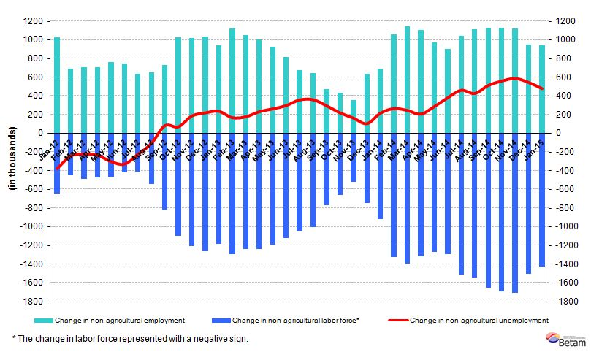
Source: TurkSTAT; Betam

Unemployment decreased

According to seasonally adjusted data thousand in the period of January 2015, nonagricultural labor force increased by 136 thousand compared to the period of December 2014, and reached 23 million 897 thousand (Figure 2, Table 1). Nonagricultural employment increased by 143 thousand and recorded 20 million 984 thousand. Hence, the number of persons unemployed in nonagricultural sectors decreased by 7 thousand and nonagricultural unemployment rate in the period of January 2015 compared to the period of December 2014 decreased to 12.4 percent.

Figure 2 Seasonally adjusted non-agricultural labor force, employment, and unemployment
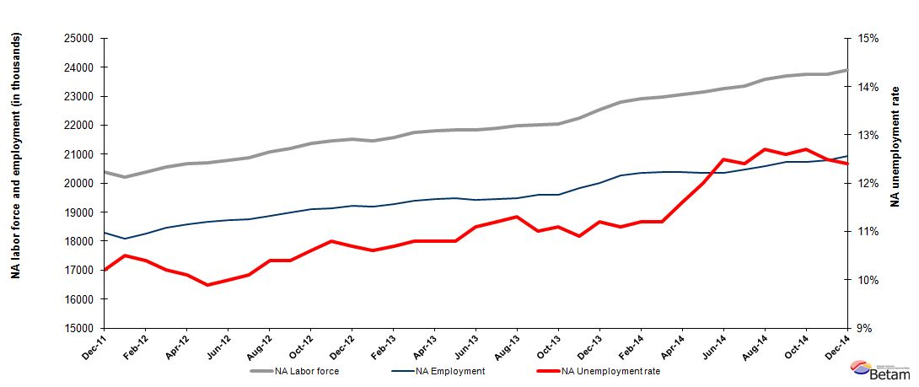
Source: TurkStat, Betam

Nonagricultural unemployment rate will increase by 0.1 percentage points

Kariyer.net's application per vacancy series used in the Betam forecasting model is depicted in Figure 3. According to Kariyer.net data, applications per vacancy remained constant in the period of January 2015 (average of December 2014, January 2015, and February 2015). Moreover, Betam's forecasting model predicts that non-agricultural unemployment will increase by 0.1 percentage points in the next period (February 2015).

Figure 3 Seasonally adjusted nonagricultural unemployment rate and application per vacancy
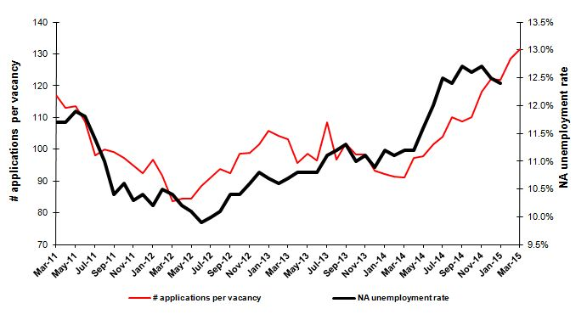
Source: Kariyer.net, TurkStat, Betam

Employment increased in manufacturing and services

According to seasonally adjusted labor market series, in the period of January 2015 employment increased in all sectors except construction (Figure 4, Table2). While manufacturing employment decreased by 7 thousand, employment increased by 13 thousand, 83 thousand, and 66 thousand in agriculture, manufacturing, and services, respectively. It would be said that the decrease in unemployment has been driven by the increase in manufacturing employment. The data on the period of January 2015 corresponds to the average of December 2014, January and February 2015 months. Industrial production index increased both in December 2014 and in February 2015. In parallel with industrial production index, increasing manufacturing employment has supported overall employment.

Figure 4 Employment by sectors (in thousands)
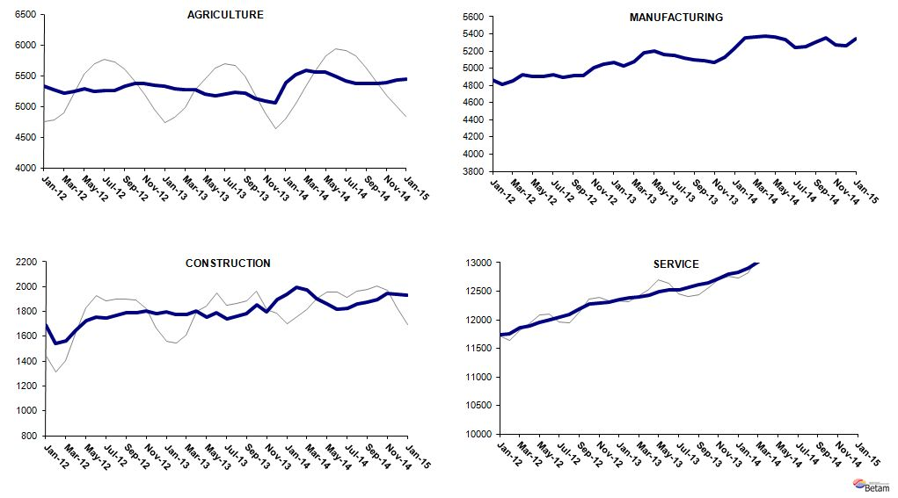
Source: TurkStat, Betam
Table 1 Seasonally adjusted non-agricultural labor force indicators (in thousands)*
 | Labor force | Employment | Unemployment | Unemployment rate | Monthly changes
December-11 | 20276 | 18167 | 2109 | 10.4% | Labor force | Employment | Unemployment
January-12 | 20379 | 18300 | 2079 | 10.2% | 103 | 133 | -30
February-12 | 20217 | 18094 | 2123 | 10.5% | -162 | -206 | 44
March-12 | 20390 | 18269 | 2121 | 10.4% | 173 | 175 | -2
April-12 | 20565 | 18467 | 2098 | 10.2% | 175 | 198 | -23
May-12 | 20676 | 18588 | 2088 | 10.1% | 112 | 121 | -9
June-12 | 20705 | 18655 | 2050 | 9.9% | 28 | 67 | -39
July-12 | 20796 | 18716 | 2080 | 10.0% | 91 | 61 | 30
August-12 | 20869 | 18761 | 2108 | 10.1% | 73 | 45 | 28
September-12 | 21070 | 18879 | 2191 | 10.4% | 202 | 118 | 84
October-12 | 21186 | 18983 | 2203 | 10.4% | 116 | 104 | 12
November-12 | 21361 | 19097 | 2264 | 10.6% | 175 | 114 | 61
December-12 | 21461 | 19143 | 2318 | 10.8% | 99 | 46 | 53
January-13 | 21525 | 19222 | 2303 | 10.7% | 64 | 79 | -15
February-13 | 21468 | 19192 | 2276 | 10.6% | -58 | -30 | -28
March-13 | 21572 | 19264 | 2308 | 10.7% | 105 | 72 | 33
April-13 | 21754 | 19405 | 2349 | 10.8% | 182 | 141 | 41
May-13 | 21808 | 19453 | 2355 | 10.8% | 54 | 48 | 6
June-13 | 21835 | 19477 | 2358 | 10.8% | 27 | 24 | 3
July-13 | 21843 | 19418 | 2425 | 11.1% | 7 | -59 | 66
August-13 | 21905 | 19452 | 2453 | 11.2% | 63 | 34 | 29
September-13 | 21971 | 19488 | 2483 | 11.3% | 65 | 36 | 29
October-13 | 22011 | 19590 | 2421 | 11.0% | 41 | 102 | -61
November-13 | 22035 | 19589 | 2446 | 11.1% | 24 | -1 | 25
December-13 | 22258 | 19832 | 2426 | 10.9% | 223 | 243 | -20
January-14 | 22527 | 20004 | 2523 | 11.2% | 269 | 172 | 97
February-14 | 22800 | 20269 | 2531 | 11.1% | 273 | 265 | 8
March-14 | 22917 | 20350 | 2567 | 11.2% | 117 | 81 | 36
April-14 | 22964 | 20392 | 2572 | 11.2% | 47 | 42 | 5
May-14 | 23060 | 20385 | 2675 | 11.6% | 96 | -7 | 103
June-14 | 23136 | 20360 | 2776 | 12.0% | 76 | -25 | 101
July-14 | 23275 | 20366 | 2909 | 12.5% | 139 | 6 | 133
August-14 | 23362 | 20465 | 2897 | 12.4% | 86 | 99 | -13
September-14 | 23575 | 20581 | 2994 | 12.7% | 213 | 116 | 97
October-14 | 23706 | 20719 | 2987 | 12.6% | 131 | 138 | -7
November-14 | 23753 | 20736 | 3017 | 12.7% | 47 | 17 | 30
December-14 | 23761 | 20791 | 2970 | 12.5% | 9 | 55 | -46
January-15 | 23897 | 20934 | 2963 | 12.4% | 136 | 143 | -7
Source: TurkStat, Betam

Table 2 Seasonally adjusted employment by sectors (in thousands)*
 | Agriculture | Manufacturing | Construction | Service | Monthly changes
December-11 | 5325 | 4873 | 1633 | 11660 | Agriculture | Manufacturing | Construction | Service
January-12 | 5328 | 4864 | 1691 | 11746 | 3 | -9 | 58 | 86
February-12 | 5272 | 4808 | 1539 | 11747 | -56 | -56 | -152 | 1
March-12 | 5219 | 4850 | 1565 | 11854 | -53 | 42 | 26 | 107
April-12 | 5246 | 4930 | 1647 | 11891 | 27 | 80 | 82 | 37
May-12 | 5290 | 4908 | 1728 | 11952 | 44 | -22 | 81 | 61
June-12 | 5248 | 4900 | 1753 | 12002 | -42 | -8 | 25 | 50
July-12 | 5261 | 4926 | 1748 | 12042 | 13 | 26 | -5 | 40
August-12 | 5260 | 4892 | 1771 | 12098 | -1 | -34 | 23 | 56
September-12 | 5325 | 4911 | 1787 | 12180 | 65 | 19 | 16 | 82
October-12 | 5366 | 4917 | 1790 | 12275 | 41 | 6 | 3 | 95
November-12 | 5371 | 5003 | 1803 | 12290 | 5 | 86 | 13 | 15
December-12 | 5345 | 5051 | 1781 | 12310 | -26 | 48 | -22 | 20
January-13 | 5322 | 5073 | 1799 | 12351 | -23 | 22 | 18 | 41
February-13 | 5291 | 5023 | 1779 | 12390 | -31 | -50 | -20 | 39
March-13 | 5276 | 5083 | 1773 | 12407 | -15 | 60 | -6 | 17
April-13 | 5266 | 5176 | 1802 | 12427 | -10 | 93 | 29 | 20
May-13 | 5205 | 5200 | 1753 | 12499 | -61 | 24 | -49 | 72
June-13 | 5178 | 5163 | 1791 | 12522 | -27 | -37 | 38 | 23
July-13 | 5195 | 5146 | 1742 | 12530 | 17 | -17 | -49 | 8
August-13 | 5222 | 5117 | 1759 | 12576 | 27 | -29 | 17 | 46
September-13 | 5219 | 5096 | 1784 | 12608 | -3 | -21 | 25 | 32
October-13 | 5131 | 5090 | 1855 | 12645 | -88 | -6 | 71 | 37
November-13 | 5086 | 5064 | 1797 | 12728 | -45 | -26 | -58 | 83
December-13 | 5058 | 5131 | 1895 | 12806 | -28 | 67 | 98 | 78
January-14 | 5389 | 5232 | 1936 | 12836 | 331 | 101 | 41 | 30
February-14 | 5520 | 5359 | 1996 | 12914 | 131 | 127 | 60 | 78
March-14 | 5592 | 5365 | 1972 | 13013 | 72 | 6 | -24 | 99
April-14 | 5558 | 5373 | 1903 | 13116 | -34 | 8 | -69 | 103
May-14 | 5560 | 5364 | 1863 | 13157 | 2 | -9 | -40 | 41
June-14 | 5487 | 5332 | 1815 | 13213 | -73 | -32 | -48 | 56
July-14 | 5414 | 5243 | 1823 | 13300 | -73 | -89 | 8 | 87
August-14 | 5376 | 5257 | 1861 | 13348 | -38 | 14 | 38 | 48
September-14 | 5366 | 5306 | 1878 | 13397 | -10 | 49 | 17 | 49
October-14 | 5370 | 5353 | 1897 | 13469 | 4 | 47 | 19 | 72
November-14 | 5388 | 5273 | 1943 | 13520 | 18 | -80 | 46 | 51
December-14 | 5432 | 5266 | 1938 | 13588 | 44 | -7 | -5 | 68
January-15 | 5445 | 5349 | 1931 | 13654 | 13 | 83 | -7 | 66
Source: TurkStat, Betam

*Prof. Dr. Seyfettin Gürsel, Betam, Director, seyfettin.gursel@eas.bahcesehir.edu.tr
∗∗ Yrd. Doç. Dr. Gokce Uysal, Betam, Assistant Director, gokce.uysal@eas.bahcesehir.edu.tr
∗∗∗Mine Durmaz, Betam, Research Assistant, mine.durmaz@eas.bahcesehir.edu.tr
Betam has ben calculating aplication per vacancy using series released by Kariyer.net for a while. Seasonal and calendar adjustment procedure is aplied to aplication per vacancy series. A decrease in aplications per vacancy may be caused by an increase in vacancies or by a decrease in the number of aplications. An increase in vacancies signals economic growth while decreasing number of aplications indicates a decrease in number of people loking for a job. Monthly labor market series released by TurkStat is the average of thre months. Therefore, aplication per vacancy statistics calculated using Kariyer.net series is the average of thre months as wel.
For detailed information on Soybilgen's forecasting model, please see Betam Research Brief 168 titled as "Kariyer.net Verisiyle Kısa Vadeli Tarım Dışı İşsizlik Tahmini" http://betam.bahcesehir.edu.tr/tr/2014/06/kariyer-net-verisiyle-kisa-vadeli-tarim-disi-issizlik-tahmini/
Employment in each sector is seasonally adjusted separately. Hence the sum of these series may differ from the seasonally adjusted series of total employment. The difference stems from the non-linearity of the seasonal adjustment process. .

