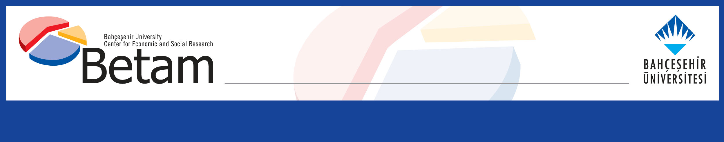
Research Brief 09/27
05.03.2009

NOTE ON THE ADVANCEMENT OF TURKEY’S EU MEMBERSHIP NEGOTIATIONS

Cengiz Aktar and Barış Gençer Baykan

betam has updated the general tableau that it has prepared and shared with public on May 2008. It is understood from its latest decisions that the Turkish government will take European Union (EU) affairs more seriously. A new Ministry of State for EU Affairs is established and Mr. Egemen Bağış, a politician close to Prime Minister, has been appointed as Chief Negotiator and Minister. We hope that the government does not fail to fulfill the expectations and four years of inertia can be caught up with.

The government should get ready after the local elections at the end of March 2009. It is crucial to support the ongoing negotiations that are proceeding quite successfully in Cyprus as a likely solution in Cyprus can break the negotiation deadlock. Indeed there are 8 chapters suspended by the EU Council since December 2006 due to the fact that Turkey did not ratify the Additional Protocol to the customs union between EU and Turkey prepared for the inclusion of the Republic of Cyprus as a new Member State since 2004. This decision will be revised later this year.

As of 30 January 2009, Croatia opened 22 chapters and closed 7 of these. In the same period Turkey opened 10 chapters and concluded 1 of these. In the next months Croatia will open 9 more chapters and close 2 already open chapters. Thus, only 2 chapters will remain to be opened. (This does not include Institutions and Other chapters that are opened and closed at the end of the negotiations). However, Turkey has 10 chapters still in the screening process which is the very first phase of the negotiations.

Indeed, Croatia has no obstacles like Cyprus issue and opposing governments –Austrian and French - to Turkey’s full membership. Nevertheless, we should remember the row between Croatia and Slovenia over the disputed Savudria Bay near Portorose. Croatia has made great efforts for EU harmonization and negotiations processes. Turkey, in contrast, appeared reluctant to take the process seriously since the 17th December 2004 when it has been decided that Turkey will start membership negotiations. Since then Turkish bureaucracy kept working hard on the issue but the government has shown no sign of its determination as in 2003 and 2004.

By the beginning of 2009 Turkey has only 2 chapters to be opened in the next months: Social Policy and Taxation. Taxation chapter is a good example for the deceleration in EU affairs. This chapter could not be opened although it was ready by the beginning of 2008. The elimination of differential between the tax rate on Turkish alcoholic drinks and the tax rate on drinks imported from the EU was an opening benchmark of the Taxation chapter. However the benchmark couldn’t be fulfilled as neither Turkish fiscal authority nor Turkish producers were ready to make concessions.

Behind this deadlock, lie Turkey’s doubt on EU membership and its perception of opening benchmarks as concessions without return. The ambiguity of the full membership will continue to affect negatively this kind of early concessions from Turkish industry and business world, imposed as opening benchmarks.

Besides, Education and Culture chapter was ready to be opened by 29 May 2006 but France and Greece imposing the education of non-Turkish languages blocked the opening of this chapter. However, this opening benchmark does not really belong to that chapter and will be included in Judiciary and Fundamental Rights chapter. This move would ensure the opening of that chapter.

Moreover, Economic and Monetary Policy chapter is ready since 4 May 2007 but its opening is blocked by France as it is directly related to full membership. There is no progress in France’s opposition to this chapter and other four which are Agriculture and Rural Development, Institutions, Regional Policy and Financial and Budgetary Provisions.

On the other hand, the 8 chapters suspended by the decision of the EU Council since December 2006 are Free Movement of Goods, Right of Establishment and Freedom to Provide Services, Financial Services, Agriculture and Rural Development, Fisheries, Transport, Customs Union and External Relations.

One should also bear in mind that the progress in open chapters are extremely slow. There are closing benchmarks alongside the opening benchmarks for the open chapters. Therefore, it is very likely that it won’t be easy for Turkey to close many open chapters.

Dr. Cengiz Aktar, Bahçeşehir University, Head of EU Departement caktar@bahcesehir.edu.tr
Barış Gençer Baykan, Research Assistant, baris.baykan@bahcesehir.edu.tr

