Labor Market Outlook:

March 2015

16 March 2015

DECREASE IN UNEMPLOYMENT
Seyfettin Gürsel* Gökçe Uysal∗∗ and Mine Durmaz∗∗∗

Abstract

Seasonally adjusted labor market data shows that compared to previous period nonagricultural unemployment rate decreased from 12.7 to 12.5 (0.2 percentage points) in the period of December 2014. Labor market data shows that the increase in nonagricultural employment is larger than that in nonagricultural labor force and thus, nonagricultural unemployment decreases. Betam forecasting model based on Kariyer.net data estimates that nonagricultural employment rate will increase slightly in the period of January 2015.

Slower increases in nonagricultural employment and labor force

According to data released by TurkStat in the period of December 2014, nonagricultural labor force increased by 1 million 499 thousand (6.8 percent), nonagricultural employment increased by 951 thousand (4.8 percent) and nonagricultural unemployment increased by 548 thousand compared the same period in the previous year (Figure1).Increases in nonagricultural labor force and employment, which accelerated since second half of 2014, slowed down in December 2014.

Figure 1 Year-on-year changes in non-agricultural labor force, employment, and unemployment
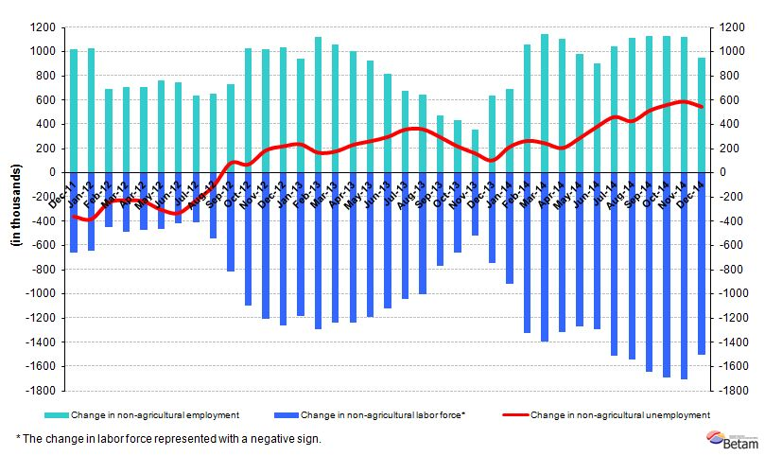
Source: TurkSTAT, Betam

Employment increased faster than labor force

According to seasonally adjusted data thousand in the period of December 2014, nonagricultural labor force increased by 12 thousand compared to the period of November 2014, and reached 23 million 752 thousand (Figure 2, Table 1). Nonagricultural employment increased by 58 thousand and recorded 20 million 783 thousand. Hence, the number of persons unemployed in nonagricultural sectors increased by 46 thousand and nonagricultural unemployment rate in the period of December 2014 compared to the period of November 2014 decreased to 12.5 percent.

Figure 2 Seasonally adjusted non-agricultural labor force, employment, and unemployment
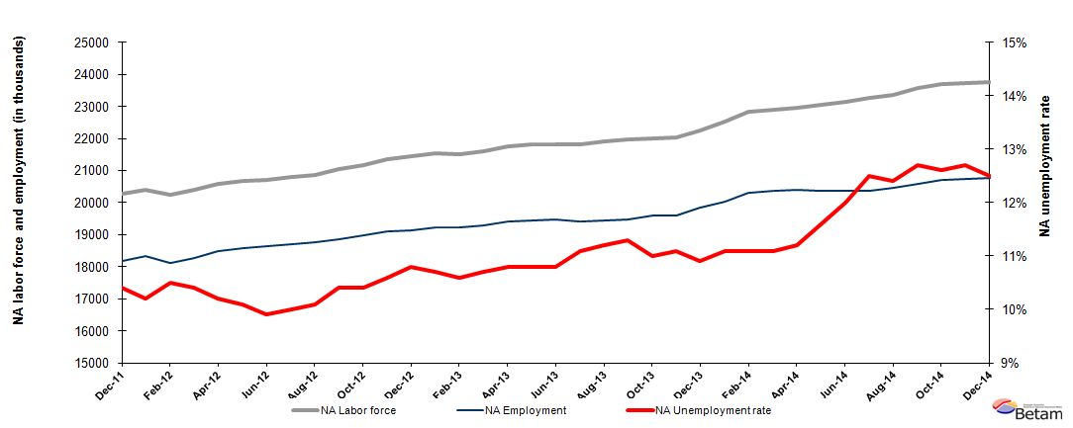
Source: TurkStat, Betam

Nonagricultural unemployment will increase in January 2015

Kariyer.net's application per vacancy series used in the Betam forecasting model is depicted in Figure 3. According to Kariyer.net data, applications per vacancy remained constant in the period of January 2015 (average of December 2014, January 2015, and February 2015). Moreover, Betam's forecasting model predicts that non-agricultural unemployment will slightly increase in the next period (January 2015).

Figure 3 Seasonally adjusted non-agricultural unemployment rate and application per vacancy
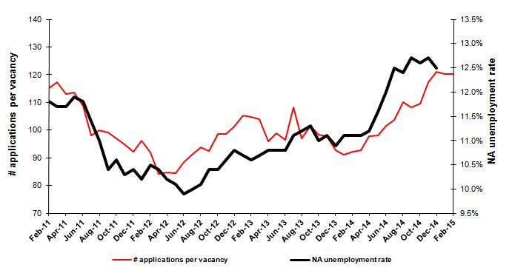
Source: Kariyer.net, TurkStat, Betam
Employment in services continues to increase

According to seasonally adjusted labor market series, employment increased in agriculture and services and decreased in manufacturing and construction in December 2014 (Figure 4, Table2). Employment increased by 67 thousand and 42 thousand in services and agriculture respectively and decreased by 7 thousand in manufacturing. Moreover, the increase in construction is limited to 1 thousand during this period. The main force behind the decrease in unemployment is the employment expansion in services.

Figure 4 Employment by sectors (in thousands)
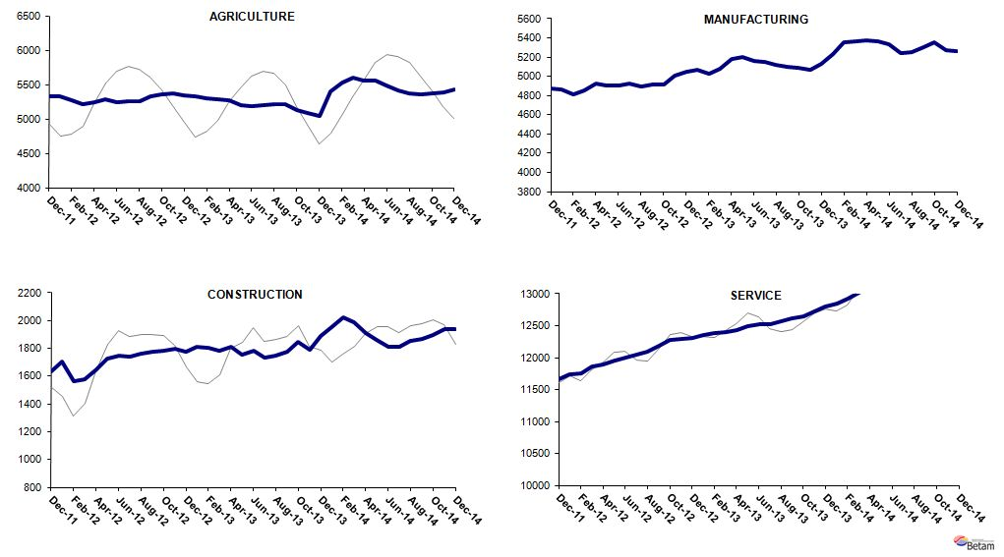
Source: TurkStat, Betam

Table 1 Seasonally adjusted non-agricultural labor force indicators (in thousands)*
 | Labor force | Employment | Unemployment | Unemployment rate | Monthly changes
November-11 | 20244 | 18159 | 2085 | 10.3% | Labor force | Employment | Unemployment
December-11 | 20276 | 18167 | 2109 | 10.4% | 32 | 8 | 24
January-12 | 20398 | 18317 | 2081 | 10.2% | 122 | 150 | -28
February-12 | 20241 | 18116 | 2125 | 10.5% | -156 | -201 | 45
March-12 | 20403 | 18281 | 2122 | 10.4% | 162 | 165 | -3
April-12 | 20571 | 18473 | 2098 | 10.2% | 168 | 192 | -24
May-12 | 20675 | 18587 | 2088 | 10.1% | 104 | 114 | -10
June-12 | 20701 | 18652 | 2049 | 9.9% | 26 | 65 | -39
July-12 | 20788 | 18709 | 2079 | 10.0% | 86 | 57 | 29
August-12 | 20860 | 18753 | 2107 | 10.1% | 72 | 44 | 28
September-12 | 21060 | 18870 | 2190 | 10.4% | 200 | 117 | 83
October-12 | 21177 | 18975 | 2202 | 10.4% | 117 | 105 | 12
November-12 | 21352 | 19089 | 2263 | 10.6% | 175 | 114 | 61
December-12 | 21452 | 19135 | 2317 | 10.8% | 99 | 46 | 53
January-13 | 21542 | 19237 | 2305 | 10.7% | 90 | 102 | -12
February-13 | 21496 | 19217 | 2279 | 10.6% | -46 | -20 | -26
March-13 | 21586 | 19276 | 2310 | 10.7% | 90 | 59 | 31
April-13 | 21760 | 19410 | 2350 | 10.8% | 174 | 134 | 40
May-13 | 21806 | 19451 | 2355 | 10.8% | 46 | 41 | 5
June-13 | 21828 | 19471 | 2357 | 10.8% | 22 | 20 | 2
July-13 | 21831 | 19408 | 2423 | 11.1% | 3 | -63 | 66
August-13 | 21896 | 19444 | 2452 | 11.2% | 65 | 36 | 29
September-13 | 21963 | 19481 | 2482 | 11.3% | 66 | 37 | 29
October-13 | 22006 | 19585 | 2421 | 11.0% | 43 | 104 | -61
November-13 | 22029 | 19584 | 2445 | 11.1% | 24 | -1 | 25
December-13 | 22254 | 19828 | 2426 | 10.9% | 224 | 244 | -20
January-14 | 22523 | 20023 | 2500 | 11.1% | 269 | 195 | 74
February-14 | 22832 | 20298 | 2534 | 11.1% | 309 | 275 | 34
March-14 | 22908 | 20365 | 2543 | 11.1% | 75 | 67 | 8
April-14 | 22971 | 20398 | 2573 | 11.2% | 63 | 33 | 30
May-14 | 23055 | 20381 | 2674 | 11.6% | 85 | -17 | 102
June-14 | 23128 | 20353 | 2775 | 12.0% | 73 | -28 | 101
July-14 | 23259 | 20352 | 2907 | 12.5% | 131 | -1 | 132
August-14 | 23348 | 20453 | 2895 | 12.4% | 89 | 101 | -12
September-14 | 23562 | 20570 | 2992 | 12.7% | 214 | 117 | 97
October-14 | 23695 | 20709 | 2986 | 12.6% | 132 | 139 | -7
November-14 | 23740 | 20725 | 3015 | 12.7% | 45 | 16 | 29
December-14 | 23752 | 20783 | 2969 | 12.5% | 12 | 58 | -46
Source: TurkStat, Betam

Table 2 Seasonally adjusted employment by sectors (in thousands)*
 | Agriculture | Manufacturing | Construction | Service | Monthly changes
November-11 | 5408 | 4870 | 1666 | 11623 | Agriculture | Manufacturing | Construction | Service
December-11 | 5325 | 4873 | 1633 | 11660 | -83 | 3 | -33 | 37
January-12 | 5330 | 4864 | 1707 | 11746 | 5 | -9 | 74 | 86
February-12 | 5275 | 4808 | 1562 | 11747 | -55 | -56 | -145 | 1
March-12 | 5221 | 4850 | 1577 | 11854 | -54 | 42 | 15 | 107
April-12 | 5248 | 4930 | 1652 | 11891 | 27 | 80 | 75 | 37
May-12 | 5292 | 4908 | 1727 | 11952 | 44 | -22 | 75 | 61
June-12 | 5249 | 4900 | 1749 | 12003 | -43 | -8 | 22 | 51
July-12 | 5260 | 4926 | 1740 | 12042 | 11 | 26 | -9 | 39
August-12 | 5259 | 4892 | 1763 | 12098 | -1 | -34 | 23 | 56
September-12 | 5324 | 4911 | 1779 | 12180 | 65 | 19 | 16 | 82
October-12 | 5363 | 4917 | 1783 | 12276 | 39 | 6 | 4 | 96
November-12 | 5367 | 5003 | 1795 | 12290 | 4 | 86 | 12 | 14
December-12 | 5340 | 5051 | 1774 | 12310 | -27 | 48 | -21 | 20
January-13 | 5326 | 5073 | 1813 | 12351 | -14 | 22 | 39 | 41
February-13 | 5295 | 5023 | 1803 | 12390 | -31 | -50 | -10 | 39
March-13 | 5280 | 5083 | 1786 | 12407 | -15 | 60 | -17 | 17
April-13 | 5269 | 5176 | 1808 | 12427 | -11 | 93 | 22 | 20
May-13 | 5207 | 5200 | 1752 | 12500 | -62 | 24 | -56 | 73
June-13 | 5179 | 5163 | 1786 | 12522 | -28 | -37 | 34 | 22
July-13 | 5195 | 5146 | 1732 | 12530 | 16 | -17 | -54 | 8
August-13 | 5221 | 5117 | 1751 | 12576 | 26 | -29 | 19 | 46
September-13 | 5216 | 5096 | 1776 | 12609 | -5 | -21 | 25 | 33
October-13 | 5127 | 5090 | 1849 | 12645 | -89 | -6 | 73 | 36
November-13 | 5079 | 5064 | 1792 | 12729 | -48 | -26 | -57 | 84
December-13 | 5050 | 5131 | 1892 | 12805 | -29 | 67 | 100 | 76
January-14 | 5393 | 5232 | 1952 | 12839 | 343 | 101 | 60 | 34
February-14 | 5526 | 5359 | 2023 | 12916 | 133 | 127 | 71 | 77
March-14 | 5598 | 5365 | 1986 | 13014 | 72 | 6 | -37 | 98
April-14 | 5563 | 5373 | 1909 | 13117 | -35 | 8 | -77 | 103
May-14 | 5564 | 5364 | 1860 | 13157 | 1 | -9 | -49 | 40
June-14 | 5489 | 5332 | 1808 | 13213 | -75 | -32 | -52 | 56
July-14 | 5415 | 5243 | 1811 | 13298 | -74 | -89 | 3 | 85
August-14 | 5375 | 5257 | 1852 | 13345 | -40 | 14 | 41 | 47
September-14 | 5363 | 5306 | 1871 | 13394 | -12 | 49 | 19 | 49
October-14 | 5365 | 5353 | 1893 | 13464 | 2 | 47 | 22 | 70
November-14 | 5380 | 5273 | 1938 | 13514 | 15 | -80 | 45 | 50
December-14 | 5422 | 5266 | 1937 | 13581 | 42 | -7 | -1 | 67
Source: TurkStat, Betam

*Prof. Dr. Seyfettin Gürsel, Betam, Director, seyfettin.gursel@eas.bahcesehir.edu.tr
∗∗ Yrd. Doç. Dr. Gokce Uysal, Betam, Vice Director, gokce.uysal@eas.bahcesehir.edu.tr
∗∗∗Mine Durmaz, Betam, Research Assistant, mine.durmaz@eas.bahcesehir.edu.tr
Betam has ben calculating aplication per vacancy using series released by Kariyer.net for a while. Seasonal and calendar adjustment procedure is aplied to aplication per vacancy series. A decrease in aplications per vacancy may be caused by an increase in vacancies or by a decrease in the number of aplications. An increase in vacancies signals economic growth while decreasing number of aplications indicates a decrease in number of people loking for a job. Monthly labor market series released by TurkStat is the average of thre months. Therefore, aplication per vacancy statistics calculated using Kariyer.net series is the average of thre months as wel.
For detailed information on Soybilgen's forecasting model, please see Betam Research Brief 168 titled as "Kariyer.net Verisiyle Kısa Vadeli Tarım Dışı İşsizlik Tahmini" http://betam.bahcesehir.edu.tr/tr/2014/06/kariyer-net-verisiyle-kisa-vadeli-tarim-disi-issizlik-tahmini/
Employment in each sector is seasonally adjusted separately. Hence the sum of these series may differ from the seasonally adjusted series of total employment. The difference stems from the non-linearity of the seasonal adjustment process. .

