Labor Market Outlook:

February 2015

16 February 2015

SLIGHT INCREASE IN NonAGRICULTURAL UNEMPLOYMENT
Seyfettin Gürsel* Gökçe Uysal∗∗ and Mine Durmaz∗∗∗

Abstract

Seasonally adjusted labor market data shows that nonagricultural unemployment rate has reached 12.8 percent, increasing by 0.1 percentage points in the period of November 2014 compared to the period of October 2014. During last three months, nonagricultural unemployment rate has stagnated at the level of 12.8 percent. In the period of November 2014, employment in manufacturing sector decreased by 80 thousand and employment in services and in construction expanded by 50 and 46 thousand, respectively. According to Betam forecasting model based on Kariyer.net data, nonagricultural unemployment rate will remain constant in the period of December 2014.

Nonagricultural labor force and employment continue to soar

According to data released by TurkStat in the period of November 2014, nonagricultural labor force increased by 1 million 710 thousand (7.8 percent), non-agricultural employment increased by 1 million 119 thousand (5.7 percent) and non-agricultural unemployment increased by 591 thousand compared the same period in the previous year (Figure1). In spite of steady increases in non-agricultural employment, the number of unemployed persons in non-agricultural sectors has been rising parallel to rapidly increasing non-agricultural employment since July 2014.

Figure 1 Year-on-year changes in non-agricultural labor force, employment, and unemployment
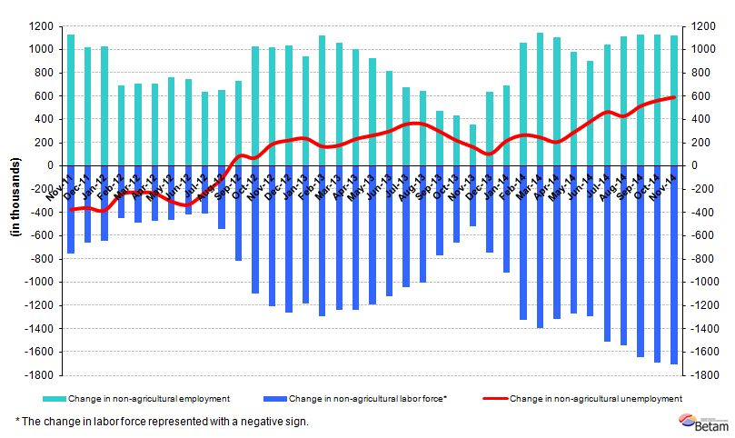
Source: TurkStat, Betam

Nonagricultural unemployment is holding its level

According to seasonally adjusted data, in the period of November 2014 non-agricultural labor force increased by 46 thousand compared to the period of October 2014, and reached 23 million 764 thousand (Figure 2, Table 1). Non-agricultural employment increased by 16 thousand and recorded 20 million 722 thousand. Hence, the number of persons unemployed in non-agricultural sectors increased by 30 thousand and non-agricultural unemployment rate in this period compared to previous period increased slightly to 12.8 percent. Seasonally adjusted non-agricultural unemployment rate holds its level at about 12.8 percent since September 2014.

Figure 2 Seasonally adjusted non-agricultural labor force, employment, and unemployment
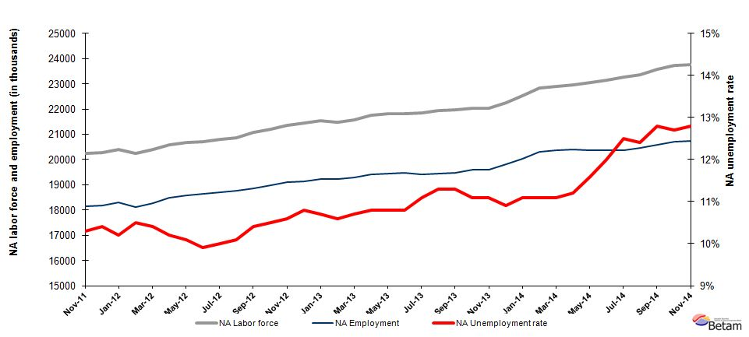
Source: TurkStat, Betam

Stagnating trend will continue in December period

Kariyer.net's application per vacancy series used in the Betam forecasting model is depicted in Figure 3. According to Kariyer.net data, applications per vacancy increased slightly in the period of December 2015 (average of November 2014, December 2014, and January 2015). Moreover, Betam's forecasting model predicts that non-agricultural unemployment will remain constant in the next period (December 2015). In previous month, Betam's forecasting model had predicted an increase in nonagricultural unemployment in November 2014. Indeed, nonagricultural unemployment rate increased even if slightly (from 12.7 percent to 12.8 percent).

Figure 3 Seasonally adjusted non-agricultural unemployment rate and application per vacancy
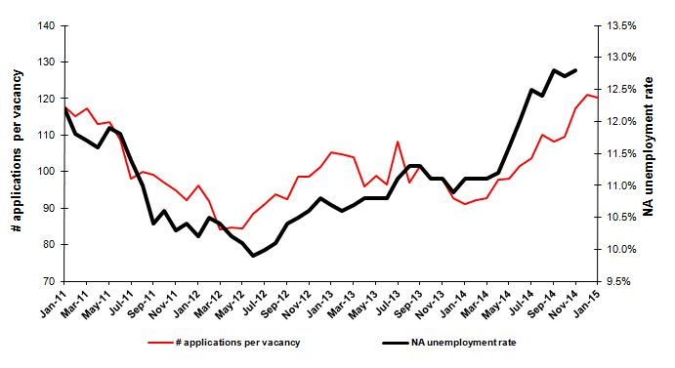
Source: Kariyer.net, TurkStat, Betam
Losses in manufacturing employment

According to seasonally adjusted labor market series, employment increased in all sectors except manufacturing in November 2014 (Figure 4, Table2). In line with the industrial production index, manufacturing employment decreased by 80 thousand. Employment in services and construction increased by 50 thousand and 46 thousand respectively.

Figure 4 Employment by sectors (in thousands)
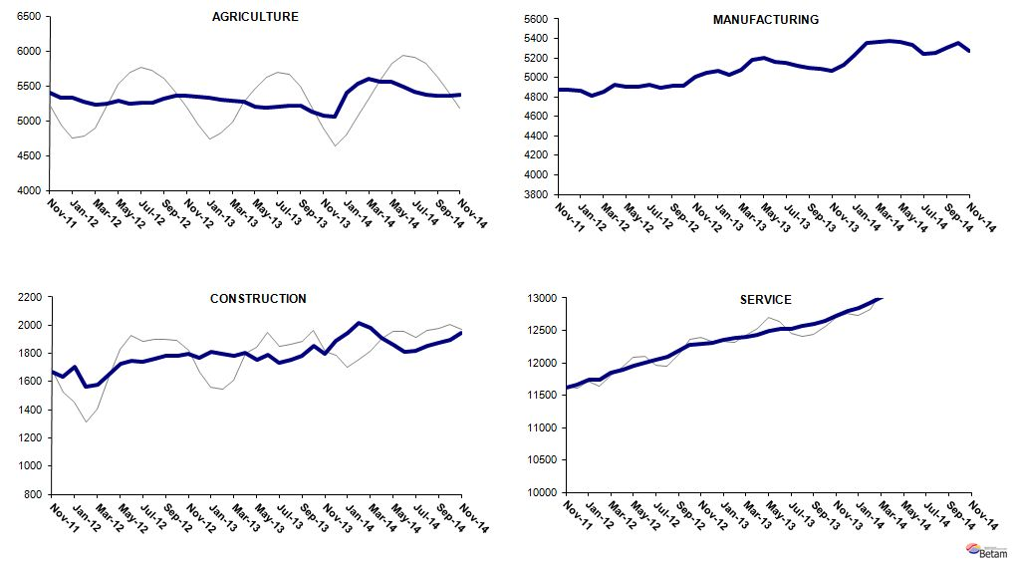
Source: TurkStat, Betam

Table 1 Seasonally adjusted non-agricultural labor force indicators (in thousands)*
 | Labor force | Employment | Unemployment | Unemployment rate | Monthly changes
September-11 | 20211 | 18109 | 2102 | 10.4% | Labor force | Employment | Unemployment
October-11 | 20149 | 18013 | 2136 | 10.6% | -62 | -96 | 34
November-11 | 20244 | 18159 | 2085 | 10.3% | 95 | 146 | -51
December-11 | 20273 | 18165 | 2108 | 10.4% | 29 | 6 | 23
January-12 | 20394 | 18314 | 2080 | 10.2% | 121 | 149 | -28
February-12 | 20241 | 18116 | 2125 | 10.5% | -153 | -198 | 45
March-12 | 20403 | 18281 | 2122 | 10.4% | 162 | 165 | -3
April-12 | 20570 | 18472 | 2098 | 10.2% | 167 | 191 | -24
May-12 | 20675 | 18587 | 2088 | 10.1% | 105 | 115 | -10
June-12 | 20700 | 18651 | 2049 | 9.9% | 25 | 64 | -39
July-12 | 20788 | 18709 | 2079 | 10.0% | 87 | 58 | 29
August-12 | 20861 | 18754 | 2107 | 10.1% | 73 | 45 | 28
September-12 | 21061 | 18871 | 2190 | 10.4% | 200 | 117 | 83
October-12 | 21201 | 18975 | 2226 | 10.5% | 140 | 104 | 36
November-12 | 21352 | 19089 | 2263 | 10.6% | 151 | 114 | 37
December-12 | 21448 | 19132 | 2316 | 10.8% | 96 | 43 | 53
January-13 | 21536 | 19232 | 2304 | 10.7% | 88 | 100 | -12
February-13 | 21491 | 19213 | 2278 | 10.6% | -45 | -19 | -26
March-13 | 21583 | 19274 | 2309 | 10.7% | 92 | 61 | 31
April-13 | 21758 | 19408 | 2350 | 10.8% | 174 | 134 | 40
May-13 | 21807 | 19452 | 2355 | 10.8% | 49 | 44 | 5
June-13 | 21830 | 19472 | 2358 | 10.8% | 22 | 20 | 2
July-13 | 21835 | 19411 | 2424 | 11.1% | 5 | -61 | 66
August-13 | 21924 | 19447 | 2477 | 11.3% | 90 | 36 | 54
September-13 | 21965 | 19483 | 2482 | 11.3% | 41 | 36 | 5
October-13 | 22031 | 19586 | 2445 | 11.1% | 66 | 103 | -37
November-13 | 22031 | 19586 | 2445 | 11.1% | 0 | 0 | 0
December-13 | 22250 | 19825 | 2425 | 10.9% | 219 | 239 | -20
January-14 | 22515 | 20016 | 2499 | 11.1% | 265 | 191 | 74
February-14 | 22825 | 20291 | 2534 | 11.1% | 309 | 275 | 34
March-14 | 22902 | 20360 | 2542 | 11.1% | 78 | 69 | 9
April-14 | 22967 | 20395 | 2572 | 11.2% | 65 | 35 | 30
May-14 | 23055 | 20381 | 2674 | 11.6% | 88 | -14 | 102
June-14 | 23130 | 20354 | 2776 | 12.0% | 74 | -27 | 101
July-14 | 23263 | 20355 | 2908 | 12.5% | 133 | 1 | 132
August-14 | 23349 | 20454 | 2895 | 12.4% | 86 | 99 | -13
September-14 | 23588 | 20569 | 3019 | 12.8% | 239 | 115 | 124
October-14 | 23718 | 20706 | 3012 | 12.7% | 130 | 137 | -7
November-14 | 23764 | 20722 | 3042 | 12.8% | 46 | 16 | 30
Source: TurkStat, Betam

Table 2 Seasonally adjusted employment by sectors (in thousands)*
 | Agriculture | Manufacturing | Construction | Service | Monthly changes
September-11 | 5384 | 4866 | 1763 | 11480 | Agriculture | Manufacturing | Construction | Service
October-11 | 5416 | 4823 | 1681 | 11510 | 32 | -43 | -82 | 30
November-11 | 5405 | 4870 | 1667 | 11622 | -11 | 47 | -14 | 112
December-11 | 5328 | 4873 | 1633 | 11659 | -77 | 3 | -34 | 37
January-12 | 5333 | 4864 | 1706 | 11745 | 5 | -9 | 73 | 86
February-12 | 5276 | 4808 | 1562 | 11746 | -57 | -56 | -144 | 1
March-12 | 5222 | 4850 | 1577 | 11853 | -54 | 42 | 15 | 107
April-12 | 5249 | 4930 | 1652 | 11890 | 27 | 80 | 75 | 37
May-12 | 5292 | 4908 | 1728 | 11951 | 43 | -22 | 76 | 61
June-12 | 5249 | 4900 | 1750 | 12001 | -43 | -8 | 22 | 50
July-12 | 5260 | 4926 | 1742 | 12041 | 11 | 26 | -8 | 40
August-12 | 5257 | 4892 | 1764 | 12097 | -3 | -34 | 22 | 56
September-12 | 5321 | 4911 | 1780 | 12179 | 64 | 19 | 16 | 82
October-12 | 5360 | 4917 | 1784 | 12274 | 39 | 6 | 4 | 95
November-12 | 5363 | 5003 | 1797 | 12289 | 3 | 86 | 13 | 15
December-12 | 5345 | 5051 | 1772 | 12309 | -18 | 48 | -25 | 20
January-13 | 5330 | 5073 | 1810 | 12349 | -15 | 22 | 38 | 40
February-13 | 5297 | 5023 | 1800 | 12389 | -33 | -50 | -10 | 40
March-13 | 5281 | 5083 | 1785 | 12406 | -16 | 60 | -15 | 17
April-13 | 5270 | 5176 | 1807 | 12425 | -11 | 93 | 22 | 19
May-13 | 5207 | 5200 | 1753 | 12498 | -63 | 24 | -54 | 73
June-13 | 5179 | 5163 | 1788 | 12521 | -28 | -37 | 35 | 23
July-13 | 5194 | 5146 | 1736 | 12528 | 15 | -17 | -52 | 7
August-13 | 5218 | 5117 | 1755 | 12575 | 24 | -29 | 19 | 47
September-13 | 5212 | 5096 | 1780 | 12607 | -6 | -21 | 25 | 32
October-13 | 5122 | 5090 | 1852 | 12644 | -90 | -6 | 72 | 37
November-13 | 5073 | 5064 | 1795 | 12726 | -49 | -26 | -57 | 82
December-13 | 5057 | 5131 | 1888 | 12806 | -16 | 67 | 93 | 80
January-14 | 5400 | 5232 | 1945 | 12839 | 343 | 101 | 57 | 33
February-14 | 5529 | 5359 | 2016 | 12916 | 129 | 127 | 71 | 77
March-14 | 5600 | 5365 | 1982 | 13014 | 71 | 6 | -34 | 98
April-14 | 5564 | 5373 | 1907 | 13115 | -36 | 8 | -75 | 101
May-14 | 5564 | 5364 | 1862 | 13155 | 0 | -9 | -45 | 40
June-14 | 5488 | 5332 | 1812 | 13210 | -76 | -32 | -50 | 55
July-14 | 5413 | 5243 | 1818 | 13295 | -75 | -89 | 6 | 85
August-14 | 5371 | 5257 | 1857 | 13340 | -42 | 14 | 39 | 45
September-14 | 5357 | 5306 | 1876 | 13388 | -14 | 49 | 19 | 48
October-14 | 5358 | 5353 | 1897 | 13456 | 1 | 47 | 21 | 68
November-14 | 5372 | 5273 | 1943 | 13506 | 14 | -80 | 46 | 50
Source: TurkStat, Betam

*Prof. Dr. Seyfettin Gürsel, Betam, Director, seyfettin.gursel@eas.bahcesehir.edu.tr
∗∗ Yrd. Doç. Dr. Gokce Uysal, Betam, Vice Director, gokce.uysal@eas.bahcesehir.edu.tr
∗∗∗Mine Durmaz, Betam, Research Assistant, mine.durmaz@eas.bahcesehir.edu.tr
Betam has ben calculating aplication per vacancy using series released by Kariyer.net for a while. Seasonal and calendar adjustment procedure is aplied to aplication per vacancy series. A decrease in aplications per vacancy may be caused by an increase in vacancies or by a decrease in the number of aplications. An increase in vacancies signals economic growth while decreasing number of aplications indicates a decrease in number of people loking for a job. Monthly labor market series released by TurkStat is the average of thre months. Therefore, aplication per vacancy statistics calculated using Kariyer.net series is the average of thre months as wel.
For detailed information on Soybilgen's forecasting model, please see Betam Research Brief 168 titled as "Kariyer.net Verisiyle Kısa Vadeli Tarım Dışı İşsizlik Tahmini" http://betam.bahcesehir.edu.tr/tr/2014/06/kariyer-net-verisiyle-kisa-vadeli-tarim-disi-issizlik-tahmini/
Employment in each sector is seasonally adjusted separately. Hence the sum of these series may differ from the seasonally adjusted series of total employment. The difference stems from the non-linearity of the seasonal adjustment process. .

