Labor Market Outlook:

January 2015

15 January 2015

NonAGRICULTURAL UNEMPLOYMENT STAGNATED
Seyfettin Gürsel* Gökçe Uysal∗∗ and Mine Durmaz∗∗∗

Abstract

Seasonally adjusted labor market data shows that nonagricultural unemployment rate remained constant at the level of 12.7 percent. According to the Betam forecasting model based on Kariyer.net data, nonagricultural employment rate will increase in the period of November 2014.

Nonagricultural labor force is soaring

According to data released by TurkStat in the period of October 2014, non-agricultural labor force increased by 1 million 692 thousand (7.7 percent), non-agricultural employment increased by 1 million 128 thousand (5.8 percent) and non-agricultural unemployment increased by 564 thousand compared to the same period in the previous year (Figure1). Although yearly increases in nonagricultural employment amount more than 1 million during last four periods, they are not enough to absorb accelerating expansion in nonagricultural labor force. Indeed, increases in nonagricultural labor force have grown gradually and the increase in nonagricultural labor force in the period of October 2015 was recorded to be more than 1.5 million. On the other hand, we think that these changes should be interpreted cautiously due to the revision in labor market statistics held in February 2014.

Figure 1 Year-on-year changes in non-agricultural labor force, employment, and unemployment
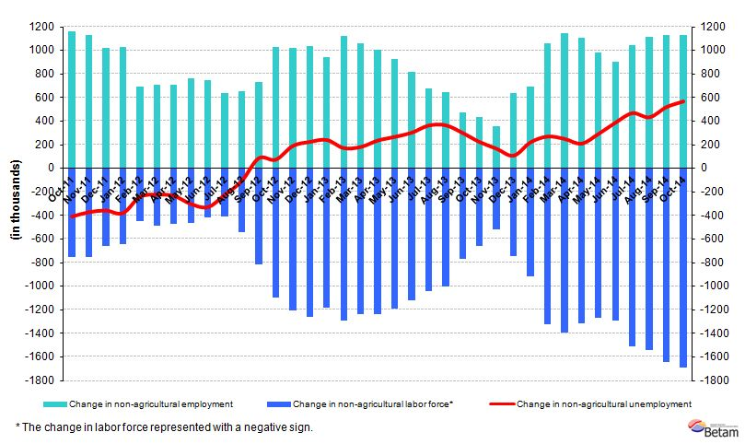
Source: TurkSTAT, Betam

Non-agricultural unemployment rate remained constant

According to seasonally adjusted data, non-agricultural labor force increased by 151 in the period of October 2014 compared to the period of September 2014, and reached 23 million 716 thousand (Figure 2, Table 1). Nonagricultural employment recorded 20 million 704 thousand, increasing by 132 thousand. Hence, the number of persons unemployed in nonagricultural sectors increased by 19 thousand and in October 2014 nonagricultural unemployment rate remained constant at the level of 12.7 percent compared to September 2014.

Figure 2 Seasonally adjusted non-agricultural labor force, employment, and unemployment
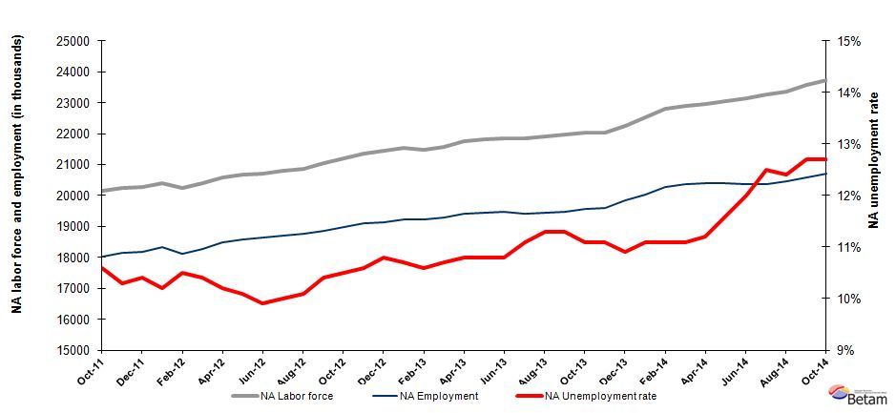
Source: TurkSTAT, Betam

Unemployment will increase in the period of November 2014

Kariyer.net's application per vacancy series used in the Betam forecasting model is depicted in Figure 3. Strikingly, the increase in applications per vacancy series has accelerated since the period of August 2014. Kariyer.net data indicates that this increase will continue in the period of November 2014. Moreover, Betam's forecasting model predicts that non-agricultural unemployment will increase in the next period (November 2014).

Figure 3 Seasonally adjusted non-agricultural unemployment rate and application per vacancy
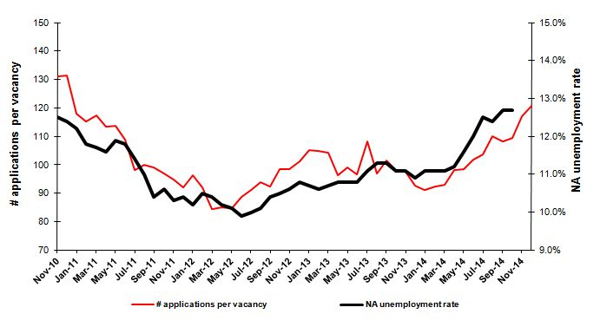
Source: Kariyer.net, TurkSTAT, Betam
Increasing employment in non-agricultural sectors

According to seasonally adjusted labor market series, employment increased in all sectors except the agriculture in the period of October 2014 (Figure 4, Table2). In this period, employment in manufacturing sector increased by 47 thousand and employment in service sector increased by 69 thousand.

Figure 4 Employment by sectors (in thousands)
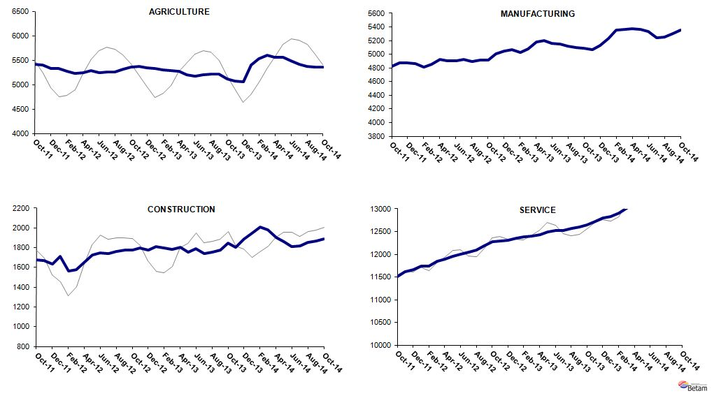
Source: TurkStat, Betam

Table 1 Seasonally adjusted non-agricultural labor force indicators (in thousands)*

 | Labor force | Employment | Unemployment | Unemployment rate | Monthly changes
September-11 | 20208 | 18106 | 2102 | 10.4% | Labor force | Employment | Unemployment
October-11 | 20148 | 18012 | 2136 | 10.6% | -60 | -94 | 34
November-11 | 20246 | 18161 | 2085 | 10.3% | 99 | 149 | -50
December-11 | 20276 | 18167 | 2109 | 10.4% | 29 | 6 | 23
January-12 | 20398 | 18317 | 2081 | 10.2% | 122 | 150 | -28
February-12 | 20245 | 18119 | 2126 | 10.5% | -153 | -198 | 45
March-12 | 20406 | 18284 | 2122 | 10.4% | 162 | 165 | -3
April-12 | 20571 | 18473 | 2098 | 10.2% | 165 | 189 | -24
May-12 | 20675 | 18587 | 2088 | 10.1% | 104 | 114 | -10
June-12 | 20699 | 18650 | 2049 | 9.9% | 24 | 63 | -39
July-12 | 20789 | 18710 | 2079 | 10.0% | 90 | 60 | 30
August-12 | 20858 | 18751 | 2107 | 10.1% | 69 | 41 | 28
September-12 | 21057 | 18867 | 2190 | 10.4% | 199 | 116 | 83
October-12 | 21197 | 18971 | 2226 | 10.5% | 140 | 104 | 36
November-12 | 21357 | 19093 | 2264 | 10.6% | 160 | 122 | 38
December-12 | 21452 | 19135 | 2317 | 10.8% | 95 | 42 | 53
January-13 | 21538 | 19233 | 2305 | 10.7% | 86 | 98 | -12
February-13 | 21489 | 19211 | 2278 | 10.6% | -49 | -22 | -27
March-13 | 21583 | 19274 | 2309 | 10.7% | 95 | 63 | 32
April-13 | 21759 | 19409 | 2350 | 10.8% | 176 | 135 | 41
May-13 | 21808 | 19453 | 2355 | 10.8% | 49 | 44 | 5
June-13 | 21832 | 19474 | 2358 | 10.8% | 24 | 21 | 3
July-13 | 21838 | 19414 | 2424 | 11.1% | 6 | -60 | 66
August-13 | 21923 | 19446 | 2477 | 11.3% | 85 | 32 | 53
September-13 | 21962 | 19480 | 2482 | 11.3% | 38 | 34 | 4
October-13 | 22025 | 19580 | 2445 | 11.1% | 63 | 100 | -37
November-13 | 22036 | 19590 | 2446 | 11.1% | 11 | 10 | 1
December-13 | 22254 | 19828 | 2426 | 10.9% | 218 | 238 | -20
January-14 | 22513 | 20014 | 2499 | 11.1% | 259 | 186 | 73
February-14 | 22818 | 20285 | 2533 | 11.1% | 305 | 271 | 34
March-14 | 22899 | 20357 | 2542 | 11.1% | 81 | 72 | 9
April-14 | 22967 | 20395 | 2572 | 11.2% | 69 | 38 | 31
May-14 | 23060 | 20385 | 2675 | 11.6% | 93 | -10 | 103
June-14 | 23135 | 20359 | 2776 | 12.0% | 75 | -26 | 101
July-14 | 23272 | 20363 | 2909 | 12.5% | 137 | 4 | 133
August-14 | 23354 | 20458 | 2896 | 12.4% | 82 | 95 | -13
September-14 | 23565 | 20572 | 2993 | 12.7% | 211 | 114 | 97
October-14 | 23716 | 20704 | 3012 | 12.7% | 151 | 132 | 19
Source: TurkStat, Betam

Table 2 Seasonally adjusted employment by sectors (in thousands)*

 | Agriculture | Manufacturing | Construction | Service | Monthly changes
September-11 | 5384 | 4866 | 1759 | 11480 | Agriculture | Manufacturing | Construction | Service
October-11 | 5414 | 4823 | 1679 | 11510 | 30 | -43 | -80 | 30
November-11 | 5406 | 4870 | 1669 | 11622 | -8 | 47 | -10 | 112
December-11 | 5329 | 4873 | 1635 | 11659 | -77 | 3 | -34 | 37
January-12 | 5333 | 4864 | 1709 | 11745 | 4 | -9 | 74 | 86
February-12 | 5276 | 4808 | 1565 | 11746 | -57 | -56 | -144 | 1
March-12 | 5222 | 4850 | 1580 | 11853 | -54 | 42 | 15 | 107
April-12 | 5249 | 4930 | 1653 | 11890 | 27 | 80 | 73 | 37
May-12 | 5292 | 4908 | 1728 | 11951 | 43 | -22 | 75 | 61
June-12 | 5249 | 4900 | 1749 | 12001 | -43 | -8 | 21 | 50
July-12 | 5259 | 4926 | 1742 | 12041 | 10 | 26 | -7 | 40
August-12 | 5257 | 4892 | 1762 | 12097 | -2 | -34 | 20 | 56
September-12 | 5320 | 4911 | 1777 | 12179 | 63 | 19 | 15 | 82
October-12 | 5358 | 4917 | 1779 | 12274 | 38 | 6 | 2 | 95
November-12 | 5365 | 5003 | 1800 | 12289 | 7 | 86 | 21 | 15
December-12 | 5346 | 5051 | 1775 | 12309 | -19 | 48 | -25 | 20
January-13 | 5331 | 5073 | 1811 | 12349 | -15 | 22 | 36 | 40
February-13 | 5298 | 5023 | 1799 | 12389 | -33 | -50 | -12 | 40
March-13 | 5281 | 5083 | 1785 | 12406 | -17 | 60 | -14 | 17
April-13 | 5269 | 5176 | 1807 | 12425 | -12 | 93 | 22 | 19
May-13 | 5207 | 5200 | 1755 | 12498 | -62 | 24 | -52 | 73
June-13 | 5178 | 5163 | 1790 | 12521 | -29 | -37 | 35 | 23
July-13 | 5193 | 5146 | 1739 | 12529 | 15 | -17 | -51 | 8
August-13 | 5217 | 5117 | 1754 | 12575 | 24 | -29 | 15 | 46
September-13 | 5211 | 5096 | 1777 | 12607 | -6 | -21 | 23 | 32
October-13 | 5120 | 5090 | 1845 | 12645 | -91 | -6 | 68 | 38
November-13 | 5077 | 5064 | 1802 | 12724 | -43 | -26 | -43 | 79
December-13 | 5060 | 5131 | 1892 | 12804 | -17 | 67 | 90 | 80
January-14 | 5402 | 5232 | 1945 | 12838 | 342 | 101 | 53 | 34
February-14 | 5530 | 5359 | 2011 | 12915 | 128 | 127 | 66 | 77
March-14 | 5600 | 5365 | 1979 | 13013 | 70 | 6 | -32 | 98
April-14 | 5563 | 5373 | 1906 | 13116 | -37 | 8 | -73 | 103
May-14 | 5563 | 5364 | 1864 | 13157 | 0 | -9 | -42 | 41
June-14 | 5487 | 5332 | 1814 | 13213 | -76 | -32 | -50 | 56
July-14 | 5411 | 5243 | 1821 | 13299 | -76 | -89 | 7 | 86
August-14 | 5369 | 5257 | 1855 | 13346 | -42 | 14 | 34 | 47
September-14 | 5354 | 5306 | 1870 | 13395 | -15 | 49 | 15 | 49
October-14 | 5354 | 5353 | 1887 | 13464 | 0 | 47 | 17 | 69
Source: TurkStat, Betam

*Prof. Dr. Seyfettin Gürsel, Betam, Director, seyfettin.gursel@eas.bahcesehir.edu.tr
∗∗ Yrd. Doç. Dr. Gokce Uysal, Betam, Vice Director, gokce.uysal@eas.bahcesehir.edu.tr
∗∗∗Mine Durmaz, Betam, Research Assistant, mine.durmaz@eas.bahcesehir.edu.tr
Betam has ben calculating aplication per vacancy using series released by Kariyer.net for a while. Seasonal and calendar adjustment procedure is aplied to aplication per vacancy series. A decrease in aplications per vacancy may be caused by an increase in vacancies or by a decrease in the number of aplications. An increase in vacancies signals economic growth while decreasing number of aplications indicates a decrease in number of people loking for a job. Monthly labor market series released by TurkStat is the average of thre months. Therefore, aplication per vacancy statistics calculated using Kariyer.net series is the average of thre months as wel.
For detailed information on Soybilgen's forecasting model, please see Betam Research Brief 168 titled as "Kariyer.net Verisiyle Kısa Vadeli Tarım Dışı İşsizlik Tahmini" http://betam.bahcesehir.edu.tr/tr/2014/06/kariyer-net-verisiyle-kisa-vadeli-tarim-disi-issizlik-tahmini/
Employment in each sector is seasonally adjusted separately. Hence the sum of these series may differ from the seasonally adjusted series of total employment. The difference stems from the non-linearity of the seasonal adjustment process. .

