

Labor Market Outlook:

October 2014

15 October 2014

RAPID INCREASE IN NON-AGRICULTURAL UNEMPLOYMENT CONTINUES

Seyfettin Gürsel* and Ayşenur Acar∗

Abstract

Seasonally adjusted labor market data shows that non-agricultural unemployment rate increased by 0.5 percentage points in the period of July 2014 compared to the period of June 2014, and reached 12.5 percent. Slight increase in non-agricultural employment was not enough to offset the strong increase in non-agricultural labor force. We observe a stagnation in construction employment. Employment losses in manufacturing sector were counterbalanced with the employment increases in service sector. Our forecasting model based on Kariyer.net series indicate that non-agricultural unemployment will continue to increase in the next period.

Rapid increase in non-agricultural labor force and slowing-down in non-agricultural employment

According to the data released by TurkSTAT, non-agricultural labor force increased by 1 million 510 thousand (6.9 percent) and non-agricultural employment increased by 1 million 46 thousand (5.4 percent) in the period of July 2014 (Figure 1). Consequently, the number of persons unemployed in non-agricultural sectors increased by 464 thousand. Non-agricultural employment increased below 1 million in the periods of May and June 2014. The increase in non-agricultural labor force in the period of July 2014 is the highest observed since the beginning of the monthly labor market series.

Figure 1 Year-on-year changes in non-agricultural labor force, employment and unemployment
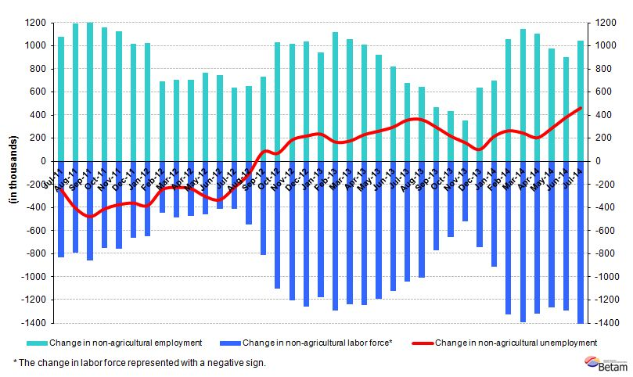
Source: TurkSTAT, Betam

Strong increase in non-agricultural unemployment

According to seasonally adjusted data, non-agricultural labor force increased by 133 thousand in the period of July 2014 compared to the period of June 2014, and reached 23 million 279 thousand (Figure 2, Table 1). Non-agricultural employment decreased by one thousand and reached 20 million 369 thousand. Hence, the number of persons unemployed in non-agricultural sectors increased by 132 thousand and non-agricultural unemployment rate increased by 0.5 percentage point and reached 12.5 percent. Non-agricultural unemployment that has been moving in the range of 10-11 percent January 2011 and reached its peak rate (12 percent) in the period of June 2014. In the period of July 2014, non-agricultural unemployment strongly increased by 0.5 percentage point and reached 12.5 percent. Low economic growth begins to sharply increase the unemployment rate.

Figure 2 Seasonally adjusted non-agricultural labor force, employment and unemployment
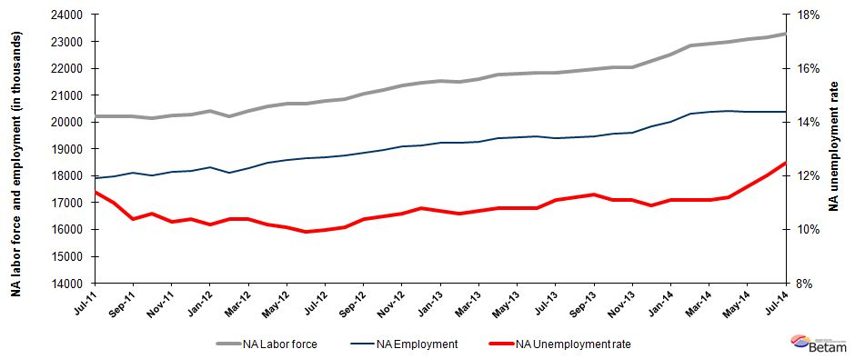

Source: TurkStat, Betam

Non-agricultural unemployment will continue to increase in the next period

Our calculations based on the seasonally adjusted application per vacancy statistics calculated using Kariyer.net series accurately predicted the direction of unemployment for the periods of June and July 2014. Parallel to our expectations, unemployment strongly increased in these two periods. The seasonally adjusted application per vacancy statistics calculated using Kariyer.net are presented in Figure 3. The application per vacancy has been increasing since January 2011, continued to increase in July and August 2014, but it decreases in September 2014. According to the our forecasting model, unemployment figure of August 2014 that is average of three months, we expect that unemployment will increase in the period of August 2014.

Figure 3 Seasonally adjusted non-agricultural unemployment rate and application per vacancy
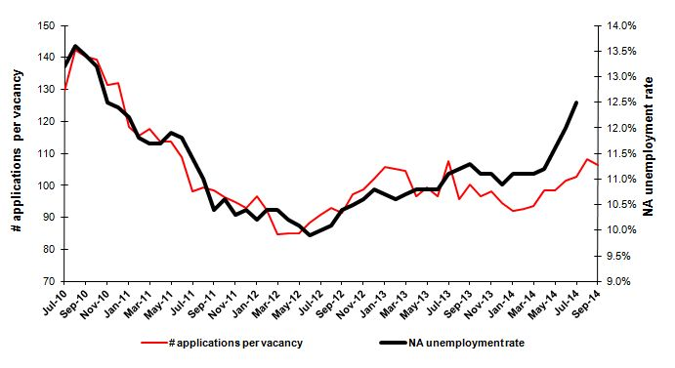
Source: Kariyer.net, TurkStat, Betam

Employment losses in manufacturing sector

Seasonally adjusted labor market series show that construction employment that has been decreasing since the last four periods, slightly increased by 2 thousand in the period July 2014 (Table 2, Figure 4). Employment in services increased by 89 thousand. However, employment in manufacturing sector that has been either decreasing or slightly increasing, decreased by 89 thousand. Employment increase in services was counterbalanced with the employment decline in manufacturing sector, and therefore, non-agricultural employment slightly increased in the period of July 2014. Even though slowdown in economic growth in the second quarter affects construction and manufacturing employment, one should be cautious in reading the labor market statistics as recent revisions caused a break in the series and the base effects continue (Figure 4). Increases in unemployment will probably slow down in the next period.

Figure 4 Employment by sectors (in thousands)
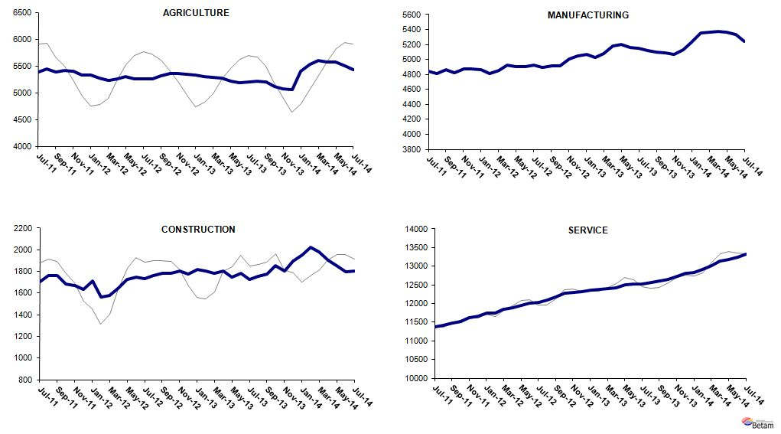
Source: TurkStat, Betam

Table 1 Seasonally adjusted non-agricultural labor force indicators (in thousands)
 | Labor force | Employment | Unemployment | Unemployment rate | Monthly changes
June-11 | 20192 | 17809 | 2383 | 11.8% | Labor force | Employment | Unemployment
July-11 | 20225 | 17919 | 2306 | 11.4% | 33 | 110 | -77
August-11 | 20208 | 17985 | 2223 | 11.0% | -17 | 66 | -83
September-11 | 20211 | 18109 | 2102 | 10.4% | 3 | 124 | -121
October-11 | 20150 | 18014 | 2136 | 10.6% | -61 | -95 | 34
November-11 | 20249 | 18163 | 2086 | 10.3% | 99 | 149 | -50
December-11 | 20277 | 18168 | 2109 | 10.4% | 28 | 5 | 23
January-12 | 20398 | 18317 | 2081 | 10.2% | 121 | 149 | -28
February-12 | 20220 | 18117 | 2103 | 10.4% | -178 | -200 | 22
March-12 | 20402 | 18280 | 2122 | 10.4% | 182 | 163 | 19
April-12 | 20569 | 18471 | 2098 | 10.2% | 167 | 191 | -24
May-12 | 20673 | 18585 | 2088 | 10.1% | 104 | 114 | -10
June-12 | 20696 | 18647 | 2049 | 9.9% | 23 | 62 | -39
July-12 | 20782 | 18704 | 2078 | 10.0% | 86 | 57 | 29
August-12 | 20860 | 18753 | 2107 | 10.1% | 78 | 49 | 29
September-12 | 21060 | 18870 | 2190 | 10.4% | 200 | 117 | 83
October-12 | 21202 | 18976 | 2226 | 10.5% | 142 | 106 | 36
November-12 | 21360 | 19096 | 2264 | 10.6% | 158 | 120 | 38
December-12 | 21456 | 19139 | 2317 | 10.8% | 96 | 43 | 53
January-13 | 21542 | 19237 | 2305 | 10.7% | 86 | 98 | -12
February-13 | 21493 | 19215 | 2278 | 10.6% | -49 | -22 | -27
March-13 | 21583 | 19274 | 2309 | 10.7% | 90 | 59 | 31
April-13 | 21756 | 19406 | 2350 | 10.8% | 172 | 132 | 40
May-13 | 21802 | 19447 | 2355 | 10.8% | 46 | 41 | 5
June-13 | 21823 | 19466 | 2357 | 10.8% | 21 | 19 | 2
July-13 | 21826 | 19403 | 2423 | 11.1% | 3 | -63 | 66
August-13 | 21893 | 19441 | 2452 | 11.2% | 67 | 38 | 29
September-13 | 21954 | 19473 | 2481 | 11.3% | 61 | 32 | 29
October-13 | 22029 | 19584 | 2445 | 11.1% | 75 | 111 | -36
November-13 | 22036 | 19590 | 2446 | 11.1% | 7 | 6 | 1
December-13 | 22259 | 19833 | 2426 | 10.9% | 223 | 243 | -20
January-14 | 22524 | 20024 | 2500 | 11.1% | 265 | 191 | 74
February-14 | 22832 | 20298 | 2534 | 11.1% | 308 | 274 | 34
March-14 | 22911 | 20368 | 2543 | 11.1% | 79 | 70 | 9
April-14 | 22980 | 20406 | 2574 | 11.2% | 69 | 38 | 31
May-14 | 23069 | 20393 | 2676 | 11.6% | 89 | -13 | 102
June-14 | 23145 | 20368 | 2777 | 12.0% | 76 | -25 | 101
July-14 | 23279 | 20369 | 2910 | 12.5% | 133 | 1 | 132
Source: TurkStat, Betam

Table 2 Seasonally adjusted employment by sector (in thousands)
 | Agriculture | Manufacturing | Construction | Service | Monthly changes
June-11 | 5364 | 4826 | 1681 | 11302 | Agriculture | Manufacturing | Construction | Service
July-11 | 5391 | 4846 | 1706 | 11367 | 27 | 20 | 25 | 65
August-11 | 5450 | 4816 | 1761 | 11408 | 59 | -30 | 55 | 41
September-11 | 5381 | 4866 | 1763 | 11481 | -69 | 50 | 2 | 73
October-11 | 5412 | 4823 | 1681 | 11510 | 31 | -43 | -82 | 29
November-11 | 5404 | 4870 | 1671 | 11622 | -8 | 47 | -10 | 112
December-11 | 5328 | 4873 | 1636 | 11659 | -76 | 3 | -35 | 37
January-12 | 5333 | 4864 | 1709 | 11745 | 5 | -9 | 73 | 86
February-12 | 5275 | 4808 | 1563 | 11746 | -58 | -56 | -146 | 1
March-12 | 5223 | 4850 | 1577 | 11853 | -52 | 42 | 14 | 107
April-12 | 5251 | 4930 | 1651 | 11890 | 28 | 80 | 74 | 37
May-12 | 5295 | 4908 | 1725 | 11951 | 44 | -22 | 74 | 61
June-12 | 5253 | 4900 | 1746 | 12002 | -42 | -8 | 21 | 51
July-12 | 5264 | 4926 | 1736 | 12041 | 11 | 26 | -10 | 39
August-12 | 5253 | 4892 | 1764 | 12097 | -11 | -34 | 28 | 56
September-12 | 5316 | 4911 | 1780 | 12179 | 63 | 19 | 16 | 82
October-12 | 5355 | 4917 | 1784 | 12275 | 39 | 6 | 4 | 96
November-12 | 5363 | 5003 | 1804 | 12289 | 8 | 86 | 20 | 14
December-12 | 5345 | 5051 | 1778 | 12309 | -18 | 48 | -26 | 20
January-13 | 5331 | 5073 | 1815 | 12350 | -14 | 22 | 37 | 41
February-13 | 5297 | 5023 | 1802 | 12389 | -34 | -50 | -13 | 39
March-13 | 5282 | 5083 | 1785 | 12406 | -15 | 60 | -17 | 17
April-13 | 5272 | 5176 | 1805 | 12426 | -10 | 93 | 20 | 20
May-13 | 5211 | 5200 | 1749 | 12499 | -61 | 24 | -56 | 73
June-13 | 5184 | 5163 | 1781 | 12521 | -27 | -37 | 32 | 22
July-13 | 5201 | 5146 | 1727 | 12530 | 17 | -17 | -54 | 9
August-13 | 5212 | 5117 | 1753 | 12571 | 11 | -29 | 26 | 41
September-13 | 5203 | 5096 | 1779 | 12598 | -9 | -21 | 26 | 27
October-13 | 5115 | 5090 | 1853 | 12641 | -88 | -6 | 74 | 43
November-13 | 5074 | 5064 | 1806 | 12720 | -41 | -26 | -47 | 79
December-13 | 5059 | 5131 | 1899 | 12803 | -15 | 67 | 93 | 83
January-14 | 5402 | 5232 | 1953 | 12839 | 343 | 101 | 54 | 36
February-14 | 5530 | 5359 | 2020 | 12919 | 128 | 127 | 67 | 80
March-14 | 5601 | 5365 | 1982 | 13022 | 71 | 6 | -38 | 103
April-14 | 5566 | 5373 | 1904 | 13129 | -35 | 8 | -78 | 107
May-14 | 5568 | 5364 | 1854 | 13175 | 2 | -9 | -50 | 46
June-14 | 5495 | 5332 | 1800 | 13236 | -73 | -32 | -54 | 61
July-14 | 5422 | 5243 | 1802 | 13325 | -73 | -89 | 2 | 89
Source: TurkStat, Betam

* Prof. Dr. Seyfettin Gürsel, Betam, Director, seyfettin.gursel@eas.bahcesehir.edu.tr
∗ Ayşenur Acar, PhD, Betam, Research Assistant, aysenur.acar@eas.bahcesehir.edu.tr
Betam has been calculating application per vacancy using series released by Kariyer.net for a while. Seasonal and calendar adjustment procedure is applied to application per vacancy series. A decrease in applications per vacancy may be caused by an increase in vacancies or by a decrease in the number of applications. An increase in vacancies signals economic growth while decreasing number of applications indicates a decrease in number of people looking for a job. Monthly labor market series released by TurkStat is the average of three months. Therefore, application per vacancy statistics calculated using Kariyer.net series is the average of three months as well.
Employment in each sector is seasonally adjusted separately. Hence the sum of these series may differ from the seasonally adjusted series of total employment. The difference stems from the non-linearity of the seasonal adjustment process.
Grey lines indicate seasonally adjusted series, where dark blue lines represent raw data.

