

Labor Market Outlook:

September 2014

15 September 2014

NON-AGRICULTURAL UNEMPLOYMENT CONTINUES
TO INCREASE RAPIDLY

Seyfettin Gürsel* , Zümrüt İmamoğlu∗ and Ayşenur Acar∗

Abstract

Seasonally adjusted labor market data shows that non-agricultural unemployment rate increased by 0.5 percentage point in the period of June 2014 compared to the period of May 2014, and reached 12 percent. In this period, we observe employment loses in all sectors, with the exception of the service sector. Employment growth could not counterbalance the increase in labor force, hence non-agricultural unemployment increased in this period. Non-agricultural unemployment rate that has stagnated in the range of 10-11 percent since January 2011, reached 12 percent in this period. Our forecasting model based on Kariyer.net data indicates that non-agricultural unemployment will continue to increase in the next period.

Slowing down in annual increases in non-agricultural employment

According to the data released by TurkSTAT, non-agricultural labor force increased by 1 million 288 thousand (5.9 percent) and non-agricultural employment increased by 904 thousand (4.6 percent) in the period of June 2014 (Figure 1). Consequently, the number of persons unemployed in non-agricultural sectors increased by 384 thousand. Annual increases in non-agricultural employment slowed down compared to the increases in non-agricultural labor force. While non-agricultural labor force has been increasing over 1 million since the last two periods, increases in non-agricultural employment has been below 1 million. Hence, number of unemployed increased in this period. Slowdown in the growth rate is reflecting on the labor market.

Figure 1 Year-on-year changes in non-agricultural labor force, employment and unemployment
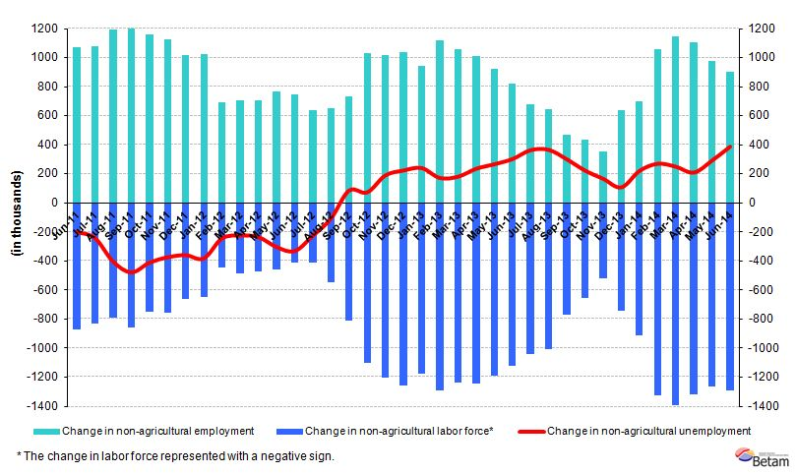
Source: TurkSTAT, Betam

Non-agricultural unemployment continues to increase

According to seasonally adjusted data, non-agricultural labor force increased by 104 thousand in the period of June 2014 compared to the period of May 2014, and reached 23 million 124 thousand (Figure 2, Table 1). Non-agricultural employment decreased by 24 thousand and reached 20 million 349 thousand. Hence, the number of persons unemployed in non-agricultural sectors increased by 128 thousand and non-agricultural unemployment rate increased by 0.5 percentage point and reached 12 percent. Given that the non-agricultural unemployment rate has been stagnating in the range of 10 to 11 percent, the increase to 12 percent is sizeable. We would like to remind our readers that non-agricultural unemployment rate reached its peak rate (16.9 percent) during 2009 financial crisis, then it rapidly decreased to the range of 10-11 percent. This rapid increase raises worries about the labor market. Moreover, unemployment forecasting model of Betam indicates that non-agricultural unemployment will continue to increase in the period of July 2014.

Figure 2 Seasonally adjusted non-agricultural labor force, employment and unemployment
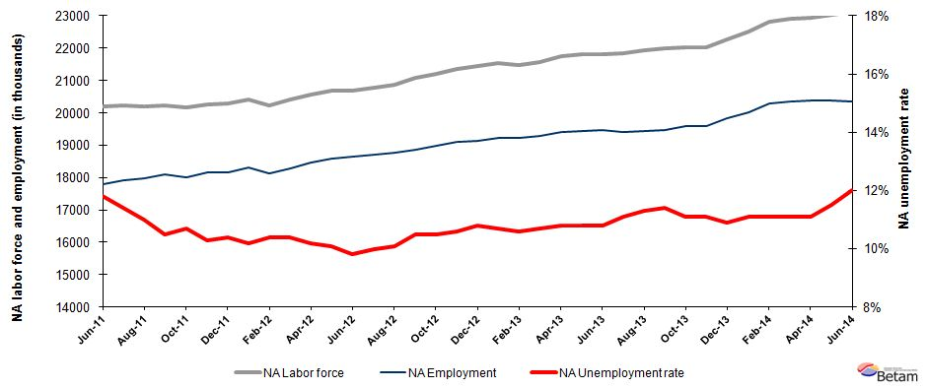

Source: TurkStat, Betam

According to Kariyer.net data, non-agricultural unemployment will continue to increase in the next period

Our calculations based on the seasonally adjusted application per vacancy statistics calculated using Kariyer.net series accurately predicted the direction of unemployment for the periods of May and June 2014. Parallel to our expectations , unemployment rapidly increased in these two periods. The seasonally adjusted application per vacancy statistics calculated using Kariyer.net are presented in Figure 3. The application per vacancy has increased since January 2011, continued to increase on July and August. According to the forecasting results, non-agricultural unemployment will increase in the period of July 2014 as well. Unemployment rate will continue to increase in the next period due to economic contraction observed in the second quarter of 2014

Figure 3 Seasonally adjusted non-agricultural unemployment rate and application per vacancy
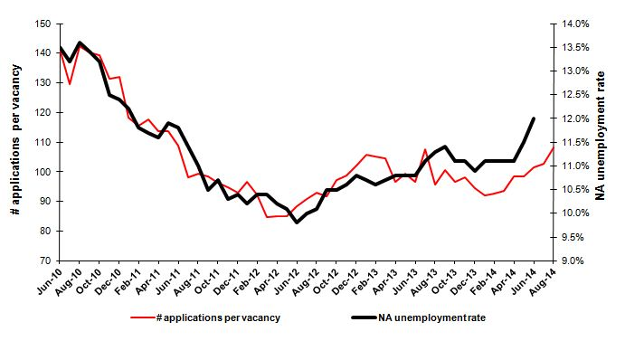
Source: Kariyer.net, TurkStat, Betam

Employment losses in all sectors, with the exception of service sector

Seasonally adjusted labor market series show that employment decreased in all sectors (except service sector) in the period of June2014 (Table 2, Figure 4). Service employment that has been decreasing since the last three periods, decreased by 54 thousand in the period of June 2014. Similarly, manufacturing employment that has been slightly decreasing in the period of May 2014, decreased by 32 thousand. Service employment increased by 62 thousand compared to the previous period. However, employment loses in manufacturing and construction sectors could not compensate the increase in manufacturing employment, hence non-agricultural employment decreased by 24 thousand. Employment losses in manufacturing and construction sectors could be taken as response of the economic slowdown in Turkey.

Figure 4 Employment by sectors (in thousands)
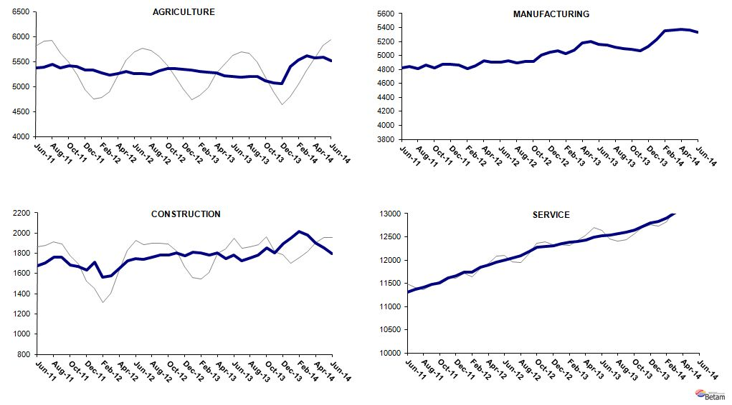
Source: TurkStat, Betam

Table 1 Seasonally adjusted non-agricultural labor force indicators (in thousands)
 | Labor force | Employment | Unemployment | Unemployment rate | Monthly changes
May-11 | 20166 | 17766 | 2400 | 11.9% | Labor force | Employment | Unemployment
June-11 | 20190 | 17808 | 2382 | 11.8% | 25 | 42 | -17
July-11 | 20225 | 17919 | 2306 | 11.4% | 34 | 111 | -77
August-11 | 20208 | 17985 | 2223 | 11.0% | -17 | 66 | -83
September-11 | 20234 | 18109 | 2125 | 10.5% | 26 | 124 | -98
October-11 | 20172 | 18014 | 2158 | 10.7% | -61 | -95 | 34
November-11 | 20249 | 18163 | 2086 | 10.3% | 76 | 149 | -73
December-11 | 20277 | 18168 | 2109 | 10.4% | 28 | 5 | 23
January-12 | 20398 | 18317 | 2081 | 10.2% | 121 | 149 | -28
February-12 | 20220 | 18117 | 2103 | 10.4% | -178 | -200 | 22
March-12 | 20403 | 18281 | 2122 | 10.4% | 183 | 164 | 19
April-12 | 20569 | 18471 | 2098 | 10.2% | 166 | 190 | -24
May-12 | 20671 | 18583 | 2088 | 10.1% | 102 | 112 | -10
June-12 | 20673 | 18647 | 2026 | 9.8% | 2 | 64 | -62
July-12 | 20782 | 18704 | 2078 | 10.0% | 109 | 57 | 52
August-12 | 20861 | 18754 | 2107 | 10.1% | 79 | 50 | 29
September-12 | 21085 | 18871 | 2214 | 10.5% | 224 | 117 | 107
October-12 | 21202 | 18976 | 2226 | 10.5% | 117 | 105 | 12
November-12 | 21360 | 19096 | 2264 | 10.6% | 158 | 120 | 38
December-12 | 21455 | 19138 | 2317 | 10.8% | 95 | 42 | 53
January-13 | 21541 | 19236 | 2305 | 10.7% | 86 | 98 | -12
February-13 | 21492 | 19214 | 2278 | 10.6% | -49 | -22 | -27
March-13 | 21582 | 19273 | 2309 | 10.7% | 90 | 59 | 31
April-13 | 21756 | 19406 | 2350 | 10.8% | 173 | 133 | 40
May-13 | 21802 | 19447 | 2355 | 10.8% | 46 | 41 | 5
June-13 | 21820 | 19463 | 2357 | 10.8% | 18 | 16 | 2
July-13 | 21836 | 19412 | 2424 | 11.1% | 16 | -51 | 67
August-13 | 21926 | 19448 | 2478 | 11.3% | 90 | 36 | 54
September-13 | 21983 | 19477 | 2506 | 11.4% | 57 | 29 | 28
October-13 | 22031 | 19586 | 2445 | 11.1% | 48 | 109 | -61
November-13 | 22038 | 19592 | 2446 | 11.1% | 7 | 6 | 1
December-13 | 22256 | 19830 | 2426 | 10.9% | 218 | 238 | -20
January-14 | 22517 | 20018 | 2499 | 11.1% | 262 | 188 | 74
February-14 | 22822 | 20289 | 2533 | 11.1% | 305 | 271 | 34
March-14 | 22898 | 20356 | 2542 | 11.1% | 75 | 67 | 8
April-14 | 22935 | 20389 | 2546 | 11.1% | 37 | 33 | 4
May-14 | 23020 | 20373 | 2647 | 11.5% | 86 | -16 | 102
June-14 | 23124 | 20349 | 2775 | 12.0% | 104 | -24 | 128
Source: TurkStat, Betam

Table 2 Seasonally adjusted employment by sector (in thousands)
 | Agriculture | Manufacturing | Construction | Service | Monthly changes
May-11 | 5310 | 4915 | 1660 | 11191 | Agriculture | Manufacturing | Construction | Service
June-11 | 5368 | 4826 | 1680 | 11301 | 58 | -89 | 20 | 110
July-11 | 5385 | 4846 | 1706 | 11367 | 17 | 20 | 26 | 66
August-11 | 5445 | 4816 | 1761 | 11408 | 60 | -30 | 55 | 41
September-11 | 5377 | 4866 | 1762 | 11480 | -68 | 50 | 1 | 72
October-11 | 5410 | 4823 | 1681 | 11510 | 33 | -43 | -81 | 30
November-11 | 5403 | 4870 | 1671 | 11622 | -7 | 47 | -10 | 112
December-11 | 5328 | 4873 | 1636 | 11659 | -75 | 3 | -35 | 37
January-12 | 5334 | 4864 | 1709 | 11745 | 6 | -9 | 73 | 86
February-12 | 5278 | 4808 | 1563 | 11746 | -56 | -56 | -146 | 1
March-12 | 5226 | 4850 | 1578 | 11853 | -52 | 42 | 15 | 107
April-12 | 5255 | 4930 | 1651 | 11890 | 29 | 80 | 73 | 37
May-12 | 5301 | 4908 | 1725 | 11951 | 46 | -22 | 74 | 61
June-12 | 5259 | 4900 | 1745 | 12001 | -42 | -8 | 20 | 50
July-12 | 5256 | 4926 | 1737 | 12041 | -3 | 26 | -8 | 40
August-12 | 5246 | 4892 | 1764 | 12097 | -10 | -34 | 27 | 56
September-12 | 5310 | 4911 | 1780 | 12179 | 64 | 19 | 16 | 82
October-12 | 5351 | 4917 | 1784 | 12274 | 41 | 6 | 4 | 95
November-12 | 5361 | 5003 | 1804 | 12289 | 10 | 86 | 20 | 15
December-12 | 5345 | 5051 | 1778 | 12309 | -16 | 48 | -26 | 20
January-13 | 5332 | 5073 | 1814 | 12349 | -13 | 22 | 36 | 40
February-13 | 5301 | 5023 | 1801 | 12389 | -31 | -50 | -13 | 40
March-13 | 5287 | 5083 | 1784 | 12406 | -14 | 60 | -17 | 17
April-13 | 5278 | 5176 | 1805 | 12425 | -9 | 93 | 21 | 19
May-13 | 5219 | 5200 | 1749 | 12498 | -59 | 24 | -56 | 73
June-13 | 5194 | 5163 | 1781 | 12519 | -25 | -37 | 32 | 21
July-13 | 5188 | 5146 | 1729 | 12537 | -6 | -17 | -52 | 18
August-13 | 5201 | 5117 | 1755 | 12576 | 13 | -29 | 26 | 39
September-13 | 5195 | 5096 | 1780 | 12602 | -6 | -21 | 25 | 26
October-13 | 5109 | 5090 | 1853 | 12643 | -86 | -6 | 73 | 41
November-13 | 5070 | 5064 | 1806 | 12721 | -39 | -26 | -47 | 78
December-13 | 5058 | 5131 | 1898 | 12801 | -12 | 67 | 92 | 80
January-14 | 5404 | 5232 | 1951 | 12835 | 346 | 101 | 53 | 34
February-14 | 5535 | 5359 | 2018 | 12912 | 131 | 127 | 67 | 77
March-14 | 5609 | 5365 | 1980 | 13011 | 74 | 6 | -38 | 99
April-14 | 5577 | 5373 | 1902 | 13114 | -32 | 8 | -78 | 103
May-14 | 5582 | 5364 | 1854 | 13155 | 5 | -9 | -48 | 41
June-14 | 5510 | 5332 | 1800 | 13217 | -72 | -32 | -54 | 62
Source: TurkStat, Betam

* Prof. Dr. Seyfettin Gürsel, Betam, Director, seyfettin.gursel@eas.bahcesehir.edu.tr
∗ Zümrüt İmamoğlu, PhD, Betam, Research Associate, zumrut.imamoglu@eas.bahcesehir.edu.tr
∗∗ Ayşenur Acar, PhD, Betam, Research Assistant, aysenur.acar@eas.bahcesehir.edu.tr
Betam has been calculating application per vacancy using series released by Kariyer.net for a while. Seasonal and calendar adjustment procedure is applied to application per vacancy series. A decrease in applications per vacancy may be caused by an increase in vacancies or by a decrease in the number of applications. An increase in vacancies signals economic growth while decreasing number of applications indicates a decrease in number of people looking for a job. Monthly labor market series released by TurkStat is the average of three months. Therefore, application per vacancy statistics calculated using Kariyer.net series is the average of three months as well.
Employment in each sector is seasonally adjusted separately. Hence the sum of these series may differ from the seasonally adjusted series of total employment. The difference stems from the non-linearity of the seasonal adjustment process.
Grey lines indicate seasonally adjusted series, where dark blue lines represent raw data.

