

# Labor Market Outlook:

# August 2014

### 15 August 2014

**LARGE INCREASE IN UnEMPLOYMENT**

Seyfettin Gürsel[1]* Mine Durmaz [2]** and Melike Kökkızıl[3]***

**Abstract**

Seasonally adjusted labor market data shows that non-agricultural unemployment rate has reached 11.5 percent, increasing by 0.4 percentage points in the period of May 2014 compared to the period of April 2014. During the same period, non-agricultural employment decreased by 11 thousand while non-agricultural labor force increased by 91 thousand. Employment in construction and industrial sectors decreased by 45 thousand and 9 thousand, respectively. However, employment in services expanded by 41 thousand. Data on the month of May, which covers April-May-June months, reveals that unemployment is increasing parallel to the slowdown in economic growth in second quarter of the year. According to our forecasting based on Kariyer.net data, unemployment rate will continue to increase in the period of June 2014.

**The decrease in employment**

According to data released by TurkStat, non-agricultural labor force increased by 1 million 267 thousand (5.8 percent) and non-agricultural employment increased by 978 thousand (5 percent) in the period of May 2014 compared to the same period in the previous year (Figure 1). Consequently, the number of persons unemployed in non-agricultural sectors increased by 289 thousand. Annual changes are affected by the revisions introduced in February 2014. Nevertheless, the decline in employment compared to the same period in the previous year is remarkable.

**Figure 1 Year-on-year changes in non-agricultural labor force, employment, and unemployment**

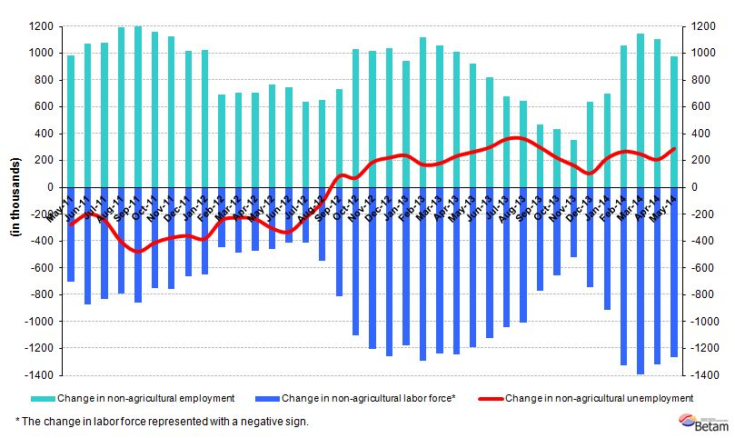

Source: TurkStat, **Betam**

**Large increase in non-agricultural unemployment by 0.4 percent points**

According to seasonally adjusted data, non-agricultural labor force increased by 91 thousand in the period of May 2014 compared to the period of April 2014, and reached 23 million 49 thousand (Figure 2, Table 1). Non-agricultural employment decreased by 11 thousand and reached 20 million 398 thousand. Hence, the number of persons unemployed in non-agricultural sectors increased by 102 thousand and non-agricultural unemployment rate increased by 0.4 percentage point compared to the period of April 2014 and reached 11.5 percent in the period of May 2014.

Figure 2 Seasonally adjusted non-agricultural labor force, employment, and unemployment

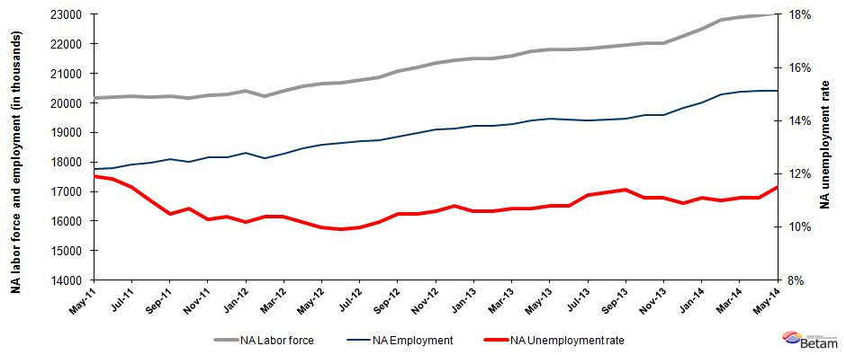

Source: TurkStat, **Betam**

**Unemployment will keep increasing in the period of June 2014**

Our calculations based on the seasonally adjusted application per vacancy statistics calculated using Kariyer.net[4] series indicate that we accurately predicted the direction of unemployment for the last two periods. The Kariyer.net series also indicates that non-agricultural unemployment might slightly increase in the period of April 2014. Also, in parallel with our expectations large increase in unemployment is recorded in the month of May, 2014.

Application per vacancy series, released by Kariyer.net, seen in the Figure 3 are used in the forecasting model. The series, which show an increasing trend since the month of January 2014, point out an increase in the unemployment rate in the period of June 2014 as well as in the period of May 2014. According to the results of our model, unemployment will increase in the period of June 2014 as it did in May 2014. [5] Betam's forecasts and current economic indicators show that economic growth significantly slowed down in the second quarter compared to first quarter of this year. Hence, our unemployment forecasting by using Kariyer.net series reveals that this slowdown will keep reflecting on the unemployment rate.

Figure 3 Seasonally adjusted non-agricultural unemployment rate and application per vacancy

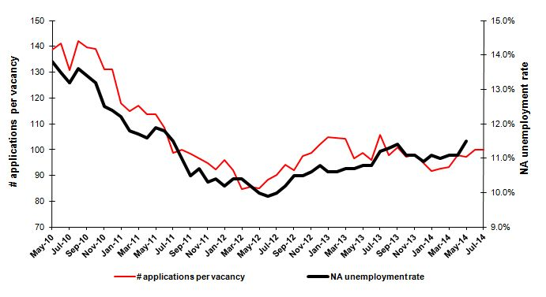

Source: Kariyer.net, TurkStat, Betam

**Employment in manufacturing and construction sectors decreased**

According to seasonally adjusted labor market series, in the period of May 2014 deceleration in the employment rise for service sector was observed and employment in this sector increased by 41 thousand (Figure 4, Table 2). [6]

The decline in construction sector employment remained unchanged since March 2014. Furthermore, employment in this sector decreased by 45 thousand in the period of May 2014. Also, in this period employment in manufacturing sector, where slight employment expansion has been recorded in previous two periods, started to fall and employment decreased by 9 thousand. Employment in services moves parallel to the manufacturing production index, which stagnated in the second quarter. Geopolitical risks related to third quarter of the year and decreasing export to Iraq signals that movements in manufacturing employment will be weak.

Figure 4 Employment by sectors (in thousands)

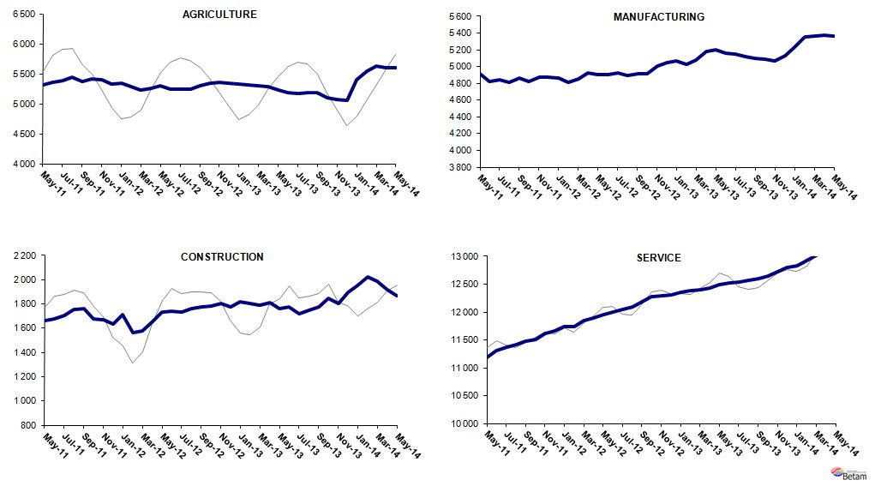

Source: TurkStat, Betam

Table 1 Seasonally adjusted non-agricultural labor force indicators (in thousands)*

|  |  |  |  |  |  |  |  |
| --- | --- | --- | --- | --- | --- | --- | --- |
|  | **Labor force** | **Employment** | **Unemployment** | **Unemployment rate** | **Monthly changes** | | |
| **April-11** | 20070 | 17742 | 2328 | 11,6% | **Labor force** | **Employment** | **Unemployment** |
| **May-11** | 20169 | 17769 | 2400 | 11,9% | 99 | 27 | 72 |
| **June-11** | 20187 | 17805 | 2382 | 11,8% | 18 | 36 | -18 |
| **July-11** | 20244 | 17916 | 2328 | 11,5% | 57 | 111 | -54 |
| **August-11** | 20204 | 17982 | 2222 | 11,0% | -40 | 66 | -106 |
| **September-11** | 20230 | 18106 | 2124 | 10,5% | 26 | 124 | -98 |
| **October-11** | 20171 | 18013 | 2158 | 10,7% | -59 | -93 | 34 |
| **November-11** | 20249 | 18163 | 2086 | 10,3% | 77 | 150 | -73 |
| **December-11** | 20278 | 18169 | 2109 | 10,4% | 29 | 6 | 23 |
| **January-12** | 20401 | 18320 | 2081 | 10,2% | 123 | 151 | -28 |
| **February-12** | 20224 | 18121 | 2103 | 10,4% | -177 | -199 | 22 |
| **March-12** | 20406 | 18284 | 2122 | 10,4% | 182 | 163 | 19 |
| **April-12** | 20575 | 18476 | 2099 | 10,2% | 168 | 192 | -24 |
| **May-12** | 20656 | 18590 | 2066 | 10,0% | 81 | 114 | -33 |
| **June-12** | 20690 | 18642 | 2048 | 9,9% | 35 | 52 | -17 |
| **July-12** | 20778 | 18700 | 2078 | 10,0% | 87 | 58 | 29 |
| **August-12** | 20879 | 18749 | 2130 | 10,2% | 101 | 49 | 52 |
| **September-12** | 21080 | 18867 | 2213 | 10,5% | 202 | 118 | 84 |
| **October-12** | 21199 | 18973 | 2226 | 10,5% | 118 | 106 | 12 |
| **November-12** | 21360 | 19096 | 2264 | 10,6% | 161 | 123 | 38 |
| **December-12** | 21455 | 19138 | 2317 | 10,8% | 95 | 42 | 53 |
| **January-13** | 21519 | 19238 | 2281 | 10,6% | 64 | 100 | -36 |
| **February-13** | 21496 | 19217 | 2279 | 10,6% | -23 | -21 | -2 |
| **March-13** | 21589 | 19279 | 2310 | 10,7% | 94 | 62 | 32 |
| **April-13** | 21740 | 19414 | 2326 | 10,7% | 151 | 135 | 16 |
| **May-13** | 21814 | 19458 | 2356 | 10,8% | 74 | 44 | 30 |
| **June-13** | 21808 | 19453 | 2355 | 10,8% | -6 | -5 | -1 |
| **July-13** | 21850 | 19403 | 2447 | 11,2% | 42 | -50 | 92 |
| **August-13** | 21918 | 19441 | 2477 | 11,3% | 67 | 38 | 29 |
| **September-13** | 21977 | 19472 | 2505 | 11,4% | 60 | 31 | 29 |
| **October-13** | 22027 | 19582 | 2445 | 11,1% | 50 | 110 | -60 |
| **November-13** | 22038 | 19592 | 2446 | 11,1% | 11 | 10 | 1 |
| **December-13** | 22259 | 19833 | 2426 | 10,9% | 221 | 241 | -20 |
| **January-14** | 22523 | 20023 | 2500 | 11,1% | 264 | 190 | 74 |
| **February-14** | 22807 | 20298 | 2509 | 11,0% | 284 | 275 | 9 |
| **March-14** | 22915 | 20371 | 2544 | 11,1% | 108 | 73 | 35 |
| **April-14** | 22957 | 20409 | 2548 | 11,1% | 43 | 38 | 5 |
| **May-14** | 23049 | 20398 | 2651 | 11,5% | 91 | -11 | 102 |

Source: TurkStat, Betam

Table 2 Seasonally adjusted employment by sectors (in thousands) *

|  |  |  |  |  |  |  |  |  |
| --- | --- | --- | --- | --- | --- | --- | --- | --- |
|  | **Agriculture** | **Manufacturing** | **Construction** | **Service** | **Monthly changes** | | | |
| **April-11** | 5359 | 4958 | 1633 | 11150 | **Agriculture** | **Manufacturing** | **Construction** | **Service** |
| **May-11** | 5313 | 4915 | 1663 | 11192 | -46 | -43 | 30 | 42 |
| **June-11** | 5362 | 4826 | 1677 | 11301 | 49 | -89 | 14 | 109 |
| **July-11** | 5379 | 4846 | 1703 | 11367 | 17 | 20 | 26 | 66 |
| **August-11** | 5441 | 4816 | 1758 | 11408 | 62 | -30 | 55 | 41 |
| **September-11** | 5374 | 4866 | 1760 | 11480 | -67 | 50 | 2 | 72 |
| **October-11** | 5409 | 4823 | 1680 | 11510 | 35 | -43 | -80 | 30 |
| **November-11** | 5403 | 4870 | 1671 | 11622 | -6 | 47 | -9 | 112 |
| **December-11** | 5329 | 4873 | 1637 | 11659 | -74 | 3 | -34 | 37 |
| **January-12** | 5336 | 4864 | 1710 | 11745 | 7 | -9 | 73 | 86 |
| **February-12** | 5283 | 4808 | 1566 | 11746 | -53 | -56 | -144 | 1 |
| **March-12** | 5232 | 4850 | 1581 | 11853 | -51 | 42 | 15 | 107 |
| **April-12** | 5260 | 4930 | 1656 | 11890 | 28 | 80 | 75 | 37 |
| **May-12** | 5306 | 4908 | 1731 | 11951 | 46 | -22 | 75 | 61 |
| **June-12** | 5249 | 4900 | 1740 | 12001 | -57 | -8 | 9 | 50 |
| **July-12** | 5247 | 4926 | 1732 | 12041 | -2 | 26 | -8 | 40 |
| **August-12** | 5240 | 4892 | 1760 | 12097 | -7 | -34 | 28 | 56 |
| **September-12** | 5306 | 4911 | 1777 | 12179 | 66 | 19 | 17 | 82 |
| **October-12** | 5350 | 4917 | 1782 | 12274 | 44 | 6 | 5 | 95 |
| **November-12** | 5360 | 5003 | 1803 | 12289 | 10 | 86 | 21 | 15 |
| **December-12** | 5346 | 5051 | 1779 | 12309 | -14 | 48 | -24 | 20 |
| **January-13** | 5335 | 5073 | 1815 | 12350 | -11 | 22 | 36 | 41 |
| **February-13** | 5308 | 5023 | 1805 | 12389 | -27 | -50 | -10 | 39 |
| **March-13** | 5296 | 5083 | 1790 | 12406 | -12 | 60 | -15 | 17 |
| **April-13** | 5288 | 5176 | 1812 | 12425 | -8 | 93 | 22 | 19 |
| **May-13** | 5230 | 5200 | 1759 | 12499 | -58 | 24 | -53 | 74 |
| **June-13** | 5180 | 5163 | 1773 | 12516 | -50 | -37 | 14 | 17 |
| **July-13** | 5176 | 5146 | 1722 | 12536 | -4 | -17 | -51 | 20 |
| **August-13** | 5192 | 5117 | 1749 | 12574 | 16 | -29 | 27 | 38 |
| **September-13** | 5189 | 5096 | 1775 | 12600 | -3 | -21 | 26 | 26 |
| **October-13** | 5106 | 5090 | 1850 | 12643 | -83 | -6 | 75 | 43 |
| **November-13** | 5068 | 5064 | 1806 | 12721 | -38 | -26 | -44 | 78 |
| **December-13** | 5058 | 5131 | 1899 | 12803 | -10 | 67 | 93 | 82 |
| **January-14** | 5407 | 5232 | 1954 | 12838 | 349 | 101 | 55 | 35 |
| **February-14** | 5545 | 5359 | 2022 | 12917 | 138 | 127 | 68 | 79 |
| **March-14** | 5623 | 5365 | 1989 | 13017 | 78 | 6 | -33 | 100 |
| **April-14** | 5593 | 5373 | 1915 | 13122 | -30 | 8 | -74 | 105 |
| **May-14** | 5598 | 5364 | 1870 | 13163 | 5 | -9 | -45 | 41 |

Source: TurkStat, Betam

1. **\***Prof. Dr. Seyfettin Gürsel, Betam, Director, seyfettin.gursel@eas.bahcesehir.edu.tr
2. **Mine Durmaz, Betam, Research Assistant, mine.durmaz@eas.bahcesehir.edu.tr
3. ***Melike Kökkızıl, Betam, Research Assistant , melike.kokkizil@eas.bahcesehir.edu.tr
4. Betam has been calculating application per vacancy using series released by Kariyer.net for a while. Seasonal and calendar adjustment procedure is applied to application per vacancy series. A decrease in applications per vacancy may be caused by an increase in vacancies or by a decrease in the number of applications. An increase in vacancies signals economic growth while decreasing number of applications indicates a decrease in number of people looking for a job. Monthly labor market series released by TurkStat is the average of three months. Therefore, application per vacancy statistics calculated using Kariyer.net series is the average of three months as well.
5. For detailed information on Soybilgen's forecasting model, please see Betam Research Brief 168 titled as "Kariyer.net Verisiyle Kısa Vadeli Tarım Dışı İşsizlik Tahmini"

   http://betam.bahcesehir.edu.tr/tr/2014/06/kariyer-net-verisiyle-kisa-vadeli-tarim-disi-issizlik-tahmini/
6. Employment in each sector is seasonally adjusted separately. Hence the sum of these series may differ from the seasonally adjusted series of total employment. The difference stems from the non-linearity of the seasonal adjustment process.

   .