

Labor Market Outlook:

June 2014

16 June 2014

NON-AGRICULTURAL EMPLOYMENT INCREASED DUE
TO INCREASE IN SERVICES EMPLOYMENT

Seyfettin Gürsel* Gökçe Uysal∗ and Ayşenur Acar∗

Abstract

Seasonally adjusted labor market data shows that non-agricultural unemployment rate remained the same at 11.0 percent in the period of Mart 2014 compared to the period of February 2014. Increases observed in employment for the period of March 2014 were mostly due to the strong increases in services employment. The increase in the services sector was the strongest increase observed in the last two years. However, job growth in other sectors remained weak. Employment increases in manufacturing decelerated, while employment in the construction sector decreased in this period.

Annual increases in non-agricultural labor force and employment are over 1 million

According to data released by TurkSTAT, non-agricultural labor force increased by 1 million 390 thousand (6.5 percent) and non-agricultural employment increased by 1 million 143 thousand (6 percent) in the period of March 2014 (Figure 1). Consequently, the number of persons unemployed in non-agricultural sectors increased by 247 thousand. We observe that annual increases in non-agricultural labor force and employment have been over 1 million for the last two periods.

Figure 1 Year-on-year changes in non-agricultural labor force, employment and unemployment
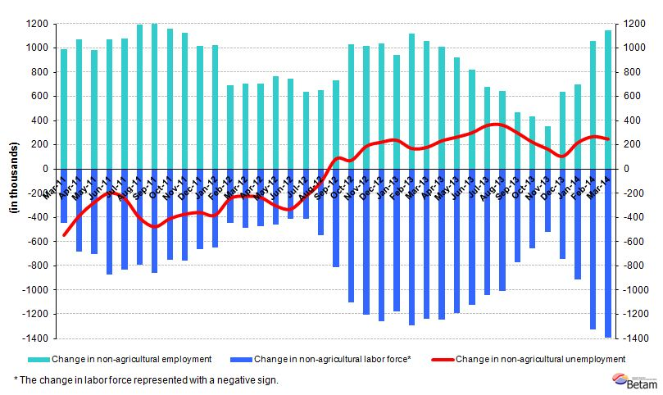
Source: TurkSTAT, Betam

Non-agricultural unemployment stagnates

According to seasonally adjusted data, non-agricultural labor force increased by 79 thousand in the period of March 2014 compared to the period of February 2014, and reached 22 million 899 thousand (Figure 2, Table 1).
Non-agricultural employment increased by 70 thousand and reached 20 million 380 thousand. Hence, the number of persons unemployed in non-agricultural sectors increased by 9 thousand and non-agricultural unemployment rate remained the same at 11.0 percent in the period of March 2014 compared to the period of February 2014.

Figure 2 Seasonally adjusted non-agricultural labor force, employment and unemployment
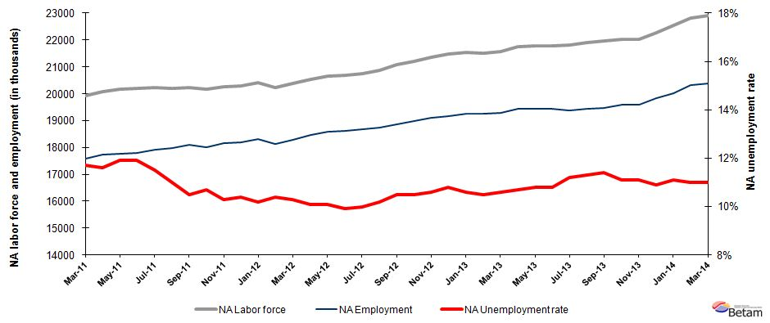

Source: TurkStat, Betam

According to Kariyer.net data, non-agricultural unemployment might slightly increase in the next period

Our calculations based on the seasonally adjusted application per vacancy statistics calculated using Kariyer.net series indicate that we accurately predicted the direction of unemployment for the last two periods. The Kariyer.net series also indicates that non-agricultural unemployment might slightly increase in the period of April 2014.

Figure 3 Seasonally adjusted non-agricultural unemployment rate and application per vacancy
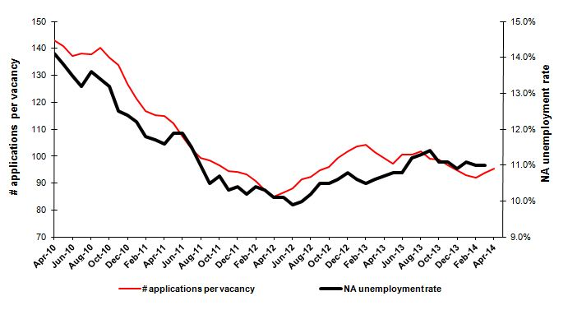
Source: Kariyer.net, TurkStat, Betam

Services continue to create employment

Seasonally adjusted labor market series show that increase in non-agricultural employment was driven by increases in services sector in the period of March 2014 (Table 2, Figure 4). Employment in the services sector increased by 102 thousand from the period of March 2014 to the period of February 2014. This increase is significantly higher than the average monthly increase of 45 thousand observed for the last two years. Strong increases in manufacturing employment for the last three months seem to have ceased as employment in manufacturing increased only 6 thousand in this period. Employment in construction sector decreased by 38 thousand, while employment in agriculture increased by 79 thousand.

Figure 4 Employment by sectors (in thousands)
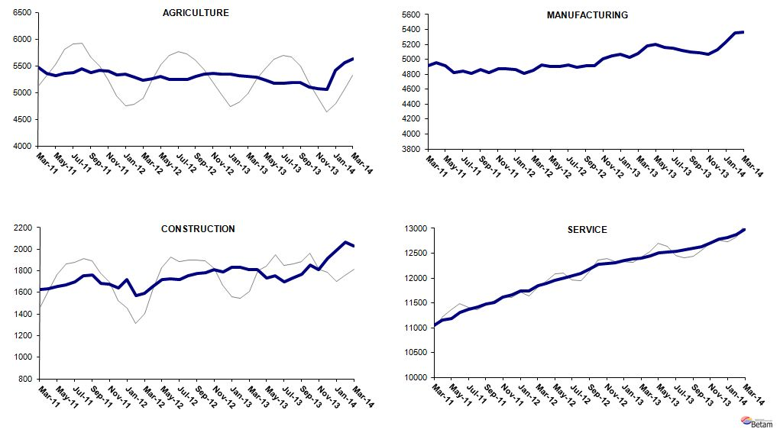
Source: TurkStat, Betam

Table 1 Seasonally adjusted non-agricultural labor force indicators (in thousands)
 | Labor force | Employment | Unemployment | Unemployment rate | Monthly changes
February-11 | 19763 | 17431 | 2332 | 11.8% | Labor force | Employment | Unemployment
March-11 | 19913 | 17583 | 2330 | 11.7% | 150 | 152 | -2
April-11 | 20069 | 17741 | 2328 | 11.6% | 156 | 158 | -2
May-11 | 20162 | 17763 | 2399 | 11.9% | 93 | 22 | 71
June-11 | 20203 | 17799 | 2404 | 11.9% | 41 | 36 | 5
July-11 | 20238 | 17911 | 2327 | 11.5% | 35 | 112 | -77
August-11 | 20204 | 17982 | 2222 | 11.0% | -34 | 71 | -105
September-11 | 20232 | 18108 | 2124 | 10.5% | 28 | 126 | -98
October-11 | 20172 | 18014 | 2158 | 10.7% | -60 | -94 | 34
November-11 | 20253 | 18167 | 2086 | 10.3% | 81 | 153 | -72
December-11 | 20285 | 18175 | 2110 | 10.4% | 32 | 8 | 24
January-12 | 20408 | 18326 | 2082 | 10.2% | 123 | 151 | -28
February-12 | 20231 | 18127 | 2104 | 10.4% | -177 | -199 | 22
March-12 | 20394 | 18293 | 2101 | 10.3% | 163 | 166 | -3
April-12 | 20548 | 18473 | 2075 | 10.1% | 155 | 180 | -25
May-12 | 20663 | 18576 | 2087 | 10.1% | 115 | 103 | 12
June-12 | 20677 | 18630 | 2047 | 9.9% | 14 | 54 | -40
July-12 | 20761 | 18685 | 2076 | 10.0% | 84 | 55 | 29
August-12 | 20872 | 18743 | 2129 | 10.2% | 111 | 58 | 53
September-12 | 21080 | 18867 | 2213 | 10.5% | 209 | 124 | 85
October-12 | 21204 | 18978 | 2226 | 10.5% | 124 | 111 | 13
November-12 | 21365 | 19100 | 2265 | 10.6% | 160 | 122 | 38
December-12 | 21470 | 19151 | 2319 | 10.8% | 105 | 51 | 54
January-13 | 21541 | 19258 | 2283 | 10.6% | 72 | 107 | -35
February-13 | 21498 | 19241 | 2257 | 10.5% | -43 | -17 | -26
March-13 | 21583 | 19295 | 2288 | 10.6% | 84 | 54 | 30
April-13 | 21760 | 19432 | 2328 | 10.7% | 178 | 137 | 41
May-13 | 21793 | 19439 | 2354 | 10.8% | 32 | 7 | 25
June-13 | 21789 | 19436 | 2353 | 10.8% | -3 | -3 | 0
July-13 | 21824 | 19380 | 2444 | 11.2% | 35 | -56 | 91
August-13 | 21899 | 19424 | 2475 | 11.3% | 74 | 44 | 30
September-13 | 21964 | 19460 | 2504 | 11.4% | 65 | 36 | 29
October-13 | 22022 | 19578 | 2444 | 11.1% | 59 | 118 | -59
November-13 | 22025 | 19580 | 2445 | 11.1% | 2 | 2 | 0
December-13 | 22257 | 19831 | 2426 | 10.9% | 232 | 251 | -19
January-14 | 22531 | 20030 | 2501 | 11.1% | 274 | 199 | 75
February-14 | 22820 | 20310 | 2510 | 11.0% | 289 | 280 | 9
March-14 | 22899 | 20380 | 2519 | 11.0% | 79 | 70 | 9
Source: TurkStat, Betam

Table 2 Seasonally adjusted employment by sector (in thousands)
 | Agriculture | Manufacturing | Construction | Service | Monthly changes
February-11 | 5481 | 4767 | 1615 | 11050 | Agriculture | Manufacturing | Construction | Service
March-11 | 5465 | 4914 | 1628 | 11040 | -16 | 147 | 13 | -10
April-11 | 5357 | 4958 | 1632 | 11150 | -108 | 44 | 4 | 110
May-11 | 5310 | 4915 | 1656 | 11192 | -47 | -43 | 24 | 42
June-11 | 5360 | 4826 | 1671 | 11302 | 50 | -89 | 15 | 110
July-11 | 5378 | 4846 | 1698 | 11367 | 18 | 20 | 27 | 65
August-11 | 5440 | 4816 | 1757 | 11408 | 62 | -30 | 59 | 41
September-11 | 5373 | 4866 | 1762 | 11481 | -67 | 50 | 5 | 73
October-11 | 5410 | 4823 | 1681 | 11510 | 37 | -43 | -81 | 29
November-11 | 5404 | 4870 | 1674 | 11622 | -6 | 47 | -7 | 112
December-11 | 5331 | 4873 | 1643 | 11659 | -73 | 3 | -31 | 37
January-12 | 5339 | 4864 | 1718 | 11745 | 8 | -9 | 75 | 86
February-12 | 5287 | 4808 | 1573 | 11746 | -52 | -56 | -145 | 1
March-12 | 5235 | 4850 | 1589 | 11853 | -52 | 42 | 16 | 107
April-12 | 5257 | 4930 | 1653 | 11890 | 22 | 80 | 64 | 37
May-12 | 5303 | 4908 | 1717 | 11951 | 46 | -22 | 64 | 61
June-12 | 5247 | 4900 | 1729 | 12002 | -56 | -8 | 12 | 51
July-12 | 5245 | 4926 | 1718 | 12041 | -2 | 26 | -11 | 39
August-12 | 5239 | 4892 | 1753 | 12097 | -6 | -34 | 35 | 56
September-12 | 5305 | 4911 | 1776 | 12179 | 66 | 19 | 23 | 82
October-12 | 5350 | 4917 | 1786 | 12274 | 45 | 6 | 10 | 95
November-12 | 5362 | 5003 | 1808 | 12289 | 12 | 86 | 22 | 15
December-12 | 5348 | 5051 | 1791 | 12309 | -14 | 48 | -17 | 20
January-13 | 5338 | 5073 | 1835 | 12350 | -10 | 22 | 44 | 41
February-13 | 5313 | 5023 | 1829 | 12389 | -25 | -50 | -6 | 39
March-13 | 5302 | 5083 | 1812 | 12400 | -11 | 60 | -17 | 11
April-13 | 5283 | 5176 | 1811 | 12446 | -19 | 93 | -1 | 46
May-13 | 5226 | 5200 | 1735 | 12505 | -57 | 24 | -76 | 59
June-13 | 5177 | 5163 | 1752 | 12522 | -49 | -37 | 17 | 17
July-13 | 5173 | 5146 | 1695 | 12539 | -4 | -17 | -57 | 17
August-13 | 5191 | 5117 | 1732 | 12574 | 18 | -29 | 37 | 35
September-13 | 5189 | 5096 | 1767 | 12597 | -2 | -21 | 35 | 23
October-13 | 5106 | 5090 | 1853 | 12635 | -83 | -6 | 86 | 38
November-13 | 5070 | 5064 | 1808 | 12708 | -36 | -26 | -45 | 73
December-13 | 5060 | 5131 | 1917 | 12783 | -10 | 67 | 109 | 75
January-14 | 5410 | 5232 | 1988 | 12810 | 350 | 101 | 71 | 27
February-14 | 5551 | 5359 | 2069 | 12881 | 141 | 127 | 81 | 71
March-14 | 5630 | 5365 | 2031 | 12983 | 79 | 6 | -38 | 102
Source: TurkStat, Betam

* Prof. Dr. Seyfettin Gürsel, Betam, Director, seyfettin.gursel@bahcesehir.edu.tr
∗ Yrd. Doç. Dr. Gökçe Uysal, Betam, Vice Director, gokce.uysal@bahcesehir.edu.tr
∗∗ Ayşenur Acar, Betam, Research Assistant, aysenur.acar@bahcesehir.edu.tr
Betam has been calculating application per vacancy using series released by Kariyer.net for a while. Seasonal and calendar adjustment procedure is applied to application per vacancy series. A decrease in applications per vacancy may be caused by an increase in vacancies or by a decrease in the number of applications. An increase in vacancies signals economic growth while decreasing number of applications indicates a decrease in number of people looking for a job. Monthly labor market series released by TurkStat is the average of three months. Therefore, application per vacancy statistics calculated using Kariyer.net series is the average of three months as well.
Employment in each sector is seasonally adjusted separately. Hence the sum of these series may differ from the seasonally adjusted series of total employment. The difference stems from the non-linearity of the seasonal adjustment process.
Grey lines indicate seasonally adjusted series, where dark blue lines represent raw data.

