

Labor Market Outlook:

May 2014

15 May 2014

REVISION IN THE UNEMPLOYMENT SERIES

Seyfettin Gürsel* Gökçe Uysal∗ and Ayşenur Acar∗

Abstract

Seasonally adjusted labor market data shows that non-agricultural unemployment rate decreased from 11.1 percent to 11.0 percent in the period of February 2014. We observed strong increases in both non-agricultural labor force and employment in this period. Seasonally adjusted labor market series show that employment increased in all sectors. Employment increases in manufacturing and construction sectors are especially interesting. On the other hand, key revisions in definitions of labor market series made by TurkStat have caused jumps in the series. Hence, in the next few periods, labor market series should be treated with caution.

Revision in labor market series

Turkstat has made key revisions in labor market series beginning February 2014. These revisions made labor market series compatible with the standards of European Union Statistics. Accordingly, the revisions can be broadly grouped into 5 categories: (i) change in reference week in the Household Labor Survey as each week of the survey year (ii) change in the sampling design (iii) change in rural/urban distribution based on the new administrative allocation (iv) change in job search process (it was decreased from 3 months to 1 month). Given the revisions, we observe certain breaks in the labor market series. This leads to major changes in especially sectoral employment series. Turkstat states that revisions to these new measurements in the labor market series take time to settle. Hence, short term fluctuations in the labor market should be treated with caution.

Extraordinary increases in non-agricultural labor force and employment

According to the data released by TurkStat, non-agricultural labor force increased by 1 million 324 thousand (6.2 percent) and non-agricultural employment increased by 1 million 57 thousand (5.6 percent) in the period of February 2014 (Figure 1). Consequently, the number of persons unemployed in non-agricultural sectors decreased by 124 thousand. Increase in non-agricultural labor force is the highest observed during the last few years. Similarly, non-agricultural employment increased over 1 million.

Figure 1 Year-on-year changes in non-agricultural labor force, employment and unemployment
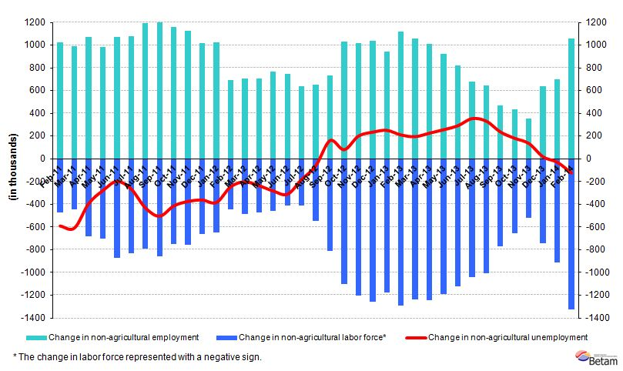
Source: TurkSTAT, Betam

Non-agricultural unemployment decreased by 0.1 percentage point

According to seasonally adjusted data, non-agricultural labor force increased by 293 thousand in the period of February 2014 compared to the period of January 2014, and reached 22 million 784 thousand (Figure 2, Table 1).
Non-agricultural employment increased by 283 thousand and reached 20 million 278 thousand. Hence, the number of persons unemployed in non-agricultural sectors increased by 10 thousand and non-agricultural unemployment rate decreased from 11.1 percent in the period of January 2014 to 11.0 percent in the period of February 2014.

Figure 2 Seasonally adjusted non-agricultural labor force, employment and unemployment
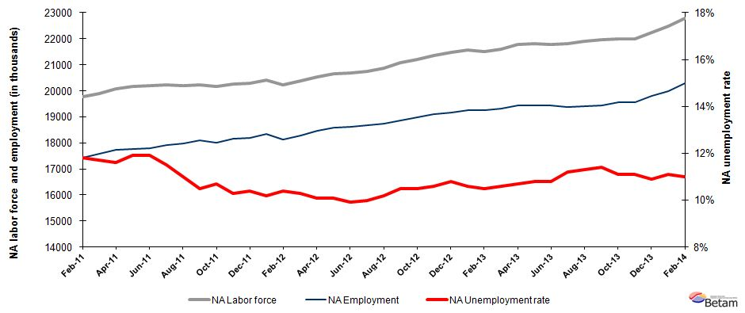

Source: TurkStat, Betam

According to Kariyer.net data, non-agricultural unemployment might increase in the next period

Our calculations based on the seasonally adjusted application per vacancy statistics calculated using Kariyer.net series indicate that we accurately predicted the direction of unemployment for the last two periods. The Kariyer.net series also indicates that non-agricultural unemployment might slightly increase in the period of March 2014.

Figure 3 Seasonally adjusted non-agricultural unemployment rate and application per vacancy
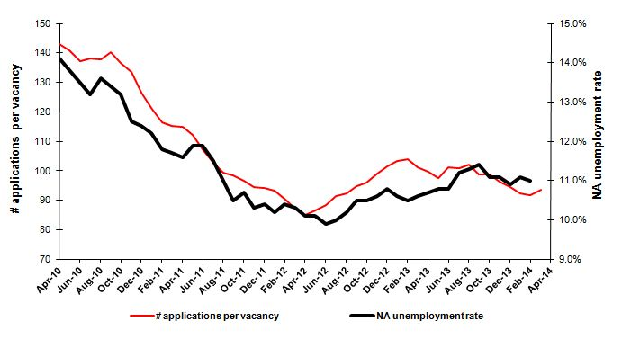
Source: Kariyer.net, TurkStat, Betam

Strong employment increase in manufacturing sector

Seasonally adjusted labor market series show that employment in manufacturing sector increased by 127 thousand in the period of February 2014 (Table 2, Figure 4). Employment in services continues to rise, amounting to 69 thousand in this period. Similarly, employment in construction sector increased consecutively during the last three periods, the rise being 86 thousand in this period.

On the other hand, agricultural employment increased by 347 thousand in the period of January 2014 and increased by 135 thousand in the period of February 2014. TurkStat states that the revision in rural/urban definition led to major changes in sectoral employment in rural areas.
Figure 4 Employment by sectors (in thousands)
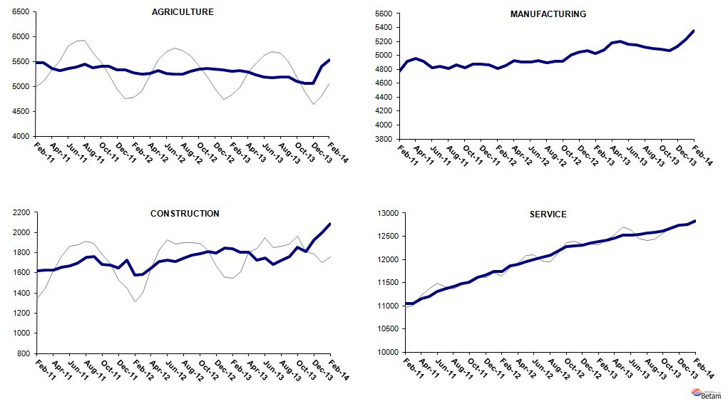
Source: TurkStat, Betam

Table 1 Seasonally adjusted non-agricultural labor force indicators (in thousands)
 | Labor force | Employment | Unemployment | Unemployment rate | Monthly changes
January-11 | 19767 | 17355 | 2412 | 12.2% | Labor force | Employment | Unemployment
February-11 | 19768 | 17435 | 2333 | 11.8% | 1 | 80 | -79
March-11 | 19909 | 17580 | 2329 | 11.7% | 142 | 145 | -3
April-11 | 20067 | 17739 | 2328 | 11.6% | 157 | 159 | -2
May-11 | 20160 | 17761 | 2399 | 11.9% | 93 | 22 | 71
June-11 | 20202 | 17798 | 2404 | 11.9% | 42 | 37 | 5
July-11 | 20237 | 17910 | 2327 | 11.5% | 35 | 112 | -77
August-11 | 20204 | 17982 | 2222 | 11.0% | -33 | 72 | -105
September-11 | 20235 | 18110 | 2125 | 10.5% | 30 | 128 | -98
October-11 | 20176 | 18017 | 2159 | 10.7% | -59 | -93 | 34
November-11 | 20255 | 18169 | 2086 | 10.3% | 79 | 152 | -73
December-11 | 20290 | 18180 | 2110 | 10.4% | 35 | 11 | 24
January-12 | 20415 | 18333 | 2082 | 10.2% | 125 | 153 | -28
February-12 | 20237 | 18132 | 2105 | 10.4% | -179 | -201 | 22
March-12 | 20387 | 18287 | 2100 | 10.3% | 150 | 155 | -5
April-12 | 20545 | 18470 | 2075 | 10.1% | 158 | 183 | -25
May-12 | 20659 | 18572 | 2087 | 10.1% | 113 | 102 | 11
June-12 | 20675 | 18628 | 2047 | 9.9% | 16 | 56 | -40
July-12 | 20754 | 18679 | 2075 | 10.0% | 80 | 51 | 29
August-12 | 20870 | 18741 | 2129 | 10.2% | 115 | 62 | 53
September-12 | 21080 | 18867 | 2213 | 10.5% | 211 | 126 | 85
October-12 | 21208 | 18981 | 2227 | 10.5% | 127 | 114 | 13
November-12 | 21368 | 19103 | 2265 | 10.6% | 160 | 122 | 38
December-12 | 21479 | 19159 | 2320 | 10.8% | 111 | 56 | 55
January-13 | 21555 | 19270 | 2285 | 10.6% | 76 | 111 | -35
February-13 | 21506 | 19248 | 2258 | 10.5% | -49 | -22 | -27
March-13 | 21600 | 19310 | 2290 | 10.6% | 93 | 62 | 31
April-13 | 21772 | 19442 | 2330 | 10.7% | 172 | 132 | 40
May-13 | 21798 | 19444 | 2354 | 10.8% | 27 | 2 | 25
June-13 | 21791 | 19438 | 2353 | 10.8% | -7 | -6 | -1
July-13 | 21814 | 19371 | 2443 | 11.2% | 23 | -67 | 90
August-13 | 21888 | 19415 | 2473 | 11.3% | 74 | 44 | 30
September-13 | 21950 | 19448 | 2502 | 11.4% | 62 | 33 | 29
October-13 | 22004 | 19562 | 2442 | 11.1% | 54 | 114 | -60
November-13 | 21994 | 19553 | 2441 | 11.1% | -10 | -9 | -1
December-13 | 22224 | 19802 | 2422 | 10.9% | 230 | 249 | -19
January-14 | 22492 | 19995 | 2497 | 11.1% | 267 | 193 | 74
February-14 | 22784 | 20278 | 2506 | 11.0% | 293 | 283 | 10
Source: TurkStat, Betam

Table 2 Seasonally adjusted employment by sector (in thousands)
 | Agriculture | Manufacturing | Construction | Service | Monthly changes
January-11 | 5373 | 4819 | 1576 | 10959 | Agriculture | Manufacturing | Construction | Service
February-11 | 5474 | 4767 | 1618 | 11050 | 101 | -52 | 42 | 91
March-11 | 5469 | 4914 | 1625 | 11041 | -5 | 147 | 7 | -9
April-11 | 5361 | 4958 | 1630 | 11151 | -108 | 44 | 5 | 110
May-11 | 5315 | 4915 | 1653 | 11193 | -46 | -43 | 23 | 42
June-11 | 5364 | 4826 | 1669 | 11302 | 49 | -89 | 16 | 109
July-11 | 5380 | 4846 | 1696 | 11367 | 16 | 20 | 27 | 65
August-11 | 5441 | 4816 | 1758 | 11409 | 61 | -30 | 62 | 42
September-11 | 5373 | 4866 | 1763 | 11481 | -68 | 50 | 5 | 72
October-11 | 5407 | 4823 | 1683 | 11511 | 34 | -43 | -80 | 30
November-11 | 5401 | 4870 | 1676 | 11623 | -6 | 47 | -7 | 112
December-11 | 5326 | 4873 | 1648 | 11660 | -75 | 3 | -28 | 37
January-12 | 5332 | 4864 | 1723 | 11745 | 6 | -9 | 75 | 85
February-12 | 5278 | 4808 | 1578 | 11746 | -54 | -56 | -145 | 1
March-12 | 5243 | 4850 | 1584 | 11854 | -35 | 42 | 6 | 108
April-12 | 5263 | 4930 | 1649 | 11890 | 20 | 80 | 65 | 36
May-12 | 5310 | 4908 | 1713 | 11952 | 47 | -22 | 64 | 62
June-12 | 5252 | 4900 | 1725 | 12002 | -58 | -8 | 12 | 50
July-12 | 5249 | 4926 | 1711 | 12042 | -3 | 26 | -14 | 40
August-12 | 5240 | 4892 | 1751 | 12098 | -9 | -34 | 40 | 56
September-12 | 5305 | 4911 | 1776 | 12179 | 65 | 19 | 25 | 81
October-12 | 5347 | 4917 | 1789 | 12275 | 42 | 6 | 13 | 96
November-12 | 5357 | 5003 | 1810 | 12290 | 10 | 86 | 21 | 15
December-12 | 5341 | 5051 | 1798 | 12310 | -16 | 48 | -12 | 20
January-13 | 5329 | 5073 | 1847 | 12350 | -12 | 22 | 49 | 40
February-13 | 5300 | 5023 | 1842 | 12383 | -29 | -50 | -5 | 33
March-13 | 5312 | 5083 | 1806 | 12421 | 12 | 60 | -36 | 38
April-13 | 5292 | 5176 | 1807 | 12459 | -20 | 93 | 1 | 38
May-13 | 5234 | 5200 | 1728 | 12516 | -58 | 24 | -79 | 57
June-13 | 5184 | 5163 | 1746 | 12529 | -50 | -37 | 18 | 13
July-13 | 5178 | 5146 | 1684 | 12541 | -6 | -17 | -62 | 12
August-13 | 5192 | 5117 | 1727 | 12571 | 14 | -29 | 43 | 30
September-13 | 5187 | 5096 | 1765 | 12586 | -5 | -21 | 38 | 15
October-13 | 5102 | 5090 | 1856 | 12616 | -85 | -6 | 91 | 30
November-13 | 5063 | 5064 | 1809 | 12680 | -39 | -26 | -47 | 64
December-13 | 5051 | 5131 | 1927 | 12744 | -12 | 67 | 118 | 64
January-14 | 5398 | 5232 | 2004 | 12759 | 347 | 101 | 77 | 15
February-14 | 5533 | 5359 | 2090 | 12828 | 135 | 127 | 86 | 69
Source: TurkStat, Betam

* Prof. Dr. Seyfettin Gürsel, Betam, Director, seyfettin.gursel@bahcesehir.edu.tr
∗ Yrd. Doç. Dr. Gökçe Uysal, Betam, Vice Director, gokce.uysal@bahcesehir.edu.tr
∗∗ Ayşenur Acar, Betam, Research Assistant, aysenur.acar@bahcesehir.edu.tr
http://www.tuik.gov.tr/HbGetir.do?id=16007&tb_id=6
Betam has been calculating application per vacancy using series released by Kariyer.net for a while. Seasonal and calendar adjustment procedure is applied to application per vacancy series. A decrease in applications per vacancy may be caused by an increase in vacancies or by a decrease in the number of applications. An increase in vacancies signals economic growth while decreasing number of applications indicates a decrease in number of people looking for a job. Monthly labor market series released by TurkStat is the average of three months. Therefore, application per vacancy statistics calculated using Kariyer.net series is the average of three months as well.
Employment in each sector is seasonally adjusted separately. Hence the sum of these series may differ from the seasonally adjusted series of total employment. The difference stems from the non-linearity of the seasonal adjustment process.
Grey lines indicate seasonally adjusted series, where dark blue lines represent raw data.

