

Labor Market Outlook:

April 2014

15 April 2014

UNEMPLOYMENT CONTINUES TO DECREASE DUE
TO EMPLOYMENT INCREASES IN CONSTRUCTION AND SERVICES

Seyfettin Gürsel* Gökçe Uysal∗ and Ayşenur Acar∗

Abstract

Seasonally adjusted labor market data shows that non-agricultural unemployment rate decreased from 11.6 percent to 11.3 percent (0.3 percentage point decline) in the period of January 2014. Seasonally adjusted labor market series show that employment increased in all sectors. Employment increases in services had slowed down in the third quarter of 2013, but they have accelerated since the last quarter of 2013. Also, we observe that employment increase in construction sector has accelerated since the period of August 2013. It increased from 1 million 672 thousand in the period of July 2013 to 2 million in the period of January 2014. An increase of approximately 20 percent that is observed in a 6-month period, indicates that the labor market needs to be carefully analyzed.

Strong increases in non-agricultural labor force and employment

According to the data released by TurkSTAT, non-agricultural labor force increased by 823 thousand (3.8 percent) and non-agricultural employment increased by 852 thousand (4.5 percent) in the period of January 2014 (Figure 1). Consequently, the number of persons unemployed in non-agricultural sectors decreased by 29 thousand. Annual increases in non-agricultural labor force and employment increased over 800 thousand.

Figure 1 Year-on-year changes in non-agricultural labor force, employment and unemployment
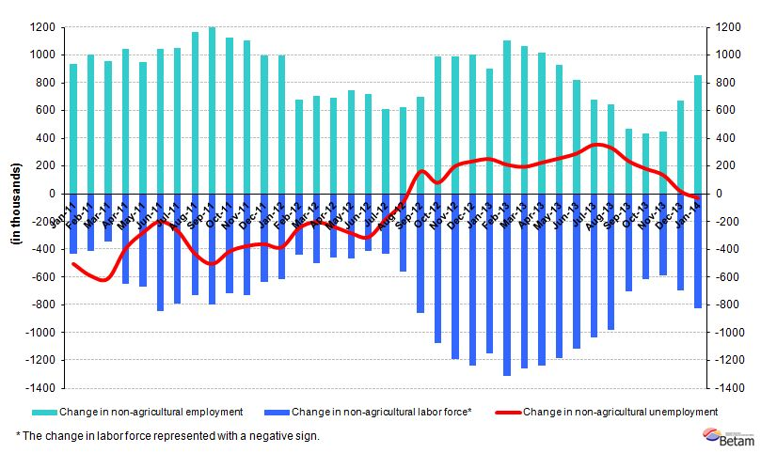
Source: TurkSTAT, Betam

A 0.3 percentage point decline in non-agricultural unemployment

According to seasonally adjusted data, non-agricultural labor force increased by 121 thousand in the period of January 2014 compared to the period of December 2013, and reached 22 million 621 thousand (Figure 2, Table 1).
Non-agricultural employment increased by 184 thousand and reached 20 million 72 thousand. Hence, the number of persons unemployed in non-agricultural sectors decreased by 63 thousand and non-agricultural unemployment rate decreased from 11.6 percent in the period of December 2013 to 11.3 percent in the period of January 2014. Monthly increases in non-agricultural employment have been over 100 thousand since the last quarter of 2013. In the same period, non-agricultural unemployment has been regularly decreasing parallel to the slowdown in the annual increase in the non-agricultural labor force.

Figure 2 Seasonally adjusted non-agricultural labor force, employment and unemployment
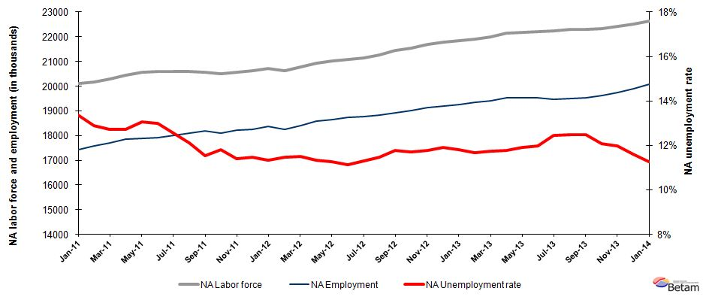

Source: TurkStat, Betam

According to Kariyer.net data, non-agricultural unemployment will continue to decrease in the next period

Our calculations based on the seasonally adjusted application per vacancy statistics calculated using Kariyer.net series indicate that we accurately predicted the direction of unemployment for the last two periods. The Kariyer.net series also indicates that non-agricultural unemployment will continue to decrease in the period of January 2014.

Figure 3 Seasonally adjusted non-agricultural unemployment rate and application per vacancy
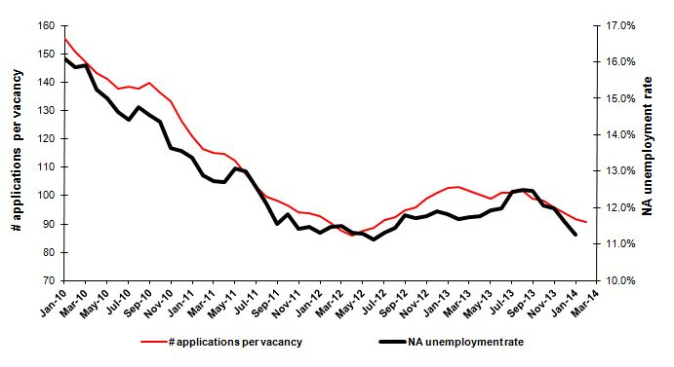
Source: Kariyer.net, TurkStat, Betam

Strong employment increases in construction and service sectors

Seasonally adjusted labor market series show that employment increased in all sectors in the period of January 2014 (Table 2, Figure 4). Employment increases in services has slowed down during the period of June-September 2013 (a monthly average increase of 20 thousand). However, we observe that increase in service employment has accelerated since the last quarter of 2013 (a monthly average increase of 60 thousand).

There have been interesting developments in the construction sector. Construction employment increased by 103 thousand in the period of January 2013 compared to that of December 2013. Construction employment increased from 1 million 672 in the period of July 2013 thousand to 2 million in the period of January 2014. This increase that has been observed in a 6-month period corresponds to a 20 percent increase. We think that this rapid increase needs to be analyzed further. In addition, agricultural employment has been increasing in the last two periods.

Figure 4 Employment by sectors (in thousands)
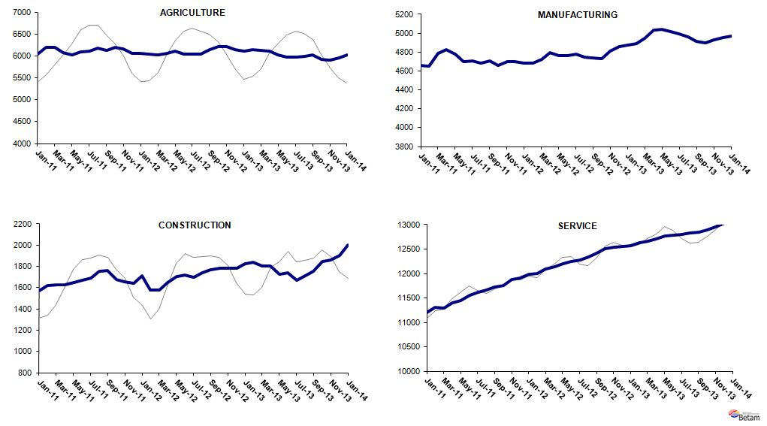
Source: TurkStat, Betam

Table 1 Seasonally adjusted non-agricultural labor force indicators (in thousands)
 | Labor force | Employment | Unemployment | Unemployment rate | Monthly changes
December-10 | 20068 | 17347 | 2720 | 13.6% | Labor force | Employment | Unemployment
January-11 | 20120 | 17431 | 2689 | 13.4% | 52 | 83 | -31
February-11 | 20170 | 17572 | 2598 | 12.9% | 50 | 141 | -91
March-11 | 20286 | 17703 | 2583 | 12.7% | 116 | 131 | -15
April-11 | 20457 | 17857 | 2600 | 12.7% | 171 | 154 | 17
May-11 | 20560 | 17871 | 2688 | 13.1% | 102 | 14 | 88
June-11 | 20589 | 17915 | 2674 | 13.0% | 29 | 44 | -15
July-11 | 20604 | 18018 | 2587 | 12.6% | 15 | 103 | -87
August-11 | 20585 | 18090 | 2495 | 12.1% | -19 | 73 | -92
September-11 | 20567 | 18192 | 2375 | 11.5% | -18 | 102 | -120
October-11 | 20516 | 18090 | 2426 | 11.8% | -52 | -103 | 51
November-11 | 20577 | 18227 | 2350 | 11.4% | 61 | 137 | -76
December-11 | 20610 | 18247 | 2363 | 11.5% | 33 | 20 | 13
January-12 | 20731 | 18384 | 2347 | 11.3% | 121 | 137 | -16
February-12 | 20622 | 18254 | 2369 | 11.5% | -109 | -130 | 21
March-12 | 20787 | 18398 | 2389 | 11.5% | 164 | 144 | 20
April-12 | 20945 | 18573 | 2371 | 11.3% | 158 | 175 | -17
May-12 | 21035 | 18661 | 2374 | 11.3% | 91 | 88 | 2
June-12 | 21068 | 18724 | 2344 | 11.1% | 33 | 63 | -30
July-12 | 21155 | 18761 | 2394 | 11.3% | 88 | 37 | 50
August-12 | 21258 | 18822 | 2436 | 11.5% | 103 | 61 | 42
September-12 | 21449 | 18921 | 2529 | 11.8% | 191 | 98 | 93
October-12 | 21548 | 19026 | 2522 | 11.7% | 99 | 105 | -6
November-12 | 21692 | 19136 | 2555 | 11.8% | 144 | 110 | 33
December-12 | 21787 | 19195 | 2592 | 11.9% | 96 | 59 | 37
January-13 | 21845 | 19262 | 2582 | 11.8% | 57 | 67 | -10
February-13 | 21912 | 19352 | 2560 | 11.7% | 68 | 90 | -22
March-13 | 22004 | 19418 | 2586 | 11.8% | 92 | 66 | 26
April-13 | 22148 | 19541 | 2607 | 11.8% | 143 | 122 | 21
May-13 | 22176 | 19533 | 2643 | 11.9% | 28 | -8 | 36
June-13 | 22199 | 19536 | 2663 | 12.0% | 23 | 3 | 20
July-13 | 22225 | 19459 | 2766 | 12.4% | 27 | -76 | 103
August-13 | 22292 | 19506 | 2786 | 12.5% | 67 | 47 | 20
September-13 | 22299 | 19518 | 2781 | 12.5% | 7 | 12 | -5
October-13 | 22325 | 19632 | 2693 | 12.1% | 26 | 114 | -88
November-13 | 22418 | 19733 | 2685 | 12.0% | 93 | 102 | -9
December-13 | 22500 | 19888 | 2612 | 11.6% | 82 | 155 | -72
January-14 | 22621 | 20072 | 2549 | 11.3% | 121 | 184 | -63
Source: TurkStat, Betam

Table 2 Seasonally adjusted employment by sector (in thousands)
 | Agriculture | Manufacturing | Construction | Service | Monthly changes
December-10 | 6033 | 4642 | 1562 | 11144 | Agriculture | Manufacturing | Construction | Service
January-11 | 6034 | 4656 | 1568 | 11207 | 2 | 14 | 6 | 63
February-11 | 6188 | 4652 | 1618 | 11302 | 153 | -4 | 50 | 95
March-11 | 6198 | 4790 | 1624 | 11289 | 11 | 138 | 6 | -13
April-11 | 6074 | 4828 | 1628 | 11401 | -124 | 38 | 4 | 112
May-11 | 6016 | 4777 | 1652 | 11443 | -58 | -51 | 24 | 42
June-11 | 6090 | 4697 | 1666 | 11552 | 74 | -80 | 15 | 109
July-11 | 6110 | 4710 | 1691 | 11616 | 19 | 13 | 25 | 65
August-11 | 6183 | 4682 | 1753 | 11656 | 73 | -28 | 61 | 39
September-11 | 6122 | 4707 | 1758 | 11727 | -61 | 25 | 6 | 71
October-11 | 6191 | 4657 | 1677 | 11756 | 68 | -50 | -81 | 29
November-11 | 6167 | 4700 | 1657 | 11870 | -23 | 43 | -20 | 114
December-11 | 6053 | 4701 | 1640 | 11907 | -115 | 1 | -18 | 37
January-12 | 6050 | 4685 | 1710 | 11989 | -3 | -16 | 71 | 82
February-12 | 6040 | 4684 | 1577 | 11993 | -10 | -1 | -133 | 4
March-12 | 6025 | 4721 | 1580 | 12097 | -16 | 37 | 3 | 104
April-12 | 6055 | 4792 | 1647 | 12134 | 30 | 71 | 67 | 37
May-12 | 6106 | 4760 | 1708 | 12193 | 52 | -32 | 61 | 59
June-12 | 6048 | 4761 | 1720 | 12243 | -58 | 1 | 11 | 50
July-12 | 6046 | 4778 | 1702 | 12282 | -2 | 17 | -18 | 38
August-12 | 6045 | 4745 | 1741 | 12336 | -1 | -33 | 40 | 54
September-12 | 6148 | 4735 | 1768 | 12418 | 103 | -10 | 26 | 82
October-12 | 6219 | 4732 | 1781 | 12513 | 71 | -3 | 13 | 95
November-12 | 6204 | 4814 | 1782 | 12541 | -15 | 82 | 1 | 28
December-12 | 6140 | 4856 | 1785 | 12554 | -64 | 42 | 3 | 14
January-13 | 6107 | 4870 | 1828 | 12564 | -33 | 14 | 44 | 9
February-13 | 6142 | 4886 | 1841 | 12625 | 35 | 16 | 12 | 62
March-13 | 6118 | 4948 | 1805 | 12665 | -24 | 62 | -36 | 40
April-13 | 6100 | 5030 | 1807 | 12703 | -18 | 82 | 2 | 38
May-13 | 6026 | 5044 | 1724 | 12765 | -74 | 14 | -84 | 62
June-13 | 5969 | 5015 | 1740 | 12780 | -57 | -29 | 17 | 15
July-13 | 5966 | 4991 | 1672 | 12796 | -3 | -24 | -68 | 16
August-13 | 5992 | 4964 | 1715 | 12827 | 26 | -27 | 43 | 31
September-13 | 6015 | 4914 | 1756 | 12848 | 23 | -50 | 41 | 21
October-13 | 5927 | 4899 | 1846 | 12887 | -89 | -15 | 90 | 39
November-13 | 5907 | 4927 | 1859 | 12947 | -20 | 28 | 14 | 60
December-13 | 5962 | 4956 | 1900 | 13032 | 55 | 29 | 41 | 85
January-14 | 6016 | 4967 | 2003 | 13102 | 54 | 11 | 103 | 70
Source: TurkStat, Betam

* Prof. Dr. Seyfettin Gürsel, Betam, Director, seyfettin.gursel@bahcesehir.edu.tr
∗ Yrd. Doç. Dr. Gökçe Uysal, Betam, Vice Director, gokce.uysal@bahcesehir.edu.tr
∗∗ Ayşenur Acar, Betam, Research Assistant, aysenur.acar@bahcesehir.edu.tr
Betam has been calculating application per vacancy using series released by Kariyer.net for a while. Seasonal and calendar adjustment procedure is applied to application per vacancy series. A decrease in applications per vacancy may be caused by an increase in vacancies or by a decrease in the number of applications. An increase in vacancies signals economic growth while decreasing number of applications indicates a decrease in number of people looking for a job. Monthly labor market series released by TurkStat is the average of three months. Therefore, application per vacancy statistics calculated using Kariyer.net series is the average of three months as well.
Employment in each sector is seasonally adjusted separately. Hence the sum of these series may differ from the seasonally adjusted series of total employment. The difference stems from the non-linearity of the seasonal adjustment process.
Grey lines indicate seasonally adjusted series, where dark blue lines represent raw data.

