

Labor Market Outlook:

February 2014

17 February 2014

EMPLOYMENT INCREASED IN MANUFACTURING AND SERVICES

Seyfettin Gürsel* Gökçe Uysal∗ and Ayşenur Acar∗

Abstract

Seasonally adjusted labor market data shows that non-agricultural unemployment rate remained at 12.1 percent in the period of November 2013. Increases in seasonally adjusted non-agricultural labor force and employment counterbalanced each other, and thus, non-agricultural unemployment remained stagnant. Increases in service employment has been accelerating during this period. Similarly, manufacturing employment that had been declining for the last five periods increased in this period.

Slowdown in increases in non-agricultural labor force and employment

According to the data released by TurkSTAT, non-agricultural labor force increased by 587 thousand (2.7 percent) and non-agricultural employment increased by 451 thousand (2.3 percent) in the period of November 2013 (Figure 1). Consequently, the number of persons unemployed in non-agricultural sectors increased by 136 thousand. Increase in non-agricultural labor force was counterbalanced with an increase in non-agricultural employment. Annual increases in non-agricultural labor force and employment decreased to below 600 thousand.

Figure 1 Year-on-year changes in non-agricultural labor force, employment and unemployment
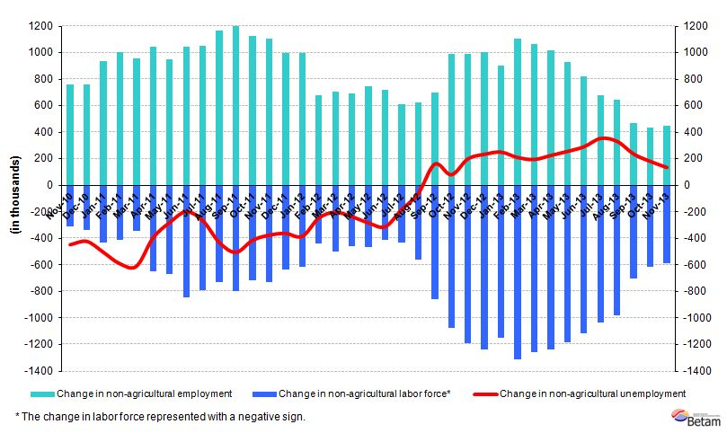
Source: TurkSTAT, Betam

Non-agricultural employment stagnates

According to seasonally adjusted data, non-agricultural labor force increased by 86 thousand in the period of November 2013 compared to the period of October 2013, and reached 22 million 347 thousand (Figure 2, Table 1). Non-agricultural employment increased by 90 thousand and reached 19 million 649 thousand. Hence, the number of persons unemployed in non-agricultural sectors decreased by 4 thousand and non-agricultural unemployment rate remained the same at 12.1 percent in the period of November 2013.

Figure 2 Seasonally adjusted non-agricultural labor force, employment and unemployment
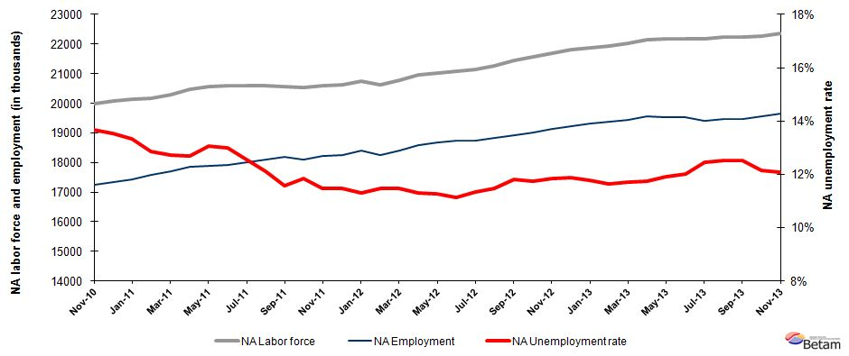

Source: TurkStat, Betam

According to Kariyer.net data, non-agricultural unemployment might slightly decrease in the next period

Seasonally adjusted application per vacancy statistics calculated using Kariyer.net series indicate that non-agricultural unemployment might slightly decrease in the period of December 2013.

Figure 3 Seasonally adjusted non-agricultural unemployment rate and application per vacancy
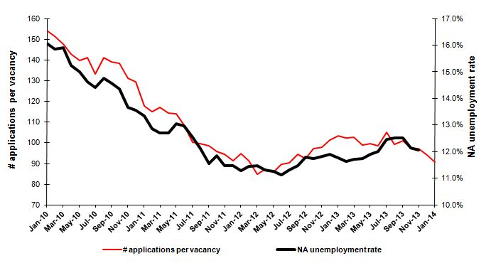
Source: Kariyer.net, TurkStat, Betam

Increases in manufacturing and service employment

Seasonally adjusted labor market series show that manufacturing employment increased by 28 thousand in the period of November 2013. The increase in manufacturing employment, which has been declining since the period of June 2013, is in line with the increase in manufacturing production index (Table 2, Figure 4). Similarly, the increase in service employment had been weakening since the period of June 2013. However, it increased by 51 thousand in the period of November 2013. Meanwhile agricultural employment decreased by 20 thousand and construction employment increased by 11 thousand.

Figure 4 Employment by sectors (in thousands)
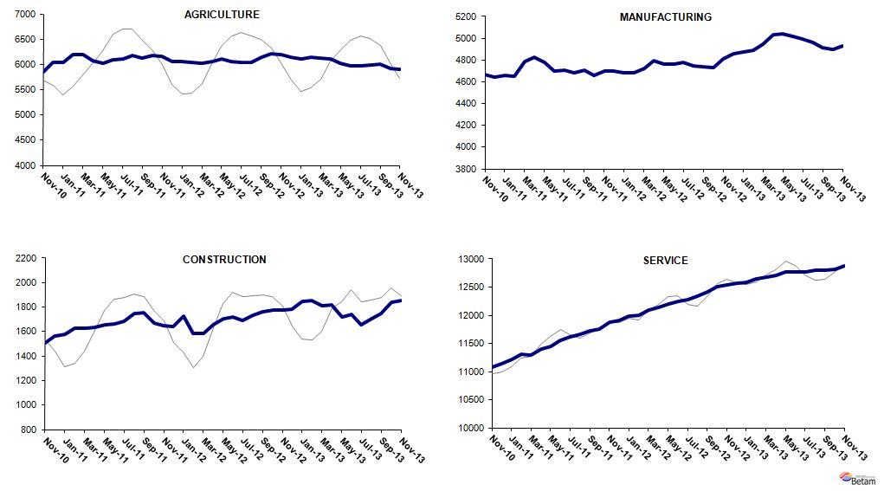
Source: TurkStat, Betam

Table 1 Seasonally adjusted non-agricultural labor force indicators (in thousands)
 | Labor force | Employment | Unemployment | Unemployment rate | Monthly changes
October-10 | 19877 | 17021 | 2856 | 14.4% | Labor force | Employment | Unemployment
November-10 | 19991 | 17258 | 2732 | 13.7% | 114 | 237 | -123
December-10 | 20070 | 17351 | 2719 | 13.5% | 80 | 93 | -14
January-11 | 20127 | 17443 | 2684 | 13.3% | 57 | 92 | -35
February-11 | 20175 | 17581 | 2594 | 12.9% | 47 | 137 | -90
March-11 | 20288 | 17709 | 2578 | 12.7% | 113 | 129 | -16
April-11 | 20459 | 17862 | 2597 | 12.7% | 172 | 153 | 19
May-11 | 20557 | 17873 | 2684 | 13.1% | 98 | 10 | 87
June-11 | 20588 | 17915 | 2673 | 13.0% | 31 | 43 | -12
July-11 | 20600 | 18014 | 2587 | 12.6% | 12 | 98 | -86
August-11 | 20585 | 18089 | 2496 | 12.1% | -15 | 76 | -90
September-11 | 20569 | 18191 | 2378 | 11.6% | -16 | 102 | -118
October-11 | 20519 | 18088 | 2432 | 11.9% | -50 | -103 | 54
November-11 | 20583 | 18223 | 2360 | 11.5% | 64 | 136 | -72
December-11 | 20614 | 18250 | 2364 | 11.5% | 31 | 26 | 4
January-12 | 20743 | 18401 | 2342 | 11.3% | 129 | 151 | -22
February-12 | 20629 | 18265 | 2364 | 11.5% | -114 | -136 | 22
March-12 | 20788 | 18403 | 2384 | 11.5% | 158 | 139 | 20
April-12 | 20949 | 18580 | 2369 | 11.3% | 161 | 177 | -16
May-12 | 21033 | 18662 | 2370 | 11.3% | 84 | 82 | 2
June-12 | 21067 | 18724 | 2343 | 11.1% | 35 | 62 | -27
July-12 | 21146 | 18752 | 2394 | 11.3% | 79 | 28 | 50
August-12 | 21255 | 18818 | 2437 | 11.5% | 109 | 66 | 43
September-12 | 21450 | 18918 | 2532 | 11.8% | 195 | 100 | 95
October-12 | 21553 | 19024 | 2529 | 11.7% | 104 | 107 | -3
November-12 | 21693 | 19126 | 2567 | 11.8% | 140 | 102 | 38
December-12 | 21806 | 19213 | 2593 | 11.9% | 113 | 87 | 27
January-13 | 21885 | 19309 | 2576 | 11.8% | 79 | 96 | -17
February-13 | 21943 | 19387 | 2555 | 11.6% | 57 | 78 | -21
March-13 | 22020 | 19440 | 2580 | 11.7% | 78 | 52 | 25
April-13 | 22160 | 19557 | 2603 | 11.7% | 140 | 117 | 23
May-13 | 22169 | 19530 | 2639 | 11.9% | 8 | -27 | 36
June-13 | 22184 | 19522 | 2663 | 12.0% | 16 | -8 | 24
July-13 | 22187 | 19422 | 2765 | 12.5% | 3 | -100 | 103
August-13 | 22248 | 19461 | 2787 | 12.5% | 61 | 39 | 21
September-13 | 22245 | 19460 | 2785 | 12.5% | -3 | -2 | -2
October-13 | 22261 | 19559 | 2702 | 12.1% | 17 | 100 | -83
November-13 | 22347 | 19649 | 2698 | 12.1% | 86 | 90 | -4
Source: TurkStat, Betam

Table 2 Seasonally adjusted employment by sector (in thousands)
 | Agriculture | Manufacturing | Construction | Service | Monthly changes
October-10 | 5801 | 4498 | 1437 | 11086 | Agriculture | Manufacturing | Construction | Service
November-10 | 5855 | 4667 | 1507 | 11084 | 53 | 169 | 70 | -2
December-10 | 6035 | 4642 | 1564 | 11145 | 181 | -25 | 57 | 61
January-11 | 6039 | 4656 | 1578 | 11209 | 4 | 14 | 14 | 64
February-11 | 6188 | 4652 | 1625 | 11304 | 149 | -4 | 46 | 95
March-11 | 6200 | 4790 | 1628 | 11291 | 12 | 138 | 4 | -13
April-11 | 6077 | 4828 | 1632 | 11402 | -123 | 38 | 4 | 111
May-11 | 6020 | 4777 | 1652 | 11443 | -56 | -51 | 20 | 41
June-11 | 6092 | 4697 | 1666 | 11552 | 71 | -80 | 14 | 109
July-11 | 6111 | 4710 | 1686 | 11618 | 19 | 13 | 20 | 66
August-11 | 6182 | 4682 | 1749 | 11658 | 72 | -28 | 64 | 40
September-11 | 6120 | 4707 | 1755 | 11729 | -63 | 25 | 6 | 71
October-11 | 6183 | 4657 | 1673 | 11757 | 63 | -50 | -82 | 28
November-11 | 6159 | 4700 | 1652 | 11872 | -23 | 43 | -21 | 114
December-11 | 6053 | 4701 | 1640 | 11909 | -107 | 1 | -12 | 38
January-12 | 6056 | 4685 | 1725 | 11991 | 4 | -16 | 85 | 82
February-12 | 6042 | 4684 | 1586 | 11995 | -15 | -1 | -139 | 4
March-12 | 6027 | 4721 | 1583 | 12099 | -15 | 37 | -2 | 104
April-12 | 6057 | 4792 | 1652 | 12136 | 31 | 71 | 69 | 37
May-12 | 6111 | 4760 | 1708 | 12195 | 53 | -32 | 55 | 59
June-12 | 6051 | 4761 | 1718 | 12245 | -60 | 1 | 10 | 50
July-12 | 6048 | 4778 | 1690 | 12284 | -3 | 17 | -28 | 40
August-12 | 6044 | 4745 | 1734 | 12339 | -4 | -33 | 45 | 55
September-12 | 6144 | 4735 | 1762 | 12420 | 100 | -10 | 28 | 82
October-12 | 6210 | 4732 | 1777 | 12515 | 66 | -3 | 15 | 95
November-12 | 6195 | 4814 | 1776 | 12536 | -15 | 82 | -1 | 21
December-12 | 6140 | 4856 | 1786 | 12571 | -55 | 42 | 10 | 35
January-13 | 6114 | 4870 | 1850 | 12589 | -26 | 14 | 64 | 18
February-13 | 6144 | 4886 | 1857 | 12644 | 30 | 16 | 7 | 55
March-13 | 6120 | 4948 | 1813 | 12679 | -24 | 62 | -44 | 35
April-13 | 6103 | 5030 | 1816 | 12711 | -18 | 82 | 3 | 32
May-13 | 6031 | 5044 | 1722 | 12764 | -72 | 14 | -94 | 53
June-13 | 5972 | 5015 | 1737 | 12770 | -59 | -29 | 15 | 6
July-13 | 5968 | 4991 | 1655 | 12775 | -4 | -24 | -82 | 6
August-13 | 5991 | 4964 | 1704 | 12793 | 23 | -27 | 48 | 18
September-13 | 6010 | 4914 | 1747 | 12799 | 19 | -50 | 43 | 5
October-13 | 5917 | 4899 | 1841 | 12819 | -93 | -15 | 94 | 20
November-13 | 5897 | 4927 | 1852 | 12870 | -20 | 28 | 11 | 51
Source: TurkStat, Betam

* Prof. Dr. Seyfettin Gürsel, Betam, Director, seyfettin.gursel@bahcesehir.edu.tr
∗ Yrd. Doç. Dr. Gökçe Uysal, Betam, Vice Director, gokce.uysal@bahcesehir.edu.tr
∗∗ Ayşenur Acar, Betam, Research Assistant, aysenur.acar@bahcesehir.edu.tr
Betam has been calculating application per vacancy using series released by Kariyer.net for a while. Seasonal and calendar adjustment procedure is applied to application per vacancy series. A decrease in applications per vacancy may be caused by an increase in vacancies or by a decrease in the number of applications. An increase in vacancies signals economic growth while decreasing number of applications indicates a decrease in number of people looking for a job.
Employment in each sector is seasonally adjusted separately. Hence the sum of these series may differ from the seasonally adjusted series of total employment. The difference stems from the non-linearity of the seasonal adjustment process.
Grey lines indicate seasonally adjusted series, where dark blue lines represent raw data.

