

Labor Market Outlook:

January 2014

15 January 2014

UNEMPLOYMENT DECREASED THANKS TO CONSTRUCTION

Seyfettin Gürsel* Gökçe Uysal∗ and Ayşenur Acar∗

Abstract

Seasonally adjusted labor market data shows that non-agricultural unemployment rate decreased from 12.5 percent to 12.1 percent (0.4 percentage points) in the period of October 2013 compared to the period of September 2013. This unexpected decline was due to the large increase in non-agricultural employment, most of which was in the construction sector. Seasonally adjusted employment increased by 99 thousand from the period of September 2013 to the period of October 2013. Hence, unemployment rate decreased by 0.5 percentage points. Consequently, seasonally adjusted non-agricultural unemployment rate increased from 11.4 percent in October 2013 to 11.9 percent in September 2013.

Increases in non-agricultural labor force and employment are returning to trend

According to the data released by TurkSTAT, non-agricultural labor force increased by 614 thousand (2.8 percent) and non-agricultural employment increased by 433 thousand (2.3 percent) in the period of October 2013 (Figure 1). Consequently, the number of persons unemployed in non-agricultural sectors increased by 181 thousand. 600 thousand increase in non-agricultural labor force is compatible with the structural trend. Similarly, 2.3 percent increase in employment is also compatible with about 4 percent GDP growth.

Figure 1 Year-on-year changes in non-agricultural labor force, employment and unemployment
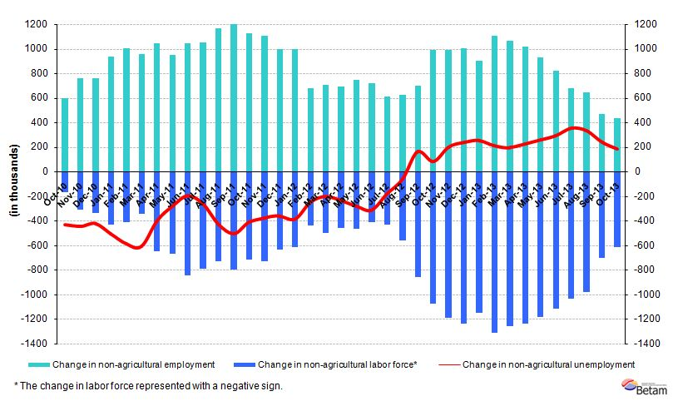
Source: TurkSTAT, Betam

Strong increase in non-agricultural employment

According to seasonally adjusted data, non-agricultural labor force decreased by 17 thousand in the period of October 2013 compared to the period of September 2013, and reached 22 million 237 thousand (Figure 2, Table 1). Non-agricultural employment increased by 99 thousand and reached 19 million 537 thousand. Hence, the number of persons unemployed in non-agricultural sectors decreased by 81 thousand and non-agricultural unemployment rate decreased from 12.5 percent in the period of September 2013 to 12.1 percent in the period of October 2013. The increase in seasonally adjusted non-agricultural employment (99 thousand) is the strongest recorded since April 2013. 117 thousand decline in non-agricultural employment (from May 2013 to September 2013) explains the strong and rapid increase.

Figure 2 Seasonally adjusted non-agricultural labor force, employment and unemployment
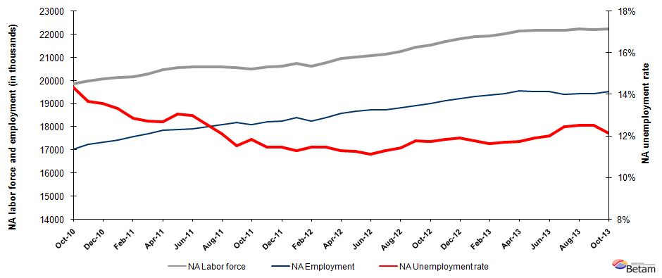

Source: TurkStat, Betam

According to Kariyer.net data, non-agricultural unemployment might continue to decrease in the next period

Seasonally adjusted application per vacancy statistics calculated using Kariyer.net series indicate that non-agricultural unemployment might slightly decrease in the period of November 2013.

Figure 3 Seasonally adjusted non-agricultural unemployment rate and application per vacancy
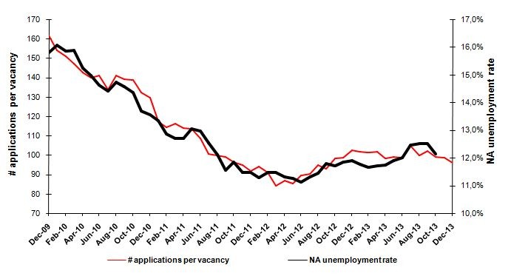
Source: Kariyer.net, TurkStat, Betam
Surprising increase in construction employment

Seasonally adjusted labor market series show that increase in construction employment that has been observed for the last two periods continues to accelerate in the period of October 2013 (Table 2, Figure 4). The monthly increase reached 94 thousand. Meanwhile the slowdown in service employment continues, i.e. service employment increased slightly (20 thousand) in the period of October 2013. However, decline in manufacturing employment that has been observed since the period of June 2013 continues in this period. Manufacturing employment decreased by 15 thousand in the period of October 2013 compared to the period of September 2013. Agricultural employment continues to decrease as well.

Figure 4 Employment by sectors (in thousands)
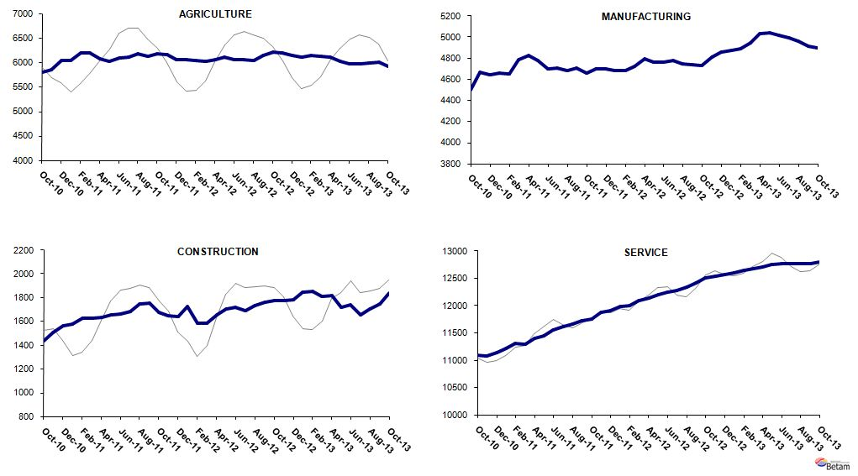
Source: TurkStat, Betam

Table 1 Seasonally adjusted non-agricultural labor force indicators (in thousands)
 | Labor force | Employment | Unemployment | Unemployment rate | Monthly changes
September-10 | 19832 | 16944 | 2888 | 14.6% | Labor force | Employment | Unemployment
October-10 | 19876 | 17021 | 2855 | 14.4% | 44 | 77 | -33
November-10 | 19992 | 17258 | 2735 | 13.7% | 116 | 236 | -120
December-10 | 20072 | 17351 | 2721 | 13.6% | 79 | 93 | -14
January-11 | 20128 | 17443 | 2685 | 13.3% | 57 | 92 | -35
February-11 | 20176 | 17580 | 2596 | 12.9% | 48 | 138 | -90
March-11 | 20288 | 17709 | 2578 | 12.7% | 112 | 129 | -17
April-11 | 20459 | 17862 | 2597 | 12.7% | 172 | 153 | 19
May-11 | 20555 | 17873 | 2683 | 13.1% | 96 | 10 | 86
June-11 | 20587 | 17915 | 2672 | 13.0% | 32 | 43 | -11
July-11 | 20599 | 18014 | 2585 | 12.6% | 12 | 99 | -87
August-11 | 20584 | 18089 | 2494 | 12.1% | -16 | 75 | -91
September-11 | 20568 | 18191 | 2377 | 11.6% | -16 | 102 | -117
October-11 | 20518 | 18088 | 2431 | 11.8% | -50 | -103 | 54
November-11 | 20585 | 18223 | 2362 | 11.5% | 67 | 135 | -69
December-11 | 20615 | 18249 | 2366 | 11.5% | 30 | 26 | 4
January-12 | 20744 | 18400 | 2344 | 11.3% | 129 | 151 | -22
February-12 | 20631 | 18264 | 2367 | 11.5% | -113 | -136 | 23
March-12 | 20788 | 18403 | 2385 | 11.5% | 157 | 139 | 18
April-12 | 20949 | 18580 | 2369 | 11.3% | 161 | 177 | -16
May-12 | 21032 | 18662 | 2369 | 11.3% | 83 | 82 | 0
June-12 | 21067 | 18724 | 2343 | 11.1% | 35 | 62 | -26
July-12 | 21145 | 18753 | 2392 | 11.3% | 78 | 29 | 49
August-12 | 21253 | 18818 | 2434 | 11.5% | 108 | 66 | 42
September-12 | 21447 | 18918 | 2529 | 11.8% | 194 | 99 | 95
October-12 | 21549 | 19022 | 2527 | 11.7% | 102 | 104 | -2
November-12 | 21703 | 19134 | 2569 | 11.8% | 154 | 112 | 42
December-12 | 21813 | 19217 | 2596 | 11.9% | 110 | 83 | 27
January-13 | 21891 | 19312 | 2579 | 11.8% | 78 | 95 | -17
February-13 | 21948 | 19389 | 2558 | 11.7% | 57 | 77 | -20
March-13 | 22022 | 19441 | 2581 | 11.7% | 75 | 51 | 23
April-13 | 22160 | 19555 | 2604 | 11.8% | 138 | 115 | 23
May-13 | 22164 | 19526 | 2638 | 11.9% | 4 | -29 | 33
June-13 | 22177 | 19514 | 2662 | 12.0% | 13 | -11 | 24
July-13 | 22174 | 19411 | 2763 | 12.5% | -3 | -103 | 100
August-13 | 22228 | 19445 | 2783 | 12.5% | 54 | 34 | 20
September-13 | 22219 | 19438 | 2781 | 12.5% | -9 | -7 | -2
October-13 | 22237 | 19537 | 2700 | 12.1% | 17 | 99 | -81
Source: TurkStat, Betam

Table 2 Seasonally adjusted employment by sector (in thousands)
 | Agriculture | Manufacturing | Construction | Service | Monthly changes
September-10 | 5648 | 4489 | 1413 | 11042 | Agriculture | Manufacturing | Construction | Service
October-10 | 5803 | 4498 | 1437 | 11086 | 155 | 9 | 24 | 44
November-10 | 5853 | 4667 | 1507 | 11084 | 50 | 169 | 69 | -2
December-10 | 6034 | 4642 | 1563 | 11145 | 181 | -25 | 57 | 61
January-11 | 6038 | 4656 | 1578 | 11209 | 4 | 14 | 14 | 64
February-11 | 6188 | 4652 | 1624 | 11304 | 150 | -4 | 47 | 95
March-11 | 6199 | 4790 | 1628 | 11291 | 12 | 138 | 4 | -13
April-11 | 6077 | 4828 | 1632 | 11402 | -123 | 38 | 4 | 111
May-11 | 6020 | 4777 | 1652 | 11443 | -56 | -51 | 20 | 41
June-11 | 6092 | 4697 | 1666 | 11552 | 72 | -80 | 14 | 109
July-11 | 6111 | 4710 | 1686 | 11618 | 19 | 13 | 20 | 66
August-11 | 6184 | 4682 | 1750 | 11658 | 72 | -28 | 63 | 40
September-11 | 6121 | 4707 | 1755 | 11729 | -62 | 25 | 5 | 71
October-11 | 6185 | 4657 | 1673 | 11757 | 64 | -50 | -82 | 28
November-11 | 6157 | 4700 | 1651 | 11872 | -28 | 43 | -22 | 114
December-11 | 6051 | 4701 | 1639 | 11909 | -107 | 1 | -12 | 37
January-12 | 6055 | 4685 | 1724 | 11991 | 4 | -16 | 85 | 82
February-12 | 6041 | 4684 | 1585 | 11995 | -14 | -1 | -139 | 4
March-12 | 6026 | 4721 | 1583 | 12099 | -14 | 37 | -2 | 104
April-12 | 6057 | 4792 | 1652 | 12136 | 31 | 71 | 69 | 37
May-12 | 6111 | 4760 | 1708 | 12194 | 54 | -32 | 56 | 59
June-12 | 6051 | 4761 | 1718 | 12245 | -60 | 1 | 10 | 50
July-12 | 6049 | 4778 | 1691 | 12284 | -3 | 17 | -28 | 40
August-12 | 6045 | 4745 | 1735 | 12339 | -3 | -33 | 44 | 54
September-12 | 6146 | 4735 | 1763 | 12420 | 100 | -10 | 28 | 82
October-12 | 6213 | 4732 | 1777 | 12512 | 67 | -3 | 15 | 92
November-12 | 6192 | 4814 | 1775 | 12545 | -20 | 82 | -2 | 32
December-12 | 6138 | 4856 | 1785 | 12576 | -54 | 42 | 10 | 32
January-13 | 6113 | 4870 | 1849 | 12593 | -25 | 14 | 64 | 17
February-13 | 6143 | 4886 | 1856 | 12647 | 30 | 16 | 7 | 54
March-13 | 6120 | 4948 | 1813 | 12680 | -23 | 62 | -44 | 33
April-13 | 6103 | 5030 | 1816 | 12709 | -17 | 82 | 3 | 29
May-13 | 6031 | 5044 | 1722 | 12759 | -72 | 14 | -94 | 50
June-13 | 5973 | 5015 | 1737 | 12762 | -58 | -29 | 15 | 2
July-13 | 5969 | 4991 | 1657 | 12763 | -3 | -24 | -81 | 1
August-13 | 5993 | 4964 | 1704 | 12777 | 24 | -27 | 48 | 13
September-13 | 6012 | 4914 | 1747 | 12777 | 19 | -50 | 43 | 0
October-13 | 5920 | 4899 | 1841 | 12797 | -92 | -15 | 94 | 20
Source: TurkStat, Betam

* Prof. Dr. Seyfettin Gürsel, Betam, Director, seyfettin.gursel@bahcesehir.edu.tr
∗ Yrd. Doç. Dr. Gökçe Uysal, Betam, Vice Director, gokce.uysal@bahcesehir.edu.tr
∗∗ Ayşenur Acar, Betam, Research Assistant, aysenur.acar@bahcesehir.edu.tr
Betam has been calculating application per vacancy using series released by Kariyer.net for a while. Seasonal and calendar adjustment procedure is applied to application per vacancy series. A decrease in applications per vacancy may be caused by an increase in vacancies or by a decrease in the number of applications. An increase in vacancies signals economic growth while decreasing number of applications indicates a decrease in number of people looking for a job.
Employment in each sector is seasonally adjusted separately. Hence the sum of these series may differ from the seasonally adjusted series of total employment. The difference stems from the non-linearity of the seasonal adjustment process.
Grey lines indicate seasonally adjusted series, where dark blue lines represent raw data.

