

Labor Market Outlook:

December 2013

16 December 2013

EMPLOYMENT INCREASE SLOWS DOWN DRASTICALLY

Seyfettin Gürsel* Gökçe Uysal∗ and Ayşenur Acar∗

Abstract

Seasonally adjusted labor market data shows that non-agricultural unemployment rate remained at 12.6 percent in the period of September 2013. Annual increases in labor force have been slowing down due to a base effect. On the other hand, it is striking that the increase in employment is the lowest observed since the global economic crisis. Manufacturing employment has been decreasing for the last four periods, while employment increases in the service sector seems to have stalled.

Increases in both non-agricultural labor force and non-agricultural employment slow down drastically

According to the data released by TurkSTAT, non-agricultural labor force increased by 705 thousand (3.3 percent) and non-agricultural employment increased by 468 thousand (2.5 percent) in the period of September 2013 (Figure 1). Consequently, the number of persons unemployed in non-agricultural sectors increased by 237 thousand (9.5 percent). Clearly increases in both non-agricultural labor force and non-agricultural employment have been slowing down. We expect lower annual increases in the upcoming periods as well. On the other hand, slow down in non-agricultural employment is striking. Given that during the past year, the employment increases were well over 600 thousand, and even reached one million on an annual basis, we believe that the abnormal GDP growth- employment elasticity may have returned to normal.

Figure 1 Year-on-year changes in non-agricultural labor force, employment and unemployment
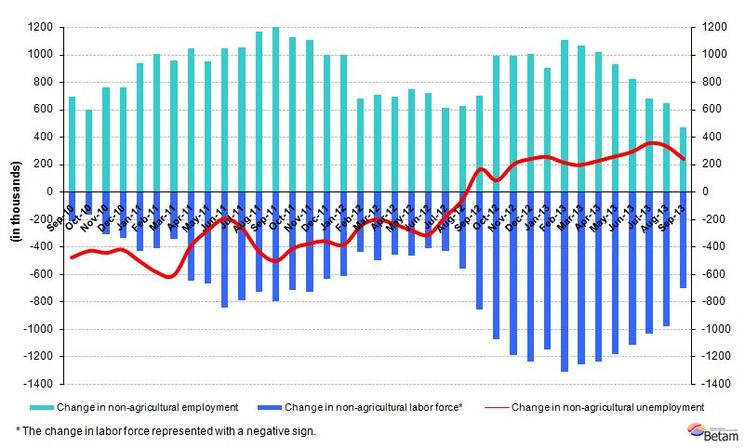
Source: TurkSTAT, Betam
Slow down in non-agricultural employment

According to seasonally adjusted data, non-agricultural labor force decreased by 7 thousand in the period of September 2013 compared to the period of August 2013 and reached 22 million 234 thousand (Figure 2, Table 1). Non-agricultural employment decreased by 8 thousand and reached 19 million 441 thousand. Hence, the number of persons unemployed in non-agricultural sectors increased by one thousand and non-agricultural unemployment rate remained at 12.6 percent in the period of September 2013. Similarly, we observe that both non-agricultural labor force and non-agricultural employment have stagnated.

Figure 2 Seasonally adjusted non-agricultural labor force, employment and unemployment

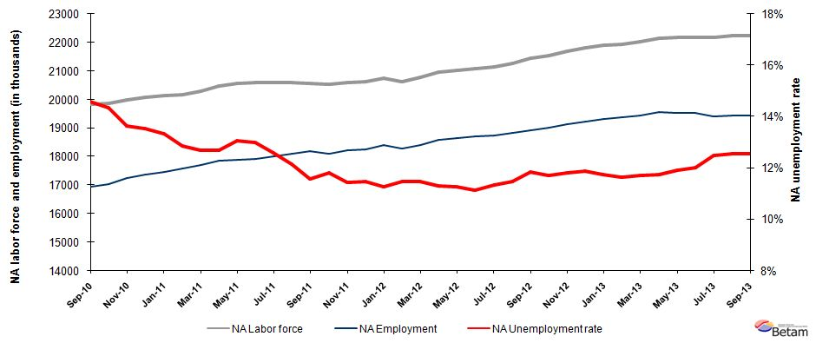
Source: TurkStat, Betam

Increases in both female labor force and female employment

Figure 3 provides seasonally adjusted non-agricultural labor force and non-agricultural employment series by gender. Long term trends indicate that female labor force and female employment have increased much more compared to males in the last year. Male employment increased by 229 thousand (1.6 percent), while female employment increased by 256 thousand (5.6 percent) from September 2012 to September 2013. However, female employment increased by 11 thousand, while female labor force decreased by 2 thousand. In the same period, male employment increased 16 thousand, while male labor force increased one thousand.

Figure 3 Seasonally adjusted non-agricultural labor force and non-agricultural employment by gender (thousand)
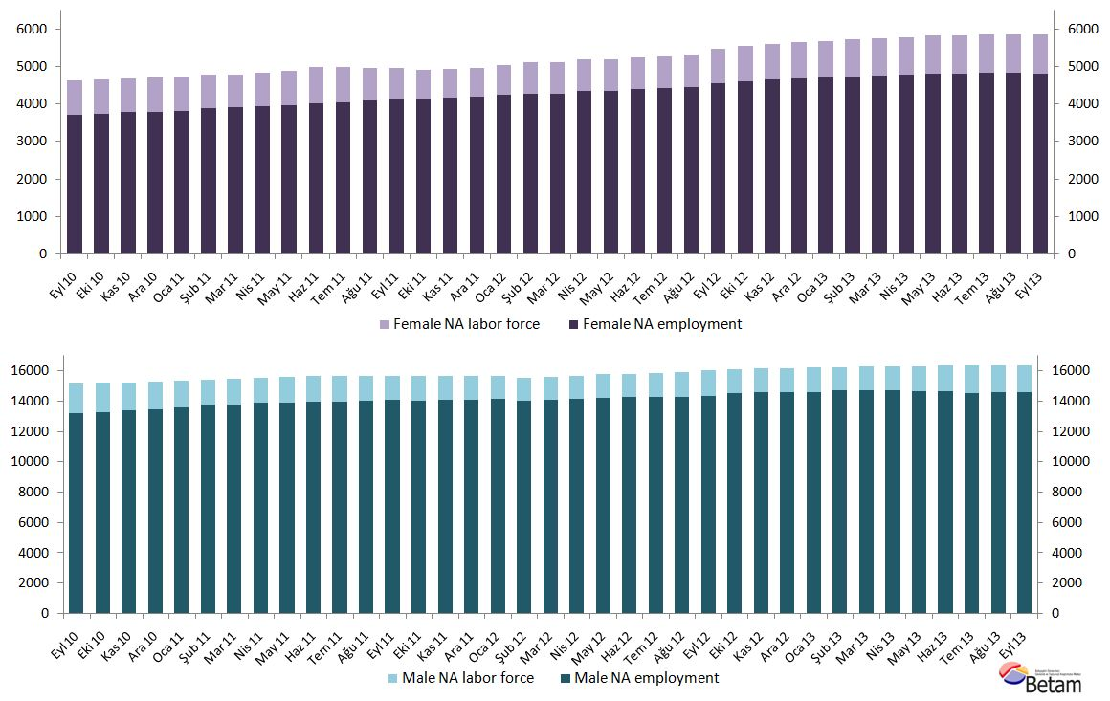
Source: TurkStat, Betam

According to Kariyer.net data, non-agricultural unemployment will stagnate in the next period

Seasonally adjusted application per vacancy statistics calculated using Kariyer.net series indicate that non-agricultural unemployment increased in the period of October 2013 and decreased in the period of November 2013. Remember that labor market series pertaining to October are the average of three months: September, October and November. Hence, we expect the non-agricultural unemployment to stagnate in the period of October 2013.

Figure 4 Seasonally adjusted non-agricultural unemployment rate and application per vacancy
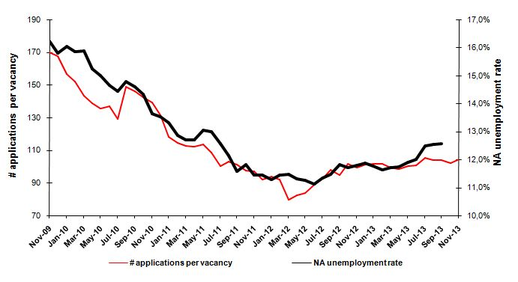
Source: Kariyer.net, TurkStat, Betam

Employment in manufacturing has been decreasing for the last four periods, and no employment increases in service sector

According to the seasonally adjusted labor market series, manufacturing employment has been decreasing for the last four periods (Table 2, Figure 5). Employment losses in manufacturing are about to 130 thousand. Employment in the service sector slightly increased (23 thousand) in the period of September 2013. In addition, we observe that increase in service employment is zero in the period of September 2013 compared to the period of August 2013. As for employment in the construction sector, we observe that it has been increasing for the last two periods.

Figure 5 Employment by sectors (in thousands)
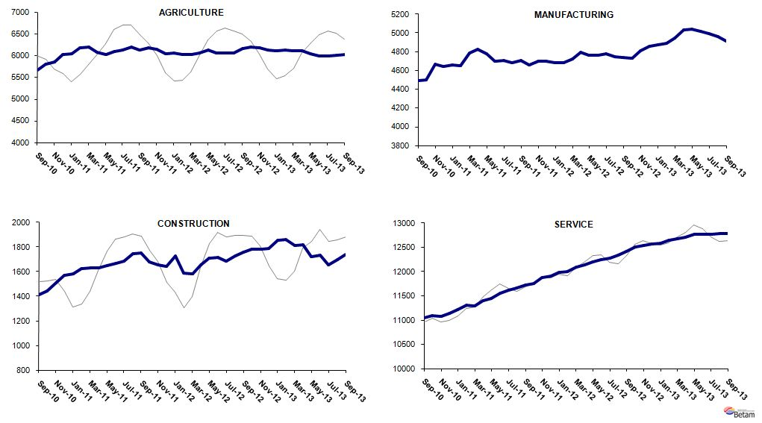
Source: TurkStat, Betam

Table 1 Seasonally adjusted non-agricultural labor force indicators (in thousands)
 | Labor force | Employment | Unemployment | Unemployment rate | Monthly changes
August-10 | 19883 | 16946 | 2937 | 14.8% | Labor force | Employment | Unemployment
September-10 | 19835 | 16940 | 2895 | 14.6% | -48 | -6 | -42
October-10 | 19875 | 17025 | 2850 | 14.3% | 40 | 85 | -45
November-10 | 19990 | 17262 | 2729 | 13.6% | 115 | 237 | -122
December-10 | 20070 | 17354 | 2716 | 13.5% | 80 | 93 | -12
January-11 | 20128 | 17446 | 2682 | 13.3% | 57 | 91 | -34
February-11 | 20176 | 17582 | 2594 | 12.9% | 48 | 137 | -89
March-11 | 20288 | 17710 | 2578 | 12.7% | 112 | 128 | -16
April-11 | 20460 | 17862 | 2598 | 12.7% | 172 | 152 | 20
May-11 | 20556 | 17871 | 2685 | 13.1% | 96 | 9 | 87
June-11 | 20588 | 17913 | 2675 | 13.0% | 32 | 42 | -10
July-11 | 20601 | 18011 | 2590 | 12.6% | 12 | 98 | -85
August-11 | 20586 | 18085 | 2500 | 12.1% | -15 | 75 | -90
September-11 | 20570 | 18186 | 2384 | 11.6% | -15 | 101 | -116
October-11 | 20519 | 18092 | 2426 | 11.8% | -51 | -94 | 43
November-11 | 20583 | 18227 | 2356 | 11.4% | 64 | 135 | -71
December-11 | 20614 | 18253 | 2361 | 11.5% | 31 | 26 | 6
January-12 | 20744 | 18403 | 2341 | 11.3% | 129 | 150 | -21
February-12 | 20631 | 18266 | 2364 | 11.5% | -113 | -137 | 24
March-12 | 20788 | 18404 | 2384 | 11.5% | 157 | 138 | 19
April-12 | 20949 | 18580 | 2369 | 11.3% | 162 | 176 | -14
May-12 | 21032 | 18661 | 2371 | 11.3% | 83 | 81 | 2
June-12 | 21068 | 18721 | 2346 | 11.1% | 36 | 61 | -25
July-12 | 21146 | 18749 | 2397 | 11.3% | 78 | 27 | 51
August-12 | 21255 | 18814 | 2441 | 11.5% | 109 | 65 | 44
September-12 | 21452 | 18914 | 2538 | 11.8% | 197 | 100 | 97
October-12 | 21546 | 19024 | 2522 | 11.7% | 94 | 110 | -16
November-12 | 21698 | 19137 | 2561 | 11.8% | 152 | 113 | 39
December-12 | 21809 | 19220 | 2589 | 11.9% | 111 | 83 | 28
January-13 | 21889 | 19315 | 2574 | 11.8% | 80 | 95 | -15
February-13 | 21947 | 19392 | 2555 | 11.6% | 58 | 77 | -19
March-13 | 22022 | 19442 | 2580 | 11.7% | 75 | 50 | 25
April-13 | 22162 | 19557 | 2605 | 11.8% | 140 | 115 | 25
May-13 | 22167 | 19527 | 2640 | 11.9% | 5 | -30 | 36
June-13 | 22183 | 19516 | 2667 | 12.0% | 15 | -11 | 26
July-13 | 22182 | 19413 | 2770 | 12.5% | 0 | -103 | 103
August-13 | 22241 | 19448 | 2793 | 12.6% | 59 | 36 | 23
September-13 | 22234 | 19441 | 2793 | 12.6% | -7 | -8 | 1
Source: TurkStat, Betam

Table 2 Seasonally adjusted employment by sector (in thousands)
 | Agriculture | Manufacturing | Construction | Service | Monthly changes
August-10 | 5666 | 4525 | 1411 | 11010 | Agriculture | Manufacturing | Construction | Service
September-10 | 5659 | 4489 | 1409 | 11042 | -8 | -36 | -1 | 32
October-10 | 5792 | 4498 | 1441 | 11086 | 133 | 9 | 32 | 44
November-10 | 5845 | 4667 | 1510 | 11084 | 53 | 169 | 69 | -2
December-10 | 6027 | 4642 | 1567 | 11145 | 183 | -25 | 57 | 61
January-11 | 6032 | 4656 | 1580 | 11209 | 5 | 14 | 14 | 64
February-11 | 6177 | 4652 | 1626 | 11304 | 145 | -4 | 46 | 95
March-11 | 6195 | 4790 | 1629 | 11291 | 18 | 138 | 3 | -13
April-11 | 6078 | 4828 | 1632 | 11402 | -117 | 38 | 3 | 111
May-11 | 6030 | 4777 | 1651 | 11443 | -48 | -51 | 19 | 41
June-11 | 6099 | 4697 | 1664 | 11552 | 70 | -80 | 13 | 109
July-11 | 6122 | 4710 | 1683 | 11618 | 22 | 13 | 19 | 66
August-11 | 6195 | 4682 | 1745 | 11658 | 73 | -28 | 63 | 40
September-11 | 6132 | 4707 | 1750 | 11729 | -62 | 25 | 5 | 71
October-11 | 6169 | 4657 | 1678 | 11757 | 37 | -50 | -72 | 28
November-11 | 6145 | 4700 | 1656 | 11872 | -23 | 43 | -22 | 114
December-11 | 6044 | 4701 | 1643 | 11909 | -101 | 1 | -13 | 38
January-12 | 6050 | 4685 | 1727 | 11991 | 6 | -16 | 84 | 82
February-12 | 6031 | 4684 | 1587 | 11995 | -19 | -1 | -140 | 4
March-12 | 6023 | 4721 | 1584 | 12099 | -8 | 37 | -3 | 104
April-12 | 6059 | 4792 | 1652 | 12136 | 36 | 71 | 68 | 37
May-12 | 6121 | 4760 | 1706 | 12194 | 62 | -32 | 54 | 59
June-12 | 6063 | 4761 | 1716 | 12245 | -58 | 1 | 10 | 50
July-12 | 6063 | 4778 | 1686 | 12284 | 0 | 17 | -30 | 40
August-12 | 6059 | 4745 | 1730 | 12339 | -4 | -33 | 44 | 55
September-12 | 6157 | 4735 | 1757 | 12421 | 97 | -10 | 27 | 83
October-12 | 6192 | 4732 | 1783 | 12509 | 35 | -3 | 26 | 88
November-12 | 6176 | 4814 | 1780 | 12543 | -16 | 82 | -2 | 34
December-12 | 6129 | 4856 | 1789 | 12575 | -47 | 42 | 9 | 32
January-13 | 6107 | 4870 | 1853 | 12592 | -23 | 14 | 63 | 18
February-13 | 6131 | 4886 | 1859 | 12647 | 25 | 16 | 6 | 55
March-13 | 6115 | 4948 | 1813 | 12681 | -16 | 62 | -45 | 34
April-13 | 6103 | 5030 | 1816 | 12711 | -12 | 82 | 2 | 30
May-13 | 6042 | 5044 | 1721 | 12762 | -62 | 14 | -95 | 51
June-13 | 5987 | 5015 | 1735 | 12766 | -54 | -29 | 14 | 4
July-13 | 5987 | 4991 | 1652 | 12770 | 0 | -24 | -83 | 3
August-13 | 6010 | 4964 | 1699 | 12785 | 23 | -27 | 47 | 15
September-13 | 6026 | 4914 | 1742 | 12785 | 16 | -50 | 42 | 0
Source: TurkStat, Betam

* Prof. Dr. Seyfettin Gürsel, Betam, Director, seyfettin.gursel@bahcesehir.edu.tr
∗ Yrd. Doç. Dr. Gökçe Uysal, Betam, Vice Director, gokce.uysal@bahcesehir.edu.tr
∗∗ Ayşenur Acar, Betam, Research Assistant, aysenur.acar@bahcesehir.edu.tr
Betam has been calculating application per vacancy using series released by Kariyer.net for a while. Seasonal and calendar adjustment procedure is applied to application per vacancy series. A decrease in applications per vacancy may be caused by an increase in vacancies or by a decrease in the number of applications. An increase in vacancies signals economic growth while decreasing number of applications indicates a decrease in number of people looking for a job.
Employment in each sector is seasonally adjusted separately. Hence the sum of these series may differ from the seasonally adjusted series of total employment. The difference stems from the non-linearity of the seasonal adjustment process.
Grey lines indicate seasonally adjusted series, where dark blue lines represent raw data.

