

Labor Market Outlook:

November 2013

15 November 2013

STAGNATION IN UNEMPLOYMENT

Seyfettin Gürsel* Gökçe Uysal∗ and Ayşenur Acar∗

Abstract

Seasonally adjusted labor market data shows that non-agricultural unemployment rate remained at 12.5 percent in the period of August 2013. The increase in non-agricultural labor force counterbalances the increase in non-agricultural employment in this period. Hence, non-agricultural unemployment rate stagnates. Seasonally adjusted employment data also shows that manufacturing employment has been decreasing for the period of June 2013. Service employment has been slightly increasing since the beginning of 2013. During this period, employment in construction increased by 48 thousand in the period of August 2013 preventing unemployment to increase further.

Increases in both non-agricultural labor force and non-agricultural employment have been slowing down

According to the data released by TurkSTAT, non-agricultural labor force increased by 978 thousand (4.6 percent) and non-agricultural employment increased by 648 thousand (3.4 percent) in the period of August 2013 (Figure 1). Clearly increases in both non-agricultural labor force and non-agricultural employment have been slowing down. Consequently, the number of persons unemployed in non-agricultural sectors increased by 332 thousand (13.9 percent).

Figure 1 Year-on-year changes in non-agricultural labor force, employment and unemployment
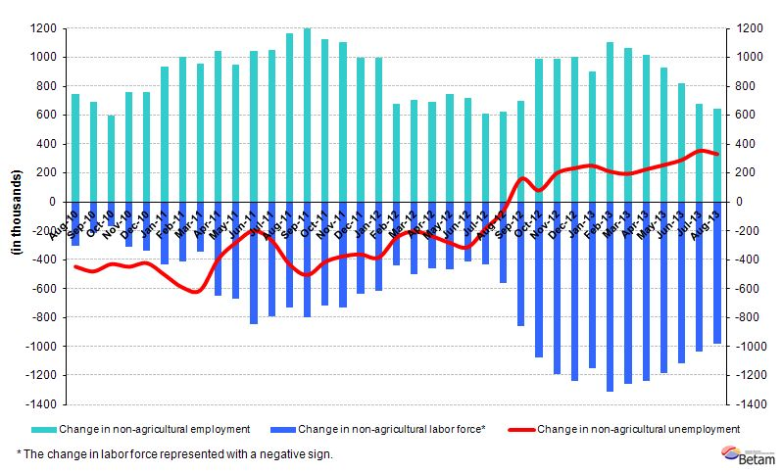
Source: TurkSTAT, Betam

Stagnation in non-agricultural unemployment

According to seasonally adjusted data, non-agricultural labor force increased by 61 thousand in the period of August 2013 compared to the period of July 2013 and reached 22 million 270 thousand (Figure 2, Table 1). Non-agricultural employment increased by 38 thousand and reached 19 million 478 thousand. Hence, the number of persons unemployed in non-agricultural sectors increased by 23 thousand and non-agricultural unemployment rate remained at 12.5 percent in the period of August 2013.

Figure 2 Seasonally adjusted non-agricultural labor force, employment and unemployment
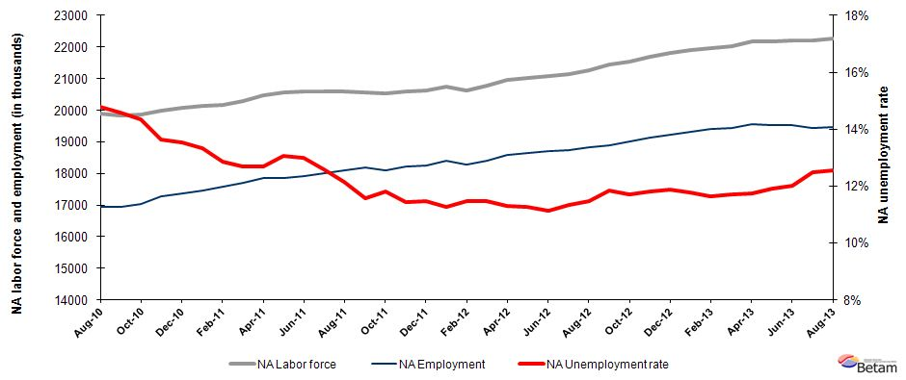
Source: TurkStat, Betam

According to Kariyer.net data, non-agricultural unemployment will stagnate in the period of October 2013

Seasonally adjusted application per vacancy statistics calculated using Kariyer.net series indicate that non-agricultural unemployment will continue to stagnate in the period of October 2013.

Figure 1 Seasonally adjusted non-agricultural unemployment rate and application per vacancy
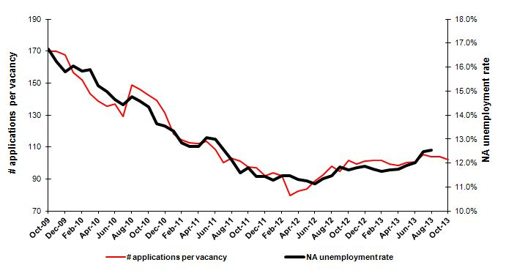
Source: Kariyer.net, TurkStat, Betam

Employment losses in manufacturing and employment increase in construction

According to the seasonally adjusted labor market series, manufacturing employment decreased by 27 thousand (Table 2, Figure 4). Manufacturing employment has been decreasing since June 2013. On the other hand, increases in service employment have been losing pace since the beginning of 2013. Employment in service sector slightly increased (17 thousand) in the period of August 2013. On the other hand, construction employment increased by 48 thousand and agricultural employment increased by 23 thousand.

Figure 2 Employment by sectors (in thousands)
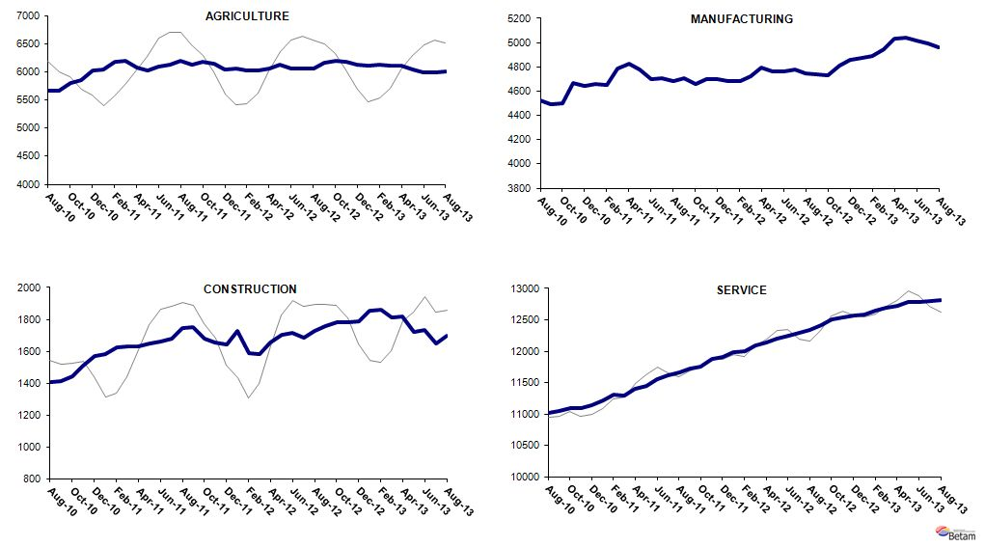
Source: TurkStat, Betam

Table 1 Seasonally adjusted non-agricultural labor force indicators (in thousands)
 | Labor force | Employment | Unemployment | Unemployment rate | Monthly changes
July-10 | 19882 | 17011 | 2871 | 14.4% | Labor force | Employment | Unemployment
August-10 | 19882 | 16944 | 2937 | 14.8% | 0 | -67 | 67
September-10 | 19836 | 16942 | 2894 | 14.6% | -45 | -2 | -43
October-10 | 19876 | 17026 | 2850 | 14.3% | 40 | 85 | -45
November-10 | 19992 | 17263 | 2729 | 13.7% | 116 | 237 | -120
December-10 | 20073 | 17356 | 2717 | 13.5% | 80 | 93 | -12
January-11 | 20130 | 17447 | 2683 | 13.3% | 57 | 91 | -34
February-11 | 20177 | 17583 | 2594 | 12.9% | 48 | 136 | -88
March-11 | 20288 | 17710 | 2577 | 12.7% | 110 | 127 | -17
April-11 | 20459 | 17862 | 2598 | 12.7% | 172 | 152 | 20
May-11 | 20554 | 17870 | 2684 | 13.1% | 94 | 8 | 86
June-11 | 20586 | 17912 | 2675 | 13.0% | 33 | 42 | -9
July-11 | 20598 | 18009 | 2590 | 12.6% | 12 | 97 | -85
August-11 | 20584 | 18084 | 2500 | 12.1% | -15 | 75 | -90
September-11 | 20572 | 18188 | 2383 | 11.6% | -12 | 105 | -117
October-11 | 20520 | 18094 | 2426 | 11.8% | -52 | -94 | 42
November-11 | 20585 | 18229 | 2356 | 11.4% | 65 | 135 | -69
December-11 | 20616 | 18255 | 2362 | 11.5% | 31 | 26 | 5
January-12 | 20746 | 18405 | 2341 | 11.3% | 129 | 150 | -21
February-12 | 20633 | 18267 | 2365 | 11.5% | -113 | -137 | 24
March-12 | 20788 | 18404 | 2384 | 11.5% | 155 | 137 | 18
April-12 | 20950 | 18580 | 2370 | 11.3% | 162 | 176 | -14
May-12 | 21030 | 18659 | 2371 | 11.3% | 80 | 80 | 1
June-12 | 21067 | 18720 | 2347 | 11.1% | 37 | 61 | -24
July-12 | 21144 | 18746 | 2397 | 11.3% | 77 | 26 | 50
August-12 | 21257 | 18816 | 2441 | 11.5% | 114 | 70 | 44
September-12 | 21442 | 18905 | 2537 | 11.8% | 185 | 89 | 96
October-12 | 21539 | 19018 | 2521 | 11.7% | 97 | 113 | -16
November-12 | 21694 | 19133 | 2561 | 11.8% | 155 | 114 | 40
December-12 | 21807 | 19218 | 2589 | 11.9% | 114 | 85 | 28
January-13 | 21890 | 19316 | 2574 | 11.8% | 83 | 98 | -15
February-13 | 21952 | 19395 | 2556 | 11.6% | 61 | 79 | -18
March-13 | 22029 | 19448 | 2580 | 11.7% | 77 | 53 | 24
April-13 | 22174 | 19568 | 2606 | 11.8% | 145 | 120 | 25
May-13 | 22182 | 19541 | 2640 | 11.9% | 8 | -27 | 35
June-13 | 22205 | 19537 | 2668 | 12.0% | 23 | -4 | 27
July-13 | 22209 | 19440 | 2770 | 12.5% | 5 | -97 | 102
August-13 | 22270 | 19478 | 2793 | 12.5% | 61 | 38 | 23
Source: TurkStat, Betam

Table 2 Seasonally adjusted employment by sector (in thousands)
 | Agriculture | Manufacturing | Construction | Service | Monthly changes
July-10 | 5692 | 4575 | 1459 | 10976 | Agriculture | Manufacturing | Construction | Service
August-10 | 5666 | 4525 | 1409 | 11010 | -26 | -50 | -51 | 34
September-10 | 5659 | 4489 | 1411 | 11042 | -6 | -36 | 2 | 32
October-10 | 5792 | 4498 | 1442 | 11086 | 133 | 9 | 32 | 44
November-10 | 5845 | 4667 | 1511 | 11085 | 53 | 169 | 69 | -1
December-10 | 6028 | 4642 | 1568 | 11146 | 183 | -25 | 57 | 61
January-11 | 6032 | 4656 | 1581 | 11210 | 5 | 14 | 13 | 64
February-11 | 6177 | 4652 | 1627 | 11305 | 145 | -4 | 45 | 95
March-11 | 6195 | 4790 | 1629 | 11291 | 18 | 138 | 2 | -13
April-11 | 6078 | 4828 | 1632 | 11402 | -117 | 38 | 3 | 111
May-11 | 6030 | 4777 | 1650 | 11443 | -48 | -51 | 18 | 41
June-11 | 6099 | 4697 | 1663 | 11552 | 69 | -80 | 13 | 109
July-11 | 6121 | 4710 | 1681 | 11618 | 22 | 13 | 18 | 66
August-11 | 6194 | 4682 | 1743 | 11659 | 73 | -28 | 63 | 40
September-11 | 6133 | 4707 | 1752 | 11730 | -61 | 25 | 9 | 71
October-11 | 6169 | 4657 | 1680 | 11758 | 36 | -50 | -72 | 28
November-11 | 6146 | 4700 | 1657 | 11872 | -23 | 43 | -23 | 114
December-11 | 6045 | 4701 | 1644 | 11910 | -101 | 1 | -13 | 38
January-12 | 6050 | 4685 | 1728 | 11992 | 6 | -16 | 84 | 82
February-12 | 6031 | 4684 | 1588 | 11996 | -20 | -1 | -141 | 4
March-12 | 6023 | 4721 | 1584 | 12099 | -8 | 37 | -4 | 104
April-12 | 6059 | 4792 | 1652 | 12136 | 36 | 71 | 68 | 37
May-12 | 6121 | 4760 | 1705 | 12194 | 62 | -32 | 53 | 58
June-12 | 6062 | 4761 | 1714 | 12245 | -58 | 1 | 9 | 50
July-12 | 6062 | 4778 | 1684 | 12285 | 0 | 17 | -31 | 40
August-12 | 6059 | 4745 | 1728 | 12343 | -4 | -33 | 44 | 59
September-12 | 6158 | 4735 | 1759 | 12411 | 99 | -10 | 32 | 67
October-12 | 6193 | 4732 | 1785 | 12502 | 35 | -3 | 25 | 91
November-12 | 6177 | 4814 | 1782 | 12537 | -16 | 82 | -3 | 35
December-12 | 6130 | 4856 | 1791 | 12571 | -47 | 42 | 9 | 35
January-13 | 6107 | 4870 | 1854 | 12592 | -23 | 14 | 64 | 20
February-13 | 6131 | 4886 | 1860 | 12650 | 24 | 16 | 5 | 58
March-13 | 6115 | 4948 | 1813 | 12687 | -16 | 62 | -46 | 37
April-13 | 6103 | 5030 | 1816 | 12722 | -12 | 82 | 3 | 35
May-13 | 6041 | 5044 | 1719 | 12778 | -62 | 14 | -97 | 56
June-13 | 5986 | 5015 | 1733 | 12789 | -55 | -29 | 14 | 11
July-13 | 5986 | 4991 | 1649 | 12800 | 0 | -24 | -84 | 11
August-13 | 6009 | 4964 | 1697 | 12817 | 23 | -27 | 48 | 17
Source: TurkStat, Betam

* Prof. Dr. Seyfettin Gürsel, Betam, Director, seyfettin.gursel@bahcesehir.edu.tr
∗ Yrd. Doç. Dr. Gökçe Uysal, Betam, Vice Director, gokce.uysal@bahcesehir.edu.tr
∗∗ Ayşenur Acar, Betam, Research Assistant, aysenur.acar@bahcesehir.edu.tr
Betam has been calculating application per vacancy using series released by Kariyer.net for a while. Seasonal and calendar adjustment procedure is applied to application per vacancy series. A decrease in applications per vacancy may be caused by an increase in vacancies or by a decrease in the number of applications. An increase in vacancies signals economic growth while decreasing number of applications indicates a decrease in number of people looking for a job.
Employment in each sector is seasonally adjusted separately. Hence the sum of these series may differ from the seasonally adjusted series of total employment. The difference stems from the non-linearity of the seasonal adjustment process.
Grey lines indicate seasonally adjusted series, where dark blue lines represent raw data.

