

Labor Market Outlook:

October 2013

11 October 2013

REMARKABLE INCREASE IN UNEMPLOYMENT

Seyfettin Gürsel* Gökçe Uysal∗ and Ayşenur Acar∗

Abstract

Seasonally adjusted labor market data shows that non-agricultural unemployment rate increased from 12 percent in the period of June 2013 to 12.5 percent in the period of July 2013. We observe strong declines in both manufacturing and construction and a slight increase in service employment. Hence, the increase in non-agricultural employment weakens, failing to compensate for the strong increases in labor force.

Decline in non-agricultural employment

According to the data released by TurkSTAT, non-agricultural labor force increased by 1 million 37 thousand (4.9 percent) and non-agricultural employment increased by 682 thousand (3.6 percent) in the period of July 2013 (Figure 1). We observe that the strong increases in non-agricultural labor force continue, while the increase in non-agricultural employment weakens. Consequently, the number of persons unemployed in non-agricultural sectors increased by 372 thousand (16.5 percent).

Figure 1 Year-on-year changes in non-agricultural labor force, employment and unemployment
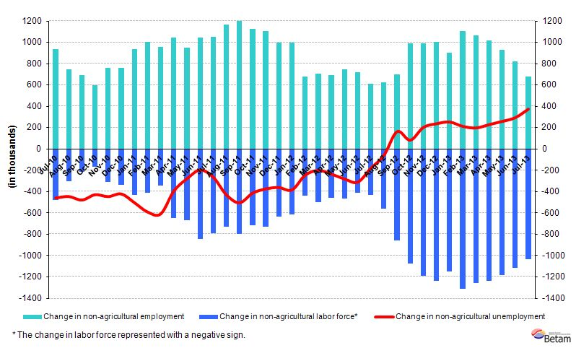
Source: TurkSTAT, Betam

Strong increase in non-agricultural unemployment

According to seasonally adjusted data, non-agricultural labor force increased by 9 thousand in the period of July 2013 compared to the period of June 2013 and reached 22 million 236 thousand (Figure 2, Table 1). Non-agricultural employment decreased by 93 thousand and reached 19 million 465 thousand. Consequently, the number of persons unemployed in non-agricultural sectors increased by 101 thousand and non-agricultural unemployment rate increased from 12 percent in June 2013 to 12.5 percent in July 2013. This marks the highest unemployment rate in the last two years.

Figure 2 Seasonally adjusted non-agricultural labor force, employment and unemployment
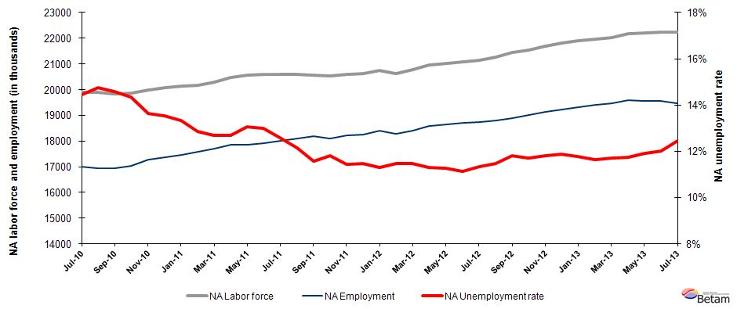
Source: TurkStat, Betam

According to Kariyer.net data, non-agricultural unemployment will stagnate in the period of September 2013

Seasonally adjusted applications per vacancy statistics calculated using Kariyer.net series indicate that non-agricultural unemployment will stagnate in the period of September 2013.

Figure 1 Seasonally adjusted non-agricultural unemployment rate and application per vacancy
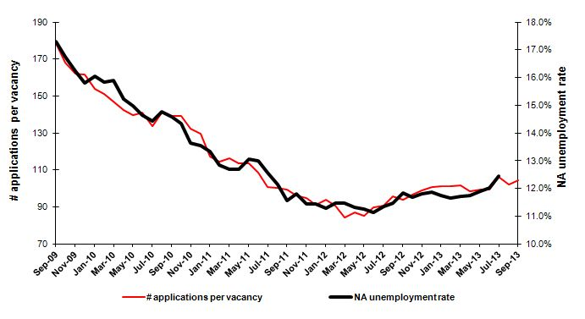
Source: Kariyer.net, TurkStat, Betam
Employment losses in both manufacturing and construction sector

According to seasonally adjusted labor market series, we observe employment losses in both manufacturing and construction sector (Table 2, Figure 4). Manufacturing employment decreased by 24 thousand, while construction employment decreased by 80 thousand in the period of July 2013 compared to the period of June 2013. Also, we observe that the increase in service sector weakens. Note that the average monthly employment increase in services was about 50 thousand for the past year. However, service employment increased by only 12 thousand in the period of July 2013. Agricultural employment decreased in the period of November 2012.

Figure 2 Employment by sectors (in thousands)
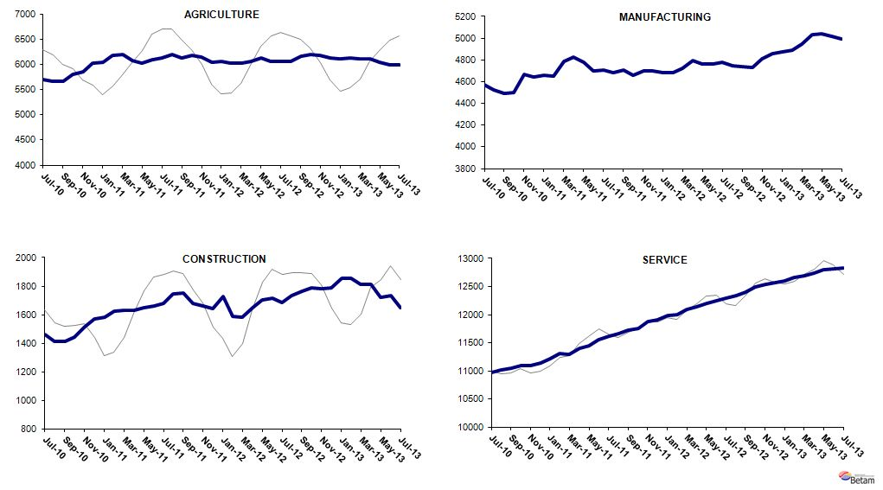
Source: TurkStat, Betam

Table 1 Seasonally adjusted non-agricultural labor force indicators (in thousands)
 | Labor force | Employment | Unemployment | Unemployment rate | Monthly changes
June-10 | 19826 | 16922 | 2904 | 14.6% | Labor force | Employment | Unemployment
July-10 | 19881 | 17009 | 2872 | 14.4% | 55 | 88 | -32
August-10 | 19883 | 16947 | 2936 | 14.8% | 2 | -62 | 64
September-10 | 19838 | 16944 | 2893 | 14.6% | -46 | -3 | -43
October-10 | 19877 | 17028 | 2849 | 14.3% | 40 | 84 | -44
November-10 | 19994 | 17264 | 2729 | 13.7% | 116 | 236 | -119
December-10 | 20073 | 17355 | 2717 | 13.5% | 79 | 91 | -12
January-11 | 20129 | 17446 | 2683 | 13.3% | 56 | 91 | -34
February-11 | 20177 | 17582 | 2595 | 12.9% | 49 | 136 | -88
March-11 | 20287 | 17710 | 2578 | 12.7% | 110 | 127 | -17
April-11 | 20459 | 17860 | 2598 | 12.7% | 171 | 151 | 20
May-11 | 20553 | 17869 | 2684 | 13.1% | 94 | 9 | 86
June-11 | 20586 | 17910 | 2676 | 13.0% | 33 | 41 | -8
July-11 | 20599 | 18008 | 2591 | 12.6% | 13 | 98 | -85
August-11 | 20586 | 18087 | 2499 | 12.1% | -13 | 79 | -92
September-11 | 20573 | 18191 | 2382 | 11.6% | -13 | 104 | -117
October-11 | 20521 | 18096 | 2424 | 11.8% | -52 | -94 | 42
November-11 | 20587 | 18230 | 2356 | 11.4% | 66 | 134 | -68
December-11 | 20616 | 18254 | 2362 | 11.5% | 30 | 24 | 6
January-12 | 20745 | 18403 | 2341 | 11.3% | 129 | 149 | -20
February-12 | 20633 | 18266 | 2366 | 11.5% | -112 | -137 | 25
March-12 | 20788 | 18404 | 2384 | 11.5% | 156 | 138 | 18
April-12 | 20949 | 18578 | 2371 | 11.3% | 160 | 174 | -13
May-12 | 21030 | 18659 | 2371 | 11.3% | 81 | 81 | 0
June-12 | 21066 | 18718 | 2348 | 11.1% | 36 | 59 | -23
July-12 | 21148 | 18750 | 2398 | 11.3% | 82 | 32 | 50
August-12 | 21251 | 18811 | 2440 | 11.5% | 102 | 61 | 41
September-12 | 21437 | 18902 | 2535 | 11.8% | 186 | 91 | 96
October-12 | 21536 | 19017 | 2519 | 11.7% | 98 | 114 | -16
November-12 | 21692 | 19131 | 2561 | 11.8% | 156 | 115 | 41
December-12 | 21805 | 19216 | 2589 | 11.9% | 113 | 85 | 28
January-13 | 21889 | 19315 | 2574 | 11.8% | 84 | 98 | -14
February-13 | 21955 | 19398 | 2557 | 11.6% | 66 | 83 | -17
March-13 | 22037 | 19456 | 2581 | 11.7% | 82 | 58 | 24
April-13 | 22184 | 19577 | 2607 | 11.8% | 147 | 122 | 26
May-13 | 22200 | 19558 | 2641 | 11.9% | 15 | -19 | 34
June-13 | 22228 | 19558 | 2670 | 12.0% | 28 | 0 | 28
July-13 | 22236 | 19465 | 2771 | 12.5% | 9 | -93 | 101
Source: TurkStat, Betam

Table 2 Seasonally adjusted employment by sector (in thousands)
 | Agriculture | Manufacturing | Construction | Service | Monthly changes
June-10 | 5723 | 4536 | 1409 | 10977 | Agriculture | Manufacturing | Construction | Service
July-10 | 5691 | 4575 | 1458 | 10977 | -31 | 39 | 49 | 0
August-10 | 5667 | 4525 | 1412 | 11011 | -24 | -50 | -46 | 34
September-10 | 5660 | 4489 | 1413 | 11042 | -7 | -36 | 1 | 32
October-10 | 5793 | 4498 | 1444 | 11086 | 133 | 9 | 31 | 44
November-10 | 5846 | 4667 | 1512 | 11085 | 53 | 169 | 68 | -2
December-10 | 6028 | 4642 | 1567 | 11146 | 182 | -25 | 55 | 61
January-11 | 6032 | 4656 | 1580 | 11210 | 4 | 14 | 13 | 64
February-11 | 6177 | 4652 | 1626 | 11305 | 144 | -4 | 45 | 95
March-11 | 6194 | 4790 | 1628 | 11291 | 18 | 138 | 3 | -13
April-11 | 6077 | 4828 | 1630 | 11402 | -117 | 38 | 2 | 111
May-11 | 6029 | 4777 | 1649 | 11443 | -48 | -51 | 19 | 41
June-11 | 6098 | 4697 | 1661 | 11552 | 69 | -80 | 12 | 109
July-11 | 6120 | 4710 | 1680 | 11618 | 22 | 13 | 19 | 66
August-11 | 6196 | 4682 | 1746 | 11659 | 76 | -28 | 67 | 40
September-11 | 6134 | 4707 | 1754 | 11730 | -61 | 25 | 8 | 71
October-11 | 6170 | 4657 | 1682 | 11758 | 36 | -50 | -73 | 28
November-11 | 6146 | 4700 | 1658 | 11872 | -24 | 43 | -23 | 114
December-11 | 6045 | 4701 | 1644 | 11910 | -102 | 1 | -15 | 38
January-12 | 6050 | 4685 | 1727 | 11992 | 6 | -16 | 83 | 82
February-12 | 6030 | 4684 | 1587 | 11996 | -20 | -1 | -140 | 4
March-12 | 6022 | 4721 | 1583 | 12099 | -8 | 37 | -3 | 104
April-12 | 6058 | 4792 | 1650 | 12136 | 36 | 71 | 66 | 37
May-12 | 6120 | 4760 | 1704 | 12195 | 62 | -32 | 54 | 58
June-12 | 6061 | 4761 | 1712 | 12245 | -59 | 1 | 8 | 50
July-12 | 6061 | 4778 | 1684 | 12288 | 0 | 17 | -28 | 43
August-12 | 6061 | 4745 | 1732 | 12335 | 0 | -33 | 47 | 47
September-12 | 6159 | 4735 | 1762 | 12405 | 99 | -10 | 30 | 71
October-12 | 6194 | 4732 | 1787 | 12498 | 34 | -3 | 25 | 92
November-12 | 6177 | 4814 | 1783 | 12534 | -16 | 82 | -3 | 36
December-12 | 6130 | 4856 | 1790 | 12570 | -47 | 42 | 7 | 36
January-13 | 6107 | 4870 | 1852 | 12593 | -23 | 14 | 62 | 23
February-13 | 6131 | 4886 | 1857 | 12654 | 24 | 16 | 6 | 61
March-13 | 6114 | 4948 | 1812 | 12695 | -17 | 62 | -45 | 41
April-13 | 6102 | 5030 | 1812 | 12735 | -12 | 82 | 0 | 39
May-13 | 6040 | 5044 | 1718 | 12796 | -62 | 14 | -94 | 61
June-13 | 5985 | 5015 | 1731 | 12812 | -55 | -29 | 13 | 16
July-13 | 5984 | 4991 | 1651 | 12824 | -1 | -24 | -80 | 12
Source: TurkStat, Betam

* Prof. Dr. Seyfettin Gürsel, Betam, Director, seyfettin.gursel@bahcesehir.edu.tr
∗ Yrd. Doç. Dr. Gökçe Uysal, Betam, Vice Director, gokce.uysal@bahcesehir.edu.tr
∗∗ Ayşenur Acar, Betam, Research Assistant, aysenur.acar@bahcesehir.edu.tr
Betam has been calculating application per vacancy using series released by Kariyer.net for a while. Seasonal and calendar adjustment procedure is applied to application per vacancy series. A decrease in applications per vacancy may be caused by an increase in vacancies or by a decrease in the number of applications. An increase in vacancies signals economic growth while decreasing number of applications indicates a decrease in number of people looking for a job.
Employment in each sector is seasonally adjusted separately. Hence the sum of these series may differ from the seasonally adjusted series of total employment. The difference stems from the non-linearity of the seasonal adjustment process.
Grey lines indicate seasonally adjusted series, where dark blue lines represent raw data.

