

Labor Market Outlook:

September 2013

16 September 2013

NON-AGRICULTURAL EMPLOYMENT DID NOT INCREASE

Seyfettin Gürsel* Gökçe Uysal∗ and Ayşenur Acar∗

Abstract

Seasonally adjusted labor market data shows that non-agricultural unemployment rate increased from 11.8 percent in the period of May 2013 to 11.9 percent in the period of June 2013. Strong increase in non-agricultural labor force and slight increase in non-agricultural employment are behind the increase in the unemployment rate. Non-agricultural employment increased only by 2 thousand from May 2013 to June 2013. We observe a slowdown in employment in all sectors. In this period, employment in construction and service sector increased by 15 thousand and 16 thousand respectively, while employment in manufacturing decreased by 29 thousand.

Increase in non-agricultural employment weakens

According to the data released by TurkSTAT, non-agricultural labor force increased by 1 million 115 thousand (5.3 percent) and non-agricultural employment increased by 823 thousand (4.3 percent) in the period of June 2013 (Figure 1). We observe strong increases in non-agricultural labor force, while increase in non-agricultural employment weakens. Consequently, the number of persons unemployed in non-agricultural sectors increased by 292 thousand (13.5 percent).

Figure 1 Year-on-year changes in non-agricultural labor force, employment and unemployment
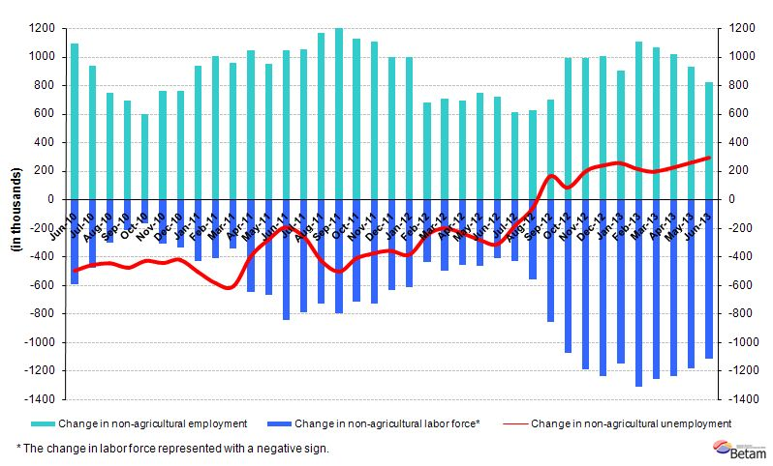
Source: TurkSTAT, Betam

Non-agricultural unemployment continued to increase in the period of June 2013

According to seasonally adjusted data, non-agricultural labor force increased by 26 thousand and reached 22 million 258 thousand in the period of June 2013 compared to the period of May 2013 (Figure 2, Table 1). Non-agricultural employment decreased by 2 thousand and reached 19 million 600 thousand. Thus, the number of persons unemployed in non-agricultural sectors increased by 24 thousand and non-agricultural unemployment rate increased to 11.9 percent. Non-agricultural unemployment has been increasing slowly but consistently since February 2013.

Figure 2 Seasonally adjusted non-agricultural labor force, employment and unemployment
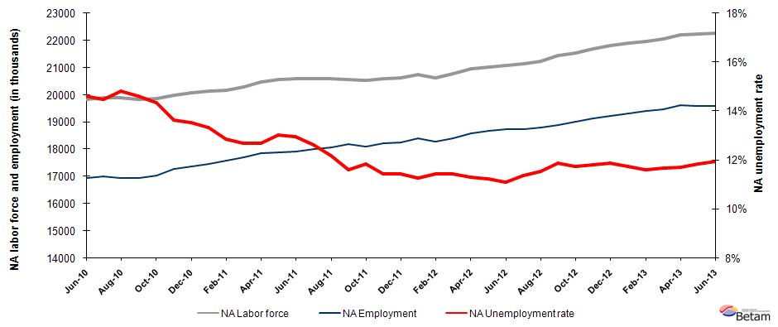
Source: TurkStat, Betam

According to Kariyer.net data, non-agricultural unemployment will stagnate

Per vacancy statistics calculated using Kariyer.net series increased in July 201 and decreased in August 2013. Hence, we expect that that non-agricultural unemployment will stagnate in the period of July 2013.

Figure 1 Seasonally adjusted non-agricultural unemployment rate and application per vacancy
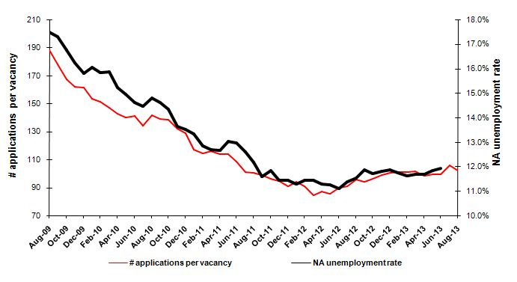
Source: Kariyer.net, TurkStat, Betam

Employment losses in manufacturing, slight increases in both construction and services

According to the seasonally adjusted labor market series, manufacturing employment decreased by 29 thousand in the period May 2013 (Table 2, Figure 4). On the other hand, employment in construction and service increased by 15 and 16 thousand, respectively. Remarkable increases in service employment observed since March 2012 weakened in this period. Agricultural employment continued to decline. There was a decrease of 55 thousand in the period of June 2013.

Figure 2 Employment by sectors (in thousands)
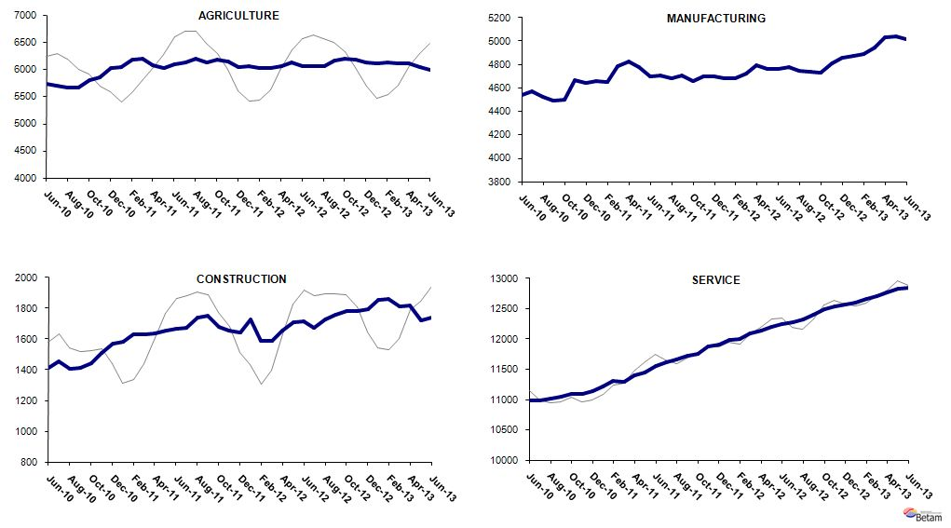
Source: TurkStat, Betam

Table 1 Seasonally adjusted non-agricultural labor force indicators (in thousands)
 | Labor force | Employment | Unemployment | Unemployment rate | Monthly changes
May-10 | 19852 | 16881 | 2971 | 15.0% | Labor force | Employment | Unemployment
June-10 | 19824 | 16927 | 2897 | 14.6% | -28 | 46 | -74
July-10 | 19881 | 17005 | 2876 | 14.5% | 57 | 78 | -21
August-10 | 19887 | 16943 | 2944 | 14.8% | 6 | -62 | 68
September-10 | 19840 | 16941 | 2899 | 14.6% | -47 | -2 | -45
October-10 | 19879 | 17026 | 2853 | 14.4% | 39 | 85 | -46
November-10 | 19993 | 17263 | 2730 | 13.7% | 113 | 237 | -123
December-10 | 20073 | 17356 | 2716 | 13.5% | 80 | 93 | -13
January-11 | 20129 | 17448 | 2681 | 13.3% | 56 | 91 | -35
February-11 | 20175 | 17584 | 2591 | 12.8% | 46 | 136 | -90
March-11 | 20287 | 17712 | 2575 | 12.7% | 111 | 128 | -17
April-11 | 20458 | 17865 | 2593 | 12.7% | 172 | 153 | 19
May-11 | 20554 | 17874 | 2680 | 13.0% | 96 | 9 | 86
June-11 | 20585 | 17917 | 2669 | 13.0% | 31 | 42 | -11
July-11 | 20598 | 18001 | 2597 | 12.6% | 13 | 85 | -72
August-11 | 20589 | 18082 | 2507 | 12.2% | -9 | 80 | -89
September-11 | 20575 | 18187 | 2388 | 11.6% | -14 | 106 | -119
October-11 | 20523 | 18094 | 2429 | 11.8% | -52 | -93 | 41
November-11 | 20586 | 18229 | 2357 | 11.4% | 63 | 135 | -72
December-11 | 20617 | 18256 | 2361 | 11.5% | 31 | 26 | 5
January-12 | 20746 | 18406 | 2339 | 11.3% | 129 | 151 | -22
February-12 | 20630 | 18268 | 2362 | 11.4% | -116 | -138 | 22
March-12 | 20786 | 18406 | 2380 | 11.5% | 156 | 138 | 19
April-12 | 20948 | 18583 | 2365 | 11.3% | 162 | 177 | -16
May-12 | 21029 | 18664 | 2366 | 11.2% | 82 | 81 | 1
June-12 | 21069 | 18729 | 2340 | 11.1% | 39 | 66 | -26
July-12 | 21132 | 18728 | 2405 | 11.4% | 64 | -1 | 65
August-12 | 21246 | 18796 | 2450 | 11.5% | 113 | 68 | 45
September-12 | 21435 | 18892 | 2544 | 11.9% | 190 | 96 | 94
October-12 | 21536 | 19010 | 2526 | 11.7% | 101 | 119 | -18
November-12 | 21692 | 19130 | 2563 | 11.8% | 157 | 120 | 37
December-12 | 21810 | 19221 | 2589 | 11.9% | 118 | 91 | 27
January-13 | 21899 | 19326 | 2572 | 11.7% | 88 | 105 | -17
February-13 | 21966 | 19414 | 2552 | 11.6% | 67 | 88 | -21
March-13 | 22054 | 19478 | 2576 | 11.7% | 88 | 64 | 24
April-13 | 22209 | 19610 | 2599 | 11.7% | 155 | 132 | 23
May-13 | 22231 | 19598 | 2633 | 11.8% | 22 | -12 | 34
June-13 | 22258 | 19600 | 2658 | 11.9% | 26 | 2 | 24
Source: TurkStat, Betam

Table 2 Seasonally adjusted employment by sector (in thousands)
 | Agriculture | Manufacturing | Construction | Service | Monthly changes
May-10 | 5582 | 4470 | 1417 | 10994 | Agriculture | Manufacturing | Construction | Service
June-10 | 5723 | 4536 | 1413 | 10978 | 141 | 66 | -4 | -16
July-10 | 5691 | 4575 | 1453 | 10977 | -32 | 39 | 40 | -1
August-10 | 5667 | 4525 | 1407 | 11011 | -24 | -50 | -46 | 34
September-10 | 5660 | 4489 | 1409 | 11042 | -7 | -36 | 2 | 32
October-10 | 5793 | 4498 | 1441 | 11087 | 132 | 9 | 32 | 44
November-10 | 5845 | 4667 | 1511 | 11085 | 53 | 169 | 70 | -2
December-10 | 6028 | 4642 | 1569 | 11146 | 182 | -25 | 57 | 61
January-11 | 6032 | 4656 | 1582 | 11210 | 4 | 14 | 14 | 64
February-11 | 6177 | 4652 | 1628 | 11305 | 144 | -4 | 45 | 95
March-11 | 6195 | 4790 | 1630 | 11292 | 18 | 138 | 3 | -13
April-11 | 6078 | 4828 | 1634 | 11403 | -117 | 38 | 3 | 112
May-11 | 6030 | 4777 | 1653 | 11445 | -48 | -51 | 19 | 41
June-11 | 6099 | 4697 | 1666 | 11554 | 69 | -80 | 13 | 109
July-11 | 6119 | 4710 | 1673 | 11619 | 21 | 13 | 6 | 65
August-11 | 6195 | 4682 | 1741 | 11659 | 76 | -28 | 68 | 40
September-11 | 6134 | 4707 | 1751 | 11730 | -61 | 25 | 10 | 71
October-11 | 6169 | 4657 | 1679 | 11758 | 35 | -50 | -72 | 28
November-11 | 6146 | 4700 | 1657 | 11872 | -23 | 43 | -22 | 114
December-11 | 6045 | 4701 | 1645 | 11910 | -101 | 1 | -12 | 37
January-12 | 6050 | 4685 | 1729 | 11992 | 6 | -16 | 84 | 82
February-12 | 6030 | 4684 | 1589 | 11996 | -20 | -1 | -141 | 4
March-12 | 6022 | 4721 | 1585 | 12100 | -8 | 37 | -3 | 104
April-12 | 6059 | 4792 | 1654 | 12137 | 36 | 71 | 69 | 37
May-12 | 6121 | 4760 | 1708 | 12196 | 62 | -32 | 54 | 59
June-12 | 6062 | 4761 | 1718 | 12250 | -59 | 1 | 10 | 55
July-12 | 6060 | 4778 | 1675 | 12275 | -2 | 17 | -43 | 24
August-12 | 6060 | 4745 | 1725 | 12326 | 0 | -33 | 50 | 51
September-12 | 6159 | 4735 | 1758 | 12399 | 99 | -10 | 32 | 73
October-12 | 6193 | 4732 | 1784 | 12494 | 34 | -3 | 26 | 96
November-12 | 6177 | 4814 | 1782 | 12534 | -16 | 82 | -2 | 40
December-12 | 6130 | 4856 | 1792 | 12573 | -47 | 42 | 10 | 39
January-13 | 6107 | 4870 | 1856 | 12600 | -23 | 14 | 64 | 27
February-13 | 6131 | 4886 | 1861 | 12667 | 24 | 16 | 5 | 67
March-13 | 6115 | 4948 | 1815 | 12715 | -16 | 62 | -46 | 48
April-13 | 6103 | 5030 | 1819 | 12762 | -12 | 82 | 3 | 47
May-13 | 6041 | 5044 | 1722 | 12832 | -62 | 14 | -97 | 71
June-13 | 5986 | 5015 | 1737 | 12848 | -55 | -29 | 15 | 16
Source: TurkStat, Betam

* Prof. Dr. Seyfettin Gürsel, Betam, Director, seyfettin.gursel@bahcesehir.edu.tr
∗ Yrd. Doç. Dr. Gökçe Uysal, Betam, Vice Director, gokce.uysal@bahcesehir.edu.tr
∗∗ Ayşenur Acar, Betam, Research Assistant, aysenur.acar@bahcesehir.edu.tr
Betam has been calculating application per vacancy using series released by Kariyer.net for a while. Seasonal and calendar adjustment procedure is applied to application per vacancy series. A decrease in applications per vacancy may be caused by an increase in vacancies or by a decrease in the number of applications. An increase in vacancies signals economic growth while decreasing number of applications indicates a decrease in number of people looking for a job.
Employment in each sector is seasonally adjusted separately. Hence the sum of these series may differ from the seasonally adjusted series of total employment. The difference stems from the non-linearity of the seasonal adjustment process.
Grey lines indicate seasonally adjusted series, where dark blue lines represent raw data.

