

Labor Market Outlook:

June 2013

17 June 2013

Non-agricultural unemployment has been stagnating

Seyfettin Gürsel* Gökçe Uysal∗ ve Ayşenur Acar∗

Abstract

Seasonally adjusted labor market data shows that unemployment rate increased from 11.6 percent in the period of February 2013 to 11.7 percent in the period of March 2013. Labor market statistics are pointing towards a new trend since October 2012. Increases in both non-agricultural labor force and non-agricultural employment have surpassed one million. Hence, non-agricultural unemployment rates continue to stagnate between 11.6 percent and 11.9 percent. Employment in manufacturing continues to increase consistently during the same period.

LABOR MARKET HIGHLIGHT

Industrial Map of Turkey

In order to maintain a high growth rate of per capita income and achieve convergence, Turkey needs to increase its share of manufacturing and decrease the share of agriculture in employment given that productivity is higher in manufacturing and lower in agriculture. We approach this topic from a regional perspective and study the regional distribution of employment in manufacturing. We find that many of the industrialized regions are clustered in the northwest. Trakya and Bursa-Bilecik-Eskişehir are the two most industrialized regions in Turkey. Gaziantep-Adıyaman-Kilis is an interesting exception. İzmir, Konya-Karaman and Kayseri-Sivas-Yozgat are moderate in terms of industrialization. Most of the least industrialized regions are in East Black Sea and East Mediterranean regions. Moreover, Central East and Southeast regions are generally even less industrialized. The least industrialized region is Van-Bitlis-Hakkari.

Both non-agricultural employment and non-agricultural labor force continue to increase

Figure 1 Year-on-year changes in non-agricultural labor force, employment and unemployment
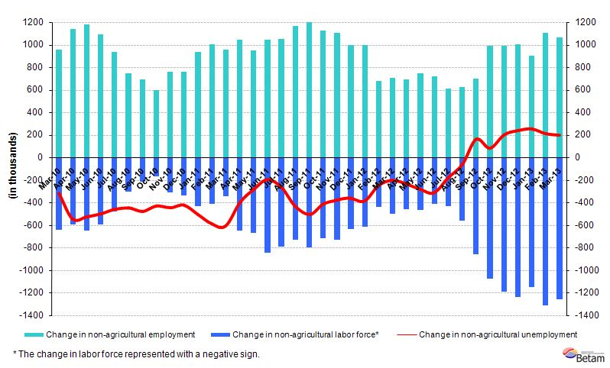
Source: TurkSTAT, Betam

According to the data released by TurkSTAT, non-agricultural labor force increased by 1 million 258 thousand (6.1 percent) and non-agricultural employment increased by 1 million 62 thousand (5.8 percent) in the period of March 2013 (Figure 1). We observe that the increase in non-agricultural employment is about one million while the increase in non-agricultural labor force is about 1.2 million. Hence, non-agricultural unemployment rate continues to stagnate. Increases over one million of employment and labor force are both above trend and require deeper research.

Seasonally adjusted non-agricultural unemployment has been stagnating since September 2012

According to seasonally adjusted data, non-agricultural labor force increased by 91 thousand and reached 22 million 57 thousand in the period of March 2013 compared to the period of February 2013 (Figure 2, Table 1). Non-agricultural employment increased by 67 thousand and reached 19 million 486 thousand. Consequently, the number of persons unemployed in non-agricultural sectors decreased by 24 thousand and non-agricultural unemployment rate reached 11.7 percent. Non-agricultural labor market continues to stagnate. Non-agricultural unemployment rate has been moving within a tight band.

Figure 2 Seasonally adjusted non-agricultural labor force, employment and unemployment
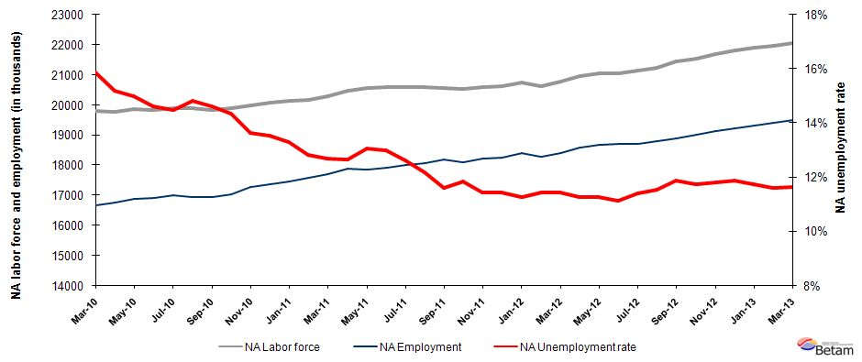
Source: TurkStat, Betam

According to Kariyer.net data, non-agricultural unemployment may decrease in the period of April 2013

Application per vacancy statistics calculated using Kariyer.net series indicate that non-agricultural unemployment rate may decrease slightly in the period of April 2013. However, it is uncertain that whether the overall stagnation will come to an end.

Figure 1 Seasonally adjusted non-agricultural unemployment rate and application per vacancy
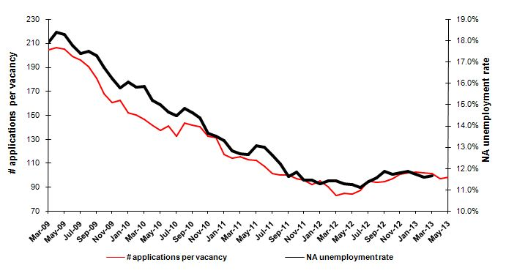
Source: Kariyer.net, TurkStat, Betam

Manufacturing employment continues to increase

Labor market series pertaining to March 2013 indicate that agricultural and construction employment continue to stagnate (Table 2, Figure 4). On the other hand, employment in manufacturing and service increased by 38 thousand and 39 thousand respectively. Manufacturing employment continues to increase consistently since the last quarter of 2012. The average monthly increase in manufacturing is about 30 thousand since the last quarter of 2012.

Figure 2 Employment by sectors (in thousands)
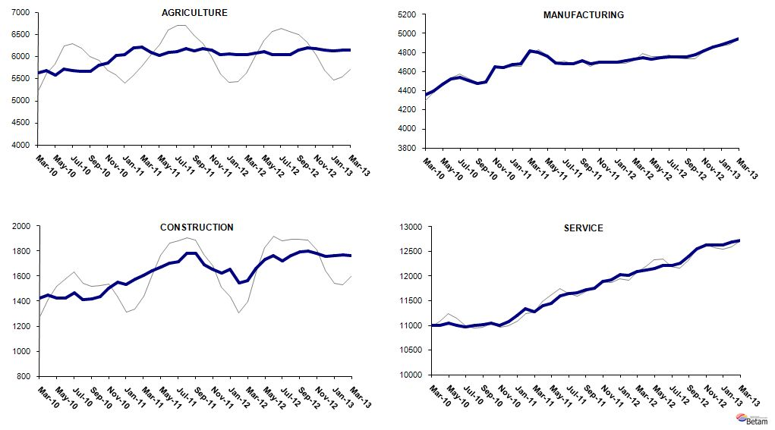
Source: TurkStat, Betam

LABOR MARKET HIGHLIGHT

Map of Industrialization in Turkey

Turkey has not completed its industrialization yet. Historically, in countries that had started their industrialization earlier, we observe that the share of manufacturing in both GDP and employment, increased fast in what could be called a first phase. Moreover, industrialization begot productivity increases in agriculture, causing the share of agriculture in employment to fall in a parallel manner. In the second phase, the demand for services increased once the per capita income was high enough, and thus the share of services in the economy increased. Today, in countries where per capita income is over 30 thousand, the share of services in employment is 65-70 percent, the share of agriculture is 3-5 percent, and the share of manufacturing is 25-30 percent, (shares depending on their specific specialization in the global sphere). The respective shares in Turkey are 50 percent, 25 percent and 19 percent. These shares indicate that Turkey has skipped the first stage and entered the second phase directly when the share of services started to increase. This jump is not specific to Turkey, it is also observed in similar developing countries. However, the asymmetry is very clear in Turkey.

There is a wide consensus among economists that Turkey needs to increase the employment share of manufacturing, a sector where productivity increases are high, and to decrease the share of agriculture, where labor productivity is low, in order to increase per capita income and achieve convergence. However, exactly how it will be done remains open for discussion. We study the regional distribution of manufacturing to shed some light on this discussion. We also examine how the regional distribution changes over time. We focus on the share of wage employment in manufacturing in non-agricultural employment as a measure of industrialization. We would like to exclude the self-employed given that many of them are working as craftsman in manufacturing and we would like to focus on “modern” employment. We also choose to exclude agricultural employment from this analysis as agricultural employment differs widely across regions; moreover, the regional differences are not always caused by differences in development. For example, the share of agriculture in employment is high in East Black Sea and low in Southeast Anatolia. However, Southeast Anatolia is more developed that East Black Sea. Map 1 provides the shares of wage employment in manufacturing in non-agricultural employment by 26 NUTS2 regions in 2011.

The East-West conflict in Industrialization

The average share of wage employment in manufacturing in non-agricultural employment is 28.3 percent in Turkey in 2011. We form 4 groups of regions: first, highly industrialized regions (shares between 31-47 percent); second, regions with above average industrialization rates (28-30 percent); third, regions with below average industrialization rates (16-27 percent); fourth, regions with the lowest industrialization rates (4-15 percent). See Map 1. Note that the highly industrialized regions are clustered in the northwest. The most industrialized regions in Turkey are Trakya and Bursa-Bilecik-Eskişehir. Gaziantep-Adıyaman-Kilis region is an interesting exception. 3 regions have moderate industrialization rates: İzmir, Konya-Karaman and Kayseri-Sivas-Yozgat. There are 10 regions in the third group and most of them are in East Black Sea and East Mediterranean regions. It may seem surprising that Balıkesir-Çanakkale is in this group. The remaining 6 regions are in the fourth group, i.e. they have the lowest industrialization rates. As expected, all of these are in the Central East and Southeast Anatolia, except for Antalya. Remember that Antalya is the leader in tourism, and thus does not need to industrialize further. The lowest industrialization rate is 4.5 percent in Van-Muş-Bitlis-Hakkâri (Table 1). Note that the industrialization rate in Trakya is almost 10 times higher than that in Hakkari (46.3 percent and 4.5 percent respectively).

Map1: Industrialization levels by region (2011)
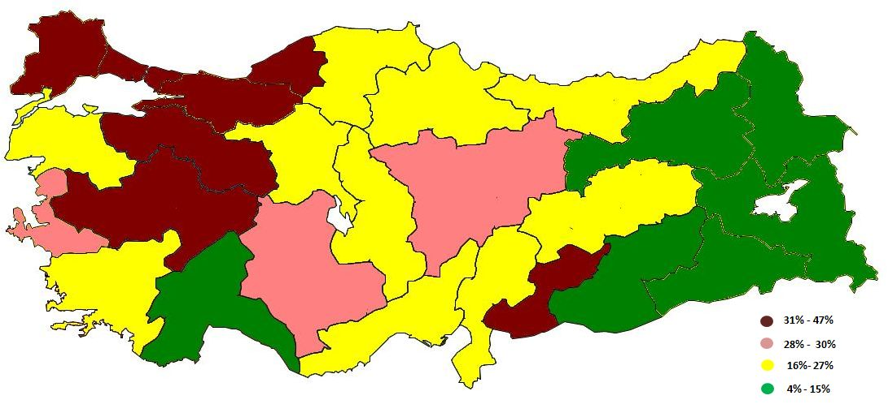
Source: Household Labor Force Survey; TurkStat, Betam

Improvement and Decline in Industrialization

There have been significant changes from 2005 to 2011 in terms of industrialization. Compared to 2005, some of the regions are more industrialized; some are less in 2011. First observe that the share of wage employment in manufacturing in non-agricultural employment has decreased by 3.4 percentage points from 31.6 percent to 28.3 percent. Taking this decline as benchmark, we form four new groups. 1) regions that increased their industrialization rates by 3 to 8 percentage points, 2) regions that increased their rates by 0 to 2 percentage points, 3) regions where the decrease in industrialization rates were the same as the overall change (0 to -4 percentage points), 4) regions where industrialization rates fell drastically (-5 to -8 percentage points).

Map 2: Change in industrialization levels by region (2005-2011)
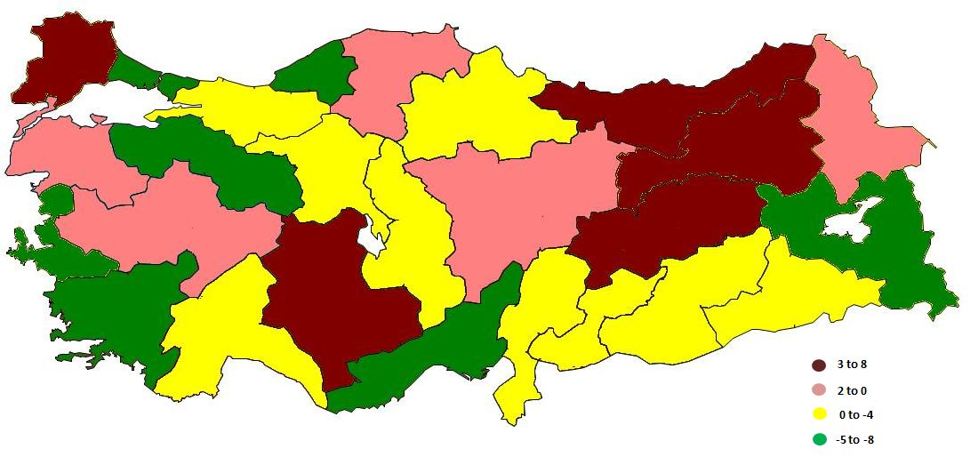
Source: Household Labor Force Survey; TurkStat, Betam

Trakya is the most striking region in the first group. Trakya was in fourth place in terms of industrialization in 2005 with a rate of 38.5 percent, sharing its place with Izmir. However, Trakya managed to increase its industrialization rate to 46.3 percent in 2011 and became the most industrialized region in Turkey. The fact that Istanbul is saturated and the factories are shifting westward, may be the major cause of this strong increase. A decrease of 4.8 percent in Istanbul’s industrialization rate during this period, confirms this intuition. Konya-Karaman, East Black Sea and Malatya-Elazığ are other regions in the first group. This is surprising, especially given that they still have low industrialization rates in 2011.

It is not surprising that Balıkesir-Çanakkale, Central West Anatolia (including Manisa), Kayseri and Samsun are in the second group. On the other hand, Northeast Anatolia (Ağrı-Kars-Iğdır-Ardahan) is interestingly also in this group. Note that the increase in the share of employment in manufacturing has been limited, i.e. from 8.6 to 8.9 percent in 6 years.

The third group has been stagnating in terms of industrialization. Kocaeli-Sakarya region seems to have reached a saturation point in industrialization. Bursa-Bilecik-Eskişehir stands out in the fourth group, in which regions had decreasing industrialization rates during the period under study. Bursa-Bilecik-Eskişehir was the most industrialized region in 2005 with a rate of 51.9. It has regressed back to 45 percent and to second place in 2011. This decline indicates that demand for services soared as income levels increased, just like in Istanbul. On the other hand, there was a fall in the industrialization rate in Van-Muş-Bitlis also. This region already had a low industrialization rate, and unfortunately it has declined by 7.8 percentage points.

Table A: Change in the share of wage earners in manufacturing employment in non-agricultural employment by region (2005-2011)
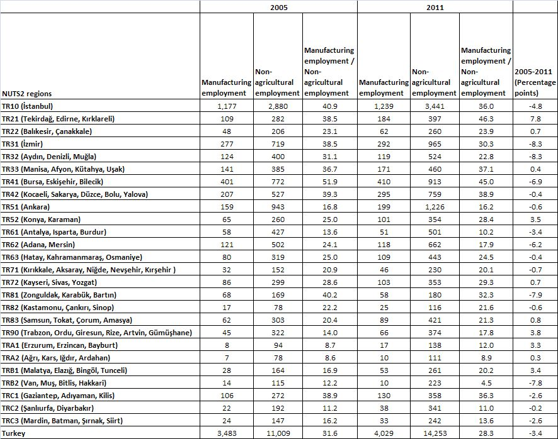
Source: Household Labor Force Survey; TurkStat, Betam

Table 1 Seasonally adjusted non-agricultural labor force indicators (in thousands)
 | Labor force | Employment | Unemployment | Unemployment rate | Monthly changes
February-10 | 19673 | 16561 | 3111 | 15.8% | Labor force | Employment | Unemployment
March-10 | 19814 | 16672 | 3142 | 15.9% | 141 | 111 | 30
April-10 | 19775 | 16768 | 3007 | 15.2% | -39 | 96 | -135
May-10 | 19850 | 16877 | 2973 | 15.0% | 75 | 109 | -34
June-10 | 19824 | 16924 | 2900 | 14.6% | -26 | 47 | -73
July-10 | 19881 | 17002 | 2879 | 14.5% | 57 | 78 | -21
August-10 | 19888 | 16941 | 2947 | 14.8% | 7 | -61 | 68
September-10 | 19841 | 16940 | 2901 | 14.6% | -47 | -1 | -46
October-10 | 19880 | 17026 | 2854 | 14.4% | 40 | 87 | -47
November-10 | 19993 | 17264 | 2729 | 13.6% | 112 | 238 | -125
December-10 | 20073 | 17358 | 2715 | 13.5% | 80 | 94 | -14
January-11 | 20130 | 17451 | 2679 | 13.3% | 57 | 92 | -36
February-11 | 20176 | 17588 | 2588 | 12.8% | 46 | 137 | -91
March-11 | 20288 | 17717 | 2571 | 12.7% | 112 | 129 | -16
April-11 | 20462 | 17871 | 2591 | 12.7% | 173 | 154 | 19
May-11 | 20551 | 17869 | 2682 | 13.0% | 89 | -2 | 91
June-11 | 20585 | 17913 | 2672 | 13.0% | 34 | 44 | -10
July-11 | 20598 | 17998 | 2600 | 12.6% | 13 | 85 | -72
August-11 | 20589 | 18079 | 2510 | 12.2% | -9 | 81 | -90
September-11 | 20576 | 18186 | 2390 | 11.6% | -13 | 107 | -120
October-11 | 20524 | 18094 | 2430 | 11.8% | -52 | -92 | 40
November-11 | 20587 | 18231 | 2356 | 11.4% | 62 | 136 | -74
December-11 | 20618 | 18258 | 2360 | 11.4% | 31 | 27 | 4
January-12 | 20746 | 18409 | 2337 | 11.3% | 129 | 152 | -23
February-12 | 20630 | 18272 | 2358 | 11.4% | -116 | -137 | 21
March-12 | 20787 | 18410 | 2377 | 11.4% | 157 | 138 | 19
April-12 | 20950 | 18588 | 2362 | 11.3% | 163 | 177 | -15
May-12 | 21036 | 18668 | 2368 | 11.3% | 86 | 81 | 6
June-12 | 21062 | 18719 | 2343 | 11.1% | 25 | 51 | -25
July-12 | 21129 | 18721 | 2408 | 11.4% | 68 | 3 | 65
August-12 | 21243 | 18790 | 2453 | 11.5% | 114 | 69 | 45
September-12 | 21433 | 18887 | 2546 | 11.9% | 190 | 97 | 93
October-12 | 21535 | 19008 | 2527 | 11.7% | 101 | 120 | -19
November-12 | 21691 | 19129 | 2562 | 11.8% | 156 | 121 | 35
December-12 | 21810 | 19222 | 2588 | 11.9% | 119 | 93 | 26
January-13 | 21899 | 19329 | 2570 | 11.7% | 89 | 107 | -18
February-13 | 21966 | 19419 | 2547 | 11.6% | 67 | 90 | -22
March-13 | 22057 | 19486 | 2571 | 11.7% | 91 | 67 | 24
Source: TurkStat, Betam

Table 2 Seasonally adjusted employment by sector (in thousands)
 | Agriculture | Manufacturing | Construction | Service | Monthly changes
February-10 | 5664 | 4349 | 1373 | 10897 | Agriculture | Manufacturing | Construction | Service
March-10 | 5624 | 4355 | 1426 | 10994 | -40 | 6 | 53 | 97
April-10 | 5675 | 4397 | 1447 | 10998 | 52 | 42 | 21 | 4
May-10 | 5579 | 4470 | 1424 | 11050 | -97 | 73 | -23 | 52
June-10 | 5712 | 4524 | 1423 | 11006 | 134 | 54 | -1 | -44
July-10 | 5681 | 4538 | 1469 | 10968 | -32 | 13 | 47 | -38
August-10 | 5659 | 4509 | 1414 | 10997 | -22 | -28 | -55 | 29
September-10 | 5655 | 4478 | 1416 | 11010 | -5 | -31 | 1 | 13
October-10 | 5792 | 4494 | 1437 | 11045 | 137 | 16 | 21 | 35
November-10 | 5847 | 4651 | 1506 | 11003 | 55 | 157 | 69 | -42
December-10 | 6030 | 4643 | 1552 | 11071 | 184 | -8 | 46 | 67
January-11 | 6040 | 4676 | 1534 | 11193 | 9 | 33 | -17 | 123
February-11 | 6188 | 4685 | 1578 | 11339 | 149 | 9 | 44 | 146
March-11 | 6208 | 4820 | 1603 | 11283 | 20 | 135 | 25 | -56
April-11 | 6087 | 4806 | 1640 | 11403 | -121 | -14 | 36 | 120
May-11 | 6025 | 4760 | 1676 | 11447 | -62 | -46 | 36 | 44
June-11 | 6085 | 4690 | 1706 | 11602 | 59 | -70 | 30 | 155
July-11 | 6106 | 4684 | 1716 | 11652 | 22 | -6 | 11 | 50
August-11 | 6185 | 4683 | 1780 | 11660 | 79 | -1 | 64 | 8
September-11 | 6127 | 4712 | 1784 | 11730 | -58 | 29 | 3 | 69
October-11 | 6169 | 4680 | 1688 | 11752 | 41 | -32 | -96 | 22
November-11 | 6148 | 4695 | 1654 | 11900 | -21 | 15 | -34 | 148
December-11 | 6048 | 4702 | 1622 | 11928 | -100 | 7 | -32 | 28
January-12 | 6059 | 4702 | 1656 | 12031 | 11 | 0 | 35 | 103
February-12 | 6044 | 4711 | 1546 | 12016 | -15 | 9 | -110 | -15
March-12 | 6039 | 4732 | 1563 | 12098 | -5 | 20 | 17 | 82
April-12 | 6071 | 4747 | 1660 | 12119 | 32 | 15 | 96 | 21
May-12 | 6115 | 4733 | 1735 | 12159 | 44 | -13 | 75 | 40
June-12 | 6043 | 4750 | 1764 | 12209 | -72 | 16 | 29 | 50
July-12 | 6043 | 4753 | 1719 | 12211 | 0 | 3 | -44 | 2
August-12 | 6047 | 4756 | 1763 | 12257 | 4 | 3 | 44 | 46
September-12 | 6151 | 4756 | 1792 | 12393 | 103 | 0 | 28 | 135
October-12 | 6192 | 4775 | 1799 | 12548 | 41 | 19 | 7 | 155
November-12 | 6180 | 4818 | 1781 | 12628 | -12 | 43 | -18 | 80
December-12 | 6135 | 4858 | 1757 | 12628 | -45 | 40 | -24 | 0
January-13 | 6118 | 4885 | 1761 | 12637 | -17 | 27 | 5 | 9
February-13 | 6149 | 4911 | 1770 | 12691 | 30 | 25 | 9 | 54
March-13 | 6136 | 4948 | 1766 | 12730 | -12 | 38 | -4 | 39
Source: TurkStat, Betam

* Prof. Dr. Seyfettin Gürsel, Betam, Director, seyfettin.gursel@bahcesehir.edu.tr
∗ Yrd. Doç. Dr. Gökçe Uysal, Betam, Vice Director, gokce.uysal@bahcesehir.edu.tr
∗∗ Ayşenur Acar, Betam, Research Assistant, aysenur.acar@bahcesehir.edu.tr
Betam has been calculating application per vacancy using series released by Kariyer.net for a while. Seasonal and calendar adjustment procedure is applied to application per vacancy series. A decrease in applications per vacancy may be caused by an increase in vacancies or by a decrease in the number of applications. An increase in vacancies signals economic growth while decreasing number of applications indicates a decrease in number of people looking for a job.
Employment in each sector is seasonally adjusted separately. Hence the sum of these series may differ from the seasonally adjusted series of total employment. The difference stems from the non-linearity of the seasonal adjustment process.
Grey lines indicate seasonally adjusted series, where dark blue lines represent raw data.

