

Labor Market Outlook:

May 2013

15 May 2013

NON-AGRICULTURAL UNEMPLOYMENT RATE DECREASED

Seyfettin Gürsel* Gökçe Uysal∗ ve Ayşenur Acar∗

Abstract

Seasonally adjusted labor market data shows that the non-agricultural unemployment rate decreased from 11.7 percent in the period of January 2013 to 11.6 percent in the period of February 2013. We observe that in the manufacturing sector, the increase in employment has been accelerating since the last quarter of 2012. Service employment increased by 55 thousand as well. Kariyer.net series indicate that this slow but consistent decline might continue in the period of March 2013.

LABOR MARKET HIGHLIGHT

How rigid is the labor market in Turkey?

Labor market rigidity can be measured via various indicators. OECD uses the ratio of minimum wage to mean or median wage as a measure of labor market rigidity. The ratio of minimum wage to median wage in Turkey is 0.71, the highest ratio among the OECD countries. According to this measure, minimum wage is closer to the mean wage in Turkey compared to other countries such as Poland, Romania, and Hungary. Given that Turkey is not competitive enough, the taxes on labor should be reduced and regional minimum wages should be introduced.
Despite low growth, both employment and labor force have been strongly increasing in non-agricultural sectors

Figure 1 Year-on-year changes in non-agricultural labor force, employment and unemployment
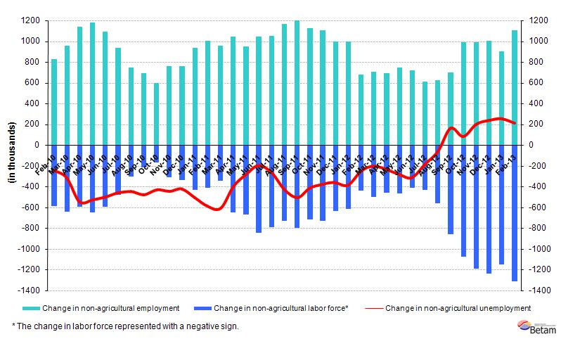
Source: TurkSTAT, Betam

According to the data released by TurkSTAT, non-agricultural labor force increased by 1 million 315 thousand (6.4 percent) and non-agricultural employment increased by 1 million 104 thousand (6.2 percent) in the period of February 2013 (Figure 1). Despite a growth rate below 3 percent, there is a remarkable increase in employment. The year-on-year increase in non-agricultural employment has been the strongest in the past year. On the other hand, the increase in non-agricultural labor force is the strongest annual increase since January 2005.

Seasonally adjusted non-agricultural unemployment continues to decrease

According to seasonally adjusted data, the non-agricultural labor force increased by 67 thousand to reach 21 million 964 thousand in the period of February 2013 compared to the period of January 2013 (Figure 2, Table 1). Non-agricultural employment increased by 91 thousand and reached 19 million 420 thousand. Consequently, the number of persons unemployed in non-agricultural sectors decreased by 23 thousand and non-agricultural unemployment rate fell slightly to 11.6 percent.

Figure 2 Seasonally adjusted non-agricultural labor force, employment and unemployment
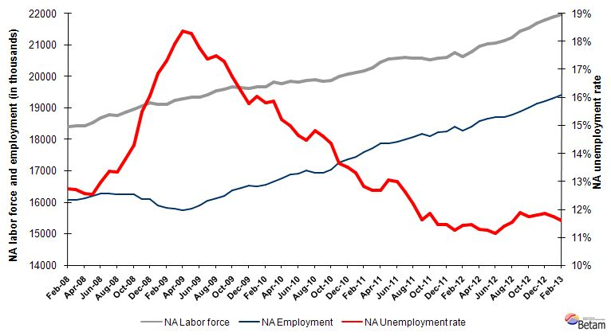
Source: TurkStat, Betam

According to Kariyer.net data, non-agricultural unemployment might decrease in the period of March 2013

Application per vacancy calculated by using series released by Kariyer.net indicates that non-agricultural unemployment rate might continue to decrease in the period of March 2013.

Figure 1 Seasonally adjusted non-agricultural unemployment rate and application per vacancy
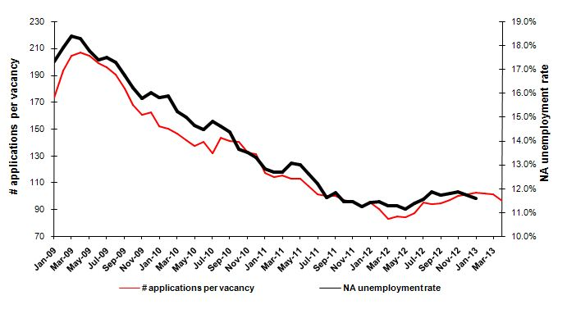
Source: Kariyer.net, TurkStat, Betam
Figure 2 Employment by sectors (in thousands)
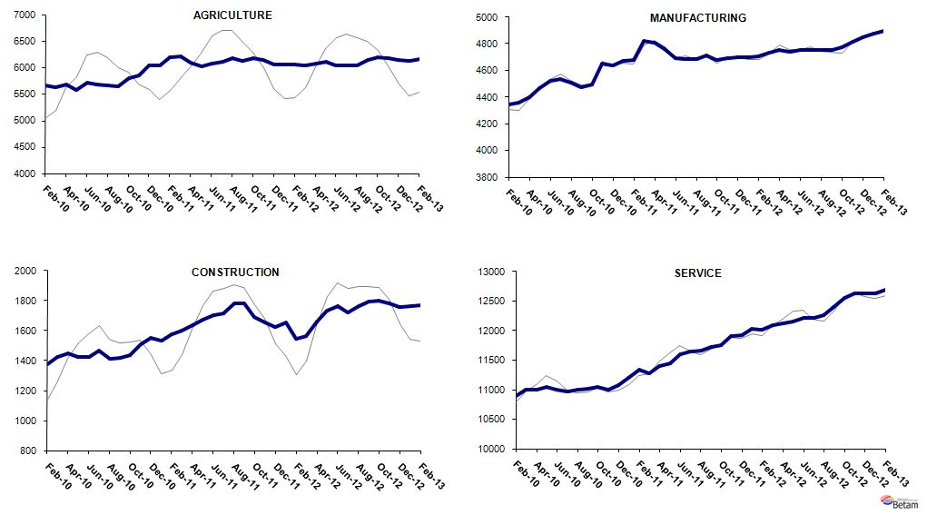
Source: TurkStat, Betam

Manufacturing employment has been continuing to increase

We observe employment increases in all sectors from January 2013 to February 2013 (Table 2, Figure 4). Even though the increase in service employment seems to have slowed down, there was still an increase of 55 thousand in the period of February 2013. Construction employment and agricultural employment increased by 9 thousand and 33 thousand respectively. Meanwhile manufacturing employment increased by 23 thousand. The increase in manufacturing employment has been accelerating since the last quarter of 2012. Consistent increases in manufacturing production index in January and February 2013 have reflected on service employment.

LABOR MARKET HIGHLIGHT

How rigid is the labor market in Turkey?

Labor market rigidity is a widely disputed issue. There is a simple reason why: A common measure of labor market rigidity or flexibility does not exist. However, the OECD has been using various indicators such as the level of firing and hiring costs, the prevalence of part-time jobs, the ratio of minimum wage to mean or median wage in order to measure the degree of labor market rigidity. Figure A presents the ratios of minimum wages to mean wages and median wages in various countries in 2011, calculated by the OECD. One should note that the OECD uses median earnings comprising all income types obtained by workers instead of the median wage, to facilitate the international comparison. We would like to remind the reader that earnings do not reflect only wages but also taxes, payments for working overtime, bonus payments, etc. As such, they reflect the labor costs. Since the OECD uses the Wage Structure Survey, a firm-level survey, the informally employed workers and their wages are not included in its calculations. Thus, comparison of rigidity or flexibility is restricted to formal labor markets.

Generally speaking, the closer the minimum wage to mean/median wage, i.e. the smaller the difference between mean/median wage and minimum wage, the more rigid the labor market. Minimum wage sets the floor of wages in labor market. Thus, wages in the labor market cannot be less than minimum wage. One could think that if the minimum wage is set close to the mean/median wage, those with lower skill sets and lower productivity levels are paid relatively higher wages.

Figure A Ratio of minimum wage to mean and median wage in various countries (2011)
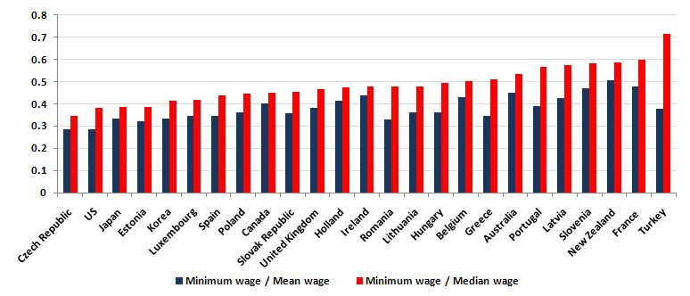
Source: OECD: http://stats.oecd.org/Index.aspx?DatasetCode=MIN2AVE

In Figure A, the ratios of minimum wages to median wages (minimum wage / median wage) in OECD countries are presented in ascending order. The ratios of minimum wages to mean wages (minimum wage / mean wage) are presented for each country as well. Given that the wage distribution is normal, median wages provide a better measure of central tendency. Clearly, among the OECD countries, Turkey has the highest ratio of minimum wage to median wage at 0.71. It is remarkable that the ratio of minimum wage to median wage is around 0.50 in countries such as Poland, Romania, Hungary, which were among the Eastern Bloc and are considered to be generous welfare states.

Turkey is the 10th among 24 countries in terms of the ratio of minimum wage to mean wage (minimum wage / mean wage = 0.38). In other words, mean wages are relatively higher than median wages in Turkey. This is a common finding. A higher share of low wage workers leads to a lower median wage than the mean wage. However, the difference is strikingly higher in Turkey.

This would be a good point to remember that wages of informal workers are not included in the calculations. Given that the wages of informal workers are lower than those of formal workers, the ratio of minimum wage to both the mean wage and median wage will be higher when informal workers are included.

Consequently, the formal labor market in Turkey, along with France, is the most rigid among the OECD countries in terms of the ratio of minimum wage to median wage. The least rigid countries are the Czech Republic and the US in terms of this measure. What should be done in the formal labor market in Turkey? Either median earnings should increase or gross minimum wage should be decreased. The first option is not acceptable for the economy in Turkey which already suffers from low competitiveness. Inevitably, gross minimum wage should be reduced. There are two ways to do this: either the tax burden on wages should be reduced or regional minimum wages should be introduced. Probably, both policies should be implemented simultaneously. We will analyze regional labor market rigidities in Turkey in the next month’s labor market highlight.

Table 1 Seasonally adjusted non-agricultural labor force indicators (in thousands)
 | Labor force | Employment | Unemployment | Unemployment rate | Monthly changes
January-10 | 19662 | 16511 | 3151 | 16.0% | Labor force | Employment | Unemployment
February-10 | 19673 | 16564 | 3109 | 15.8% | 11 | 53 | -42
March-10 | 19814 | 16670 | 3144 | 15.9% | 141 | 106 | 35
April-10 | 19775 | 16766 | 3009 | 15.2% | -39 | 96 | -134
May-10 | 19851 | 16876 | 2975 | 15.0% | 75 | 110 | -34
June-10 | 19824 | 16923 | 2901 | 14.6% | -27 | 47 | -74
July-10 | 19881 | 17001 | 2880 | 14.5% | 57 | 79 | -21
August-10 | 19888 | 16941 | 2948 | 14.8% | 7 | -61 | 68
September-10 | 19841 | 16940 | 2901 | 14.6% | -47 | -1 | -47
October-10 | 19881 | 17027 | 2854 | 14.4% | 40 | 87 | -48
November-10 | 19992 | 17265 | 2727 | 13.6% | 112 | 238 | -126
December-10 | 20073 | 17360 | 2713 | 13.5% | 80 | 95 | -14
January-11 | 20130 | 17453 | 2677 | 13.3% | 57 | 93 | -36
February-11 | 20177 | 17591 | 2585 | 12.8% | 47 | 138 | -92
March-11 | 20288 | 17714 | 2573 | 12.7% | 111 | 123 | -12
April-11 | 20461 | 17869 | 2593 | 12.7% | 174 | 154 | 20
May-11 | 20551 | 17867 | 2684 | 13.1% | 90 | -1 | 91
June-11 | 20585 | 17912 | 2673 | 13.0% | 34 | 44 | -11
July-11 | 20598 | 17998 | 2601 | 12.6% | 13 | 86 | -73
August-11 | 20590 | 18079 | 2511 | 12.2% | -8 | 81 | -90
September-11 | 20577 | 18187 | 2390 | 11.6% | -13 | 108 | -121
October-11 | 20525 | 18095 | 2430 | 11.8% | -51 | -92 | 40
November-11 | 20587 | 18232 | 2355 | 11.4% | 62 | 137 | -75
December-11 | 20618 | 18260 | 2358 | 11.4% | 31 | 27 | 4
January-12 | 20747 | 18412 | 2335 | 11.3% | 129 | 152 | -23
February-12 | 20630 | 18275 | 2355 | 11.4% | -117 | -137 | 20
March-12 | 20787 | 18409 | 2378 | 11.4% | 157 | 134 | 23
April-12 | 20950 | 18586 | 2364 | 11.3% | 163 | 177 | -14
May-12 | 21037 | 18667 | 2370 | 11.3% | 87 | 81 | 6
June-12 | 21062 | 18718 | 2344 | 11.1% | 25 | 51 | -26
July-12 | 21129 | 18721 | 2409 | 11.4% | 68 | 3 | 65
August-12 | 21243 | 18790 | 2453 | 11.5% | 114 | 69 | 45
September-12 | 21434 | 18887 | 2546 | 11.9% | 190 | 97 | 93
October-12 | 21535 | 19008 | 2527 | 11.7% | 101 | 121 | -20
November-12 | 21690 | 19129 | 2561 | 11.8% | 155 | 121 | 34
December-12 | 21808 | 19222 | 2586 | 11.9% | 118 | 93 | 26
January-13 | 21896 | 19329 | 2567 | 11.7% | 88 | 107 | -19
February-13 | 21964 | 19420 | 2544 | 11.6% | 67 | 91 | -23
Source: TurkStat, Betam

Table 2 Seasonally adjusted employment by sector (in thousands)
 | Agriculture | Manufacturing | Construction | Service | Monthly changes
January-10 | 5682 | 4299 | 1383 | 10794 | Agriculture | Manufacturing | Construction | Service
February-10 | 5667 | 4347 | 1374 | 10897 | -14 | 49 | -9 | 103
March-10 | 5621 | 4356 | 1425 | 10993 | -46 | 9 | 52 | 96
April-10 | 5673 | 4399 | 1446 | 10997 | 51 | 43 | 21 | 4
May-10 | 5576 | 4472 | 1423 | 11050 | -97 | 73 | -23 | 52
June-10 | 5711 | 4525 | 1423 | 11006 | 135 | 54 | 0 | -44
July-10 | 5679 | 4538 | 1469 | 10968 | -32 | 13 | 47 | -38
August-10 | 5658 | 4509 | 1414 | 10997 | -21 | -29 | -55 | 29
September-10 | 5654 | 4477 | 1416 | 11010 | -4 | -32 | 1 | 13
October-10 | 5793 | 4493 | 1437 | 11045 | 139 | 16 | 21 | 35
November-10 | 5849 | 4649 | 1506 | 11004 | 55 | 156 | 69 | -41
December-10 | 6033 | 4641 | 1552 | 11071 | 184 | -9 | 46 | 67
January-11 | 6043 | 4673 | 1535 | 11194 | 10 | 33 | -17 | 123
February-11 | 6193 | 4682 | 1579 | 11340 | 150 | 8 | 44 | 146
March-11 | 6205 | 4823 | 1602 | 11282 | 12 | 141 | 24 | -57
April-11 | 6084 | 4810 | 1639 | 11402 | -121 | -13 | 37 | 120
May-11 | 6021 | 4763 | 1675 | 11446 | -63 | -47 | 36 | 44
June-11 | 6082 | 4692 | 1706 | 11602 | 61 | -71 | 31 | 155
July-11 | 6104 | 4685 | 1716 | 11652 | 22 | -7 | 11 | 50
August-11 | 6184 | 4683 | 1780 | 11660 | 80 | -2 | 64 | 9
September-11 | 6127 | 4711 | 1784 | 11730 | -57 | 28 | 3 | 69
October-11 | 6171 | 4678 | 1688 | 11752 | 44 | -32 | -96 | 22
November-11 | 6151 | 4692 | 1654 | 11900 | -20 | 14 | -34 | 148
December-11 | 6051 | 4699 | 1622 | 11929 | -100 | 6 | -32 | 28
January-12 | 6063 | 4698 | 1657 | 12031 | 12 | -1 | 35 | 103
February-12 | 6050 | 4706 | 1547 | 12017 | -13 | 8 | -110 | -14
March-12 | 6035 | 4736 | 1562 | 12097 | -15 | 31 | 16 | 80
April-12 | 6067 | 4754 | 1659 | 12118 | 32 | 17 | 97 | 21
May-12 | 6111 | 4739 | 1734 | 12158 | 44 | -15 | 75 | 40
June-12 | 6040 | 4753 | 1764 | 12208 | -71 | 15 | 30 | 50
July-12 | 6041 | 4755 | 1719 | 12210 | 1 | 2 | -44 | 3
August-12 | 6046 | 4756 | 1763 | 12257 | 5 | 1 | 44 | 47
September-12 | 6151 | 4755 | 1792 | 12393 | 105 | -2 | 28 | 135
October-12 | 6195 | 4772 | 1799 | 12548 | 44 | 17 | 7 | 155
November-12 | 6183 | 4813 | 1781 | 12629 | -12 | 41 | -18 | 80
December-12 | 6138 | 4851 | 1757 | 12629 | -45 | 38 | -24 | 0
January-13 | 6123 | 4876 | 1762 | 12638 | -16 | 25 | 5 | 9
February-13 | 6155 | 4900 | 1771 | 12693 | 33 | 23 | 9 | 55
Source: TurkStat, Betam

* Prof. Dr. Seyfettin Gürsel, Betam, Director, seyfettin.gursel@bahcesehir.edu.tr
∗ Yrd. Doç. Dr. Gökçe Uysal, Betam, Vice Director, gokce.uysal@bahcesehir.edu.tr
∗∗ Ayşenur Acar, Betam, Research Assistant, aysenur.acar@bahcesehir.edu.tr
Betam has been calculating application per vacancy using series released by Kariyer.net for a while. Seasonal and calendar adjustment procedure is applied to application per vacancy series. A decrease in applications per vacancy may be caused by an increase in vacancies or by a decrease in the number of applications. An increase in vacancies signals economic growth while decreasing number of applications indicates a decrease in number of people looking for a job.
Grey lines indicate seasonally adjusted series, where dark blue lines represent raw data.
Employment in each sector is seasonally adjusted separately. Hence the sum of these series may differ from the seasonally adjusted series of total employment. The difference stems from the non-linearity of the seasonal adjustment process.

