

Labor Market Outlook:

April 2013

15 April 2013

STRONG INCREASES IN EMPLOYMENT AND LABOR FORCE CONTINUE

Seyfettin Gürsel* Gökçe Uysal∗ ve Ayşenur Acar∗

Abstract

Seasonally adjusted labor market data shows that the unemployment rate is still stagnant. Non-agricultural unemployment rate remained at 11.8 percent in the period of January 2013. Increases in manufacturing employment that has been observed for the last two periods prevented an increase in the unemployment rate. It seems that the increase in services has stopped. The increase in manufacturing production index pertaining to February 2013 and the application per vacancy of Kariyer.net indicate that the non-agricultural unemployment rate might slightly decrease in the period of February 2013.
LABOR MARKET HIGHLIGHT
The Highest Female Labor Force Participation Rate is in the Zonguldak Region,
The Lowest One is in the Şanlıurfa Region
Low female labor force participation rates (LFPR) in Turkey vary across regions. Even among women with similar education levels, regional differences in LFPR are large. For example, labor force participation rate of females with high school degrees is 33.5 percent in Turkey in 2012. The same rate is 45.5 percent in Zonguldak-Karabük-Bartın and is 7.3 percent in Şanlıurfa-Diyarbakır. Similarly, while labor force participation rate of females with university degrees is 80 percent in Zonguldak-Karabük-Bartın, and 50 percent Şanlıurfa-Diyarbakır. Given that the education level is held fixed, differences in female LFPR across regions may stem from economic and institutional factors like the regional unemployment rates, the share of service sector in total employment, the prevalence of pre-school education and cultural factors like social gender roles that may deepen along the West-East axis.

Strong increases in both non-agricultural employment and non-agricultural labor force

Figure 1 Year-on-year changes in non-agricultural labor force, employment and unemployment
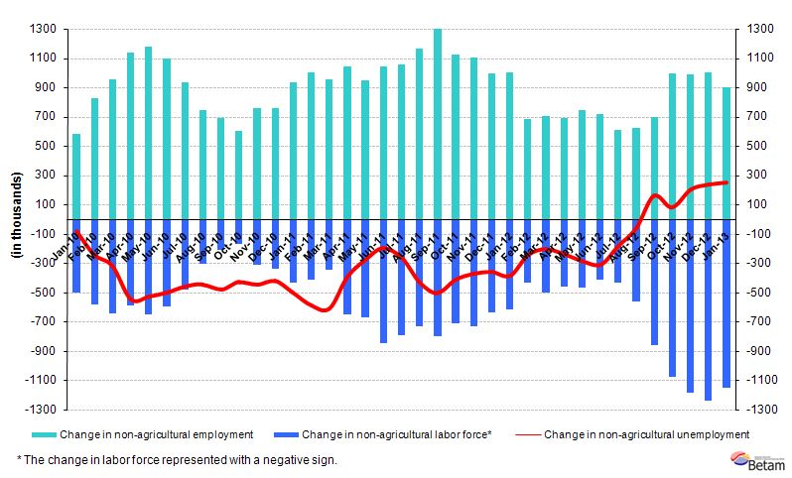
Source: TurkSTAT, Betam
According to the data released by TurkSTAT, non-agricultural labor force increased by 1 million 152 thousand (5.6 percent), the non-agricultural employment increased by 900 thousand (5 percent) and non-agricultural unemployment increased by 252 thousand to 2 million 808 thousand persons in the period of January 2013 on a year-on-year basis (Figure 1).

Seasonally adjusted non-agricultural unemployment has been stagnating

According to seasonally adjusted data, the non-agricultural labor force increased by 42 thousand to reach 21 million 866 thousand in the period of January 2013 compared to the period of December 2012 (Figure 2, Table 1). Non-agricultural employment increased by 38 thousand and reached 19 million 256 thousand. Consequently, the number of persons unemployed in non-agricultural sectors increased by 4 thousand and non-agricultural unemployment rate remained at 11.8 percent.

Figure 2 Seasonally adjusted non-agricultural labor force, employment and unemployment
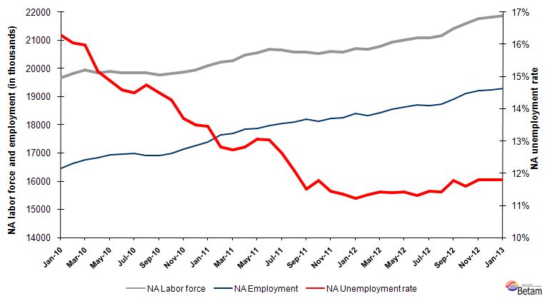
Source: TurkStat, Betam

According to Kariyer.net data, non-agricultural unemployment might slightly decrease in the period of February 2013

Application per vacancy calculated by using series released by Kariyer.net indicates that non-agricultural unemployment rate might decrease in the period of February 2013. This prediction is line with the increases in the manufacturing production index in January and February 2013.

Figure 1 Seasonally adjusted non-agricultural unemployment rate and application per vacancy
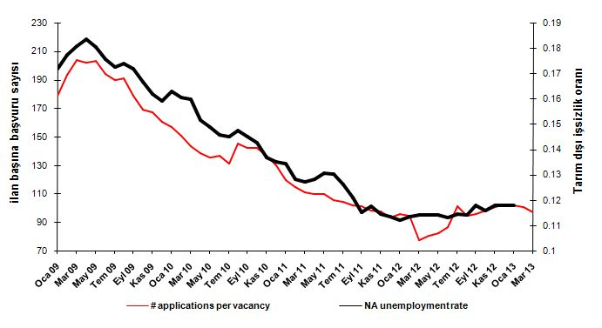
Source: Kariyer.net, TurkStat, Betam

Manufacturing employment has been continuing to increase

Seasonally adjusted data shows that employment in manufacturing increased by 24 thousand and reached 4 million 872 thousand, which is the reflection of the increases in manufacturing production index in January and February 2013. Manufacturing employment has increased by 119 thousand in the last quarter of 2012.

In January 2013, construction employment increased by 5 thousand, service employment increased 9 thousand (Table 2, Figure 4). We have been observing a rapid increase in service employment since the last quarter of 2010. It seems to be slowing down for the last two periods. We do not observe an increase in service employment in the periods of December 2012 and January 2013.

Agricultural employment decreased by 15 thousand. However, the general trend indicates that agricultural employment has been stagnating since the beginning of 2011.

Figure 2 Employment by sectors (in thousands)
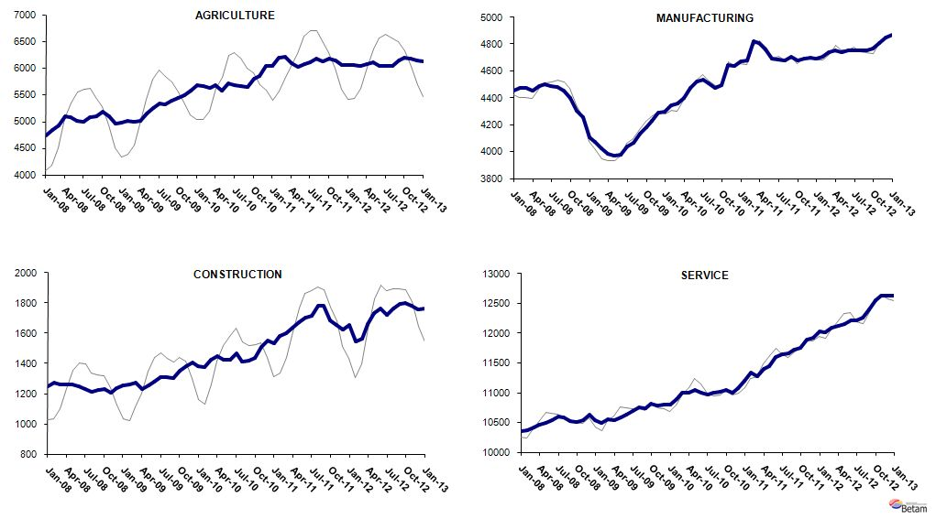
Source: TurkStat, Betam

LABOR MARKET HIGHLIGHT
The Highest Female Labor Force Participation Rate is in the Zonguldak Region,
The Lowest One is in the Şanlıurfa Region
Female labor force participation has been a hot topic of economic debate in the past couple of years. The reason is simple. The female labor force participation rate (LFPR) is far below that of South European countries. Even in countries like Greece, Spain and Italy, more than half of women participate in the labor market. Even though the female LFPR increased in Turkey in the past couple of years, it stil hovers around 30 percent. Researchers have been trying hard to explain why females are not fully integrated in the labor market.
Now we know that the reasons behind the low female LFPR are multi-dimensional. There are both supply-side and demand-side constraints. To name a few, women are relatively more costly to hire, the regional labor market conditions are not always favorable, the wages in the labor market are low, there are very few family and work reconciliation policies, etc. There are also cultural factors such as traditional gender roles, etc. We choose to focus on the regional differences in female LFPR in this month’s labor market highlight. Needless to say, wages are a major determinant in the labor supply decision. Education, being an important determinant of wages, plays an important role. High school and university graduate women will enjoy higher wages in the labor market, and they will have higher LFPR. However, our brief look at women with similar education levels reveals that there are stark differences in labor supply decisions. We provide very basic statistics on regional differences in female LFPR:
Figure A Regional distribution of females with high school and university degrees, 2012
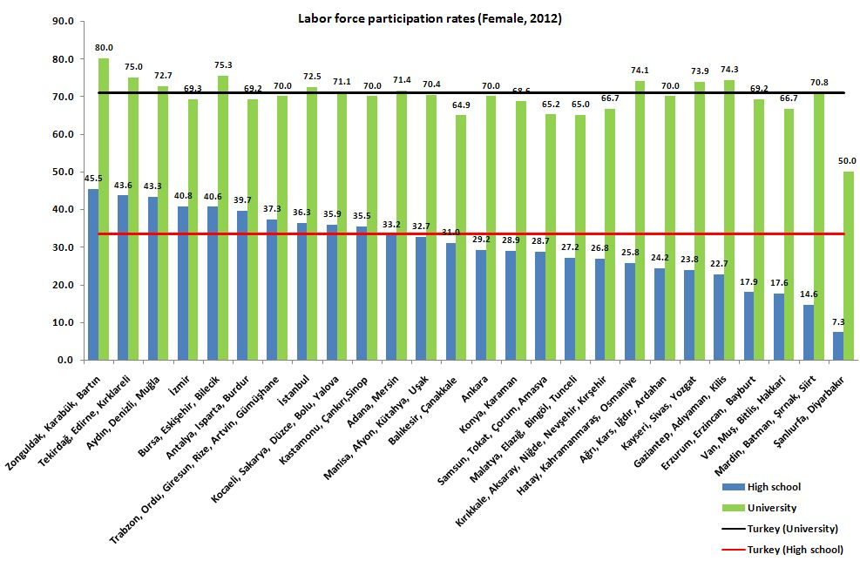Source: TurkStat; Betam

Figure A presents the LFPR of high school and university graduate women for the 26 NUTS1 regions in Turkey. The first striking observation is that there are no major regional differences among women with a university degree. In 2011, the female LFPR among this group is 71 percent. The highest rate is in Zonguldak-Karabük-Bartın at 80 percent, and the lowest is in Şanlıurfa-Diyarbakır at 50 percent. The difference between the highest and the lowest is 30 percentage points. However, Şanlıurfa-Diyarbakır is a clear outlier. LFPRs of the rest fall within a narrow interval.

On the other hand, there are enormous differences in LFPR of women with a high school degree. The average is 33.5 percent in Turkey. Zonguldak-Karabük-Bartın still leads with 45.5 percent and Şanlıurfa-Diyarbakır still has the lowest rate at a very disappointing 7.3 percent. The difference between the highest and the lowest is larger.

How can we explain the fact that the female LFPR of high school graduates differ widely across regions, whereas that of university graduates do not vary much. Clearly, the scope of this research brief is too limited to answer this question. However, we can point to some hints. The local labor market conditions undoubtedly play an important role. For example, women may be more likely to participate in the labor market if the local unemployment rates are low; the share of the service sector is large, etc. There may also be institutional differences across regions. The regions where pre-school education is more wide-spread probably have higher female LFPR. However, given that the central government has a strong grip in Turkey, we doubt that this is the case. Lastly, note that the female LFPR falls as we move from the western to the eastern regions. It may be that the cultural effects are more strongly felt by high school graduate women. On the other hand, university graduates do enjoy higher wages in the labor market, and moreover, they may have stronger labor market attachment due to higher levels of education. Let us also point out that families’ attitudes towards work may differ by education.

Table 1 Seasonally adjusted non-agricultural labor force indicators (in thousands)
 | Labor force | Employment | Unemployment | Unemployment rate | Monthly changes
November-09 | 19561 | 16394 | 3167 | 16.2% | Labor force | Employment | Unemployment
December-09 | 19617 | 16497 | 3119 | 15.9% | 56 | 103 | -47
January-10 | 19669 | 16463 | 3207 | 16.3% | 52 | -35 | 87
February-10 | 19815 | 16635 | 3180 | 16.0% | 146 | 172 | -26
March-10 | 19936 | 16752 | 3183 | 16.0% | 121 | 118 | 3
April-10 | 19832 | 16826 | 3006 | 15.2% | -104 | 73 | -177
May-10 | 19896 | 16935 | 2961 | 14.9% | 64 | 110 | -46
June-10 | 19839 | 16947 | 2892 | 14.6% | -57 | 11 | -69
July-10 | 19857 | 16978 | 2879 | 14.5% | 19 | 32 | -13
August-10 | 19849 | 16923 | 2927 | 14.7% | -8 | -56 | 48
September-10 | 19778 | 16911 | 2866 | 14.5% | -72 | -11 | -60
October-10 | 19829 | 17002 | 2827 | 14.3% | 51 | 90 | -39
November-10 | 19879 | 17157 | 2721 | 13.7% | 50 | 155 | -106
December-10 | 19964 | 17270 | 2694 | 13.5% | 85 | 112 | -27
January-11 | 20104 | 17399 | 2705 | 13.5% | 141 | 130 | 11
February-11 | 20232 | 17635 | 2597 | 12.8% | 128 | 236 | -108
March-11 | 20284 | 17704 | 2580 | 12.7% | 52 | 69 | -17
April-11 | 20470 | 17846 | 2624 | 12.8% | 186 | 142 | 44
May-11 | 20551 | 17869 | 2682 | 13.1% | 81 | 23 | 58
June-11 | 20672 | 17977 | 2696 | 13.0% | 121 | 107 | 14
July-11 | 20645 | 18041 | 2604 | 12.6% | -27 | 65 | -92
August-11 | 20591 | 18102 | 2489 | 12.1% | -54 | 61 | -115
September-11 | 20575 | 18208 | 2367 | 11.5% | -16 | 106 | -122
October-11 | 20541 | 18126 | 2416 | 11.8% | -33 | -82 | 49
November-11 | 20602 | 18244 | 2358 | 11.4% | 61 | 119 | -58
December-11 | 20599 | 18264 | 2335 | 11.3% | -3 | 19 | -23
January-12 | 20718 | 18389 | 2328 | 11.2% | 119 | 126 | -7
February-12 | 20675 | 18328 | 2347 | 11.4% | -43 | -62 | 19
March-12 | 20792 | 18419 | 2373 | 11.4% | 117 | 91 | 26
April-12 | 20928 | 18540 | 2389 | 11.4% | 137 | 121 | 16
May-12 | 21017 | 18618 | 2399 | 11.4% | 88 | 78 | 10
June-12 | 21084 | 18698 | 2385 | 11.3% | 67 | 81 | -13
July-12 | 21086 | 18674 | 2411 | 11.4% | 2 | -24 | 26
August-12 | 21166 | 18749 | 2417 | 11.4% | 80 | 74 | 6
September-12 | 21432 | 18909 | 2523 | 11.8% | 266 | 160 | 106
October-12 | 21610 | 19108 | 2502 | 11.6% | 178 | 199 | -20
November-12 | 21779 | 19212 | 2567 | 11.8% | 169 | 105 | 64
December-12 | 21829 | 19256 | 2573 | 11.8% | 50 | 44 | 6
Source: TurkStat, Betam

Table 2 Seasonally adjusted employment by sector (in thousands)
 | Agriculture | Manufacturing | Construction | Service | Monthly changes
November-09 | 5500 | 4226 | 1384 | 10788 | Agriculture | Manufacturing | Construction | Service
December-09 | 5581 | 4290 | 1408 | 10798 | 81 | 64 | 24 | 10
January-10 | 5678 | 4299 | 1383 | 10794 | 98 | 9 | -25 | -4
February-10 | 5665 | 4349 | 1373 | 10895 | -13 | 50 | -9 | 101
March-10 | 5620 | 4357 | 1425 | 10990 | -45 | 9 | 52 | 94
April-10 | 5672 | 4400 | 1446 | 10995 | 52 | 42 | 21 | 5
May-10 | 5575 | 4472 | 1423 | 11047 | -97 | 73 | -23 | 52
June-10 | 5711 | 4526 | 1422 | 11002 | 136 | 53 | 0 | -44
July-10 | 5680 | 4539 | 1469 | 10967 | -31 | 13 | 47 | -35
August-10 | 5659 | 4509 | 1414 | 10999 | -21 | -30 | -55 | 32
September-10 | 5656 | 4477 | 1416 | 11014 | -3 | -32 | 2 | 15
October-10 | 5795 | 4492 | 1437 | 11048 | 139 | 15 | 22 | 35
November-10 | 5851 | 4648 | 1507 | 11009 | 56 | 156 | 69 | -39
December-10 | 6036 | 4639 | 1553 | 11078 | 185 | -9 | 46 | 69
January-11 | 6039 | 4673 | 1535 | 11190 | 3 | 34 | -18 | 112
February-11 | 6190 | 4684 | 1578 | 11335 | 151 | 11 | 44 | 145
March-11 | 6203 | 4826 | 1602 | 11279 | 13 | 142 | 24 | -56
April-11 | 6083 | 4812 | 1639 | 11400 | -121 | -13 | 37 | 120
May-11 | 6021 | 4765 | 1675 | 11445 | -62 | -48 | 36 | 45
June-11 | 6082 | 4692 | 1705 | 11598 | 61 | -72 | 31 | 153
July-11 | 6105 | 4685 | 1716 | 11653 | 23 | -8 | 11 | 55
August-11 | 6186 | 4682 | 1780 | 11666 | 80 | -3 | 64 | 13
September-11 | 6129 | 4709 | 1784 | 11734 | -57 | 27 | 4 | 69
October-11 | 6173 | 4676 | 1688 | 11754 | 44 | -34 | -95 | 20
November-11 | 6154 | 4689 | 1655 | 11902 | -20 | 14 | -34 | 148
December-11 | 6055 | 4695 | 1623 | 11935 | -99 | 6 | -32 | 33
January-12 | 6058 | 4697 | 1657 | 12021 | 3 | 2 | 34 | 86
February-12 | 6046 | 4710 | 1546 | 12010 | -11 | 13 | -110 | -11
March-12 | 6033 | 4741 | 1562 | 12092 | -14 | 32 | 16 | 83
April-12 | 6065 | 4758 | 1659 | 12116 | 32 | 17 | 97 | 23
May-12 | 6110 | 4742 | 1734 | 12158 | 45 | -16 | 75 | 42
June-12 | 6040 | 4755 | 1763 | 12206 | -70 | 13 | 30 | 48
July-12 | 6042 | 4755 | 1719 | 12216 | 2 | 0 | -44 | 10
August-12 | 6048 | 4755 | 1763 | 12268 | 6 | 0 | 44 | 52
September-12 | 6153 | 4751 | 1792 | 12400 | 106 | -3 | 29 | 132
October-12 | 6198 | 4767 | 1799 | 12551 | 44 | 16 | 8 | 151
November-12 | 6187 | 4807 | 1782 | 12630 | -11 | 40 | -18 | 79
December-12 | 6143 | 4844 | 1758 | 12636 | -44 | 37 | -24 | 7
Source: TurkStat, Betam

* Prof. Dr. Seyfettin Gürsel, Betam, Director, seyfettin.gursel@bahcesehir.edu.tr
∗ Yrd. Doç. Dr. Gökçe Uysal, Betam, Vice Director, gokce.uysal@bahcesehir.edu.tr
∗∗ Ayşenur Acar, Betam, Research Assistant, aysenur.acar@bahcesehir.edu.tr
Betam has been calculating application per vacancy using series released by Kariyer.net for a while. Seasonal and calendar adjustment procedure is applied to application per vacancy series. A decrease in applications per vacancy may be caused by an increase in vacancies or by a decrease in the number of applications. An increase in vacancies signals economic growth while decreasing number of applications indicates a decrease in number of people looking for a job.
Employment in each sector is seasonally adjusted separately. Hence the sum of these series may differ from the seasonally adjusted series of total employment. The difference stems from the non-linearity of the seasonal adjustment process.
Grey lines indicate seasonally adjusted series, where dark blue lines represent raw data.

