

Labor Market Outlook:

March 2013

15 March 2013

STRONG INCREASES CONTINUE
BOTH IN EMPLOYMENT AND IN LABOR FORCE

Seyfettin Gürsel* Gökçe Uysal∗ ve Ayşenur Acar∗

Abstract

According to the labor market data released by TurkSTAT, we observe sizeable increases in non-agricultural employment. However, unemployment on a year-on-year basis increased due to strong increases in labor force. Seasonally adjusted labor market data shows that the monthly unemployment rate has been stagnating. Non-agricultural unemployment rate remains at its previous level in the period of December 2012, i.e. it is still at 11.8 percent. Application per vacancy calculated by using Kariyer.net series indicates that stagnation in the non-agricultural unemployment rate will continue.

LABOR MARKET HIGHLIGHT
Boom in Female Employment
A strong increase in female labor force participation is the pushing factor behind the increase in labor force. Parallel to this, we observe increases in both share of female employment in total employment and share of wage-earners in non-agricultural female employment. Despite this, we underline higher decline in female unemployment rate than total unemployment rate. This development shows that the common belief that increasing female labor force participation increases unemployment is unfounded.

Annual increase in non-agricultural labor force has been strengthening

According to the data released by TurkSTAT, non-agricultural labor force increased by 1 million 237 thousand (6 percent), the non-agricultural employment increased by 1 million one thousand (5.5 percent) and non-agricultural unemployment increased by 236 thousand to 2 million 701 thousand persons in the period of December 2012 on a year-on-year basis (Figure 1). Despite an increase of over 1 million in non-agricultural employment, an even stronger increase in the non-agricultural labor force leads to an increase in non-agricultural unemployment.

Figure 1 Year-on-year changes in non-agricultural labor force, employment and unemployment
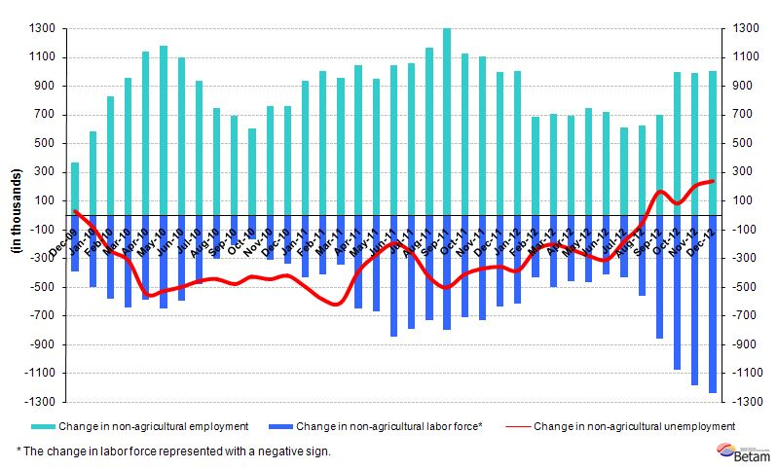
Source: TurkSTAT, Betam

Stagnation in seasonally adjusted non-agricultural unemployment continues

According to seasonally adjusted data, the non-agricultural labor force increased by 50 thousand to reach 21 million 829 thousand in the period of December 2012 compared to the period of November 2012 (Figure 2, Table 1). Non-agricultural employment increased by 44 thousand to reach 19 million 256 thousand. Consequently, the number of persons unemployed in non-agricultural sectors increased by 6 thousand and non-agricultural unemployment rate remained at 11.8 percent.

Figure 2 Seasonally adjusted non-agricultural labor force, employment and unemployment
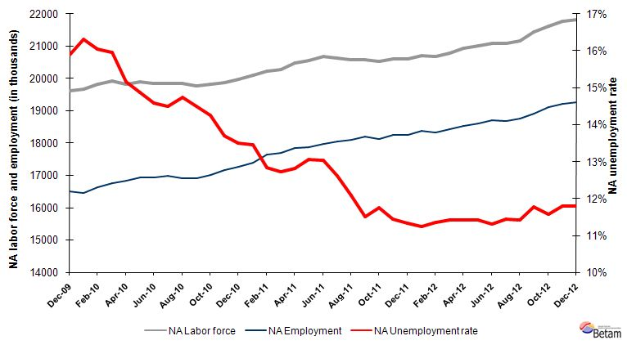
Source: TurkStat, Betam

According to Kariyer.net data, stagnation in non-agricultural unemployment continues

Application per vacancy calculated by using series released by Kariyer.net indicates that the stagnation in non-agricultural unemployment rate will continue in the period of January 2013.

Figure 1 Seasonally adjusted non-agricultural unemployment rate and application per vacancy
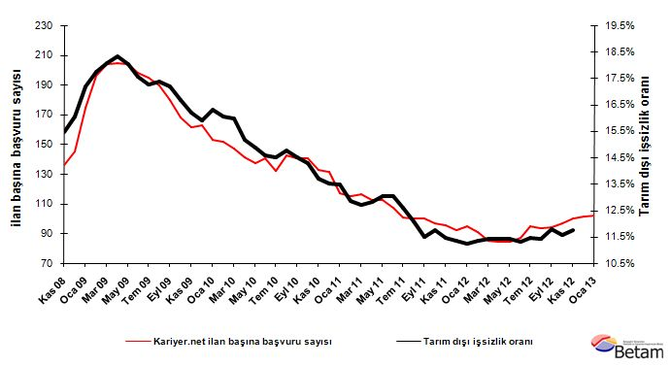
Source: Kariyer.net, TurkStat, Betam

Manufacturing employment increased by 37 thousand

Seasonally adjusted data shows that employment in manufacturing increased by 37 thousand, while employment in services increased only by 7 thousand in the period of December 2012 compared to the period of November 2012 (Table 2, Figure 4). Employment in construction decreased by 24 thousand during the same period. When we consider the slight increase in the manufacturing production index, the increase in manufacturing employment is surprising, especially given that it has been stagnating for some time. However, we observe that employment in services stagnated in the period of December 2012. Let us keep a closer watch on this as the increase in services has been strong over a prolonged period.

Stagnation in agricultural employment continues in the period of December 2012. Structural transformation dictates that employment and production both shift away from agriculture towards non-agricultural sectors. We had observed just the opposite from 2008 to 2011 as both increased. This seems to have stopped two years ago. However, we still do not observe a decline in agricultural employment.

Figure 2 Employment by sectors (in thousands)
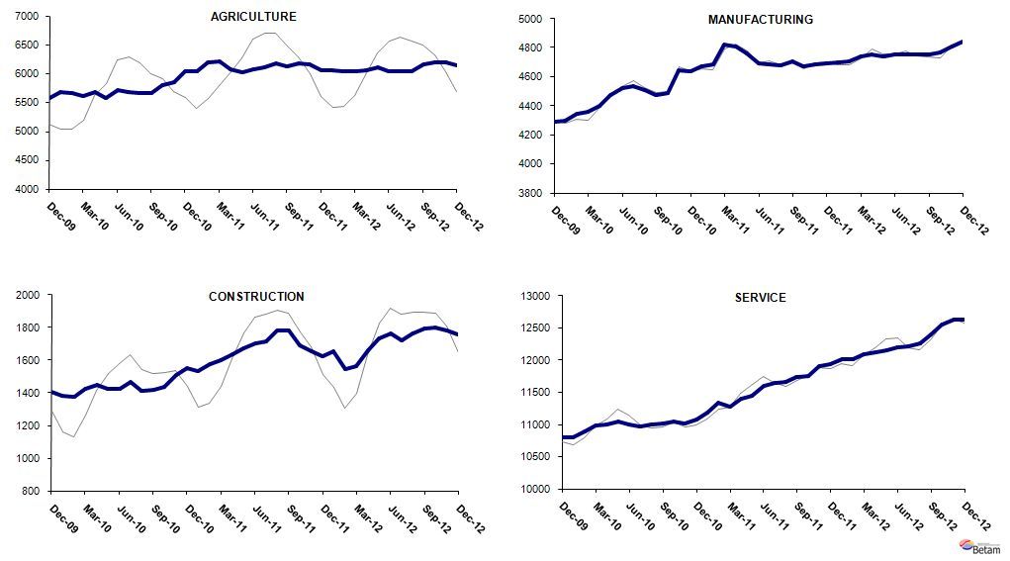
Source: TurkStat, Betam

LABOR MARKET HIGHLIGHT
Boom in Female Employment

We had observed strong increases in employment due to the high GDP growth rate after the crisis. We also know that the increases are mostly observed in non-agricultural sectors, especially in services. A less known fact is that the increase in female employment is main pushing force behind this development. Female labor force participation in non-agricultural sectors has accelerated after the crisis. Nevertheless, female unemployment rate decreased in line with the total unemployment rate. This shows that common belief that female unemployment increases with female labor force participation is unfounded.

Female labor force and employment have been rapidly increasing for 3 years
Figure A presents the evolution of seasonally adjusted non-agricultural female labor force, non-agricultural female employment and female wage earners from November 2009 to November 2012. Data points to an acceleration in the increase in non-agricultural female labor force. There are substantial increases in total female employment and female wage earners as well.

Figure A Seasonally adjusted female non-agricultural labor force and non-agricultural employment
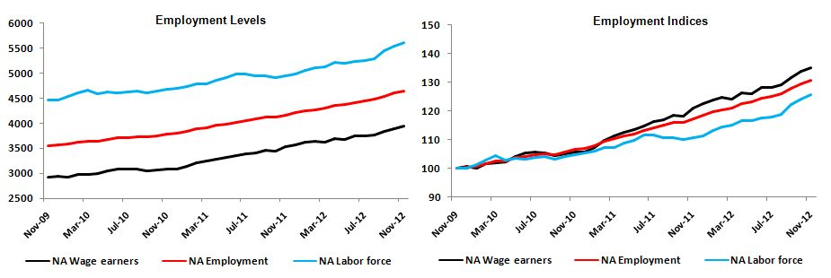
Source: TurkStat; Betam

Let us examine these increases more closely by creating indices in which November 2009 constitutes the base. According to indices presented in Figure A, increase in employment has been considerably moving over the increase in labor force since the 4th quarter of 2010. While labor force increased by 26 percent in three years, employment increased by 31 percent. In other words, average annual increase in female employment is 9.5 percent, which is considerably higher than that before the crisis.

Another positive development is the increase in the share of female wage earners in total female employment. During the crisis, female employment increased among the self –employed group due to the added worker effect. Surprisingly, the recent increase is among the wage earners. Share of female wage earners in female non-agricultural employment increased from 82 percent in the period of November 2009 to 85 percent in the period of November 2012.

Decreasing trend in female unemployment rate
We underline that decline in female unempoyment rate is due to a higher increase in employment than that in the labor force. Figure B presents the seasonally adjusted female non-agricultural and total non-agricultural unemployment rates. The data indicates that female non-agricultural unemployment rate decreased from about 21 percent in the late 2009 to about 16 percent in the first half of 2012. However, the decline seems to have stopped in the second half of 2012 and there is a small increase in female unemployment. Looking at monthly data may be misleading, especially if we concentrate on the medium term. However, we should keep an eye on the female unemployment rates in the future.

Figure B Seasonally adjusted non-agricultural unemployment rates
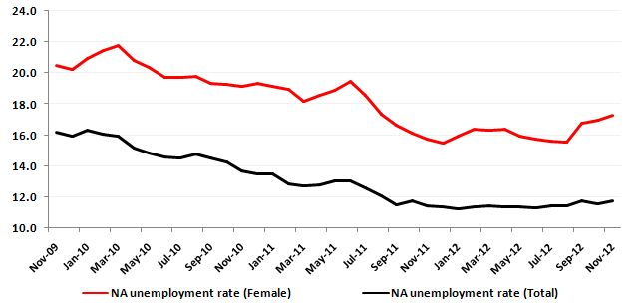
Source: TurkStat; Betam

Employment among uneducated and high educated females has been increasing more rapidly
Figure C presents both employment levels and employment indices based on November 2009 by education level.
It is clear that female employment increased for all education levels, but note that the increase is not uniform across different education groups. Employment of university graduate women increased by 40 percent in three years, and this is not surprising. However, the second highest increase is not among women with high school degrees, but among women have less education (an increase by 30 percent). The increase in employment of high school graduate women is 18 percent. Moreover, it has been stagnant for a year. The differences across education levels are important and they should be studied more thoroughly.

Figure C Seasonally adjusted non-agricultural employment by education level
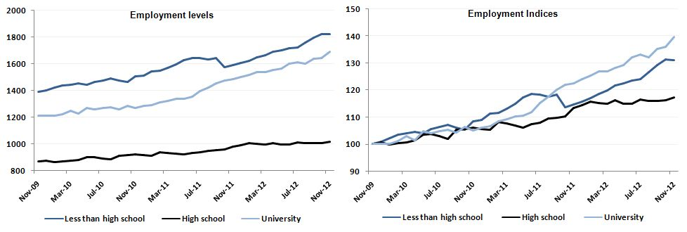
Source: TurkStat; Betam

Table 1 Seasonally adjusted non-agricultural labor force indicators (in thousands)
 | Labor force | Employment | Unemployment | Unemployment rate | Monthly changes
November-09 | 19561 | 16394 | 3167 | 16.2% | Labor force | Employment | Unemployment
December-09 | 19617 | 16497 | 3119 | 15.9% | 56 | 103 | -47
January-10 | 19669 | 16463 | 3207 | 16.3% | 52 | -35 | 87
February-10 | 19815 | 16635 | 3180 | 16.0% | 146 | 172 | -26
March-10 | 19936 | 16752 | 3183 | 16.0% | 121 | 118 | 3
April-10 | 19832 | 16826 | 3006 | 15.2% | -104 | 73 | -177
May-10 | 19896 | 16935 | 2961 | 14.9% | 64 | 110 | -46
June-10 | 19839 | 16947 | 2892 | 14.6% | -57 | 11 | -69
July-10 | 19857 | 16978 | 2879 | 14.5% | 19 | 32 | -13
August-10 | 19849 | 16923 | 2927 | 14.7% | -8 | -56 | 48
September-10 | 19778 | 16911 | 2866 | 14.5% | -72 | -11 | -60
October-10 | 19829 | 17002 | 2827 | 14.3% | 51 | 90 | -39
November-10 | 19879 | 17157 | 2721 | 13.7% | 50 | 155 | -106
December-10 | 19964 | 17270 | 2694 | 13.5% | 85 | 112 | -27
January-11 | 20104 | 17399 | 2705 | 13.5% | 141 | 130 | 11
February-11 | 20232 | 17635 | 2597 | 12.8% | 128 | 236 | -108
March-11 | 20284 | 17704 | 2580 | 12.7% | 52 | 69 | -17
April-11 | 20470 | 17846 | 2624 | 12.8% | 186 | 142 | 44
May-11 | 20551 | 17869 | 2682 | 13.1% | 81 | 23 | 58
June-11 | 20672 | 17977 | 2696 | 13.0% | 121 | 107 | 14
July-11 | 20645 | 18041 | 2604 | 12.6% | -27 | 65 | -92
August-11 | 20591 | 18102 | 2489 | 12.1% | -54 | 61 | -115
September-11 | 20575 | 18208 | 2367 | 11.5% | -16 | 106 | -122
October-11 | 20541 | 18126 | 2416 | 11.8% | -33 | -82 | 49
November-11 | 20602 | 18244 | 2358 | 11.4% | 61 | 119 | -58
December-11 | 20599 | 18264 | 2335 | 11.3% | -3 | 19 | -23
January-12 | 20718 | 18389 | 2328 | 11.2% | 119 | 126 | -7
February-12 | 20675 | 18328 | 2347 | 11.4% | -43 | -62 | 19
March-12 | 20792 | 18419 | 2373 | 11.4% | 117 | 91 | 26
April-12 | 20928 | 18540 | 2389 | 11.4% | 137 | 121 | 16
May-12 | 21017 | 18618 | 2399 | 11.4% | 88 | 78 | 10
June-12 | 21084 | 18698 | 2385 | 11.3% | 67 | 81 | -13
July-12 | 21086 | 18674 | 2411 | 11.4% | 2 | -24 | 26
August-12 | 21166 | 18749 | 2417 | 11.4% | 80 | 74 | 6
September-12 | 21432 | 18909 | 2523 | 11.8% | 266 | 160 | 106
October-12 | 21610 | 19108 | 2502 | 11.6% | 178 | 199 | -20
November-12 | 21779 | 19212 | 2567 | 11.8% | 169 | 105 | 64
December-12 | 21829 | 19256 | 2573 | 11.8% | 50 | 44 | 6
Source: TurkStat, Betam

Table 2 Seasonally adjusted employment by sector (in thousands)
 | Agriculture | Manufacturing | Construction | Service | Monthly changes
November-09 | 5500 | 4226 | 1384 | 10788 | Agriculture | Manufacturing | Construction | Service
December-09 | 5581 | 4290 | 1408 | 10798 | 81 | 64 | 24 | 10
January-10 | 5678 | 4299 | 1383 | 10794 | 98 | 9 | -25 | -4
February-10 | 5665 | 4349 | 1373 | 10895 | -13 | 50 | -9 | 101
March-10 | 5620 | 4357 | 1425 | 10990 | -45 | 9 | 52 | 94
April-10 | 5672 | 4400 | 1446 | 10995 | 52 | 42 | 21 | 5
May-10 | 5575 | 4472 | 1423 | 11047 | -97 | 73 | -23 | 52
June-10 | 5711 | 4526 | 1422 | 11002 | 136 | 53 | 0 | -44
July-10 | 5680 | 4539 | 1469 | 10967 | -31 | 13 | 47 | -35
August-10 | 5659 | 4509 | 1414 | 10999 | -21 | -30 | -55 | 32
September-10 | 5656 | 4477 | 1416 | 11014 | -3 | -32 | 2 | 15
October-10 | 5795 | 4492 | 1437 | 11048 | 139 | 15 | 22 | 35
November-10 | 5851 | 4648 | 1507 | 11009 | 56 | 156 | 69 | -39
December-10 | 6036 | 4639 | 1553 | 11078 | 185 | -9 | 46 | 69
January-11 | 6039 | 4673 | 1535 | 11190 | 3 | 34 | -18 | 112
February-11 | 6190 | 4684 | 1578 | 11335 | 151 | 11 | 44 | 145
March-11 | 6203 | 4826 | 1602 | 11279 | 13 | 142 | 24 | -56
April-11 | 6083 | 4812 | 1639 | 11400 | -121 | -13 | 37 | 120
May-11 | 6021 | 4765 | 1675 | 11445 | -62 | -48 | 36 | 45
June-11 | 6082 | 4692 | 1705 | 11598 | 61 | -72 | 31 | 153
July-11 | 6105 | 4685 | 1716 | 11653 | 23 | -8 | 11 | 55
August-11 | 6186 | 4682 | 1780 | 11666 | 80 | -3 | 64 | 13
September-11 | 6129 | 4709 | 1784 | 11734 | -57 | 27 | 4 | 69
October-11 | 6173 | 4676 | 1688 | 11754 | 44 | -34 | -95 | 20
November-11 | 6154 | 4689 | 1655 | 11902 | -20 | 14 | -34 | 148
December-11 | 6055 | 4695 | 1623 | 11935 | -99 | 6 | -32 | 33
January-12 | 6058 | 4697 | 1657 | 12021 | 3 | 2 | 34 | 86
February-12 | 6046 | 4710 | 1546 | 12010 | -11 | 13 | -110 | -11
March-12 | 6033 | 4741 | 1562 | 12092 | -14 | 32 | 16 | 83
April-12 | 6065 | 4758 | 1659 | 12116 | 32 | 17 | 97 | 23
May-12 | 6110 | 4742 | 1734 | 12158 | 45 | -16 | 75 | 42
June-12 | 6040 | 4755 | 1763 | 12206 | -70 | 13 | 30 | 48
July-12 | 6042 | 4755 | 1719 | 12216 | 2 | 0 | -44 | 10
August-12 | 6048 | 4755 | 1763 | 12268 | 6 | 0 | 44 | 52
September-12 | 6153 | 4751 | 1792 | 12400 | 106 | -3 | 29 | 132
October-12 | 6198 | 4767 | 1799 | 12551 | 44 | 16 | 8 | 151
November-12 | 6187 | 4807 | 1782 | 12630 | -11 | 40 | -18 | 79
December-12 | 6143 | 4844 | 1758 | 12636 | -44 | 37 | -24 | 7
Source: TurkStat, Betam

* Prof. Dr. Seyfettin Gürsel, Betam, Director, seyfettin.gursel@bahcesehir.edu.tr
∗ Yrd. Doç. Dr. Gökçe Uysal, Betam, Vice Director, gokce.uysal@bahcesehir.edu.tr
∗∗ Ayşenur Acar, Betam, Research Assistant, aysenur.acar@bahcesehir.edu.tr
Betam has been calculating application per vacancy using series released by Kariyer.net for a while. Seasonal and calendar adjustment procedure is applied to application per vacancy series. A decrease in applications per vacancy may be caused by an increase in vacancies or by a decrease in the number of applications. An increase in vacancies signals economic growth while decreasing number of applications indicates a decrease in number of people looking for a job.
Employment in each sector is seasonally adjusted separately. Hence the sum of these series may differ from the seasonally adjusted series of total employment. The difference stems from the non-linearity of the seasonal adjustment process.
Grey lines indicate seasonally adjusted series, where dark blue lines represent raw data.

