

Labor Market Outlook:

February 2013

15 February 2013

INCREASE IN UNEMPLOYMENT CONTINUES

Seyfettin Gürsel* Gökçe Uysal∗ ve Ayşenur Acar∗

Abstract

Seasonally adjusted labor market data shows that non-agricultural unemployment increased from 11.6 percent in October 2012 to 11.8 percent in November 2012. Despite the strong increase in non-agricultural employment, stronger increase in non-agricultural labor force leads to an increase in non-agricultural unemployment. Slow but sustainable increasing trend in non-agricultural unemployment that we have been observing since February 2012 continues. Data released by Kariyer.net shows that the slow increase in unemployment might continue in the next period.

Labor market highlight
This month, our analysis on the structural characteristics of labor market focuses on the relationship between growth and employment in different sectors. The results show that this relationship is tight in manufacturing and service. We observe increases in labor productivity in both two sectors after the global economic crisis. On the other hand, employment in construction did not decline during the crisis despite the continuous fall in value added in construction. After the crisis, both value added and employment in construction increase in a parallel manner. In other words, the negative productivity shock that arose in the crisis seems to be permanent. This may be due to a measurement error in construction.

Increase in non-agricultural labor force has been over 1 million

According to the data released by TurkSTAT, non-agricultural labor force increased by 1 million 188 thousand (5.8 percent), the non-agricultural employment increased by 987 thousand (5.4 percent) and non-agricultural unemployment increased by 201 thousand to 2 million 533 thousand persons in the period of November 2012 on a year-on-year basis (Figure 1). Despite the strong increase in non-agricultural employment, an increase of over 1 million in the non-agricultural labor force leads to an increase in non-agricultural unemployment

Figure 1 Year-on-year changes in non-agricultural labor force, employment and unemployment
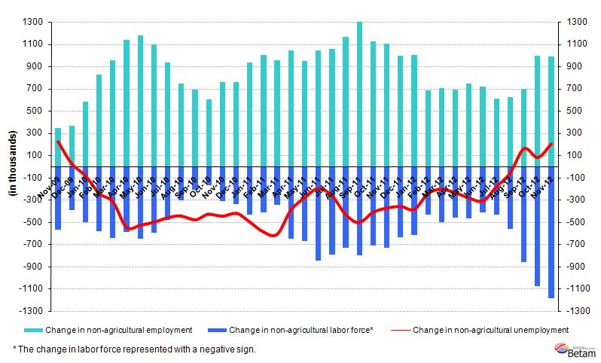
Source: TurkSTAT, Betam

Increasing trend in seasonally adjusted non-agricultural unemployment continues

According to seasonally adjusted data, the non-agricultural labor force increased by 169 thousand to reach 21 million 784 thousand in the period of November 2012 compared to the period of October 2012 (Figure 2, Table 1). Non-agricultural employment increased by107 thousand to reach 19 million 221 thousand. Consequently, the number of persons employed in non-agricultural sectors decreased by 62 thousand and non-agricultural unemployment rate increased from 11.6 percent to 11.8 percent.

Figure 2 Seasonally adjusted non-agricultural labor force, employment and unemployment
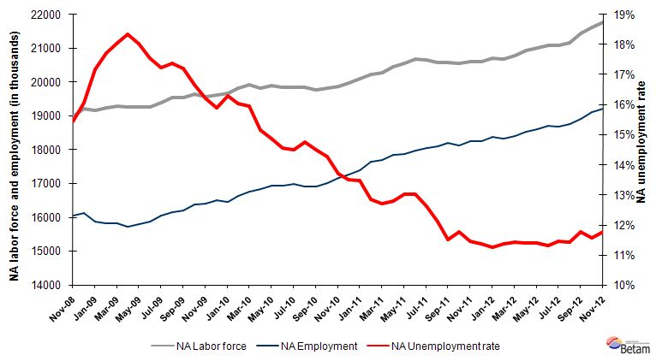
Source: TurkStat, Betam

According to Kariyer.net data, increase in non-agricultural unemployment continues

Application per vacancy calculated by using series released by Kariyer.net indicates that the increase non-agricultural unemployment rate will continue in the period of December 2012.

Figure 1 Seasonally adjusted non-agricultural unemployment rate and application per vacancy
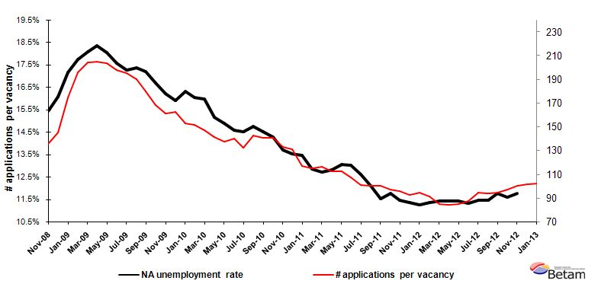
Source: Kariyer.net, TurkStat, Betam

Increase in service employment continues

Seasonally adjusted data shows that the increase in service employment has been continuing in the period of November 2012 (Table 2, Figure 4). Manufacturing employment increased by 38 thousand, while construction employment decreased by 17 thousand in this period.

Figure 2 Employment by sectors (in thousands)
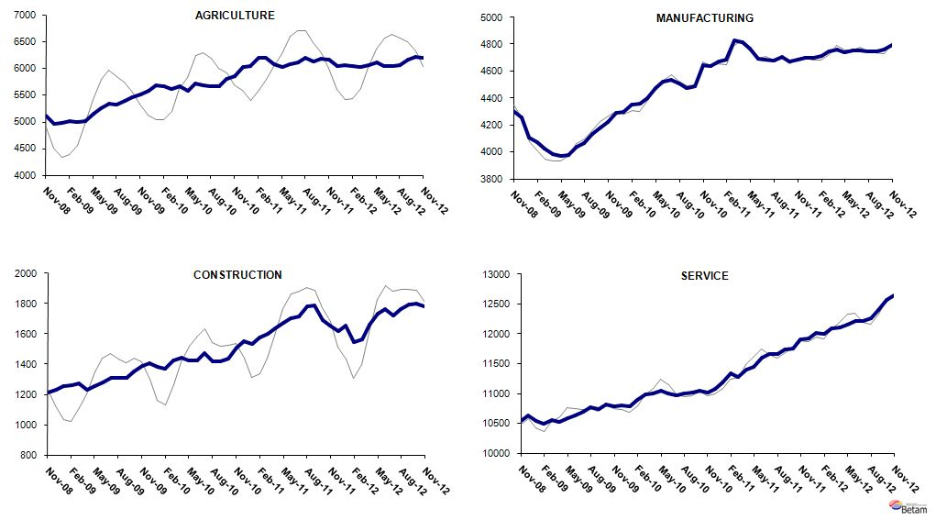
Source: TurkStat, Betam

LABOR MARKET HIGLIGHT

Decoupling between economic growth and employment

There is a relationship between economic growth and employment due to changes in the concentration of capital and in labor productivity. GDP growth (increase in value added) has been moving over employment growth with some exceptions. GDP growth is higher than employment growth when there are increases in the concentration of capital and/or labor productivity. Hence, value added per employee increases continuously, which governs the dynamics of growth. However, employment might not follow declines in GDP during crisis periods. If firms predict that contraction in demand and hence in production will not last long, i.e. if they predict that the crisis will be temporary; they may restrict the number of layoffs or even not lay off workers at all. Note that firing is costly due to factors such as severance pay, loss of experienced employees etc. Also, the firms may lower hours of work and wages to temper the costs of not being able to reduce employment following a decline in production.

The relationship between GDP growth and employment varies across sectors. In order to understand the sectoral relationships, we seasonally adjust the sectoral Gross Domestic Product series (calculated using the product approach) and let the first quarter of 2005 be the base quarter (100). We present indices and figures in Figure A and Table A.

As seen in Figure A, there is no clear relationship between growth and employment in agriculture due to the dominance of family farms in agricultural production. However, the relationship in manufacturing is tight. Both before and after the crisis, value added increased at a faster speed than employment, indicating an increase in labor productivity in manufacturing. During the crisis, employment fell following a decrease in value added.

Looking at the service sector, we observe an increase in labor productivity before the crisis, similar to the one in the manufacturing sector. During the crisis, value added in service decreases, while employment is stagnant. We think that this is extraordinary. The underlying reason could be that the added value of self-employed women, which increased during the crisis, are not reflected in national accounts. Other reasons need to be investigated. The value added index of the service sector has been consistently increasing since the first quarter of 2009. It increased from 113.1 to 141.6 (25 percent), while the employment index of the service sector increased from 111.7 to 129.8 percent (an increase by 16 percent). This indicates that labor productivity increased, just like it did before the crisis.

Developments in construction sector are very different from other sectors and very surprising indeed. Normally, we would expect a similar relationship in construction to the one in manufacturing. Hiring costs for unskilled workers employed in the construction sector are relatively low. When there is an increase in demand, employment may not decrease at best. However, if there is an increase in demand, it is not economically normal that employment increases. Obviously, there was an anomaly in the construction sector during the 2008-09 crisis. Value added in construction decreased continuously from the 3th quarter of 2007 to the 3th quarter of 2009. During this period, the value added index of the construction sector decreased from 129.2 to 95.6 (25.3 percent). We would expect a large negative impact on employment especially given that the contraction lasted for two years. However, construction employment increases slightly (1.4 percent) in this period. Consequently, employment index in the construction sector hovers above the value added index since the first quarter of 2009. Following this period, the value added index increased by 29 percent, while the employment index increased by 28 percent from the fourth quarter of 2009 to the third of 2012. In other words, negative productivity shock that happened during the crisis seems to be permanent rather than temporary, which obviously raises red flags. Also, while value added in construction has been stagnant during the past couple periods, there are sudden increases and decreases in employment.

Consequently, we think that there could be a measurement error in construction employment. Due to the small share of construction in overall employment (7 percent), this potential measurement error will not cause changes in the overall employment and unemployment figures. We still think that it would be a good idea for TUIK to look into employment series in construction more carefully.

Figure A Indices of sectoral growth and employment: 2005(1)-2012(3) (Seasonally adjusted, 2005(1)=100)
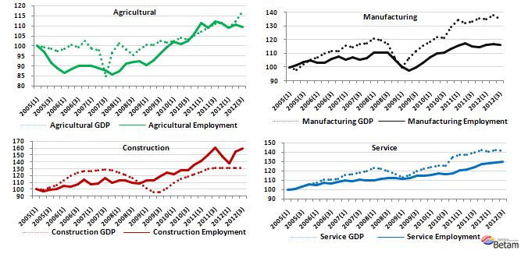
Source: Gross Domestic Product, Product Approach (Constant Prices Base 1998), Household Labor Force Survey ; TukStat, İndex Calculations; Betam

Table A Indices of sectoral growth and employment: 2005(1)-2012(3) (Seasonally adjusted, 2005(1)=100)
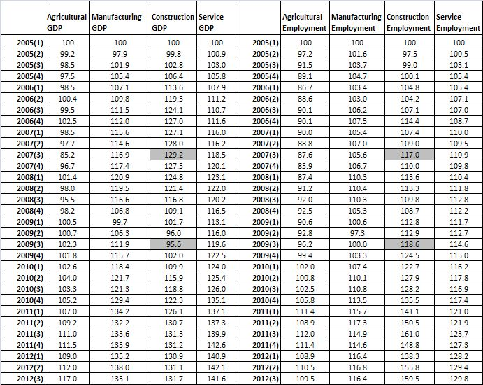
Source: Gross Domestic Product, by Product Approach (Constant Prices 1998 Base), Household Labor Force Survey ; TukStat, İndex Calculations; Betam

Table 1 Seasonally adjusted non-agricultural labor force indicators (in thousands)
 | Labor force | Employment | Unemployment | Unemployment rate | Monthly changes
October-09 | 19649 | 16373 | 3277 | 16.7% | Labor force | Employment | Unemployment
November-09 | 19564 | 16395 | 3169 | 16.2% | -85 | 22 | -108
December-09 | 19615 | 16495 | 3121 | 15.9% | 51 | 100 | -49
January-10 | 19667 | 16460 | 3207 | 16.3% | 52 | -35 | 87
February-10 | 19812 | 16634 | 3179 | 16.0% | 145 | 174 | -28
March-10 | 19933 | 16752 | 3181 | 16.0% | 121 | 119 | 2
April-10 | 19830 | 16826 | 3004 | 15.2% | -103 | 74 | -176
May-10 | 19895 | 16937 | 2958 | 14.9% | 64 | 111 | -46
June-10 | 19838 | 16948 | 2890 | 14.6% | -56 | 12 | -68
July-10 | 19858 | 16980 | 2878 | 14.5% | 20 | 32 | -12
August-10 | 19852 | 16923 | 2929 | 14.8% | -6 | -57 | 51
September-10 | 19781 | 16911 | 2870 | 14.5% | -71 | -12 | -59
October-10 | 19833 | 17002 | 2830 | 14.3% | 52 | 91 | -39
November-10 | 19883 | 17159 | 2724 | 13.7% | 50 | 157 | -106
December-10 | 19962 | 17265 | 2697 | 13.5% | 79 | 106 | -27
January-11 | 20102 | 17396 | 2706 | 13.5% | 139 | 131 | 9
February-11 | 20230 | 17633 | 2596 | 12.8% | 128 | 238 | -109
March-11 | 20282 | 17704 | 2578 | 12.7% | 52 | 70 | -18
April-11 | 20468 | 17847 | 2621 | 12.8% | 186 | 144 | 43
May-11 | 20549 | 17871 | 2678 | 13.0% | 81 | 24 | 57
June-11 | 20671 | 17979 | 2692 | 13.0% | 122 | 108 | 14
July-11 | 20646 | 18043 | 2603 | 12.6% | -25 | 64 | -89
August-11 | 20594 | 18103 | 2491 | 12.1% | -52 | 60 | -112
September-11 | 20578 | 18210 | 2368 | 11.5% | -16 | 107 | -123
October-11 | 20545 | 18128 | 2417 | 11.8% | -33 | -81 | 49
November-11 | 20607 | 18249 | 2358 | 11.4% | 61 | 121 | -60
December-11 | 20597 | 18258 | 2339 | 11.4% | -10 | 9 | -19
January-12 | 20714 | 18384 | 2329 | 11.2% | 117 | 126 | -9
February-12 | 20672 | 18324 | 2349 | 11.4% | -42 | -61 | 19
March-12 | 20789 | 18417 | 2372 | 11.4% | 117 | 93 | 24
April-12 | 20926 | 18540 | 2386 | 11.4% | 137 | 123 | 14
May-12 | 21015 | 18619 | 2396 | 11.4% | 89 | 79 | 10
June-12 | 21083 | 18701 | 2382 | 11.3% | 68 | 82 | -14
July-12 | 21088 | 18675 | 2412 | 11.4% | 5 | -26 | 30
August-12 | 21170 | 18749 | 2421 | 11.4% | 82 | 74 | 8
September-12 | 21436 | 18913 | 2524 | 11.8% | 266 | 163 | 103
October-12 | 21615 | 19114 | 2501 | 11.6% | 179 | 201 | -22
November-12 | 21784 | 19221 | 2563 | 11.8% | 169 | 107 | 62
Source: TurkStat, Betam

Table 2 Seasonally adjusted employment by sector (in thousands)
 | Agriculture | Manufacturing | Construction | Service | Monthly changes
October-09 | 5451 | 4180 | 1353 | 10813 | Agriculture | Manufacturing | Construction | Service
November-09 | 5505 | 4225 | 1386 | 10789 | 54 | 44 | 33 | -24
December-09 | 5576 | 4290 | 1405 | 10793 | 71 | 66 | 19 | 4
January-10 | 5674 | 4300 | 1381 | 10789 | 98 | 10 | -24 | -4
February-10 | 5663 | 4350 | 1372 | 10893 | -11 | 50 | -9 | 104
March-10 | 5618 | 4358 | 1424 | 10990 | -46 | 8 | 52 | 96
April-10 | 5670 | 4400 | 1445 | 10995 | 52 | 42 | 21 | 5
May-10 | 5573 | 4473 | 1423 | 11048 | -97 | 73 | -22 | 53
June-10 | 5711 | 4526 | 1423 | 11005 | 138 | 53 | 0 | -43
July-10 | 5680 | 4538 | 1470 | 10969 | -31 | 12 | 47 | -36
August-10 | 5660 | 4508 | 1416 | 11000 | -20 | -30 | -54 | 31
September-10 | 5658 | 4475 | 1418 | 11015 | -2 | -33 | 2 | 15
October-10 | 5801 | 4490 | 1439 | 11051 | 143 | 15 | 22 | 36
November-10 | 5858 | 4645 | 1509 | 11012 | 56 | 155 | 70 | -39
December-10 | 6030 | 4640 | 1550 | 11070 | 172 | -5 | 41 | 58
January-11 | 6034 | 4676 | 1533 | 11185 | 4 | 36 | -17 | 115
February-11 | 6189 | 4686 | 1577 | 11333 | 155 | 11 | 44 | 148
March-11 | 6201 | 4827 | 1601 | 11277 | 12 | 141 | 24 | -56
April-11 | 6081 | 4814 | 1638 | 11399 | -121 | -14 | 37 | 121
May-11 | 6018 | 4765 | 1675 | 11445 | -63 | -48 | 37 | 46
June-11 | 6082 | 4692 | 1706 | 11601 | 64 | -73 | 31 | 156
July-11 | 6106 | 4684 | 1717 | 11654 | 24 | -9 | 11 | 53
August-11 | 6188 | 4680 | 1782 | 11666 | 82 | -4 | 65 | 12
September-11 | 6133 | 4706 | 1786 | 11737 | -55 | 26 | 4 | 71
October-11 | 6182 | 4672 | 1690 | 11761 | 49 | -35 | -95 | 24
November-11 | 6162 | 4684 | 1657 | 11911 | -19 | 12 | -33 | 151
December-11 | 6047 | 4698 | 1620 | 11925 | -115 | 14 | -37 | 14
January-12 | 6051 | 4702 | 1655 | 12016 | 4 | 5 | 35 | 90
February-12 | 6043 | 4714 | 1545 | 12006 | -7 | 12 | -110 | -9
March-12 | 6030 | 4745 | 1561 | 12089 | -14 | 31 | 16 | 83
April-12 | 6062 | 4760 | 1658 | 12113 | 33 | 16 | 97 | 24
May-12 | 6107 | 4743 | 1734 | 12156 | 45 | -18 | 76 | 43
June-12 | 6040 | 4754 | 1764 | 12208 | -68 | 11 | 30 | 52
July-12 | 6042 | 4753 | 1720 | 12216 | 3 | -1 | -44 | 7
August-12 | 6050 | 4751 | 1765 | 12267 | 8 | -2 | 45 | 51
September-12 | 6159 | 4746 | 1794 | 12405 | 109 | -5 | 29 | 138
October-12 | 6209 | 4759 | 1801 | 12562 | 50 | 13 | 8 | 158
November-12 | 6198 | 4797 | 1784 | 12645 | -11 | 38 | -17 | 83
Source: TurkStat, Betam

* Prof. Dr. Seyfettin Gürsel, Betam, Director, seyfettin.gursel@bahcesehir.edu.tr
∗ Yrd. Doç. Dr. Gökçe Uysal, Betam, Vice Director, gokce.uysal@bahcesehir.edu.tr
∗∗ Ayşenur Acar, Betam, Research Assistant, aysenur.acar@bahcesehir.edu.tr
Betam has been calculating application per vacancy using series released by Kariyer.net for a while. Seasonal and calendar adjustment procedure is applied to application per vacancy series. A decrease in applications per vacancy may be caused by an increase in vacancies or by a decrease in the number of applications. An increase in vacancies signals economic growth while decreasing number of applications indicates a decrease in number of people looking for a job.
Seasonal adjustment procedure is applied to each sector of employment series separately. Hence the sum of these series may differ from the seasonally adjusted series of total employment. The difference stems from the non-linearity of the seasonal adjustment process.
Grey lines indicate seasonally adjusted series, where dark blue lines represent raw data.

