

Labor Market Outlook:

January 2013

15 January 2013

SERVICES PULL EMPLOYMENT

Seyfettin Gürsel* Gökçe Uysal∗ ve Ayşenur Acar∗

Abstract

Seasonally adjusted labor market data shows that non-agricultural unemployment decreased from 11.7 percent in September 2012 to 11.5 percent in October 2012. We have not observed a sizeable increase in non-agricultural unemployment for a year. Increases in non-agricultural employment mostly stem from increases in service employment. Half of the increases in service employment are due to the increases in following sub-sectors: administrative and support service activities, public administration and defense, education, human health and social work activities.

Strong increases in non-agricultural labor force and non-agricultural employment

According to the data released by TurkSTAT, non-agricultural labor force increased by 1 million 74 thousand (5.2 percent), the non-agricultural employment increased by 993 thousand (5.5 percent) and non-agricultural unemployment increased by 81 thousand to 2 million 469 thousand persons in the period of October 2012 on a year on year basis (Figure 1).

Figure 1 Year-on-year changes in non-agricultural labor force, employment and unemployment
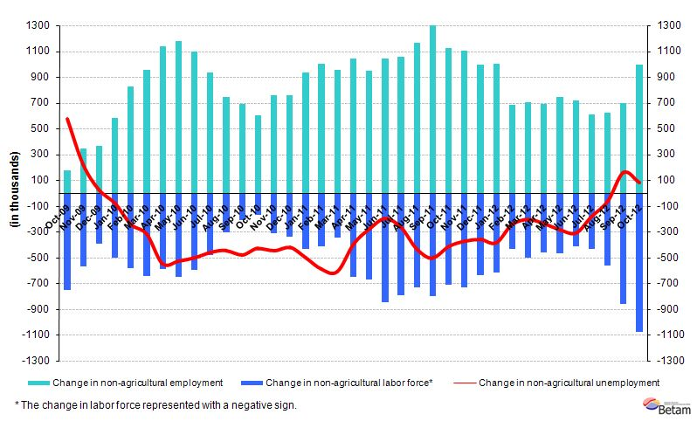
Source: TurkSTAT, Betam

An increase in seasonally adjusted non-agricultural unemployment

According to seasonally adjusted data, compared to the period of September 2012, non-agricultural labor force increased by 176 thousand to 21 million 598 thousand in the period of October2012 (Figure 2, Table 1). Non-agricultural employment increased by 201 thousand to 19 million 107 thousand. Consequently, the number of persons in non-agricultural decreased by 25 thousand, non-agricultural unemployment rate decreased from 11.7 percent to 11.5 percent.

Figure 2 Seasonally adjusted non-agricultural labor force, employment and unemployment
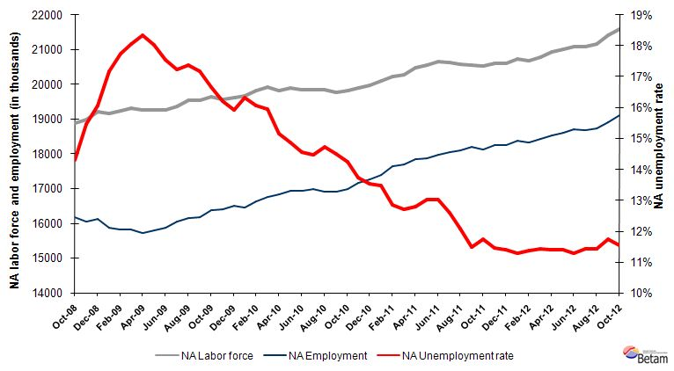
Source: TurkStat, Betam

According to Kariyer.net data, increase in non-agricultural unemployment continues

Application per vacancy calculated by using series released by Kariyer.net indicates that non-agricultural unemployment rate will increase slightly in the period of November 2012.

Figure 1 Seasonally adjusted non-agricultural unemployment rate and application per vacancy
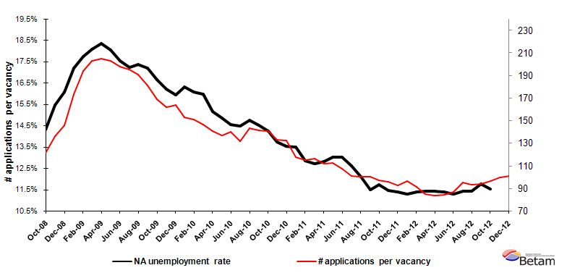
Data source: Kariyer.net, TurkStat, Betam

Increase in service employment continues

Seasonally adjusted data shows that service employment increased by 160 thousand in October 2012 compared to September 2012 (Table 2, Figure 4). Manufacturing employment increased by only 9 thousand, while construction employment increased by 8 thousand in this period.

Employment increased by 1 million 19 thousand in the past year. Approximately 800 thousand of the increase stems from increases in service employment. To study the driving factors behind the increase, we seasonally adjust service employment data by subsectors (Table 3). Increases in service employment are concentrated in certain sub-sectors. We grouped those sub-sectors, which are administrative and support service activities (N), public administration and defence (O), education (P) and human health and social work activities (Q). This group created 652 thousand jobs in service employment, which is 80 percent of the 820 thousand increase in service employment in the past year. This group constitutes 72 thousand of the 148 thousand increases in service employment from October 2012 to September 2012 as well.

Seasonally adjusted service employment series show that share of this group (administrative and support service activities (N), public administration and defence (O), education (P) and human health and social work activities (Q) in total service employment has been increasing regularly. While the share of the group is 31.1 percent in October 2009, it increased to 36.4 percent in October 2012. In other words, more employment was created in this group relative to other sub-sectors.

Tablo 1 Seasonally adjusted non-agricultural labor force indicators (in thousands)
 | Labor force | Employment | Unemployment | Unemployment rate | Monthly changes
September-09 | 19549 | 16189 | 3360 | 17.2% | Labor force | Employment | Unemployment
October-09 | 19642 | 16371 | 3271 | 16.7% | 93 | 182 | -89
November-09 | 19569 | 16396 | 3174 | 16.2% | -72 | 25 | -98
December-09 | 19622 | 16496 | 3125 | 15.9% | 52 | 101 | -48
January-10 | 19672 | 16461 | 3211 | 16.3% | 50 | -36 | 86
February-10 | 19816 | 16635 | 3181 | 16.1% | 144 | 174 | -30
March-10 | 19936 | 16754 | 3182 | 16.0% | 119 | 119 | 1
April-10 | 19832 | 16827 | 3005 | 15.2% | -104 | 73 | -177
May-10 | 19894 | 16938 | 2957 | 14.9% | 63 | 111 | -48
June-10 | 19837 | 16949 | 2887 | 14.6% | -58 | 11 | -69
July-10 | 19854 | 16980 | 2875 | 14.5% | 18 | 31 | -13
August-10 | 19846 | 16920 | 2926 | 14.7% | -8 | -59 | 51
September-10 | 19773 | 16908 | 2866 | 14.5% | -73 | -13 | -60
October-10 | 19823 | 16998 | 2825 | 14.2% | 49 | 90 | -41
November-10 | 19890 | 17160 | 2729 | 13.7% | 67 | 162 | -95
December-10 | 19970 | 17267 | 2704 | 13.5% | 81 | 106 | -26
January-11 | 20108 | 17397 | 2711 | 13.5% | 138 | 131 | 7
February-11 | 20235 | 17635 | 2599 | 12.8% | 127 | 238 | -111
March-11 | 20285 | 17706 | 2580 | 12.7% | 50 | 70 | -20
April-11 | 20470 | 17849 | 2620 | 12.8% | 184 | 144 | 41
May-11 | 20549 | 17872 | 2677 | 13.0% | 79 | 23 | 56
June-11 | 20669 | 17980 | 2689 | 13.0% | 120 | 108 | 12
July-11 | 20641 | 18042 | 2600 | 12.6% | -28 | 62 | -89
August-11 | 20586 | 18099 | 2487 | 12.1% | -55 | 57 | -112
September-11 | 20568 | 18205 | 2362 | 11.5% | -18 | 107 | -125
October-11 | 20532 | 18123 | 2409 | 11.7% | -35 | -82 | 47
November-11 | 20616 | 18253 | 2363 | 11.5% | 84 | 130 | -46
December-11 | 20608 | 18261 | 2346 | 11.4% | -8 | 8 | -17
January-12 | 20723 | 18388 | 2335 | 11.3% | 115 | 126 | -11
February-12 | 20679 | 18326 | 2353 | 11.4% | -44 | -62 | 18
March-12 | 20794 | 18418 | 2375 | 11.4% | 115 | 92 | 22
April-12 | 20928 | 18542 | 2386 | 11.4% | 134 | 124 | 11
May-12 | 21014 | 18620 | 2395 | 11.4% | 86 | 78 | 8
June-12 | 21080 | 18701 | 2379 | 11.3% | 65 | 81 | -16
July-12 | 21081 | 18672 | 2409 | 11.4% | 1 | -29 | 30
August-12 | 21159 | 18743 | 2417 | 11.4% | 79 | 71 | 8
September-12 | 21422 | 18906 | 2516 | 11.7% | 263 | 163 | 99
October-12 | 21598 | 19107 | 2491 | 11.5% | 176 | 201 | -25
Source: TurkStat, Betam

Tablo 2 Seasonally adjusted employment by sector (in thousands)
 | Agriculture | Manufacturing | Construction | Service | Monthly changes
September-09 | 5393 | 4129 | 1309 | 10734 | Agriculture | Manufacturing | Construction | Service
October-09 | 5455 | 4178 | 1355 | 10811 | 62 | 49 | 46 | 77
November-09 | 5503 | 4227 | 1384 | 10790 | 48 | 49 | 29 | -21
December-09 | 5574 | 4294 | 1403 | 10794 | 71 | 67 | 20 | 4
January-10 | 5673 | 4304 | 1379 | 10789 | 99 | 10 | -24 | -5
February-10 | 5663 | 4353 | 1371 | 10895 | -10 | 50 | -9 | 105
March-10 | 5617 | 4359 | 1423 | 10991 | -46 | 5 | 53 | 96
April-10 | 5670 | 4401 | 1445 | 10996 | 53 | 42 | 22 | 5
May-10 | 5572 | 4473 | 1423 | 11049 | -97 | 73 | -22 | 53
June-10 | 5712 | 4526 | 1423 | 11006 | 139 | 52 | 0 | -43
July-10 | 5681 | 4538 | 1471 | 10968 | -30 | 12 | 48 | -38
August-10 | 5662 | 4504 | 1417 | 10998 | -19 | -34 | -54 | 30
September-10 | 5660 | 4469 | 1419 | 11011 | -2 | -34 | 2 | 14
October-10 | 5805 | 4482 | 1441 | 11048 | 145 | 13 | 22 | 36
November-10 | 5855 | 4647 | 1507 | 11015 | 49 | 165 | 66 | -33
December-10 | 6027 | 4645 | 1548 | 11072 | 173 | -2 | 42 | 57
January-11 | 6032 | 4681 | 1531 | 11187 | 5 | 36 | -17 | 115
February-11 | 6189 | 4691 | 1576 | 11336 | 156 | 11 | 44 | 149
March-11 | 6201 | 4831 | 1600 | 11279 | 12 | 139 | 25 | -57
April-11 | 6080 | 4817 | 1638 | 11399 | -121 | -13 | 38 | 120
May-11 | 6017 | 4767 | 1675 | 11445 | -63 | -51 | 37 | 45
June-11 | 6082 | 4690 | 1706 | 11601 | 65 | -77 | 31 | 157
July-11 | 6107 | 4680 | 1718 | 11652 | 24 | -10 | 12 | 50
August-11 | 6190 | 4673 | 1783 | 11661 | 83 | -7 | 65 | 9
September-11 | 6136 | 4697 | 1787 | 11732 | -54 | 25 | 4 | 71
October-11 | 6187 | 4659 | 1692 | 11756 | 51 | -38 | -95 | 24
November-11 | 6159 | 4688 | 1655 | 11919 | -28 | 29 | -37 | 163
December-11 | 6044 | 4707 | 1618 | 11931 | -116 | 18 | -36 | 11
January-12 | 6048 | 4711 | 1653 | 12021 | 5 | 4 | 35 | 90
February-12 | 6042 | 4722 | 1544 | 12010 | -6 | 11 | -110 | -10
March-12 | 6029 | 4751 | 1560 | 12091 | -14 | 30 | 17 | 81
April-12 | 6062 | 4766 | 1658 | 12113 | 33 | 15 | 98 | 22
May-12 | 6107 | 4744 | 1734 | 12155 | 45 | -22 | 76 | 41
June-12 | 6040 | 4751 | 1764 | 12207 | -67 | 7 | 30 | 52
July-12 | 6043 | 4746 | 1721 | 12210 | 3 | -5 | -43 | 3
August-12 | 6053 | 4739 | 1766 | 12258 | 10 | -7 | 45 | 48
September-12 | 6163 | 4730 | 1795 | 12396 | 110 | -9 | 29 | 139
October-12 | 6215 | 4739 | 1803 | 12556 | 52 | 9 | 8 | 160
Source: TurkStat, Betam
Figure 2 Employment by sectors (in thousands)
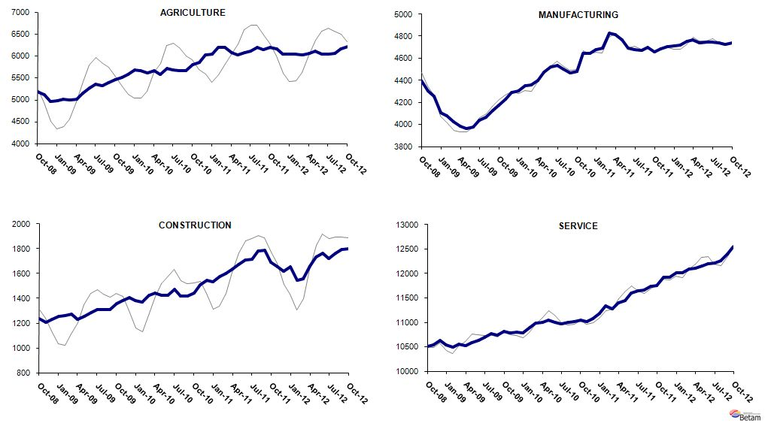
Source: TurkStat, Betam

Tablo 3 Service employment, seasonally adjusted (thousand)
 | Whole-sale and retail trade (G) | Transportation and storage (H) | Accommodation and food service activities (I) | Information and communication (J) | Financial and insurance activities (K) | Real estate activities (L) | Professional, scientific and technical activities (M) | Administrative and support service activities (N) | Public administra-tion and defence (O) | Education (P) | Human health and social work activities (Q) | Arts, entertain-ment and recreation (R) | Other social, comminity and personal service activities (S+T+U) | Total service employment
Jan-09 | 3387 | 976 | 1053 | 163 | 284 | 58 | 378 | 509 | 1203 | 960 | 608 | 145 | 836 | 10561
Feb-09 | 3355 | 982 | 1043 | 162 | 278 | 61 | 370 | 538 | 1188 | 959 | 598 | 143 | 831 | 10507
Mar-09 | 3361 | 975 | 1036 | 173 | 278 | 61 | 377 | 548 | 1206 | 962 | 602 | 146 | 818 | 10543
Apr-09 | 3328 | 980 | 1022 | 185 | 290 | 57 | 376 | 554 | 1225 | 965 | 606 | 135 | 822 | 10545
May-09 | 3363 | 983 | 1021 | 187 | 276 | 58 | 393 | 559 | 1228 | 967 | 600 | 136 | 829 | 10598
Jun-09 | 3331 | 995 | 1024 | 169 | 280 | 59 | 401 | 583 | 1215 | 971 | 590 | 129 | 876 | 10624
Jul-09 | 3396 | 992 | 1047 | 154 | 269 | 59 | 416 | 608 | 1203 | 973 | 582 | 127 | 870 | 10697
Aug-09 | 3426 | 977 | 1054 | 139 | 276 | 60 | 427 | 626 | 1195 | 975 | 588 | 124 | 874 | 10742
Sep-09 | 3400 | 996 | 1074 | 132 | 268 | 61 | 422 | 633 | 1201 | 977 | 590 | 119 | 864 | 10737
Oct-09 | 3393 | 1004 | 1070 | 140 | 262 | 64 | 402 | 661 | 1215 | 979 | 589 | 118 | 868 | 10766
Nov-09 | 3370 | 1000 | 1081 | 141 | 265 | 73 | 404 | 671 | 1218 | 983 | 586 | 119 | 865 | 10776
Dec-09 | 3372 | 1009 | 1071 | 162 | 269 | 67 | 411 | 715 | 1234 | 984 | 578 | 112 | 827 | 10810
Jan-10 | 3323 | 992 | 1071 | 174 | 275 | 59 | 423 | 723 | 1249 | 986 | 586 | 108 | 838 | 10808
Feb-10 | 3319 | 999 | 1075 | 199 | 271 | 47 | 422 | 733 | 1299 | 996 | 592 | 107 | 838 | 10896
Mar-10 | 3320 | 1004 | 1090 | 200 | 282 | 54 | 423 | 742 | 1308 | 1004 | 593 | 103 | 859 | 10982
Apr-10 | 3348 | 1008 | 1076 | 195 | 275 | 58 | 443 | 748 | 1305 | 1006 | 590 | 109 | 841 | 11002
May-10 | 3331 | 1014 | 1099 | 186 | 287 | 65 | 444 | 766 | 1329 | 1010 | 585 | 103 | 841 | 11059
Jun-10 | 3353 | 1003 | 1092 | 187 | 265 | 62 | 435 | 754 | 1317 | 1015 | 596 | 109 | 815 | 11003
Jul-10 | 3317 | 1021 | 1093 | 202 | 265 | 61 | 413 | 764 | 1298 | 1022 | 603 | 108 | 816 | 10982
Aug-10 | 3335 | 1022 | 1086 | 215 | 264 | 62 | 418 | 764 | 1288 | 1029 | 596 | 107 | 818 | 11003
Sep-10 | 3345 | 1016 | 1076 | 222 | 269 | 66 | 427 | 789 | 1271 | 1037 | 583 | 101 | 824 | 11026
Oct-10 | 3350 | 991 | 1083 | 216 | 277 | 68 | 434 | 789 | 1264 | 1050 | 578 | 88 | 839 | 11027
Nov-10 | 3336 | 996 | 1075 | 218 | 271 | 67 | 433 | 793 | 1251 | 1054 | 590 | 91 | 829 | 11002
Dec-10 | 3350 | 998 | 1097 | 201 | 269 | 87 | 422 | 763 | 1277 | 1065 | 608 | 96 | 848 | 11079
Jan-11 | 3397 | 1003 | 1109 | 204 | 259 | 106 | 418 | 763 | 1290 | 1071 | 616 | 102 | 839 | 11178
Feb-11 | 3466 | 997 | 1127 | 199 | 278 | 121 | 424 | 751 | 1287 | 1076 | 628 | 101 | 868 | 11322
Mar-11 | 3433 | 1011 | 1125 | 199 | 268 | 126 | 414 | 748 | 1280 | 1078 | 641 | 96 | 857 | 11278
Apr-11 | 3468 | 1023 | 1152 | 197 | 263 | 137 | 408 | 747 | 1296 | 1087 | 653 | 94 | 880 | 11404
May-11 | 3457 | 1039 | 1146 | 196 | 271 | 149 | 398 | 764 | 1282 | 1096 | 674 | 99 | 866 | 11436
Jun-11 | 3525 | 1039 | 1151 | 202 | 280 | 149 | 410 | 779 | 1298 | 1105 | 679 | 101 | 864 | 11583
Jul-11 | 3517 | 1033 | 1139 | 215 | 290 | 155 | 411 | 788 | 1348 | 1111 | 695 | 102 | 864 | 11668
Aug-11 | 3464 | 1056 | 1144 | 223 | 283 | 166 | 435 | 788 | 1357 | 1124 | 708 | 102 | 833 | 11683
Sep-11 | 3487 | 1054 | 1132 | 232 | 284 | 175 | 437 | 791 | 1397 | 1132 | 729 | 104 | 809 | 11762
Oct-11 | 3465 | 1069 | 1129 | 224 | 287 | 181 | 451 | 797 | 1401 | 1136 | 749 | 99 | 783 | 11771
Nov-11 | 3517 | 1078 | 1140 | 226 | 287 | 180 | 459 | 813 | 1430 | 1148 | 754 | 100 | 793 | 11924
Dec-11 | 3510 | 1076 | 1142 | 229 | 283 | 177 | 473 | 828 | 1410 | 1156 | 761 | 102 | 805 | 11951
Jan-12 | 3517 | 1097 | 1146 | 221 | 283 | 173 | 476 | 847 | 1406 | 1169 | 766 | 101 | 797 | 11998
Feb-12 | 3493 | 1101 | 1148 | 210 | 273 | 180 | 490 | 863 | 1398 | 1179 | 773 | 103 | 769 | 11979
Mar-12 | 3527 | 1100 | 1159 | 205 | 270 | 179 | 504 | 888 | 1402 | 1189 | 772 | 102 | 766 | 12064
Apr-12 | 3505 | 1090 | 1177 | 209 | 268 | 179 | 504 | 920 | 1397 | 1200 | 777 | 109 | 750 | 12086
May-12 | 3509 | 1077 | 1181 | 229 | 259 | 171 | 509 | 921 | 1414 | 1211 | 787 | 103 | 751 | 12120
Jun-12 | 3464 | 1087 | 1200 | 247 | 266 | 182 | 511 | 933 | 1450 | 1219 | 801 | 99 | 723 | 12182
Jul-12 | 3455 | 1090 | 1206 | 246 | 264 | 188 | 531 | 929 | 1460 | 1232 | 809 | 101 | 721 | 12231
Aug-12 | 3472 | 1044 | 1225 | 248 | 263 | 190 | 506 | 950 | 1500 | 1237 | 820 | 102 | 737 | 12294
Sep-12 | 3480 | 1095 | 1252 | 248 | 262 | 184 | 514 | 955 | 1501 | 1250 | 834 | 110 | 756 | 12442
Oct-12 | 3519 | 1109 | 1278 | 264 | 253 | 186 | 527 | 958 | 1521 | 1260 | 847 | 112 | 755 | 12591
Source: TurkStat, Betam

Tablo 4 Employment by service sub-sectors selected, seasonally adjusted (thousand)
 | N+O+P+Q | Total | N+O+P+Q / Total | Change in N+O+P+Q | Total change in service employment
Jan-09 | 3280 | 10561 | 31.1%
Feb-09 | 3283 | 10507 | 31.2% | -7 | -54
Mar-09 | 3319 | 10543 | 31.5% | 29 | 37
Apr-09 | 3350 | 10545 | 31.8% | 18 | 2
May-09 | 3353 | 10598 | 31.6% | 1 | 53
Jun-09 | 3360 | 10624 | 31.6% | 10 | 26
Jul-09 | 3366 | 10697 | 31.5% | 30 | 73
Aug-09 | 3384 | 10742 | 31.5% | 25 | 44
Sep-09 | 3401 | 10737 | 31.7% | 36 | -5
Oct-09 | 3444 | 10766 | 32.0% | 39 | 30
Nov-09 | 3458 | 10776 | 32.1% | 26 | 9
Dec-09 | 3511 | 10810 | 32.5% | 43 | 35
Jan-10 | 3544 | 10808 | 32.8% | 33 | -3
Feb-10 | 3620 | 10896 | 33.2% | 80 | 89
Mar-10 | 3647 | 10982 | 33.2% | 42 | 86
Apr-10 | 3649 | 11002 | 33.2% | -12 | 20
May-10 | 3690 | 11059 | 33.4% | 63 | 57
Jun-10 | 3682 | 11003 | 33.5% | -15 | -56
Jul-10 | 3686 | 10982 | 33.6% | 6 | -21
Aug-10 | 3677 | 11003 | 33.4% | -17 | 21
Sep-10 | 3679 | 11026 | 33.4% | -8 | 23
Oct-10 | 3681 | 11027 | 33.4% | 9 | 1
Nov-10 | 3688 | 11002 | 33.5% | -1 | -25
Dec-10 | 3713 | 11079 | 33.5% | 47 | 77
Jan-11 | 3740 | 11178 | 33.5% | 39 | 98
Feb-11 | 3741 | 11322 | 33.0% | 20 | 144
Mar-11 | 3748 | 11278 | 33.2% | 4 | -43
Apr-11 | 3783 | 11404 | 33.2% | 62 | 126
May-11 | 3815 | 11436 | 33.4% | 26 | 32
Jun-11 | 3861 | 11583 | 33.3% | 51 | 148
Jul-11 | 3942 | 11668 | 33.8% | 69 | 85
Aug-11 | 3977 | 11683 | 34.0% | 40 | 14
Sep-11 | 4048 | 11762 | 34.4% | 59 | 79
Oct-11 | 4082 | 11771 | 34.7% | 31 | 9
Nov-11 | 4145 | 11924 | 34.8% | 74 | 153
Dec-11 | 4155 | 11951 | 34.8% | 12 | 27
Jan-12 | 4187 | 11998 | 34.9% | 36 | 47
Feb-12 | 4213 | 11979 | 35.2% | 28 | -19
Mar-12 | 4252 | 12064 | 35.2% | 49 | 85
Apr-12 | 4294 | 12086 | 35.5% | 61 | 22
May-12 | 4332 | 12120 | 35.7% | 42 | 34
Jun-12 | 4403 | 12182 | 36.1% | 90 | 63
Jul-12 | 4430 | 12231 | 36.2% | 33 | 49
Aug-12 | 4507 | 12294 | 36.7% | 96 | 63
Sep-12 | 4540 | 12442 | 36.5% | 60 | 149
Oct-12 | 4586 | 12591 | 36.4% | 72 | 148
Source: TurkStat, Betam

* Prof. Dr. Seyfettin Gürsel, Betam, Director, seyfettin.gursel@bahcesehir.edu.tr
∗ Yrd. Doç. Dr. Gökçe Uysal, Betam, Vice Director, gokce.uysal@bahcesehir.edu.tr
∗∗ Ayşenur Acar, Betam, Research Assistant, aysenur.acar@bahcesehir.edu.tr
Betam has been calculating application per vacancy using series released by Kariyer.net for a while. Seasonal and calendar adjustment procedure is applied to application per vacancy series. A decrease in applications per vacancy may be caused by an increase in vacancies or by a decrease in the number of applications. An increase in vacancies signals economic growth while decreasing number of applications indicates a decrease in number of people looking for a job.
Seasonal adjustment procedure is applied to each sector of employment series separately. Hence the sum of these series may differ from the seasonally adjusted series of total employment. The difference stems from the non-linearity of the seasonal adjustment process.
Seasonal adjustment procedure is applied to each sub-sector of service employment separately. Hence the sum of these series may differ from the seasonally adjusted series of total service employment. The difference stems from the non-linearity of the seasonal adjustment process.
Grey lines indicate seasonally adjusted series, where dark blue lines represent raw data.

