

Labor Market Outlook:

December 2012

17 December 2012

NOTABLE INCREASE IN UNEMPLOYMENT

Seyfettin Gürsel* Gökçe Uysal∗ ve Ayşenur Acar∗

Abstract

Seasonally adjusted labor market data shows that non-agricultural unemployment increased to 11.8 percent in September 2012. The increase in the non-agricultural employment was due to the increase in service employment. Employment in services increased by 144 thousand compared to August 2012 and 657 thousand compared to September 2011. However, labor force grew at a faster rate, and thus non-agricultural unemployment rate increased from 11.4 percent to 11.8 percent. We expect that increase in non-agricultural employment would stagnate parallel to stagnating growth. The application per vacancy data released by Kariyer.net also points out that non-agricultural unemployment will continue to increase in October 2012.

Increases in non-agricultural labor force returns to its long-term trend

According to the data released by TurkSTAT, non-agricultural labor force increased by 857 thousand (4.2 percent), non-agricultural employment increased by 696 thousand (3.8 percent) and non-agricultural unemployment increased by 161 thousand to 2 million 489 thousand in September 2012 on a year on year basis (Figure 1). Increases in non-agricultural unemployment rates were curbed by slower than trend increases in labor force in the past periods. This was reversed in September 2012. Labor force increased by 857 thousand this period on a yearly basis (its trend is 550 - 600 thousand) whereas non-agricultural employment to increase by 696 thousand. As a result, the number of unemployed persons increased by 161 thousand. Unemployment increased in this period for the first time since January 2008 (Figure 1).

Figure 1 Year-on-year changes in non-agricultural labor force, employment and unemployment
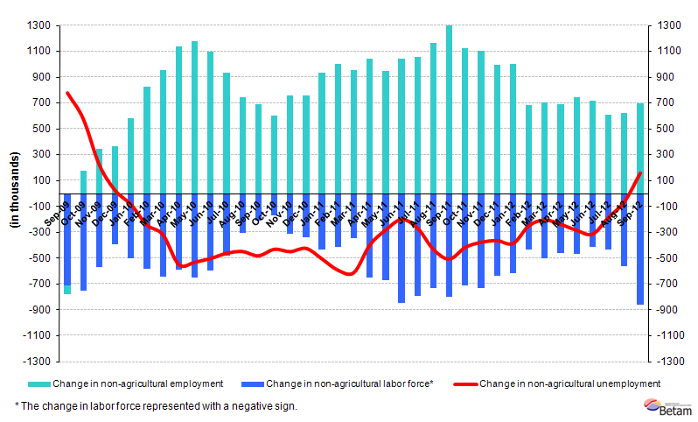
Source: TurkSTAT, Betam

An increase in seasonally adjusted non-agricultural unemployment

According to seasonally adjusted data, the non-agricultural labor force increased by 256 thousand to 21 million 405 thousand in September 2012 (Figure 2, Table 1). Non-agricultural employment increased by 145 thousand to 18 million 875 thousand. Consequently, the number of unemployed increased by 111 thousand, non-agricultural unemployment rate increased from 11.4 percent to 11.8 percent. We have been expecting an increase in non-agricultural unemployment rate since October 2012, parallel to the slowdown in growth rate (See Labor Market Outlook: October 2012 – “TURNING POINT IN UNEMPLOYMENT”). Albeit a considerable increase in non-agricultural employment, non-agricultural unemployment rate reached 11.8 percent due to a higher increase in labor force in September 2012.

Figure 2 Seasonally adjusted non-agricultural labor force, employment and unemployment
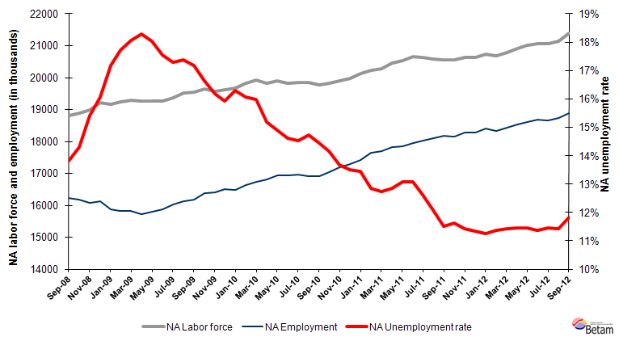
Source: TurkStat, Betam

According to Kariyer.net data, the non-agricultural unemployment will increase in October 2012

Application per vacancy calculated by using series released by Kariyer.net indicates that non-agricultural unemployment rate will continue to increase in the period of October 2012.

Figure 1 Seasonally adjusted non-agricultural unemployment rate and application per vacancy

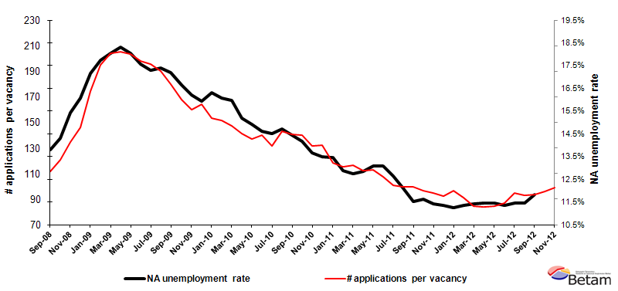
Data source: Kariyer.net, TurkStat, Betam

Service employment is the driving force behind the increase non-agricultural employment

Seasonally adjusted data shows that service employment increased by 144 thousand in September 2012 compared to August 2012 (Table 2, Figure 4). Employment fell by 9 thousand in manufacturing and 30 thousand in construction. Summarizing the developments in the past year, manufacturing employment increased by 31 thousand, while construction employment increased slightly (8 thousand). On the other hand, increase in service employment reached to 657 thousand on a year-on-year basis. Clearly low growth rates have taken a toll in the labor market and employment was created mainly in services.

Table 1 Seasonally adjusted non-agricultural labor force indicators (in thousands)
 | Labor force | Employment | Unemployment | Unemployment rate | Monthly changes
August-09 | 19527 | 16133 | 3394 | 17.4% | Labor force | Employment | Unemployment
September-09 | 19543 | 16186 | 3357 | 17.2% | 16 | 53 | -37
October-09 | 19649 | 16380 | 3270 | 16.6% | 107 | 194 | -87
November-09 | 19580 | 16409 | 3170 | 16.2% | -70 | 30 | -100
December-09 | 19629 | 16504 | 3125 | 15.9% | 49 | 94 | -45
January-10 | 19677 | 16469 | 3208 | 16.3% | 48 | -35 | 83
February-10 | 19817 | 16633 | 3184 | 16.1% | 140 | 164 | -23
March-10 | 19932 | 16746 | 3186 | 16.0% | 115 | 114 | 2
April-10 | 19828 | 16819 | 3010 | 15.2% | -104 | 73 | -176
May-10 | 19889 | 16925 | 2964 | 14.9% | 60 | 106 | -46
June-10 | 19830 | 16934 | 2896 | 14.6% | -59 | 10 | -68
July-10 | 19847 | 16966 | 2881 | 14.5% | 17 | 32 | -15
August-10 | 19840 | 16919 | 2921 | 14.7% | -8 | -47 | 40
September-10 | 19767 | 16909 | 2857 | 14.5% | -73 | -10 | -63
October-10 | 19834 | 17026 | 2808 | 14.2% | 68 | 117 | -49
November-10 | 19904 | 17182 | 2721 | 13.7% | 69 | 156 | -87
December-10 | 19982 | 17285 | 2697 | 13.5% | 78 | 103 | -25
January-11 | 20115 | 17409 | 2706 | 13.5% | 133 | 123 | 10
February-11 | 20238 | 17635 | 2603 | 12.9% | 123 | 227 | -103
March-11 | 20283 | 17699 | 2585 | 12.7% | 45 | 64 | -18
April-11 | 20465 | 17833 | 2632 | 12.9% | 181 | 134 | 47
May-11 | 20540 | 17854 | 2686 | 13.1% | 75 | 21 | 54
June-11 | 20658 | 17957 | 2701 | 13.1% | 118 | 103 | 15
July-11 | 20631 | 18026 | 2605 | 12.6% | -26 | 69 | -95
August-11 | 20578 | 18091 | 2486 | 12.1% | -53 | 66 | -119
September-11 | 20556 | 18190 | 2367 | 11.5% | -22 | 98 | -120
October-11 | 20546 | 18157 | 2389 | 11.6% | -10 | -33 | 23
November-11 | 20632 | 18276 | 2356 | 11.4% | 86 | 120 | -33
December-11 | 20622 | 18285 | 2337 | 11.3% | -10 | 9 | -19
January-12 | 20732 | 18400 | 2332 | 11.2% | 109 | 115 | -5
February-12 | 20686 | 18336 | 2350 | 11.4% | -46 | -64 | 18
March-12 | 20794 | 18420 | 2374 | 11.4% | 109 | 84 | 24
April-12 | 20923 | 18527 | 2396 | 11.5% | 129 | 107 | 22
May-12 | 21004 | 18600 | 2404 | 11.4% | 81 | 74 | 8
June-12 | 21067 | 18674 | 2393 | 11.4% | 63 | 73 | -11
July-12 | 21070 | 18656 | 2414 | 11.5% | 3 | -17 | 20
August-12 | 21149 | 18730 | 2419 | 11.4% | 79 | 74 | 5
September-12 | 21405 | 18875 | 2529 | 11.8% | 256 | 145 | 111
Source: TurkStat, Betam

Table 2 Seasonally adjusted employment by sector (in thousands)
 | Agriculture | Manufacturing | Construction | Service | Monthly changes
August-09 | 5314 | 4064 | 1310 | 10759 | Agriculture | Manufacturing | Construction | Service
September-09 | 5391 | 4128 | 1310 | 10723 | 77 | 65 | 0 | -37
October-09 | 5457 | 4178 | 1354 | 10819 | 66 | 50 | 44 | 97
November-09 | 5505 | 4227 | 1383 | 10793 | 48 | 49 | 29 | -26
December-09 | 5575 | 4294 | 1403 | 10796 | 70 | 67 | 20 | 3
January-10 | 5674 | 4304 | 1379 | 10787 | 99 | 9 | -24 | -9
February-10 | 5665 | 4353 | 1370 | 10898 | -9 | 49 | -9 | 111
March-10 | 5617 | 4359 | 1423 | 10996 | -47 | 6 | 53 | 98
April-10 | 5669 | 4400 | 1445 | 10998 | 52 | 41 | 22 | 2
May-10 | 5570 | 4473 | 1423 | 11051 | -99 | 72 | -22 | 53
June-10 | 5710 | 4525 | 1424 | 11008 | 140 | 52 | 1 | -43
July-10 | 5679 | 4536 | 1471 | 10963 | -31 | 12 | 48 | -46
August-10 | 5659 | 4503 | 1417 | 10984 | -20 | -33 | -54 | 21
September-10 | 5657 | 4469 | 1420 | 10993 | -2 | -35 | 3 | 9
October-10 | 5808 | 4484 | 1440 | 11059 | 151 | 15 | 20 | 66
November-10 | 5857 | 4649 | 1506 | 11022 | 49 | 165 | 66 | -37
December-10 | 6029 | 4646 | 1548 | 11073 | 172 | -3 | 42 | 51
January-11 | 6034 | 4681 | 1531 | 11191 | 5 | 35 | -17 | 117
February-11 | 6191 | 4691 | 1575 | 11345 | 157 | 10 | 44 | 154
March-11 | 6202 | 4830 | 1600 | 11283 | 11 | 139 | 25 | -62
April-11 | 6080 | 4816 | 1638 | 11400 | -122 | -14 | 38 | 117
May-11 | 6015 | 4765 | 1675 | 11443 | -65 | -51 | 37 | 43
June-11 | 6081 | 4689 | 1707 | 11603 | 66 | -76 | 32 | 161
July-11 | 6104 | 4678 | 1718 | 11640 | 23 | -11 | 12 | 36
August-11 | 6187 | 4671 | 1783 | 11636 | 83 | -7 | 65 | -4
September-11 | 6133 | 4695 | 1788 | 11707 | -54 | 24 | 5 | 71
October-11 | 6191 | 4662 | 1691 | 11775 | 58 | -33 | -97 | 68
November-11 | 6162 | 4692 | 1654 | 11939 | -29 | 30 | -37 | 163
December-11 | 6046 | 4709 | 1618 | 11941 | -117 | 17 | -36 | 2
January-12 | 6050 | 4712 | 1653 | 12034 | 4 | 3 | 35 | 93
February-12 | 6045 | 4722 | 1543 | 12023 | -5 | 10 | -110 | -11
March-12 | 6030 | 4751 | 1560 | 12097 | -15 | 29 | 17 | 74
April-12 | 6061 | 4764 | 1658 | 12113 | 32 | 14 | 98 | 16
May-12 | 6105 | 4742 | 1734 | 12148 | 43 | -22 | 76 | 35
June-12 | 6038 | 4749 | 1765 | 12202 | -67 | 7 | 31 | 54
July-12 | 6040 | 4743 | 1721 | 12186 | 2 | -5 | -43 | -16
August-12 | 6049 | 4736 | 1766 | 12219 | 9 | -8 | 45 | 33
September-12 | 6159 | 4726 | 1796 | 12364 | 110 | -9 | 30 | 144
Source: TurkStat, Betam
Figure 2 Employment by sectors (in thousands)
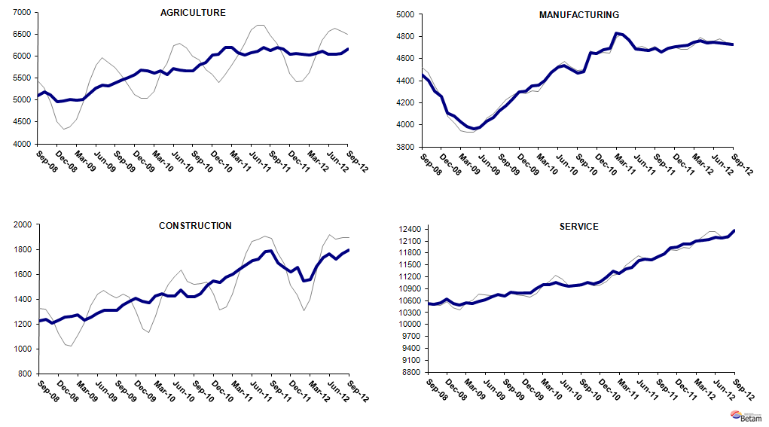
Source: TurkStat, Betam

* Prof. Dr. Seyfettin Gürsel, Betam, Director, seyfettin.gursel@bahcesehir.edu.tr
∗ Yrd. Doç. Dr. Gökçe Uysal, Betam, Vice Director, gokce.uysal@bahcesehir.edu.tr
∗∗ Ayşenur Acar, Betam, Research Assistant, aysenur.acar@bahcesehir.edu.tr
Betam has been calculating application per vacancy using series released by Kariyer.net for a while. Seasonal and calendar adjustment procedure is applied to application per vacancy series. A decrease in applications per vacancy may be caused by an increase in vacancies or by a decrease in the number of applications. An increase in vacancies signals economic growth while decreasing number of applications indicates a decrease in number of people looking for a job.
Seasonal adjustment procedure is applied to each sector of employment series separately. Hence the sum of these series may differ from the seasonally adjusted series of total employment. The difference stems from the non-linearity of the seasonal adjustment process.
Grey lines indicate seasonally adjusted series, where dark blue lines represent raw data.

