

Labor Market Outlook:

November 2012

15 November 2012

NON AGRICULTURAL EMPLOYMENT HAS BEEN
STAGNATING FOR A YEAR

Seyfettin Gürsel* Gökçe Uysal∗ ve Ayşenur Acar∗

Abstract

Seasonally adjusted labor market data shows that non-agricultural unemployment rate remained at 11.4 percent in August 2012. Non-agricultural labor force increased by 78 thousand and non-agricultural employment increased by 65 thousand in the period of August 2012 compared to the period of July 2012. Hence, non-agricultural unemployment rate remained stagnant. Although employment in manufacturing declined slightly, increases in service and construction employment prevented an increase in the non-agricultural unemployment rate.

Declines in non-agricultural unemployment slowed down

According to the labor market statistics released by TurkStat on November 15th non-agricultural labor force increased by 563 thousand (2.7 percent), non-agricultural employment by 623 thousand (3.4 percent) on a year-on-year basis in August 2012 and the number of unemployed persons in non-agricultural decreased by 60 thousand to 2 million 395 thousand (Figure 1). Annual increases in non-agricultural labor force, which have been slower than their trend, started to accelerate again. The number of unemployed persons decreased only by 60 thousand due to the increases in both non-agricultural employment and non-agricultural labor force. In previous periods, we observed rapid declines in the number of unemployed persons in non-agricultural sectors due to higher increase in employment than increases in labor force. However, in this period, decline in the number of unemployment persons in non-agricultural sectors slowed down parallel to stronger increase in the labor force. We think that the base effect that brought about sharp declines in non-agricultural unemployment rates on a yearly basis has come to an end.

Figure 1 Year-on-year changes in non-agricultural labor force, employment and unemployment 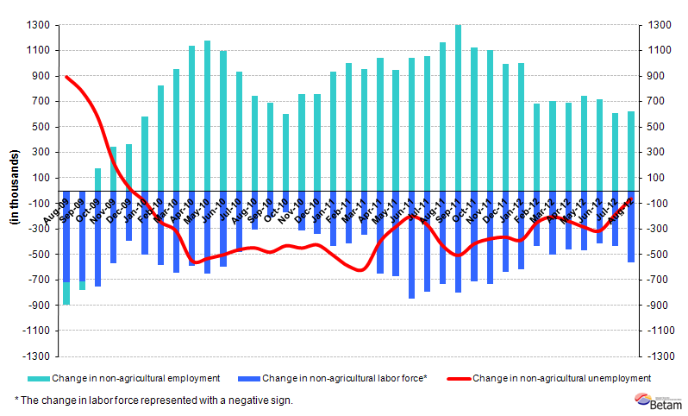
Source: TurkStat, Betam
Seasonally adjusted non-agricultural unemployment rate remained stagnant

According to seasonally adjusted series, non-agricultural labor force increased by 78 thousand from 21 million 30 thousand to 21 million 108 thousand in the period of August 2012 compared to July 2012 (Figure 2, Table 1). Non-agricultural employment increased by 65 thousand and reached to18 million 697 thousand. Consequently, the number of unemployed persons in non-agricultural sectors increased by 13 thousand and non-agricultural unemployment rate stagnated at 11.4 percent.

Figure 2 Seasonally adjusted non-agricultural labor force, employment and unemployment 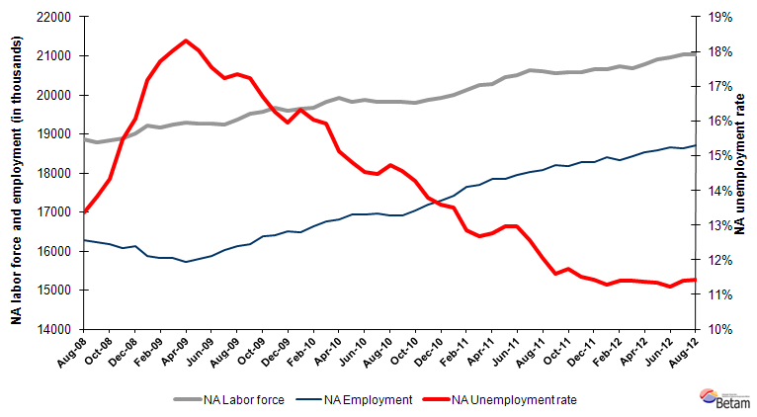
Source: TurkStat, Betam

According to Kariyer.net series, non-agricultural unemployment will stagnate in the next period

Application per vacancy calculated by using series released by Kariyer.net indicates that non-agricultural unemployment rate will stagnate in the period of September 2012. According to seasonally adjusted figures, although there has decline in vacancies, application per vacancy remained the same due to a slowdown in increase in applications.

Figure 3 Seasonally adjusted non-agricultural unemployment rate and application per vacancy
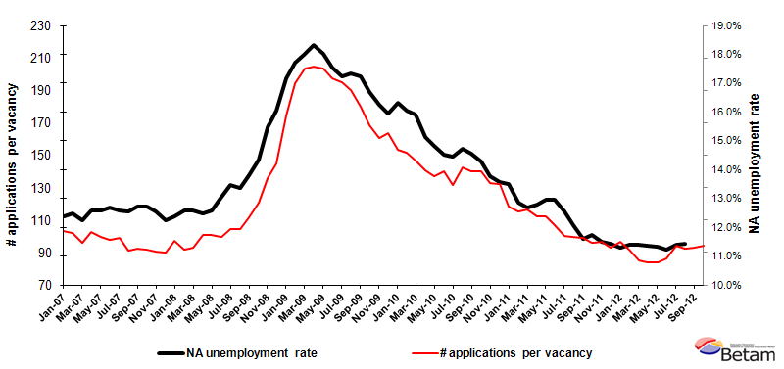
Data source: Kariyer.net, TurkStat, Betam

The increase in construction employment has been continuing

Seasonally adjusted series point to employment losses of 6 thousand in manufacturing in the period of August 2012 (Table 2, Figure 4). On the other hand, employment in services and in construction increased by 27 thousand and 45 thousand, respectively. Agricultural employment, which increased from the beginning of 2008 to 2011, has been stagnating for a year.
Table 1 Seasonally adjusted non-agricultural labor force indicators (in thousands)

 | Labor force | Employment | Unemployment | Unemployment rate | Monthly changes
April-09 | 19253 | 15726 | 3527 | 18.3% | Labor force | Employment | Unemployment
May-09 | 19260 | 15788 | 3472 | 18.0% | 7 | 62 | -56
June-09 | 19250 | 15873 | 3377 | 17.5% | -10 | 84 | -94
July-09 | 19360 | 16025 | 3335 | 17.2% | 110 | 152 | -42
August-09 | 19513 | 16127 | 3385 | 17.3% | 153 | 103 | 50
September-09 | 19561 | 16189 | 3372 | 17.2% | 48 | 61 | -14
October-09 | 19667 | 16386 | 3282 | 16.7% | 106 | 197 | -90
November-09 | 19598 | 16412 | 3187 | 16.3% | -69 | 26 | -95
December-09 | 19640 | 16507 | 3133 | 16.0% | 42 | 95 | -53
January-10 | 19683 | 16469 | 3213 | 16.3% | 42 | -38 | 80
February-10 | 19814 | 16636 | 3177 | 16.0% | 131 | 167 | -36
March-10 | 19920 | 16750 | 3170 | 15.9% | 107 | 114 | -7
April-10 | 19817 | 16820 | 2997 | 15.1% | -103 | 70 | -173
May-10 | 19872 | 16925 | 2946 | 14.8% | 54 | 105 | -51
June-10 | 19812 | 16933 | 2879 | 14.5% | -60 | 7 | -67
July-10 | 19828 | 16961 | 2867 | 14.5% | 16 | 28 | -12
August-10 | 19822 | 16904 | 2918 | 14.7% | -6 | -57 | 51
September-10 | 19794 | 16911 | 2884 | 14.6% | -27 | 7 | -34
October-10 | 19864 | 17028 | 2836 | 14.3% | 69 | 117 | -48
November-10 | 19931 | 17186 | 2746 | 13.8% | 68 | 158 | -90
December-10 | 20004 | 17287 | 2717 | 13.6% | 72 | 101 | -29
January-11 | 20125 | 17410 | 2715 | 13.5% | 121 | 123 | -2
February-11 | 20241 | 17639 | 2601 | 12.9% | 115 | 229 | -113
March-11 | 20274 | 17702 | 2572 | 12.7% | 34 | 63 | -29
April-11 | 20447 | 17836 | 2611 | 12.8% | 173 | 135 | 38
May-11 | 20513 | 17853 | 2659 | 13.0% | 66 | 17 | 49
June-11 | 20626 | 17954 | 2672 | 13.0% | 113 | 100 | 12
July-11 | 20601 | 18014 | 2587 | 12.6% | -25 | 60 | -85
August-11 | 20549 | 18070 | 2479 | 12.1% | -52 | 56 | -108
September-11 | 20590 | 18203 | 2386 | 11.6% | 41 | 134 | -93
October-11 | 20584 | 18166 | 2418 | 11.7% | -6 | -38 | 32
November-11 | 20666 | 18288 | 2378 | 11.5% | 82 | 122 | -41
December-11 | 20651 | 18291 | 2360 | 11.4% | -14 | 3 | -17
January-12 | 20746 | 18406 | 2340 | 11.3% | 95 | 115 | -20
February-12 | 20694 | 18336 | 2358 | 11.4% | -51 | -70 | 18
March-12 | 20789 | 18418 | 2371 | 11.4% | 94 | 82 | 13
April-12 | 20903 | 18526 | 2377 | 11.4% | 114 | 108 | 6
May-12 | 20972 | 18594 | 2378 | 11.3% | 69 | 68 | 1
June-12 | 21026 | 18663 | 2363 | 11.2% | 54 | 69 | -15
July-12 | 21030 | 18631 | 2399 | 11.4% | 4 | -32 | 36
August-12 | 21108 | 18697 | 2411 | 11.4% | 78 | 65 | 13
Source: TurkStat, Betam

Table 2 Seasonally adjusted employment by sector (in thousands)

 | Agriculture | Manufacturing | Construction | Service | Monthly changes
April-09 | 5004 | 3983 | 1232 | 10525 | Agriculture | Manufacturing | Construction | Service
May-09 | 5139 | 3967 | 1256 | 10580 | 135 | -17 | 24 | 54
June-09 | 5257 | 3978 | 1282 | 10624 | 118 | 12 | 26 | 44
July-09 | 5340 | 4036 | 1310 | 10694 | 84 | 57 | 28 | 70
August-09 | 5308 | 4064 | 1309 | 10753 | -32 | 29 | 0 | 59
September-09 | 5397 | 4128 | 1311 | 10730 | 89 | 64 | 1 | -23
October-09 | 5461 | 4177 | 1355 | 10825 | 65 | 49 | 44 | 95
November-09 | 5508 | 4227 | 1384 | 10797 | 47 | 49 | 29 | -28
December-09 | 5578 | 4294 | 1403 | 10798 | 69 | 67 | 20 | 1
January-10 | 5675 | 4303 | 1379 | 10787 | 97 | 9 | -24 | -11
February-10 | 5664 | 4353 | 1371 | 10899 | -11 | 49 | -9 | 112
March-10 | 5617 | 4359 | 1423 | 10997 | -47 | 6 | 53 | 97
April-10 | 5668 | 4401 | 1445 | 10996 | 51 | 42 | 22 | 0
May-10 | 5569 | 4473 | 1423 | 11049 | -99 | 72 | -22 | 53
June-10 | 5707 | 4525 | 1423 | 11006 | 137 | 52 | 0 | -43
July-10 | 5674 | 4537 | 1471 | 10956 | -32 | 12 | 48 | -49
August-10 | 5653 | 4505 | 1416 | 10973 | -22 | -32 | -54 | 17
September-10 | 5665 | 4468 | 1421 | 11001 | 13 | -37 | 4 | 28
October-10 | 5813 | 4483 | 1441 | 11066 | 148 | 15 | 20 | 65
November-10 | 5861 | 4648 | 1507 | 11027 | 48 | 165 | 66 | -39
December-10 | 6032 | 4646 | 1548 | 11076 | 171 | -3 | 42 | 49
January-11 | 6035 | 4681 | 1531 | 11192 | 3 | 35 | -17 | 117
February-11 | 6190 | 4691 | 1576 | 11347 | 155 | 10 | 44 | 155
March-11 | 6201 | 4830 | 1600 | 11283 | 11 | 140 | 25 | -64
April-11 | 6078 | 4816 | 1638 | 11397 | -122 | -14 | 38 | 114
May-11 | 6013 | 4766 | 1675 | 11438 | -65 | -50 | 37 | 41
June-11 | 6076 | 4690 | 1706 | 11600 | 63 | -75 | 31 | 161
July-11 | 6098 | 4680 | 1718 | 11630 | 22 | -10 | 12 | 30
August-11 | 6178 | 4674 | 1782 | 11620 | 80 | -6 | 65 | -10
September-11 | 6142 | 4694 | 1789 | 11719 | -36 | 20 | 6 | 99
October-11 | 6197 | 4660 | 1692 | 11785 | 55 | -34 | -97 | 66
November-11 | 6167 | 4690 | 1655 | 11947 | -30 | 30 | -37 | 162
December-11 | 6050 | 4708 | 1618 | 11945 | -118 | 18 | -36 | -2
January-12 | 6052 | 4711 | 1653 | 12038 | 2 | 3 | 35 | 93
February-12 | 6044 | 4721 | 1544 | 12026 | -8 | 10 | -110 | -11
March-12 | 6028 | 4750 | 1560 | 12097 | -16 | 29 | 17 | 70
April-12 | 6059 | 4764 | 1658 | 12109 | 31 | 14 | 98 | 13
May-12 | 6102 | 4743 | 1734 | 12141 | 43 | -21 | 76 | 32
June-12 | 6032 | 4751 | 1764 | 12196 | -70 | 8 | 30 | 54
July-12 | 6033 | 4747 | 1721 | 12172 | 0 | -4 | -43 | -24
August-12 | 6039 | 4741 | 1765 | 12199 | 6 | -6 | 45 | 27

Source: TurkStat, Betam
Figure 4 Employment by sectors (in thousands)
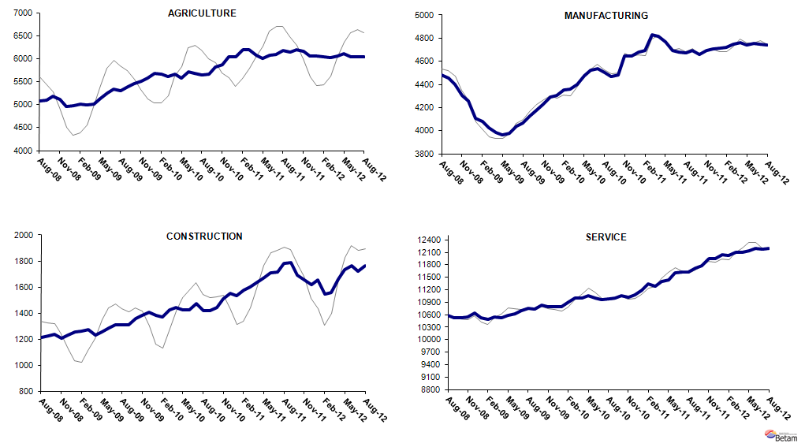
Source: TurkStat, Betam

* Prof. Dr. Seyfettin Gürsel, Betam, Director, seyfettin.gursel@bahcesehir.edu.tr
∗ Asst. Prof. Gökçe Uysal, Betam, Vice Director, gokce.uysal @bahcesehir.edu.tr
∗∗ Ayşenur Acar, Betam, Research Assistant, aysenur.acar@bahcesehir.edu.tr
Betam has been calculating application per vacancy using series released by Kariyer.net for a while. Seasonal and calendar adjustment procedure is applied to application per vacancy series. A decrease in applications per vacancy may be caused by an increase in vacancies or by a decrease in the number of applications. An increase in vacancies signals economic growth while decreasing number of applications indicates a decrease in number of people looking for a job.
Seasonal adjustment procedure is applied to each sector of employment series separately. Hence the sum of these series may differ from the seasonally adjusted series of total employment. The difference stems from the non-linearity of the seasonal adjustment process.
Grey lines indicate seasonally adjusted series, where dark blue lines represent raw data.

