

May 15, 2012

Labor Market Outlook:

October 2012

October 15, 2012

TURNING POINT IN UNEMPLOYMENT

Seyfettin Gürsel* Gökçe Uysal∗ and Ayşenur Acar∗

Executive Summary

Seasonally adjusted labor market data shows that non-agricultural unemployment rate increased from 11.2 percent to 11.4 percent in the period of July 2012. The slowdown in increase in non-agricultural labor force prevents a larger increase in the non-agricultural unemployment rate. Seasonally adjusted sectoral employment data points to employment losses in all sectors except agriculture. Employment in manufacturing decreased by 4 thousand, while employment in construction declined by 44 thousand from the period of June 2012 to July 2012. Service employment fell by 25 thousand. Data indicates low GDP growth is finally taking a toll on unemployment. We observe that current GDP growth, which is lower compared to the last year’s, has already begun to affect the labor market.

Insufficient increase in non-agricultural employment

According to the labor market statisics released by TurkStat on October 15th (June – July – August) non-agricultural labor force increased by 430 thousand (2.1 percent), non-agricultural employment increased by 612 thousand (3.4 percent) and the number of unemployment in non-agricultural decreased by 182 thousand on a year-on-year basis and reached 2 million 260 thousand in the period of July 2012 (Figure 1). Although the increase in non-agricultural employment has been weak, the decrease in the number of unemployed has been curbed by a relatively low increase in the non-agricultural labor force.

Figure 1 Year-on-year changes in non-agricultural labor force, employment and unemployment
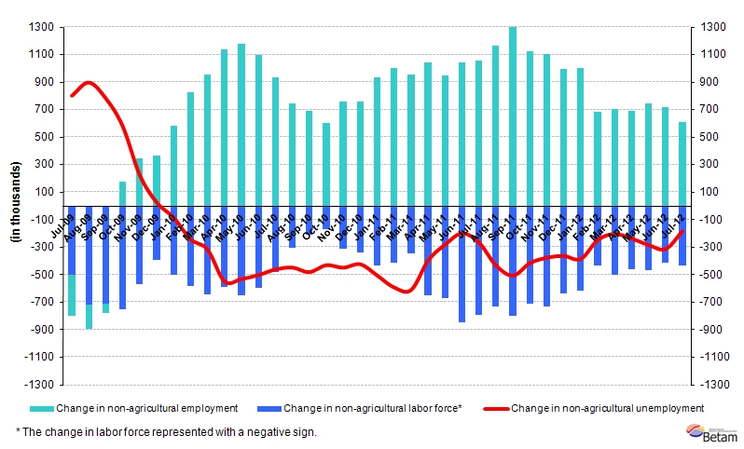Source: TurkStat, Betam

Non-agricultural unemployment has begun to increase

According to seasonally adjusted series, non-agricultural labor force increased only by 6 thousand from 21 million 6 thousand to 21 million 12 thousand in the period of July 2012 compared to the period of June 2012 (Figure 2, Table 1). Non-agricultural employment decreased by 29 thousand and reached 18 million 625 thousand. Consequently, the number of unemployed persons in non-agricultural sectors increased by 35 thousand and non-agricultural unemployment rate increased from 11.2 percent to 11.4 percent. Weak increase in the non-agricultural labor force prevented a larger increase in non-agricultural unemployment.

Figure 2 Seasonally adjusted non-agricultural labor force, employment and unemployment
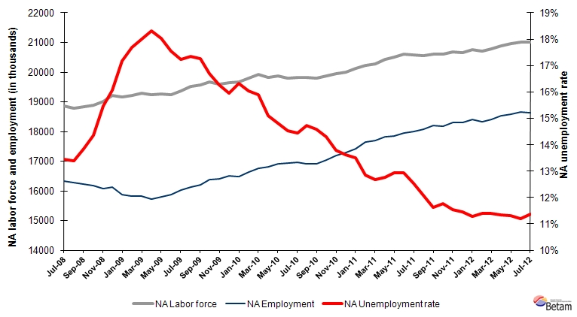Source: TurkStat, Betam

According to Kariyer.net series, non-agricultural unemployment rate may increase in the period of August 2012

Application per vacancy calculated by using series released by Kariyer.net indicates that increase in non-agricultural unemployment may continue in the period of August 2012 corresponding to the average of July, August and September.

Figure 3 Seasonally adjusted non-agricultural unemployment rate and total vacancy cycle
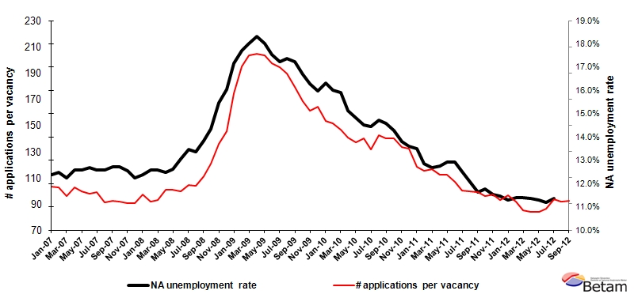
Data source: Kariyer.net, TurkStat, Betam

Employment losses in all sectors except agriculture

There are employment losses in all non-agricultural sectors (Table 2, Figure 4) . Employment in manufacturing decreased by 4 thousand while construction employment decreased by 44 thousand. Service employment decreased by 25 thousand. Employment loss in construction sector corresponds to 2.5 percent although the decline in service employment with high share in the total employment may be negligible.

Stagnation in agricultural employment,which has been observed for a long time, continues in the period of July 2012.
Table 1 Seasonally adjusted non-agricultural labor force indicators (in thousand)
 | Labor force | Employment | Unemployment | Unemployment rate | Monthly changes
April-09 | 19253 | 15728 | 3525 | 18.3% | Labor force | Employment | Unemployment
May-09 | 19259 | 15788 | 3470 | 18.0% | 6 | 61 | -55
June-09 | 19249 | 15872 | 3377 | 17.5% | -9 | 84 | -93
July-09 | 19356 | 16022 | 3334 | 17.2% | 107 | 150 | -43
August-09 | 19517 | 16129 | 3388 | 17.4% | 161 | 107 | 54
September-09 | 19566 | 16191 | 3375 | 17.2% | 49 | 62 | -13
October-09 | 19671 | 16387 | 3285 | 16.7% | 105 | 195 | -90
November-09 | 19605 | 16414 | 3191 | 16.3% | -67 | 27 | -94
December-09 | 19643 | 16508 | 3136 | 16.0% | 39 | 94 | -55
January-10 | 19683 | 16470 | 3213 | 16.3% | 40 | -38 | 78
February-10 | 19810 | 16635 | 3175 | 16.0% | 126 | 165 | -38
March-10 | 19912 | 16747 | 3165 | 15.9% | 103 | 113 | -10
April-10 | 19811 | 16817 | 2994 | 15.1% | -101 | 70 | -171
May-10 | 19864 | 16922 | 2942 | 14.8% | 53 | 104 | -52
June-10 | 19805 | 16929 | 2876 | 14.5% | -59 | 7 | -66
July-10 | 19821 | 16958 | 2864 | 14.4% | 16 | 29 | -12
August-10 | 19829 | 16909 | 2920 | 14.7% | 8 | -49 | 56
September-10 | 19805 | 16917 | 2888 | 14.6% | -24 | 8 | -32
October-10 | 19874 | 17033 | 2840 | 14.3% | 68 | 116 | -48
November-10 | 19941 | 17189 | 2752 | 13.8% | 68 | 156 | -88
December-10 | 20012 | 17289 | 2722 | 13.6% | 70 | 100 | -30
January-11 | 20128 | 17411 | 2716 | 13.5% | 116 | 122 | -6
February-11 | 20240 | 17637 | 2602 | 12.9% | 112 | 226 | -114
March-11 | 20268 | 17699 | 2569 | 12.7% | 28 | 61 | -33
April-11 | 20437 | 17831 | 2606 | 12.8% | 169 | 132 | 37
May-11 | 20499 | 17848 | 2651 | 12.9% | 62 | 17 | 45
June-11 | 20610 | 17947 | 2663 | 12.9% | 111 | 100 | 12
July-11 | 20588 | 18009 | 2579 | 12.5% | -22 | 62 | -84
August-11 | 20558 | 18076 | 2482 | 12.1% | -30 | 67 | -97
September-11 | 20603 | 18209 | 2393 | 11.6% | 45 | 133 | -88
October-11 | 20597 | 18173 | 2424 | 11.8% | -6 | -36 | 31
November-11 | 20677 | 18291 | 2386 | 11.5% | 80 | 119 | -39
December-11 | 20662 | 18294 | 2368 | 11.5% | -15 | 3 | -18
January-12 | 20750 | 18406 | 2343 | 11.3% | 87 | 112 | -24
February-12 | 20697 | 18336 | 2361 | 11.4% | -53 | -70 | 18
March-12 | 20785 | 18416 | 2369 | 11.4% | 88 | 80 | 8
April-12 | 20891 | 18520 | 2372 | 11.4% | 107 | 104 | 2
May-12 | 20955 | 18587 | 2368 | 11.3% | 64 | 67 | -3
June-12 | 21006 | 18654 | 2352 | 11.2% | 51 | 67 | -17
July-12 | 21012 | 18625 | 2387 | 11.4% | 6 | -29 | 35
Source: TurkStat, Betam

Table 2 Seasonally adjusted employment by sector (in thousand)
 | Agriculture | Manufacturing | Construction | Service | Monthly changes
April-09 | 5004 | 3983 | 1231 | 10526 | Agriculture | Manufacturing | Construction | Service
May-09 | 5140 | 3967 | 1254 | 10580 | 135 | -16 | 23 | 55
June-09 | 5257 | 3978 | 1280 | 10624 | 118 | 12 | 26 | 44
July-09 | 5342 | 4036 | 1308 | 10695 | 84 | 58 | 27 | 71
August-09 | 5307 | 4064 | 1311 | 10752 | -34 | 28 | 4 | 57
September-09 | 5396 | 4128 | 1312 | 10729 | 88 | 64 | 1 | -23
October-09 | 5460 | 4177 | 1357 | 10825 | 64 | 50 | 45 | 96
November-09 | 5507 | 4227 | 1385 | 10796 | 48 | 49 | 28 | -29
December-09 | 5577 | 4294 | 1404 | 10798 | 70 | 67 | 19 | 2
January-10 | 5675 | 4303 | 1380 | 10787 | 98 | 10 | -25 | -11
February-10 | 5663 | 4353 | 1371 | 10899 | -11 | 50 | -9 | 113
March-10 | 5617 | 4359 | 1423 | 10997 | -46 | 6 | 52 | 98
April-10 | 5668 | 4401 | 1444 | 10997 | 52 | 42 | 21 | 0
May-10 | 5571 | 4474 | 1421 | 11050 | -98 | 73 | -23 | 53
June-10 | 5708 | 4526 | 1421 | 11007 | 137 | 52 | 0 | -43
July-10 | 5676 | 4538 | 1469 | 10957 | -32 | 12 | 47 | -50
August-10 | 5652 | 4504 | 1418 | 10972 | -24 | -34 | -50 | 15
September-10 | 5665 | 4467 | 1422 | 11000 | 13 | -37 | 4 | 28
October-10 | 5812 | 4482 | 1443 | 11065 | 147 | 15 | 21 | 65
November-10 | 5860 | 4648 | 1508 | 11026 | 49 | 166 | 65 | -39
December-10 | 6031 | 4645 | 1549 | 11075 | 171 | -2 | 41 | 49
January-11 | 6035 | 4681 | 1532 | 11192 | 3 | 36 | -18 | 117
February-11 | 6189 | 4691 | 1576 | 11348 | 154 | 10 | 44 | 156
March-11 | 6200 | 4831 | 1600 | 11284 | 12 | 140 | 24 | -64
April-11 | 6079 | 4817 | 1637 | 11398 | -122 | -14 | 37 | 114
May-11 | 6015 | 4767 | 1673 | 11440 | -64 | -50 | 36 | 41
June-11 | 6078 | 4692 | 1704 | 11602 | 63 | -76 | 31 | 162
July-11 | 6100 | 4682 | 1716 | 11631 | 22 | -10 | 11 | 29
August-11 | 6178 | 4673 | 1784 | 11618 | 77 | -9 | 69 | -13
September-11 | 6141 | 4692 | 1790 | 11717 | -36 | 19 | 6 | 99
October-11 | 6195 | 4658 | 1694 | 11784 | 53 | -34 | -96 | 67
November-11 | 6166 | 4689 | 1656 | 11947 | -29 | 30 | -38 | 163
December-11 | 6049 | 4707 | 1619 | 11944 | -117 | 18 | -37 | -3
January-12 | 6051 | 4711 | 1654 | 12038 | 3 | 4 | 34 | 93
February-12 | 6043 | 4722 | 1544 | 12027 | -8 | 11 | -110 | -11
March-12 | 6028 | 4751 | 1560 | 12098 | -15 | 30 | 16 | 70
April-12 | 6060 | 4766 | 1657 | 12110 | 32 | 15 | 97 | 13
May-12 | 6104 | 4745 | 1732 | 12143 | 44 | -21 | 75 | 32
June-12 | 6034 | 4754 | 1762 | 12198 | -69 | 8 | 30 | 55
July-12 | 6035 | 4750 | 1719 | 12173 | 1 | -4 | -44 | -25
Source: TurkStat, Betam
Figure 4 Employment by sectors (in thousand)
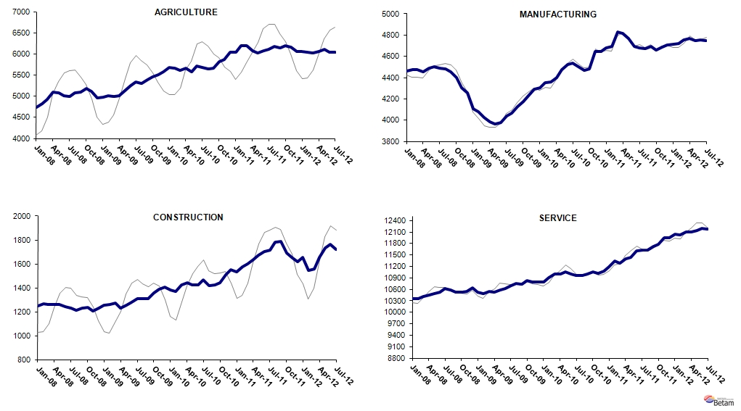
Source: TurkStat, Betam

* Prof. Seyfettin Gürsel, Betam, Director, seyfettin.gursel@bahcesehir.edu.tr
∗ Assoc. Prof. Gökçe Uysal, Betam, Vice Director, gokce.uysal @bahcesehir.edu.tr
∗∗ Ayşenur Acar, Betam, Research Assistant, aysenur.acar@bahcesehir.edu.tr
Betam has been calculating application per vacancy using series released by Kariyer.net for a while. Seasonal and calendar adjustment procedure is applied to application per vacancy series . A decrease in applications per vacancy may be caused by an increase in vacancies or by a decrease in the number of applications. An increase in vacancies signals economic growth while decreasing number of applications indicates a decrease in number of people looking for a job.
Seasonal adjustment procedure is applied to each sector of employment series separately. Hence the sum of these series may differ from the seasonally adjusted series of total employment. The difference stems from the non-linearity of the seasonal adjustment process.
Grey lines indicate seasonally adjusted series, where dark blue lines represent raw data.

