

May 15, 2012

Labor Market Outlook:

September 2012

August 15, 2012

LOW GDP GROWTH RATE HAS NOT

AFFECTED EMPLOYMENT YET

Seyfettin Gürsel* Gökçe Uysal∗ and Ayşenur Acar∗

Executive Summary

Seasonally adjusted labor market data shows that non-agricultural unemployment rate decreased from 11.2 percent to 11 percent in the period of June 2012. There is a decline in non-agricultural unemployment which had remained stagnant for a long time. However, we observe that the decrease in unemployment rates is slowing down parallel to slower growth rates. The data released by the Kariyer.Net indicates that the non-agricultural unemployment may increase slightly in the period of July.

Increase in non-agricultural unemployment

According to the labor market statisics released by TurkStat on September 17th ( May – June – July) non-agricultural labor force increased by 410 thousand (2 percent), non-agricultural employment increased by 721 thousand (3.9 percent) and the number of unemployment in non-agricultural decreased by 311 thousand to 2 million 161 thousand on a year-on-year basis in the period of June 2012 (Figure 1).

Figure 1 Year-on-year changes in non-agricultural labor force, employment and unemployment
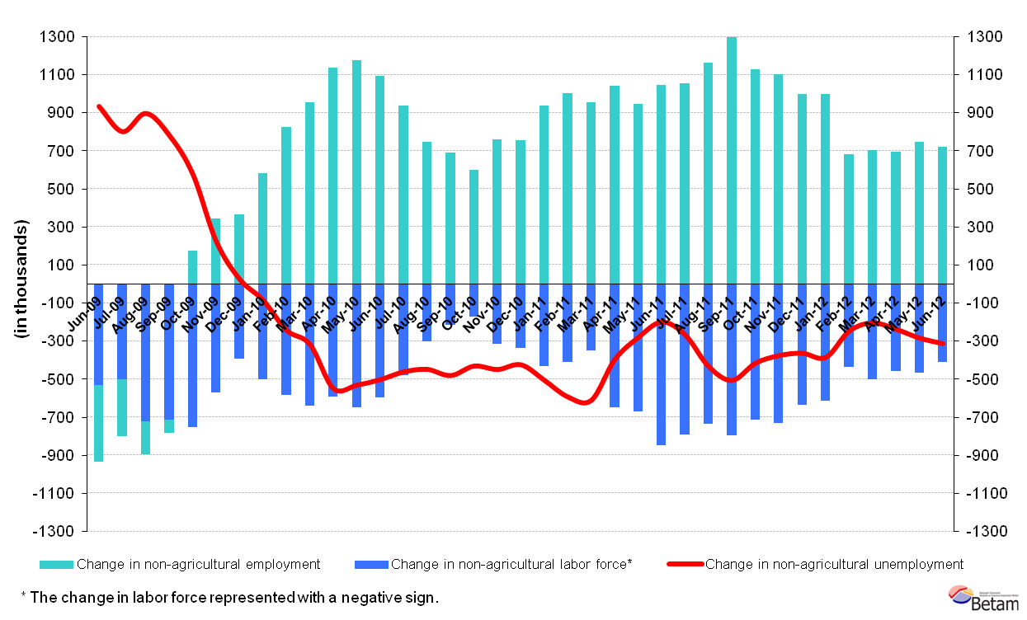Source: TurkStat, Betam

Slight decline in Non-agricultural unemployment

According to seasonally adjusted series, non-agricultural labor force increased by 52 thousand from 20 million 961 thousand to 21 million 18 thousand in the period of June compared to the period of May 2012 (Figure 2, Table 1). Non-agricultural employment increased by 75 thousand and reached 18 million 698 thousand. Consequently, the number of unemployed persons in non-agricultural sectors decreased by 23 thousand and seasonally adjusted non-agricultural unemployment rate decreased to 11 percent. We already know that labor market statistics follow GDP growth with a lag. Hence, we expect to observe the effects of the slower growth rates on non-agricultural unemployment rates in the upcoming periods.

Figure 2 Seasonally adjusted non-agricultural labor force, employment and unemployment
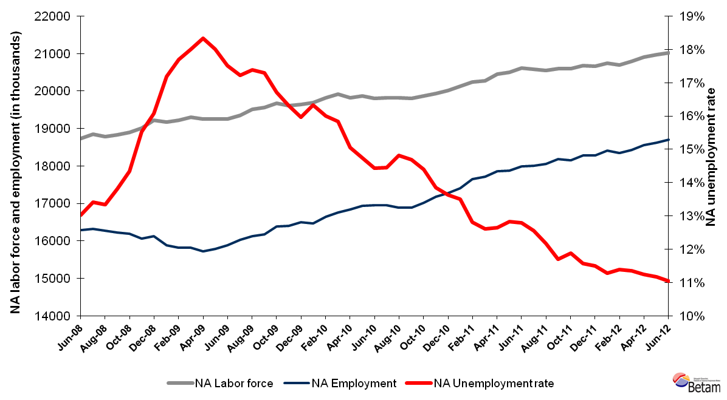Source: TurkStat, Betam

According to Kariyer.net series Non-agricultural unemployment may increase

Seasonal and calendar day adjusted total vacancy series show a sizeable increase in August 2012, which indicates an increase in non-agricultural unemployment for the upcoming period. Note that data which will be released by TurkStat next month pertains to July 2012 and it will comprise of the averages of three months, in turn, June, July and August. We expect that the effect of the increase indicated by Kariyer.net total vacancy series on non-agricultural unemployment rate will be observed in the next period.

Figure 3 Seasonally adjusted non-agricultural unemployment rate and total vacancy cycle
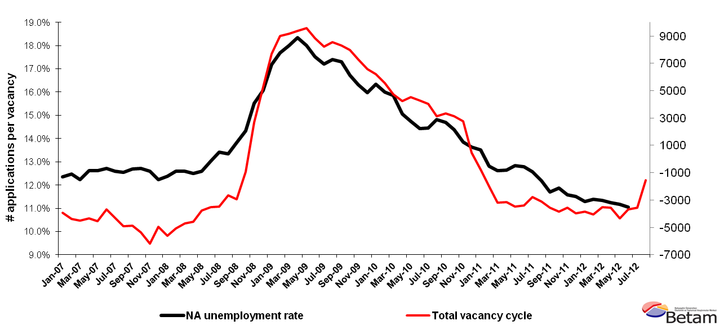
Data source: Kariyer.net, TurkStat, Betam

Increase in agricultural employment came to an end

According to seasonally adjusted labor market series, employment in services increased by 67 thousand in the period of June 2012 (Table 2, Figure 4) . Employment in construction had a sizeable increase (30 thousand) whereas employment in manufacturing increased only slightly (10 thousand).

Agricultural employment decreased by 69 thousand compared to the period of May 2012. In addition, agricultural employment decreased by 43 thousand on a year-on-year basis (Table 2). We expect that agricultural employment, which has been increasing since 2008, came to the an end.

Table 1 Seasonally adjusted non-agricultural labor force indicators (in thousands)
 | Labor force | Employment | Unemployment | Unemployment rate | Monthly changes
May-09 | 19260 | 15791 | 3469 | 18.0% | Labor force | Employment | Unemployment
June-09 | 19250 | 15879 | 3371 | 17.5% | -10 | 88 | -98
July-09 | 19354 | 16023 | 3332 | 17.2% | 105 | 144 | -39
August-09 | 19515 | 16121 | 3394 | 17.4% | 160 | 98 | 62
September-09 | 19563 | 16180 | 3383 | 17.3% | 49 | 59 | -11
October-09 | 19669 | 16381 | 3288 | 16.7% | 106 | 202 | -95
November-09 | 19601 | 16405 | 3196 | 16.3% | -68 | 24 | -92
December-09 | 19642 | 16506 | 3136 | 16.0% | 41 | 100 | -60
January-10 | 19683 | 16468 | 3216 | 16.3% | 41 | -38 | 79
February-10 | 19813 | 16644 | 3169 | 16.0% | 129 | 176 | -47
March-10 | 19918 | 16762 | 3156 | 15.8% | 105 | 118 | -13
April-10 | 19815 | 16832 | 2983 | 15.1% | -102 | 71 | -173
May-10 | 19869 | 16941 | 2927 | 14.7% | 54 | 109 | -56
June-10 | 19809 | 16950 | 2859 | 14.4% | -59 | 9 | -68
July-10 | 19819 | 16954 | 2865 | 14.5% | 10 | 4 | 6
August-10 | 19825 | 16886 | 2939 | 14.8% | 5 | -68 | 73
September-10 | 19799 | 16891 | 2908 | 14.7% | -25 | 6 | -31
October-10 | 19869 | 17010 | 2859 | 14.4% | 69 | 118 | -49
November-10 | 19936 | 17175 | 2761 | 13.9% | 68 | 165 | -98
December-10 | 20008 | 17279 | 2729 | 13.6% | 72 | 104 | -32
January-11 | 20127 | 17409 | 2718 | 13.5% | 119 | 130 | -10
February-11 | 20241 | 17647 | 2594 | 12.8% | 114 | 239 | -125
March-11 | 20273 | 17716 | 2557 | 12.6% | 31 | 68 | -37
April-11 | 20444 | 17858 | 2586 | 12.6% | 171 | 143 | 29
May-11 | 20508 | 17877 | 2631 | 12.8% | 64 | 19 | 45
June-11 | 20620 | 17981 | 2639 | 12.8% | 112 | 104 | 8
July-11 | 20586 | 18001 | 2585 | 12.6% | -34 | 20 | -54
August-11 | 20552 | 18049 | 2503 | 12.2% | -34 | 48 | -82
September-11 | 20596 | 18186 | 2410 | 11.7% | 44 | 137 | -94
October-11 | 20590 | 18144 | 2446 | 11.9% | -5 | -42 | 37
November-11 | 20672 | 18279 | 2393 | 11.6% | 81 | 135 | -54
December-11 | 20657 | 18282 | 2375 | 11.5% | -14 | 3 | -17
January-12 | 20749 | 18407 | 2342 | 11.3% | 92 | 125 | -33
February-12 | 20697 | 18340 | 2357 | 11.4% | -52 | -67 | 15
March-12 | 20789 | 18429 | 2359 | 11.3% | 92 | 89 | 3
April-12 | 20900 | 18552 | 2348 | 11.2% | 111 | 123 | -11
May-12 | 20966 | 18623 | 2343 | 11.2% | 67 | 72 | -5
June-12 | 21018 | 18698 | 2321 | 11.0% | 52 | 75 | -23
Source: TurkStat, Betam

Table 2 Seasonally adjusted employment by sector (in thousands)
 | Agriculture | Manufacturing | Construction | Service | Monthly changes
May-09 | 5141 | 3968 | 1258 | 10586 | Agriculture | Manufacturing | Construction | Service
June-09 | 5259 | 3980 | 1284 | 10632 | 118 | 12 | 27 | 47
July-09 | 5340 | 4036 | 1303 | 10695 | 82 | 56 | 18 | 63
August-09 | 5306 | 4063 | 1308 | 10749 | -34 | 28 | 5 | 54
September-09 | 5395 | 4127 | 1311 | 10723 | 89 | 64 | 3 | -26
October-09 | 5459 | 4177 | 1354 | 10822 | 64 | 50 | 44 | 99
November-09 | 5507 | 4226 | 1384 | 10791 | 48 | 50 | 29 | -30
December-09 | 5577 | 4293 | 1404 | 10794 | 70 | 67 | 20 | 2
January-10 | 5675 | 4303 | 1382 | 10783 | 98 | 10 | -22 | -11
February-10 | 5664 | 4353 | 1373 | 10903 | -11 | 50 | -9 | 120
March-10 | 5617 | 4360 | 1425 | 11003 | -46 | 7 | 52 | 101
April-10 | 5669 | 4402 | 1446 | 11003 | 52 | 42 | 21 | -1
May-10 | 5572 | 4475 | 1423 | 11058 | -98 | 73 | -23 | 56
June-10 | 5709 | 4528 | 1424 | 11021 | 138 | 53 | 1 | -37
July-10 | 5675 | 4537 | 1462 | 10955 | -35 | 9 | 38 | -66
August-10 | 5651 | 4502 | 1414 | 10962 | -24 | -34 | -48 | 7
September-10 | 5664 | 4466 | 1420 | 10989 | 13 | -37 | 6 | 26
October-10 | 5811 | 4481 | 1440 | 11060 | 147 | 16 | 19 | 71
November-10 | 5860 | 4647 | 1507 | 11021 | 49 | 166 | 67 | -39
December-10 | 6031 | 4645 | 1550 | 11067 | 172 | -2 | 43 | 47
January-11 | 6035 | 4681 | 1536 | 11189 | 4 | 36 | -14 | 122
February-11 | 6189 | 4691 | 1579 | 11354 | 154 | 11 | 44 | 165
March-11 | 6201 | 4832 | 1605 | 11290 | 12 | 140 | 25 | -64
April-11 | 6080 | 4818 | 1639 | 11405 | -121 | -14 | 34 | 114
May-11 | 6016 | 4769 | 1674 | 11449 | -63 | -49 | 35 | 44
June-11 | 6080 | 4695 | 1706 | 11620 | 63 | -74 | 32 | 172
July-11 | 6099 | 4679 | 1708 | 11627 | 19 | -15 | 3 | 7
August-11 | 6176 | 4670 | 1778 | 11605 | 77 | -10 | 70 | -23
September-11 | 6140 | 4690 | 1787 | 11704 | -36 | 20 | 9 | 99
October-11 | 6194 | 4657 | 1689 | 11777 | 54 | -33 | -97 | 74
November-11 | 6165 | 4688 | 1655 | 11944 | -29 | 31 | -35 | 167
December-11 | 6049 | 4707 | 1622 | 11937 | -117 | 19 | -33 | -6
January-12 | 6052 | 4711 | 1659 | 12037 | 3 | 5 | 37 | 100
February-12 | 6044 | 4723 | 1548 | 12035 | -8 | 12 | -111 | -3
March-12 | 6029 | 4753 | 1567 | 12105 | -15 | 31 | 18 | 70
April-12 | 6061 | 4769 | 1660 | 12118 | 32 | 16 | 93 | 12
May-12 | 6106 | 4750 | 1732 | 12152 | 44 | -19 | 73 | 34
June-12 | 6037 | 4759 | 1763 | 12219 | -69 | 10 | 30 | 67
Source: TurkStat, Betam
Figure 4 Employment by sectors (in thousands)
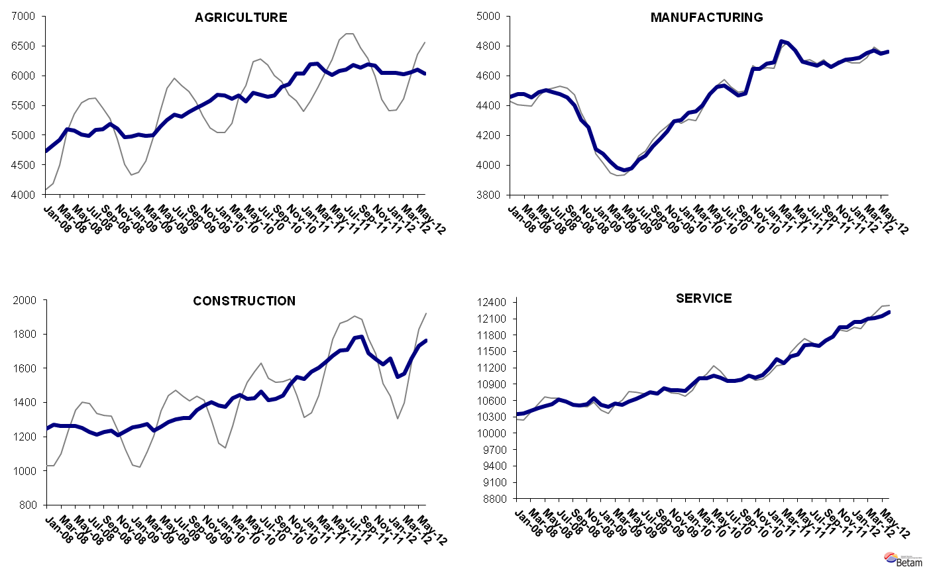
Source: TurkStat, Betam

* Prof. Seyfettin Gürsel, Betam, Director, seyfettin.gursel@bahcesehir.edu.tr
∗ Assoc. Prof. Gökçe Uysal, Betam, Vice Director, gokce.uysal @bahcesehir.edu.tr
∗∗ Ayşenur Acar, Betam, Research Assistant, aysenur.acar@bahcesehir.edu.tr
We have been using seasonal and calendar adjusted application per vacancy series released by Kariyer.net. However, we started using total vacancy series as the total application series contains a structural break due to technical difficulties since April 2012. Seasonal and calendar adjustment procedure is applied to total vacancy series released by Kariyer.net. Total vacancy series is continuously increasing given that the customers base of Kariyer.net is widening overtime. Therefore we calculate the cycle of the series by subtracting the absolute number from the trend calculated by a Hodrick-Prescott fitler. Since the changes in the number of vacancies are negatively correlated with the changes in unemployment we use the inverse of total vacancy series by multiplying it with -1. Although this vacancy series are not as strong forecasters as the application per vacancy series, it gives an idea for the direction of non-agricultural unemployment.
Seasonal adjustment procedure is applied to each sector of employment series separately. Hence the sum of these series may differ from the seasonally adjusted series of total employment. The difference stems from the non-linearity of the seasonal adjustment process.
Grey lines indicate seasonally adjusted series, where dark blue lines represent raw data.

