

May 15, 2012

Labor Market Outlook:

August 2012

August 15, 2012

NON-AGRICULTURAL UNEMPLOYMENT STAGNATES

Seyfettin Gürsel* Gökçe Uysal∗ and Ayşenur Acar∗

Executive Summary

Seasonally adjusted labor market data shows that non-agricultural unemployment rate is 11.2 percent in the period of May 2012. Both unemployment and non-agricultural unemployment rate remained stagnant in this period. According to the Kariyer.net data, we believe that non-agricultural unemployment rate will continue to stagnate in the period of June 2012. Also, we observe employment losses in manufacturing and increases in service and construction employment.

There is a slowdown in the non-agricultural labor market

According to the labor market statisics released by TurkStat on August 15th, in the period of May 2012 (April – May – June) non-agricultural labor force only increased by 465 thousand ( 2.3 percent), non-agricultural employment increased by 747 thousand (4.1 percent) and the number of unemployed persons in non-agricultural decreased by 282 thousand to 2 million 196 thousand on a year-on-year basis (Figure 1).

Figure 1 Year-on-year changes in non-agricultural labor force, employment and unemployment
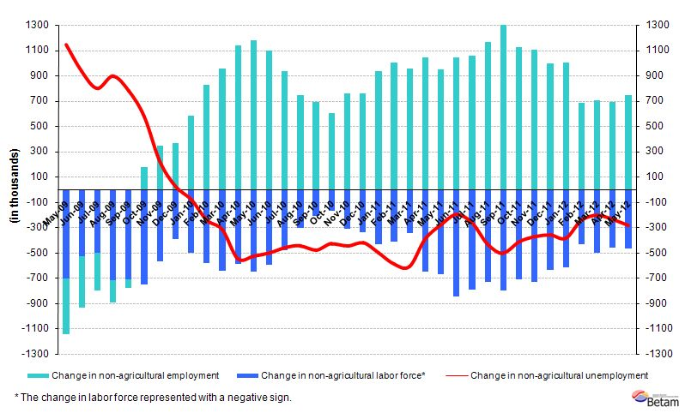Source: TurkStat, Betam

No decline in non-agricultural unemployment

According to seasonally adjusted series, non-agricultural labor force increased by 66 thousand to 20 million 961 thousand in the period of May compared to the period of April 2012 (Figure 2, Table 1). Non-agricultural employment increased by 71 thousand and reached 18 million 618 thousand. Consequently, the number of unemployed persons in non-agricultural sectors decreased by 5 thousand and seasonally adjusted non-agricultural unemployment rate remained 11.2 percent (Figure 2). We observe that non-agricultural unemployment rate has been stagnating since the period of December 2011.

Figure 2 Seasonally adjusted non-agricultural labor force, employment and unemployment
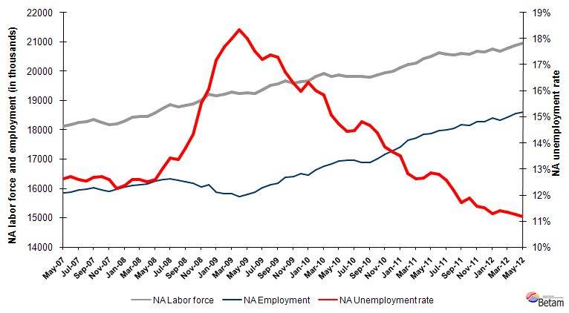Source: TurkStat, Betam

According to Kariyer.net series non-agricultural employment will continue to stagnate

In the previous research briefs, we used seasonal and calendar adjusted application per vacancy series released by Kariyer.net. However, we started using total vacancy series as the total application series contains a structural break due to technical difficulties since April 2012.

According to data released by Kariyer.net on vacancies provided by the firms, we believe that non-agricultural unemployment rate will continue to stagnate in the period of June 2012.

Figure 3 Seasonally adjusted non-agricultural unemployment rate and total vacancy cycle
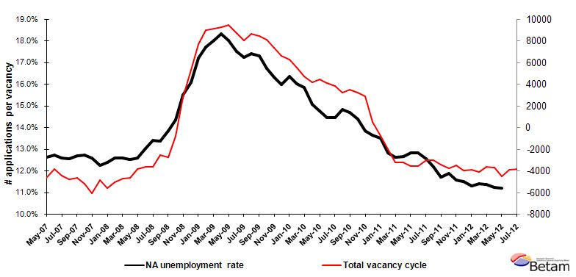
Data source: Kariyer.net, TurkStat, Betam

Construction employment has been increasing

According to seasonally adjusted figures, employment in manufacturing decreased by 20 thousand in the period of May 2012 (Table 2, Figure 4) . However, employment in services and construction increased by 34 thousand and 73 thousand, respectively. Albeit a relatively small share of construction employment in non-agricultural employment (10 percent), strong increases in these past two periods have cumulated to above 150 thousand. Consequently, developments in the construction sector had considerable effects on the labor market.

Table 1 Seasonally adjusted non-agricultural labor force indicators (in thousands)
 | Labor force | Employment | Unemployment | Unemployment rate | Monthly changes
April-09 | 19252 | 15722 | 3530 | 18.3% | Labor force | Employment | Unemployment
May-09 | 19258 | 15789 | 3469 | 18.0% | 6 | 67 | -61
June-09 | 19251 | 15880 | 3372 | 17.5% | -7 | 90 | -97
July-09 | 19356 | 16023 | 3333 | 17.2% | 104 | 144 | -39
August-09 | 19516 | 16122 | 3394 | 17.4% | 160 | 99 | 61
September-09 | 19564 | 16181 | 3383 | 17.3% | 49 | 59 | -11
October-09 | 19670 | 16382 | 3288 | 16.7% | 106 | 201 | -95
November-09 | 19602 | 16406 | 3196 | 16.3% | -68 | 24 | -92
December-09 | 19642 | 16506 | 3136 | 16.0% | 40 | 100 | -60
January-10 | 19683 | 16468 | 3215 | 16.3% | 41 | -38 | 79
February-10 | 19811 | 16642 | 3169 | 16.0% | 128 | 175 | -46
March-10 | 19916 | 16759 | 3156 | 15.8% | 104 | 117 | -13
April-10 | 19813 | 16830 | 2983 | 15.1% | -102 | 70 | -173
May-10 | 19866 | 16938 | 2928 | 14.7% | 53 | 108 | -55
June-10 | 19811 | 16951 | 2860 | 14.4% | -55 | 13 | -68
July-10 | 19821 | 16955 | 2866 | 14.5% | 10 | 4 | 6
August-10 | 19826 | 16889 | 2938 | 14.8% | 5 | -66 | 72
September-10 | 19801 | 16894 | 2907 | 14.7% | -25 | 6 | -31
October-10 | 19870 | 17012 | 2858 | 14.4% | 69 | 118 | -49
November-10 | 19937 | 17176 | 2761 | 13.8% | 67 | 164 | -97
December-10 | 20008 | 17280 | 2728 | 13.6% | 71 | 104 | -32
January-11 | 20126 | 17408 | 2718 | 13.5% | 118 | 129 | -10
February-11 | 20240 | 17646 | 2594 | 12.8% | 113 | 237 | -124
March-11 | 20270 | 17713 | 2557 | 12.6% | 31 | 67 | -37
April-11 | 20441 | 17854 | 2586 | 12.7% | 171 | 142 | 29
May-11 | 20504 | 17873 | 2631 | 12.8% | 63 | 18 | 45
June-11 | 20622 | 17982 | 2640 | 12.8% | 118 | 110 | 9
July-11 | 20589 | 18003 | 2586 | 12.6% | -33 | 21 | -54
August-11 | 20555 | 18052 | 2503 | 12.2% | -34 | 49 | -83
September-11 | 20598 | 18189 | 2409 | 11.7% | 43 | 137 | -93
October-11 | 20592 | 18147 | 2445 | 11.9% | -6 | -42 | 36
November-11 | 20672 | 18280 | 2392 | 11.6% | 80 | 133 | -53
December-11 | 20657 | 18283 | 2375 | 11.5% | -15 | 3 | -18
January-12 | 20748 | 18406 | 2342 | 11.3% | 90 | 124 | -33
February-12 | 20695 | 18339 | 2357 | 11.4% | -53 | -68 | 15
March-12 | 20786 | 18426 | 2359 | 11.4% | 90 | 88 | 3
April-12 | 20895 | 18547 | 2349 | 11.2% | 110 | 121 | -11
May-12 | 20961 | 18618 | 2343 | 11.2% | 66 | 71 | -5
Source: TurkStat, Betam

Table 2 Seasonally adjusted employment by sector (in thousands)
 | Agriculture | Manufacturing | Construction | Service | Monthly changes
April-09 | 5012 | 3985 | 1234 | 10526 | Agriculture | Manufacturing | Construction | Service
May-09 | 5150 | 3968 | 1258 | 10584 | 138 | -17 | 24 | 58
June-09 | 5251 | 3981 | 1284 | 10637 | 101 | 13 | 27 | 52
July-09 | 5335 | 4037 | 1303 | 10698 | 84 | 56 | 18 | 61
August-09 | 5304 | 4064 | 1308 | 10750 | -31 | 28 | 5 | 52
September-09 | 5393 | 4127 | 1310 | 10722 | 89 | 63 | 2 | -28
October-09 | 5452 | 4177 | 1354 | 10821 | 60 | 50 | 44 | 100
November-09 | 5504 | 4227 | 1383 | 10790 | 51 | 50 | 29 | -31
December-09 | 5576 | 4293 | 1404 | 10792 | 72 | 66 | 20 | 2
January-10 | 5675 | 4302 | 1382 | 10781 | 99 | 9 | -22 | -11
February-10 | 5662 | 4351 | 1373 | 10902 | -13 | 49 | -9 | 122
March-10 | 5622 | 4359 | 1425 | 11004 | -40 | 7 | 52 | 101
April-10 | 5678 | 4400 | 1446 | 11002 | 56 | 42 | 21 | -2
May-10 | 5587 | 4472 | 1423 | 11058 | -90 | 72 | -23 | 56
June-10 | 5702 | 4528 | 1424 | 11028 | 114 | 56 | 1 | -30
July-10 | 5670 | 4538 | 1462 | 10958 | -32 | 10 | 38 | -70
August-10 | 5649 | 4505 | 1414 | 10962 | -21 | -33 | -49 | 3
September-10 | 5665 | 4468 | 1420 | 10986 | 15 | -37 | 6 | 25
October-10 | 5803 | 4484 | 1440 | 11059 | 139 | 16 | 19 | 72
November-10 | 5856 | 4648 | 1507 | 11019 | 52 | 165 | 67 | -40
December-10 | 6030 | 4645 | 1550 | 11064 | 174 | -3 | 43 | 45
January-11 | 6035 | 4680 | 1536 | 11187 | 5 | 35 | -14 | 123
February-11 | 6185 | 4689 | 1579 | 11355 | 151 | 10 | 44 | 168
March-11 | 6205 | 4829 | 1605 | 11291 | 19 | 140 | 25 | -64
April-11 | 6091 | 4814 | 1639 | 11404 | -114 | -15 | 35 | 113
May-11 | 6037 | 4764 | 1674 | 11448 | -54 | -50 | 35 | 44
June-11 | 6071 | 4697 | 1706 | 11629 | 35 | -67 | 31 | 181
July-11 | 6093 | 4683 | 1708 | 11631 | 22 | -14 | 3 | 3
August-11 | 6171 | 4674 | 1778 | 11603 | 78 | -9 | 70 | -28
September-11 | 6139 | 4693 | 1787 | 11701 | -32 | 19 | 9 | 98
October-11 | 6183 | 4661 | 1689 | 11776 | 44 | -33 | -97 | 75
November-11 | 6159 | 4690 | 1655 | 11943 | -24 | 29 | -35 | 167
December-11 | 6049 | 4707 | 1622 | 11934 | -111 | 17 | -33 | -8
January-12 | 6054 | 4709 | 1659 | 12036 | 6 | 3 | 37 | 102
February-12 | 6043 | 4719 | 1548 | 12036 | -11 | 10 | -111 | 0
March-12 | 6037 | 4748 | 1567 | 12106 | -6 | 28 | 18 | 70
April-12 | 6076 | 4761 | 1660 | 12117 | 40 | 13 | 93 | 11
May-12 | 6129 | 4742 | 1733 | 12151 | 52 | -20 | 73 | 34
Source: TurkStat, Betam
Figure 4 Employment by sectors (in thousands)
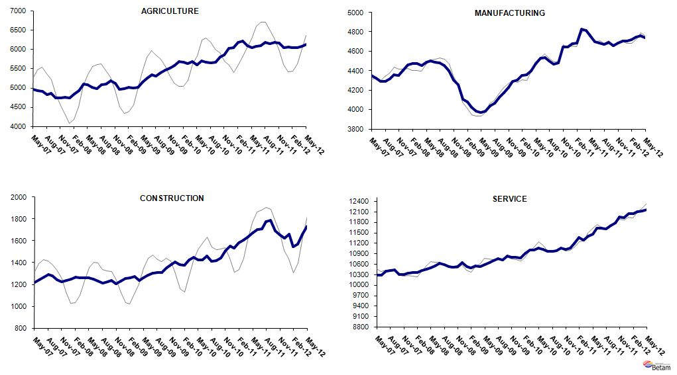
Source: TurkStat, Betam

* Prof. Seyfettin Gürsel, Betam, Director, seyfettin.gursel@bahcesehir.edu.tr
∗ Assoc. Prof. Gökçe Uysal, Betam, Vice Director, gokce.uysal @bahcesehir.edu.tr
∗∗ Ayşenur Acar, Betam, Research Assistant, aysenur.acar@bahcesehir.edu.tr
Seasonal and calendar adjustment procedure is applied to total vacancy series released by Kariyer.net. Total vacancy series is continuously increasing given that the customers base of Kariyer.net is widening overtime. Therefore we calculate the cycle of the series by subtracting the absolute number from the trend calculated by a Hodrick-Prescott fitler. Since the changes in the number of vacancies are negatively correlated with the changes in unemployment we use the inverse of total vacancy series by multiplying it with -1. Although this vacancy series are not as strong forecasters as the application per vacancy series, it gives an idea for the direction of non-agricultural unemployment.
Seasonal adjustment procedure is applied to each sector of employment series separately. Hence the sum of these series may differ from the seasonally adjusted series of total employment. The difference stems from the non-linearity of the seasonal adjustment process.
Grey lines indicate seasonally adjusted series, where dark blue lines represent raw data.

