

May 15, 2012

Labor Market Outlook:

July 2012

July 16, 2012

EMPLOYMENT IN CONSTRUCTION PREVENTED AN INCREASE IN NON-AGRICULTURAL UNEMPLOYMENT

Seyfettin Gürsel* Gökçe Uysal∗ and Ayşenur Acar∗

Executive Summary

Seasonally adjusted labor market data shows that non-agricultural unemployment rate decreased from 11.3 percent to 11.2 percent in the period of April 2012. Increase in both service and manufacturing remained limited in line with the low growth rate; however we observe that an increase in construction employment prevented an increase in non-agricultural unemployment.

There is a slowdown in the non-agricultural labor market

According to the labor market statisics released by TurkStat on July 16th, in the period of April 2012 (March – April – May) non-agricultural labor force only increased by 458 thousand ( 2.2 percent), non-agricultural employment increased by 694 thousand (3.9 percent) and the number of unemployed persons in non-agricultural decreased by 236 thousand to 2 million 325 thousand on a year-on-year basis (Figure 1). Non-agricultural unemployment rate has been decreasing parallel to stagnation in increase in employment and labor force for past three periods.

Figure 1 Year-on-year changes in non-agricultural labor force, employment and unemployment
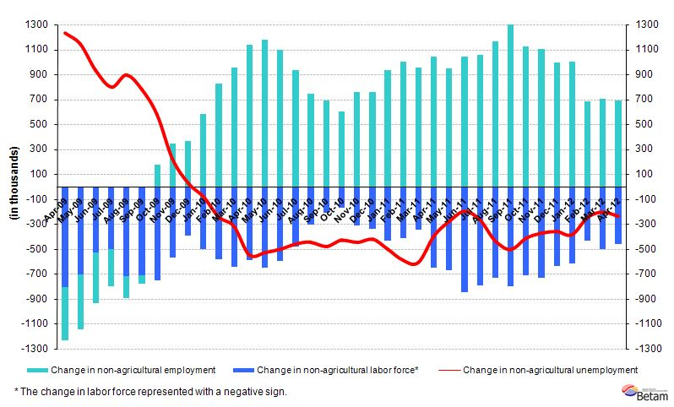Source: TurkStat, Betam

Seasonally adjusted non-agricultural unemployment stagnates

According to seasonally adjusted series, non-agricultural labor force increased by 109 thousand to 20 million 888 thousand in the period of April compared to the period of March 2012 (Figure 2, Table 1). Non-agricultural employment increased by 119 thousand and reached 18 million 543 thousand. Consequently, the number of unemployed persons in non-agricultural sectors decreased by 10 thousand and seasonally adjusted non-agricultural unemployment rate decreased by 0.1 percentage point from 11.3 percent to 11.2 percent (Figure 2). Increases in employment and in labor force both slowed down leading to slight declines in the non-agricultural unemployment rate.

Figure 2 Seasonally adjusted non-agricultural labor force, employment and unemployment 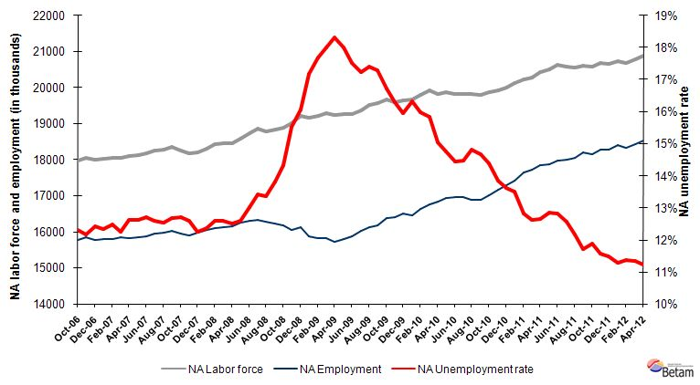
Source: TurkStat, Betam

According to Kariyer.net series non-agricultural employment will continue to stagnate in the period of May 2012

In the previous research briefs, we used seasonal and calendar adjusted application per vacancy series released by Kariyer.net. However, we started using total vacancy series as the total application series contains a structural break due to technical difficulties since April 2012.

According to data released by Kariyer.net the vacancy series provided by the firms in the previous period pointed to a decline in non-agricultural unemployment rate for the period of April 2012. Data from April 2012 verified this expectation. Current Kariyer.net series show a slight increase in non-agricultural unemployment rate. We believe that non-agricultural unemployment rate will remain stagnant in the next period considering the labor force market indicators in the past periods.

Figure 3 Seasonally adjusted non-agricultural unemployment rate and total vacancy cycle
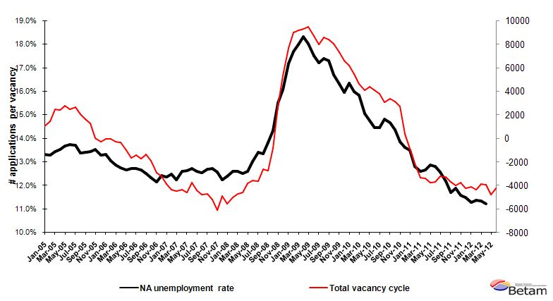
Data source: Kariyer.net, TurkStat, Betam

Construction employment increased by 5.8 percent in a single period

According to seasonally adjusted figures, construction employment increased by 91 thousand in the period of April 2012(Table 2, Figure 4). This indicates a 5.8 percent increase from the period of March to the period of April. Strong increase in construction employment, which has been decreasing since the period of October 2011, is surprising. New developments in the construction sector should be monitored closely.

Service and manufacturing employment increased by 12 thousand and 17 thousand, respectively. We oberve that low growth rate has an effect on service and manufacturing employment. However, abnormal increase in construction employment prevented an increase in non-agricultural unemployment.

Agricultural employment had been decreasing since October 2011. In April 2012, it increased by 40 thousand.

Table 1 Seasonally adjusted non-agricultural labor force indicators (in thousands)
 | Labor force | Employment | Unemployment | Unemployment rate | Monthly changes
March-09 | 19292 | 15818 | 3473 | 18.0% | Labor force | Employment | Unemployment
April-09 | 19250 | 15722 | 3529 | 18.3% | -41 | -97 | 55
May-09 | 19260 | 15790 | 3470 | 18.0% | 10 | 69 | -59
June-09 | 19253 | 15880 | 3373 | 17.5% | -7 | 90 | -97
July-09 | 19357 | 16024 | 3334 | 17.2% | 104 | 143 | -39
August-09 | 19517 | 16123 | 3394 | 17.4% | 159 | 99 | 60
September-09 | 19565 | 16182 | 3383 | 17.3% | 48 | 60 | -11
October-09 | 19670 | 16383 | 3288 | 16.7% | 105 | 200 | -95
November-09 | 19602 | 16407 | 3195 | 16.3% | -69 | 24 | -93
December-09 | 19641 | 16506 | 3136 | 16.0% | 40 | 99 | -59
January-10 | 19682 | 16467 | 3214 | 16.3% | 40 | -38 | 79
February-10 | 19810 | 16641 | 3168 | 16.0% | 128 | 174 | -46
March-10 | 19913 | 16758 | 3156 | 15.8% | 104 | 117 | -13
April-10 | 19810 | 16828 | 2982 | 15.1% | -103 | 70 | -173
May-10 | 19870 | 16939 | 2931 | 14.8% | 59 | 111 | -51
June-10 | 19814 | 16951 | 2863 | 14.4% | -55 | 13 | -68
July-10 | 19823 | 16956 | 2868 | 14.5% | 9 | 4 | 5
August-10 | 19828 | 16890 | 2938 | 14.8% | 5 | -65 | 70
September-10 | 19802 | 16896 | 2906 | 14.7% | -26 | 6 | -31
October-10 | 19870 | 17013 | 2856 | 14.4% | 68 | 118 | -50
November-10 | 19936 | 17177 | 2760 | 13.8% | 67 | 163 | -97
December-10 | 20007 | 17280 | 2727 | 13.6% | 70 | 103 | -33
January-11 | 20124 | 17408 | 2717 | 13.5% | 118 | 128 | -10
February-11 | 20237 | 17644 | 2593 | 12.8% | 112 | 236 | -124
March-11 | 20267 | 17711 | 2556 | 12.6% | 30 | 67 | -37
April-11 | 20436 | 17851 | 2585 | 12.6% | 170 | 141 | 29
May-11 | 20509 | 17873 | 2636 | 12.9% | 73 | 22 | 51
June-11 | 20627 | 17983 | 2645 | 12.8% | 118 | 110 | 9
July-11 | 20593 | 18004 | 2589 | 12.6% | -34 | 21 | -56
August-11 | 20558 | 18054 | 2503 | 12.2% | -35 | 50 | -85
September-11 | 20600 | 18190 | 2409 | 11.7% | 42 | 136 | -94
October-11 | 20592 | 18149 | 2444 | 11.9% | -7 | -42 | 35
November-11 | 20672 | 18280 | 2391 | 11.6% | 79 | 132 | -53
December-11 | 20655 | 18283 | 2373 | 11.5% | -16 | 2 | -19
January-12 | 20745 | 18405 | 2339 | 11.3% | 89 | 122 | -33
February-12 | 20691 | 18337 | 2354 | 11.4% | -54 | -68 | 14
March-12 | 20780 | 18424 | 2356 | 11.3% | 89 | 87 | 2
April-12 | 20888 | 18543 | 2346 | 11.2% | 109 | 119 | -10
Source: TurkStat, Betam

Table 2 Seasonally adjusted sector of employment (in thousands)
 | Agriculture | Manufacturing | Construction | Service | Monthly changes
March-09 | 4994 | 4025 | 1271 | 10550 | Agriculture | Manufacturing | Construction | Service
April-09 | 5010 | 3984 | 1231 | 10526 | 16 | -41 | -40 | -24
May-09 | 5152 | 3965 | 1260 | 10584 | 142 | -19 | 29 | 57
June-09 | 5252 | 3978 | 1287 | 10636 | 100 | 13 | 26 | 52
July-09 | 5336 | 4035 | 1304 | 10697 | 84 | 57 | 18 | 62
August-09 | 5305 | 4063 | 1309 | 10750 | -31 | 28 | 5 | 53
September-09 | 5394 | 4127 | 1312 | 10722 | 89 | 64 | 2 | -28
October-09 | 5452 | 4177 | 1354 | 10822 | 57 | 50 | 42 | 99
November-09 | 5503 | 4227 | 1383 | 10791 | 51 | 50 | 29 | -31
December-09 | 5575 | 4294 | 1403 | 10793 | 72 | 68 | 20 | 2
January-10 | 5673 | 4305 | 1381 | 10782 | 98 | 10 | -22 | -11
February-10 | 5659 | 4355 | 1372 | 10902 | -14 | 50 | -9 | 121
March-10 | 5620 | 4361 | 1423 | 11003 | -39 | 7 | 51 | 101
April-10 | 5676 | 4404 | 1443 | 11002 | 56 | 42 | 20 | -2
May-10 | 5592 | 4471 | 1426 | 11057 | -84 | 67 | -17 | 55
June-10 | 5704 | 4525 | 1426 | 11026 | 112 | 54 | 0 | -31
July-10 | 5673 | 4536 | 1464 | 10957 | -31 | 11 | 38 | -69
August-10 | 5652 | 4501 | 1415 | 10962 | -21 | -35 | -49 | 5
September-10 | 5667 | 4465 | 1422 | 10988 | 15 | -36 | 6 | 25
October-10 | 5802 | 4481 | 1440 | 11059 | 135 | 16 | 18 | 72
November-10 | 5855 | 4648 | 1506 | 11020 | 52 | 167 | 66 | -39
December-10 | 6028 | 4646 | 1549 | 11066 | 173 | -1 | 43 | 46
January-11 | 6032 | 4683 | 1535 | 11188 | 4 | 37 | -14 | 123
February-11 | 6180 | 4695 | 1578 | 11354 | 148 | 12 | 44 | 166
March-11 | 6201 | 4835 | 1603 | 11290 | 20 | 141 | 25 | -64
April-11 | 6087 | 4823 | 1636 | 11403 | -113 | -12 | 33 | 113
May-11 | 6042 | 4762 | 1677 | 11447 | -45 | -61 | 42 | 44
June-11 | 6074 | 4689 | 1708 | 11626 | 32 | -72 | 31 | 179
July-11 | 6096 | 4677 | 1710 | 11630 | 22 | -12 | 2 | 4
August-11 | 6173 | 4668 | 1779 | 11604 | 77 | -9 | 69 | -26
September-11 | 6141 | 4689 | 1788 | 11702 | -32 | 21 | 8 | 98
October-11 | 6182 | 4657 | 1689 | 11777 | 40 | -32 | -99 | 74
November-11 | 6158 | 4689 | 1654 | 11943 | -24 | 32 | -35 | 167
December-11 | 6047 | 4709 | 1621 | 11936 | -111 | 20 | -33 | -8
January-12 | 6052 | 4715 | 1658 | 12037 | 5 | 6 | 37 | 101
February-12 | 6038 | 4728 | 1547 | 12035 | -14 | 13 | -111 | -2
March-12 | 6032 | 4760 | 1565 | 12105 | -6 | 32 | 18 | 70
April-12 | 6072 | 4777 | 1656 | 12116 | 40 | 17 | 91 | 12
Source: TurkStat, Betam
Figure 4 Employment changes in sectors (in thousands)
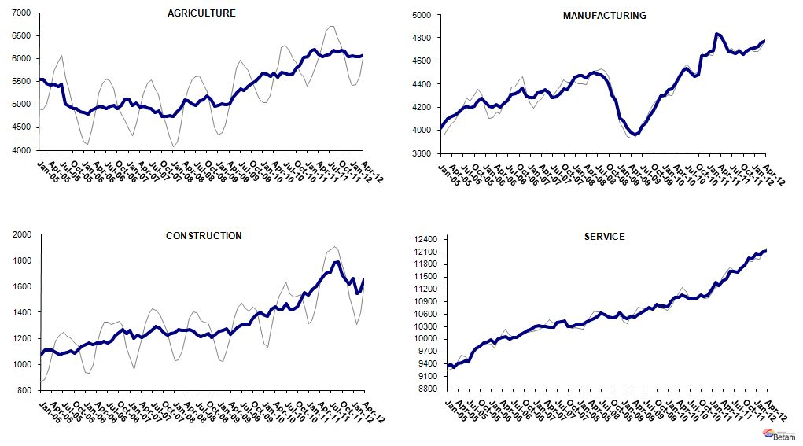
Source: TurkStat, Betam

* Prof. Seyfettin Gürsel, Betam, Director, seyfettin.gursel@bahcesehir.edu.tr
∗ Assoc. Prof. Gökçe Uysal, Betam, Vice Director, gokce.uysal @bahcesehir.edu.tr
∗∗ Ayşenur Acar, Betam, Research Assistant, aysenur.acar@bahcesehir.edu.tr
Seasonal and calendar adjustment procedure is applied to total vacancy series released by Kariyer.net. Total vacancy series is continuously increasing given that the customers base of Kariyer.net is widening overtime. Therefore we calculate the cycle of the series by subtracting the absolute number from the trend calculated by a Hodrick-Prescott fitler. Since the changes in the number of vacancies are negatively correlated with the changes in unemployment we use the inverse of total vacancy series by multiplying it with -1. Although this vacancy series are not as strong forecasters as the application per vacancy series, it gives an idea for the direction of non-agricultural unemployment.
Seasonal adjustment procedure is applied to each sector of employment series separately. Hence the sum of these series may differ from the seasonally adjusted series of total employment. The difference stems from the non-linearity of the seasonal adjustment process.
Grey lines indicate seasonally adjusted series, where dark blue lines represent raw data.

