

May 15, 2012

Labor Market Outlook:

June 2012

June 15, 2012

NON-AGRICULTURAL EMPLOYMENT STAGNATES

Seyfettin Gürsel* Gökçe Uysal∗ and Ayşenur Acar∗

Executive Summary

According to the labor market statistics released by Turk-Stat, non-agricultural unemployment rate decreased from 12.7 percent to 12.1 percent. Seasonally adjusted labor market data shows that non-agricultural unemployment rate decreased from 11.4 percent to 11.3 percent in the period of March 2012.
Non-agricultural unemployment rate declined slightly following an increase in non-agricultural employment which was counterbalanced with an increase in non-agricultural labor force. The increase in non-agricultural employment is mostly driven by a 71 thousand increase in service employment. Increases in manufacturing and construction employment remains limited.

There is a slowdown in the annual increase in non-agricultural employment

According to the labor market statisics released by TurkStat on June 15th, in the period of March 2012 (February – March – April) non-agricultural labor force only increased by 502 thousand ( 2.5 percent), non-agricultural employment increased by 704 thousand (4 percent) and the number of unemployed persons in non-agricultural decreased by 202 thousand to 2 million 506 thousand on a year-on-year basis (Figure 1). Annual increases in non-agricultural labor force had been over 600 thousand in the past periods. Thanks to strong annual increases of almost 1 million in non-agricultural employment, non-agricultural unemployment was decreasing rapidly. Increases in non-agricultural labor force and in non-agricultural employment have been slowing down since February 2012. Hence, the decline in unemployed has been slowing down as well.

Figure 1 Year-on-year changes in non-agricultural labor force, employment and unemployment
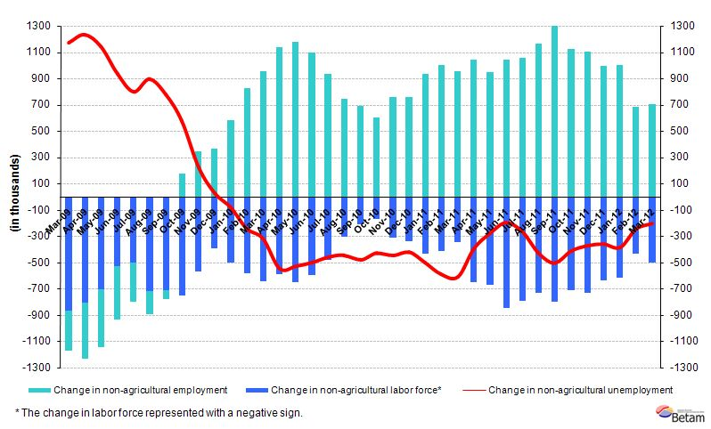Source: TurkStat, Betam
Seasonally adjusted non-agricultural unemployment remained stagnant

According to seasonally adjusted series, non-agricultural labor force increased by 89 thousand to 20 million 763 thousand in the period of March compared to the period of February 2012 (Figure 2, Table 1). Non-agricultural employment increased by 87 thousand and reached to 18 million 412 thousand. Consequently, the number of unemployed persons in non-agricultural sectors increased by 2 thousand and seasonally adjusted non-agricultural unemployment rate decreased by 0.1 percentage point from 11.4 percent to 11.3 percent (Figure 2).

Figure 2 Seasonally adjusted non-agricultural labor force, employment and unemployment 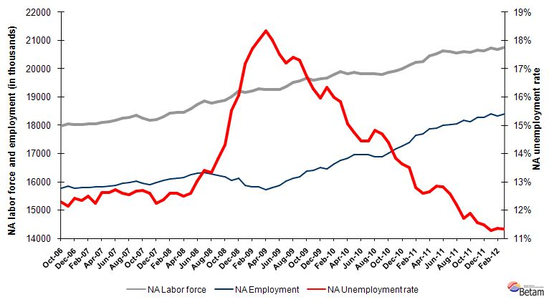
Source: TurkStat, Betam

According to Kariyer.net series non-agricultural employment will increase in the period of April 2012

In the previous research briefs, we used seasonal and calendar adjusted application per vacancy series released by Kariyer.net. However, we have been using total vacancy series in this brief due to technical difficulties as the total application series contains a structural break since April 2012.

According to data released by Kariyer.net the vacancy series provided by the firms has a significant increase in May. In light of this data, we believe that non-agricultural employment will have stronger increase in the period of April 2012 (March – April – May).

Figure 3 Seasonally adjusted non-agricultural unemployment rate and total vacancy cycle
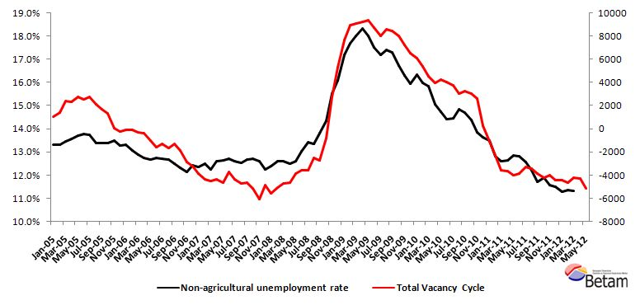
Data source: Kariyer.net, TurkStat, Betam

Strong increase in service employment

According to seasonally adjusted figures, sectoral employment data points to significant employment increases in services. Employment in this sector increased by 71 thousand in the period of March 2012 compared to February 2012. While construction employment suffered significant losses (110 thousand) in the period of February, it increased by 11 thousand in the period of March 2012 (Table 2, Figure 4). Employment in manufacturing increased only by 3 thousand in the period of March. This is consistent with the decline in manufacturing production index.

Decline in agricultural employment has been continuing. Hence, we believe that increase in agricultural employment observed in the past 3 years has been coming to an end.

Table 1 Seasonally adjusted non-agricultural labor force indicators (in thousands)
 | Labor force | Employment | Unemployment | Unemployment rate | Monthly changes
February-09 | 19224 | 15821 | 3403 | 17.7% | Labor force | Employment | Unemployment
March-09 | 19289 | 15814 | 3475 | 18.0% | 65 | -7 | 72
April-09 | 19255 | 15724 | 3531 | 18.3% | -33 | -90 | 56
May-09 | 19265 | 15795 | 3471 | 18.0% | 10 | 71 | -61
June-09 | 19257 | 15885 | 3371 | 17.5% | -9 | 91 | -100
July-09 | 19360 | 16029 | 3331 | 17.2% | 104 | 143 | -40
August-09 | 19518 | 16123 | 3395 | 17.4% | 157 | 94 | 63
September-09 | 19564 | 16180 | 3384 | 17.3% | 46 | 57 | -11
October-09 | 19668 | 16380 | 3288 | 16.7% | 104 | 201 | -96
November-09 | 19597 | 16402 | 3195 | 16.3% | -71 | 21 | -93
December-09 | 19636 | 16501 | 3135 | 16.0% | 40 | 100 | -60
January-10 | 19676 | 16462 | 3215 | 16.3% | 40 | -40 | 80
February-10 | 19805 | 16638 | 3167 | 16.0% | 129 | 176 | -47
March-10 | 19909 | 16755 | 3155 | 15.8% | 104 | 117 | -13
April-10 | 19821 | 16838 | 2982 | 15.0% | -89 | 83 | -172
May-10 | 19880 | 16950 | 2930 | 14.7% | 60 | 112 | -52
June-10 | 19822 | 16962 | 2861 | 14.4% | -58 | 12 | -70
July-10 | 19828 | 16962 | 2866 | 14.5% | 6 | 1 | 5
August-10 | 19829 | 16887 | 2942 | 14.8% | 0 | -75 | 75
September-10 | 19799 | 16890 | 2909 | 14.7% | -30 | 2 | -32
October-10 | 19865 | 17005 | 2860 | 14.4% | 66 | 116 | -50
November-10 | 19929 | 17170 | 2759 | 13.8% | 64 | 164 | -100
December-10 | 19998 | 17272 | 2726 | 13.6% | 69 | 102 | -33
January-11 | 20116 | 17400 | 2716 | 13.5% | 118 | 128 | -10
February-11 | 20228 | 17638 | 2589 | 12.8% | 112 | 238 | -126
March-11 | 20257 | 17705 | 2552 | 12.6% | 30 | 67 | -37
April-11 | 20452 | 17868 | 2585 | 12.6% | 195 | 163 | 33
May-11 | 20526 | 17889 | 2637 | 12.8% | 74 | 22 | 52
June-11 | 20642 | 17997 | 2644 | 12.8% | 116 | 108 | 7
July-11 | 20602 | 18013 | 2589 | 12.6% | -40 | 15 | -55
August-11 | 20560 | 18052 | 2508 | 12.2% | -42 | 40 | -81
September-11 | 20597 | 18186 | 2411 | 11.7% | 37 | 134 | -97
October-11 | 20586 | 18139 | 2447 | 11.9% | -11 | -47 | 36
November-11 | 20663 | 18273 | 2389 | 11.6% | 76 | 134 | -58
December-11 | 20643 | 18272 | 2371 | 11.5% | -20 | -1 | -19
January-12 | 20732 | 18396 | 2336 | 11.3% | 89 | 124 | -34
February-12 | 20674 | 18325 | 2349 | 11.4% | -58 | -70 | 13
March-12 | 20763 | 18412 | 2351 | 11.3% | 89 | 87 | 2

Source: TurkStat, Betam

Table 2 Seasonally adjusted sector of employment (in thousands)
 | Agriculture | Manufacturing | Construction | Service | Monthly changes
February-09 | 5016 | 4093 | 1259 | 10483 | Agriculture | Manufacturing | Construction | Service
March-09 | 4992 | 4014 | 1265 | 10552 | -24 | -80 | 6 | 69
April-09 | 5011 | 3975 | 1233 | 10525 | 19 | -39 | -33 | -27
May-09 | 5154 | 3961 | 1262 | 10582 | 143 | -14 | 30 | 57
June-09 | 5253 | 3975 | 1289 | 10633 | 99 | 15 | 27 | 51
July-09 | 5337 | 4036 | 1307 | 10695 | 84 | 61 | 18 | 62
August-09 | 5307 | 4058 | 1310 | 10749 | -31 | 22 | 3 | 54
September-09 | 5395 | 4125 | 1311 | 10723 | 88 | 66 | 1 | -26
October-09 | 5451 | 4172 | 1355 | 10822 | 56 | 47 | 44 | 99
November-09 | 5502 | 4218 | 1383 | 10792 | 51 | 46 | 28 | -30
December-09 | 5574 | 4289 | 1403 | 10794 | 72 | 71 | 19 | 3
January-10 | 5671 | 4323 | 1378 | 10784 | 97 | 34 | -24 | -10
February-10 | 5656 | 4374 | 1369 | 10904 | -15 | 51 | -9 | 120
March-10 | 5617 | 4349 | 1416 | 11005 | -39 | -26 | 47 | 101
April-10 | 5677 | 4404 | 1446 | 11000 | 60 | 55 | 29 | -5
May-10 | 5595 | 4478 | 1429 | 11055 | -82 | 74 | -16 | 55
June-10 | 5706 | 4531 | 1430 | 11022 | 111 | 53 | 1 | -32
July-10 | 5675 | 4544 | 1468 | 10955 | -31 | 14 | 38 | -67
August-10 | 5654 | 4496 | 1417 | 10962 | -21 | -48 | -51 | 7
September-10 | 5669 | 4458 | 1421 | 10989 | 15 | -38 | 4 | 26
October-10 | 5802 | 4467 | 1441 | 11060 | 133 | 9 | 20 | 71
November-10 | 5854 | 4636 | 1506 | 11021 | 52 | 169 | 65 | -39
December-10 | 6027 | 4640 | 1548 | 11068 | 173 | 3 | 41 | 47
January-11 | 6030 | 4699 | 1530 | 11191 | 3 | 59 | -17 | 123
February-11 | 6176 | 4714 | 1574 | 11356 | 147 | 15 | 44 | 165
March-11 | 6196 | 4821 | 1593 | 11292 | 20 | 107 | 19 | -64
April-11 | 6089 | 4832 | 1639 | 11401 | -107 | 11 | 45 | 110
May-11 | 6046 | 4774 | 1681 | 11445 | -43 | -58 | 43 | 43
June-11 | 6077 | 4692 | 1713 | 11622 | 31 | -82 | 32 | 177
July-11 | 6099 | 4682 | 1715 | 11628 | 22 | -10 | 2 | 6
August-11 | 6175 | 4660 | 1783 | 11605 | 76 | -22 | 68 | -23
September-11 | 6143 | 4682 | 1789 | 11704 | -32 | 22 | 6 | 99
October-11 | 6181 | 4637 | 1692 | 11777 | 38 | -44 | -97 | 74
November-11 | 6157 | 4676 | 1654 | 11944 | -24 | 39 | -38 | 167
December-11 | 6046 | 4702 | 1618 | 11938 | -111 | 26 | -37 | -6
January-12 | 6049 | 4727 | 1652 | 12039 | 3 | 25 | 35 | 101
February-12 | 6033 | 4743 | 1542 | 12036 | -16 | 16 | -110 | -3
March-12 | 6027 | 4747 | 1553 | 12107 | -6 | 3 | 11 | 71
Source: TurkStat, Betam
Figure 4 Employment changes in sectors (in thousands)
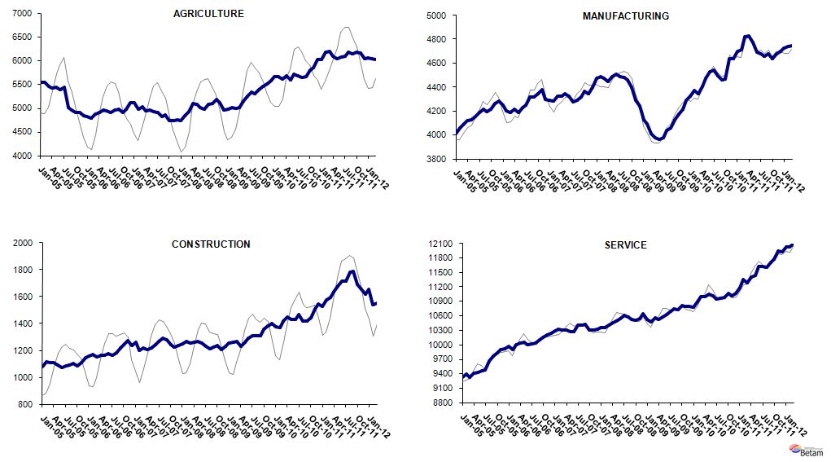
Source: TurkStat, Betam

* Prof. Seyfettin Gürsel, Betam, Director, seyfettin.gursel@bahcesehir.edu.tr
∗ Assoc. Prof. Gökçe Uysal, Betam, Vice Director, gokce.uysal @bahcesehir.edu.tr
∗∗ Ayşenur Acar, Betam, Research Assistant, aysenur.acar@bahcesehir.edu.tr
Seasonal and calendar adjustment procedure is applied to total vacancy series released by Kariyer.net. Total vacancy series is continuously increasing given that the customers base of Kariyer.net is widening overtime. Therefore we calculate the cycle of the series by subtracting the absolute number from the trend calculated by a Hodrick-Prescott fitler. Since the changes in the number of vacancies are negatively correlated with the changes in unemployment we use the inverse of total vacancy series by multiplying it with -1. Although this vacancy series are not as strong forecasters as the application per vacancy series, it gives an idea for the direction of non-agricultural unemployment.
Seasonal adjustment procedure is applied to each sector of employment series separately. Hence the sum of these series may differ from the seasonally adjusted series of total employment. The difference stems from the non-linearity of the seasonal adjustment process.
Grey lines indicate seasonally adjusted series, where dark blue lines represent raw data.

