

May 15, 2012

Labor Market Outlook:

May 2012

May 15, 2012

A SHARP DECLINE IN EMPLOYMENT OF CONSTRUCTION SECTOR

Seyfettin Gürsel* Gökçe Uysal∗ and Merve Yiğit Yontar∗

Executive Summary

According to the labor market statistics released by Turk-Stat, non-agricultural unemployment rate is 12.7 percent in the period of February 2012. Seasonally adjusted labor market data shows that non-agricultural unemployment rate increased by 0.1 points to 11.3 percent. We observe a slowdown in the increase of non-agricultural employment in the period of February 2012. Due to a slowdown in the increase in non-agricultural labor force, the increase in non-agricultural unemployment is limited. Employment in construction sector decreased by 110 thousand with a sharp decline, whereas the increase in manufacturing and the decline in services are limited. These numbers reflect the slow down in the growth rate.

There is a slowdown in the increase in non-agricultural employment

According to the labor market statisics released by TurkStat on May 15th, in the period of February 2012 (January-February-March) non-agricultural labor force only increased by 436 thousand ( 2.2 percent), non-agricultural employment increased by 682 thousand (4 percent) and the number of unemployed persons in non-agricultural decreased by 246 thousand to 2 million 606 thousand on a year-on-year basis (Figure 1). Annual increases in non-agricultural labor force had been over 600 thousand in the past periods. Moreover, non-agricultural unemployment was decreasing rapidly in parallel to strong annual increases of almost 1 million in non-agricultural employment. We observe that increases in both non-agricultural labor force and non-agricultural employment both slowed down as a result non-agricultural unemployment stagnated.

Figure 1 Year-on-year changes in non-agricultural labor force, employment and unemployment
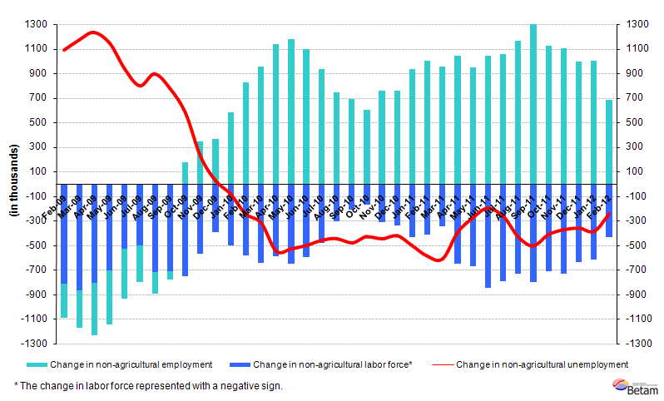 Source: TurkStat, Betam

Seasonally adjusted non-agricultural unemployment increased to 11.3 percent

According to seasonally adjusted series, non-agricultural labor force decreased by 60 thousand to 20 million 657 thousand in the period of February compared to the period of January 2011 (Figure 2, Table 1). Non-agricultural employment decreased by 73 thousand and fell back to 18 million 331 thousand. Consequently, the number of unemployed persons in non-agricultural sectors increased by 13 thousand and seasonally adjusted non-agricultural unemployment rate increased from 11.2 percent to 11.3 percent (Figure 2). The monthly loss in non-agricultural employment is the largest decrease recorded since August 2010. However, note that the slow down in non-agricultural labor force prevented a stronger increase in non-agricultural unemployment.

Figure 2 Seasonally adjusted non-agricultural labor force, employment and unemployment 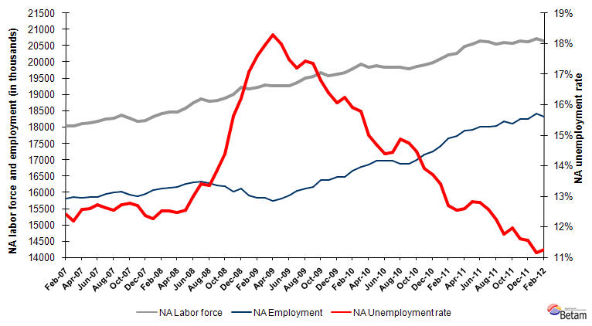
Source: TurkStat, Betam

According to Kariyer.net series non-agricultural unemployment rate will stagnate in the period of March 2012

In the previous research briefs, we used seasonal and calendar adjusted application per vacancy series released by Kariyer.net. However, we will be using total vacancy series in this brief as the total application series pertaining to April 2012 contains a structural break due to technical difficulties.

According to data released by Kariyer.net the vacancy series provided by the firms point to a slowdown in the decrease in non-agricultural unemployment starting from the period of January 2012. In light of this data, we believe that non-agricultural unemployment rate will stagnate in the period of March 2012.

Figure 3 Seasonally adjusted non-agricultural unemployment rate and total vacancy cycle
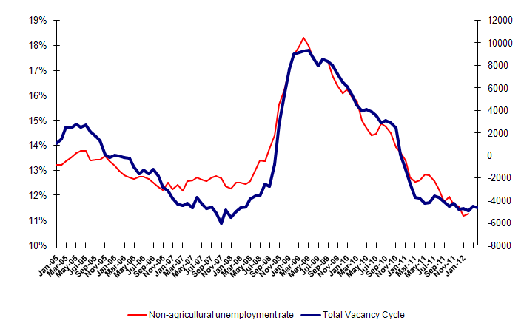
Data source: Kariyer.net, TurkStat, Betam

110 thousand construction employment loss in one month

According to seasonally adjusted figures, sectoral employment data points to significant employment losses in the construction sector. Employment in construction sector decreased by 110 thousand (6.7 percent) in the period of February 2012 compared to the period of January 2012 (Table 2, Figure 4). From the period of September 2011 to the period of February 2012 the cumulative decrease in construction sector is 246 thousand (14 percent).

The employment in manufacturing only increased by 16 thousand, the employment in services decreased by 5 thousand in the period of February 2012. These are reflections of slowing growth rates on the labor market. A moderate decline in the agricultural sector continues.

Table 1 Seasonally adjusted non-agricultural labor force indicators (in thousands)
 | Labor force | Employment | Unemployment | Unemployment rate | Monthly changes
January-09 | 19166 | 15894 | 3272 | 17.1% | Labor force | Employment | Unemployment
February-09 | 19220 | 15836 | 3384 | 17.6% | 55 | -58 | 112
March-09 | 19297 | 15833 | 3464 | 18.0% | 77 | -3 | 80
April-09 | 19260 | 15736 | 3524 | 18.3% | -37 | -97 | 59
May-09 | 19270 | 15805 | 3465 | 18.0% | 10 | 69 | -59
June-09 | 19259 | 15893 | 3366 | 17.5% | -11 | 88 | -99
July-09 | 19363 | 16033 | 3330 | 17.2% | 104 | 140 | -36
August-09 | 19517 | 16116 | 3402 | 17.4% | 154 | 83 | 72
September-09 | 19561 | 16165 | 3395 | 17.4% | 43 | 50 | -7
October-09 | 19664 | 16363 | 3302 | 16.8% | 103 | 197 | -94
November-09 | 19589 | 16377 | 3211 | 16.4% | -75 | 15 | -90
December-09 | 19629 | 16474 | 3155 | 16.1% | 41 | 97 | -56
January-10 | 19669 | 16476 | 3193 | 16.2% | 40 | 1 | 38
February-10 | 19800 | 16652 | 3148 | 15.9% | 131 | 176 | -45
March-10 | 19923 | 16777 | 3146 | 15.8% | 123 | 125 | -3
April-10 | 19832 | 16858 | 2974 | 15.0% | -91 | 80 | -172
May-10 | 19892 | 16967 | 2925 | 14.7% | 60 | 109 | -49
June-10 | 19831 | 16975 | 2856 | 14.4% | -61 | 8 | -69
July-10 | 19833 | 16967 | 2866 | 14.4% | 2 | -8 | 10
August-10 | 19827 | 16876 | 2951 | 14.9% | -6 | -91 | 85
September-10 | 19792 | 16871 | 2921 | 14.8% | -35 | -5 | -30
October-10 | 19856 | 16981 | 2874 | 14.5% | 64 | 110 | -46
November-10 | 19917 | 17145 | 2772 | 13.9% | 61 | 163 | -103
December-10 | 19985 | 17243 | 2742 | 13.7% | 68 | 98 | -30
January-11 | 20105 | 17410 | 2695 | 13.4% | 120 | 167 | -47
February-11 | 20217 | 17649 | 2568 | 12.7% | 112 | 239 | -127
March-11 | 20273 | 17728 | 2544 | 12.5% | 56 | 80 | -24
April-11 | 20469 | 17891 | 2578 | 12.6% | 197 | 163 | 34
May-11 | 20544 | 17909 | 2635 | 12.8% | 75 | 17 | 57
June-11 | 20657 | 18014 | 2643 | 12.8% | 113 | 105 | 8
July-11 | 20610 | 18019 | 2591 | 12.6% | -47 | 5 | -52
August-11 | 20559 | 18041 | 2518 | 12.2% | -51 | 22 | -73
September-11 | 20590 | 18170 | 2419 | 11.8% | 31 | 129 | -98
October-11 | 20575 | 18114 | 2461 | 12.0% | -15 | -56 | 41
November-11 | 20649 | 18250 | 2399 | 11.6% | 74 | 136 | -62
December-11 | 20625 | 18243 | 2382 | 11.6% | -23 | -7 | -16
January-12 | 20717 | 18404 | 2313 | 11.2% | 92 | 161 | -70
February-12 | 20657 | 18331 | 2326 | 11.3% | -60 | -73 | 13

Source: TurkStat, Betam

Table 2 Seasonally adjusted sector of employment (in thousands)

 | Agriculture | Manufacturing | Construction | Service | Monthly changes
January-09 | 4981 | 4126 | 1253 | 10526 | Agriculture | Manufacturing | Construction | Service
February-09 | 5018 | 4094 | 1259 | 10481 | 37 | -33 | 7 | -45
March-09 | 4990 | 4014 | 1265 | 10553 | -27 | -79 | 6 | 73
April-09 | 5009 | 3975 | 1232 | 10527 | 19 | -39 | -33 | -27
May-09 | 5152 | 3961 | 1262 | 10583 | 143 | -14 | 30 | 57
June-09 | 5252 | 3975 | 1289 | 10633 | 100 | 15 | 27 | 50
July-09 | 5337 | 4036 | 1306 | 10695 | 84 | 61 | 18 | 62
August-09 | 5306 | 4058 | 1310 | 10750 | -31 | 22 | 3 | 55
September-09 | 5395 | 4125 | 1310 | 10724 | 89 | 66 | 1 | -26
October-09 | 5452 | 4172 | 1355 | 10822 | 58 | 47 | 44 | 98
November-09 | 5504 | 4218 | 1383 | 10792 | 51 | 46 | 28 | -30
December-09 | 5576 | 4289 | 1403 | 10794 | 72 | 71 | 20 | 2
January-10 | 5674 | 4323 | 1379 | 10783 | 98 | 34 | -24 | -11
February-10 | 5659 | 4374 | 1369 | 10900 | -14 | 51 | -9 | 118
March-10 | 5615 | 4349 | 1416 | 11006 | -44 | -25 | 47 | 105
April-10 | 5675 | 4404 | 1445 | 11001 | 60 | 55 | 29 | -5
May-10 | 5592 | 4478 | 1429 | 11055 | -83 | 74 | -16 | 54
June-10 | 5704 | 4530 | 1430 | 11021 | 113 | 53 | 1 | -34
July-10 | 5674 | 4544 | 1467 | 10955 | -31 | 13 | 38 | -66
August-10 | 5653 | 4496 | 1417 | 10965 | -21 | -48 | -51 | 9
September-10 | 5668 | 4458 | 1420 | 10991 | 15 | -38 | 4 | 26
October-10 | 5804 | 4468 | 1441 | 11060 | 135 | 9 | 20 | 69
November-10 | 5856 | 4637 | 1506 | 11021 | 52 | 169 | 65 | -39
December-10 | 6029 | 4640 | 1548 | 11068 | 173 | 3 | 42 | 47
January-11 | 6033 | 4699 | 1531 | 11189 | 4 | 59 | -17 | 121
February-11 | 6181 | 4714 | 1574 | 11351 | 148 | 15 | 44 | 162
March-11 | 6194 | 4820 | 1593 | 11293 | 13 | 107 | 19 | -58
April-11 | 6086 | 4831 | 1638 | 11402 | -108 | 11 | 45 | 109
May-11 | 6042 | 4773 | 1681 | 11445 | -44 | -58 | 43 | 43
June-11 | 6075 | 4692 | 1713 | 11620 | 33 | -82 | 32 | 175
July-11 | 6097 | 4682 | 1714 | 11628 | 22 | -10 | 2 | 8
August-11 | 6174 | 4660 | 1783 | 11608 | 78 | -21 | 68 | -20
September-11 | 6143 | 4682 | 1788 | 11706 | -32 | 22 | 6 | 99
October-11 | 6183 | 4638 | 1692 | 11778 | 41 | -44 | -97 | 71
November-11 | 6160 | 4677 | 1654 | 11943 | -24 | 39 | -38 | 166
December-11 | 6049 | 4703 | 1618 | 11938 | -111 | 26 | -36 | -6
January-12 | 6053 | 4727 | 1653 | 12036 | 4 | 24 | 35 | 98
February-12 | 6039 | 4743 | 1542 | 12031 | -14 | 16 | -110 | -5

Source: TurkStat, Betam
Figure 4 Employment changes in sectors (in thousands)
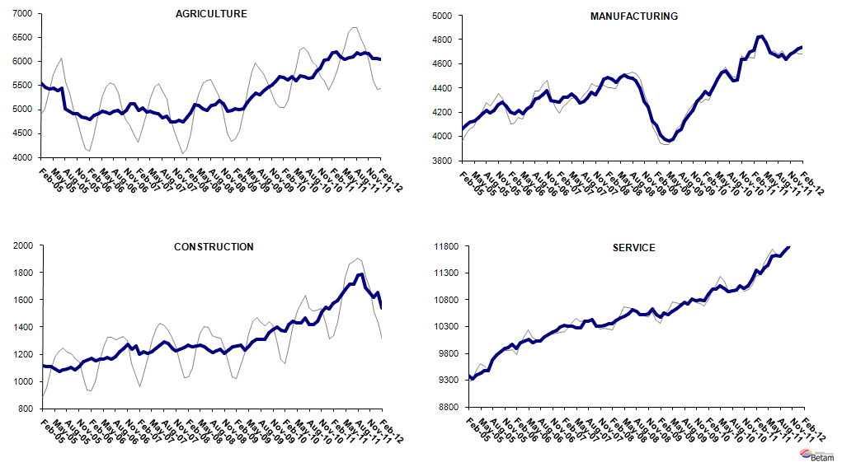
Source: TurkStat, Betam

* Prof. Seyfettin Gürsel, Betam, Director, seyfettin.gursel@bahcesehir.edu.tr
∗ Assoc. Prof. Gökçe Uysal, Betam, Vice Director, gokce.uysal @bahcesehir.edu.tr
∗∗ Merve Yiğit Yontar, Betam, Research Assistant, merve.yigityontar@bahcesehir.edu.tr
Seasonal and calendar adjustment procedure is applied to total vacancy series released by Kariyer.net. Total vacancy series is continuously increasing given that the customers base of Kariyer.net is widening overtime. Therefore we calculate the cycle of the series by subtracting the absolute number from the trend calculated by a Hodrick-Prescott fitler. Since the changes in the number of vacancies are negatively correlated with the changes in unemployment we use the inverse of total vacancy series by multiplying it with -1. Although this vacancy series are not as strong forecasters as the application per vacancy series, it gives an idea for the direction of non-agricultural unemployment.
Seasonal adjustment procedure is applied to each sector of employment series separately. Hence the sum of these series may differ from the seasonally adjusted series of total employment. The difference stems from the non-linearity of the seasonal adjustment process.
Grey lines indicate seasonally adjusted series, where dark blue lines represent raw data.

