

Labor Market Outlook:

January 2012

January 16, 2012

SIZEABLE EMPLOYMENT LOSSES
IN CONSTRUCTION AND MANUFACTURING

Seyfettin Gursel*, Gokce Uysal ∗ and Aysenur Acar∗

Executive Summary

According to the labor market statistics released by TurkStat, non-agricultural unemployment rate fell by 2.5 percentage points to 11.6 percent in the period of October 2011 compared to same period of the previous year. Seasonally adjusted non-agricultural unemployment rate in the period of October 2011 is 11.7 percent, which was 11.6 percent in the period of September 2011. Stagnant unemployment rate indicates that employment losses in construction and manufacturing were compensated by employment gains in services and agricultural employment.

Decline in the number of unemployed in non-agricultural sectors

According to the labor market statistics released by TurkStat on the 16th of January, non-agricultural employment has reached 18 million 194 thousand in the period of October 2011 (September – October – November). Raw labor market statistics reveal that non-agricultural labor force increased by 713 thousand (3.6 percent), non-agricultural employment increased by 1 million 127 thousand (6.6 percent) and non-agricultural unemployment rate decreased from 14.1 percent to 11.6 percent in October 2011 on a yearly basis (Figure 1). In non-agricultural sectors, the number of unemployed decreased by 414 thousand over the same period.

Figure 1 Year-on-year changes in non-agricultural labor force, employment and unemployment
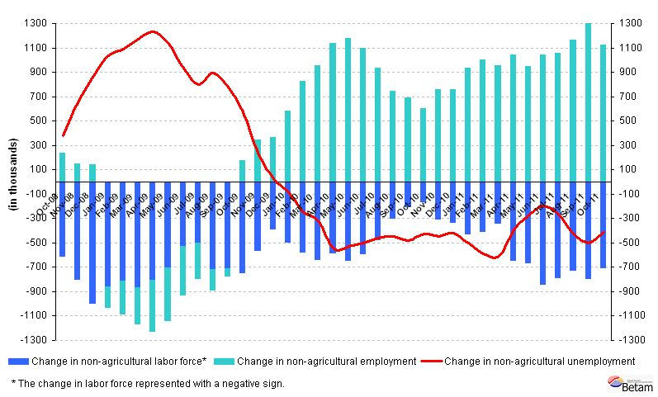
Source: TurkStat, Betam

Seasonally adjusted non-agricultural unemployment was stagnant

According to seasonally adjusted series, non-agricultural labor force increased by 11 thousand in October compared to its level in September (Figure 2, App. 1 Table 1). Non-agricultural employment decreased by 28 thousand and reached 18 million 171 thousand. Consequently, the number of unemployed persons in non-agricultural sectors increased by 18 thousand and non-agricultural unemployment rate increased from 11.6 percent to 11.7 percent. Non-agricultural labor force was almost at the same level, while non-agricultural employment decreased a little. Non-agricultural employment had a decline, the first decline since August 2010.

Figure 2 Seasonally adjusted non-agricultural labor force, employment and unemployment
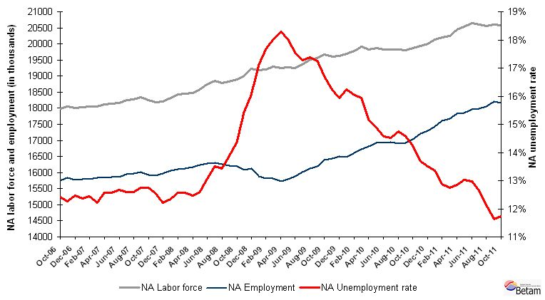
Source: TurkStat, Betam

According to Kariyer.net data, non-agricultural unemployment might decrease

The application per vacancy series released by Kariyer.net indicates that non-agricultural unemployment will decrease in October, November and December 2011. However, taking account the strong decline in the construction sector, we believe that non-agricultural unemployment rate may stagnate in the next period, November 2011.

Figure 3 Non-agricultural unemployment rate and application per vacancy (SA)
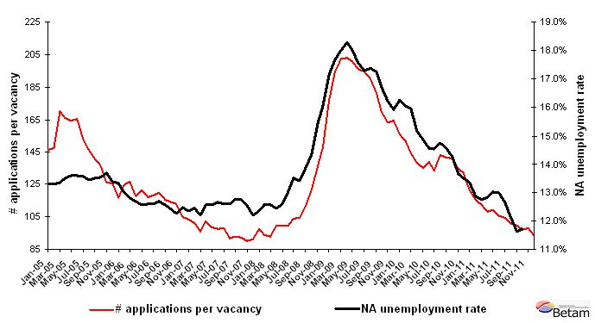
Data source: Kariyer.net, TurkStat, Betam

Employment in construction has started to fall

According to seasonally adjusted figures, employment in construction decreased by 95 thousand and employment in manufacturing sector decreased by 50 thousand in the period of October compared to the period of September (App. 1 Table 2, App. 2 Figure 4). In Betam Research Brief 11/123, we pointed to the surprising growth of employment in construction. We find that the employment elasticity of growth in construction had been extremely high during the crisis; hence we had been expecting a decrease in employment in construction. The decline of 95 thousand indicates that the decline has already started in construction.

We think that the decline in manufacturing employment corresponds to 2.5 percentage points decline in manufacturing output index pertaining to November 2011. We would like to point out the consistent decline in manufacturing employment since May 2011. In the period of October 2011, the increase of 56 thousand in service employment and the increase of 40 thousand in agricultural employment obviously compensated the negative impact of employment losses on unemployment.

Appendix 1: Table 1 Seasonally adjusted non-agricultural labor force indicators (in thousands)
 | Labor force | Employment | Unemployment | Unemployment rate | Monthly changes
September-08 | 18829 | 16219 | 2610 | 13.9% | Labor force | Employment | Unemployment
October-08 | 18896 | 16183 | 2713 | 14.4% | 68 | -36 | 104
November-08 | 19012 | 16079 | 2933 | 15.4% | 116 | -104 | 220
December-08 | 19217 | 16135 | 3082 | 16.0% | 205 | 56 | 149
January-09 | 19177 | 15892 | 3284 | 17.1% | -41 | -243 | 202
February-09 | 19215 | 15817 | 3399 | 17.7% | 39 | -75 | 114
March-09 | 19288 | 15813 | 3475 | 18.0% | 73 | -4 | 76
April-09 | 19256 | 15734 | 3522 | 18.3% | -32 | -79 | 47
May-09 | 19265 | 15794 | 3471 | 18.0% | 9 | 60 | -51
June-09 | 19256 | 15878 | 3378 | 17.5% | -9 | 84 | -93
July-09 | 19359 | 16015 | 3345 | 17.3% | 103 | 136 | -34
August-09 | 19517 | 16124 | 3393 | 17.4% | 157 | 110 | 48
September-09 | 19563 | 16189 | 3374 | 17.2% | 46 | 64 | -18
October-09 | 19667 | 16382 | 3285 | 16.7% | 104 | 193 | -89
November-09 | 19607 | 16428 | 3179 | 16.2% | -59 | 47 | -106
December-09 | 19634 | 16507 | 3127 | 15.9% | 26 | 79 | -53
January-10 | 19686 | 16487 | 3198 | 16.2% | 52 | -20 | 72
February-10 | 19793 | 16617 | 3176 | 16.0% | 107 | 129 | -23
March-10 | 19908 | 16734 | 3175 | 15.9% | 116 | 117 | -1
April-10 | 19821 | 16816 | 3005 | 15.2% | -88 | 82 | -170
May-10 | 19879 | 16923 | 2956 | 14.9% | 59 | 107 | -49
June-10 | 19821 | 16935 | 2886 | 14.6% | -58 | 12 | -70
July-10 | 19827 | 16947 | 2879 | 14.5% | 6 | 12 | -6
August-10 | 19828 | 16905 | 2923 | 14.7% | 1 | -42 | 43
September-10 | 19799 | 16916 | 2882 | 14.6% | -29 | 11 | -41
October-10 | 19864 | 17034 | 2831 | 14.2% | 65 | 117 | -52
November-10 | 19945 | 17218 | 2727 | 13.7% | 81 | 185 | -104
December-10 | 19995 | 17294 | 2700 | 13.5% | 49 | 76 | -27
January-11 | 20130 | 17440 | 2690 | 13.4% | 136 | 146 | -10
February-11 | 20209 | 17606 | 2604 | 12.9% | 79 | 166 | -87
March-11 | 20257 | 17676 | 2581 | 12.7% | 48 | 71 | -22
April-11 | 20452 | 17827 | 2625 | 12.8% | 195 | 151 | 44
May-11 | 20524 | 17852 | 2672 | 13.0% | 72 | 25 | 47
June-11 | 20639 | 17959 | 2680 | 13.0% | 114 | 107 | 8
July-11 | 20599 | 17993 | 2606 | 12.7% | -40 | 34 | -74
August-11 | 20558 | 18065 | 2493 | 12.1% | -41 | 72 | -113
September-11 | 20595 | 18199 | 2396 | 11.6% | 37 | 134 | -97
October-11 | 20585 | 18171 | 2414 | 11.7% | -11 | -28 | 18
Source: TurkStat, Betam

Appendix 1: Table 2 Seasonally adjusted sector of employment (in thousands)
 | Agriculture | Manufacturing | Construction | Service | Monthly changes
September-08 | 5103 | 4454 | 1232 | 10518 | Agriculture | Manufacturing | Construction | Service
October-08 | 5193 | 4394 | 1244 | 10513 | 89 | -60 | 12 | -5
November-08 | 5120 | 4295 | 1206 | 10554 | -73 | -99 | -37 | 40
December-08 | 4961 | 4248 | 1223 | 10641 | -159 | -47 | 16 | 88
January-09 | 4977 | 4132 | 1249 | 10549 | 16 | -116 | 27 | -93
February-09 | 5008 | 4100 | 1257 | 10492 | 31 | -32 | 7 | -57
March-09 | 4985 | 4019 | 1263 | 10553 | -23 | -81 | 6 | 61
April-09 | 5005 | 3977 | 1231 | 10529 | 20 | -42 | -32 | -24
May-09 | 5152 | 3961 | 1262 | 10577 | 147 | -16 | 31 | 48
June-09 | 5251 | 3973 | 1289 | 10618 | 99 | 12 | 28 | 41
July-09 | 5341 | 4032 | 1309 | 10677 | 90 | 59 | 19 | 59
August-09 | 5318 | 4051 | 1313 | 10740 | -24 | 19 | 5 | 63
September-09 | 5410 | 4115 | 1316 | 10724 | 93 | 64 | 3 | -16
October-09 | 5467 | 4159 | 1362 | 10813 | 56 | 44 | 46 | 89
November-09 | 5514 | 4221 | 1382 | 10818 | 47 | 62 | 21 | 5
December-09 | 5560 | 4295 | 1395 | 10810 | 46 | 74 | 12 | -8
January-10 | 5657 | 4332 | 1375 | 10812 | 97 | 37 | -19 | 2
February-10 | 5633 | 4385 | 1367 | 10898 | -23 | 52 | -9 | 85
March-10 | 5599 | 4357 | 1414 | 10997 | -35 | -28 | 47 | 100
April-10 | 5667 | 4409 | 1444 | 10992 | 68 | 52 | 30 | -5
May-10 | 5597 | 4479 | 1429 | 11039 | -71 | 70 | -15 | 47
June-10 | 5707 | 4528 | 1430 | 10991 | 111 | 49 | 2 | -48
July-10 | 5685 | 4538 | 1470 | 10940 | -22 | 10 | 39 | -50
August-10 | 5673 | 4485 | 1420 | 10967 | -12 | -53 | -49 | 27
September-10 | 5697 | 4443 | 1426 | 10997 | 24 | -42 | 6 | 30
October-10 | 5829 | 4448 | 1448 | 11052 | 132 | 5 | 22 | 55
November-10 | 5873 | 4639 | 1505 | 11059 | 43 | 191 | 58 | 8
December-10 | 6005 | 4648 | 1540 | 11098 | 132 | 9 | 34 | 39
January-11 | 6008 | 4712 | 1527 | 11222 | 3 | 64 | -12 | 124
February-11 | 6141 | 4728 | 1572 | 11339 | 133 | 17 | 44 | 117
March-11 | 6165 | 4833 | 1591 | 11290 | 24 | 104 | 19 | -49
April-11 | 6073 | 4840 | 1637 | 11394 | -92 | 7 | 46 | 104
May-11 | 6047 | 4777 | 1681 | 11430 | -26 | -63 | 44 | 36
June-11 | 6080 | 4689 | 1713 | 11578 | 32 | -88 | 33 | 148
July-11 | 6113 | 4673 | 1717 | 11607 | 34 | -15 | 3 | 29
August-11 | 6199 | 4645 | 1786 | 11612 | 86 | -28 | 70 | 4
September-11 | 6181 | 4661 | 1794 | 11707 | -18 | 16 | 8 | 95
October-11 | 6221 | 4611 | 1699 | 11763 | 40 | -50 | -95 | 56
Source: TurkStat, Betam
Appendix 2: Figure 4 Employment changes in sectors (in thousand)
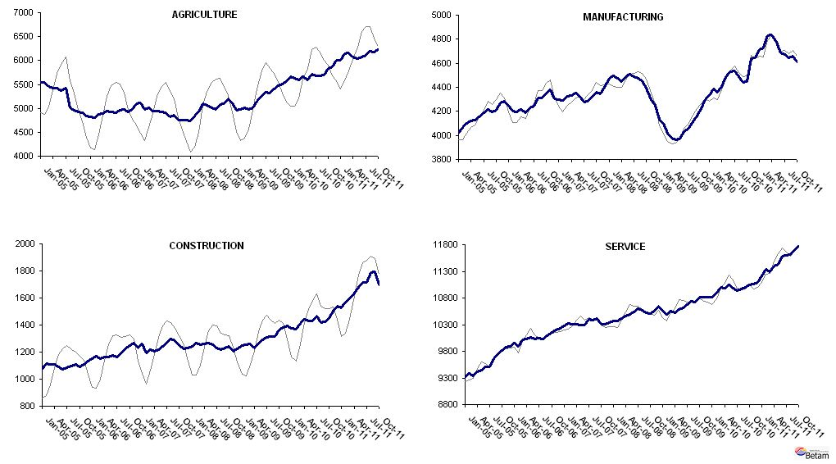
Source: TurkStat, Betam

* Prof. Seyfettin Gürsel, Betam, Director, seyfettin.gursel@bahcesehir.edu.tr
∗ Assoc. Prof. Gökçe Uysal, Betam, Vice Director, gokce.uysal @bahcesehir.edu.tr
∗∗ Aysenur Acar, Betam, Research Assistant, aysenur.acar@bahcesehir.edu.tr
Starting from April, Betam will be using a new series released by Kariyer.net on application per vacancy. Kariyer.net collects this data via their website which is one of the largest job search engines in Turkey. Given the lack of data on vacancies in Turkey, we believe that this new series will provide useful insight to the labor market in Turkey. It provides information on the number of unemployed who are actively seeking work as well as the number of jobs that are available in the labor market. A decrease in applications per vacancy may be caused by an increase in vacancies or by a decrease in the number of applications. An increase in vacancies signals economic growth while decreasing number of applications indicates a decrease in number of people looking for a job. Figure 3 illustrates the seasonally adjusted non-agricultural unemployment rate and deseasonalized calendar day adjusted application per vacancy (Kariyer.net) series. It is clear that these series are highly correlated (almost 90 percent).
Seasonal adjustment procedure is applied to each sector of employment series separately. Hence the sum of these series may differ from the seasonally adjusted series of total employment. The difference stems from the non-linearity of the seasonal adjustment process.
Grey lines indicate seasonally adjusted series, where dark blue lines represent raw data.

