

Labor Market Outlook:

December 2011

December 15, 2011

RAPID DECLINE IN UNEMPLOYMENT

Seyfettin Gursel*, Gokce Uysal ∗ and Aysenur Acar∗

Executive Summary

According to the labor market statistics released by TurkStat, non-agricultural unemployment rate fell by 3 percentage points to 11.3 percent in the period of September 2011 compared to previous year. Seasonally adjusted labor market data shows that non-agricultural unemployment rate fell by 0.5 percentage points and decreased from 11.9 percent to 11.4 percent during September 2011 compared to the period of August 2011. Non-agricultural unemployment rate has been rapidly falling during the periods of July, August and September. The increase in non-agricultural employment is caused mainly by an increase in the service sector employment during the period of September. Manufacturing employment, which has been falling since April, increased during this period as well.

Rapid increase in non-agricultural employment

According to the labor market statistics released by TurkStat on the 15th of December, non-agricultural employment has reached 18 million 274 thousand in the period of September 2011 (August – September – October). Raw labor market statistics reveal that non-agricultural labor force increased by 796 thousand (4 percent) and non-agricultural employment increased by 1 million 300 thousand (7.7 percent) and non-agricultural unemployment rate decreased from 14.3 percent to 11.3 percent during the same period in August 2011 on a year-on-year basis (Figure 1). The number of unemployed persons in non-agricultural sectors decreased by 504 thousand on a year-on-year basis and retreated to 2 million 328 thousand. The strong increase of 1 million 300 thousand in non-agricultural employment in the period of September 2011 is behind this rapid decline.

Figure 1 Year-on-year changes in non-agricultural labor force, employment and unemployment
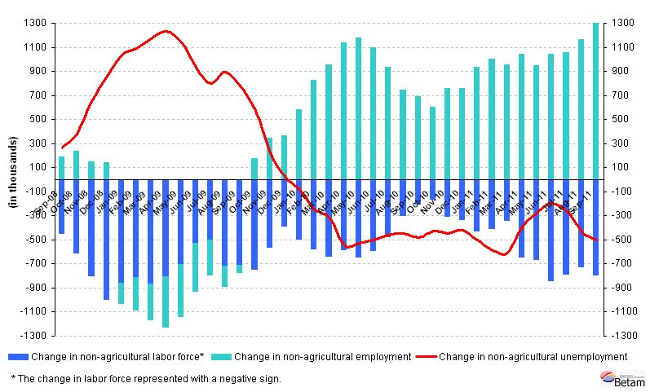
Source: TurkStat, Betam

Accelerating decline in seasonally adjusted non-agricultural unemployment

According to seasonally adjusted series, non-agricultural labor force increased by 41 thousand in September compared to its level in August and was 20 million 611 thousand (Figure 2, App. 1 Table 1). On the other hand, non-agricultural employment increased by 141 thousand and reached 18 million 254 thousand. Consequently, the number of unemployed persons in non-agricultural sectors decreased by 100 thousand and non-agricultural unemployment rate decreased from 11.9 percent to 11.4 percent (0.5 percentage points). Non-agricultural unemployment rate decreased by 0.4 percentage points from June to July, by 0.6 percentage points from July to August, by 0.5 percentage points from August to September. Non-agricultural unemployment rate has been falling rapidly.

Figure 2 Seasonally adjusted non-agricultural labor force, employment and unemployment
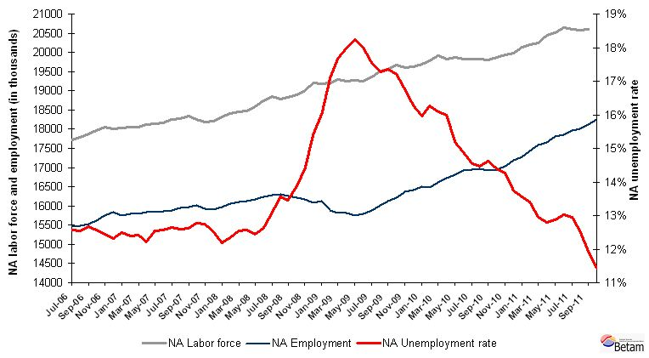
Source: TurkStat, Betam

According to Kariyer.net data, decrease in non-agricultural unemployment will slow down in the period of October 2011

The application per vacancy series released by Kariyer.net indicates that non-agricultural unemployment will stagnate in September, October and November 2011. On the other hand, taking account the strong decline in the non-agricultural unemployment rate, we believe that the decrease in non-agricultural unemployment rate will slow down in the period of October 2011.

Figure 3 Non-agricultural unemployment rate and application per vacancy (SA)
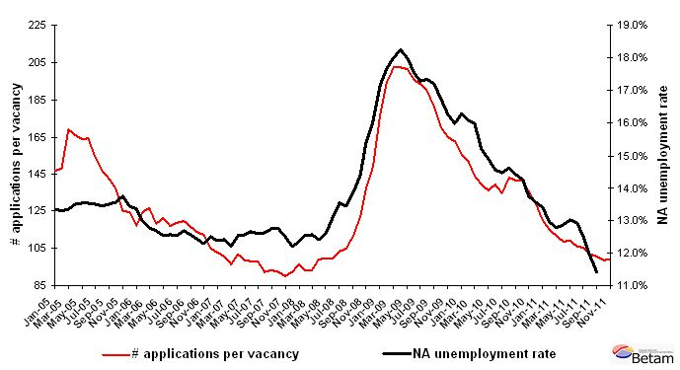
Data source: Kariyer.net, TurkStat, Betam

Strong increase in employment levels in services

According to seasonally adjusted figures, the increase in non-agricultural employment is mainly caused by the increase of 95 thousand in service sector. (App. 1 Table 2, App. 2 Figure 4). An increase of 16 thousand in manufacturing employment is also striking given that it has been decreasing for last five periods. Note that the increase in manufacturing employment is in line with the increase in the manufacturing production index.

Appendix 1: Table 1 Seasonally adjusted non-agricultural labor force indicators (in thousands)
 | Labor force | Employment | Unemployment | Unemployment rate | Monthly changes
August-08 | 18791 | 16264 | 2527 | 13.4% | Labor force | Employment | Unemployment
September-08 | 18832 | 16221 | 2612 | 13.9% | 42 | -43 | 85
October-08 | 18893 | 16175 | 2719 | 14.4% | 61 | -46 | 107
November-08 | 19009 | 16078 | 2931 | 15.4% | 116 | -96 | 212
December-08 | 19214 | 16131 | 3084 | 16.0% | 205 | 52 | 153
January-09 | 19175 | 15889 | 3286 | 17.1% | -40 | -242 | 202
February-09 | 19213 | 15817 | 3396 | 17.7% | 39 | -72 | 111
March-09 | 19286 | 15816 | 3471 | 18.0% | 73 | -2 | 74
April-09 | 19256 | 15744 | 3512 | 18.2% | -30 | -72 | 42
May-09 | 19266 | 15801 | 3465 | 18.0% | 10 | 57 | -47
June-09 | 19259 | 15884 | 3374 | 17.5% | -8 | 83 | -91
July-09 | 19362 | 16019 | 3344 | 17.3% | 104 | 134 | -30
August-09 | 19521 | 16135 | 3387 | 17.3% | 159 | 116 | 43
September-09 | 19570 | 16205 | 3365 | 17.2% | 48 | 70 | -22
October-09 | 19663 | 16370 | 3293 | 16.7% | 94 | 165 | -71
November-09 | 19604 | 16416 | 3188 | 16.3% | -59 | 46 | -105
December-09 | 19631 | 16495 | 3135 | 16.0% | 27 | 79 | -53
January-10 | 19683 | 16481 | 3202 | 16.3% | 52 | -15 | 67
February-10 | 19789 | 16607 | 3182 | 16.1% | 106 | 126 | -20
March-10 | 19905 | 16725 | 3180 | 16.0% | 116 | 118 | -2
April-10 | 19819 | 16810 | 3009 | 15.2% | -86 | 86 | -171
May-10 | 19879 | 16921 | 2958 | 14.9% | 60 | 110 | -51
June-10 | 19823 | 16938 | 2885 | 14.6% | -56 | 17 | -74
July-10 | 19831 | 16961 | 2871 | 14.5% | 8 | 23 | -14
August-10 | 19836 | 16935 | 2901 | 14.6% | 4 | -26 | 30
September-10 | 19810 | 16956 | 2853 | 14.4% | -26 | 22 | -48
October-10 | 19859 | 17025 | 2835 | 14.3% | 50 | 69 | -19
November-10 | 19940 | 17200 | 2740 | 13.7% | 81 | 175 | -94
December-10 | 19990 | 17279 | 2711 | 13.6% | 50 | 79 | -29
January-11 | 20126 | 17428 | 2698 | 13.4% | 136 | 149 | -13
February-11 | 20205 | 17587 | 2619 | 13.0% | 79 | 159 | -80
March-11 | 20254 | 17663 | 2591 | 12.8% | 49 | 76 | -27
April-11 | 20450 | 17815 | 2635 | 12.9% | 196 | 152 | 44
May-11 | 20524 | 17852 | 2672 | 13.0% | 73 | 37 | 37
June-11 | 20640 | 17968 | 2672 | 12.9% | 117 | 116 | 1
July-11 | 20605 | 18020 | 2585 | 12.5% | -35 | 52 | -87
August-11 | 20570 | 18113 | 2457 | 11.9% | -36 | 92 | -128
September-11 | 20611 | 18254 | 2357 | 11.4% | 41 | 141 | -100
Source: TurkStat, Betam

Appendix 1: Table 2 Seasonally adjusted sector of employment (in thousands)
 | Agriculture | Manufacturing | Construction | Service | Monthly changes
August-08 | 5085 | 4478 | 1216 | 10568 | Agriculture | Manufacturing | Construction | Service
September-08 | 5103 | 4455 | 1232 | 10517 | 18 | -24 | 17 | -51
October-08 | 5192 | 4392 | 1243 | 10514 | 89 | -62 | 11 | -3
November-08 | 5119 | 4303 | 1206 | 10554 | -72 | -90 | -36 | 40
December-08 | 4961 | 4256 | 1222 | 10642 | -158 | -46 | 16 | 88
January-09 | 4977 | 4109 | 1249 | 10548 | 16 | -147 | 27 | -94
February-09 | 5008 | 4078 | 1257 | 10491 | 30 | -31 | 8 | -57
March-09 | 4985 | 4029 | 1263 | 10553 | -22 | -49 | 6 | 62
April-09 | 5005 | 3988 | 1231 | 10529 | 20 | -41 | -32 | -24
May-09 | 5153 | 3968 | 1261 | 10577 | 148 | -21 | 30 | 48
June-09 | 5251 | 3979 | 1289 | 10618 | 99 | 11 | 27 | 41
July-09 | 5342 | 4035 | 1308 | 10677 | 90 | 56 | 19 | 59
August-09 | 5319 | 4061 | 1314 | 10739 | -23 | 26 | 6 | 62
September-09 | 5412 | 4124 | 1318 | 10722 | 93 | 63 | 4 | -18
October-09 | 5466 | 4161 | 1361 | 10816 | 54 | 37 | 44 | 94
November-09 | 5513 | 4226 | 1382 | 10819 | 47 | 65 | 20 | 4
December-09 | 5559 | 4296 | 1393 | 10811 | 46 | 70 | 12 | -8
January-10 | 5656 | 4305 | 1376 | 10812 | 97 | 9 | -17 | 2
February-10 | 5632 | 4356 | 1368 | 10899 | -24 | 50 | -8 | 86
March-10 | 5598 | 4369 | 1414 | 10998 | -34 | 14 | 46 | 100
April-10 | 5667 | 4412 | 1444 | 10992 | 69 | 43 | 29 | -6
May-10 | 5598 | 4477 | 1428 | 11039 | -70 | 65 | -16 | 46
June-10 | 5708 | 4528 | 1429 | 10991 | 110 | 51 | 1 | -48
July-10 | 5687 | 4536 | 1468 | 10939 | -21 | 8 | 39 | -52
August-10 | 5675 | 4499 | 1421 | 10964 | -11 | -38 | -47 | 25
September-10 | 5700 | 4460 | 1429 | 10993 | 24 | -39 | 8 | 29
October-10 | 5829 | 4452 | 1448 | 11055 | 129 | -7 | 19 | 63
November-10 | 5872 | 4645 | 1505 | 11061 | 43 | 192 | 56 | 5
December-10 | 6004 | 4649 | 1538 | 11098 | 132 | 4 | 33 | 38
January-11 | 6006 | 4683 | 1529 | 11223 | 3 | 34 | -9 | 124
February-11 | 6138 | 4696 | 1574 | 11342 | 132 | 13 | 44 | 119
March-11 | 6164 | 4850 | 1592 | 11291 | 25 | 154 | 18 | -51
April-11 | 6073 | 4838 | 1636 | 11394 | -91 | -11 | 45 | 104
May-11 | 6049 | 4773 | 1679 | 11430 | -24 | -65 | 43 | 35
June-11 | 6081 | 4697 | 1712 | 11578 | 32 | -77 | 32 | 149
July-11 | 6115 | 4680 | 1715 | 11605 | 34 | -16 | 4 | 27
August-11 | 6202 | 4667 | 1786 | 11607 | 87 | -13 | 71 | 2
September-11 | 6185 | 4683 | 1796 | 11702 | -17 | 16 | 10 | 95
Source: TurkStat, Betam
Appendix 2: Figure 4 Employment changes in sectors (in thousand)
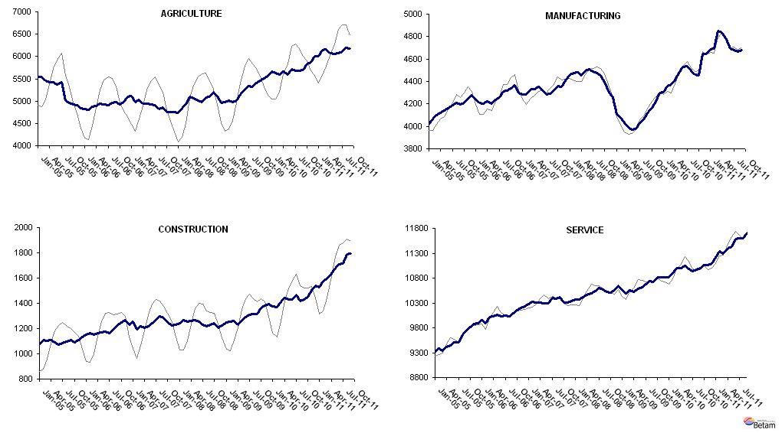
Source: TurkStat, Betam

* Prof. Seyfettin Gürsel, Betam, Director, seyfettin.gursel@bahcesehir.edu.tr
∗ Assoc. Prof. Gökçe Uysal, Betam, Vice Director, gokce.uysal @bahcesehir.edu.tr
∗∗ Aysenur Acar, Betam, Research Assistant, aysenur.acar@bahcesehir.edu.tr
Starting from April, Betam will be using a new series released by Kariyer.net on application per vacancy. Kariyer.net collects this data via their website which is one of the largest job search engines in Turkey. Given the lack of data on vacancies in Turkey, we believe that this new series will provide useful insight to the labor market in Turkey. It provides information on the number of unemployed who are actively seeking work as well as the number of jobs that are available in the labor market. A decrease in applications per vacancy may be caused by an increase in vacancies or by a decrease in the number of applications. An increase in vacancies signals economic growth while decreasing number of applications indicates a decrease in number of people looking for a job. Figure 3 illustrates the seasonally adjusted non-agricultural unemployment rate and deseasonalized calendar day adjusted application per vacancy (Kariyer.net) series. It is clear that these series are highly correlated (almost 90 percent).
Seasonal adjustment procedure is applied to each sector of employment series separately. Hence the sum of these series may differ from the seasonally adjusted series of total employment. The difference stems from the non-linearity of the seasonal adjustment process.
Grey lines indicate seasonally adjusted series, where dark blue lines represent raw data.

