

Labor Market Outlook:

November 2011

November 15, 2011

SHARP DECLINE IN UNEMPLOYMENT

Seyfettin Gursel*, Gokce Uysal ∗ and Aysenur Acar∗

Executive Summary

According to the labor market statistics released by TurkStat, non-agricultural unemployment rate fell by 2.6 percentage points to 11.9 percent in the period of August 2011 compared to previous year. Seasonally adjusted labor market data shows that non-agricultural unemployment rate fell 0.5 percentage poinst and decreased from 12.6 percent in July to 12.1 percent compared to August. Reasons behind the sharp decline are the decline in seasonally adjusted non-agricultural labor force and the increase in non-agricultural employment. As for sectoral data, manufacturing employment decreased, agricultural and construction employment increased considerably in this period.

Slowdown in increase in labor force and employment acceleration

According to the labor market statistics released by TurkStat on the 15th of November, non-agricultural employment has reached 18 million 180 thousand in the period of August 2011 (July – August – September). Raw labor market statistics reveal that non-agricultural labor force increased by 733 thousand (3.7 percent) and non-agricultural employment increased by 1 million 163 thousand (6.8 percent) in August 2011 on a year-on-year basis. Non-agricultural unemployment rate decreased from 14.5 percent to 11.9 percent during the same period (Figure 1). The number of unemployed decreased by 430 thousand and was 2 million 456 thousand. Clearly, the increase in non-agricultural labor force slowed down compared to the period of July 2011 on year-on-year basis. Moreover, the increase in employment remained strong.

Figure 1 Year-on-year changes in non-agricultural labor force, employment and unemployment
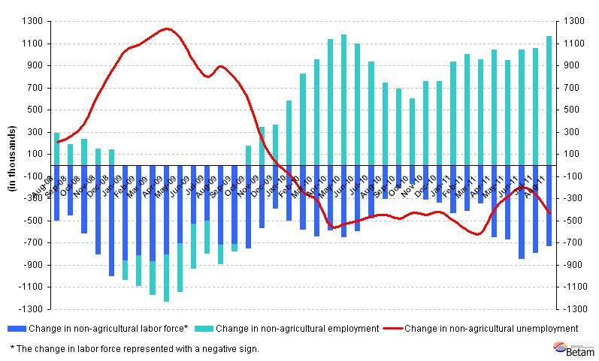
Source: TurkStat, Betam

Sharp decline in seasonally adjusted non-agricultural unemployment

According to seasonally adjusted series, non-agricultural labor force decreased by 35 thousand in August compared to its level in July and was 20 million 567 thousand. On the other hand, non-agricultural employment increased by 88 thousand and reached 18 million 86 thousand. Consequently, non-agricultural unemployment rate decreased from 12.6 percent to 12.1 percent. This decrease of 0.5 percentage points has been the largest decline during the crisis and the recovery. Non-agricultural unemployment decreased by 0.4 percentage points compared to the previous month (Figure 2, App. 1 Table 1).

Figure 2 Seasonally adjusted non-agricultural labor force, employment and unemployment
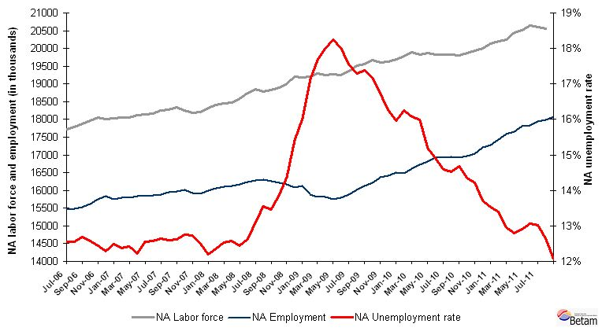
Source: TurkStat, Betam

According to Kariyer.net data, non-agricultural unemployment will continue to decrease in the period of September 2011

The application per vacancy series released by Kariyer.net decreases in August, September and October 2011. Note that the unemployment rate which will be released next month, refers to the period of September, i.e. the average of August, September and October. Therefore, we expect the seasonally adjusted non-agricultural unemployment rate to decrease further in the period of September 2011.

Figure 3 Non-agricultural unemployment rate and application per vacancy (SA)
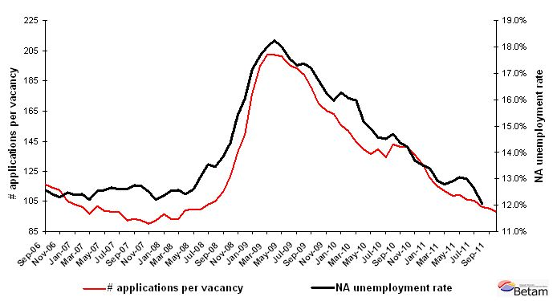
Data source: Kariyer.net, TurkStat, Betam

Strong increase in employment levels in agriculture and construction

According to seasonally adjusted figures, employment in the construction sector increased by 70 thousand and employment in service sector only increased by 2 thousand in August 2011. However, employment in the manufacturing sector experienced a decrease of 16 thousand (App. 1 Table 2, App. 2 Figure 4).2. Consequently, the increase in non-agricultural employment is mainly caused by increase in construction sector.

Seasonally adjusted labor force data shows that agricultural employment increased, by 38 and 90 thousand in the period of July and August 2011 respectively. Strong increasses in agricultural employment are striking.

Appendix 1: Table 1 Seasonally adjusted non-agricultural labor force indicators (in thousands)
 | Labor force | Employment | Unemployment | Unemployment rate | Monthly changes
July-08 | 18857 | 16300 | 2557 | 13,6% | Labor force | Employment | Unemployment
August-08 | 18790 | 16260 | 2530 | 13,5% | -68 | -40 | -27
September-08 | 18833 | 16223 | 2610 | 13,9% | 43 | -37 | 80
October-08 | 18894 | 16178 | 2716 | 14,4% | 62 | -45 | 107
November-08 | 19011 | 16081 | 2929 | 15,4% | 116 | -97 | 213
December-08 | 19214 | 16133 | 3082 | 16,0% | 204 | 51 | 153
January-09 | 19175 | 15890 | 3285 | 17,1% | -40 | -243 | 203
February-09 | 19213 | 15818 | 3395 | 17,7% | 38 | -73 | 111
March-09 | 19285 | 15815 | 3470 | 18,0% | 72 | -2 | 75
April-09 | 19256 | 15743 | 3513 | 18,2% | -29 | -72 | 43
May-09 | 19266 | 15799 | 3467 | 18,0% | 10 | 56 | -46
June-09 | 19258 | 15881 | 3378 | 17,5% | -8 | 82 | -89
July-09 | 19361 | 16013 | 3348 | 17,3% | 103 | 133 | -30
August-09 | 19520 | 16128 | 3392 | 17,4% | 159 | 115 | 44
September-09 | 19571 | 16211 | 3360 | 17,2% | 51 | 83 | -32
October-09 | 19665 | 16377 | 3288 | 16,7% | 94 | 166 | -72
November-09 | 19606 | 16422 | 3185 | 16,2% | -58 | 45 | -104
December-09 | 19632 | 16500 | 3133 | 16,0% | 26 | 78 | -52
January-10 | 19684 | 16483 | 3200 | 16,3% | 51 | -16 | 68
February-10 | 19789 | 16608 | 3181 | 16,1% | 105 | 124 | -19
March-10 | 19903 | 16724 | 3180 | 16,0% | 115 | 116 | -1
April-10 | 19818 | 16807 | 3011 | 15,2% | -86 | 83 | -169
May-10 | 19877 | 16915 | 2962 | 14,9% | 59 | 108 | -49
June-10 | 19821 | 16930 | 2891 | 14,6% | -56 | 15 | -71
July-10 | 19829 | 16950 | 2879 | 14,5% | 9 | 20 | -12
August-10 | 19834 | 16921 | 2913 | 14,7% | 5 | -29 | 34
September-10 | 19813 | 16969 | 2844 | 14,4% | -21 | 48 | -70
October-10 | 19863 | 17040 | 2823 | 14,2% | 50 | 71 | -21
November-10 | 19944 | 17212 | 2732 | 13,7% | 81 | 172 | -91
December-10 | 19993 | 17288 | 2705 | 13,5% | 49 | 76 | -27
January-11 | 20128 | 17434 | 2694 | 13,4% | 134 | 145 | -11
February-11 | 20205 | 17588 | 2617 | 13,0% | 77 | 154 | -77
March-11 | 20253 | 17660 | 2592 | 12,8% | 48 | 72 | -25
April-11 | 20448 | 17808 | 2640 | 12,9% | 195 | 148 | 48
May-11 | 20520 | 17840 | 2680 | 13,1% | 72 | 32 | 40
June-11 | 20636 | 17951 | 2685 | 13,0% | 116 | 111 | 5
July-11 | 20602 | 17998 | 2604 | 12,6% | -35 | 47 | -81
August-11 | 20567 | 18086 | 2481 | 12,1% | -35 | 88 | -123
Source: TurkStat, Betam

Appendix 1: Table 2 Seasonally adjusted sector of employment (in thousands)
 | Agriculture | Manufacturing | Construction | Service | Monthly changes
July-08 | 4985 | 4488 | 1234 | 10588 | Agriculture | Manufacturing | Construction | Service
August-08 | 5090 | 4476 | 1217 | 10563 | 104 | -11 | -17 | -25
September-08 | 5098 | 4456 | 1231 | 10521 | 9 | -21 | 14 | -42
October-08 | 5187 | 4394 | 1242 | 10518 | 89 | -61 | 11 | -3
November-08 | 5116 | 4304 | 1205 | 10557 | -71 | -90 | -37 | 39
December-08 | 4959 | 4257 | 1222 | 10644 | -157 | -47 | 17 | 86
January-09 | 4976 | 4110 | 1249 | 10550 | 17 | -147 | 27 | -93
February-09 | 5007 | 4079 | 1257 | 10493 | 31 | -32 | 8 | -57
March-09 | 4986 | 4029 | 1263 | 10553 | -21 | -50 | 7 | 60
April-09 | 5007 | 3988 | 1231 | 10528 | 21 | -41 | -32 | -25
May-09 | 5156 | 3966 | 1262 | 10574 | 149 | -21 | 31 | 47
June-09 | 5256 | 3977 | 1290 | 10614 | 100 | 11 | 28 | 39
July-09 | 5347 | 4032 | 1310 | 10671 | 92 | 55 | 19 | 58
August-09 | 5326 | 4057 | 1315 | 10733 | -21 | 25 | 5 | 62
September-09 | 5404 | 4126 | 1315 | 10729 | 79 | 68 | 0 | -4
October-09 | 5459 | 4165 | 1360 | 10821 | 55 | 39 | 45 | 92
November-09 | 5508 | 4229 | 1381 | 10824 | 49 | 64 | 21 | 4
December-09 | 5555 | 4299 | 1394 | 10815 | 48 | 69 | 13 | -10
January-10 | 5654 | 4307 | 1375 | 10816 | 98 | 8 | -19 | 1
February-10 | 5631 | 4357 | 1367 | 10899 | -23 | 49 | -8 | 83
March-10 | 5599 | 4369 | 1414 | 10996 | -32 | 13 | 48 | 98
April-10 | 5670 | 4411 | 1444 | 10989 | 71 | 41 | 30 | -7
May-10 | 5602 | 4474 | 1429 | 11033 | -68 | 63 | -15 | 44
June-10 | 5714 | 4524 | 1431 | 10983 | 112 | 50 | 2 | -50
July-10 | 5695 | 4531 | 1471 | 10931 | -19 | 7 | 39 | -52
August-10 | 5686 | 4492 | 1422 | 10955 | -9 | -39 | -49 | 24
September-10 | 5689 | 4463 | 1425 | 11006 | 2 | -28 | 3 | 50
October-10 | 5819 | 4459 | 1446 | 11064 | 130 | -4 | 21 | 59
November-10 | 5864 | 4651 | 1504 | 11070 | 45 | 191 | 58 | 6
December-10 | 5998 | 4653 | 1539 | 11106 | 134 | 2 | 35 | 36
January-11 | 6003 | 4686 | 1527 | 11227 | 5 | 33 | -12 | 121
February-11 | 6137 | 4697 | 1572 | 11340 | 134 | 11 | 45 | 113
March-11 | 6165 | 4849 | 1591 | 11289 | 28 | 152 | 20 | -51
April-11 | 6077 | 4836 | 1637 | 11390 | -88 | -13 | 46 | 101
May-11 | 6056 | 4768 | 1681 | 11422 | -21 | -67 | 44 | 32
June-11 | 6091 | 4689 | 1714 | 11565 | 35 | -79 | 33 | 144
July-11 | 6128 | 4670 | 1718 | 11592 | 38 | -19 | 3 | 26
August-11 | 6218 | 4654 | 1788 | 11593 | 90 | -16 | 70 | 2
Source: TurkStat, Betam
Appendix 2: Figure 4 Employment changes in sectors (in thousand)
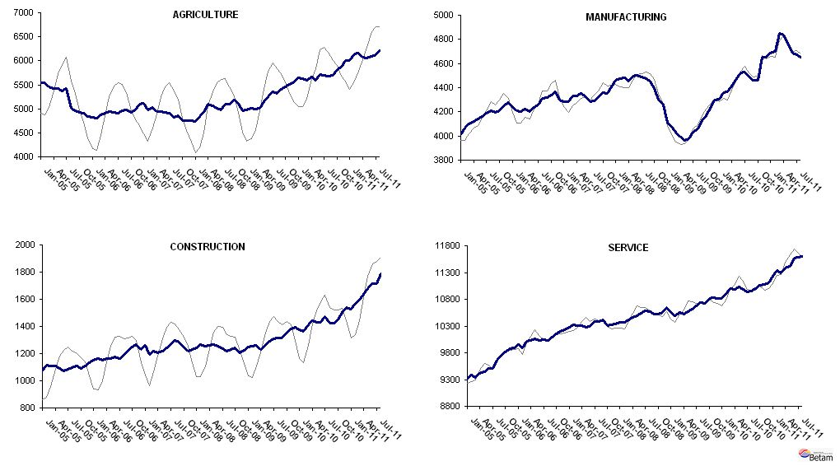
Source: TurkStat, Betam

* Prof. Seyfettin Gürsel, Betam, Director, seyfettin.gursel@bahcesehir.edu.tr
∗ Assoc. Prof. Gökçe Uysal, Betam, Vice Director, gokce.uysal @bahcesehir.edu.tr
∗∗ Aysenur Acar, Betam, Research Assistant, aysenur.acar@bahcesehir.edu.tr
Starting from April, Betam will be using a new series released by Kariyer.net on application per vacancy. Kariyer.net collects this data via their website which is one of the largest job search engines in Turkey. Given the lack of data on vacancies in Turkey, we believe that this new series will provide useful insight to the labor market in Turkey. It provides information on the number of unemployed who are actively seeking work as well as the number of jobs that are available in the labor market. A decrease in applications per vacancy may be caused by an increase in vacancies or by a decrease in the number of applications. An increase in vacancies signals economic growth while decreasing number of applications indicates a decrease in number of people looking for a job. Figure 3 illustrates the seasonally adjusted non-agricultural unemployment rate and deseasonalized calendar day adjusted application per vacancy (Kariyer.net) series. It is clear that these series are highly correlated (almost 90 percent).
Grey lines indicate seasonally adjusted series, where dark blue lines represent raw data.

