

Labor Market Outlook:

October 2011

October 17, 2011

UNEMPLOYMENT RATE IS DECREASING

Seyfettin Gursel*, Gokce Uysal ∗ and Aysenur Acar∗

Executive Summary

According to the labor market statistics released by TurkStat, non-agricultural unemployment rate fell to 11.8 percent in the period of July 2011. Seasonally adjusted labor market data shows that non-agricultural unemployment rate decreased from 13.2 percent to 12.8 percent in the period of June 2011. Seasonally adjusted data indicates that non-agricultural labor force decreased and non-agricultural employment increased compared to previous period. As for sectoral data, manufacturing employment decreased, agricultural employment increased in this period.

Decrease in unemployment continues

According to the labor market statistics released by TurkStat on the 17th of October, non-agricultural employment has reached 18 million 248 thousand in the period of July 2011 (June – July – August). Raw labor market statistics reveal that non-agricultural labor force increased by 789 thousand (4 percent) and non-agricultural employment increased by 1 million 54 thousand (6.1 percent) in July 2011 on a year-on-year basis. Non-agricultural unemployment rate decreased from 13.6 percent to 11.8 percent during the same period (Figure 1). The number of unemployed fell to 2 million 441 thousand since increase in non-agricultural labor force slowed down compared to the period of June 2011 on year-on-year basis whereas the increase in employment was as strong.

Figure 1 Year-on-year changes in non-agricultural labor force, employment and unemployment
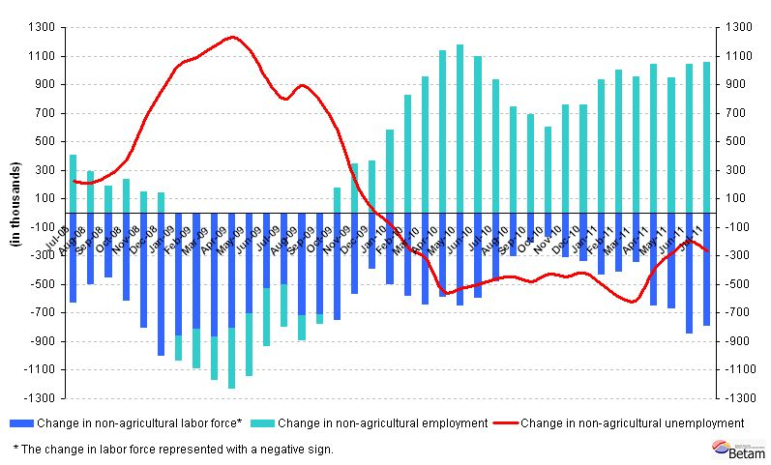
Source: TurkStat, Betam

Seasonally adjusted non-agricultural unemployment is decreasing

According to seasonally adjusted series, non-agricultural labor force decreased by 37 thousand in July compared to its level in June and was 20 million 623 thousand. However, non-agricultural employment increased 49 thousand and reached 17 million 986 thousand. Consequently, non-agricultural unemployment rate decreased from 13.2 percent to 12.8 percent (Figure 2). Hence, non-agricultural unemployment rate retreated to its pre-crisis level.

Figure 2 Seasonally adjusted non-agricultural labor force, employment and unemployment
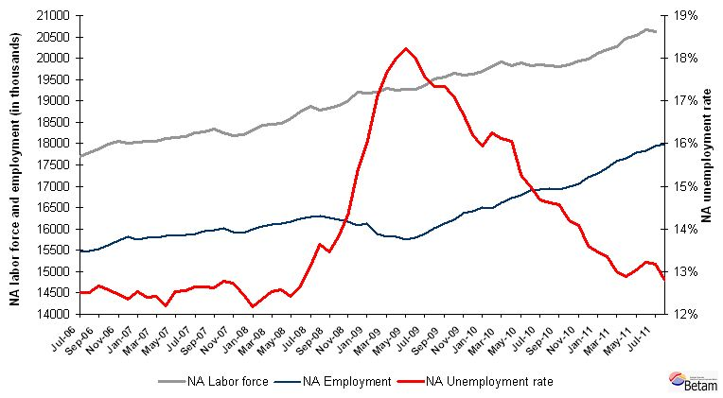
Source: TurkStat, Betam

According to Kariyer.net data, non-agricultural unemployment will continue to decrease in the period of August 2011

The application per vacancy series released by Kariyer.net decreased in August and September 2011. In the light of this data and given the fact that labor force data, which will be the average of July – August – September, we expect seasonally adjusted non-agricultural employment rate to decrease in August 2011.

Figure 3 Non-agricultural unemployment rate and application per vacancy (SA)
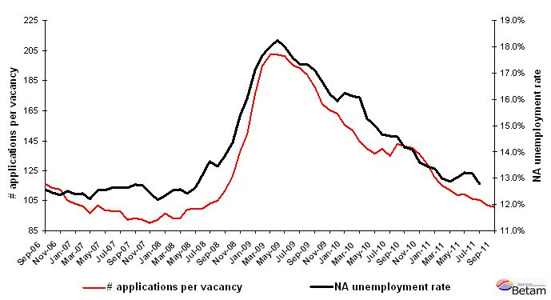
Data source: Kariyer.net, TurkStat, Betam

Manufacturing employment continues to decrease in the period of July 2011

According to seasonally adjusted figures, employment in the service sector increased by 25 thousand in July 2011 and employment in construction sector remained stagnant. (App. 1 Table 2, App. 2 Figure 4).2
On the other hand, manufacturing employment decreased by 19 thousand. Even though the industrial production index increased in July 2011, it decreased in August 2011. Remember that the labor market data for July pertains to the average of June, July and August. Thus, we believe that the decrease in employment in manufacturing during the period of July is still consistent.

Seasonally adjusted labor force data shows that agricultural employment increased, by 31 and 36 thousand in the period of June and July 2011 respectively. However, considering the total decrease in agricultural employment (108 thousand) in April and May, we think that the future path of agricultural employment remains uncertain.

Appendix 1: Table 1 Seasonally adjusted non-agricultural labor force indicators (in thousands)
 | Labor force | Employment | Unemployment | Unemployment rate | Monthly changes
June-08 | 18742 | 16281 | 2460 | 13.1% | Labor force | Employment | Unemployment
July-08 | 18865 | 16293 | 2572 | 13.6% | 123 | 12 | 112
August-08 | 18785 | 16256 | 2529 | 13.5% | -80 | -37 | -43
September-08 | 18827 | 16221 | 2607 | 13.8% | 42 | -36 | 78
October-08 | 18889 | 16177 | 2712 | 14.4% | 62 | -43 | 105
November-08 | 19005 | 16086 | 2919 | 15.4% | 116 | -92 | 208
December-08 | 19213 | 16134 | 3080 | 16.0% | 208 | 48 | 160
January-09 | 19175 | 15891 | 3284 | 17.1% | -39 | -243 | 204
February-09 | 19216 | 15819 | 3397 | 17.7% | 42 | -71 | 113
March-09 | 19292 | 15817 | 3475 | 18.0% | 76 | -2 | 78
April-09 | 19260 | 15748 | 3512 | 18.2% | -32 | -69 | 37
May-09 | 19271 | 15801 | 3470 | 18.0% | 12 | 53 | -41
June-09 | 19264 | 15881 | 3383 | 17.6% | -8 | 80 | -87
July-09 | 19370 | 16010 | 3360 | 17.3% | 106 | 129 | -23
August-09 | 19512 | 16131 | 3382 | 17.3% | 143 | 121 | 22
September-09 | 19560 | 16215 | 3345 | 17.1% | 48 | 84 | -36
October-09 | 19656 | 16377 | 3279 | 16.7% | 96 | 163 | -67
November-09 | 19596 | 16423 | 3173 | 16.2% | -60 | 46 | -105
December-09 | 19626 | 16499 | 3127 | 15.9% | 30 | 76 | -46
January-10 | 19682 | 16484 | 3198 | 16.2% | 56 | -15 | 71
February-10 | 19794 | 16605 | 3189 | 16.1% | 112 | 121 | -9
March-10 | 19914 | 16719 | 3195 | 16.0% | 121 | 114 | 7
April-10 | 19828 | 16801 | 3027 | 15.3% | -86 | 82 | -169
May-10 | 19890 | 16907 | 2983 | 15.0% | 62 | 106 | -44
June-10 | 19834 | 16923 | 2912 | 14.7% | -56 | 15 | -71
July-10 | 19843 | 16944 | 2898 | 14.6% | 8 | 22 | -13
August-10 | 19821 | 16932 | 2889 | 14.6% | -22 | -13 | -9
September-10 | 19793 | 16984 | 2809 | 14.2% | -28 | 52 | -80
October-10 | 19846 | 17052 | 2794 | 14.1% | 53 | 68 | -15
November-10 | 19928 | 17219 | 2709 | 13.6% | 81 | 167 | -86
December-10 | 19982 | 17293 | 2689 | 13.5% | 54 | 74 | -20
January-11 | 20124 | 17436 | 2688 | 13.4% | 142 | 143 | -1
February-11 | 20209 | 17582 | 2627 | 13.0% | 85 | 146 | -61
March-11 | 20264 | 17652 | 2611 | 12.9% | 54 | 70 | -16
April-11 | 20464 | 17795 | 2669 | 13.0% | 200 | 143 | 57
May-11 | 20541 | 17827 | 2714 | 13.2% | 78 | 32 | 45
June-11 | 20661 | 17937 | 2724 | 13.2% | 119 | 109 | 10
July-11 | 20623 | 17986 | 2637 | 12.8% | -37 | 49 | -87
Source: TurkStat, Betam

Appendix 1: Table 2 Seasonally adjusted sector of employment (in thousands)
 | Agriculture | Manufacturing | Construction | Service | Monthly changes
June-08 | 5005 | 4506 | 1251 | 10533 | Agriculture | Manufacturing | Construction | Service
July-08 | 4982 | 4489 | 1230 | 10593 | -23 | -17 | -22 | 60
August-08 | 5092 | 4476 | 1220 | 10562 | 110 | -12 | -9 | -31
September-08 | 5100 | 4456 | 1234 | 10519 | 8 | -20 | 14 | -43
October-08 | 5188 | 4394 | 1245 | 10516 | 88 | -62 | 11 | -3
November-08 | 5117 | 4303 | 1207 | 10556 | -71 | -91 | -38 | 40
December-08 | 4961 | 4257 | 1223 | 10644 | -156 | -47 | 16 | 88
January-09 | 4977 | 4111 | 1249 | 10549 | 16 | -146 | 26 | -95
February-09 | 5007 | 4079 | 1256 | 10492 | 30 | -31 | 7 | -57
March-09 | 4986 | 4029 | 1262 | 10554 | -21 | -50 | 6 | 62
April-09 | 5006 | 3987 | 1230 | 10529 | 20 | -42 | -32 | -25
May-09 | 5154 | 3966 | 1260 | 10577 | 148 | -21 | 30 | 48
June-09 | 5252 | 3978 | 1287 | 10617 | 98 | 11 | 27 | 40
July-09 | 5343 | 4033 | 1306 | 10676 | 91 | 56 | 18 | 59
August-09 | 5331 | 4056 | 1318 | 10729 | -12 | 23 | 13 | 53
September-09 | 5409 | 4124 | 1318 | 10725 | 78 | 68 | 0 | -4
October-09 | 5461 | 4164 | 1363 | 10818 | 52 | 39 | 45 | 94
November-09 | 5509 | 4228 | 1383 | 10821 | 48 | 64 | 20 | 3
December-09 | 5556 | 4298 | 1395 | 10813 | 47 | 70 | 12 | -9
January-10 | 5653 | 4308 | 1375 | 10814 | 97 | 9 | -20 | 1
February-10 | 5629 | 4358 | 1366 | 10900 | -24 | 50 | -9 | 86
March-10 | 5597 | 4370 | 1413 | 10999 | -32 | 12 | 47 | 99
April-10 | 5667 | 4412 | 1443 | 10993 | 71 | 42 | 30 | -6
May-10 | 5600 | 4476 | 1427 | 11039 | -67 | 64 | -16 | 46
June-10 | 5709 | 4527 | 1428 | 10990 | 109 | 50 | 1 | -48
July-10 | 5689 | 4534 | 1467 | 10937 | -20 | 8 | 38 | -53
August-10 | 5695 | 4489 | 1425 | 10948 | 6 | -45 | -41 | 11
September-10 | 5697 | 4460 | 1428 | 10998 | 2 | -30 | 3 | 50
October-10 | 5823 | 4456 | 1449 | 11060 | 126 | -4 | 21 | 62
November-10 | 5867 | 4648 | 1506 | 11064 | 44 | 192 | 57 | 4
December-10 | 5998 | 4652 | 1540 | 11101 | 131 | 4 | 34 | 37
January-11 | 6002 | 4686 | 1527 | 11225 | 3 | 35 | -13 | 124
February-11 | 6133 | 4699 | 1571 | 11344 | 131 | 12 | 44 | 119
March-11 | 6160 | 4851 | 1590 | 11292 | 27 | 152 | 19 | -52
April-11 | 6073 | 4839 | 1636 | 11395 | -88 | -11 | 45 | 103
May-11 | 6052 | 4772 | 1679 | 11429 | -20 | -67 | 43 | 34
June-11 | 6083 | 4693 | 1711 | 11577 | 31 | -80 | 32 | 148
July-11 | 6120 | 4674 | 1714 | 11602 | 36 | -19 | 2 | 25
Source: TurkStat, Betam
Appendix 2: Figure 4 Employment changes in sectors (in thousand)
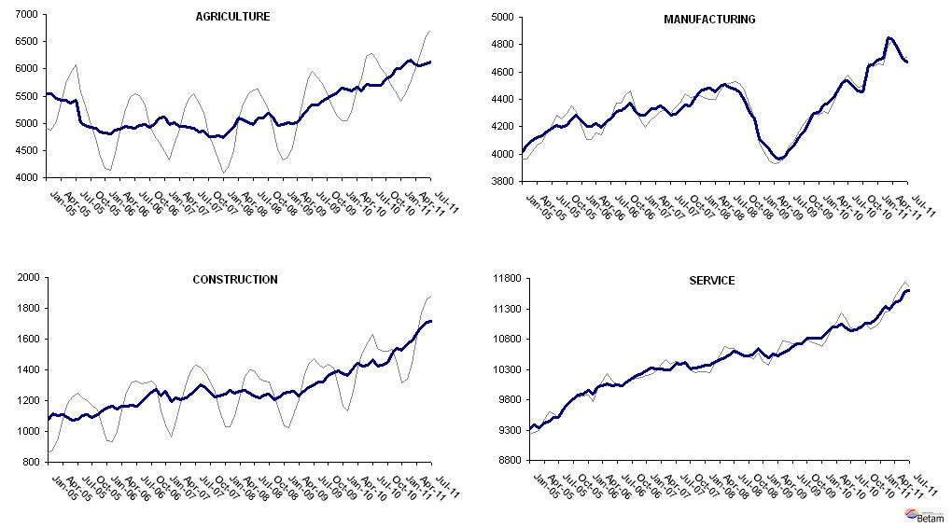
Source: TurkStat, Betam

* Prof. Seyfettin Gürsel, Betam, Director, seyfettin.gursel@bahcesehir.edu.tr
∗ Assoc. Prof. Gökçe Uysal, Betam, Vice Director, gokce.uysal @bahcesehir.edu.tr
∗∗ Aysenur Acar, Betam, Research Assistant, aysenur.acar@bahcesehir.edu.tr
Starting from April, Betam will be using a new series released by Kariyer.net on application per vacancy. Kariyer.net collects this data via their website which is one of the largest job search engines in Turkey. Given the lack of data on vacancies in Turkey, we believe that this new series will provide useful insight to the labor market in Turkey. It provides information on the number of unemployed who are actively seeking work as well as the number of jobs that are available in the labor market. A decrease in applications per vacancy may be caused by an increase in vacancies or by a decrease in the number of applications. An increase in vacancies signals economic growth while decreasing number of applications indicates a decrease in number of people looking for a job. Figure 3 illustrates the seasonally adjusted non-agricultural unemployment rate and deseasonalized calendar day adjusted application per vacancy (Kariyer.net) series. It is clear that these series are highly correlated (almost 90 percent).
Grey lines indicate seasonally adjusted series, where dark blue lines represent raw data.

