

Labor Market Outlook:

September 2011

September 15, 2011

NON-AGRICULTURAL UNEMPLOYMENT RATE
HAS NOT BEEN DECREASING

Seyfettin Gursel*, Gokce Uysal ∗ and Aysenur Acar∗

Executive Summary

According to the labor market statistics released by TurkStat, non-agricultural unemployment rate came down to 11.9 percent in the period of June 2011. However, seasonally adjusted labor market data shows that non-agricultural unemployment rate remained the same in the period of June 2011 (13.2 percent). According to seasonally adjusted labor market data, increase in service employment (148 thousand) counterbalanced the decline in manufacturing employment. However, strong increase in non-agricultural labor force neutralized the increase in service and construction sector employment, which would have decreased the non-agricultural unemployment rate.

Strong Increase in non-agricultural labor force

According to the labor market statistics released by TurkStat on the 15th of September, employment has reached 24 million 901 thousand in the period of June 2011 (May – June - July), while non-agricultural employment reached 18 million 301 thousand. Raw labor market statistics reveal that on year-on-year basis, non-agricultural labor force increased by 848 thousand (4.3 percent) and non-agricultural employment increased by 1 million 46 thousand (6.1 percent) in June 2011. On the other hand, non-agricultural unemployment rate decreased from 13.4 percent to 11.9 percent (Figure 1). The salient point is that the increase in non-agricultural labor force has risen to 800 thousand in June 2011. It had reverted back to its trend of 600 thousand in the last three periods.

Figure 1 Year-on-year changes in non-agricultural labor force, employment and unemployment
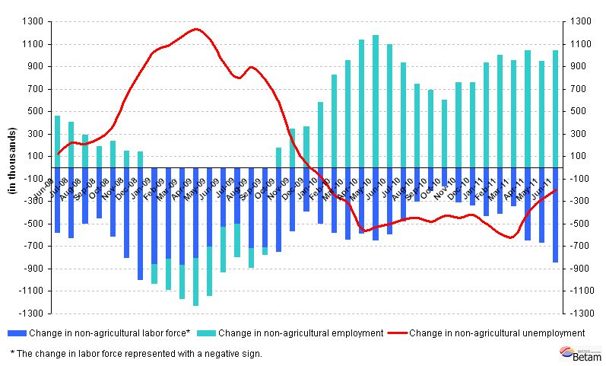
Source: TurkStat, Betam

Seasonally adjusted non-agricultural unemployment remained stagnant

According to seasonally adjusted series, non-agricultural labor force increased by 125 thousand in May compared to its level in May and reached 20 million 677 thousand. The increase in non-agricultural labor force corresponds to 832 thousand people on year-on-year basis. However, non-agricultural employment increased 111 thousand and reached 17 million 957 thousand. Consequently, non-agricultural unemployment increased only by 42 thousand and non-agricultural unemployment rate remained at 13.2 percent (Figure 2). Non-agricultural unemployment remained stagnant since increase in non-agricultural employment was counterbalanced by a strong increase in non-agricultural labor force.

Figure 2 Seasonally adjusted non-agricultural labor force, employment and unemployment
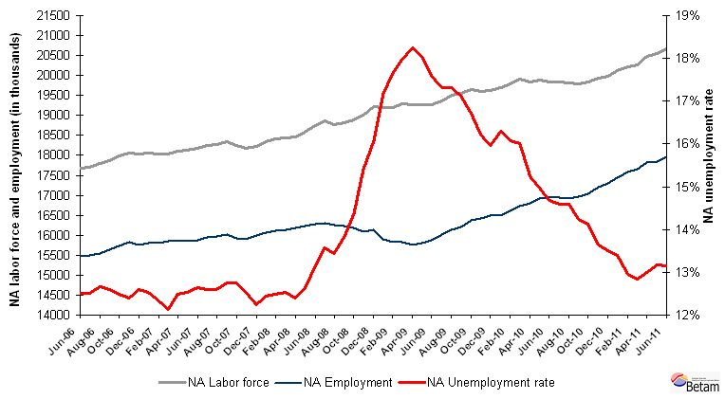
Source: TurkStat, Betam

According to Kariyer.net data, non-agricultural unemployment may decrease in the period of June 2011

The application per vacancy series released by Kariyer.net, which had been remained stagnant in June and July, had a slight decline in August 2011. Given the fact that labor force data will be the average of June – July - August, we expect that seasonally adjusted non-agricultural employment rate may decrease slightly in July 2011.

Figure 3 Non-agricultural unemployment rate and application per vacancy (SA)
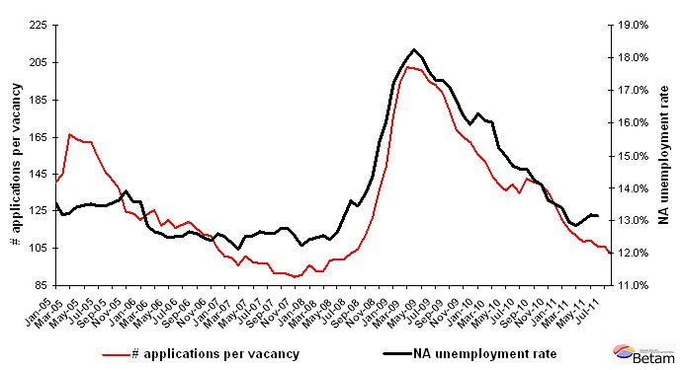
Data source: Kariyer.net, TurkStat, Betam

Increase in service employment in the period of June 2011

According to the seasonally adjusted figures, manufacturing employment decreased by 68 thousand in June 2011 (App. 1 Table 2, App. 2 Figure 4). Employment losses in the manufacturing sector during last three periods (April, May, June) are in line with the declines in the industrial production index. Parallel to the increase in the industrial production index in July 2011, we expect an increase in employment in the manufacturing sector in July 2011 as well. Employment in the service sector increased by 148 thousand compared to the previous period and is the main factor behind the increase in non-agricultural employment.

Seasonally adjusted labor force data shows that agricultural employment, which decreased in the period of April and May 2011, increased 31 thousand in the period of June 2011. The future direction of agricultural employment still remains uncertain.
Appendix 1: Table 1 Seasonally adjusted non-agricultural labor force indicators (in thousands)
 | Labor force | Employment | Unemployment | Unemployment rate | Monthly changes
May-08 | 18588 | 16243 | 2346 | 12.6% | Labor force | Employment | Unemployment
June-08 | 18744 | 16285 | 2459 | 13.1% | 156 | 42 | 114
July-08 | 18856 | 16295 | 2561 | 13.6% | 112 | 10 | 102
August-08 | 18780 | 16257 | 2523 | 13.4% | -77 | -38 | -38
September-08 | 18826 | 16221 | 2604 | 13.8% | 46 | -36 | 82
October-08 | 18891 | 16177 | 2714 | 14.4% | 65 | -44 | 110
November-08 | 19011 | 16083 | 2928 | 15.4% | 120 | -94 | 214
December-08 | 19221 | 16133 | 3088 | 16.1% | 211 | 50 | 160
January-09 | 19187 | 15891 | 3296 | 17.2% | -34 | -242 | 208
February-09 | 19208 | 15819 | 3389 | 17.6% | 21 | -72 | 92
March-09 | 19286 | 15817 | 3469 | 18.0% | 78 | -2 | 80
April-09 | 19259 | 15746 | 3513 | 18.2% | -27 | -71 | 44
May-09 | 19274 | 15802 | 3472 | 18.0% | 15 | 55 | -40
June-09 | 19271 | 15883 | 3388 | 17.6% | -3 | 82 | -85
July-09 | 19359 | 16007 | 3352 | 17.3% | 88 | 123 | -35
August-09 | 19504 | 16126 | 3378 | 17.3% | 145 | 119 | 26
September-09 | 19556 | 16211 | 3346 | 17.1% | 52 | 85 | -32
October-09 | 19655 | 16376 | 3280 | 16.7% | 99 | 165 | -66
November-09 | 19600 | 16422 | 3179 | 16.2% | -55 | 46 | -101
December-09 | 19633 | 16500 | 3133 | 16.0% | 33 | 78 | -45
January-10 | 19692 | 16485 | 3207 | 16.3% | 59 | -15 | 74
February-10 | 19788 | 16608 | 3180 | 16.1% | 96 | 124 | -28
March-10 | 19911 | 16724 | 3187 | 16.0% | 123 | 116 | 7
April-10 | 19830 | 16808 | 3022 | 15.2% | -81 | 84 | -165
May-10 | 19896 | 16916 | 2980 | 15.0% | 66 | 108 | -42
June-10 | 19845 | 16933 | 2913 | 14.7% | -51 | 16 | -67
July-10 | 19828 | 16937 | 2891 | 14.6% | -18 | 4 | -22
August-10 | 19808 | 16918 | 2890 | 14.6% | -19 | -18 | -1
September-10 | 19787 | 16971 | 2816 | 14.2% | -21 | 52 | -74
October-10 | 19844 | 17042 | 2802 | 14.1% | 57 | 71 | -14
November-10 | 19931 | 17214 | 2717 | 13.6% | 87 | 172 | -85
December-10 | 19989 | 17291 | 2698 | 13.5% | 58 | 77 | -19
January-11 | 20134 | 17437 | 2697 | 13.4% | 146 | 146 | -1
February-11 | 20208 | 17590 | 2617 | 13.0% | 73 | 153 | -80
March-11 | 20265 | 17663 | 2602 | 12.8% | 58 | 73 | -15
April-11 | 20470 | 17811 | 2659 | 13.0% | 205 | 148 | 57
May-11 | 20552 | 17845 | 2707 | 13.2% | 82 | 34 | 48
June-11 | 20677 | 17957 | 2720 | 13.2% | 125 | 111 | 13
Source: TurkStat, Betam

Appendix 1: Table 2 Seasonally adjusted sector of employment (in thousands)
 | Agriculture | Manufacturing | Construction | Service | Monthly changes
May-08 | 5066 | 4492 | 1266 | 10491 | Agriculture | Manufacturing | Construction | Service
June-08 | 5006 | 4505 | 1252 | 10533 | -60 | 13 | -14 | 42
July-08 | 4981 | 4489 | 1229 | 10592 | -24 | -16 | -24 | 59
August-08 | 5091 | 4478 | 1219 | 10562 | 110 | -12 | -9 | -31
September-08 | 5100 | 4457 | 1233 | 10519 | 8 | -21 | 14 | -42
October-08 | 5188 | 4395 | 1244 | 10516 | 88 | -62 | 11 | -3
November-08 | 5117 | 4304 | 1207 | 10556 | -71 | -91 | -37 | 40
December-08 | 4961 | 4257 | 1223 | 10644 | -156 | -47 | 16 | 88
January-09 | 4977 | 4110 | 1249 | 10549 | 16 | -147 | 26 | -95
February-09 | 5008 | 4079 | 1257 | 10492 | 30 | -32 | 7 | -57
March-09 | 4987 | 4028 | 1263 | 10554 | -21 | -51 | 6 | 62
April-09 | 5006 | 3986 | 1231 | 10529 | 20 | -42 | -32 | -25
May-09 | 5155 | 3965 | 1261 | 10577 | 148 | -21 | 30 | 48
June-09 | 5253 | 3976 | 1288 | 10618 | 98 | 11 | 27 | 40
July-09 | 5342 | 4035 | 1305 | 10675 | 89 | 59 | 16 | 58
August-09 | 5330 | 4058 | 1317 | 10729 | -12 | 23 | 13 | 54
September-09 | 5408 | 4126 | 1317 | 10725 | 78 | 68 | 0 | -4
October-09 | 5460 | 4165 | 1362 | 10818 | 52 | 39 | 45 | 94
November-09 | 5509 | 4229 | 1383 | 10821 | 49 | 64 | 21 | 3
December-09 | 5556 | 4299 | 1395 | 10813 | 47 | 70 | 12 | -9
January-10 | 5653 | 4307 | 1375 | 10814 | 97 | 9 | -20 | 1
February-10 | 5629 | 4357 | 1367 | 10900 | -24 | 50 | -9 | 87
March-10 | 5597 | 4369 | 1414 | 11000 | -31 | 11 | 47 | 99
April-10 | 5668 | 4410 | 1444 | 10993 | 71 | 42 | 30 | -6
May-10 | 5602 | 4474 | 1428 | 11039 | -67 | 64 | -16 | 46
June-10 | 5711 | 4523 | 1429 | 10991 | 109 | 50 | 1 | -48
July-10 | 5688 | 4536 | 1466 | 10936 | -22 | 13 | 36 | -55
August-10 | 5694 | 4493 | 1424 | 10947 | 6 | -43 | -41 | 11
September-10 | 5696 | 4463 | 1427 | 10997 | 2 | -30 | 3 | 51
October-10 | 5823 | 4458 | 1448 | 11059 | 126 | -5 | 21 | 62
November-10 | 5867 | 4649 | 1506 | 11064 | 45 | 191 | 58 | 5
December-10 | 5998 | 4652 | 1540 | 11101 | 131 | 3 | 34 | 37
January-11 | 6002 | 4686 | 1527 | 11225 | 3 | 34 | -13 | 124
February-11 | 6133 | 4697 | 1572 | 11344 | 131 | 12 | 44 | 119
March-11 | 6161 | 4848 | 1591 | 11293 | 28 | 151 | 19 | -52
April-11 | 6074 | 4836 | 1637 | 11396 | -87 | -12 | 46 | 103
May-11 | 6054 | 4768 | 1680 | 11430 | -20 | -68 | 43 | 34
June-11 | 6085 | 4687 | 1712 | 11578 | 31 | -81 | 32 | 148
Source: TurkStat, Betam
Appendix 2: Figure 4 Employment changes in sectors (in thousand)
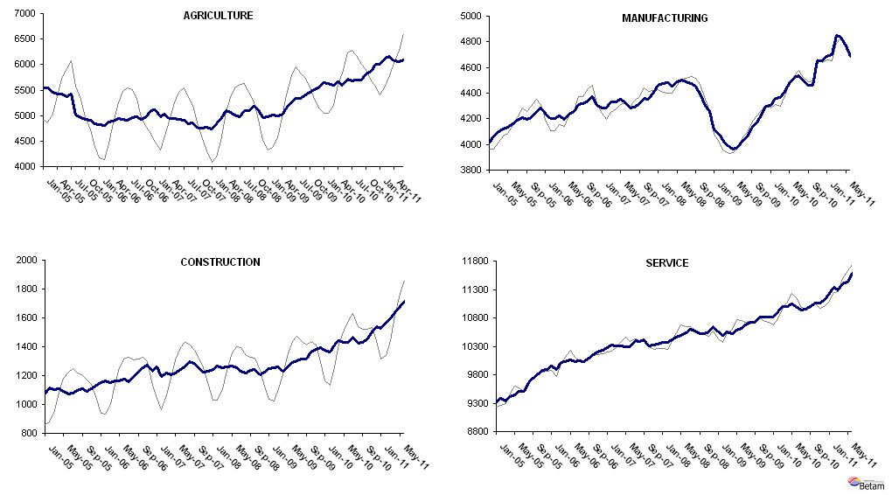
Source: TurkStat, Betam

* Prof. Seyfettin Gürsel, Betam, Director, seyfettin.gursel@bahcesehir.edu.tr
∗ Assoc. Prof. Gökçe Uysal, Betam, Vice Director, gokce.uysal @bahcesehir.edu.tr
∗∗ Aysenur Acar, Betam, Research Assistant, aysenur.acar@bahcesehir.edu.tr
Starting from April, Betam will be using a new series released by Kariyer.net on application per vacancy. Kariyer.net collects this data via their website which is one of the largest job search engines in Turkey. Given the lack of data on vacancies in Turkey, we believe that this new series will provide useful insight to the labor market in Turkey. It provides information on the number of unemployed who are actively seeking work as well as the number of jobs that are available in the labor market. A decrease in applications per vacancy may be caused by an increase in vacancies or by a decrease in the number of applications. An increase in vacancies signals economic growth while decreasing number of applications indicates a decrease in number of people looking for a job. Figure 3 illustrates the seasonally adjusted non-agricultural unemployment rate and deseasonalized calendar day adjusted application per vacancy (Kariyer.net) series. It is clear that these series are highly correlated (almost 90 percent).
Seasonal adjustment procedure is applied to each sector of employment series separately. Hence the sum of these series may differ from the seasonally adjusted series of total employment. The difference stems from the non-linearity of the seasonal adjustment process.
Grey lines indicate seasonally adjusted series, where dark blue lines represent raw data.

